Materials and Methods
In the reference work¹⁠ authors used Swiss-Prot database (release 48, 2005) which contained 201 650 proteins and 874 functional keywords (Swiss-Prota) keywords). The study included 196 326 proteins longer than 40 amino acids and 710 keywords that annotated at least 20 of mentioned proteins. Because of the statistical redundancy (consequence of many homologous sequences), TribeMCL was used to cluster Swiss-Prot proteins into 27 217 protein families. Later statistical analysis used protein family size to adjust for single protein weight (contribution).
Dataset in this study was constructed from CAFA3 dataset, training dataset used in 2016 CAFA (Critical Assessment of Functional Annotation) challenge. CAFA3 dataset was intended for training predictors of protein function, therefore we assume it’s a good representation of protein function space. It consists of 66 841 proteins (in FASTA format) and GO functional annotations. It can be viewed as carefully chosen subset of 2016 Swiss-Prot database. Predominantly (not exclusively) it’s comprised of eukaryotic proteins from several model organisms as shown in Illustration 1. Also, as shown in Illustration 2, 70% of sequences have the highest evidence of existence (protein level). Given it’s small size (compared to Swiss-Prot superset), composition and intended use, we assume that statistical redundancy (as described in the reference work^{1⁠}) is minimal. Therefore our method doesn’t require protein family clustering and uses simpler statistical analysis. If this was not the case there would be no benefit in using smaller CAFA3 dataset compared to the whole Swiss-Prot database.
Sequences containing 21st or 22nd amino acid, unambiguous IUPAC codes (’B’, ’J’, ‘X’ and ‘Z’) or are shorter than 9 amino acids are not supported by VSL2b disorder predictor and were excluded leaving 66 599 CAFA3 proteins. To better understand the composition of CAFA3 dataset (Illustration 1) and obtain Swiss-Prot keyword annotations, CAFA3 dataset was merged back with 2018 Swiss-Prot database. The merging procedure was as fallow: 1) find the entries with the same primary accession number, 2) keep protein sequence from CAFA3 dataset, but take GO term & Swiss-Prot keyword annotations from newer Swiss-Prot. Over time, an entry in Swiss-Prot can be split into two (or more) similar but distinct entries (with new, different primary accession numbers). Since this can increase statistical redundancy, described merging procedure ignores such entries. The other possibility is that several entries are merged into one new entry (with new accession number), but since only four entries were recoverable from this scenario described merging procedure ignores this case as well. Due to differences in primary accession number described merging procedure produced 66 530 proteins .

Illustration 1: CAFA3 proteins grouped by origin (species), compared with Swiss-Prot. Histogram is sorted by number of CAFA3 proteins in decreasing order. Majority of proteins belong to a couple of model organisms. In total there are 939 species, but only the ones contributing with at least 100 proteins are shown. This represents 93% of all CAFA3 proteins.
Illustration 2: Number of proteins grouped by “level of existence” and compared with Swiss-Prot v. database.

With over ____ GO terms to date, Gene Ontology is much larger then hierarchical structure that is Swiss-Prot keywords. In Swiss-Prot db, if keywords K₁ … K_{n} are child nodes (specializations) of a more general keyword K then all proteins annotated by K₁ … K_{n} are also annotated by K. For this study such behavior is desirable, but GO annotations do not fallow this behavior. Instead, annotations are assigned as precisely as possible to GO terms that best describe the function. Yet, due to the nature of GO ‘is_a’ parental relationship, such annotation grouping is implicitly implied and known as ‘true path rule’.² Because of the share size and complexity (Direct Acyclic Graph) of GO, we delay annotation grouping to when needed (lazy evaluation). Out of ____ MF terms in GO, 1146 directly annotates at least 20 proteins while after annotation grouping that number rises to 1781.

Predicting disordered regions in proteins
The reference work¹⁠ used PONDR VL3E disorder predictor to classify proteins into putatively ordered or disordered.
VL3E was developed using 162 long (>30 residues) disordered regions from a non-redundant set of 152 DisProt proteins and 290 completely ordered proteins. The predictor consists of an ensemble of neural network classifiers, and it achieves ∼87% cross-validation accuracy on balanced data with equal number of ordered and disordered residues.¹⁠
This study used a newer predictor of PONDR family, VSL2b. VSL2 architecture consists of two specialized predictors: predictor of short disordered regions (<30) and predictor of long disordered regions (>30) combined together by a meta predictor. Compared to VL3E, VSL2 achieves similar accuracy (ACC) for long disordered regions, but has more than 10% lower specificity (SP). VSL2b has slightly lower overall accuracy (3%) compared to VSL2. For the purpose of further statistical analysis we introduce the following definition:
Definition 1. Protein is (labeled) putatively disordered if it contains a predicted IDPr that is at least 40 consecutive amino acids long, otherwise putatively ordered.
Given the Definition 1 we introduce the disorder operator d such that:

Relationship between Long Disorder Prediction and Protein Length
Given the above Definition 1, the likelihood of labeling a protein putatively disordered grows with it’s length.¹⁠ Such behavior will increase statistical significance of putatively disordered proteins and must be taken into account. Probability that protein of length () is (by chance) labeled as putatively disordered can be approximated in the following way. Let be a subset of dataset with proteins of length from interval . Then the probability is calculated as a fraction of putatively disordered proteins in set :

Interval is an averaging window that grows with protein length . Following the reference work¹⁠, we use making the window 20% of current Graph of is shown in Illustration 3.
Illustration 3: Fraction of putative disorder as a function of length. Smoothed uses averaging window thats 20% of L.

Additionally, we found that can also be approximated by replacing our dataset with randomly generated proteins. Similar approaches have already been employed for decoy database generation and False Discovery Rate (FDR) assessment³⁠. Given two generative models, random & uniform we created two decoy datasets by replacing each sequence with a generated sequence of same length. As illustrated on
Illustration 4 ,random model generates a sequence based on AA composition from original dataset while uniform model assumes equal probability for every amino acid (1/20). Visual comparison with original , shown by Illustration 5, hints that closely matches originally proposed . High divergence of uniform model can be explained by it’s non-biological nature therefor it was not used in the rest of the study.
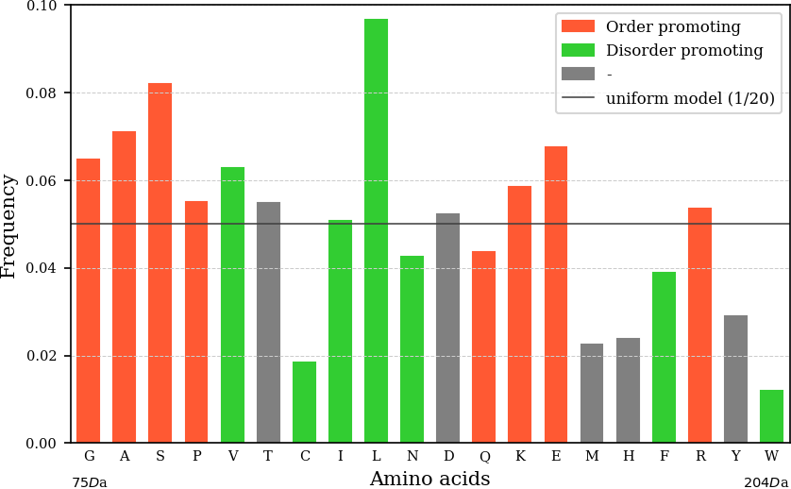Illustration 4: Amino acid frequency (from CAFA3 dataset) representing random model and compared with uniform model. Amino acids are ordered by weight and colored to label order/disorder promoting characteristics.

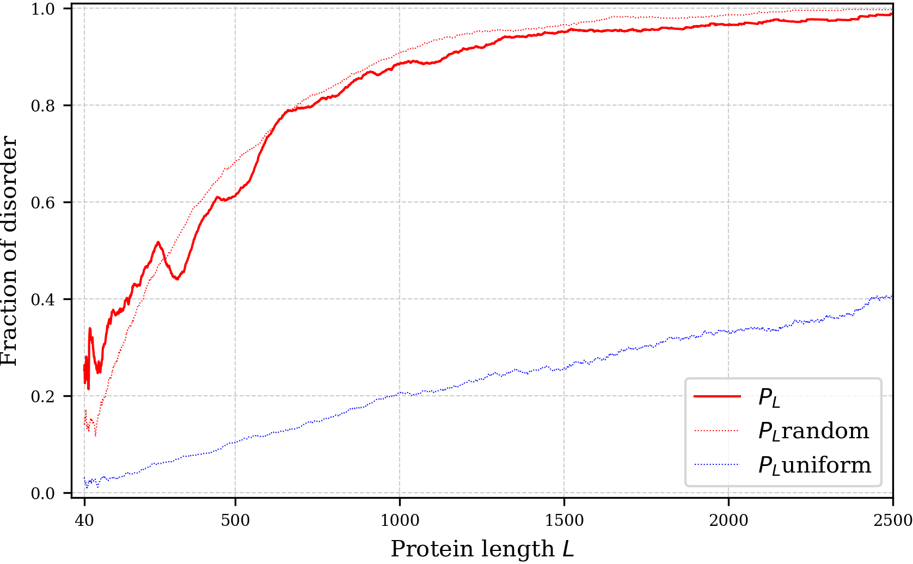Illustration 5: Comparing P_{L} with random and uniform generative models.

Assessing correlation between function and order/disorder
Let be a set of proteins annotated with function . By disorder level (of function ) we assume the fraction () of putatively disordered proteins inside set .

Null hypothesis states that disorder level depends only on sequence length. Instead of we use Bernoulli random variable () that is 1 with the probability and 0 with probability . Then the null model () becomes:

If is in the left tail of distribution (the p-value is near 1), the function is enriched in ordered proteins, while if it’s in the right tail (the p-value is near 0) it is enriched with disordered proteins.

Definition 2:
- If p-value > 0.95, then the function is disorder related (correlated with disorder)
- If p-value < 0.05, then the function is order related (correlated with order)
- Otherwise, nothing can be said about functions order/disorder correlation

Because of it is difficult to analytically derive distribution of , so empirical calculation is used. Empirical p-value is determined by generating 1000 realizations of and then calculating the fraction of realizations that are larger then .

… more detailed explanation and Z-score.

Bibliography

1. Xie, H. et al. Functional anthology of intrinsic disorder. 1. Biological processes and functions of proteins with long disordered regions. J. Proteome Res. 6, 1882–1898 (2007).
2. Camon, E. The Gene Ontology Annotation (GOA) Database: sharing knowledge in Uniprot with Gene Ontology. Nucleic Acids Res. 32, 262D–266 (2004).
3. Zhang, Z. et al. Reverse and Random Decoy Methods for False Discovery Rate Estimation in High Mass Accuracy Peptide Spectral Library Searches. J. Proteome Res. 17, 846–857 (2018).

a) The term UniProtKB keywords (or UniProtKB/Swiss-Prot) is also used.

