Rebase Merge strategy:

# Tasks:

1. Create a working directory and initiate git into it

Cmd : git init

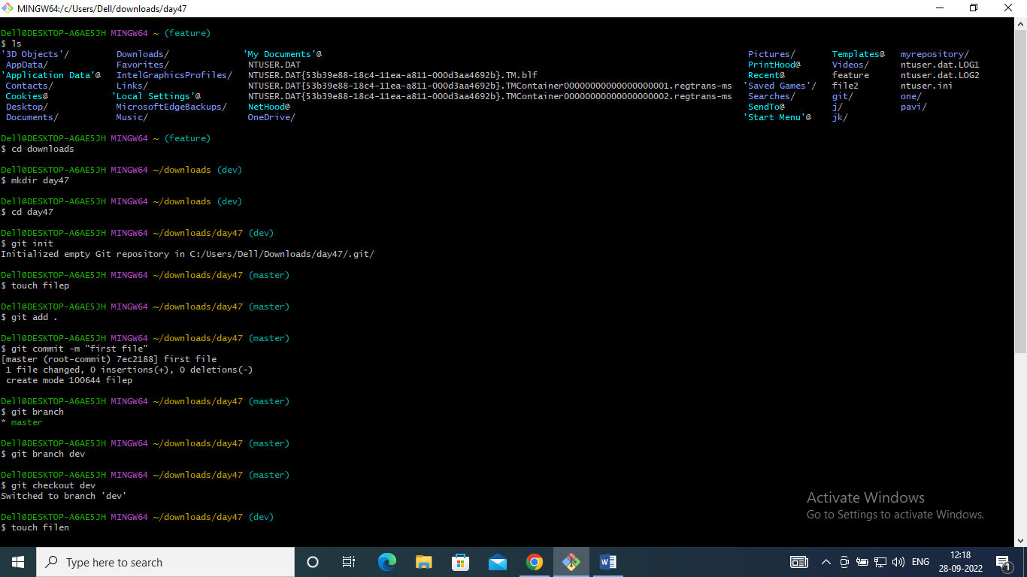

1. Create a new branch as a Dev branch

Cmd : git branch dev



1. Switch to the Dev branch

Cmd : git checkout dev



1. Create new files and commit files in the Dev branch

Cmd : touch <filename> dev

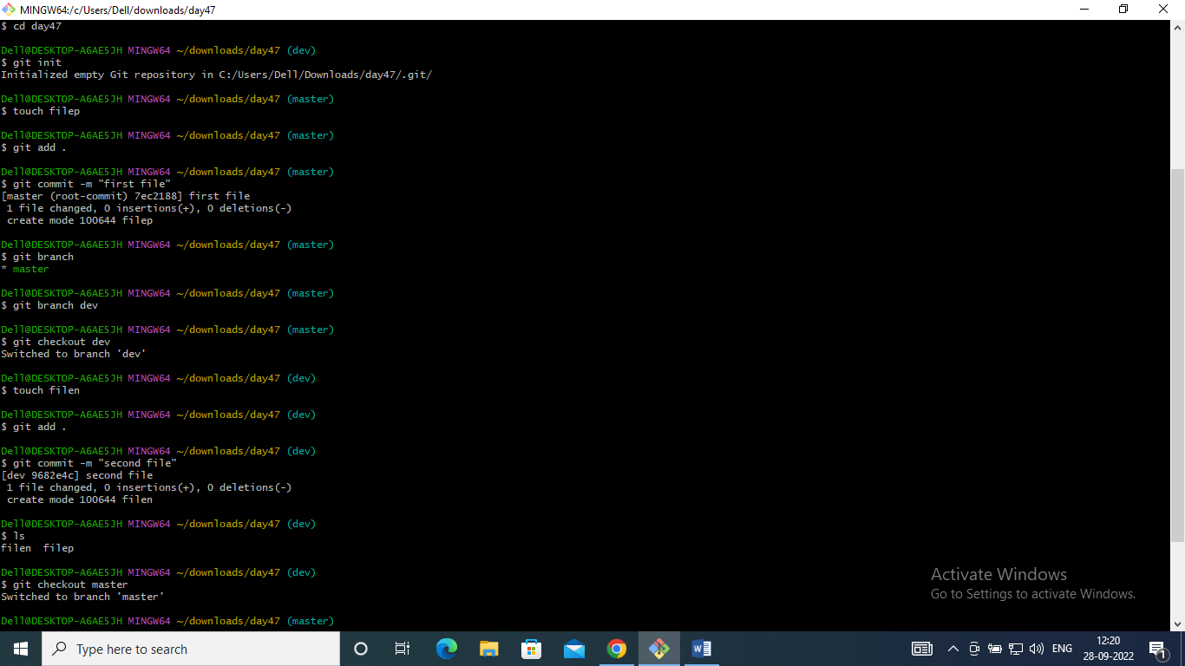

1. Checkout to the master branch

Cmd : git checkout master

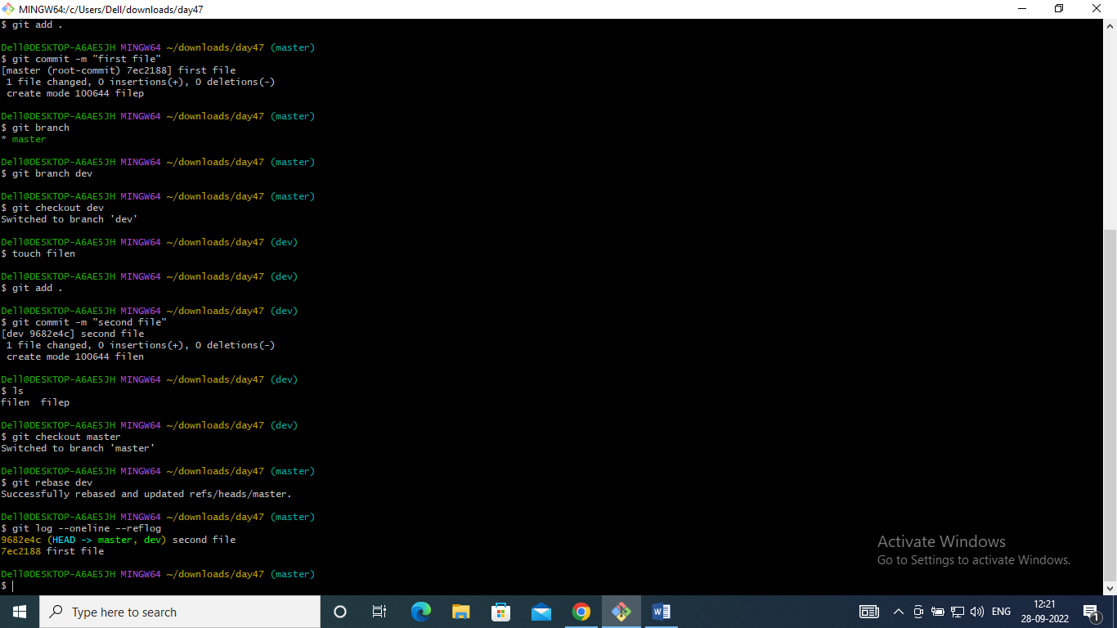

1. Create new files and commit files in the master branch

Cmd : touch <filename> master

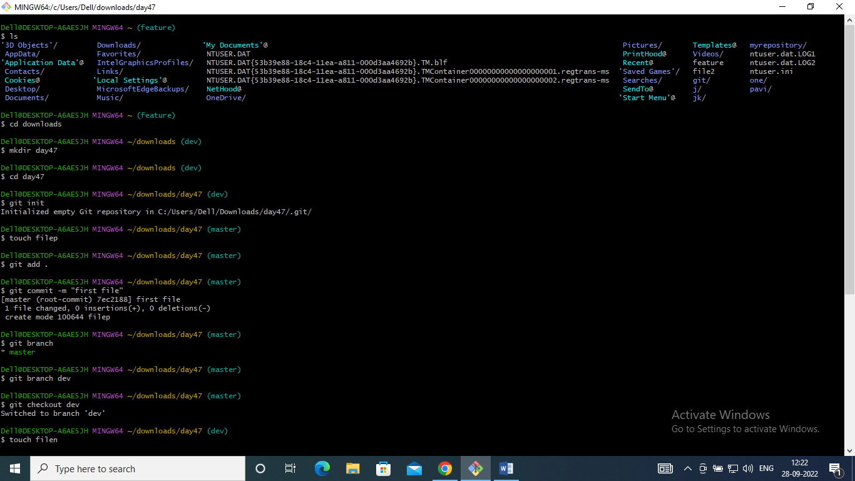

1. Switch to the Dev branch

Cmd: git checkout dev



1. Now execute the command for rebase merge strategy

Cmd : git rebase dev

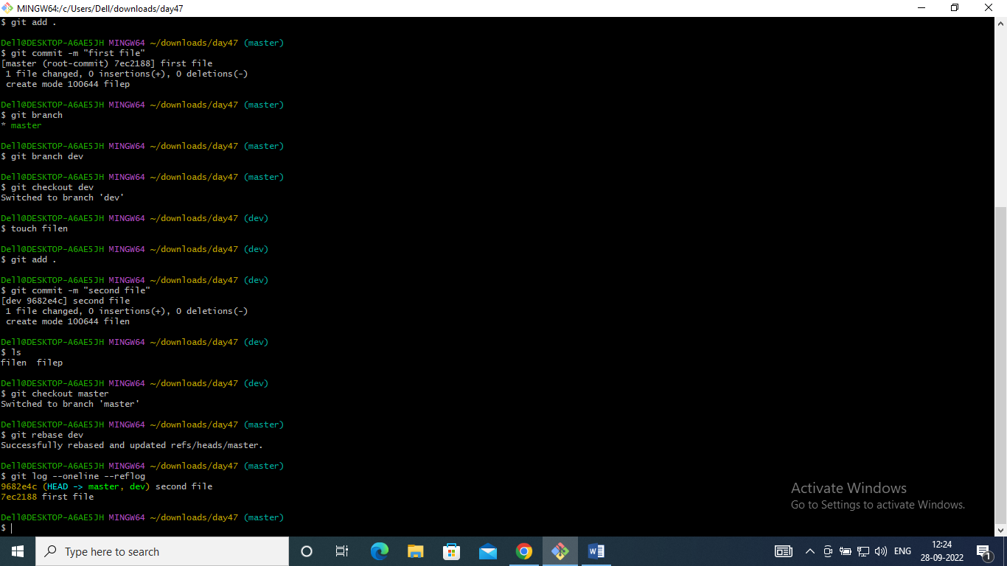

1. Check if your commit history has been changed.

Cmd : git log –oneline --reflog

