New York City - Traffic Collision Mapping Tutorial, by HP Haven OnDemand version 1.0

Revision History
Author | Revision Number | Date
TopCoder | 1 | 15/3/2015

1. Organization of Submission 3
2. Deployment Instructions 3
2.1 Application Setup 3
2.2 Development 4
2.3 Production 6
2.4 Google Maps 7
2.5 Increasing Maximum Records from the server 8
3. Code Overview and Overall Functionality. 8
4. Verification 8
5. Resource Contact List 9

Organization of Submission

Submission includes documentation, video, eclipse package (source code), war file, blog, data folder and readme text file. Components of the application are as follows:

Structure of source code is as follows:
- Java Classes (/src/web):
  - Index – Java Servlet
  - AccidentDTO – DTO for data transfer
  - VerticaDAL – DAL Layer to communicate with Vertica Server
- Pages(/WebContent/pages):
  - Index.jsp
- CSS (/WebContent/css)
  - Style
- JS (/WebContent/js):
  - Constants.js – Global constants for Page
  - Script.js – script file

- config.properties (/WebContent/WEB-INF) – config file

Deployment Instructions

2.1 Application Setup
- Install Vertica Server. Refer Essentials_5.0_LabManual_1_Node file in the same folder for detailed steps.
- Import data folder to Vertica VM

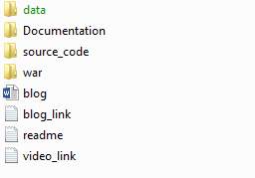

- Run “data/schema.sql” to create the table ( \i path_to_file ). Check Essentials_5.0_LabManual_1_ Node for running script in vsql.

- Run “data/sample_data/data_nypd_motor_vehicle_collisions.xml” to import the data.

- Install Java JDK on the server (http://docs.oracle.com/javase/8/docs/technotes/guides/install/windows_jdk_install.html )

- Install Tomcat 7 on the machine for deployment on the server. (http://tomcat.apache.org/tomcat-7.0-doc/appdev/installation.html )

2.2 Development
- Eclipse has been used as IDE for development
- Download Java EE Release for eclipse (https://eclipse.org/downloads/packages/eclipse-ide-java-ee-developers/keplerr )
- Create a project of type Dynamic Web Project.
- Import “source_code\NYCAccidentsVisualizer” in project.
  - Click on File -> Import
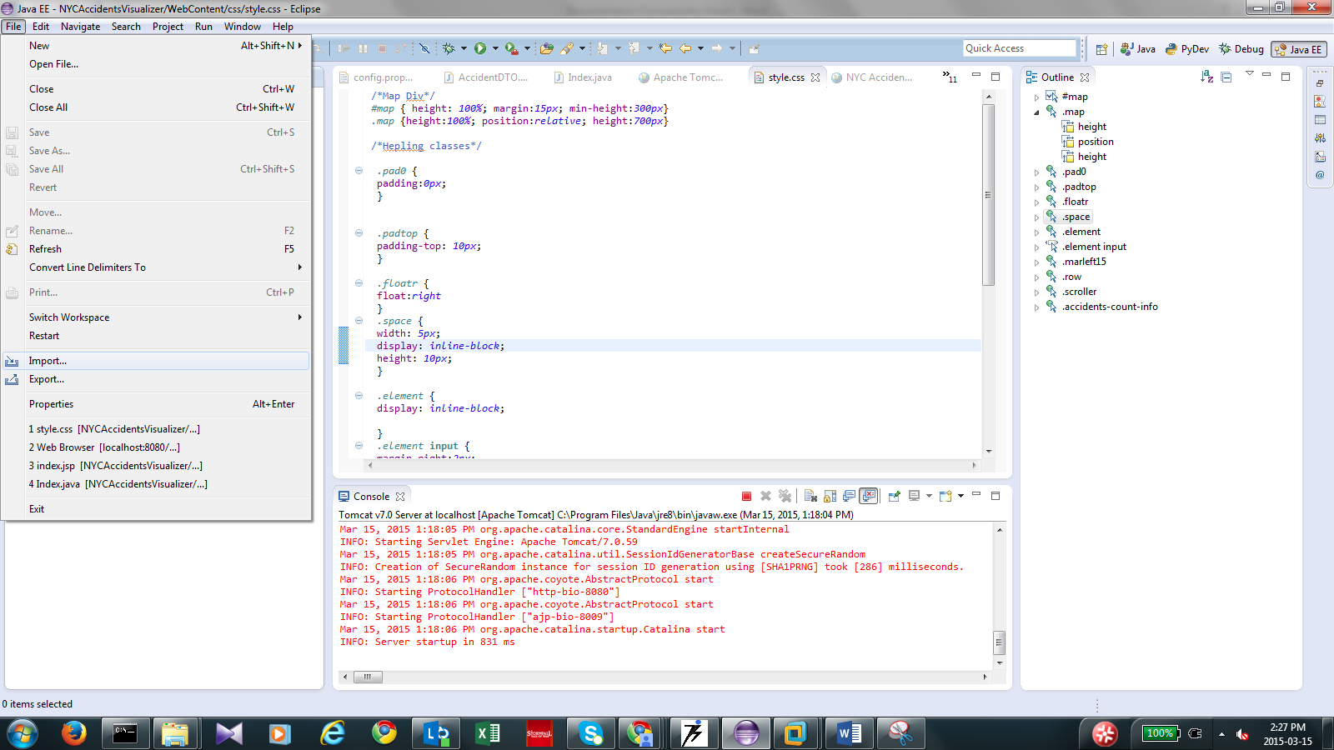

  - Click on File System

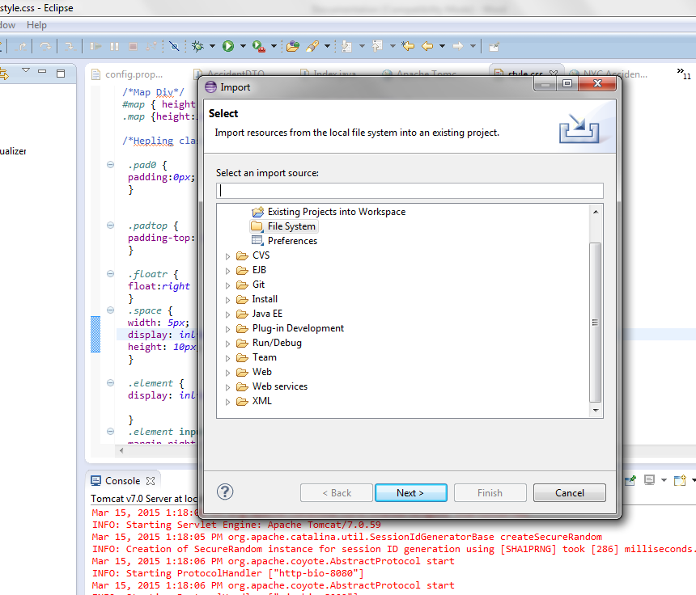
  - Import folder into the project
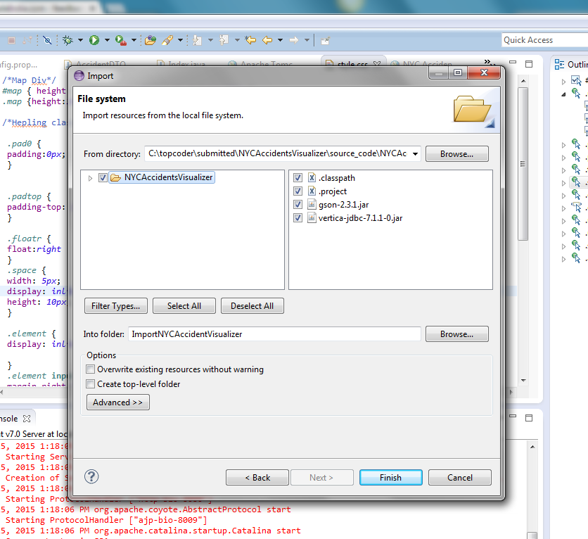

  - Configure tomcat server for eclipse (http://www.eclipse.org/webtools/community/education/web/t320/Configuring_an_Application_Server_in_Eclipse.pdf )

  - Go to config.properties and change the Vertica server address as desired.

  - Right click the folder and click on run as server.

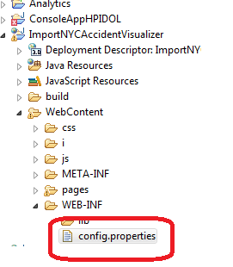

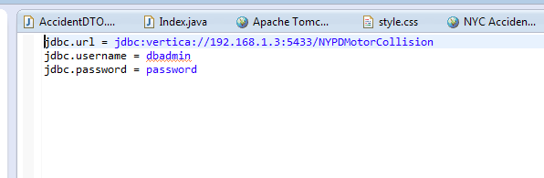

  - Open the browser and navigate to http://localhost:8080/{ProjectName} /Index. If the tomcat is running on some other port, then change port number accordingly. Also change placeholder ProjectName with the project name in eclipse. In our case port number is 8080 and ProjectName is NYCAccidentsVisualizer, so if all steps has been implemented without any custom changes then app will be accessible at http://localhost:8080/ NYCAccidentsVisualizer/Index

2.3 Production

- Copy NYCAccidentsVisualizer.war file to {Tomcat 7.0 Installed Folder}\webapps. Default location is C:\Program Files\Apache Software Foundation\Tomcat 7.0\webapps. Files will be extracted to the NYCAccidentsVisualizer

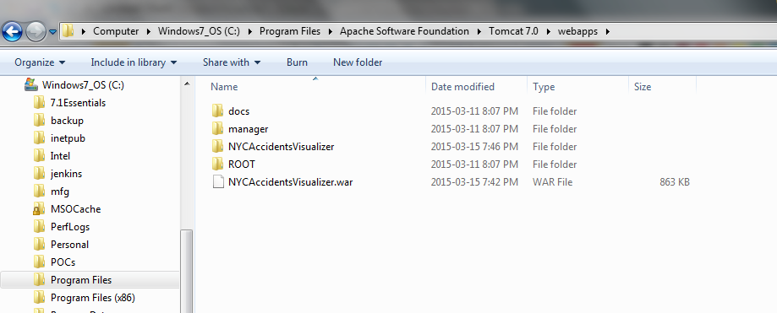

- Go to NYCAccidentsVisualizer\WEB-INF folder, change the connection string as required.
- Go to Window Start->Monitor Tomcat, restart the server.
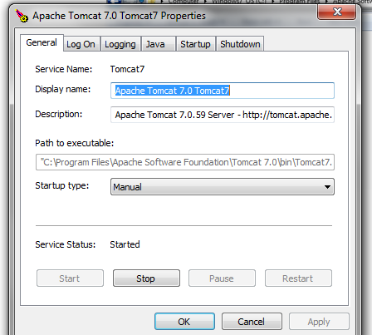

- Open browser, app will be accessible at to http://localhost:8080/ NYCAccidentsVisualizer /Index where 8080 is the port number on which tomcat is running.

2.4 Google Maps

- Right now application uses generic key which is allows request from any domain created by developer using his account.

- For changing the key refer https://developers.google.com/maps/documentation/javascript/tutorial#api_key

- Replace the present key with the key obtained in NYCAccidentsVisualizer/WebContent/pages/index.jsp file.

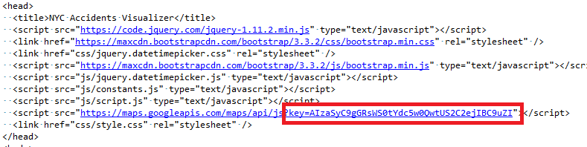

2.5 Increasing Maximum Records from the server

- Change the number in MAXCOUNTACCIDENTS variable in NYCAccidentsVisualizer\WebContent\js\constants.js file as desired.

Code Overview and Overall Functionality.

- Starting GET Request fetches the JSP Page from the Server.

- Depending upon the filter configurations, query string is generated which is sent as an AJAX POST request to the server. Data from the server is fetched as JSON which is then plotted on the MAP.

Verification
- Manual testing of the app has been done.

- Please find some of the screenshots and the query associated.

Select * from nypd_motor_vehicle_collisions where date >= '2014-03-15 00:00' and date < '2015-03-15 19:00' and number_of_persons_killed > 0 and number_of_motorist_killed > 0 and (contributing_factor_vehicle_1 in ('Backing Unsafely','Traffic Control Disregarded') or contributing_factor_vehicle_2 in ('Backing Unsafely','Traffic Control Disregarded') or contributing_factor_vehicle_3 in ('Backing Unsafely','Traffic Control Disregarded') or contributing_factor_vehicle_4 in ('Backing Unsafely','Traffic Control Disregarded') or contributing_factor_vehicle_5 in ('Backing Unsafely','Traffic Control Disregarded')) and longitude is not null and latitude is not null LIMIT 400

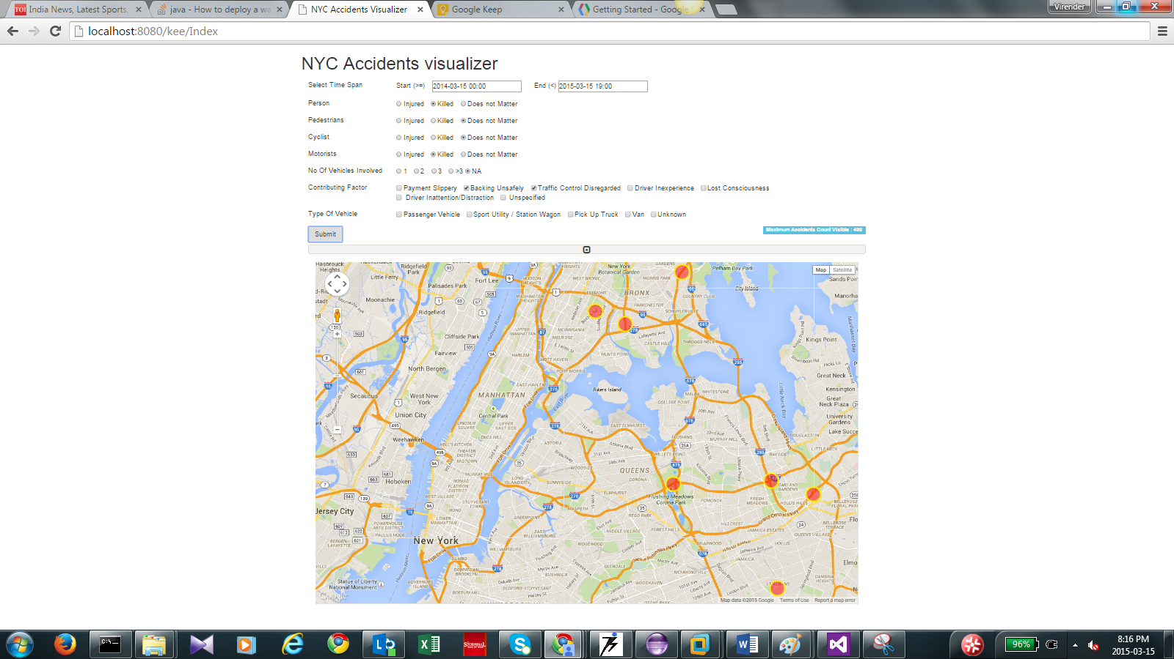

Select * from nypd_motor_vehicle_collisions where date >= '2014-03-15 00:00' and date < '2015-03-15 19:00' and number_of_persons_killed > 0 and number_of_motorist_killed > 0 and (vehicle_type_code_1 in ('VAN') or vehicle_type_code_2 in ('VAN') or vehicle_type_code_3 in ('VAN') or vehicle_type_code_4 in ('VAN') or vehicle_type_code_5 in ('VAN')) and longitude is not null and latitude is not null LIMIT 400
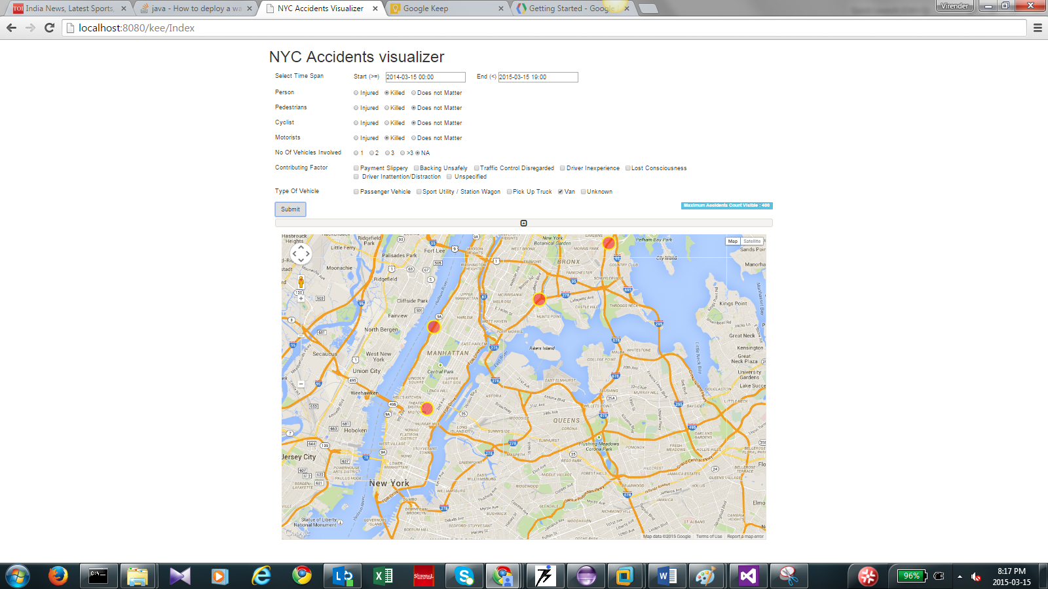

Resource Contact List

Name
TopCoder

