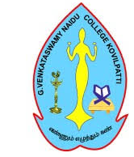
G. VENKATASWAMY NAIDU COLLEGE (AUTONOMOUS)

KOVILPATTI
Reaccredited with ‘A’ Grade by NAAC
Affiliated to Manonmaniam Sundaranar University, Tirunelveli
Department of _________________
1.1.2: Number of Programmes where syllabus revision carried out during the academic year (2025-2026)

S.No | Semester | Course Code | Course Title | Content Added | Content Removed | Percentage Content Syllabus Revised

If revision has been carried out in the syllabus , During the year , Total percentage of content
Added or replaced is 100%.

Signature of HOD Signature of Director Signature of Principal

