Food Violations Report

Abstract
The main theme of the this assignment shows the food violations of the perticular area. Here we have discuss on two files inspections, violations.
In this assignment we have the shown on the how to create datasbase and
Import the data from the excel files to the corresponding tables in the database. A count of the violations for each at least 1 violation.
We have to create a new work book to print count of the each food violation.

Introduction
This report is use full for maintaining of what all the work we done the given task and how we analyze the data and what are the tables and data types we used in that task. f we have any similar task like this that time this report is very use full to us

Database Structure
A description of the schema of your database (table names, attribute types)
In this task I have created one database --- sheets and I created two tables in that data base by using given Excel Files and mentioned their names as inspections and violations.
In Inspections I have used attributes and data types are:
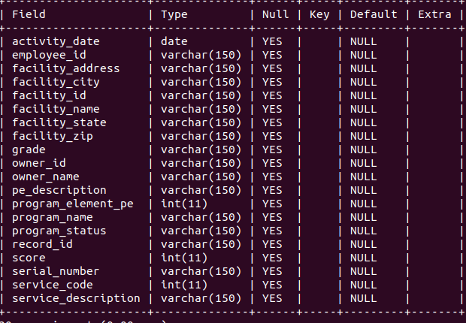
In violations I have used attributes and data types are:
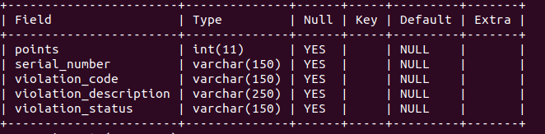

based on distinctive violations we created one table called previous_violations and their attributes and data types are:

name-------------varchar(150)
address-----------varchar(150)
zip_code-------------varchar(150)
city-----------------varchar(150)

Violation counts
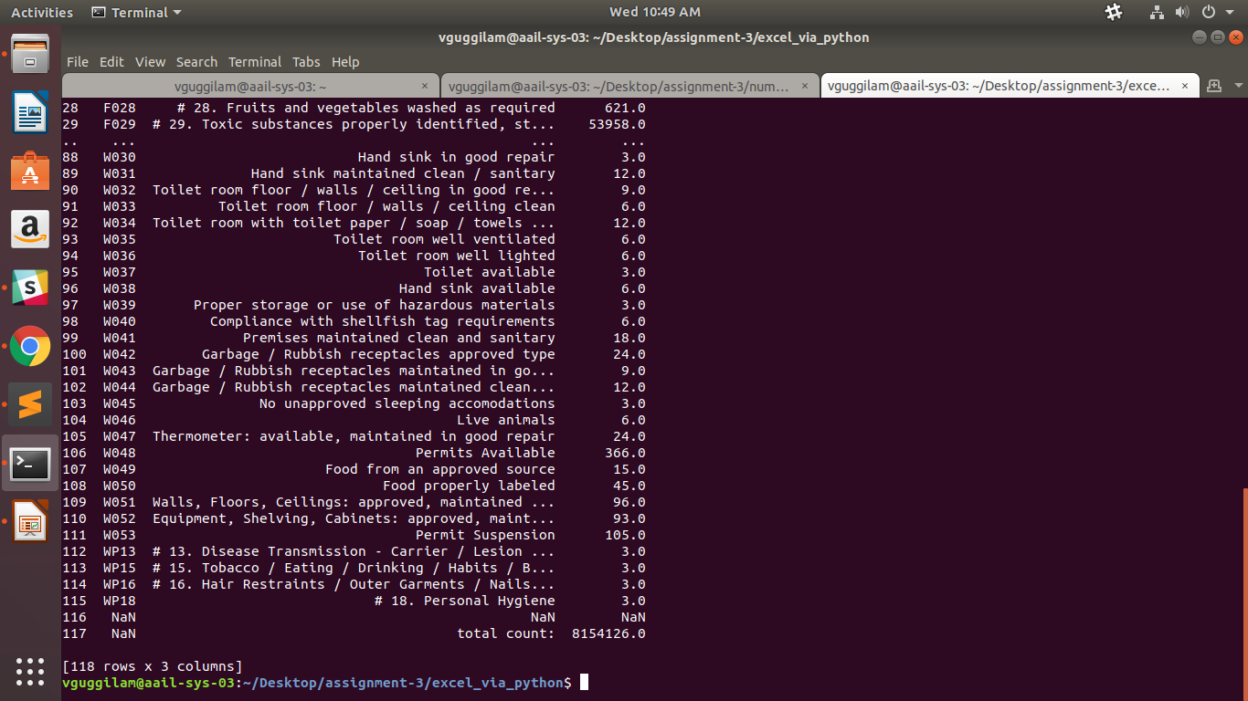
Here I have seen the violation count for the violations sheets from the attributes of Code, Description, Count from the number violations.
- I have to create a new workbook type ViolationTypes and create the sheet name as violationtype

Violations over time
Here retrieve data to calculate the average violations for every month
between July 2015 and December 2017 for each postcode. Here by using MatPlotLib to plot the flow charts.
Here the graph name is violations difference . So im taking x-axis as dates and y-axis as differences of max and min postcodes .
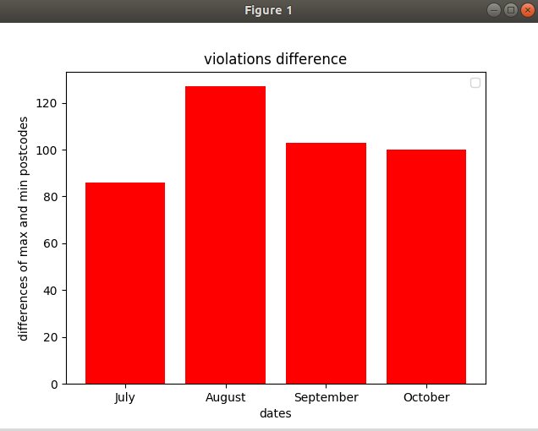

Here the second graph shows the averages of the violations. X-axis on dates and y-axis on monthly average violations.

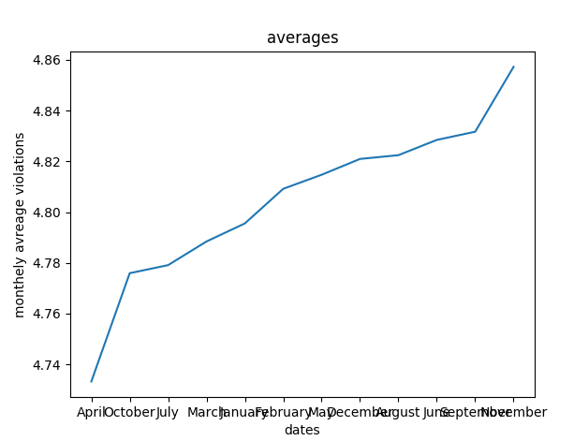
Here the next graph shows the monthly averege of the mcd and burgerking.
X-axis on months and y-axis on averages per month.
