Asynchronous Up and Down Counters

Introduction to Asynchronous (Ripple) Counters
An asynchronous counter (ripple counter) is a sequential circuit in which flip-flops are connected so that
the output of one flip-flop acts as the clock input of the next flip-flop.
The term 'asynchronous' means that not all flip-flops are triggered simultaneously.
Each flip-flop divides the clock frequency by two. An n-bit counter can count 2ⁿ states.

1. 2-Bit Asynchronous Up Counter
Circuit Description:
- Two JK flip-flops (FF1 and FF2) are used, with J = K = 1.
- FF1 is triggered by the external clock.
- FF2 is triggered by the output of FF1 (Q0).
Truth Table:
Clock Pulse | Q1 | Q0 | Binary Count
0 | 0 | 0 | 0
1 | 0 | 1 | 1
2 | 1 | 0 | 2
3 | 1 | 1 | 3
4 | 0 | 0 | Repeat
Sequence: 00 → 01 → 10 → 11 → 00 (Repeats)

2. 3-Bit Asynchronous Up Counter
Circuit Description:
- Three JK flip-flops with J = K = 1.
- FF1 is triggered by the external clock, FF2 by Q0, and FF3 by Q1.
Counting Sequence: 000 → 001 → 010 → 011 → 100 → 101 → 110 → 111 → 000

3. 4-Bit Asynchronous Up Counter
Circuit Description:
- Four JK flip-flops (J = K = 1).
- FF1 clocked by external clock, FF2 by Q0, FF3 by Q1, and FF4 by Q2.
Counting Sequence: 0000 → 0001 → ... → 1111 → 0000 (Repeats)

Summary of Asynchronous Up Counters
Each flip-flop toggles at half the frequency of the previous one.
The counters count upward from 0 to maximum binary value and then repeat.

Asynchronous Down Counters
An asynchronous down counter counts in reverse order (descending binary values).
Here, each flip-flop is triggered by the complement output (Q′) of the previous flip-flop.

1. 2-Bit Asynchronous Down Counter
Circuit Description:
- Two JK flip-flops with J = K = 1.
- FF1 clocked by external clock.
- FF2 clocked by Q0′ (the complement of Q0).
Sequence: 11 → 10 → 01 → 00 → 11 (Repeats)

2. 3-Bit Asynchronous Down Counter
Circuit Description:
- Three JK flip-flops with J = K = 1.
- FF1 clocked by external clock, FF2 by Q0′, FF3 by Q1′.
Counting Sequence: 111 → 110 → 101 → 100 → 011 → 010 → 001 → 000 → 111

3. 4-Bit Asynchronous Down Counter
Circuit Description:
- Four JK flip-flops with J = K = 1.
- FF1 clocked by external clock, FF2 by Q0′, FF3 by Q1′, FF4 by Q2′.
Counting Sequence: 1111 → 1110 → ... → 0000 → 1111 (Repeats)

Comparison: Up Counter vs Down Counter
Feature | Up Counter | Down Counter
Triggering | Triggered by Q output | Triggered by Q′ output
Counting Direction | Ascending (000 to 111) | Descending (111 to 000)
Initial State | 000 | 111
Next State | Increment by 1 | Decrement by 1

Applications
- Digital clocks and timers
- Frequency dividers
- Event counters
- Countdown systems
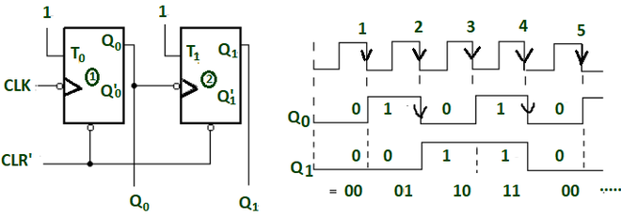

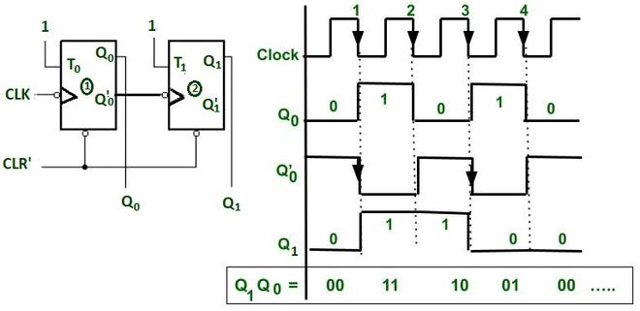3-bit asynchronous up counter
Clock Pulse # | Q2 | Q1 | Q0 | Decimal
0 (initial) | 0 | 0 | 0 | 0
1 | 0 | 0 | 1 | 1
2 | 0 | 1 | 0 | 2
3 | 0 | 1 | 1 | 3
4 | 1 | 0 | 0 | 4
5 | 1 | 0 | 1 | 5
6 | 1 | 1 | 0 | 6
7 | 1 | 1 | 1 | 7
8 | 0 | 0 | 0 | (repeats)

3 bit asynchronous down counter
Clock Pulse # | Q2 | Q1 | Q0 | Decimal
0 (initial) | 1 | 1 | 1 | 7
1 | 1 | 1 | 0 | 6
2 | 1 | 0 | 1 | 5
3 | 1 | 0 | 0 | 4
4 | 0 | 1 | 1 | 3
5 | 0 | 1 | 0 | 2
6 | 0 | 0 | 1 | 1
7 | 0 | 0 | 0 | 0
8 | 1 | 1 | 1 | (repeats)

