

Software Engineering
Software Requirements Specification
(SRS) Document

Author(s): Philip Knouff
Brittany Little
William Whelchel
Stephen Mustgrave
Affiliation: IT Department
Web Address: www.radford.edu/~team15
Date: March 24, 2011

Revisions

Version | Primary Author(s) | Description of Version | Date Completed
Draft: 6  Version: 1 | Philip Knouff  Brittany Little  Stephen Mustgrave  William Whelchel | Version 1 consists of the final report to be turned in. All required fields have been completed and are to date. | 03/24/2011

Review & Approval
Requirements Document Approval History
Approving Party | Version Approved | Signature | Date
Philip Knouff | 1.6 | Philip Knouff | 03/24/2011
Dr. T. L. Lewis | 1.6

Requirements Document Review History
Reviewer | Version Reviewed | Signature | Date
Brittany Little | 1.6 | Brittany Little | 03/24/2011
Stephen Mustgrave | 1.6 | Stephen Mustgrave | 03/24/2011
William Whelchel | 1.6 | William Whelchel | 03/24/2011

Contents

1. Introduction 3
1.1 Purpose of this document 3
1.2 Scope of this document 3
1.3 Overview 3
1.4 Business Context 3
2. General Description 4
2.1 Product Functions 4
2.2 Similar System Information 4
2.3 User Characteristics Stephen 10
2.4 User Problem Statement 10
2.5 User Objectives 10
2.6 General Constraints 11
3. Functional Requirements 12
4. Interface Requirements 18
4.1 User Interfaces 18
4.2 Hardware Interfaces 19
4.3 Communications Interfaces 19
4.4 Software Interfaces 19
5. Performance Requirements 20
6. Other non-functional attributes 20
6.1 Security 20
6.2 Binary Compatibility 20
6.3 Reliability 20
6.4 Maintainability 20
6.5 Portability 20
6.6 Extensibility 20
6.7 Reusability 20
6.8 Application Affinity/Compatibility 21
6.9 Resource Utilization 21
6.10 Serviceability 21
7. Operational Scenarios 22
8. Preliminary Use Case Model 24
8.1 Use Case Model 24
9. Updated Schedule 25
10. Updated Budget 26
11. Appendices 27
11.1 Definitions, Acronyms, Abbreviations 27
11.2 References 27

1. Introduction
1.1 Purpose of this document
The purpose of this document is to describe in detail the requirements given by our Client, Mr. Meade, for the new Association for Computing Machinery’s (ACM) Content Management System (CMS) which will be useable and accessible for everyone at Radford University by the end of the semester. In addition to listing and explaining our Client’s requirements, the document serves as a roadmap for the key stakeholders involved, of what we are currently doing on the site, what we plan to do and what additional features we might include if time allows us to. Within this document, readers can find information about our general project concepts, a list of functional and non-functional requirements, examples of our graphical user interfaces (GUI), as well as information about our current schedule, budget and case models.
1.2 Scope of this document
The requirements elicitation team for the ACM’s Content Management System during this semester, Spring 2011, is known as the ITEC370 Software Engineering team the IT Crowd, which consists of the following members: Brittany Little, Philip Knouff, Stephen Mustgrave, and William Whelchel. As developers, and system engineers of the IT Crowd, we responsible for completing all the steps required to make this CMS fully functional and aesthetically pleasing in the eyes of not only our client, Mr. Meade, ACM members and officers but also Radford University (RU) faculty as a whole. During this elicitation process, several constraints have been place on our team such as the complex scheduling procedure to ensure there is enough time to complete all of the requirements requested by Mr. Meade by the end of the semester and team members’ limited knowledge about Joomla’s overall system, it plugin and compatible restrictions on these CMS systems.
1.3 Overview
The purpose of this project is to create a new Association for Computing Machinery (ACM) website for the Radford University chapter inspired by the ACM National website, www.acm.org, colors and layout. This Content Management System (CMS) will allow anyone at Radford University, the ability to find information not only about the current officers, but also the past ones. In addition to officer information, it will provide upcoming events and hopefully the opportunity to display some of the ITEC student's talents and projects.
1.4 Business Context
ACM, the Association of Computing Machinery, is an international scientific and educational organization dedicated to advancing the arts, sciences, and applications of information technology. With a world-wide membership of 80,000, ACM functions as a locus for computing professionals and students working in the various fields of Information Technology.
ACM is the world’s oldest and largest educational and scientific computing society. Since 1947 ACM has provided a vital forum for the exchange of information, ideas, and discoveries. Today, ACM serves a membership of more than 80,000 computing professionals in more than 100 countries in all areas of industry, academia, and government.

2. General Description
2.1 Product Functions
The proposed system will be able to maintain uploaded files and embedded videos for users. Certain users shall be able to log on to update information and documents available to the general public. Among certain features there will be a Game Repository, a YouTube embedded page, an ACM photo Album, and other features. Any user visiting the site shall be able to use every feature mentioned providing their computer has the proper software and/or hardware.
2.2 Similar System Information
We researched the characteristics of other ACM chapter websites at several universities in Virginia, including Virginia Tech, James Madison University, George Mason University and Old Dominion University. The following is a comparison of how each of the sites implemented features that our client requested. Not all of the sites contained all of the features requested and some of the features, such as the game repository, were not available in any of the websites.

Event Calendars
Virginia Tech
http://www.acm.vt.edu

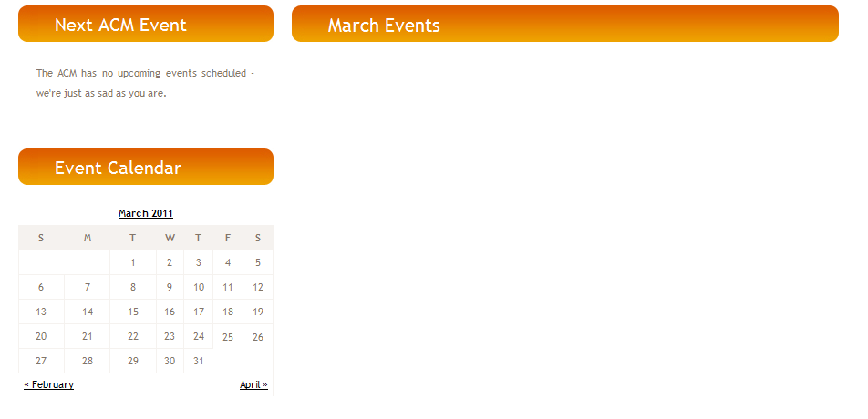

An integrated calendar is part of the left navigation bar on every page. Selecting a month will load a page with all of the events for that month (no upcoming events are posted). This calendar only provides the ability to view events for the previous, current and next month. It does not provide the ability to see events for a specific date.

Old Dominion University http://cs.odu.edu/~acm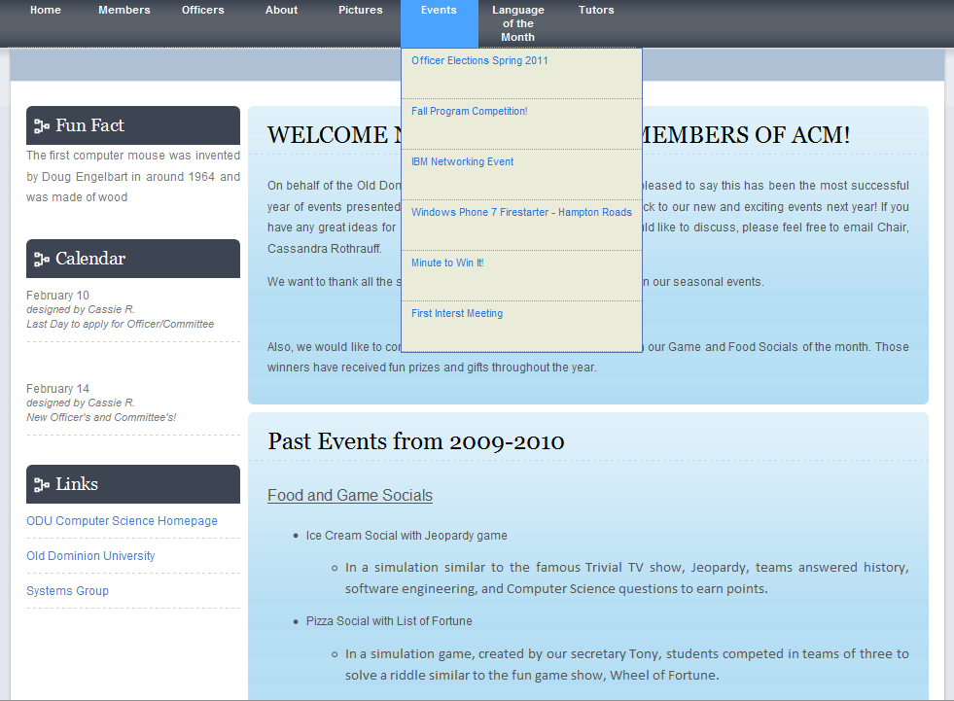

Upcoming events are accessed through a dropdown menu on the top navigation bar. Clicking on “Events” will take the user to a page with a list of events (currently only displays past events because there are no upcoming events posted).

Current Radford ACM Website
Events are listed by date in the left navigation pane via Google calendar. Clicking on event will expand it to show details of the event.
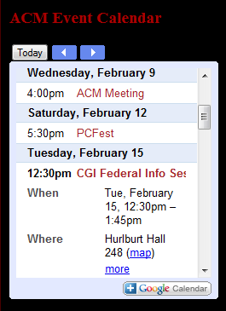
While functional, this implementation is limited in usability because of its size and limited range of dates.

Proposed Functionality for Our Client
Using Gcalendar for Joomla, we plan to integrate ACM’s existing Google calendar into their CMS as a module in the left navigation pane. Clicking on the pane will expand the calendar to fill the window and will allow the user to see a monthly view of all upcoming events. Upcoming events will also be listed on the left-hand side of this pop-out window.

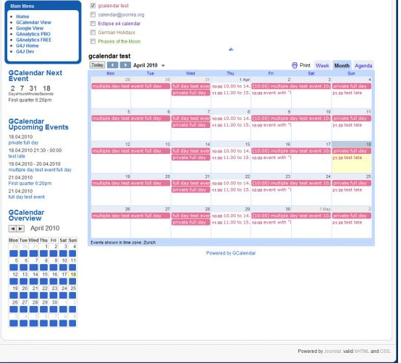
Photo Galleries
James Madison University
http://acm.cs.jmu.edu/

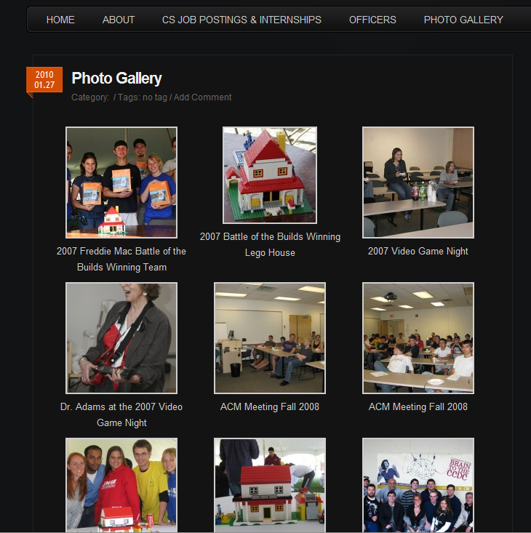

A simple photo gallery displays thumbnails of images. The photos, however, are not in albums (though a cursory glance at the captions displayed below them could easily lead a user to believe that they are), and are displayed oldest to newest.

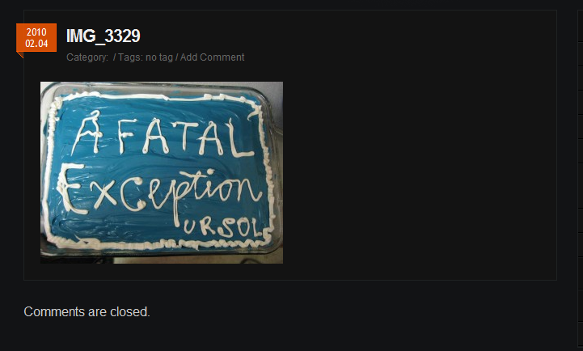

Clicking on an image takes the user to a page with a larger image and the file name as a header (e.g. IMG_3329). This page does not include the caption associated with the photo in the gallery or provide the user with a way to return to the gallery other than through their browser’s back button.

George Mason University
http://ite.gmu.edu/~acm

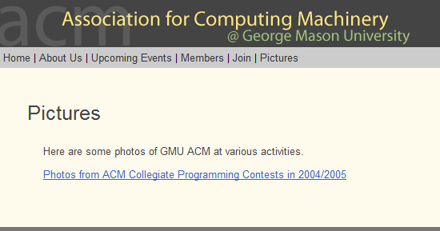

When a user selects the pictures section, links to each album are displayed (only one album is currently posted).

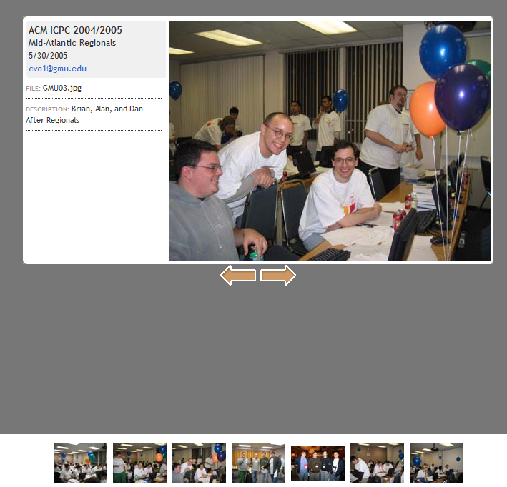

Within an album, a full-size image is displayed along with a brief description. Navigation arrows allow the user to easily view the previous/next photos in the album.

Old Dominion University
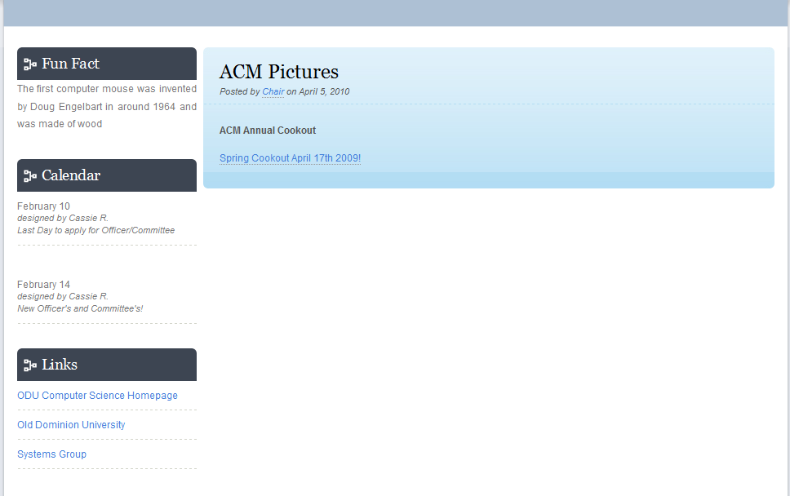

Like George Mason, clicking on the pictures tab displays a link to each album. Within an album, a full-size picture is displayed with navigation between pictures provided by back/next links in the top left-hand corner. Clicking on an image will also advance to the next one in the album. There is no thumbnail view where a user can see all of the images in the album. While there is no functionality to return the ACM homepage, there is a link in the footer to return the ODU Computer Science page.

Current Radford ACM Website
When a user selects photos from the top navigation links, a list of links to albums is displayed. Selecting an album loads all of the pictures in that album in a simple table.

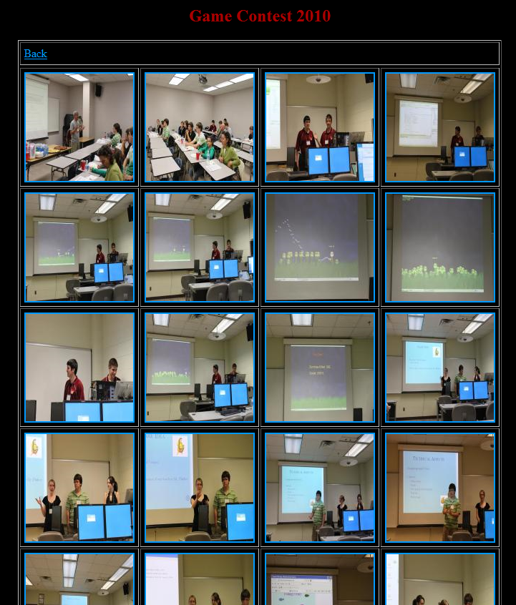
This is effective, but it loads comparatively slowly and is completely static. Clicking on a photo shows a full-size version that often is too large for the browser window. The photos don’t contain captions which our client would like to have included.
Proposed Functionality for Our Client
We plan to use the CSS Gallery plug-in for Joomla to provide the photo gallery for ACM. When a user selects the Pictures tab in the top navigation bar, they will be presented with a list of albums and a thumbnail of an image from each. When a user selects an album, they will see a large image from the album and thumbnails of the other pictures in the album below it. The user can view a specific picture either by rolling over it or by clicking on it. There will also be previous/next links and a “Back to Gallery” link below the images.
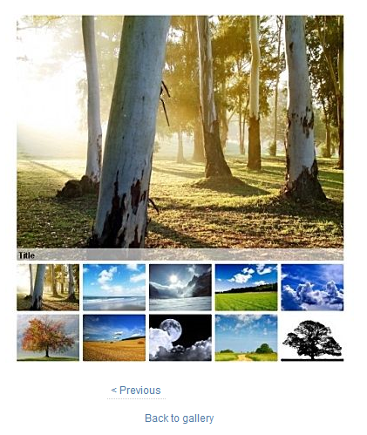

2.3 User Characteristics
The new content management system will be incorporated into the new ACM webpage that our team is working on creating. The user will need to have some expertise in using dropdown bars, slideshows, and be able to download files from the database that will be created. The majority of the users will be ACM members or prospective members and therefore will have prior knowledge on navigating a web- interface.
2.4 User Problem Statement
The current ACM webpage is out of date and difficult to navigate. The colors make the webpage seem unwelcoming and difficult to read the information on the page. Also the current functions are just links to other pages. The information is poorly organized and inconsistent in some places
2.5 User Objectives
A log on shall be placed on the site. The system administrator (administrator) and ACM officers (officers) will have their own accounts and privileges to update certain aspects of the management system. A Game Repository shall be available for users visiting the site to download a variety of games programmed by students at Radford University. The administrator and officers that have properly logged in shall be able to update and add and/or remove selected games. Another page will display embedded YouTube videos created by ACM and have proper links to the YouTube channel. Upon the page loading there shall be a small video player next to a description or title of the video where any users can watch at the ACM site or follow the link to the YouTube channel. A properly logged in administrator shall be able to update the videos on the page.
An ACM photo album shall be installed on a separate page of the website and shall be able to be viewed by any user visiting the site. A properly logged in administrator shall be able to update the album(s). A Google calendar specified by ACM shall be installed on the homepage of the site listing ACM events. The calendar shall be able to be viewed by any user but changes can only be made through an administrator logged into Google Calendar; a separate website. On a separate page the same Google calendar will be displayed in a larger form with a list of current, upcoming, and past events with descriptions of each event. There shall be a document on the home page that describes the purpose of ACM and what ACM is. The document shall be edited by the administrator only. A separate page will be dedicated to the history of ACM within the Radford chapter. This page shall display every past officer and major events ACM participated or hosted in.

2.6 General Constraints
- The project must be completed within the time-constraints of the semester.
- The project must be completed using Joomla CMS

3. Functional Requirements

Criticality Scale
1= Not Critical
2 = Slightly Critical
3 = Critical
4 = Very Critical
5 = Extremely Critical

- System shall allow the administrator login
  - Description
On the home page top navigation bar the last link shall take the user to another page and prompt for an administrator username and password. If 5 failed attempts to login the user will be banned from the site for 15 minutes. After login the user shall be taken back to the home page.
  - Criticality
5
  - Technical issues
- Implementing a ban feature after a user inputs 5 invalid parameters.
- Changing the login link to a log out link after a successful login.
  - Risks
A possible threat exists if the system does not recognize a proper administrator login. To prevent this risk extensive testing with multiple user logins should find any problems.
  - Dependencies with other requirements
None

- System shall allow officers to login
  - Description
On the home page top navigation bar the last link shall take the user to another page and prompt for an officer username and password. If 5 failed attempts to login the user will be banned from the site for 15 minutes. After login the user shall be taken back to the home page.
  - Criticality
5
  - Technical issues
- Implementing a ban feature after a user inputs 5 invalid parameters.
- Changing the login link to a log out link after a successful login.
  - Risks
A possible threat exists if the system does not recognize a proper officer login. To prevent this risk extensive testing with multiple user logins should find any problems.
Dependencies with other requirements
None
- System shall allow the administrator log out
  - Description
After a successful login on the home page top navigation bar the last link shall allow the administrator to log out. After log out the user shall be taken back to the home page.
  - Criticality
5
  - Technical issues
- Implementing a timeout feature after a period of inactivity.
- Changing the login link to a login link after logging out.
  - Risks
A possible threat exists if the system does not recognize a proper log out and keeps the administrator logged in, possibly giving someone unauthorized access. To prevent this risk extensive testing shall be done to insure there are no problems.
  - Dependencies with other requirement
1
- System shall allow officers log out
  - Description
After a successful login on the home page top navigation bar the last link shall allow the officer to log out. After log out the user shall be taken back to the home page.
  - Criticality
5
  - Technical issues
- Implementing a timeout feature after a period of inactivity.
- Changing the login link to a login link after logging out.
  - Risks
A possible threat exists if the system does not recognize a proper log out and keeps the officer logged in, possibly giving someone unauthorized access. To prevent this risk extensive testing shall be done to insure there are no problems.
  - Dependencies with other requirement
1

- System shall allow the administrator to add photos
  - Description
After a successful login on the home page administrator shall be able to navigate to the photo gallery and add photos with captions.
  - Criticality
3
  - Technical issues
- Being able to add photos of different types and sizes.
  - Risks
A possible risk to the system is a photo’s file size is too large for the system to handle. To prevent this risk any file or photo upload will have a set size limitation that will be visible to the administrator.
  - Dependencies with other requirement
1
- System shall allow administrator to delete photo
  - Description
After a successful login an administrator shall be able to navigate to the photo gallery and remove selected photos or an entire album from the site.
  - Criticality
3
  - Technical issues
- System refuses removal of photo(s).
- Prompt refuses to appear.
  - Risks
Accidental removal of a photo(s). The system should prompt the administrator if they are sure they wish to permanently remove the selected photo(s).
  - Dependencies with other requirement
1
- System shall allow the administrator to add Files
  - Description
After a successful login an administrator shall be able to upload files to the Game Repository page for users to download.
  - Criticality
3
  - Technical issues
- File size is too large for the system.
  - Risks
A possible risk is a virus is attached to the file being uploaded. The system shall notify the administrator of the risks of uploading a file and recommend the file be scanned before being published.
  - Dependencies with other requirement
1
- System shall allow officer to add Files
  - Description
After a successful login an officer shall be able to upload files to the Game Repository page for users to download.
  - Criticality
3
  - Technical issues
- File size is too large for the system.
  - Risks
A possible risk is a virus is attached to the file being uploaded. The system shall notify the officer of the risks of uploading a file and recommend the file be scanned before being published.
  - Dependencies with other requirement
1

- System shall allow the administrator to remove a file
  - Description
After a successful login the administrator shall be able to navigate to the Game Repository and remove any selected file(s).
  - Criticality
5
  - Technical issues
- System refuses to remove the file.
  - Risks
A possible risk is accidental removal of the file. The system should prompt the administrator ensuring the selected file(s) are meant to be removed.
  - Dependencies with other requirement
1, 7
- System shall allow an officer to remove a file
  - Description
After a successful login the officer shall be able to navigate to the Game Repository and remove any selected file(s).
  - Criticality
5
  - Technical issues
- System refuses to remove the file.
  - Risks
A possible risk is accidental removal of the file. The system should prompt the officer ensuring the selected file(s) are meant to be removed.
  - Dependencies with other requirement
1, 8

- System shall allow users to download files
  - Description
Any user on the site shall be able to navigate to the Game Repository page and download files that were uploaded by the administrator.
  - Criticality
3
  - Technical issues
- System cannot find the desired file path
  - Risks
None
  - Dependencies with other requirement
5
- System shall allow the administrator to add documents
  - Description
After a successful login the administrator shall be able to navigate to the history page and shall be able to add documentation. The documentation shall include history and information about past and current officers.
  - Criticality
3
  - Technical issues
- Improper tags, changing the format of the document
  - Risks
None
  - Dependencies with other requirement
1
- System shall allow the administrator to delete documents
  - Description
After a successful login the administrator shall be able to navigate to the history page and shall be able to delete documentation. The documentation shall include history and information about past and current officers.
  - Criticality
3
  - Technical issues
- System refuses to delete documentation.
  - Risks
After an administrator deletes a document, the information is permanently deleted and cannot be recovered. To avoid this risk the system will prompt the administrator to ensure the documentation should be removed.
  - Dependencies with other requirement
1, 12

- System shall allow administrator to add YouTube videos
  - Description
After a successful login the administrator shall be allowed to add videos from the ACM YouTube channel to the Tutorial page. These videos shall be in a thumbnail form and shall be able to be played on the site. The upload shall also include a description of the video and the link to the videos location.
  - Criticality
3
  - Technical issues
- Link is broken upon or after the upload of the video.
  - Risks
Adobe Flash player fails to load the video. Extensive testing of uploaded videos from YouTube should ensure the Flash players effectiveness.
  - Dependencies with other requirement
1

- System shall allow administrator to remove a YouTube video
  - Description
After a successful login the administrator shall be able to navigate to the tutorial page and remove a selected video(s). Any removed videos shall also remove the video description and link.
  - Criticality
3
  - Technical issues
- The video doesn’t get removed
  - Risks
The administrator could accidently remove the wrong video or description of another video. The system shall prompt the administrator for confirmation of the removal of any video or description.
  - Dependencies with other requirement
1, 16

- System shall allow any user to view the Google Calendar
  - Description
After navigating to the site the system shall allow any user to access the ACM Google Calendar to view dates and events.
  - Criticality
4
  - Technical issues
- The user already has a Google calendar and the site could display the user’s calendar instead of the ACM calendar.
  - Risks
There are no known risks associating the Google Calendar with the website.
  - Dependencies with other requirement
1

- System shall have a slideshow on the main page
  - Description
Any user visiting the site shall be able to view a top bar slideshow. The photos will consist of photos chosen by an administrator.
  - Criticality
4
  - Technical issues
- Photos that are chosen may be removed from the gallery but not from the slideshow resulting in a file not found error.
  - Risks
There are no known risks at this time.
  - Dependencies with other requirement
N/A
- System shall allow administrator to change the homepage slideshow
  - Description
After a successful login the administrator shall be able to choose which photos and how many photos appear in the Home Page slideshow.
  - Criticality
4
  - Technical issues
- Photo format is not supported or photo is too large/small.
  - Risks
There are no known risks at this time.
  - Dependencies with other requirement
1
- System shall allow administrator to change their system password
  - Description
After a successful login the administrator shall be able to change the password to access the system
  - Criticality
4
  - Technical issues
- Password is too long/short
  - Risks
The administrator may forget the password or not remember the previous one that needs to be replaced
  - Dependencies with other requirement
1
- System shall allow an officer to change their system password
  - Description
After a successful login the officer shall be able to change the password to access the system
  - Criticality
4
  - Technical issues
- Password is too long/short
  - Risks
The officer may forget the password or not remember the previous one that needs to be replaced
  - Dependencies with other requirement
1

4. Interface Requirements
4.1 User Interfaces
Describes how this product interfaces with the user.
- 4.1.1 GUI
The web interface for this new CMS will be customized by a Joomla template called OrangeLab.

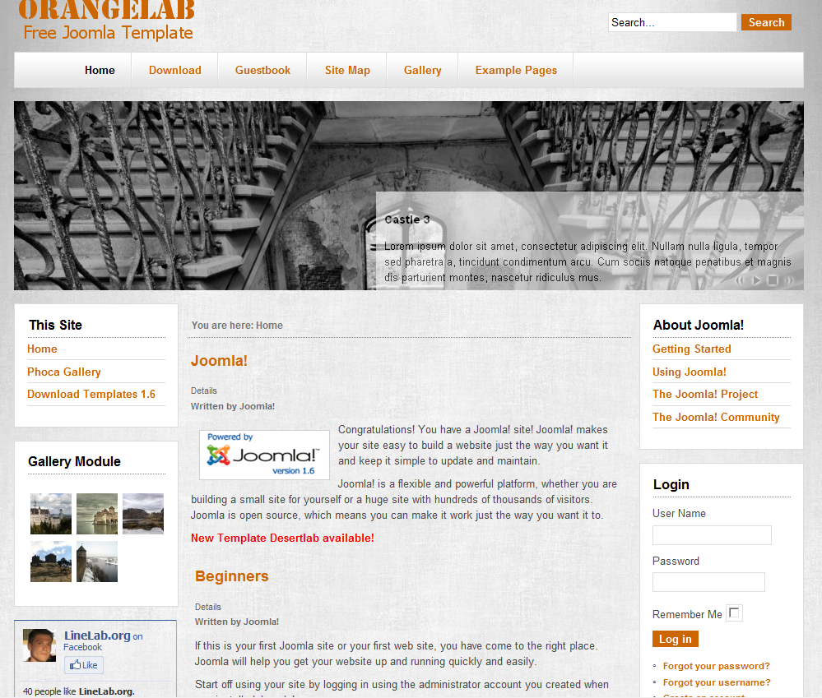

The color-scheme will be altered to reflect the colors of the national ACM website (http://acm.org). The top navigation bar will include drop-down menus.

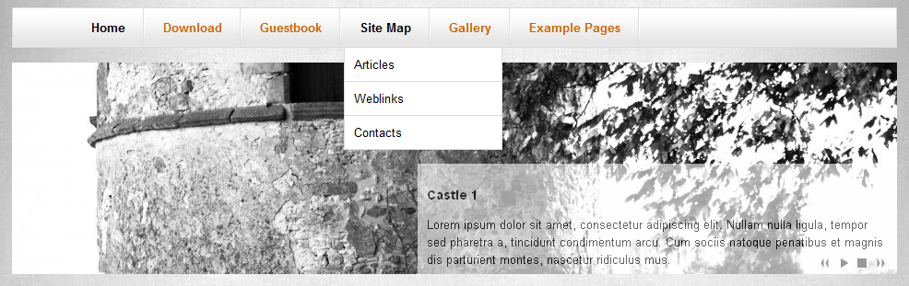

The image slide show underneath the top navigation bar will contain image highlights from the photo gallery. The photo gallery will be dynamic and elegant.
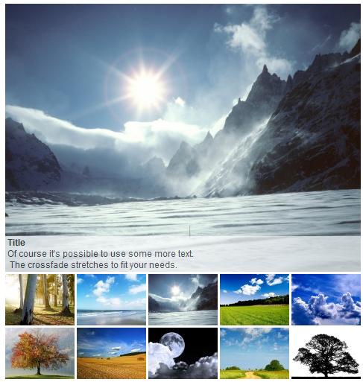
- 4.1.2 CLI
There are no CLI’s required for the functionality we desire.
- 4.1.3 API
There are no API’s required for the functionality we desire.
- 4.1.4 Diagnostics or ROM
There are no Diagnostic’s or ROM’s user interfaces required for the functionality we desire.
4.2 Hardware Interfaces
The users need to have access to a keyboard, monitor, and a computer to view and manage our CMS. Users are highly recommended to have a mouse, and speakers for full functionality.
4.3 Communications Interfaces
The users need to have access to unrestricted Internet via broadband, dial-up or wired.
4.4 Software Interfaces
The users need to have a functional operating system that includes an up to date Internet browser with JavaScript enabled, such as Internet Explorer, Google Chrome, Firefox, Opera or Safari. In addition to a functional operating system, and Internet browser, users need an up-to-date version of Adobe Flash Player.

5. Performance Requirements
Users should have a moderate computer with at least a 56k modem for Internet access.

6. Other non-functional attributes

6.1 Security
The secure system shall be able to verify the adminstrator and officer’s username and password. In order to maintain correct information and features on the site, only the administrator has full functionality to add, edit and manage the photo gallery, officer information, general information, the games repository, calendar and the tutorial sections on the CMS. In addition to the system verifying the administrator’s username and password, it should recognize the officer’s username and password. The distinction between these two users needs to be implemented, so that the officers can view the tutorial, calendar, information and the photo album sections but not add, edit or delete any information without the admins permission. After 5 failed attempts to login the user will be barred from the site for 15 minutes, and allowed to retry after that time period has passed.

6.2 Binary Compatibility
The system shall not require any local binary coding operating system in order to access to Radford University PHP server while loading our web page, but should be compatible with all operating systems that have an internet connection and run a web browser.

6.3 Reliability
The system should be accessible 24 hours a day, 7 days a week as long as the Radford University server is up and running correctly. The users of the system shall be able to view ACM’s CMS from their chosen web browser consistently and from any computer they want to.

6.4 Maintainability
The system should be easily maintainable for the average administrator and club officer. Through the use of the secure log-in aspect of ACM’s CMS, these individuals should be able to add, edit, or delete any information or features they feel necessary, with very little knowledge about Joomla’s system. In order to do so, the system should be well documented and provide simple navigation, so future individuals can keep the site up-to-date.

6.5 Portability
The system should allow users to access its site, from any web browser, as well as through a mobile device. The system should have the ability to run on any Radford University’s PHP server account and in addition the capability to be move to other Internet servers which render PHP pages.

6.6 Extensibility
The system should be extensible for the average IT person through the use of Joomla’s open source CMS. New features can be added with compatible plug-ins as the administrator feels is necessary. CSS styles such as font type, font colors, background colors, and images can be easily altered through the use of the administrators control panel, and new updated information can be added through the administration view. In addition to this extensibility provided through Joomla’s graphical user interface design, users knowledgeable of web design can also edit the HTML, CSS, and PHP files through the use of a standard text editor or a WYSIWYG program such as Dreamweaver, if desired.

6.7 Reusability
The system should implement an easily navigable CMS with a secure login feature for the administrator and officers to access the site in order to maintain and update the information as needed, as well as organized documentation about system. The documentation will allow the users to learn how to add, delete and edit files in the photo gallery and the game repository, as well as add calendar events and update information easily through the use of the CMS graphical user interface, without have know any prior knowledge about Joomla, its system and the programming languages used to develop the system.

6.8 Application Affinity/Compatibility
The system should be compatible with an internet connection of at least 56K and modern web browser such as Firefox, Internet Explorer, Safari and Google Chrome, regardless of what operating system that users in using.

6.9 Resource Utilization
The system shall require input from a mouse and keyboard, an output from a monitor and steady Internet connection to fulfill its client’s desired requirements. In addition to hardware resources, the system shall require proper human resource utilization of the IT Crowd, Dr. Lewis, Mr. Alex Meade, as well as other ACM officers and members.

6.10 Serviceability
Any future modifications or services that ACM Radford chapter requires, after this Spring 2011 semester is over, shall to be easily implemented and managed for the average administrator with this system due to the well designed layout of the site and its corresponding documentation.

7. Operational Scenarios
- Administrator/webmaster login
The user is presented with a login form requesting username and password. They enter their username and password. The system then logs them in and shows them the administrator home page which consists of options to manage, articles, categories, media, users and templates.
- Officer login
The user is presented with a login form requesting username and password. They enter their username and password. The system then logs them in and shows them the officer home page which consists of options to manage articles and media.
- Administrator/webmaster change password
User rolls over the “Site” dropdown menu and selects “My profile.” The system then displays a form with fields for Name, login (user) name, password with confirmation, and email. The user enters their new info and clicks “Save” then “Close” or clicks “Save and Close.” The system updates the user’s info to the supplied info.
- Officer change password
User rolls over the “Site” dropdown menu and selects “My profile.” The system then displays a form with fields for Name, login (user) name, password with confirmation, and email. The user enters their new info and clicks “Save” then “Close” or clicks “Save and Close.” The system updates the user’s info to the supplied info.
- Administrator/webmaster logout
While logged in and on any page, the user clicks the “Logout” link in the top right-hand corner. The system logs the user out and displays the login page.
- Officer logout
While logged in and on any page, the user clicks the “Logout” link in the top right-hand corner. The system logs the user out and displays the login page.
- Administrator/webmaster add photos
While logged in, the user selects “Media Manager” from the main control panel and selects “Add photos”. The user is presented with a prompt for a file path to an image or folder of images on their computer. The user inputs the path and clicks upload. The system adds the image(s) to its images library and prompts the user for additional information such as captions. The user inputs the information and clicks finish.
- Administrator/webmaster remove photos
While logged in, the user selects “Media manager” from the main control panel and selects “Remove photos.” The system displays a list of photos in its library. The user selects which photo(s) they would like to remove and the system prompts for a confirmation. Once confirmed, the system removes the selected image(s) from its library.
- Administrator/webmaster add files
While logged in, the user selects “File Manager” from the main control panel and selects “Add files”. The user is presented with a prompt for a file path to an executable file on their computer. The user inputs the path and clicks upload. The system adds the files to its repository and prompts the user for additional information such as description, file size and type. The user inputs the information and clicks finish.

- Administrator/webmaster remove files
While logged in, the user selects “File manager” from the main control panel and selects “Remove files.” The system displays a list of files in the repository. The user selects which file(s) they would like to remove and the system prompts for a confirmation. Once confirmed, the system removes the selected file(s) from the repository.
- User download files
The user selects the “Games” link from the top navigation bar. The system displays a list of games available for download. When the user clicks on one, the bowser’s download manager downloads the file.
- Administrator/webmaster add documents
While logged in, the user selects “File Manager” from the main control panel and selects “Add documents”. The user is presented with a prompt for a file path to a document on their computer. The user inputs the path and clicks upload. The system adds the document to its library and prompts the user for additional information such as description, file size and type. The user inputs the information and clicks finish.
- Administrator/webmaster remove documents
While logged in, the user selects “File manager” from the main control panel and selects “Remove documents.” The system displays a list of documents in the library. The user selects which document(s) they would like to remove and the system prompts for a confirmation. Once confirmed, the system removes the selected documents from the library.
- Administrator/webmaster add YouTube videos
While logged in, the user selects “Media Manager” from the main control panel and selects “Add tutorial.” The system prompts for the HTML to embed a video (this can be found underneath of the video on youtube.com). The user inputs the code and clicks “Add.” The system adds the video to the tutorial section and returns the user to the control panel.
- Administrator/webmaster remove YouTube videos
While logged in, the user selects “Media Manager” from the main control panel and selects “Remove tutorial.” The system provides the user with a list of embedded tutorials. The user selects the tutorial(s) they would like to remove and the system prompts for confirmation. Once confirmed, the system removes the video from the tutorials section.
- User view YouTube tutorials
When the user selects the “Tutorials” option from the top navigation bar, they will see a series of embedded YouTube videos containing tutorials for new ITEC students. They will be able to play the videos directly from within the page.
- Administrator/webmaster add event to Google calendar
The user logs into their Google account and accesses their calendar. The user adds an event to the calendar and the system automatically syncs the changes to its calendar.
- Administrator/webmaster remove event to Google calendar
The user logs into their Google account and accesses their calendar. The user removes an event from the calendar and the system automatically syncs the changes to its calendar.
- User view events on Google calendar
A calendar will be integrated into the left navigation pane on every page. When the user clicks on this calendar, it will expand to fill the window, showing a monthly view. The user will be able to click on a specific date and see any events scheduled for that day. There will also be a list view of all upcoming events on the left of this pop-out window.
- User view ACM info
When a user selects the ACM info link from the top navigation they will be presented with a webpage that contains information about ACM.

8. Preliminary Use Case Model
8.1 Use Case Model
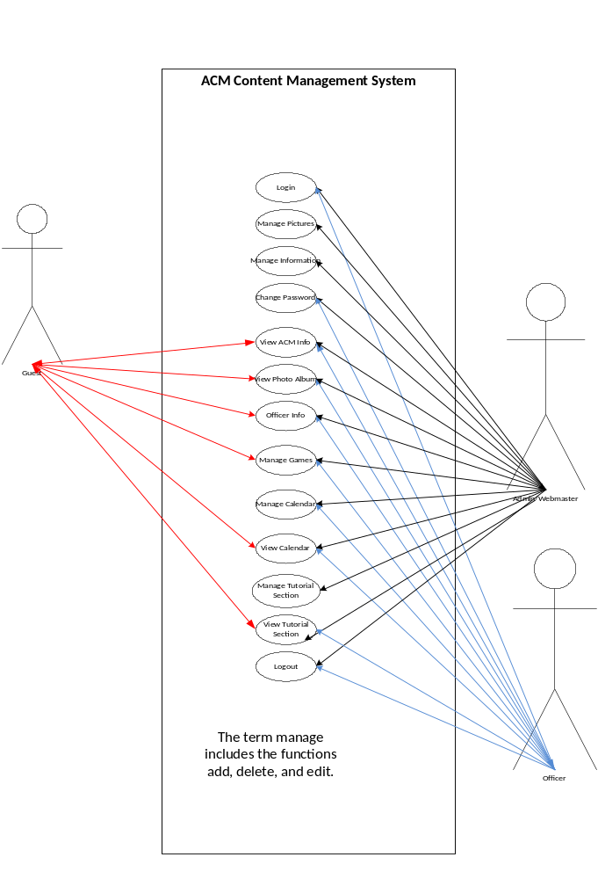

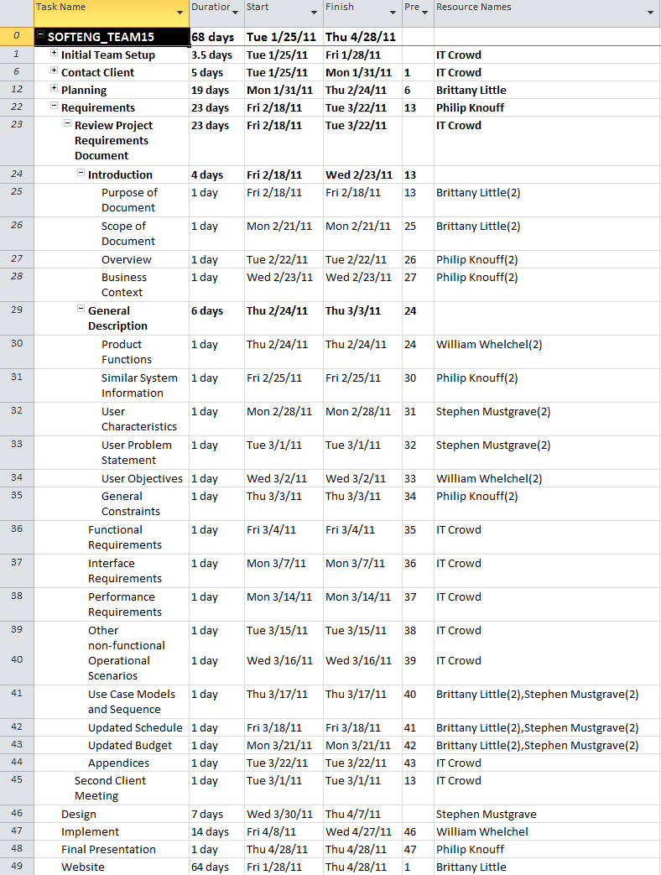
9. Updated Schedule

10. Updated Budget
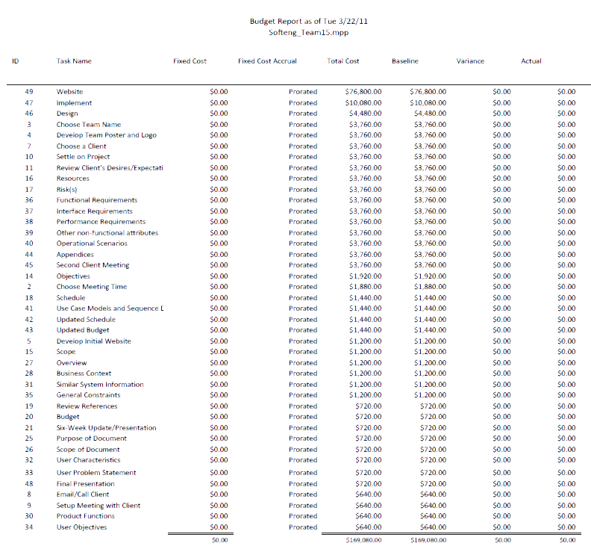

11. Appendices
11.1 Definitions, Acronyms, Abbreviations
Provides definitions of unfamiliar definitions, terms, and acronyms.
- ACM: Association of Computing Machinery
- CMS: Content Management System
- GUI: Graphical User Interface
- ITEC/IT: Information Technology
- RU: Radford University
- Joomla: A free and open-source Content Management System (CMS) written in PHP.
- CLI: Command Line Interface
- API: Application Programming Interface
- ROM: Read-Only Memory
- HTML: Hypertext Markup Language
- CSS: Cascading Style Sheets
- WYSIWYG program: What you see is what you get
- PHP: Hypertext Pre-processor
11.2 References
- Team08 ITEC 370 Fall 2010 Requirements Document
  - http://www.radford.edu/~team08
- Joomla website
  - http://www.joomla.org
- ACM National website
  - http://www.acm.org

