**31st Oct task**

1. **Query:**

Find all the information about each products.

db.product.find();

**Results:**

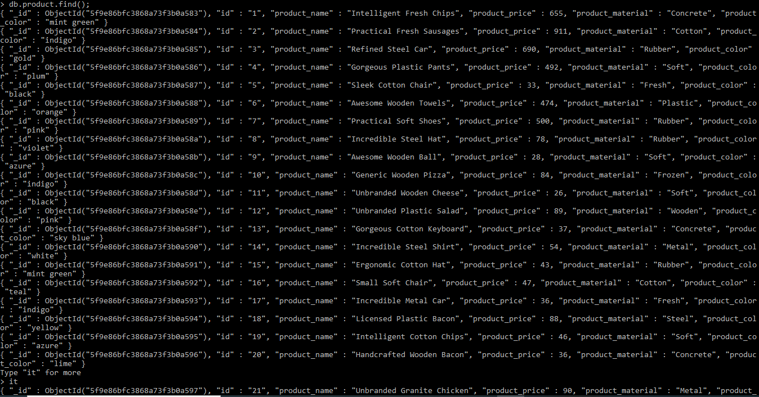

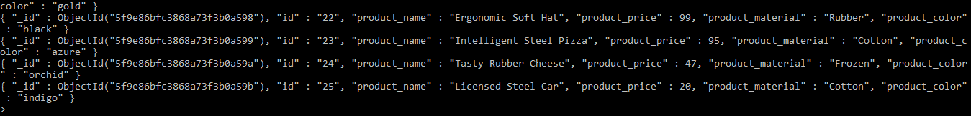

1. **Query:**

Find the product price which are between 400 to 800

db.product.find( {product_price : { $gt : 400, $lt : 800 } } ).pretty();

**Results:**

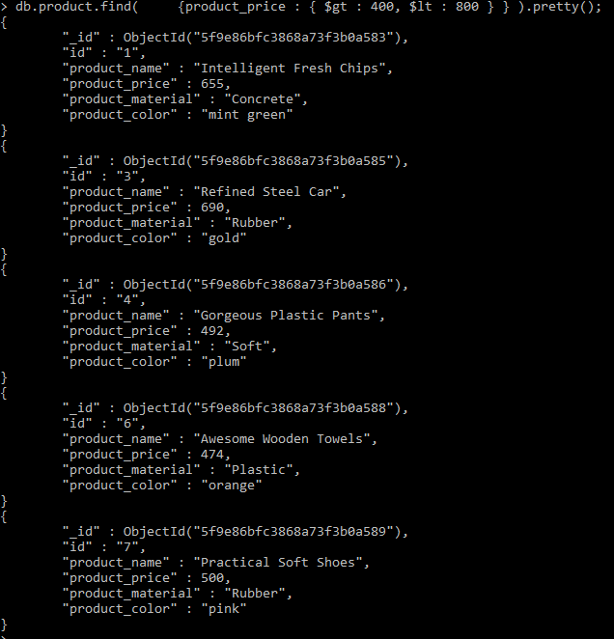

1. **Query:**

Find the product price which are not between 400 to 600

db.product.find(

    { $or : [{product_price : { $lt : 400 }},

             {product_price : { $gt : 600 }}]},

    {product_name : 1,product_price : 1}

);

**Results:**

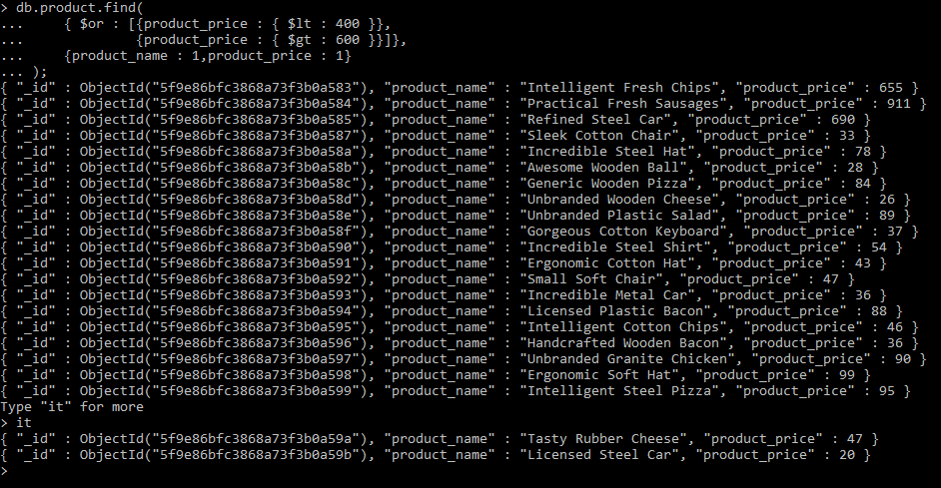

1. **Query:**

List the four product which are greater than 500 in price.

db.product.find(

    {product_price : { $gt : 500 }},

    {product_name : 1,product_price : 1}

).limit(4);

**Results:**

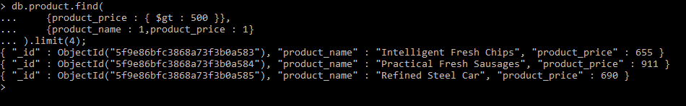

1. **Query:**

Find the product name and product material of each products.

db.product.find(

    {},

    {product_name : 1,product_material : 1}

);

**Results:**

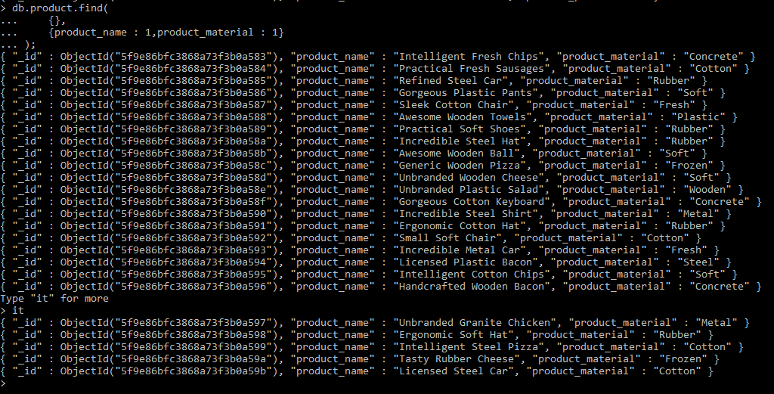

1. **Query:**

Find the product with a row id of 10

db.product.find(

    {id : '10'}

).pretty();

**Results:**

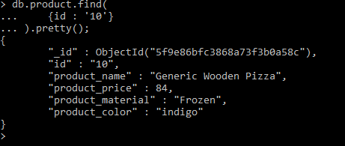

1. **Query:**

Find all products which contain the value of soft in product material.

db.product.find(

{product_material : /Soft/}

).pretty();

**Results:**

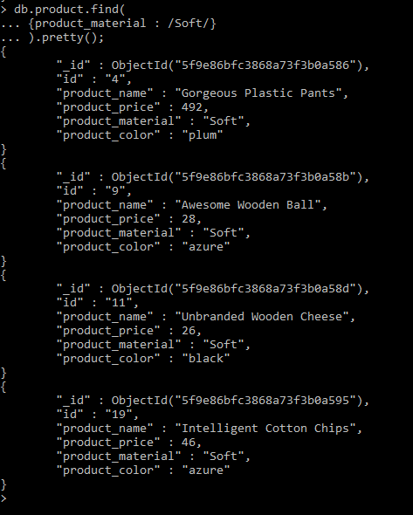

1. **Query:**

Find products which contain product color indigo or product price 492.00

db.product.find(

{$or : [{product_color : 'indigo'}, {product_price : 492}]}

).pretty();

**Results:**

