FROM OPERATION LOGS
TO AN AUTOMATION PROPOSAL
Dataset-B Work-Unit Recovery, Process Discovery, and Human-in-the-Loop PI and LA Automation Prototypes
━━━━━━━━━━━━━━━━━━━━━━━━━━━━━━━━
Submission-ready technical report
September 2026
Name | Gaurav Girish Rathod
University | IIT Mandi
Program | B.Tech in Civil Engineering
Email | b24076@students.iitmandi.ac.in
Primary evidence: Dataset A ground truth + Dataset B operation logs + controlled PI/LA prototype validation
Automation demonstration
The visible browser demonstration of the PI prototype is provided as a separate video:
https://youtu.be/LL4OfRidPTM
Latest PI/LA submission demonstration:
https://youtu.be/82_9SsIhONg

Executive conclusion: recover the work first, understand the work second, automate only the mechanical portion, and keep consequential decisions human-controlled.

1. Executive Summary
This project converts low-level desktop operation logs into an evidence-based automation proposal. The central challenge is that the logs record clicks, keystrokes, application switches, browser activity, clipboard transfers and screenshots, but do not explicitly mark when a business process starts or ends. The work therefore followed a staged approach: first recover coherent work units on the labelled Dataset A; then apply the learned boundary method to the unlabelled Dataset B; then determine what the inferred work units represent; then select and prototype automation targets with an explicit human-decision boundary. The completed submission contains the original PI workflow prototype and a follow-on LA attendance/leave prototype.
Outcome at a glance
Dataset B yielded 540 inferred work units across 15 sessions and 20,477 events. Five stable quantitative families were identified. The PI family contains 209 segments and 35.78% of observed segmented time. A human-in-the-loop PI automation prototype was built and validated in a controlled local reconstruction: 16/16 combined prototype tests passed, the final focused six-case validation passed 6/6, Register/Hold remained untouched in all tested runs, and no manual corrections were required in final validation.

Project metric | Result
Dataset B sessions | 15
Dataset B raw events | 20,477
Final Step-1 work units | 540
Final segments.jsonl | 540 lines; pi 209, la 99, ob 77, si 68, rt 55, other 32
Total observed segmented time | 10,574.831 sec = 176.25 min = 2.94 hr
PI workload | 209 segments; 3,783.777 sec = 63.06 min = 35.78% time share
PI real-event evidence | 7,325 raw events attached to 209 PI segments
PI direct OCR evidence | 77/209 = 36.84% in the PI-specific extraction
Prototype validation | 16/16 combined pass; final focused 6/6 pass
LA follow-on prototype | Working local /leave-applications prototype + visible demonstration; production integration not performed
Production integration | Not performed; production /payroll-items target was unavailable

Core conclusion. The evidence supports a first human-in-the-loop PI pilot that automates repetitive retrieval, transfer, transformation, field entry and document preparation while leaving review, approval/hold/rejection, policy interpretation, exceptions and final release to humans. A follow-on LA attendance/leave prototype was also completed using the same parameterized-core plus human-gate pattern. Production correctness and production time savings are not claimed for either prototype.

2. Problem Definition, Scope, and Engineering Principles

2.1 Problem statement
The input is a chronological event stream containing low-level desktop operations. A single session can contain multiple business executions, workers can switch away from a task and return later, the same process can have different execution paths, and unrelated activity may be mixed with the target work. Dataset A provides ground truth; Dataset B does not.
- Recover execution boundaries rather than treating recording chunks as business boundaries.
- Use Dataset A as the development/evaluation population and reserve Dataset B for production-style inference.
- Preserve raw evidence and tolerate missing screenshots or incomplete structured context.
- Do not use ground-truth fields such as process_code, process_name, case_id or current_process to create the Dataset-B segmentation.
- Keep segmentation, business-process identification, and automation selection as separate decisions.
- Prefer the least complicated method that the evidence justifies; technical sophistication is not itself the objective.

2.2 Engineering principles adopted
1. Evidence before interpretation: establish reliable data handling before modelling.
2. Boundary detection is not the same as segmentation: a classifier may identify a boundary region without identifying one unique boundary timestamp.
3. Direct semantic evidence is stronger than structural inference; unsupported propagation is rejected rather than hidden.
4. A work family is not automatically a subprocess. Application patterns are behavioural evidence, not business truth.
5. Automation must be separated from business judgement. Mechanical preparation can be automated; consequential decisions remain human-controlled.
6. Production readiness requires live-system validation. Local prototype correctness does not imply production correctness.

3. Data Discovery, Session Reconstruction, and Integrity

3.1 Initial inventory
Population | Sessions | Events | Event files | Ground-truth files | Screenshots
All data | 78 | 183,245 | 137 | 63 | 39,309
Dataset A | 63 | 162,768 | 117 | 63 | -
Dataset B | 15 | 20,477 | 20 | 0 | -

3.2 Canonical session reconstruction
The raw download contained multiple events.jsonl files per session. Five Dataset-B sessions and 53 Dataset-A sessions were multi-chunk. The canonical loader therefore recursively discovers event files, identifies the dataset, groups events by session_id, attaches source metadata, tolerates missing application context, and sorts the events chronologically across chunks.
Important data-model decision
Recording chunks are treated as storage artifacts, not as business-process boundaries. Physical chunk location is not considered authoritative when it conflicts with the logical correlation metadata.

3.3 Robustness findings
- Some events contained context.active_app = null. The loader was changed to treat missing context safely rather than failing.
- Sequence numbers occasionally appeared out of timestamp order. Timestamp chronology was selected as authoritative, with sequence retained as secondary evidence.
- One physical-chunk versus correlation.chunk_id mismatch was observed. Raw data was not modified; the metadata inconsistency was documented.
- Duplicate event IDs were zero, and screenshot references had zero missing references in the inventory check.

4. Step 1 - Recover Units of Work
Step 1 asks: where does one coherent business execution start and end? Dataset A ground truth was used to define a measurable target, while Dataset B remained untouched by ground-truth labels.

4.1 Ground-truth extraction
Dataset A ground truth was flattened into execution and boundary artifacts. Ground truth included process codes/names, domain, variants, case IDs, start/end timestamps and execution metadata. There were 257 executions missing end_ts; these were kept as incomplete rather than assigning fabricated endpoints.
Boundary event type | Interpretation
process_started | Start of an execution
process_switched_out | Execution temporarily left
process_resumed | Execution returned
process_suspended | Execution explicitly suspended

The extraction produced 3,698 raw boundary events and 3,583 unique boundary timestamps after collapsing duplicate (session_id, timestamp) occurrences.

4.2 Boundary signal analysis
A +/-10-second boundary window analysis compared event activity near true boundaries with randomly selected control windows. The strongest raw signals were application switching (~2.26x), browser navigation (~2.18x), browser clicks (~1.47x), and mouse clicks (~1.44x). This showed that context transitions carry real signal, but also established that activity intensity alone cannot define a business boundary.

5. Step 1 Modelling Experiments and Evaluation

5.1 Heuristic baseline V1
A lightweight time-bin heuristic combined weighted app switches, browser navigation, browser clicks, mouse clicks and window changes. The result was 2,770 predicted boundaries against 3,583 ground-truth boundaries, with precision 0.5560, recall 0.4298, F1 0.4848 and mean boundary error 1.50 seconds.

5.2 Before/after-context heuristic V2
A second heuristic examined the immediate before/after event context using event counts, app switches, navigation, browser clicks, mouse clicks, window changes, unique applications and keyboard activity. It generated 4,557 predicted boundaries from 45,782 candidate points. Precision was 0.4215, recall 0.5361, F1 0.4720 and mean error 2.29 seconds. Recall improved, but over-segmentation increased.
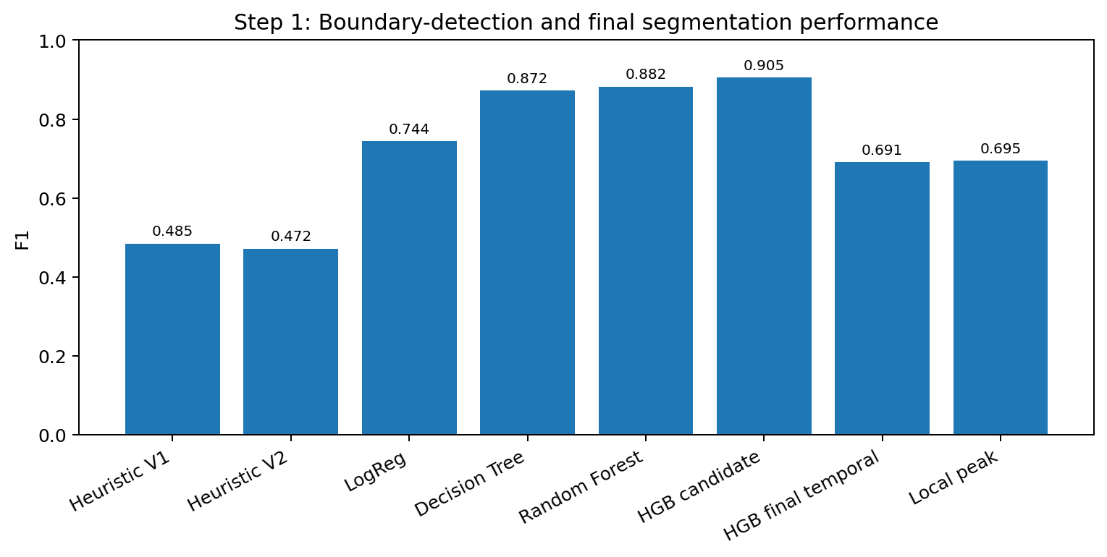
Figure 1. Progression from heuristic boundary detection through candidate classification and final temporal consolidation.

5.3 Supervised candidate-boundary model
Supervised ML became justified after the heuristics plateaued. The candidate dataset contained 45,782 timestamps across 63 sessions. A point was treated as positive when it lay within +/-5 seconds of a ground-truth boundary. The class balance was approximately 22.31% positive. The split was by whole session to prevent row-level leakage: 44 training sessions, 9 validation sessions and 10 test sessions.
Model | Test precision | Test recall | Test F1 | PR-AUC
Logistic Regression | 0.6447 | 0.8796 | 0.7440 | 0.8575
Decision Tree | 0.8749 | 0.8688 | 0.8719 | -
Random Forest | 0.9081 | 0.8574 | 0.8820 | 0.9487
HistGradientBoosting | 0.8864 | 0.9246 | 0.9051 | 0.9652

5.4 The key methodological correction: candidate classification is not final segmentation
The 0.9051 HGB test F1 measures whether candidate timestamps look boundary-like. It does not mean that the final segmentation has 0.9051 F1. Several nearby timestamps can all be classified positive around one true transition. Therefore the problem was split into two stages: (A) detect boundary-like regions; (B) consolidate each region into one actual boundary timestamp.

5.5 Consolidation and bottleneck analysis
Experiment | Main result | Interpretation
HGB post-processing | 1,646 raw positives -> 364 boundaries; precision 0.8516; recall 0.5784; F1 0.6889; mean error 1.10 s | Strong candidate-region detection, but consolidation was too aggressive.
Raw-positive diagnostic | 533/536 test GT boundaries had a positive candidate within +/-5 s = 99.44% coverage | Missing boundary regions were not the main problem; choosing the correct timestamp/count was.
Merge-gap sweep | 1 s: F1 0.489; 2 s: ~0.683; 3 s: ~0.683; 4-5 s: ~0.689 | 2 s was retained as a practical balance; further capacity alone was not solving the bottleneck.
Raw-JSON rebuild | 46,160 candidate rows with independent feature construction | Strengthened reproducibility and reduced concern that the model depended on a precomputed feature artifact.
max_iter sweep | 200 -> ~0.6975 validation F1; 300 -> ~0.6861; 500 -> ~0.6861; 800 -> ~0.6844 | More boosting iterations did not fix temporal consolidation.
Local-peak experiment | precision 0.9783; recall 0.5388; F1 0.6949; mean error 0.646 s | High precision but slightly below the selected validation result; not adopted.

5.6 Frozen Step-1 configuration
Parameter | Final value
Candidate spacing | 2 sec
Context window | +/-6 sec
Model | HistGradientBoosting
max_iter | 200
learning_rate | 0.08
max_leaf_nodes | 31
Classification threshold | 0.20
Merge gap | 2 sec

Why the model was frozen
The limiting factor was candidate-to-boundary consolidation, not raw classifier capacity. Further deep-learning work, large hyperparameter sweeps and full screenshot model training were therefore not justified by the evidence at this stage.

6. Applying Step 1 to Dataset B
The frozen Step-1 pipeline was applied to Dataset B without ground-truth fields. It produced 5,294 candidate points, 772 positive candidates, 525 predicted boundaries and 540 final inferred work units across 15 sessions.
Dataset-B segmentation output | Value
Sessions | 15
Raw events | 20,477
Candidate points | 5,294
Positive candidates | 772
Predicted boundaries | 525
Final inferred work units | 540

6.1 Final segments.jsonl
The authoritative Step-1 deliverable is the full Dataset-B segments.jsonl, not the downstream PI subset. The final artifact was independently checked to contain exactly 540 JSONL records, all with valid UTC start/end timestamps, across 15 sessions.
Label | Segments | Share
pi | 209 | 38.70%
la | 99 | 18.33%
ob | 77 | 14.26%
si | 68 | 12.59%
rt | 55 | 10.19%
other | 32 | 5.93%

Important distinction
The 209 PI segments are a downstream Step-2/Step-3 subset of the 540 Dataset-B work units. They must not replace the 540-line Step-1 deliverable.

7. Step 2 - Process Discovery and Business Interpretation
Step 2 changes the question from “where are the work units?” to “what do these work units represent, what repeats, what requires judgement, and what is a defensible automation candidate?”

7.1 Behavioural inventory
Each segment was represented using duration, event-type counts, application sequence, transitions, clipboard activity, form input, navigation, browser clicks, mouse clicks, keyboard activity, browser paths, page classification, cross-application behaviour and screenshot availability.

7.2 Application-sequence false lead
Recurring sequences such as Edge -> Word -> Edge and Edge -> Notepad -> Edge were investigated because they repeated across the logs. These patterns were useful behavioural evidence but could not uniquely identify a business process. The same sequence can support multiple tasks. The project therefore rejected the shortcut “application sequence = business process”.

7.3 Screenshot evidence strategy
A first screenshot selector over-weighted segment position. It was replaced by a selector that prioritized application transitions, meaningful interactions and application diversity, using temporal position as fallback. That produced 2,199 representative screenshots, approximately 99.6% selected using event/transition evidence. Even this was not used as the final semantic source: for semantic understanding, all screenshots associated with complete segments were preserved.

7.4 Manual validation queue
Four provisional behavioural families were selected for manual semantic validation. Three executions from each family produced 12 representative segments across multiple sessions. All 571 raw events and 137 screenshot references were collected and resolved successfully. The evidence chain was kept explicit: session -> chunk -> events.jsonl -> segment time range -> screenshot reference -> source screenshot file.

8. Japanese OCR, Semantic Interpretation, and Evidence Quality
The raw data came from a Japanese-company environment, so screenshot OCR was introduced to recover business semantics that application metadata alone could not provide.

8.1 OCR validation
A dedicated .venv_vision environment was created so the primary environment remained isolated. PaddlePaddle, PaddleOCR, PyTorch, Transformers and SentencePiece were installed. An initial five-screenshot test recovered business-specific labels such as 経費精算・給与変更, 扶養控除変更, 役職手当新設, 年次有給休暇, 半日有給申請 and 特別休暇（慶弔） with mean confidence approximately 0.9765–0.9929.

8.2 Translation experiment and correction
A local Helsinki-NLP / Marian Japanese-to-English model was tested on raw OCR dumps. The output was poor because the input mixed UI labels, IDs, names, URLs, numbers, statuses, browser chrome and OCR errors. The output was rejected as evidence. The analysis shifted from literal translation to structured semantic interpretation: screenshot -> OCR regions -> cleaning/filtering -> relevant labels -> targeted terminology -> structured UI interpretation -> business-process interpretation.
Japanese term | Interpretation used in analysis
申請 | Application
承認 | Approval
処理待ち | Pending processing
登録確定 | Confirm/finalize registration
保留 | Hold
社員 ID | Employee ID
金額 | Amount
給与変更 | Payroll change
経費精算 | Expense reimbursement
勤怠 | Attendance
休暇申請 | Leave application

8.3 OCR coverage and representativeness
The larger 20%-sampled Dataset-B OCR run produced 1,113 OCR records; 1,104 contained Japanese, with 3,366 unique Japanese OCR lines and 283,417 Japanese characters. However, coverage was not uniform: 160/540 segments were directly covered overall (29.63%), with family coverage ranging from 47.85% for PI to 0% for “other”. Therefore OCR-derived subprocess counts were not extrapolated across the full 540-segment population.
Evidence rule
Direct OCR evidence is kept separate from structural or propagated evidence. English translation is analytical support, not a replacement for the original Japanese evidence or a claim of business truth.

9. Conservative Process Taxonomy and Full-Population Quantification

9.1 Semantic propagation test
A structural propagation method attempted to infer semantics for OCR-uncovered segments using route, DOM fields, button families, window/document patterns and application patterns. A held-out validation was intentionally built. Of approximately 40 held-out OCR cases, 17 were accepted as high-confidence and only 8 were correct, giving 47.1% precision among accepted cases. Family-level precision varied widely. The propagation method was rejected for full-dataset assignment.

9.2 Subprocess recurrence threshold
A conservative candidate-subprocess floor was defined as at least 5 OCR-covered segments, at least 2 sessions and at least 2 operators. No subprocess survived this floor. The correct conclusion was not that no meaningful variants exist, but that the evidence did not justify creating finer-grained quantified subprocesses. OCR-observed case types were retained as branch evidence within stable families.

9.3 Authoritative family inventory
Family | Segments | Segment share | Observed time | Time share | Median s | Mean events/seg | Sessions | Operators
PI | 209 | 38.70% | 63.06 min | 35.78% | 14 | 35.05 | 15 | 4
LA | 99 | 18.33% | 42.62 min | 24.18% | 22 | 48.08 | 14 | 4
OB | 77 | 14.26% | 29.60 min | 16.80% | 20 | 44.22 | 10 | 4
SI | 68 | 12.59% | 20.59 min | 11.68% | 16 | 43.79 | 8 | 4
RT | 55 | 10.19% | 15.17 min | 8.61% | 16 | 28.69 | 9 | 4
Other | 32 | 5.93% | 5.20 min | 2.95% | 4 | 13.50 | 13 | 4

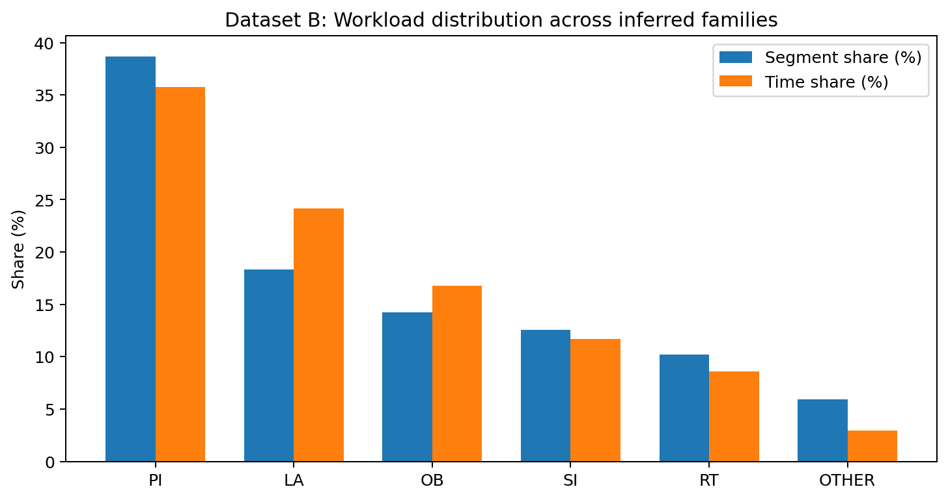
Figure 2. Segment share and time share use all 540 inferred work units.
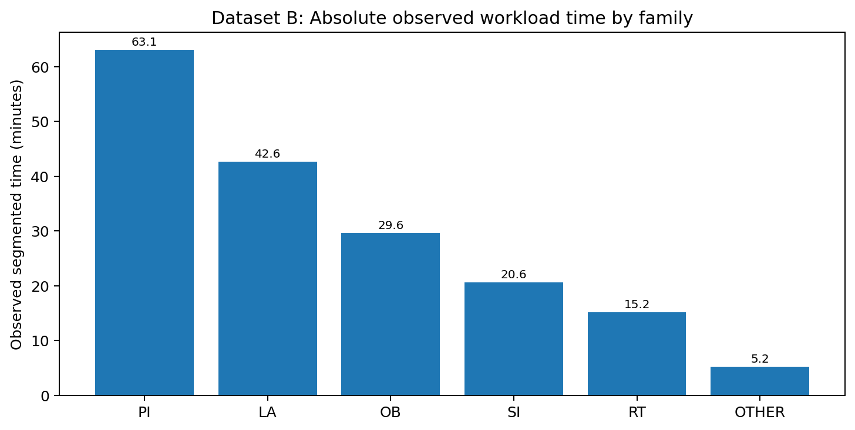
Figure 3. Absolute observed segmented time; this is workload observed, not guaranteed automation savings.

9.4 Operator distribution
All five primary families span all four observed operators. There is therefore no evidence that a single operator is a unique bottleneck for any primary family. An earlier inventory accidentally copied segment counts into the operator column; this was corrected before the final evidence package was frozen.

10. Mechanical Work Versus Human Judgement
Automation feasibility was decomposed into two fundamentally different categories. Mechanical work includes reading, copying, transferring, transforming, entering, document preparation, navigating predictable pages and preparing submissions. Human judgement includes approval, rejection, hold decisions, exception handling, policy interpretation and ambiguous cases.
Boundary rule
The existence of an Approve, Register, Hold or similar button is not evidence that the surrounding business process should be automated. The automation boundary is defined by the nature of the decision, not by the presence of a UI control.

10.1 Evidence by primary family
Family | Decision evidence | Clipboard | Browser interaction | Word | Excel | Notepad | Feasibility / risk
PI | 34.45% | 88.04% | 89.95% | 29.67% | 5.74% | 15.31% | Pilot-first / high governance risk
LA | 18.18% | 93.94% | 92.93% | 49.49% | 2.02% | 4.04% | Feasible with validation / medium risk
OB | 9.09% | 88.31% | 93.51% | 67.53% | 1.30% | 3.90% | Defer / high governance risk
SI | 17.65% | 91.18% | 97.06% | 35.29% | 7.35% | 16.18% | Defer / high governance risk
RT | 23.64% | 85.45% | 92.73% | 34.55% | 0.00% | 3.64% | Defer / high governance risk

11. Automation Candidate Analysis and Selection
The final decision package uses explicit evidence dimensions rather than a composite weighted score. Earlier numerical score experiments were treated as exploratory and were removed from the final decision mechanism so that workload, repetition, judgement, feasibility and governance were visible rather than collapsed into an opaque number.

11.1 Candidate comparison
Priority | Family | Observed workload | Time | Mechanical evidence | Human / governance consideration | Decision
1 | PI | 209 segments / 38.70% | 63.06 min / 35.78% | Very strong transfer, browser and form-entry pattern | Highest decision density; therefore business decisions are explicitly excluded | First HITL pilot
2 | LA | 99 / 18.33% | 42.62 min / 24.18% | Very strong transfer and browser pattern; longer executions | Lower decision density than PI; still needs validation | Second opportunity
Deferred | OB | 77 / 14.26% | 29.60 min / 16.80% | Strong mechanical activity | Higher governance sensitivity and exception/access validation | Defer
Deferred | SI | 68 / 12.59% | 20.59 min / 11.68% | Strong repetitive activity | Governance sensitivity and human review | Defer
Deferred | RT | 55 / 10.19% | 15.17 min / 8.61% | Strong repetitive activity | Smaller workload and governance sensitivity | Defer
Deferred | Other | 32 / 5.93% | 5.20 min / 2.95% | Limited stable semantic evidence | Higher ambiguity / unknown workflow meaning | Defer

11.2 Why PI is the first build target
PI is selected because it combines the largest workload and largest observed time share with pervasive repetitive transfer/form behaviour. The key objection is that PI also has relatively high human-decision evidence. The response is to exclude those decisions from the automation boundary rather than to ignore them. The result is not an autonomous payroll/expense decision system; it is a preparation assistant that completes deterministic work and hands control back to an operator before consequential actions.
PI scope wording
PI is treated as a family / payroll-item processing workflow. Direct OCR-supported case types include expense reimbursement and payroll change, but these case types are not assumed to exhaustively quantify the entire PI family.

12. Step 3 - PI Workflow Reconstruction
The 209 PI segments were analysed as the candidate population for the first automation. A workflow map and automation boundary were built from phase-level event evidence and direct semantic evidence.

12.1 Common workflow phases
Phase | Common support | Typical mechanical role
DESKTOP_INPUT | 50.0% of phase-support relationships | Receive or prepare source information
APPLICATION_SWITCH | 81.25% | Move between source/target applications
BROWSER | 68.75% | Retrieve or interact with target web application
DATA_TRANSFER | 87.50% | Copy/transfer information between contexts
FORM_ENTRY | 100.0% | Populate structured target fields
DOCUMENT_WORK | 25.0% | Prepare or attach supporting documents

12.2 Repeated phase-order evidence
Transition | Common | Not common | Support
DATA_TRANSFER -> FORM_ENTRY | 126 | 50 | 71.59%
APPLICATION_SWITCH -> DATA_TRANSFER | 141 | 1 | 99.30%
BROWSER -> FORM_ENTRY | 98 | 38 | 72.06%
BROWSER -> DATA_TRANSFER | 100 | 33 | 75.19%
DESKTOP_INPUT -> FORM_ENTRY | 95 | 26 | 78.51%
DESKTOP_INPUT -> DATA_TRANSFER | 88 | 32 | 73.33%
DESKTOP_INPUT -> BROWSER | 87 | 22 | 79.82%
APPLICATION_SWITCH -> DOCUMENT_WORK | 46 | 0 | 100.00%
DATA_TRANSFER -> DOCUMENT_WORK | 45 | 0 | 100.00%
FORM_ENTRY -> DOCUMENT_WORK | 31 | 13 | 70.45%

12.3 Automation boundary by phase
Phase | Treatment | Segments affected | Evidence / rationale
BROWSER_WORK | AUTOMATE + FLAG | 139 (66.51%) | Predictable interactions; unexpected state must stop and surface to a human.
APPLICATION_SWITCH | AUTOMATE | 150 (71.77%) | Deterministic context movement with strong transfer relationship.
DESKTOP_INPUT | UNKNOWN / VALIDATE | 124 (59.33%) | Evidence varies; validate source availability and runtime interfaces.
DATA_TRANSFER | AUTOMATE + FLAG | 177 (84.69%) | Strong clipboard/transfer evidence; validate content before writing.
FORM_ENTRY | AUTOMATE + FLAG | 206 (98.56%) | Highly repetitive structured-field population.
DOCUMENT_WORK | AUTOMATE + FLAG | 46 (22.01%) | Repetitive preparation possible where document requirements are deterministic.

13. Technical Interface Discovery and Production Boundary
A dedicated interface-discovery pass was built rather than assuming the local repository contained the production application. The first environment scan was noisy because it included analysis code and environments; a corrected scan excluded analysis/output/environment directories and found no executable /payroll-items implementation. The final classification was NO EXECUTABLE TARGET EVIDENCE.

13.1 Real PI interface evidence
Interface evidence | Rows | Sessions | Segments
/payroll-items | 3,523 | 14 | 190
/onboarding | 42 | 4 | 7
/social-insurance | 36 | 4 | 6
/leave-applications | 18 | 2 | 4
/resident-tax | 1 | 1 | 1
BROWSER_FORM_INPUT | 234 | 14 | 154
CLIPBOARD_TRANSFER | 336 | 15 | 184
BROWSER_NAVIGATION | 57 | 13 | 42
BROWSER_CLICK | 726 | 14 | 188
APP_SWITCH | 436 | 15 | 150
KEYBOARD | 1,618 | 15 | 190
SHORTCUT | 497 | 15 | 188
TEXT_INPUT_COMPLETE | 48 | 9 | 20

13.2 Production unknowns
- Selector stability and exact page structure.
- Authentication/session state and expiration behaviour.
- Production permissions and authorization boundaries.
- API availability or programmatic access to business rules.
- Validation/error messages and exception recovery behaviour.
- Audit logging and deployment controls.

14. PI Automation Prototype
Because the production portal was unavailable, a controlled local sandbox was created to test the mechanical sequence without presenting it as production integration. The prototype is deterministic, parameterized and human-in-the-loop.

14.1 Architecture
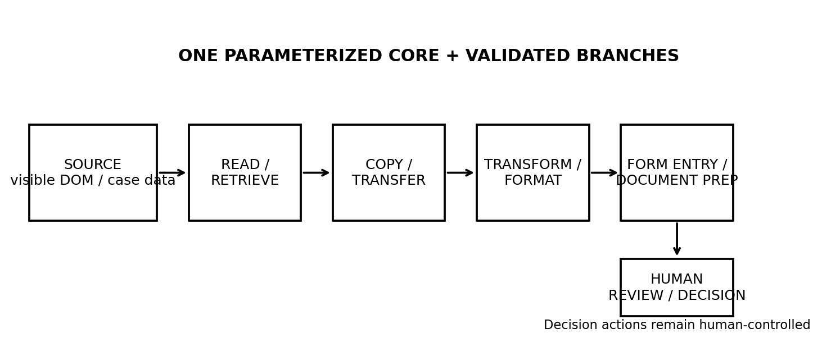
Figure 4. Final architecture: one parameterized mechanical core, validated branches for workflow variants, and a mandatory human gate before consequential business decisions.

14.2 Parameterized core versus branch logic
The prototype follows one parameterized core plus validated branches. Different data values inside the same mechanical flow are parameters. A different mechanical workflow is handled as a branch. A different business decision is not a branch to automate; it remains a human gate.

14.3 Reconstructed local target
Local target field | Role
employee_id | Employee identifier
employee_name | Employee name
request_type | Business/request subtype
category | Structured category
amount | Numeric amount
effective_date | Effective date
status | Workflow status
document | Supporting document
processing_comment | Prepared comment

Register and Hold controls are visible in the local interface for realism, but the automation runner is explicitly prohibited from clicking them.
Fixture | Case purpose | Expected handling
PI-REAL-001 | NORMAL expense reimbursement | Prepare fields; stop at human gate
PI-REAL-002 | BUSINESS_SUBTYPE payroll change | Use same core with parameter/variant handling
PI-REAL-003 | DOCUMENT_VARIANT expense reimbursement | Prepare document variant; stop at human gate
PI-REAL-004 | MISSING_FIELD | Safe stop
PI-REAL-005 | INVALID_VALUE | Safe stop
PI-REAL-006 | DECISION_EXCEPTION | Prepare available mechanical data; leave decision to human

14.4 Prototype execution and live demonstration
Playwright and Chromium were installed successfully. An initial Windows invocation using /usr/bin/env python3 failed because it did not correspond to the Windows environment; the correct Windows Python invocation succeeded. The initial runner was headless for repeatable tests. A separate visible runner was then created to make the browser actions observable during the demonstration.
PI automation demo video: https://youtu.be/LL4OfRidPTM
Latest PI/LA submission demonstration: https://youtu.be/82_9SsIhONg
The supplied video link is the external demonstration reference; the report does not treat access to the video as evidence of production integration.

15. Prototype Validation and Safety Invariants

15.1 Progressive validation
Validation set | Coverage | Result
3E-1 | 6 cases | 4 successful preparation/human-gate outcomes + 2 safe stops; 7/7 fields verified on successful cases; Register=0; Hold=0
3E-2 | 10 cases | 10/10 expected outcomes passed; 5 preparation/human-gate + 5 safe stops; Register=0; Hold=0
3E-3 consolidated | 16 tests | 16/16 pass; zero manual corrections; human gate preserved in all runs
3F focused final | 6 cases | 6/6 pass; 6 correct fields in successful cases; Register=0; Hold=0

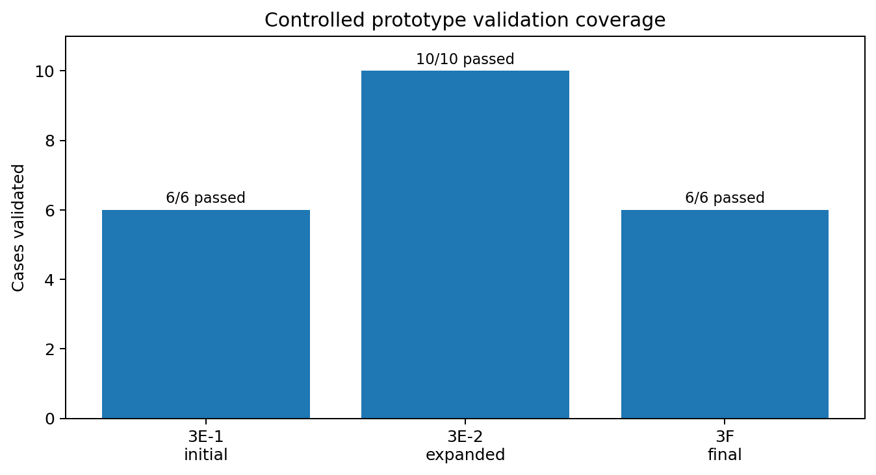
Figure 5. Controlled validation coverage; pass status is 100% within the reconstructed local sandbox, not a production-accuracy metric.

15.2 Final six-case validation
Case | Scenario | Observed outcome
A | NORMAL expense reimbursement | SUCCESS; extraction/transformation/navigation true; 6 fields correct; human takeover before Register/Hold
B | DIFFERENT_BUSINESS_SUBTYPE payroll change | SUCCESS; 6 fields correct
C | DOCUMENT_APPLICATION_VARIANT expense reimbursement | SUCCESS; 6 fields correct
D | MISSING_FIELD | STOP
E | UNEXPECTED_VALUE / invalid amount | STOP
F | DECISION_EXCEPTION | SUCCESS_HUMAN_GATE; 6 fields correct

Safety invariant
No test permitted the automation to click Register or Hold. The prototype is intentionally a preparation assistant; the final consequential action is reserved for the operator.

16. Real Dataset-B PI Replay
The next question was how much of the 209 observed PI workload could be reconstructed from the actual Dataset-B event stream. The first replay implementation incorrectly assumed raw events contained a segment_index field. That assumption was false. The mapping was corrected to use canonical timestamp intervals and then re-run against all 20,477 Dataset-B events.

16.1 Final replay coverage
Evidence | PI segments / observations | Coverage
Raw event mapping | 209/209 | 100.00%
Browser target evidence | 186/209 | 89.00%
Browser navigation | 42/209 | 20.10%
Form-input evidence | 154/209 | 73.68%
Clipboard evidence | 184/209 | 88.04%
Application-switch evidence | 150/209 | 71.77%
Transformation evidence | 190/209 | 90.91%
Core preparation supported | 70/209 | 33.49%
Human-gate evidence | 59/209 | 28.23%
Direct OCR evidence | 77/209 | 36.84%

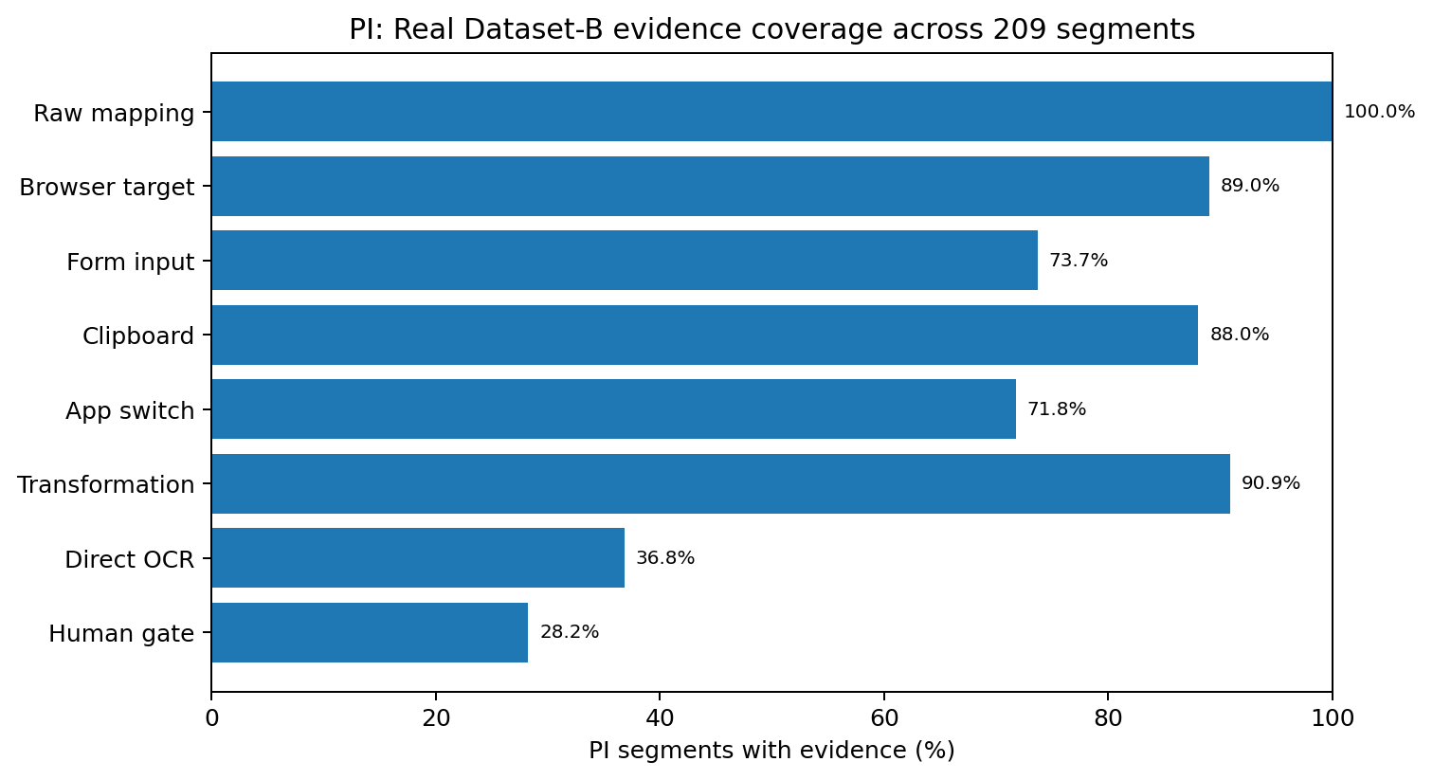
Figure 6. Coverage of directly observable PI evidence in Dataset B. Coverage categories measure evidence presence, not automation accuracy.

16.2 Replay classification
Replay class | Segments | Share | Meaning
STRUCTURAL_ONLY | 132 | 63.16% | Mechanical event structure is observable, but case content/target semantics are incomplete for full replay.
HUMAN_GATE | 55 | 26.32% | Execution reaches or contains a consequential human decision boundary.
REPLAYABLE_WITH_VARIANT | 14 | 6.70% | Sufficient structure exists, but mechanical path differs from the core and needs a validated branch.
INSUFFICIENT_TARGET_EVIDENCE | 7 | 3.35% | Not enough target/interface evidence for a safe replay.
REPLAYABLE | 1 | 0.48% | Sufficient evidence for direct offline mechanical replay.

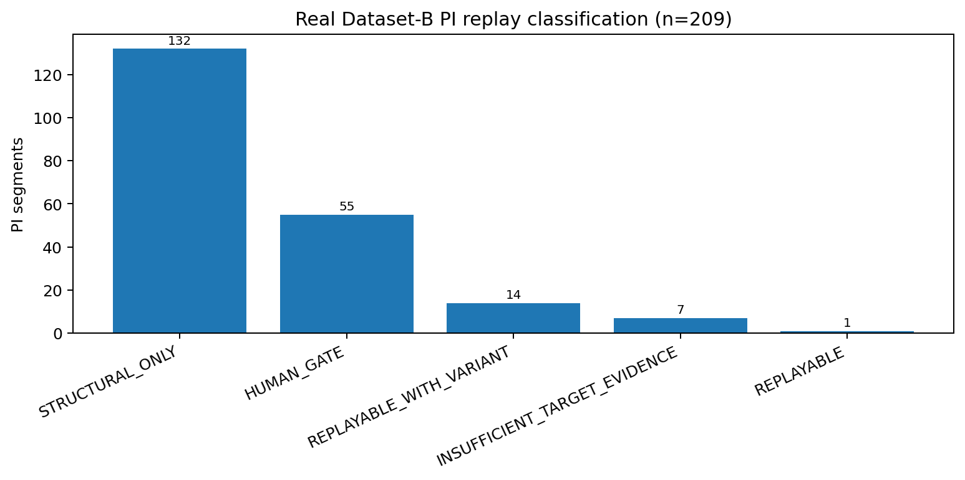
Figure 7. Offline replay classes over all 209 PI segments.

17. Real-Data Case Content Extraction: What the Logs Do Not Contain
A further experiment attempted to feed real Dataset-B case content, including translated OCR, into the simulator and compare the resulting target state. Early versions produced approximately zero similarity and no field recovery. Instead of manufacturing a successful result, the payloads were inspected to determine the source of the mismatch.

17.1 Root cause
Raw browser events contained interaction metadata and DOM target identifiers such as pi-note and btn-pi-ok, but the employee ID, employee name, amount, category and status were not available as structured text in the event payloads. The data shows that case values were read from the rendered screen rather than being encoded directly in the operation event. Although context.extracted_text was documented by the schema as an available mechanism, it was observed at 0% in the delivered PI logs used for this experiment.
Precise limitation statement
Structured case data (employee ID, name, category, amount, status) could not be recovered from raw operation logs for any of the 77 OCR-scored PI segments. For these logs, screenshots are the sole source of case content. Production automation must therefore read authoritative case data from the live DOM or another structured runtime source.

17.2 Interpretation
- The historical event log is sufficient to establish that a mechanical interaction pattern exists.
- The historical event log is not sufficient by itself to reconstruct every target field value for a complete production replay.
- OCR remains useful for semantic discovery and variant identification, but it should not be treated as the runtime source of truth.
- A production implementation should use the live application DOM/API for case values and reserve screenshots/OCR for analysis, fallback diagnostics or audit evidence where appropriate.

18. Expected Impact, Manual Work Remaining, and Measurement Boundaries

18.1 What the automation covers
- Retrieve or read visible source information.
- Copy and transfer structured information between contexts.
- Transform or normalize values into target formats.
- Populate predictable structured fields.
- Prepare repetitive supporting documents.
- Navigate predictable pages and states.
- Prepare a transaction/request for the final human decision.

18.2 What remains manual
- Review whether the prepared information is appropriate.
- Interpret policy and business rules when they are not deterministic.
- Approve, hold, reject or otherwise decide the business outcome.
- Handle ambiguous or exceptional cases.
- Perform final business release / consequential submission.

18.3 What can be quantified now
The complete Dataset-B segmentation represents 10,574.831 seconds of segmented activity, or approximately 176.25 minutes (2.94 hours). PI represents 3,783.777 seconds, or approximately 63.06 minutes, which is 35.78% of the observed segmented time. These are workload measurements, not realized automation savings.

18.4 What cannot be quantified honestly yet
- True per-case time savings cannot be calculated because comparable manual and production-automation timings were not collected.
- Local mock execution time (~0.0991 s mean in the controlled sandbox) must not be compared directly with operator time or multiplied across all 209 PI segments.
- Production success rate cannot be inferred from 16/16 local prototype tests because the production portal was not executed.
- OCR-derived case-type shares cannot be extrapolated to the full PI family because direct OCR coverage was partial.
Recommended future measurement
During a controlled production-like pilot, capture baseline operator time and automation-assisted time on the same case mix, along with safe-stop rate, exception rate, field-correction rate, human-review time and final decision latency. Only then should time savings or throughput impact be estimated.

19. Risks, Failure Modes, and Mitigations
Risk / failure mode | Evidence | Potential consequence | Mitigation
Production UI differs from reconstruction | Production /payroll-items not accessible | Selectors or workflow may fail | Validate selectors, structure and field behaviour in controlled production-like environment.
Historical logs lack case values | 77 OCR-scored PI segments lacked structured employee/amount/category/status payload data | Replay cannot recover full target state | Read authoritative values from live DOM/API at runtime.
OCR error | OCR is screenshot-dependent | Wrong semantic interpretation | Use OCR as supporting evidence; retain original Japanese; validate runtime fields.
Variant drift | 14 PI segments marked replayable-with-variant | Unseen branch may be mishandled | Use parameterized core + validated branches + safe stop.
Accidental business decision | Register/Hold are consequential controls | Incorrect or premature transaction | Keep decision actions outside automation; assert they are not clicked.
Duplicate submission | Final release is consequential | Duplicate processing | Validate target state, keep audit trail, require explicit human confirmation.
Authentication expiry | Production auth state not observed | Execution interruption | Detect unexpected authentication state and stop safely.
Sensitive employee data | PI contains HR/payroll/expense information | Privacy/security exposure | Least-privilege access, data minimization, audit logging, security review.
Segmentation errors | Dataset B has no GT | Incorrect grouping or candidate selection | Keep segmentation confidence separate; manually review representative cases.
Unsupported semantic propagation | 47.1% held-out accepted precision | False business-process labels | Do not extrapolate unsupported semantics; retain unresolved state.

20. Implementation and Rollout Plan

20.1 Near-term rollout sequence
1. Validate the prototype against a controlled instance of the real PI portal using non-sensitive test data.
2. Confirm stable selectors, target fields, document interfaces, validation rules, authentication and authorization.
3. Connect runtime data retrieval to the live DOM/API rather than relying on historical screenshots for case values.
4. Run a human-in-the-loop pilot where the automation only prepares data and documents and stops before consequential decisions.
5. Measure baseline versus assisted execution on matched cases and record corrections, safe stops and exceptions.
6. Add only validated variants to the branch set and maintain an explicit unsupported-state stop condition.
7. Expand to the LA family only after the PI pilot produces sufficient production-like evidence.

20.2 Seven-day allocation
Allocation slot | Planned focus | Primary output
1 | Dataset discovery, schema, loader and integrity | Canonical loader + inventory
2 | Session reconstruction, chunks and ground truth | Reconstructed sessions + GT boundary tables
3 | Boundary analysis and heuristic baselines | Baseline metrics + error analysis
4 | Supervised boundary model + consolidation | HGB model + post-processing analysis
5 | Dataset-B segmentation + process/family discovery | 540 segments + Step-2 evidence package
6 | PI workflow mapping + interface discovery + prototype | PI evidence + local automation prototype
7 | Validation + real-data replay + impact/risk + packaging | Final validation, report, README and submission artifacts

21. Reproducibility, Repository Structure, and Git History

21.1 Reproducibility principles
- Raw data remains outside Git through raw_data/ in the local working environment.
- Analysis scripts generate explicit CSV/XLSX evidence artifacts so findings can be audited independently of the final prose.
- Dataset A evaluation is reproducible from the raw JSON event stream and GT extraction scripts.
- Dataset B segmentation is reproducible from the frozen Step-1 configuration and canonical segments.jsonl.
- The PI sandbox is deterministic and testable independently of production access.

21.2 Key repository artifacts
Artifact | Purpose
src/loader.py | Raw event discovery, dataset identification, session grouping and chronological reconstruction
src/ground_truth.py | Dataset-A ground-truth extraction
src/gt_boundaries.py | Boundary-event extraction
segments.jsonl | Authoritative 540-line Dataset-B Step-1 deliverable
Step2_Final_Evidence_Package.xlsx | Authoritative Step-2 integrity, 540-segment evidence, taxonomy, inventory and decision package
STEP2_DECISION_SCORECARD_FINAL.xlsx | Candidate comparison and qualitative decision evidence
step3a4_pi_workflow_map_v3.xlsx | PI workflow-phase map and common-order evidence
step3b_pi_automation_boundary_v3.xlsx | PI phase-level automation treatment and human-gate evidence
step3d_pi_technical_interface_discovery_v2.xlsx | Observed PI routes and event-interface evidence
step3h_pi_real_dataset_replay_v6.xlsx | Final timestamp-mapped real Dataset-B PI replay classification
step3i_pi_real_data_extraction_similarity_v3.xlsx | Real-data extraction/similarity experiment and limitation evidence
prototype_pi_sandbox/ | Controlled local PI target and Playwright automation runner
Work log - Complete.docx | Detailed project history, experiments, failures, corrections and final state
LA automation extension pack | Attendance/leave extension scripts and local prototype: step3a1-step3i_la_*; la_run_pipeline.py; prototype/la_leave_applications.html; la_test_cases.json; la_demo_runner.py; la_demo_runner_live.py; README_LA_AUTOMATION.md; requirements_la.txt

21.3 Git history
The repository history contains meaningful incremental commits rather than one opaque final snapshot. The documented progression includes: Initialize project structure; Add initial dataset discovery loader; Improve dataset validation; Build canonical session reconstruction; Add ground truth extraction; Add ground truth boundary extraction; Add baseline segmentation and error analysis. Subsequent development continued through ML boundary modelling, Step-2 evidence construction, PI workflow analysis and Step-3 validation. Raw data was kept out of Git.
Final repository check
The final submission should contain the complete 540-segment segments.jsonl, the root README/reproduction instructions, the visible live runner inside the prototype directory, and the authoritative evidence artifacts. Experimental/debug scripts may remain in history, but the README should clearly identify authoritative outputs.

22. AI-Assisted Engineering Disclosure
AI assistance was used during the project for iterative code development, debugging, experiment design, analysis review, validation planning and documentation. AI-assisted work was treated as an engineering aid rather than as a source of ground truth. Dataset statistics, measured model metrics, OCR results, replay results and prototype test results were checked against the generated artifacts and test runs. Unsupported interpretations were explicitly rejected when the evidence did not justify them.

23. Limitations and Final Conclusion

23.1 Principal limitations
- Dataset B has no ground-truth process boundaries, so its 540 work units are inferred rather than accuracy-labelled.
- Final segmentation remains imperfect; the model is materially better at identifying boundary regions than at consolidating them into one timestamp.
- Direct semantic/OCR evidence is partial and non-uniform.
- Structural propagation was tested and rejected as a full-dataset semantic labelling mechanism due insufficient precision.
- Real historical logs do not expose all case content as structured event payloads.
- The production PI portal was unavailable, so selectors, permissions, authentication, backend rules and production runtime correctness remain unverified.
- No credible production time-saving estimate was available because comparable manual and assisted timings were not measured.

23.2 Final conclusion
The project demonstrates a complete evidence chain from raw operation logs to an automation proposal. Step 1 recovered 540 inferred work units from Dataset B after developing and evaluating a session-aware boundary method on Dataset A. Step 2 converted those units into five stable quantitative families, measured their workload and time contribution over the full population, tested semantic enrichment conservatively, and separated mechanical work from human decision-making. Step 3 then selected the PI family for a first human-in-the-loop pilot and implemented a parameterized local browser automation prototype with explicit safe-stop and human-gate behaviour.
The strongest positive evidence is not a claim of autonomous production automation. It is the combination of: complete 540-unit segmentation output; transparent evidence boundaries; 209 observed PI segments; 7,325 real PI events attached to those segments; a controlled prototype that passed 16/16 combined tests and 6/6 focused final tests; and an explicit invariant that consequential decisions remain human. The most important limitations are also explicit: production integration was unavailable, raw historical events do not contain every case value, and production savings have not been measured.

24. LA Automation Extension - Attendance and Leave Applications
After the PI prototype was completed, the LA family was extended into a second automation prototype. In Dataset B, LA corresponds to attendance and leave application processing and is the second opportunity identified by the Step-2 evidence package. The extension reuses the same design principle: automate deterministic preparation and transfer, but stop before consequential business decisions.

24.1 Why LA is a follow-on opportunity
Evidence dimension | LA observation
Observed workload | 99 segments; 18.33% of Dataset-B segments
Observed segmented time | 42.62 minutes; 24.18% of observed segmented time
Execution characteristics | Median 22 s; mean 48.08 events/segment; 14 sessions; 4 operators
Browser / transfer evidence | Browser 100%; clipboard 93.94%; browser interaction 92.93%
Supporting desktop work | Word 49.49%; Excel 2.02%; Notepad 4.04%
Decision evidence | 18.18% of LA segments contain direct decision-oriented evidence
Step-2 treatment | Second opportunity; feasible with validation; medium governance risk
Direct semantic evidence identified attendance/leave activity in the LA family, including terms for attendance, leave, vacation/paid leave, employee ID, full name, request type, department and status. These observations were used as branch evidence and were not expanded into unsupported full-population subprocess claims.

24.2 Reconstructed target and workflow
The local prototype targets the observed /leave-applications workflow. Its reconstructed interface contains the fields employee_id, employee_name, request_type, department, attendance, leave_type, leave_start, leave_end, supporting_document and processing_comment. The implementation is parameterized so that different data values can use the same mechanical core, while different mechanical paths can be isolated as explicitly validated branches.
Workflow phase | Prototype treatment
Read / retrieve source information | Automate where the source is available and unambiguous
Copy / transfer | Automate predictable transfer into the target form
Transform / normalize | Automate deterministic formatting and date/value normalization
Form entry | Automate structured field population with validation
Document preparation | Automate predictable supporting-document preparation
Human review / decision | Keep outside the automation boundary
Unexpected state / missing input | Safe stop and surface to the operator

24.3 Human boundary and safety design
- Approval, rejection, hold, ambiguous policy interpretation and final business release remain human responsibilities.
- The automation is designed to fail closed on missing input, invalid values, unsupported parameters or unexpected UI state.
- Historical screenshots/OCR are semantic evidence for analysis; authoritative runtime case values should come from the live DOM or another structured runtime source.
- Production authentication, authorization, selector stability, validation messages, backend rules and audit controls remain to be validated in the real application.

24.4 Prototype implementation and demonstration
A controlled local /leave-applications sandbox and Playwright-based prototype were created for the LA workflow. The prototype is intentionally a preparation assistant rather than an autonomous approval system. A visible browser demonstration was recorded for the completed extension:
https://youtu.be/82_9SsIhONg
The video is a demonstration reference only. It does not constitute proof of production integration or production success rate.

24.5 Relationship to the original PI prototype
The original PI prototype remains the primary, most extensively quantified Step-3 case in this report: it has the full 16-test combined validation, focused six-case validation, real Dataset-B replay and payload-level limitation analysis. The LA extension demonstrates reuse of the same engineering pattern on a second family without changing the authoritative 540-line Step-1 segmentation output.

24.6 LA limitations and next validation step
The LA prototype was reconstructed from operation-log evidence and a local target, not from a live production portal. Consequently, production selector stability, authentication state, authorization, backend validation rules, error semantics and final business-release behaviour remain unverified. The next validation step is controlled execution against a non-sensitive instance of the real attendance/leave system, followed by matched manual-versus-assisted timing measurements and correction/exception tracking.

Appendix A. Final Submission Checklist
Requirement | Status | Evidence / report location
Step 1 methodology on Dataset A | Complete | Sections 4-5
Apply segmentation to Dataset B | Complete | Section 6
segments.jsonl full Dataset-B deliverable | Complete | Section 6.1; 540 records
Step 2 process inventory | Complete | Sections 7-10
Absolute time totals | Complete | Sections 9 and 18
Candidate analysis | Complete | Section 11
Candidate ordering | Complete | Section 11
Step 3 prototype | Complete | PI: Sections 12-15; LA follow-on: Section 24
Visible live demo | Complete | Section 14.4 + supplied video link
Real Dataset-B replay | Complete | Section 16
Production integration | Explicitly not performed | Section 13 + limitations
Manual work + realistic impact | Complete | Section 18
Risk + mitigation | Complete | Section 19
Seven-day allocation | Complete | Section 20.2
Detailed work log | Complete | Separate Work Log artifact
Final report | Complete | This document
Root README / reproduction | Required for final repository packaging | Section 21
Git history | Documented / meaningful | Section 21.3
Final submission structure | Checklist provided | This appendix
LA follow-on automation prototype | Complete | Section 24
Latest PI/LA visible demonstration | Complete | Sections 14.4 and 24.4 + supplied video link

Appendix B. Evidence Artifact Index
Artifact | What it proves / contains
Step2_Final_Evidence_Package.xlsx | Dataset-B integrity, 540-segment evidence, subprocess discovery, authoritative family inventory, OCR/workflow evidence and final automation decision
STEP2_DECISION_SCORECARD_FINAL.xlsx | Candidate comparison and qualitative decision rationale
step3a4_pi_workflow_map_v3.xlsx | 209 PI workflow segments, common phases and phase-order relationships
step3b_pi_automation_boundary_v3.xlsx | 1,402 phase rows and 118 human-gate evidence rows with phase-level automation treatment
step3d_pi_technical_interface_discovery_v2.xlsx | 209 PI segments, 7,325 raw event rows, routes and DOM/event interface evidence
step3e2_pi_prototype_validation_v1.xlsx | 10-case validation evidence
step3e3_pi_final_prototype_assessment_v1.xlsx | Combined 16-test assessment
step3f_pi_actual_variant_validation_v1.xlsx | Final six-case variant validation
step3g_pi_value_quantification_v*.xlsx | Observed PI population and prototype impact framing
step3h_pi_real_dataset_replay_v6.xlsx | Corrected timestamp-based replay evidence across 209 PI segments
step3i_pi_real_data_extraction_similarity_v3.xlsx | Real-data content extraction experiment and payload-level limitation diagnosis
segments.jsonl | 540 canonical Dataset-B inferred work units
Work log - Complete.docx | Detailed historical work log with all experiments, failures and corrections
Automation demo video | https://youtu.be/LL4OfRidPTM

Appendix C. Metric Definitions and Interpretation Rules
Metric | Definition used in this report
Segment share | Family segment count divided by all 540 Dataset-B work units
Time share | Family observed segmented duration divided by total observed segmented duration
Boundary precision | Predicted boundaries matched to GT boundary tolerance divided by predicted boundaries
Boundary recall | GT boundaries matched by predicted boundaries within tolerance divided by GT boundaries
Mean boundary error | Mean absolute time difference for matched predicted/ground-truth boundaries
Direct OCR coverage | Segments with direct screenshot/OCR semantic evidence within the stated population
Replay class | Offline classification of how much of the observed mechanical workflow can be reconstructed from the real event evidence
Human gate | A point where consequential business judgement must remain with an operator

