STEP 1 — Install & Configure Git
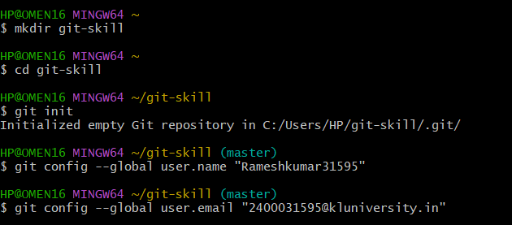
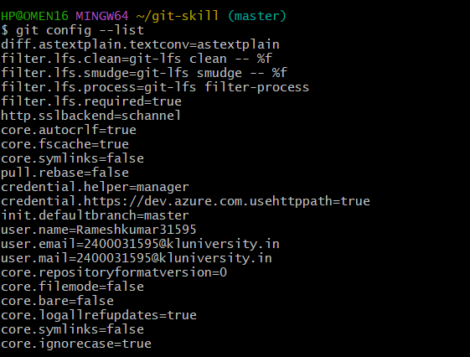

STEP 2 — Create Files & Add to Staging

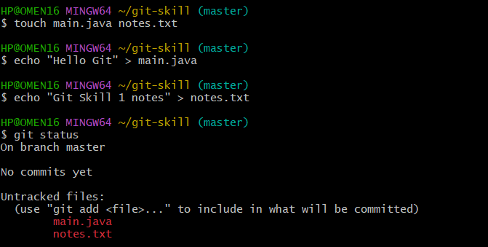
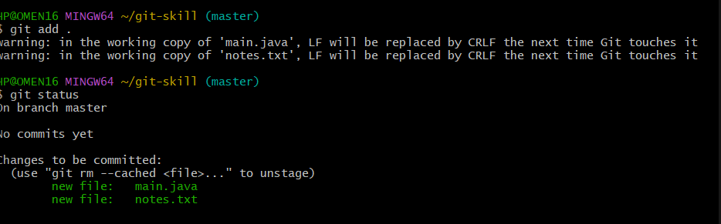

STEP 3 — Commit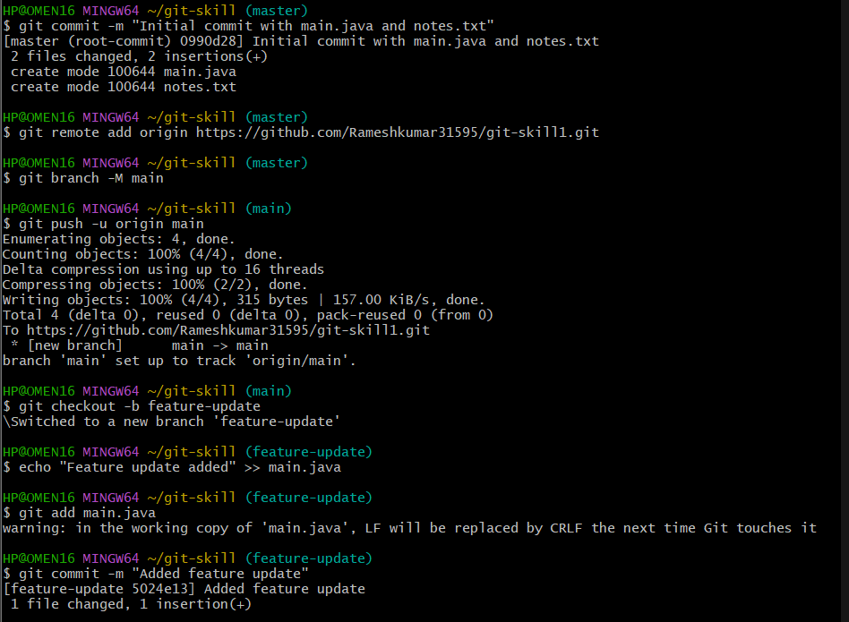
STEP 4 — Push to GitHub
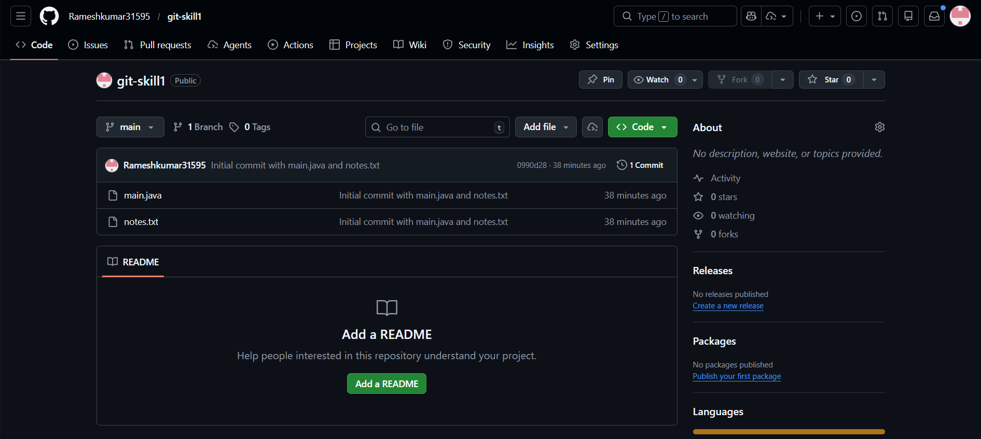
STEP 5 — Create First Branch
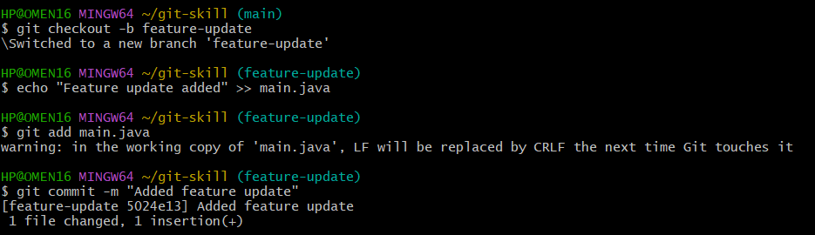
STEP 6 — Second Branch
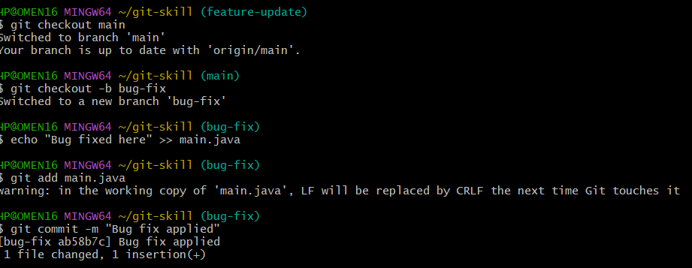
STEP 7 — Merge
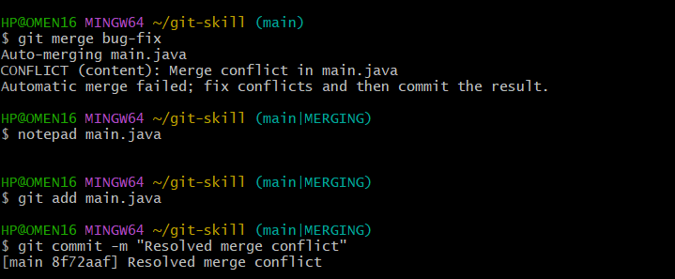
STEP 8 — Final Check
