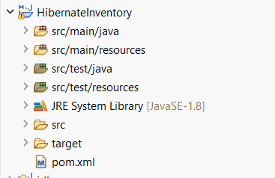
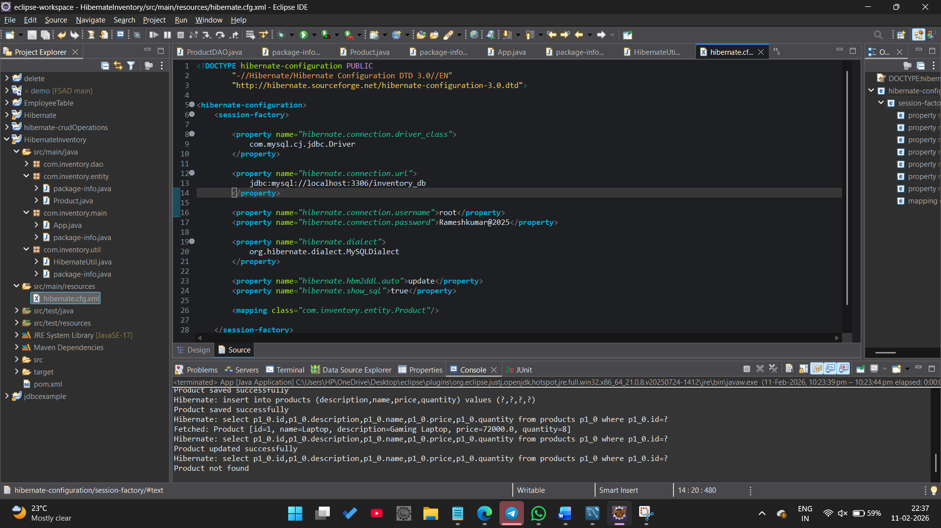
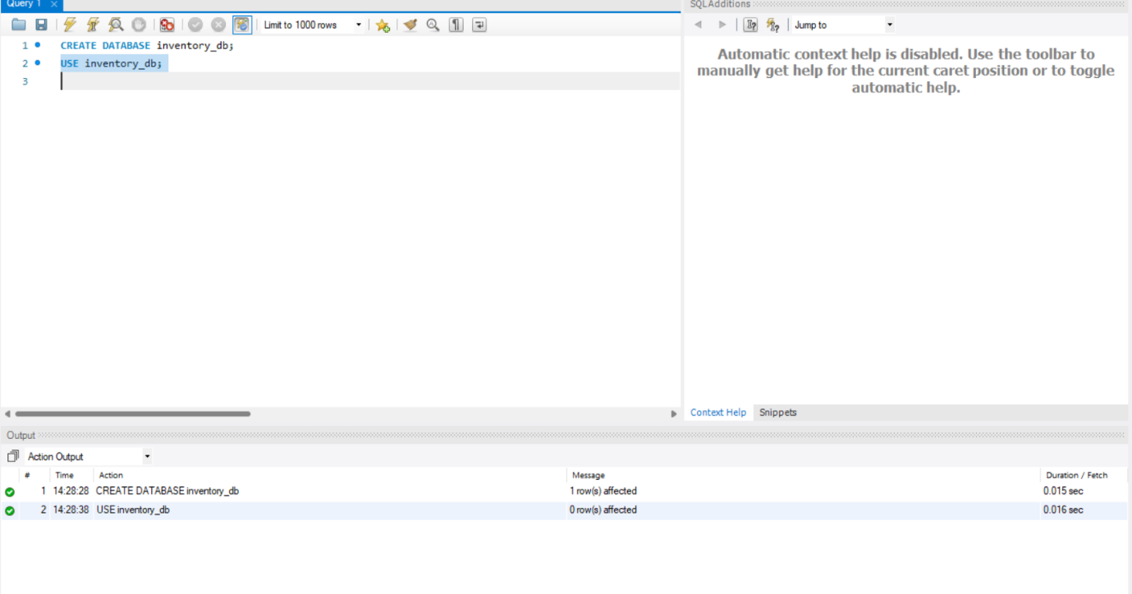

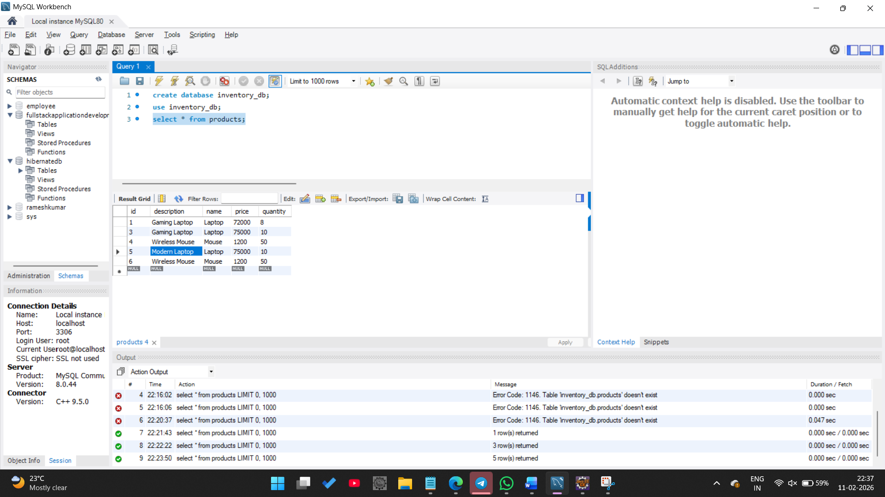

Recording of the output : https://drive.google.com/file/d/15IyOZvr8Z2yDeP4b7xVWH15fZ0Fy_jow/view?usp=drive_link

