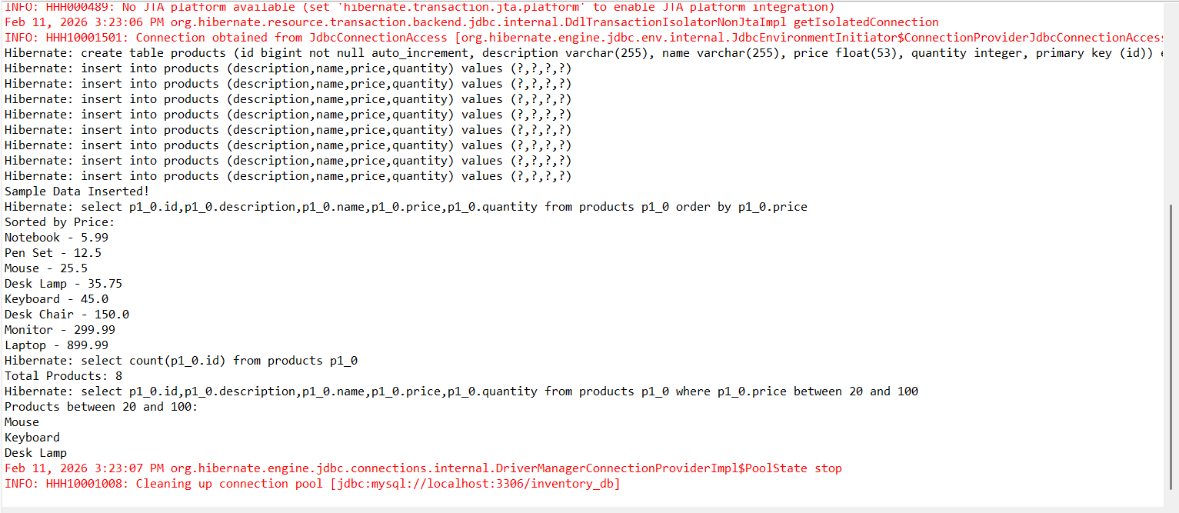
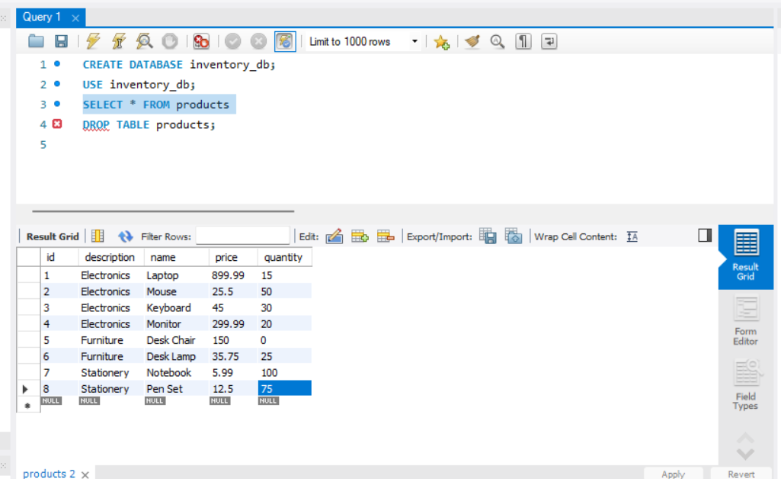
Recording of output:
https://drive.google.com/file/d/1_1vEXagD9ovKFLWSj6RJraPvXJk-3kzM/view?usp=sharing

