SKILL – 4: Spring Dependency Injection – Constructor & Setter Injection

ID : 2400031595
NAME : Ramesh kumar kandula

PROCEDURE :
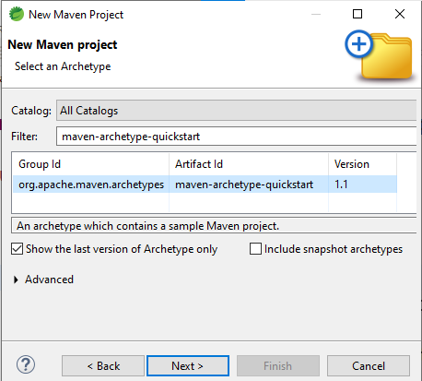
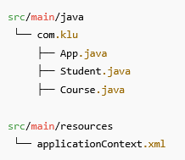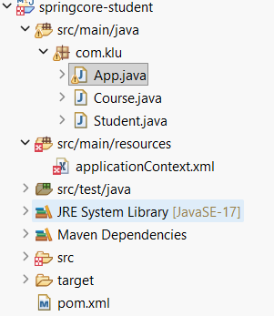
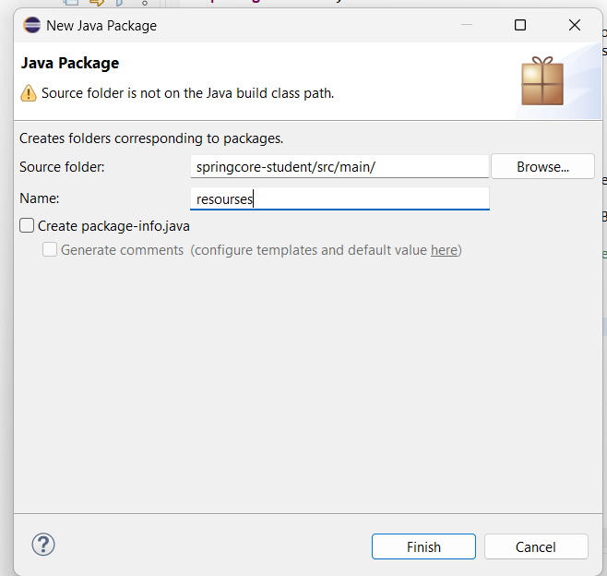
Add Spring Dependency (pom.xml):
-----------------------------------------------------------------------------------------------------
<dependency>
<groupId>org.springframework</groupId>
<artifactId>spring-context</artifactId>
<version>5.3.30</version>
</dependency>

Course.java :
package com.klu;
public class Course {
private String courseName;
private int duration; // duration in months
// Constructor Injection
public Course(String courseName, int duration) {
this.courseName = courseName;
this.duration = duration;
}
// Getters (optional but good practice)
public String getCourseName() {
return courseName;
}
public int getDuration() {
return duration;
}
@Override
public String toString() {
return courseName + " (" + duration + " months)";
}
}
Student.java:
package com.klu;
public class Student {
private int studentId;
private String name;
private int year;
private Course course;
private String email;
private String phoneNumber;
// Constructor Injection
public Student(int studentId, String name, int year) {
this.studentId = studentId;
this.name = name;
this.year = year;
}
// Setter Injection
public void setCourse(Course course) {
this.course = course;
}
public void setEmail(String email) {
this.email = email;
}
public void setPhoneNumber(String phoneNumber) {
this.phoneNumber = phoneNumber;
}
// Display method (each detail in a separate line)
public void display() {
System.out.println("Student ID : " + studentId);
System.out.println("Student Name : " + name);
System.out.println("Academic Year : " + year);
System.out.println("Email : " + email);
System.out.println("Phone Number : " + phoneNumber);
System.out.println("Course : " + course);
}
}
applicationContext.xml:
📁 src/main/resources/applicationContext.xml
-----------------------------------------------------------------------------------------------------
<?xml version="1.0" encoding="UTF-8"?>
<beans xmlns="http://www.springframework.org/schema/beans"
xmlns:xsi="http://www.w3.org/2001/XMLSchema-instance"
xsi:schemaLocation="
http://www.springframework.org/schema/beans
https://www.springframework.org/schema/beans/spring-beans.xsd">

<!-- Course Bean -->
<bean id="course" class="com.klu.Course">
<constructor-arg value="Spring Framework"/>
<constructor-arg value="6"/>
</bean>

<!-- Student Bean -->
<bean id="student" class="com.klu.Student">

<!-- Constructor Injection -->
<constructor-arg value="101"/>
<constructor-arg value="ram"/>
<constructor-arg value="2026"/>
<!-- Setter Injection -->
<property name="course" ref="course"/>
<property name="email" value="ram@klu.edu"/>
<property name="phoneNumber" value="9876543210"/>
</bean>
</beans>

App.java:
package com.klu;
import org.springframework.context.ApplicationContext;
import org.springframework.context.support.ClassPathXmlApplicationContext;
public class App {
public static void main(String[] args) {
ApplicationContext context =
new ClassPathXmlApplicationContext("applicationContext.xml");
Student student = (Student) context.getBean("student");
// IMPORTANT: call display(), do NOT use println(student)
student.display();
}
}
=====================================================================Run the Application:
- Right-click App.java
- Run As → Java Application
OUTPUT on the console:

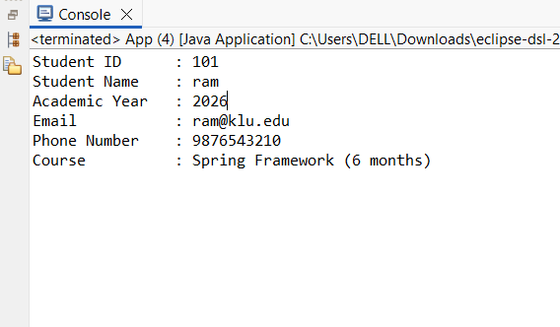
Now Add the Springcore-students into the Github:
There are 2 ways to push into the Github
1.Through the eclipse
2.Through the files to direct Github.
*The easiest method is do it from the files
Now go the file and type springcore-students as shown below
