SKILL 5 : Spring Autowiring Demo using @Autowired

ID : 2400031595
NAME : Ramesh kumar kandula
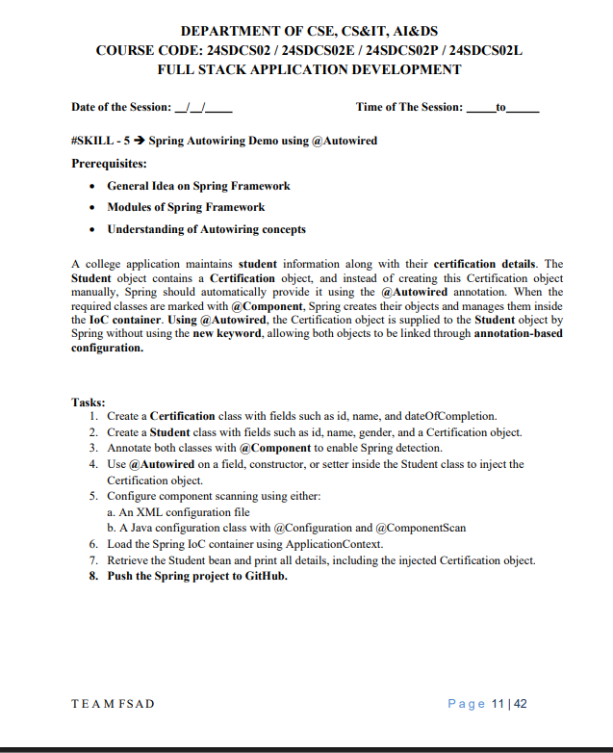

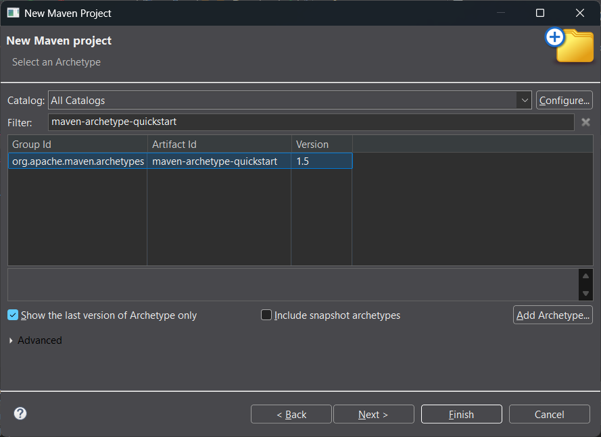
Enter details:
- Group Id: com.klu
- Artifact Id: Spring-Autowiring
- Packaging: com.klu
- Finish

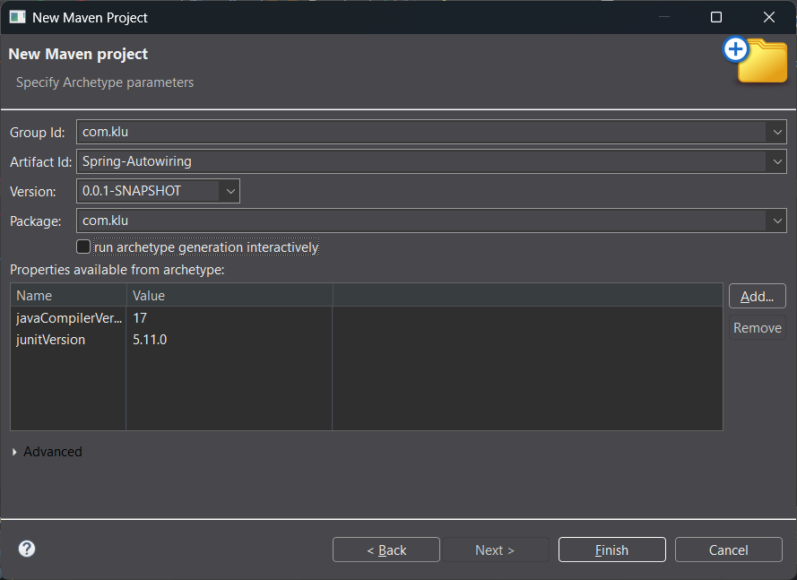

com.klu
├── App.java
├── Student.java
├── Certification.java
src/main/resources
---applicationContext.xml

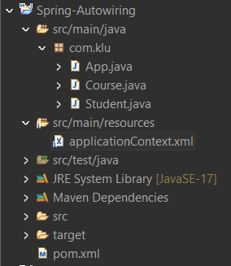

Add Spring Dependency (pom.xml):-
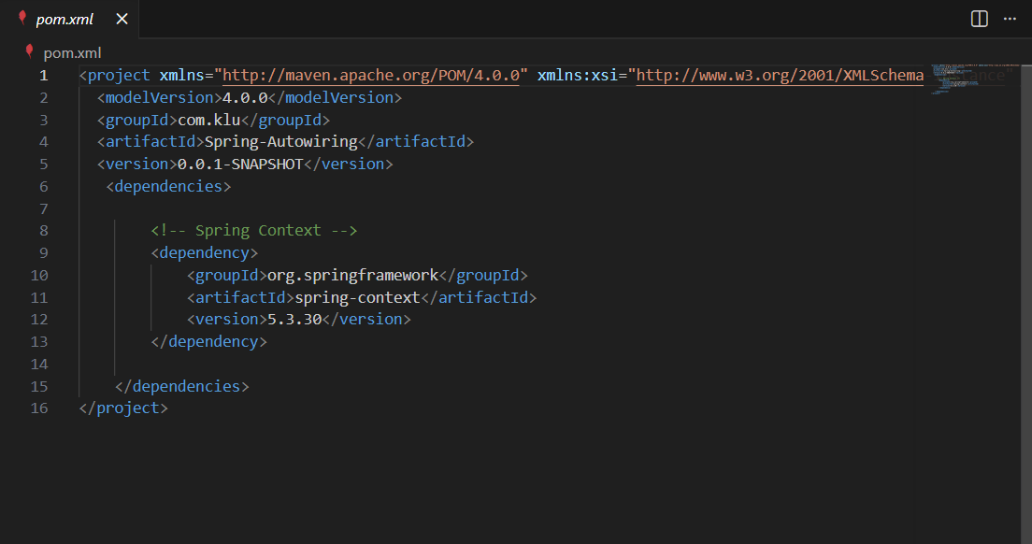

Course.java:-
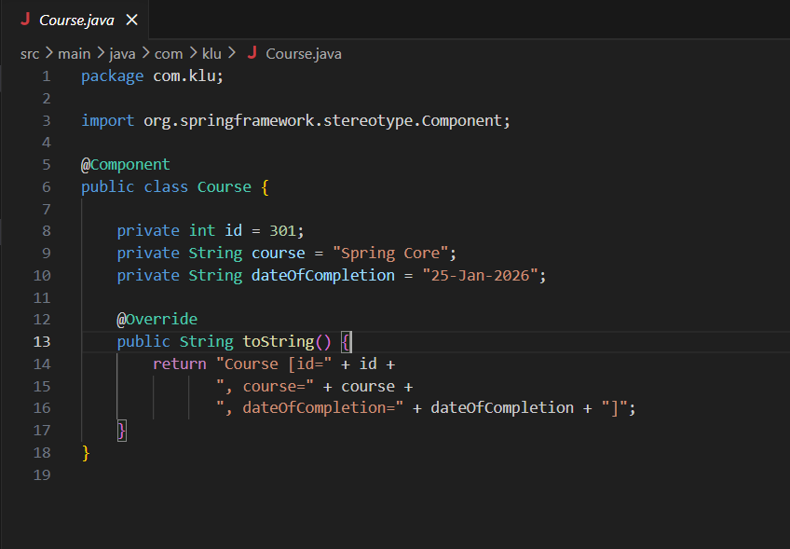
Student.java:-
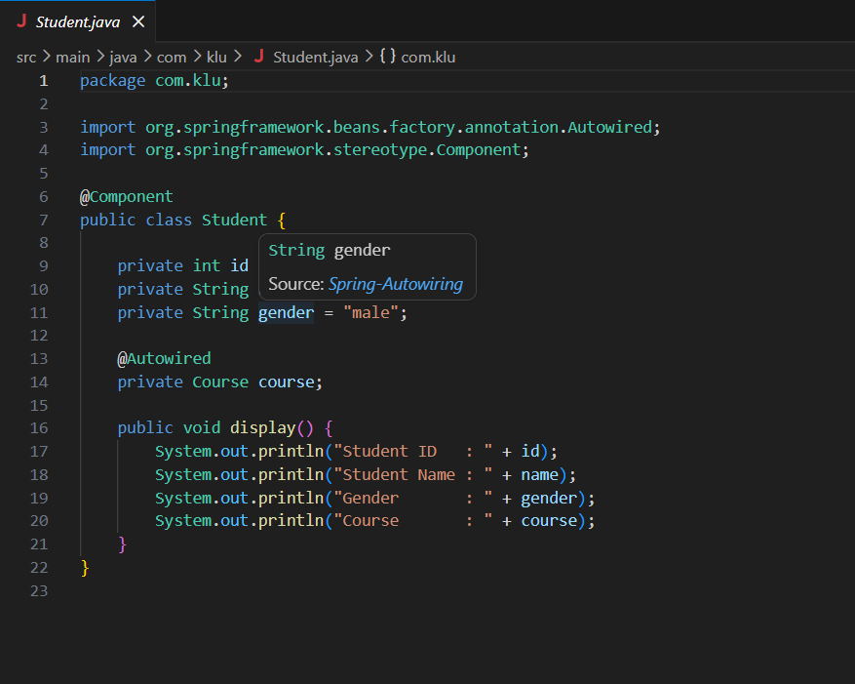}
===========================================================
applicationContext.xml
📁 src/main/resources/applicationContext.xml

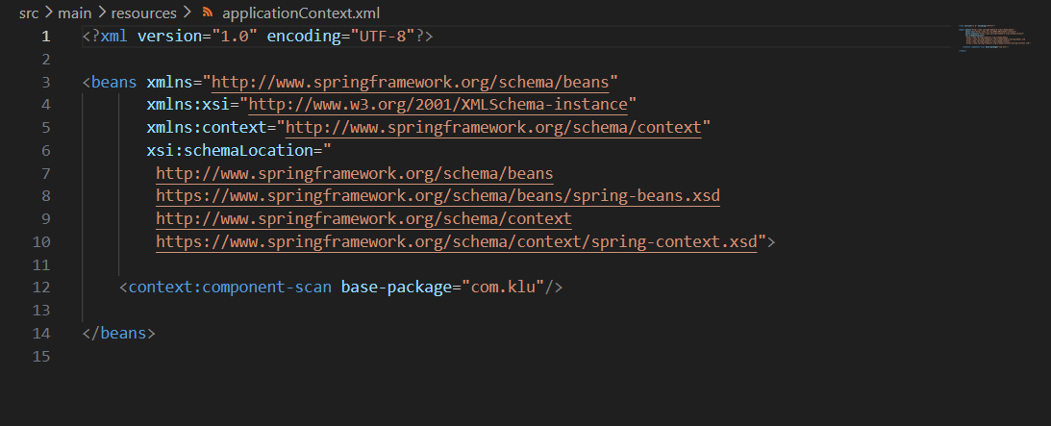App.java:-
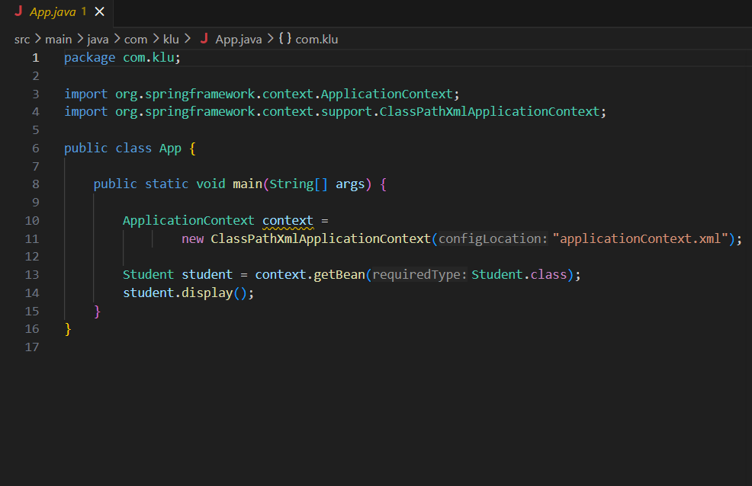================================================================
Run the Application:
- Right-click App.java
- Run As → Java Application
OUTPUT on the console:
