SKILL 6 : Spring MVC Web Request Handling Demo

NAME : Ramesh kumar Kandula
ID : 2400031595

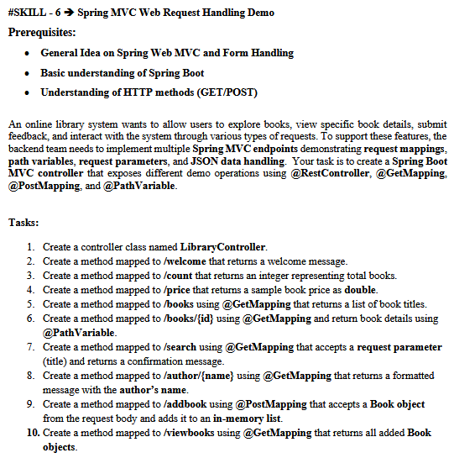
Spring MVC Web Request Handling Demo Prerequisites

1)File → New → Spring Starter Project
Field | Value
Name | SpringMVCWeb
Type | Maven
Packaging | Jar
Java Version | 17
Group | com.klu
Click Next
Add Dependencies
Select: Spring Web
Click Finish
2) Project Structure
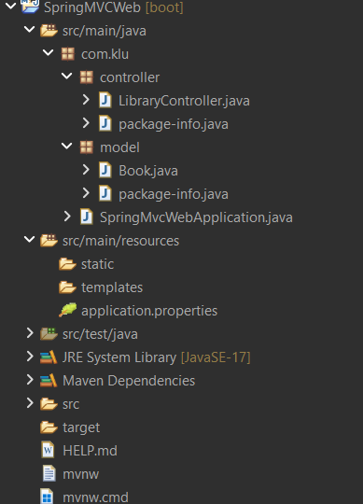

Model ->Book :
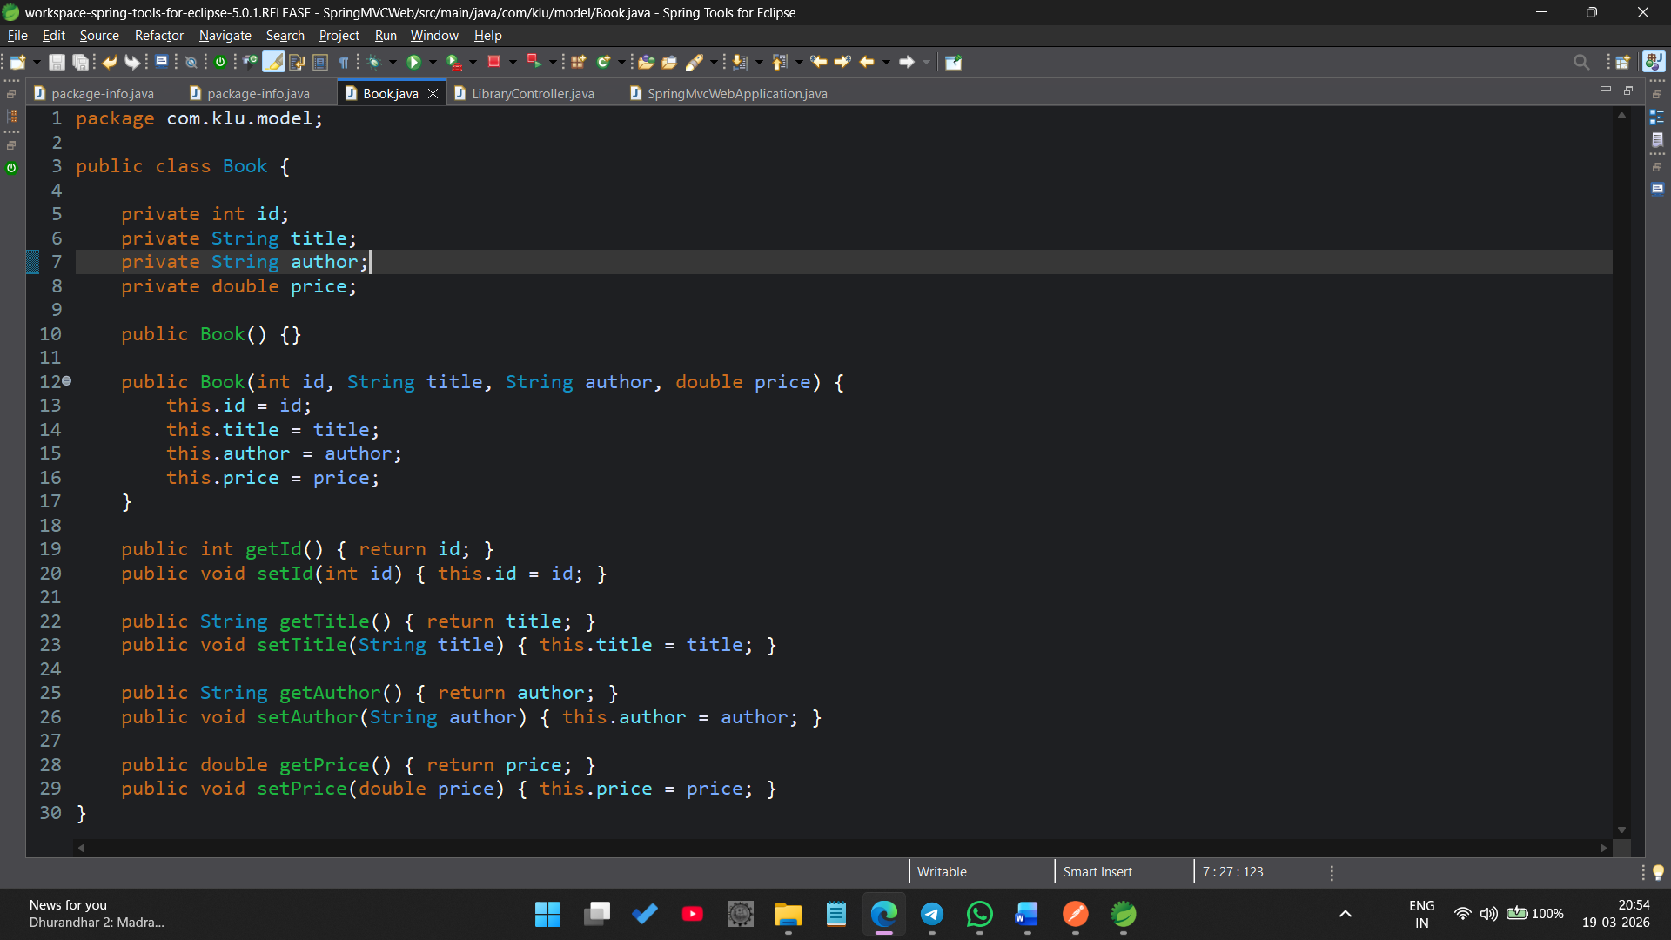
Controller -> LibraryController:
========================================
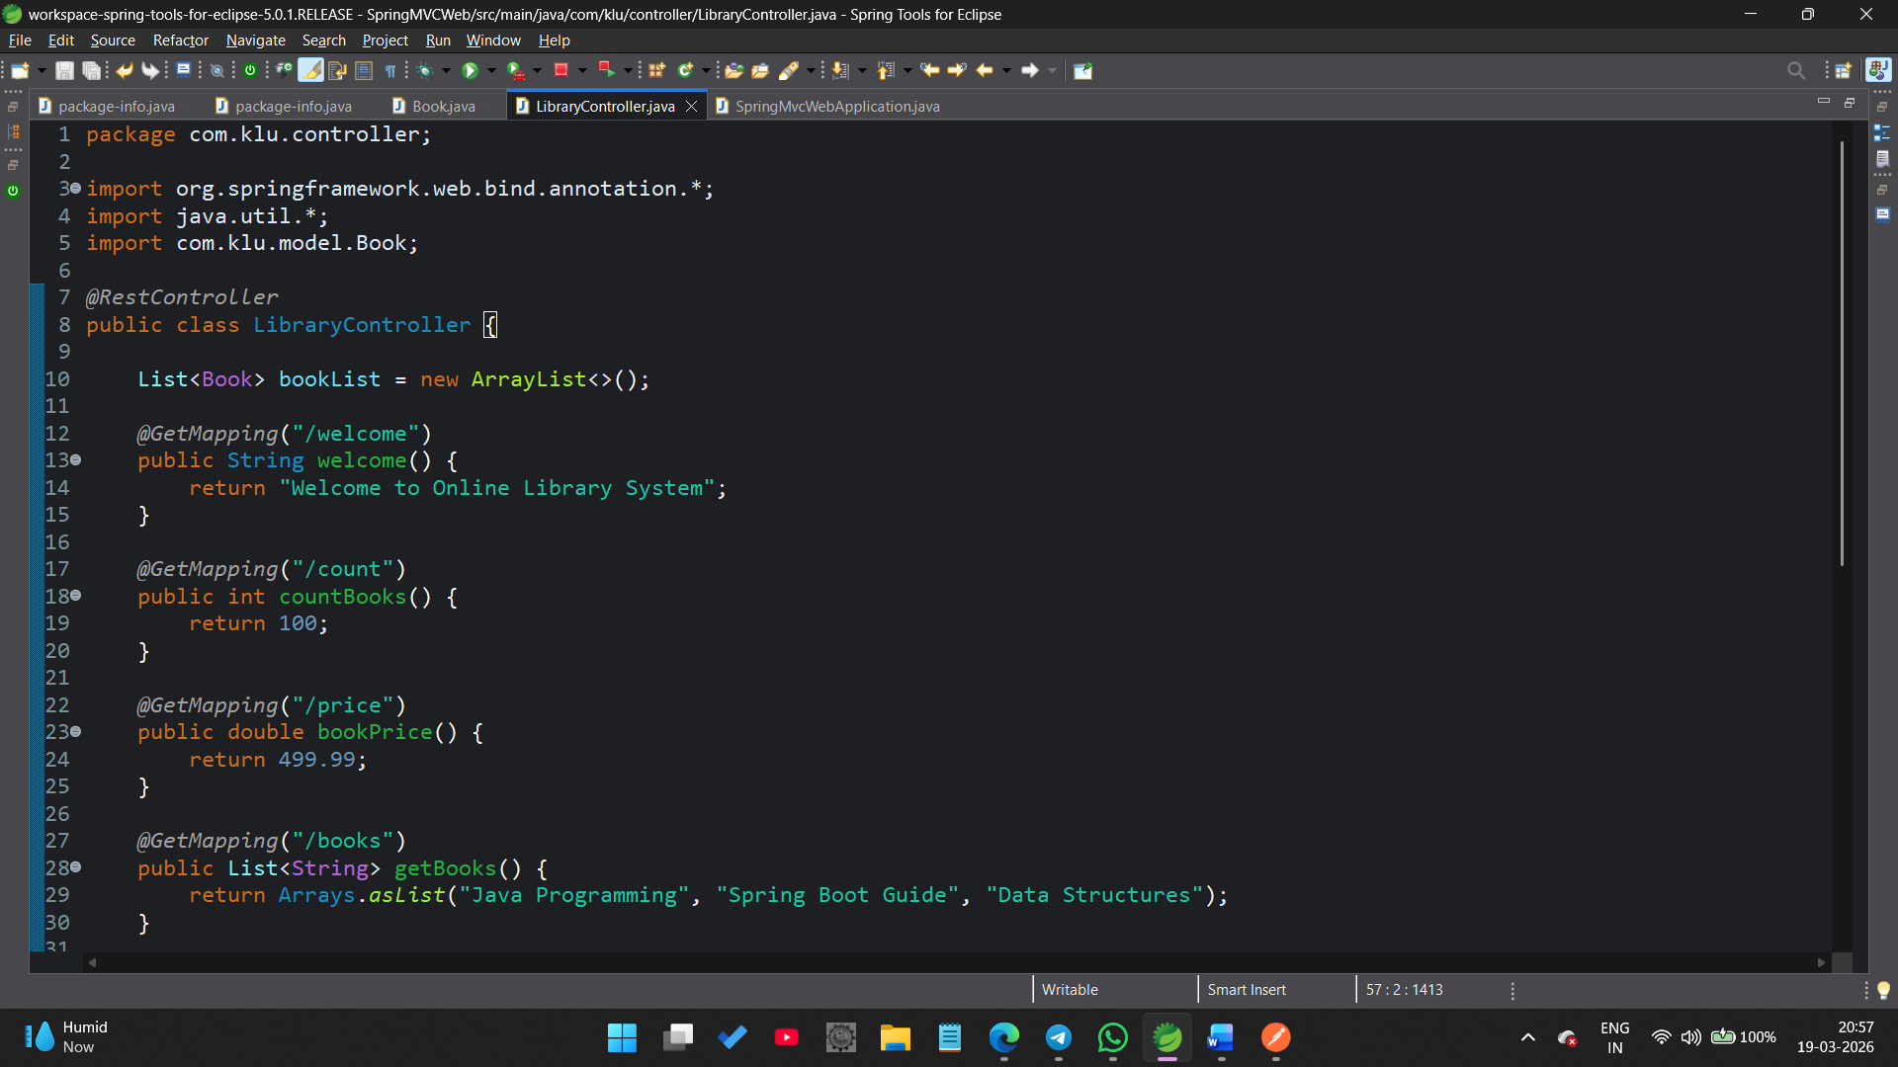===============================================
Run the Application:
Run As → Spring Boot App
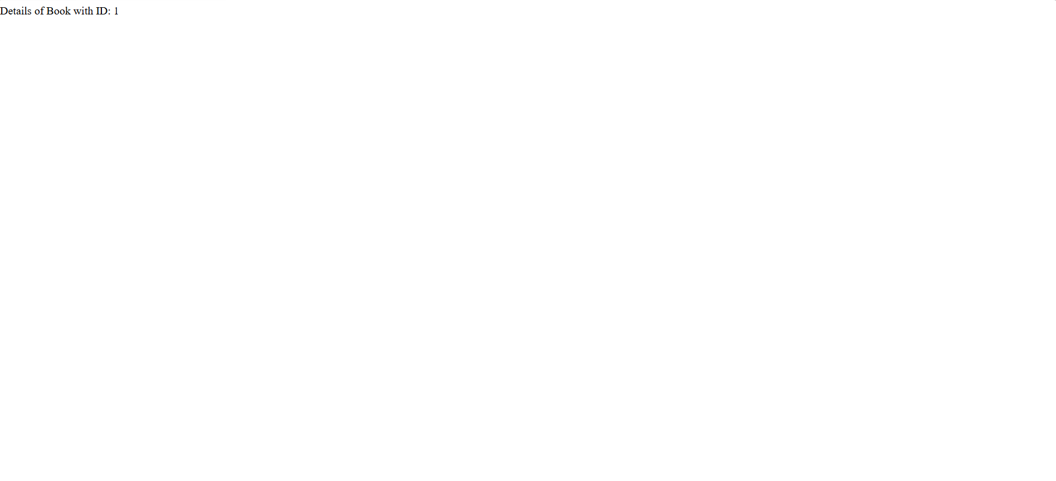

Open Postman app:
