**Vehicle Accident Alert System**

**ABSTRACT**

In highly populated Countries, everyday people lose their lives because of accidents and poor emergency facilities. These lives could have been saved if medical facilities are provided at the right time. This project implies a system that is a solution to this drawback when a vehicle meets with an accident.

The proposed systems have been simulated and practically designed by the use of hardware components and the results are satisfied with the expectation. The accelerometer detects the sudden change in the axes of the vehicle and the GSM module sends the alert message on your Mobile Phone with the location of the accident. The location of the accident is sent in the form of a Google Map link, derived from the latitude and longitude of the GPS module. There is an SOS button(switch) present to trigger the buzzer if anyone needs help immediately or if the person is feeling sick. A Reset button(switch) is also provided in order to terminate the sending of a message in the rare case where there is no casualty, this can save the precious time of the ambulance.

At the monitoring centre various software’s are used to plot the Vehicle on a map. In this way, the Vehicle owners are able to track their vehicle on a real-time basis. Due to real-time tracking facility, vehicle tracking systems are becoming increasingly popular among owners of expensive vehicles

**Keywords:** Accident alert system, Arduino UNO, GPS, GSM

**Schematic diagram:**

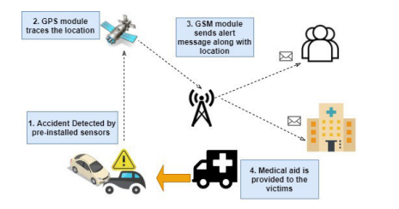

### **Prototypes:**

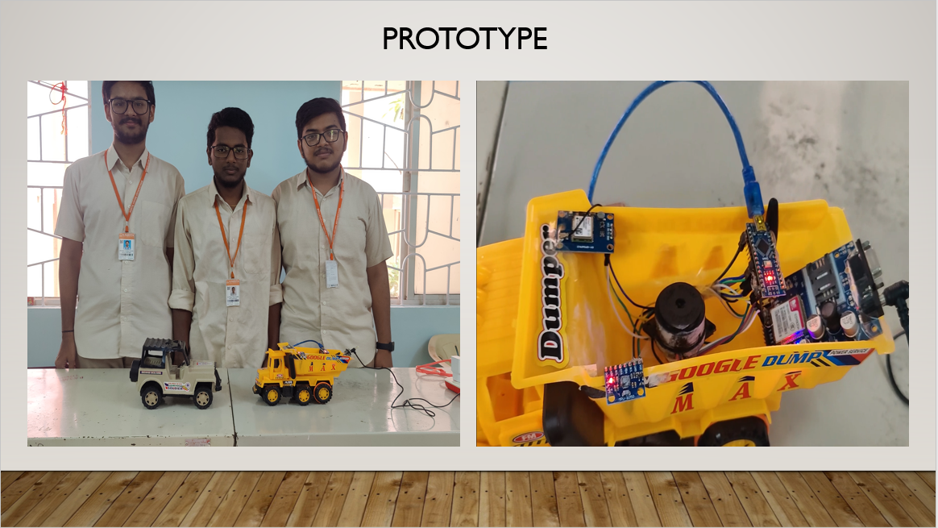

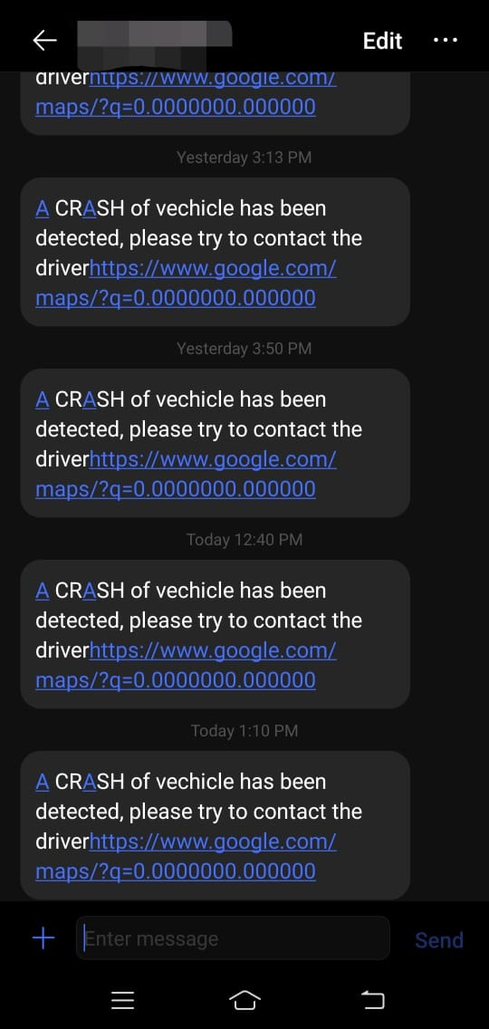

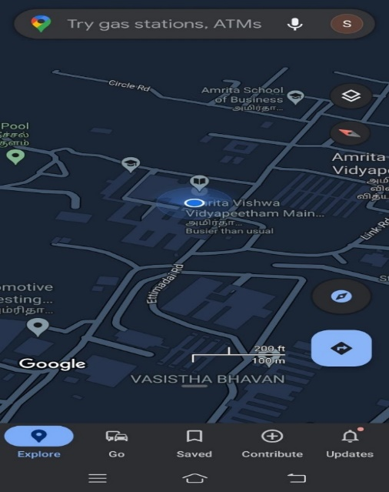

--- Thank you ---