**Instructions:**

* Fill your Name and REGNO.
* Lab 1 question is uploaded in MS TEAM
* Complete all the programs, add the code java and XML, input and output Screenshots after the question on the same document.
* Save this File name with your **registerno**_**lab1**

**eg 18ABC1234_LAB1.doc**

* Upload it in assignment ->LAB1 in MS TEAM

Lab1:

1. Exploring all types of Texts supported in Android studio. Screen shot the keyboards that popsup. Observe the difference.
2. Display a toast Message
3. Read a Name and display hello Name.
4. Read username and password and check for validity, and display login successful or failure.
5. Read two numbers and write a program to add, subtract, multiply and divide.

**Q1: Exploring all types of Texts supported in Android studio. Screen shot the keyboards that popsup. Observe the difference.**

**MainActivity.java**

package com.example.textviews;  
import androidx.appcompat.app.AppCompatActivity;  
import android.os.Bundle;  
public class MainActivity extends AppCompatActivity {  
 @Override  
 protected void onCreate(Bundle savedInstanceState) {  
 super.onCreate(savedInstanceState);  
 setContentView(R.layout.*activity_main*);  
 }  
}

**activity_main.xml:**

<?xml version="1.0" encoding="utf-8"?>  
<androidx.constraintlayout.widget.ConstraintLayout xmlns:android="http://schemas.android.com/apk/res/android"  
 xmlns:app="http://schemas.android.com/apk/res-auto"  
 xmlns:tools="http://schemas.android.com/tools"  
 android:layout_width="match_parent"  
 android:layout_height="match_parent"  
 tools:context=".MainActivity">  
  
 <TextView  
 android:layout_width="194dp"  
 android:layout_height="46dp"  
 android:text="Plain Text"  
 app:layout_constraintBottom_toTopOf="@+id/editTextTextPersonName"  
 app:layout_constraintLeft_toLeftOf="parent"  
 app:layout_constraintRight_toRightOf="parent"  
 app:layout_constraintTop_toTopOf="parent"  
 app:layout_constraintVertical_bias="0.731" />  
  
 <EditText  
 android:id="@+id/editTextTextPersonName"  
 android:layout_width="287dp"  
 android:layout_height="56dp"  
 android:ems="10"  
 android:hint="This is a plain text view"  
 android:inputType="textPersonName"  
 app:layout_constraintEnd_toEndOf="parent"  
 app:layout_constraintStart_toStartOf="parent"  
 tools:layout_editor_absoluteY="279dp" />  
  
 <EditText  
 android:id="@+id/editTextTextPassword"  
 android:layout_width="287dp"  
 android:layout_height="48dp"  
 android:layout_marginTop="36dp"  
 android:ems="10"  
 android:hint="This is Text Password"  
 android:inputType="textPassword"  
 app:layout_constraintEnd_toEndOf="parent"  
 app:layout_constraintStart_toStartOf="parent"  
 app:layout_constraintTop_toBottomOf="@+id/editTextTextPersonName" />  
  
 <EditText  
 android:id="@+id/editTextNumberPassword"  
 android:layout_width="286dp"  
 android:layout_height="41dp"  
 android:layout_marginTop="20dp"  
 android:ems="10"  
 android:hint="Numeric Password"  
 android:inputType="numberPassword"  
 app:layout_constraintEnd_toEndOf="parent"  
 app:layout_constraintHorizontal_bias="0.536"  
 app:layout_constraintStart_toStartOf="parent"  
 app:layout_constraintTop_toBottomOf="@+id/editTextTextPassword" />  
  
 <EditText  
 android:id="@+id/editTextTextEmailAddress"  
 android:layout_width="287dp"  
 android:layout_height="50dp"  
 android:layout_marginTop="28dp"  
 android:ems="10"  
 android:hint="E-Mail"  
 android:inputType="textEmailAddress"  
 app:layout_constraintTop_toBottomOf="@+id/editTextNumberPassword"  
 tools:layout_editor_absoluteX="67dp" />  
  
 <EditText  
 android:id="@+id/editTextDate"  
 android:layout_width="290dp"  
 android:layout_height="53dp"  
 android:layout_marginTop="32dp"  
 android:ems="10"  
 android:hint="Date"  
 android:inputType="date"  
 app:layout_constraintTop_toBottomOf="@+id/editTextTextEmailAddress"  
 tools:layout_editor_absoluteX="67dp" />  
  
</androidx.constraintlayout.widget.ConstraintLayout>

**Output:**

**Plain Text Input:**

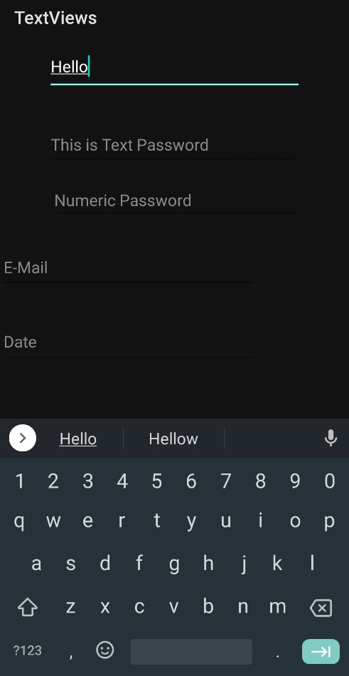

**Regular Password Input:**

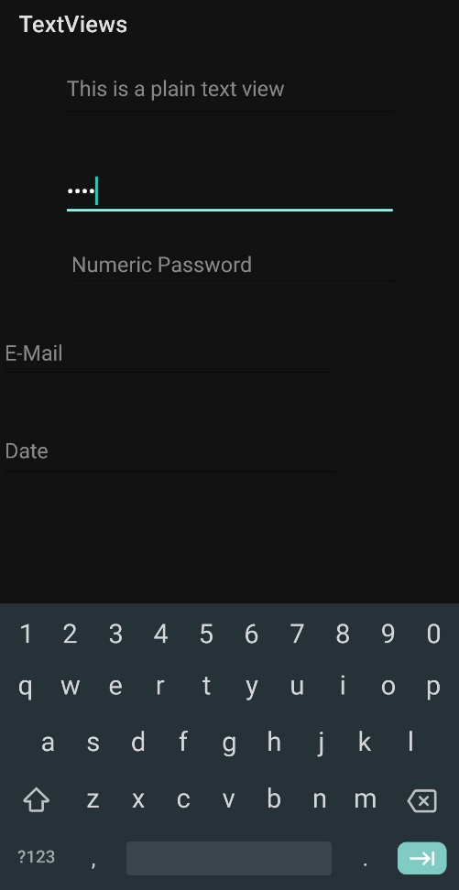

**Numeric Password Input:**

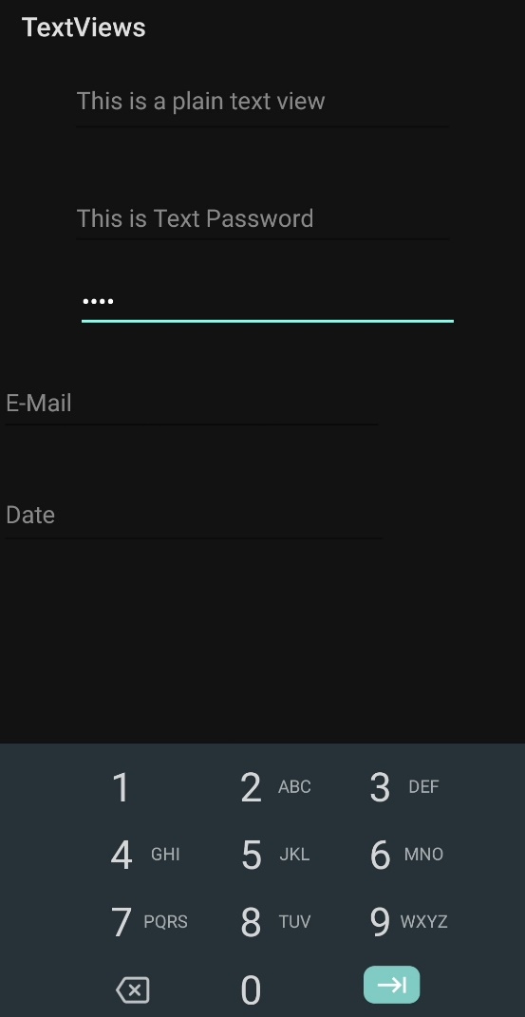

**E-Mail Input:**

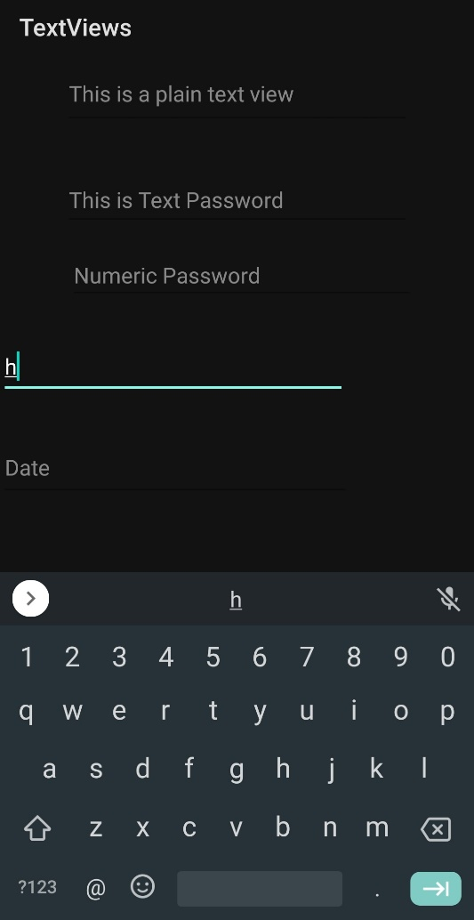

**Date Input:**

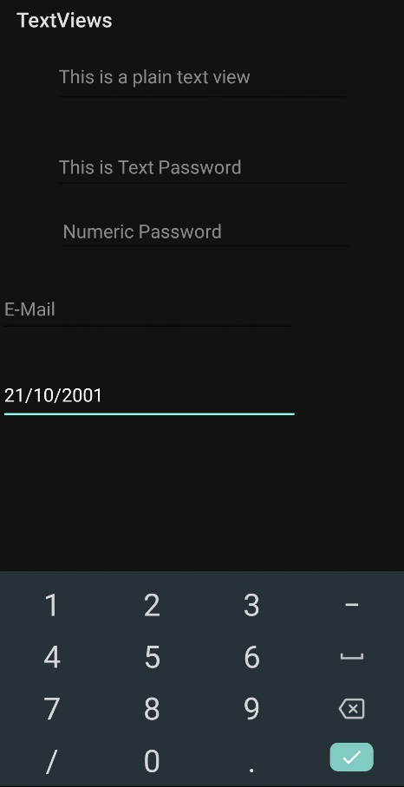

**Q2: Displaying Toast Message**

**Mainactivity.java**

package com.example.labone;  
  
import androidx.appcompat.app.AppCompatActivity;  
  
import android.os.Bundle;  
import android.widget.Toast;  
  
public class MainActivity extends AppCompatActivity  
{  
 @Override  
 protected void onCreate(Bundle savedInstanceState) {  
 super.onCreate(savedInstanceState);  
 setContentView(R.layout.*activity_main*);  
 Toast.*makeText*(this,"Hello! Welcome to Android",Toast.*LENGTH_SHORT*).show();  
 }  
}

**Activity_main.xml**

<?xml version="1.0" encoding="utf-8"?>  
<androidx.constraintlayout.widget.ConstraintLayout xmlns:android="http://schemas.android.com/apk/res/android"  
 xmlns:app="http://schemas.android.com/apk/res-auto"  
 xmlns:tools="http://schemas.android.com/tools"  
 android:layout_width="match_parent"  
 android:layout_height="match_parent"  
 tools:context=".MainActivity">  
  
 <TextView  
 android:id="@+id/textView"  
 android:layout_width="wrap_content"  
 android:layout_height="wrap_content"  
 android:text="Android Toast"  
 app:layout_constraintBottom_toBottomOf="parent"  
 app:layout_constraintEnd_toEndOf="parent"  
 app:layout_constraintStart_toStartOf="parent"  
 app:layout_constraintTop_toTopOf="parent" />  
</androidx.constraintlayout.widget.ConstraintLayout>

**Output:**

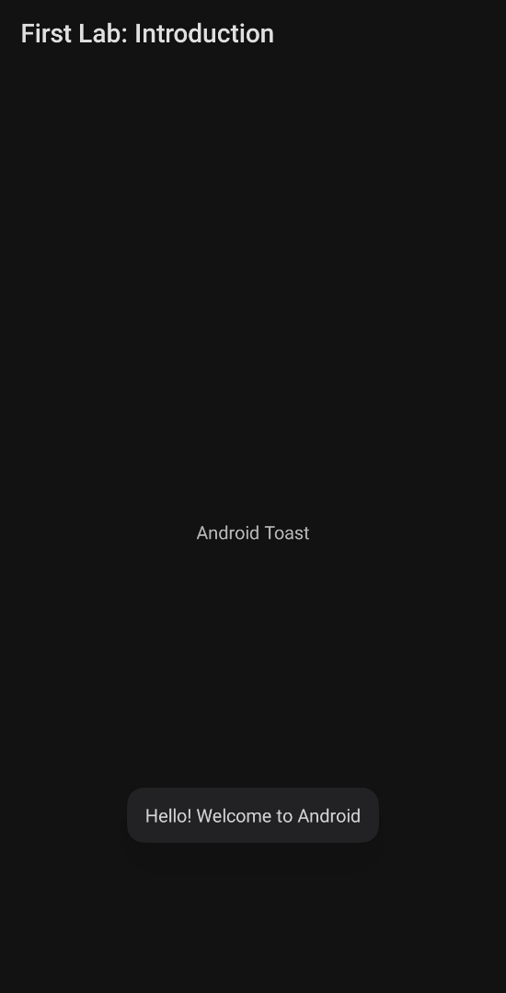

**3. Read a Name and display hello Name:**

**Activity_main.xml**

<?xml version="1.0" encoding="utf-8"?>  
<androidx.constraintlayout.widget.ConstraintLayout xmlns:android="http://schemas.android.com/apk/res/android"  
 xmlns:app="http://schemas.android.com/apk/res-auto"  
 xmlns:tools="http://schemas.android.com/tools"  
 android:layout_width="match_parent"  
 android:layout_height="match_parent"  
 tools:context=".MainActivity">  
  
 <EditText  
 android:id="@+id/t1"  
 android:layout_width="wrap_content"  
 android:layout_height="wrap_content"  
 android:layout_marginTop="116dp"  
 android:ems="10"  
 android:hint="Name"  
 android:inputType="textPersonName"  
 app:layout_constraintEnd_toEndOf="parent"  
 app:layout_constraintHorizontal_bias="0.497"  
 app:layout_constraintStart_toStartOf="parent"  
 app:layout_constraintTop_toTopOf="parent" />  
  
 <TextView  
 android:id="@+id/t2"  
 android:layout_width="304dp"  
 android:layout_height="98dp"  
 android:text="Result Will Be Displayed Here"  
 android:textSize="25dp"  
 app:layout_constraintBottom_toBottomOf="parent"  
 app:layout_constraintEnd_toEndOf="parent"  
 app:layout_constraintStart_toStartOf="parent"  
 app:layout_constraintTop_toBottomOf="@+id/button"  
 app:layout_constraintVertical_bias="0.377" />  
  
 <Button  
 android:id="@+id/button"  
 android:layout_width="wrap_content"  
 android:layout_height="wrap_content"  
 android:layout_marginTop="120dp"  
 android:text="Click Me"  
 app:layout_constraintEnd_toEndOf="parent"  
 app:layout_constraintHorizontal_bias="0.498"  
 app:layout_constraintStart_toStartOf="parent"  
 app:layout_constraintTop_toBottomOf="@+id/t1" />  
  
 <TextView  
 android:id="@+id/textView3"  
 android:layout_width="230dp"  
 android:layout_height="44dp"  
 android:layout_marginBottom="32dp"  
 android:text="Please Enter Your Name Below"  
 android:textSize="14dp"  
 app:layout_constraintBottom_toTopOf="@+id/t1"  
 app:layout_constraintEnd_toEndOf="parent"  
 app:layout_constraintHorizontal_bias="0.498"  
 app:layout_constraintStart_toStartOf="parent" />  
  
</androidx.constraintlayout.widget.ConstraintLayout>

**MainActivity.java**

package com.example.helloname;  
  
import androidx.appcompat.app.AppCompatActivity;  
  
import android.os.Bundle;  
import android.view.View;  
import android.widget.Button;  
import android.widget.EditText;  
import android.widget.TextView;  
import android.widget.Toast;  
  
public class MainActivity extends AppCompatActivity {  
 EditText t1;  
 TextView t2;  
 Button b1;  
  
 @Override  
 protected void onCreate(Bundle savedInstanceState) {  
 super.onCreate(savedInstanceState);  
 setContentView(R.layout.*activity_main*);  
 t1=findViewById(R.id.*t1*);  
 t2=findViewById(R.id.*t2*);  
 b1=findViewById(R.id.*button*);  
 b1.setOnClickListener(new View.OnClickListener() {  
 @Override  
 public void onClick(View v) {  
 t2.setText("Hello "+t1.getText());  
 }  
 });  
 }  
}

**Output:**

**Initial Screen:**

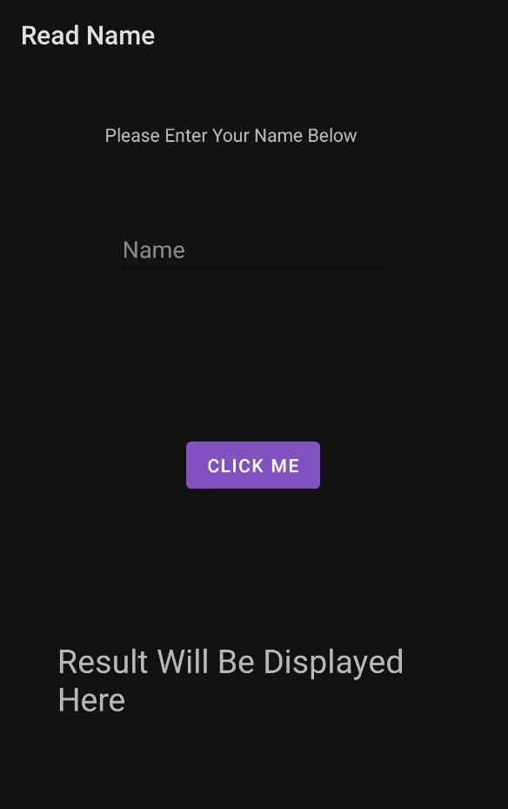

**Output Screen:**

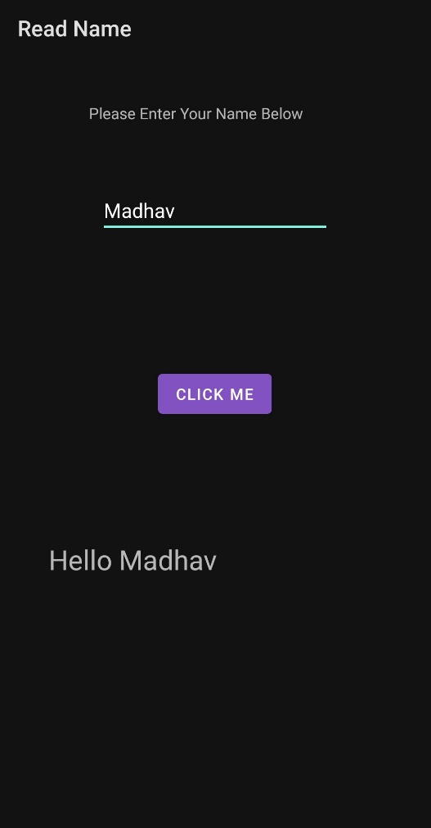

**4. Read username and password and check for validity, and display login successful or failure.**

package com.example.upass;  
  
import androidx.appcompat.app.AppCompatActivity;  
import android.os.Bundle;  
import android.view.View;  
import android.widget.Button;  
import android.widget.EditText;  
import android.widget.Toast;  
  
public class MainActivity extends AppCompatActivity  
{  
 EditText t1,t2;  
 Button b1;  
 @Override  
 protected void onCreate(Bundle savedInstanceState) {  
 super.onCreate(savedInstanceState);  
 setContentView(R.layout.*activity_main*);  
 Toast.*makeText*(this,"Welcome to Login Page", Toast.*LENGTH_SHORT*).show();  
 t1=findViewById(R.id.*t1*);  
 t2=findViewById(R.id.*t2*);  
 b1=findViewById(R.id.*b1*);  
 b1.setOnClickListener(new View.OnClickListener() {  
 @Override  
 public void onClick(View v) {  
 if (t1.getText().toString().equals("madhav") && t2.getText().toString().equals("vit"))  
 Toast.*makeText*(getApplicationContext(),(t1.getText()+" Login Successful"),Toast.*LENGTH_SHORT*).show();  
 else  
 Toast.*makeText*(getApplicationContext(),("Login Failed! Please Enter Correct Details"),Toast.*LENGTH_SHORT*).show();  
 }  
 });  
 }  
}

**activity_main.xml**

<?xml version="1.0" encoding="utf-8"?>  
<androidx.constraintlayout.widget.ConstraintLayout  
 xmlns:android="http://schemas.android.com/apk/res/android"  
 xmlns:tools="http://schemas.android.com/tools"  
 xmlns:app="http://schemas.android.com/apk/res-auto"  
 android:layout_width="match_parent"  
 android:layout_height="match_parent"  
 tools:context=".MainActivity">  
  
 <TextView  
 android:id="@+id/textView7"  
 android:layout_width="267dp"  
 android:layout_height="54dp"  
 android:layout_marginTop="44dp"  
 android:text="Please Enter Your Password Below"  
 app:layout_constraintEnd_toEndOf="parent"  
 app:layout_constraintStart_toStartOf="parent"  
 app:layout_constraintTop_toBottomOf="@+id/t1" />  
  
 <TextView  
 android:id="@+id/textView6"  
 android:layout_width="267dp"  
 android:layout_height="54dp"  
 android:text="Please Enter Your User ID Below"  
 app:layout_constraintEnd_toEndOf="parent"  
 app:layout_constraintStart_toStartOf="parent"  
 tools:layout_editor_absoluteY="58dp" />  
  
 <EditText  
 android:id="@+id/t1"  
 android:layout_width="wrap_content"  
 android:layout_height="wrap_content"  
 android:layout_marginTop="52dp"  
 android:ems="10"  
 android:hint="User ID"  
 android:inputType="textPersonName"  
 app:layout_constraintEnd_toEndOf="parent"  
 app:layout_constraintHorizontal_bias="0.497"  
 app:layout_constraintStart_toStartOf="parent"  
 app:layout_constraintTop_toBottomOf="@+id/textView6" />  
  
 <EditText  
 android:id="@+id/t2"  
 android:layout_width="wrap_content"  
 android:layout_height="wrap_content"  
 android:layout_marginTop="32dp"  
 android:ems="10"  
 android:hint="Password"  
 android:inputType="textPassword"  
 app:layout_constraintEnd_toEndOf="parent"  
 app:layout_constraintHorizontal_bias="0.497"  
 app:layout_constraintStart_toStartOf="parent"  
 app:layout_constraintTop_toBottomOf="@+id/textView7" />  
  
 <Button  
 android:id="@+id/b1"  
 android:layout_width="wrap_content"  
 android:layout_height="wrap_content"  
 android:layout_marginTop="76dp"  
 android:text="Submit"  
 app:layout_constraintEnd_toEndOf="parent"  
 app:layout_constraintHorizontal_bias="0.498"  
 app:layout_constraintStart_toStartOf="parent"  
 app:layout_constraintTop_toBottomOf="@+id/t2" />  
  
</androidx.constraintlayout.widget.ConstraintLayout>

**Output:**

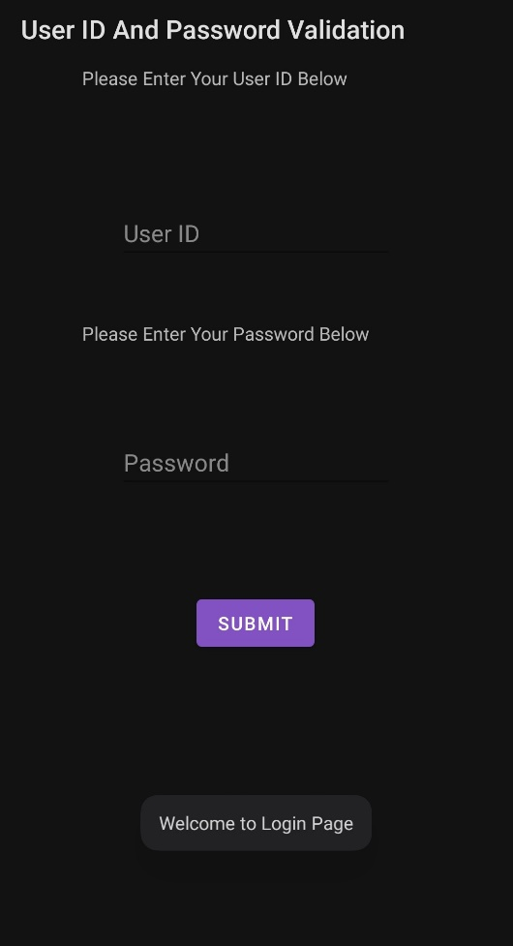

**Successful Login:**

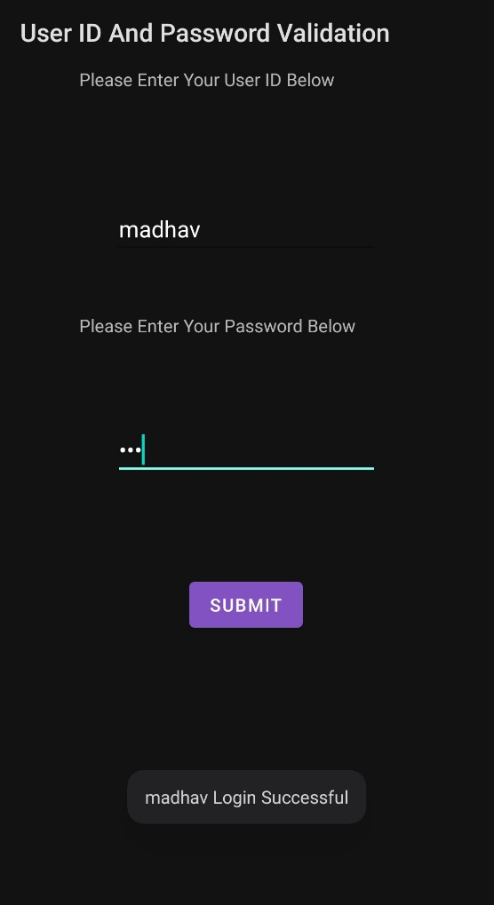

**Failed Login:**

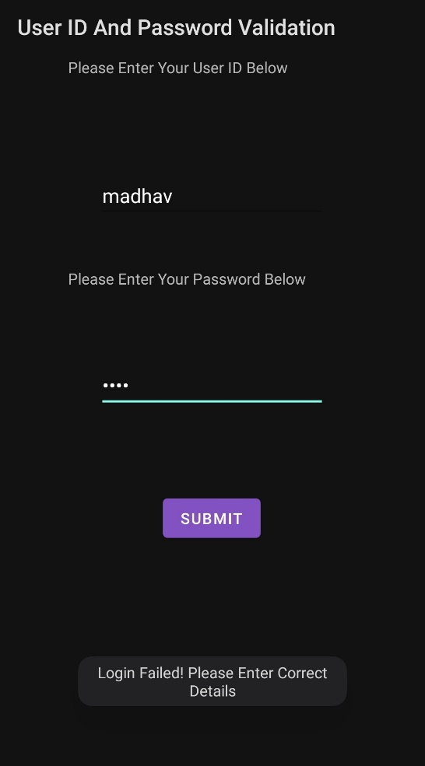

**5. Read two numbers and write a program to add, subtract, multiply and divide.**

**MainActivity.java**

package com.example.buttoncalc;  
  
import androidx.appcompat.app.AppCompatActivity;  
import android.os.Bundle;  
import android.view.View;  
import android.widget.Button;  
import android.widget.EditText;  
import android.widget.TextView;  
public class MainActivity extends AppCompatActivity {  
 TextView t3;  
 EditText t1,t2;  
 Button b1,b2,b3,b4;  
 @Override  
 protected void onCreate(Bundle savedInstanceState) {  
 super.onCreate(savedInstanceState);  
 setContentView(R.layout.*activity_main*);  
 t1=findViewById(R.id.*t1*);  
 t2=findViewById(R.id.*t2*);  
 t3=findViewById(R.id.*t3*);  
 b1=findViewById(R.id.*b1*);  
 b2=findViewById(R.id.*b2*);  
 b3=findViewById(R.id.*b3*);  
 b4=findViewById(R.id.*b4*);  
 b1.setOnClickListener(new View.OnClickListener() {  
 @Override  
 public void onClick(View v) {  
 int a=Integer.*parseInt*(t1.getText().toString());  
 int b=Integer.*parseInt*(t2.getText().toString());  
 int c=a+b;  
 t3.setText(String.*valueOf*(c));  
 }  
 });  
 b2.setOnClickListener(new View.OnClickListener() {  
 @Override  
 public void onClick(View v) {  
 int a=Integer.*parseInt*(t1.getText().toString());  
 int b=Integer.*parseInt*(t2.getText().toString());  
 int c=a-b;  
 t3.setText(String.*valueOf*(c));  
 }  
 });  
 b3.setOnClickListener(new View.OnClickListener() {  
 @Override  
 public void onClick(View v) {  
 int a=Integer.*parseInt*(t1.getText().toString());  
 int b=Integer.*parseInt*(t2.getText().toString());  
 int c=a*b;  
 t3.setText(String.*valueOf*(c));  
 }  
 });  
 b4.setOnClickListener(new View.OnClickListener() {  
 @Override  
 public void onClick(View v) {  
 int a=Integer.*parseInt*(t1.getText().toString());  
 int b=Integer.*parseInt*(t2.getText().toString());  
 int c=a/b;  
 t3.setText(String.*valueOf*(c));  
 }  
 });  
 }  
}

**activity_main.xml**

<?xml version="1.0" encoding="utf-8"?>  
<androidx.constraintlayout.widget.ConstraintLayout xmlns:android="http://schemas.android.com/apk/res/android"  
 xmlns:app="http://schemas.android.com/apk/res-auto"  
 xmlns:tools="http://schemas.android.com/tools"  
 android:layout_width="match_parent"  
 android:layout_height="match_parent"  
 tools:context=".MainActivity">  
  
 <EditText  
 android:id="@+id/t2"  
 android:layout_width="wrap_content"  
 android:layout_height="wrap_content"  
 android:layout_marginTop="40dp"  
 android:ems="10"  
 android:hint="Please Enter 2nd Number"  
 android:inputType="number"  
 app:layout_constraintEnd_toEndOf="parent"  
 app:layout_constraintHorizontal_bias="0.447"  
 app:layout_constraintStart_toStartOf="parent"  
 app:layout_constraintTop_toBottomOf="@+id/t1" />  
  
 <EditText  
 android:id="@+id/t1"  
 android:layout_width="wrap_content"  
 android:layout_height="wrap_content"  
 android:layout_marginTop="112dp"  
 android:ems="10"  
 android:hint="Please Enter 1st Number"  
 android:inputType="number"  
 app:layout_constraintEnd_toEndOf="parent"  
 app:layout_constraintHorizontal_bias="0.447"  
 app:layout_constraintStart_toStartOf="parent"  
 app:layout_constraintTop_toTopOf="parent" />  
  
 <Button  
 android:id="@+id/b1"  
 android:layout_width="wrap_content"  
 android:layout_height="wrap_content"  
 android:layout_marginStart="48dp"  
 android:layout_marginTop="76dp"  
 android:text="ADD"  
 app:layout_constraintStart_toStartOf="parent"  
 app:layout_constraintTop_toBottomOf="@+id/t2" />  
  
 <Button  
 android:id="@+id/b2"  
 android:layout_width="wrap_content"  
 android:layout_height="wrap_content"  
 android:layout_marginStart="64dp"  
 android:layout_marginTop="76dp"  
 android:text="SUB"  
 app:layout_constraintEnd_toEndOf="parent"  
 app:layout_constraintStart_toEndOf="@+id/b1"  
 app:layout_constraintTop_toBottomOf="@+id/t2" />  
  
 <Button  
 android:id="@+id/b3"  
 android:layout_width="wrap_content"  
 android:layout_height="wrap_content"  
 android:layout_marginStart="48dp"  
 android:layout_marginTop="40dp"  
 android:text="MUL"  
 app:layout_constraintStart_toStartOf="parent"  
 app:layout_constraintTop_toBottomOf="@+id/b1" />  
  
 <Button  
 android:id="@+id/b4"  
 android:layout_width="wrap_content"  
 android:layout_height="wrap_content"  
 android:layout_marginStart="64dp"  
 android:layout_marginTop="40dp"  
 android:text="DIV"  
 app:layout_constraintEnd_toEndOf="parent"  
 app:layout_constraintStart_toEndOf="@+id/b3"  
 app:layout_constraintTop_toBottomOf="@+id/b2" />  
  
 <TextView  
 android:id="@+id/t3"  
 android:layout_width="231dp"  
 android:layout_height="81dp"  
 android:layout_marginTop="248dp"  
 android:text="Result"  
 app:layout_constraintEnd_toEndOf="parent"  
 app:layout_constraintHorizontal_bias="0.444"  
 app:layout_constraintStart_toStartOf="parent"  
 app:layout_constraintTop_toBottomOf="@+id/t2" />  
</androidx.constraintlayout.widget.ConstraintLayout>

**Output:**

**Initial Screen**

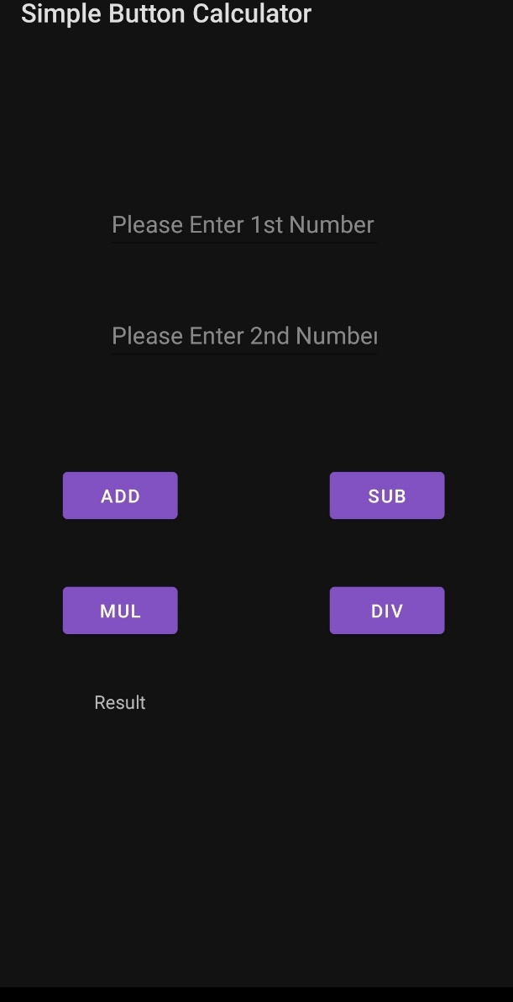

**Entering Two Numbers:**

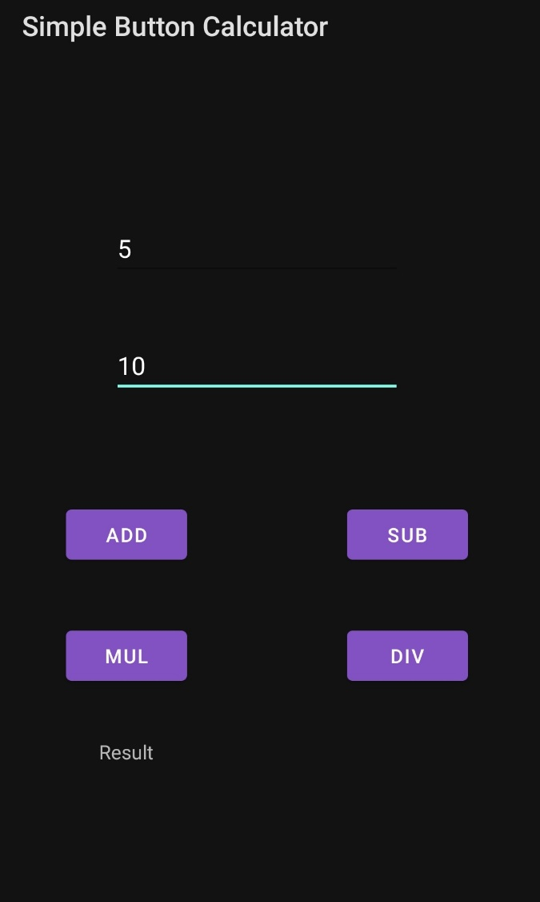

**Adding Two Numbers:**

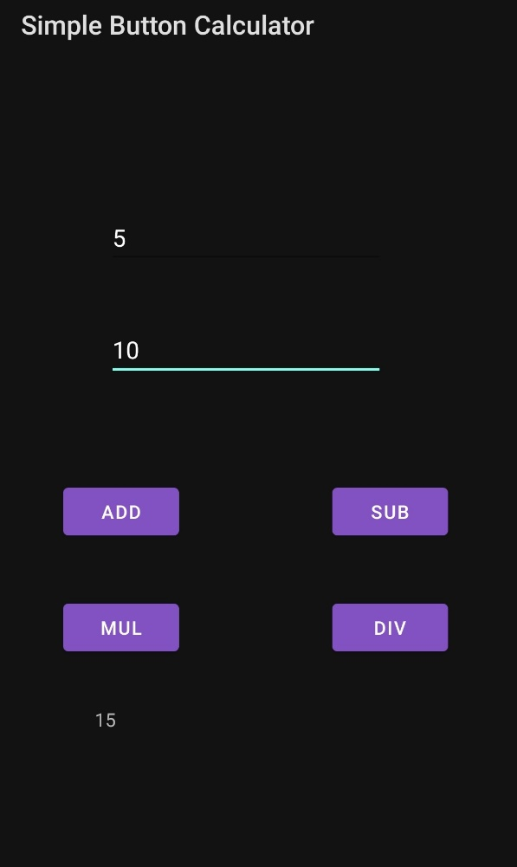

**Subtracting Two Numbers:**

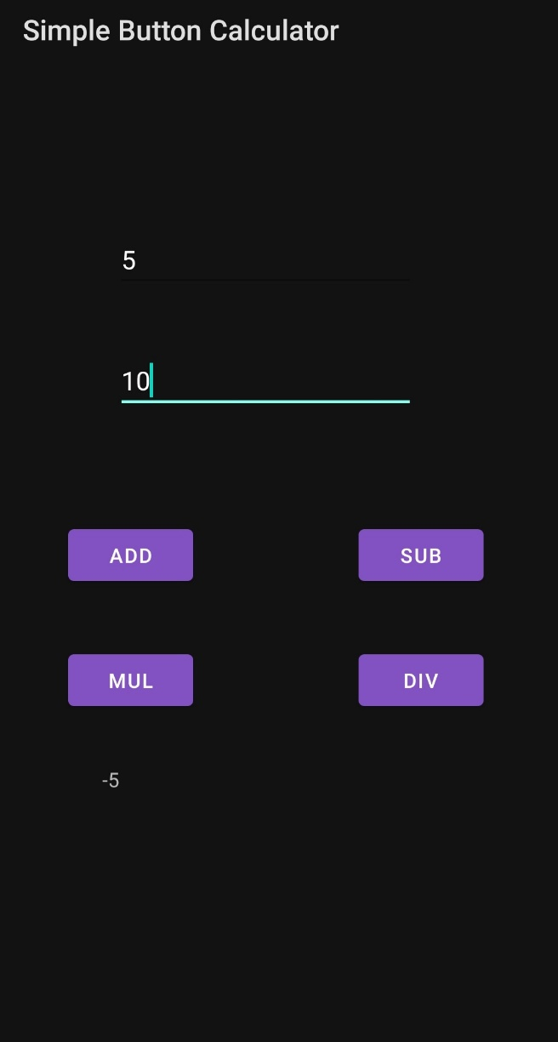

**Multiplication of Two Numbers:**

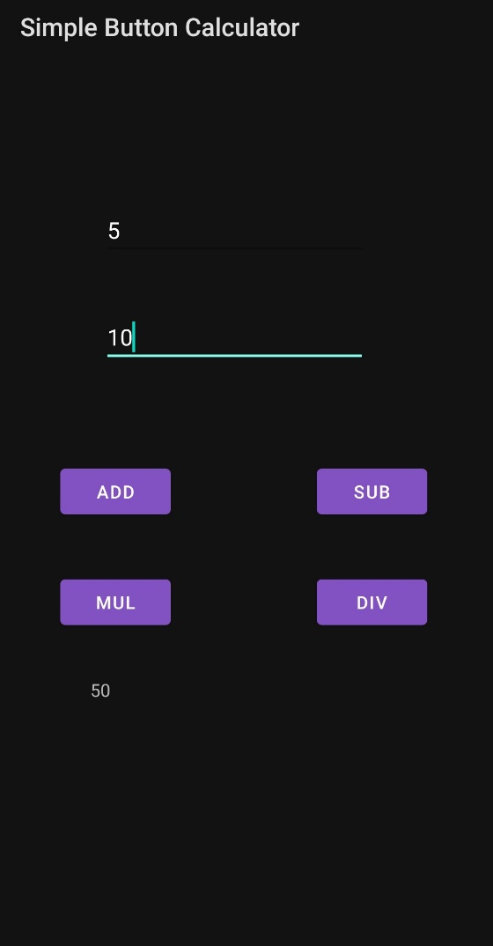

**Division of Two Numbers:**

