**NAME: GVS SAI MADHAV**

**REG.NO: 19BCN7228**

**LAB-TEST:**

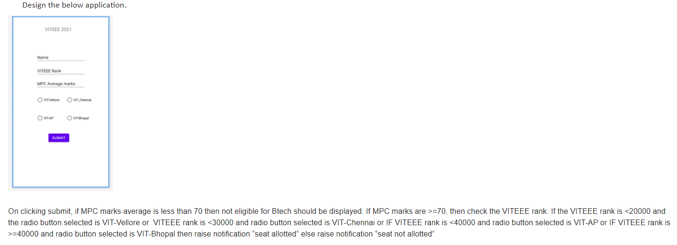

**activity_main.xml:**

<?xml version="1.0" encoding="utf-8"?>  
<androidx.constraintlayout.widget.ConstraintLayout xmlns:android="http://schemas.android.com/apk/res/android"  
 xmlns:app="http://schemas.android.com/apk/res-auto"  
 xmlns:tools="http://schemas.android.com/tools"  
 android:layout_width="match_parent"  
 android:layout_height="match_parent"  
 tools:context=".MainActivity">  
  
 <TextView  
 android:id="@+id/t0"  
 android:layout_width="108dp"  
 android:layout_height="16dp"  
 android:text="VITEEE 2021"  
 app:layout_constraintBottom_toBottomOf="parent"  
 app:layout_constraintEnd_toEndOf="parent"  
 app:layout_constraintHorizontal_bias="0.462"  
 app:layout_constraintLeft_toLeftOf="parent"  
 app:layout_constraintRight_toRightOf="parent"  
 app:layout_constraintStart_toStartOf="parent"  
 app:layout_constraintTop_toTopOf="parent"  
 app:layout_constraintVertical_bias="0.048" />  
  
 <EditText  
 android:id="@+id/t1"  
 android:layout_width="wrap_content"  
 android:layout_height="wrap_content"  
 android:layout_marginTop="72dp"  
 android:ems="10"  
 android:hint="Name"  
 android:inputType="textPersonName"  
 app:layout_constraintEnd_toEndOf="parent"  
 app:layout_constraintHorizontal_bias="0.497"  
 app:layout_constraintStart_toStartOf="parent"  
 app:layout_constraintTop_toBottomOf="@+id/t0" />  
  
 <EditText  
 android:id="@+id/t2"  
 android:layout_width="wrap_content"  
 android:layout_height="wrap_content"  
 android:layout_marginTop="24dp"  
 android:ems="10"  
 android:hint="VITEEE Rank"  
 android:inputType="number"  
 app:layout_constraintEnd_toEndOf="parent"  
 app:layout_constraintHorizontal_bias="0.497"  
 app:layout_constraintStart_toStartOf="parent"  
 app:layout_constraintTop_toBottomOf="@+id/t1" />  
  
 <EditText  
 android:id="@+id/t3"  
 android:layout_width="wrap_content"  
 android:layout_height="wrap_content"  
 android:layout_marginTop="20dp"  
 android:ems="10"  
 android:hint="MPC Average Marks"  
 android:inputType="number"  
 app:layout_constraintEnd_toEndOf="parent"  
 app:layout_constraintHorizontal_bias="0.497"  
 app:layout_constraintStart_toStartOf="parent"  
 app:layout_constraintTop_toBottomOf="@+id/t2" />  
  
 <RadioGroup  
 android:id="@+id/rg"  
 android:layout_width="317dp"  
 android:layout_height="195dp"  
 android:layout_marginTop="12dp"  
 app:layout_constraintEnd_toEndOf="parent"  
 app:layout_constraintStart_toStartOf="parent"  
 app:layout_constraintTop_toBottomOf="@+id/t3">  
  
 <RadioButton  
 android:id="@+id/r1"  
 android:layout_width="123dp"  
 android:layout_height="wrap_content"  
 android:text="VIT_Vellore" />  
  
 <RadioButton  
 android:id="@+id/r2"  
 android:layout_width="123dp"  
 android:layout_height="wrap_content"  
 android:text="VIT_Chennai" />  
  
 <RadioButton  
 android:id="@+id/r3"  
 android:layout_width="123dp"  
 android:layout_height="wrap_content"  
 android:text="VIT-AP" />  
  
 <RadioButton  
 android:id="@+id/r4"  
 android:layout_width="123dp"  
 android:layout_height="wrap_content"  
 android:text="VIT_Bhopal" />  
 </RadioGroup>  
  
 <Button  
 android:id="@+id/b1"  
 android:layout_width="wrap_content"  
 android:layout_height="wrap_content"  
 android:layout_marginTop="4dp"  
 android:text="Check"  
 app:layout_constraintEnd_toEndOf="parent"  
 app:layout_constraintHorizontal_bias="0.485"  
 app:layout_constraintStart_toStartOf="parent"  
 app:layout_constraintTop_toBottomOf="@+id/rg" />  
  
</androidx.constraintlayout.widget.ConstraintLayout>

**check.java:**

package com.example.madhav;  
  
 import androidx.appcompat.app.AppCompatActivity;  
  
 import android.os.Bundle;  
 import android.text.Editable;  
 import android.view.View;  
 import android.widget.Button;  
 import android.widget.EditText;  
 import android.widget.LinearLayout;  
 import android.widget.RadioButton;  
 import android.widget.Toast;  
  
public class check extends AppCompatActivity {  
EditText t1,t2,t3;  
RadioGroup rg;  
RadioButton r1,r2,r3,r4;  
Button b1;  
TextView t0;  
String op;

@Override  
 protected void onCreate(Bundle savedInstanceState) {  
 super.onCreate(savedInstanceState);  
 setContentView(R.layout.activity_check);  
  
 t1 = findViewById(R.id.t1);  
 t2 = findViewById(R.id.t2);  
 t3 = findViewById(R.id.t3);  
 b1 = findViewById(R.id.b1);  
 l = findViewById(R.id.visi);  
 r1 = findViewById(R.id.r1);  
 r2 = findViewById(R.id.r2);  
 r3 = findViewById(R.id.r3);  
 r4 = findViewById(R.id.r4);  
  
 String a = marks.getText().toString();  
 String b = rank.getText().toString();  
  
 if(70 <= Integer.*parseInt*(a) ){  
 l.setVisibility(View.*VISIBLE*);  
 }  
 else  
 l.setVisibility(View.*INVISIBLE*);  
  
 submit.setOnClickListener(new View.OnClickListener() {  
 @Override  
 public void onClick(View view) {  
 if(Integer.*parseInt*(a) >= 70){  
 if(Integer.*parseInt*(b) <20000)  
 if(b1.isChecked())  
 Toast.makeText(getApplicationContext(),"seat alloted", Toast.LENGTH_SHORT).show();  
  
 if(20000<= Integer.*parseInt*(b) && Integer.*parseInt*(b) <30000)  
 if(b2.isChecked())  
 Toast.makeText(getApplicationContext(),"seat alloted", Toast.LENGTH_SHORT).show();  
  
 if(30000<= Integer.*parseInt*(b) && Integer.*parseInt*(b) <40000)  
 if(b3.isChecked())  
 Toast.makeText(getApplicationContext(),"seat alloted", Toast.LENGTH_SHORT).show();  
  
 if(Integer.*parseInt*(b) >=40000)  
 if(b4.isChecked())  
 Toast.makeText(getApplicationContext(),"seat alloted", Toast.LENGTH_SHORT).show();  
 }  
 else  
 Toast.makeText(getApplicationContext(),"seat not alloted sorry",Toast.LENGTH_SHORT).show();  
 }  
 });  
  
  
 }  
}

**Output:**

