**Instructions:**

* Fill your Name and REGNO.
* Complete all the programs, add the code java and XML, input and output Screenshots after the question on the same document.
* Save this File name with your **registerno**_**lab2**

**eg 18ABC1234_LAB2.doc**

* Upload it in assignment ->LAB2 in MS TEAM

Lab2:

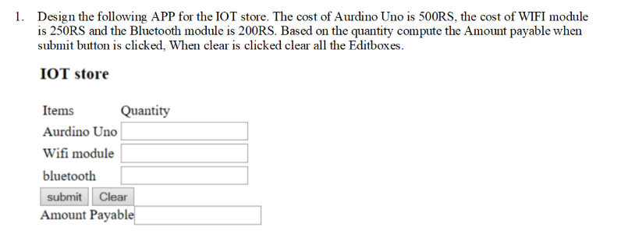

**MainActivity.java:**

package com.example.ardcalc;  
  
import androidx.appcompat.app.AppCompatActivity;  
import android.widget.Button;  
import android.widget.EditText;  
import android.widget.TextView;  
import android.widget.Toast;  
import android.os.Bundle;  
import android.view.View;  
  
public class MainActivity extends AppCompatActivity {  
 TextView t1,t2,t3,t4,t5,t6;  
 EditText t7,t8,t9,t10;  
 Button b1,b2;  
  
 @Override  
 protected void onCreate(Bundle savedInstanceState) {  
 super.onCreate(savedInstanceState);  
 setContentView(R.layout.*activity_main*);  
 /*t1=findViewById(R.id.t1);  
 t2=findViewById(R.id.t2);  
 t3=findViewById(R.id.t3);  
 t4=findViewById(R.id.t4);  
 t5=findViewById(R.id.t5);  
 t6=findViewById(R.id.t6);*/  
 t7=findViewById(R.id.*t7*);  
 t8=findViewById(R.id.*t8*);  
 t9=findViewById(R.id.*t9*);  
 t10=findViewById(R.id.*t10*);  
 b1=findViewById(R.id.*b1*);  
 b2=findViewById(R.id.*b2*);  
 b1.setOnClickListener(new View.OnClickListener() {  
 @Override  
 public void onClick(View v) {  
 int a=Integer.*parseInt*(t7.getText().toString());  
 int b=Integer.*parseInt*(t8.getText().toString());  
 int c=Integer.*parseInt*(t9.getText().toString());  
 int d= (500*a)+(250*b)+(200*c);  
 t10.setText(String.*valueOf*(d));  
 }  
 });  
 b2.setOnClickListener(new View.OnClickListener() {  
 @Override  
 public void onClick(View v) {  
 t7.setText("");  
 t8.setText("");  
 t9.setText("");  
 t10.setText("");  
 }  
 });  
  
 }  
}

**activity_main.xml:**

<?xml version="1.0" encoding="utf-8"?>  
<androidx.constraintlayout.widget.ConstraintLayout xmlns:android="http://schemas.android.com/apk/res/android"  
 xmlns:app="http://schemas.android.com/apk/res-auto"  
 xmlns:tools="http://schemas.android.com/tools"  
 android:layout_width="match_parent"  
 android:layout_height="match_parent"  
 tools:context=".MainActivity"  
 tools:layout_editor_absoluteX="-23dp"  
 tools:layout_editor_absoluteY="-5dp">  
  
 <EditText  
 android:id="@+id/t9"  
 android:layout_width="wrap_content"  
 android:layout_height="wrap_content"  
 android:layout_marginEnd="50dp"  
 android:ems="10"  
 android:hint="Quantity"  
 android:inputType="number"  
 app:layout_constraintEnd_toEndOf="parent"  
 app:layout_constraintStart_toEndOf="@+id/t5"  
 app:layout_constraintTop_toTopOf="@+id/t5" />  
  
 <EditText  
 android:id="@+id/t8"  
 android:layout_width="0dp"  
 android:layout_height="41dp"  
 android:layout_marginTop="66dp"  
 android:layout_marginEnd="51dp"  
 android:layout_marginBottom="67dp"  
 android:ems="10"  
 android:hint="Quantity"  
 android:inputType="number"  
 app:layout_constraintBottom_toBottomOf="@+id/t9"  
 app:layout_constraintEnd_toEndOf="parent"  
 app:layout_constraintStart_toEndOf="@+id/t4"  
 app:layout_constraintTop_toTopOf="@+id/t7"  
 app:layout_constraintVertical_bias="1.0" />  
  
 <TextView  
 android:id="@+id/t1"  
 android:layout_width="0dp"  
 android:layout_height="46dp"  
 android:layout_marginStart="4dp"  
 android:layout_marginTop="36dp"  
 android:layout_marginEnd="50dp"  
 android:text="Items"  
 app:layout_constraintEnd_toStartOf="@+id/t2"  
 app:layout_constraintStart_toStartOf="parent"  
 app:layout_constraintTop_toTopOf="parent" />  
  
 <TextView  
 android:id="@+id/t2"  
 android:layout_width="0dp"  
 android:layout_height="0dp"  
 android:layout_marginTop="2dp"  
 android:layout_marginEnd="102dp"  
 android:layout_marginBottom="2dp"  
 android:text="Quantity"  
 app:layout_constraintBottom_toBottomOf="@+id/t1"  
 app:layout_constraintEnd_toEndOf="parent"  
 app:layout_constraintStart_toEndOf="@+id/t1"  
 app:layout_constraintTop_toTopOf="@+id/t1" />  
  
 <TextView  
 android:id="@+id/t3"  
 android:layout_width="0dp"  
 android:layout_height="50dp"  
 android:layout_marginStart="8dp"  
 android:layout_marginTop="18dp"  
 android:layout_marginEnd="6dp"  
 android:layout_marginBottom="18dp"  
 android:text="Arduino Uno"  
 app:layout_constraintBottom_toTopOf="@+id/t8"  
 app:layout_constraintEnd_toStartOf="@+id/t7"  
 app:layout_constraintStart_toStartOf="parent"  
 app:layout_constraintTop_toBottomOf="@+id/t2" />  
  
 <TextView  
 android:id="@+id/t4"  
 android:layout_width="138dp"  
 android:layout_height="42dp"  
 android:layout_marginStart="8dp"  
 android:layout_marginTop="62dp"  
 android:layout_marginEnd="11dp"  
 android:layout_marginBottom="64dp"  
 android:text="Wifi Module"  
 app:layout_constraintBottom_toBottomOf="@+id/t5"  
 app:layout_constraintEnd_toStartOf="@+id/t8"  
 app:layout_constraintStart_toStartOf="parent"  
 app:layout_constraintTop_toTopOf="@+id/t3" />  
  
 <TextView  
 android:id="@+id/t5"  
 android:layout_width="143dp"  
 android:layout_height="43dp"  
 android:layout_marginStart="7dp"  
 android:layout_marginTop="84dp"  
 android:layout_marginEnd="8dp"  
 android:layout_marginBottom="83dp"  
 android:text="Bluetooth"  
 app:layout_constraintBottom_toTopOf="@+id/t6"  
 app:layout_constraintEnd_toStartOf="@+id/t9"  
 app:layout_constraintStart_toStartOf="parent"  
 app:layout_constraintTop_toBottomOf="@+id/t7" />  
  
 <Button  
 android:id="@+id/b1"  
 android:layout_width="wrap_content"  
 android:layout_height="wrap_content"  
 android:layout_marginBottom="8dp"  
 android:text="SUBMIT"  
 app:layout_constraintBottom_toTopOf="@+id/t6"  
 app:layout_constraintEnd_toEndOf="@+id/t6" />  
  
 <Button  
 android:id="@+id/b2"  
 android:layout_width="wrap_content"  
 android:layout_height="wrap_content"  
 android:layout_marginStart="37dp"  
 android:layout_marginBottom="8dp"  
 android:text="Clear"  
 app:layout_constraintBottom_toTopOf="@+id/t10"  
 app:layout_constraintStart_toStartOf="@+id/t10" />  
  
 <TextView  
 android:id="@+id/t6"  
 android:layout_width="0dp"  
 android:layout_height="43dp"  
 android:layout_marginEnd="43dp"  
 android:text="Amount Payable"  
 app:layout_constraintBottom_toBottomOf="parent"  
 app:layout_constraintEnd_toStartOf="@+id/t10"  
 app:layout_constraintStart_toStartOf="parent"  
 app:layout_constraintTop_toTopOf="parent" />  
  
 <EditText  
 android:id="@+id/t10"  
 android:layout_width="wrap_content"  
 android:layout_height="wrap_content"  
 android:layout_marginEnd="31dp"  
 android:ems="10"  
 android:hint="Cost"  
 android:inputType="number"  
 app:layout_constraintEnd_toEndOf="parent"  
 app:layout_constraintStart_toEndOf="@+id/t6"  
 app:layout_constraintTop_toTopOf="@+id/t6" />  
  
 <EditText  
 android:id="@+id/t7"  
 android:layout_width="wrap_content"  
 android:layout_height="wrap_content"  
 android:layout_marginTop="12dp"  
 android:layout_marginEnd="50dp"  
 android:ems="10"  
 android:hint="Quantity"  
 android:inputType="number"  
 app:layout_constraintEnd_toEndOf="parent"  
 app:layout_constraintStart_toEndOf="@+id/t3"  
 app:layout_constraintTop_toBottomOf="@+id/t1" />  
  
</androidx.constraintlayout.widget.ConstraintLayout>

**Output:**

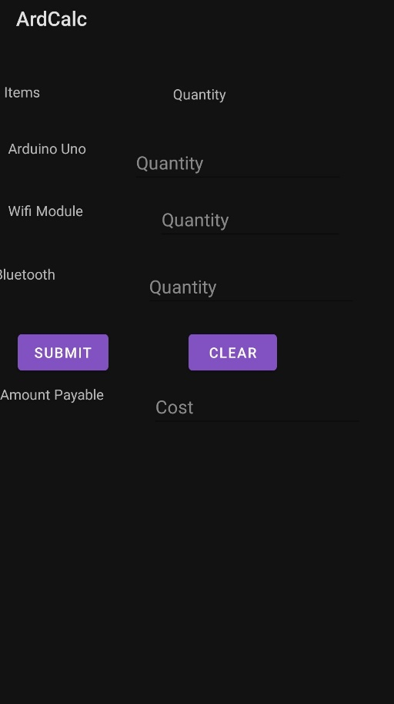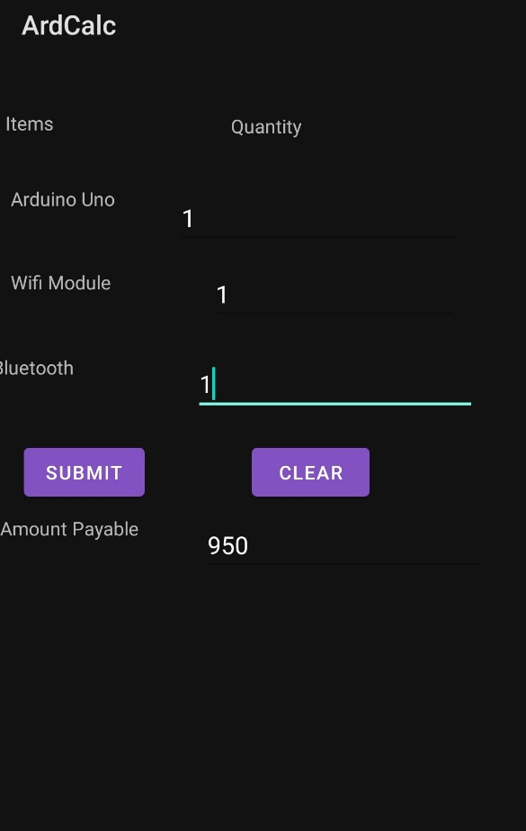

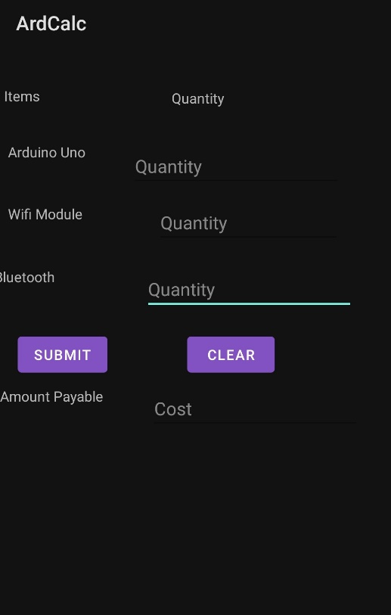

**Q2: Currency Converter:**

**MainActivity.java**

package com.example.currconv;  
import androidx.appcompat.app.AppCompatActivity;  
import android.os.Bundle; import  
 android.view.View; import  
 android.widget.Button; import  
 android.widget.EditText;  
import android.widget.RadioButton;  
import android.widget.RadioGroup;  
import android.widget.TextView;  
  
public class MainActivity extends AppCompatActivity {  
 EditText t1;  
 TextView t2;  
 RadioGroup rg;  
 RadioButton r1;  
 Button b1;  
 String op;  
 double res;  
 String result;  
 int n = 0;  
 @Override  
 protected void onCreate(Bundle savedInstanceState) {  
 super.onCreate(savedInstanceState);  
 setContentView(R.layout.*activity_main*);  
 rg = findViewById(R.id.*RG1*);  
 t1 = findViewById(R.id.*T1*);  
 t2 = findViewById(R.id.*T2*);  
 b1 = findViewById(R.id.*B1*);  
  
 rg.setOnCheckedChangeListener(new RadioGroup.OnCheckedChangeListener()  
 {  
 @Override  
 public void onCheckedChanged(RadioGroup group, int checkedId) {  
 int i = rg.getCheckedRadioButtonId();  
 r1 = findViewById(i);  
 op = r1.getText().toString();  
 }  
 });  
  
 b1.setOnClickListener(new View.OnClickListener() {  
 @Override  
 public void onClick(View v) {  
 if (op.equals("USD")) {  
 n = Integer.*parseInt*(t1.getText().toString());  
 res = (double)n * 0.014;  
 }  
 else if (op.equals("EURO")) {  
 n =Integer.*parseInt*(t1.getText().toString());  
 res = (double)n * 0.011;  
 }  
 else if (op.equals("YEN")) {  
 n =Integer.*parseInt*(t1.getText().toString());  
 res = (double)n * 1.45;  
 }  
 result = Double.*toString*(res);  
 t2.setText(result);  
 }  
 });  
 }  
}

**activity_main.xml:**

<?xml version="1.0" encoding="utf-8"?>  
<androidx.constraintlayout.widget.ConstraintLayout  
 xmlns:android="http://schemas.android.com/apk/res/android"  
 xmlns:app="http://schemas.android.com/apk/res-auto"  
 xmlns:tools="http://schemas.android.com/tools"  
 android:layout_width="match_parent"  
 android:layout_height="match_parent"  
 tools:context=".MainActivity">  
  
 <TextView  
 android:id="@+id/textView"  
 android:layout_width="wrap_content"  
 android:layout_height="wrap_content"  
 android:layout_marginTop="73dp"  
 android:maxLines="2"  
 android:text="CURRENCY\nCONVERTER"  
 android:textColor="#4CAF50"  
 android:textSize="36sp"  
 android:textStyle="bold"  
 app:layout_constraintEnd_toEndOf="parent"  
 app:layout_constraintStart_toStartOf="parent"  
 app:layout_constraintTop_toTopOf="parent" />  
  
 <RadioGroup  
 android:id="@+id/RG1"  
 android:layout_width="wrap_content"  
 android:layout_height="wrap_content"  
 android:layout_marginStart="31dp"  
 android:layout_marginTop="68dp"  
 app:layout_constraintStart_toStartOf="parent"  
 app:layout_constraintTop_toBottomOf="@+id/T1">  
  
 <RadioButton  
 android:id="@+id/RB3"  
 android:layout_width="wrap_content"  
 android:layout_height="wrap_content"  
 android:text="YEN"  
 android:textColor="@color/black"  
 android:textSize="24sp" />  
  
 <RadioButton  
 android:id="@+id/RB1"  
 android:layout_width="wrap_content"  
 android:layout_height="wrap_content"  
 android:text="USD"  
 android:textColor="@color/black"  
 android:textSize="24sp" />  
  
 <RadioButton  
 android:id="@+id/RB2"  
 android:layout_width="wrap_content"  
 android:layout_height="wrap_content"  
 android:text="EURO"  
 android:textColor="@color/black"  
 android:textSize="24sp" />  
 </RadioGroup>  
  
 <Button  
 android:id="@+id/B1"  
 android:layout_width="wrap_content"  
 android:layout_height="wrap_content"  
 android:layout_marginTop="41dp"  
 android:text="CONVERT" android:textSize="24sp"  
 app:backgroundTint="@color/teal_700"  
 app:layout_constraintEnd_toEndOf="parent"  
 app:layout_constraintStart_toStartOf="parent"  
 app:layout_constraintTop_toBottomOf="@+id/RG1" />  
  
 <TextView  
 android:id="@+id/T2"  
 android:layout_width="wrap_content"  
 android:layout_height="wrap_content"  
 android:layout_marginStart="50dp"  
 android:layout_marginBottom="81dp"  
 android:textColor="@color/black"  
 app:layout_constraintBottom_toBottomOf="parent"  
 app:layout_constraintStart_toStartOf="@+id/B1" />  
  
 <EditText  
 android:id="@+id/T1"  
 android:layout_width="wrap_content"  
 android:layout_height="wrap_content"  
 android:layout_marginTop="47dp"  
 android:layout_marginEnd="3dp"  
 android:ems="10"  
 android:hint="in RS" android:inputType="textPersonName"  
 app:layout_constraintEnd_toEndOf="@+id/textView"  
 app:layout_constraintTop_toBottomOf="@+id/textView" />  
</androidx.constraintlayout.widget.ConstraintLayout>

**Output:**

