**Instructions:**

* Fill your Name and REGNO.
* Complete the program, add the code java and XML, input and output Screenshots after the question on the same document.
* Save this File name with your **registerno**_**lab3**

**eg 18ABC1234_LAB3.doc**

* Upload it in assignment ->LAB3 in MS TEAM

Lab3:

1. Design a Calculator App.

**MainActivity.java**

package com.example.calculator;  
import androidx.appcompat.app.AppCompatActivity; import android.os.Bundle;  
import android.view.View;  
import android.widget.Button; import android.widget.TextView;  
public class MainActivity extends AppCompatActivity  
{  
 TextView t1;  
 Button b0,b1,b2,b3,b4,b5,b6,b7,b8,b9,ba,bs,bd,bm,bc,be;  
 int res = 0, temp = 0;  
 String t,r,op;  
 @Override  
 protected void onCreate(Bundle savedInstanceState)  
 {  
 super.onCreate(savedInstanceState);  
 setContentView(R.layout.*activity_main*);  
 t1 = findViewById(R.id.*T1*);  
 b0 = findViewById(R.id.*B0*);  
 b1 = findViewById(R.id.*B1*);  
 b2 = findViewById(R.id.*B2*);  
 b3 = findViewById(R.id.*B3*);  
 b4 = findViewById(R.id.*B4*);  
 b5 = findViewById(R.id.*B5*);  
 b6 = findViewById(R.id.*B6*);  
 b7 = findViewById(R.id.*B7*);  
 b8 = findViewById(R.id.*B8*);  
 b9 = findViewById(R.id.*B9*);  
 ba = findViewById(R.id.*BA*);  
 bs = findViewById(R.id.*BS*);  
 bd = findViewById(R.id.*BD*);  
 bm = findViewById(R.id.*BM*);  
 bc = findViewById(R.id.*BC*);  
 be = findViewById(R.id.*BE*);  
 b0.setOnClickListener(new View.OnClickListener()  
 {  
 @Override  
 public void onClick(View v)  
 {  
 t = t1.getText().toString();  
 r = t + "0";  
 t1.setText(r);  
 }  
 });  
 b1.setOnClickListener(new View.OnClickListener()  
 {  
 @Override  
 public void onClick(View v)  
 {  
 t = t1.getText().toString();  
 r = t + "1";  
 t1.setText(r);  
 }  
 });  
 b2.setOnClickListener(new View.OnClickListener()  
 {  
 @Override  
 public void onClick(View v)  
 {  
 t = t1.getText().toString();  
 r = t + "2";  
 t1.setText(r);  
 }  
 });  
 b3.setOnClickListener(new View.OnClickListener()  
 {  
 @Override  
 public void onClick(View v)  
 {  
 t = t1.getText().toString();  
 r = t + "3";  
 t1.setText(r);  
 }  
 });  
 b4.setOnClickListener(new View.OnClickListener()  
 {  
 @Override  
 public void onClick(View v)  
 {  
 t = t1.getText().toString();  
 r = t + "4";  
 t1.setText(r);  
 }  
 });  
 b5.setOnClickListener(new View.OnClickListener()  
 {  
 @Override  
 public void onClick(View v)  
 {  
 t = t1.getText().toString();  
 r = t + "5";  
 t1.setText(r);  
 }  
 });  
 b6.setOnClickListener(new View.OnClickListener()  
 {  
 @Override  
 public void onClick(View v)  
 {  
 t = t1.getText().toString();  
 r = t + "6";  
 t1.setText(r);  
 }  
 });  
 b7.setOnClickListener(new View.OnClickListener()  
 {  
 @Override  
 public void onClick(View v)  
 {  
 t = t1.getText().toString();  
 r = t + "7";  
 t1.setText(r);  
 }  
 });  
 b8.setOnClickListener(new View.OnClickListener()  
 {  
 @Override  
 public void onClick(View v)  
 {  
 t = t1.getText().toString();  
 r = t + "8";  
 t1.setText(r);  
 }  
 });  
 b9.setOnClickListener(new View.OnClickListener()  
 {  
 @Override  
 public void onClick(View v)  
 {  
 t = t1.getText().toString();  
 r = t + "9";  
 t1.setText(r);  
 }  
 });  
 ba.setOnClickListener(new View.OnClickListener()  
 {  
 @Override  
 public void onClick(View v)  
 {  
 op = "+";  
 temp = Integer.*parseInt*(t1.getText().toString());  
 t1.setText("");  
 }  
 });  
 bs.setOnClickListener(new View.OnClickListener()  
 {  
 @Override  
 public void onClick(View v)  
 {  
 op = "-";  
 temp = Integer.*parseInt*(t1.getText().toString());  
 t1.setText("");  
 }  
 });  
 bd.setOnClickListener(new View.OnClickListener()  
 {  
 @Override  
 public void onClick(View v)  
 {  
 op = "/";  
 temp = Integer.*parseInt*(t1.getText().toString());  
 t1.setText("");  
 }  
 });  
 bm.setOnClickListener(new View.OnClickListener()  
 {  
 @Override  
 public void onClick(View v)  
 {  
 op = "*";  
 temp = Integer.*parseInt*(t1.getText().toString());  
 t1.setText("");  
 }  
 });  
 bc.setOnClickListener(new View.OnClickListener()  
 {  
 @Override  
 public void onClick(View v)  
 {  
 temp = 0;  
 t1.setText("");  
 }  
 });  
 be.setOnClickListener(new View.OnClickListener()  
 {  
 @Override  
 public void onClick(View v)  
 {  
 if (op.equals("+"))  
 {  
 res = temp + Integer.*parseInt*(t1.getText().toString());  
 t1.setText(String.*valueOf*(res));  
 }  
 else if (op.equals("-"))  
 {  
 res = temp - Integer.*parseInt*(t1.getText().toString());  
 t1.setText(String.*valueOf*(res));  
 }  
 else if (op.equals("/"))  
 {  
 res = temp / Integer.*parseInt*(t1.getText().toString());  
 t1.setText(String.*valueOf*(res));  
 }  
 else if (op.equals("*")) {  
 res = temp * Integer.*parseInt*(t1.getText().toString());  
 t1.setText(String.*valueOf*(res));  
 }  
 }  
 });  
 }  
}

**activity_main.xml**

<?xml version="1.0" encoding="utf-8"?>  
<androidx.constraintlayout.widget.ConstraintLayout  
 xmlns:android="http://schemas.android.com/apk/res/android"  
 xmlns:app="http://schemas.android.com/apk/res-auto"  
 xmlns:tools="http://schemas.android.com/tools"  
 android:layout_width="match_parent"  
 android:layout_height="match_parent"  
 tools:context=".MainActivity">  
  
 <TextView  
 android:id="@+id/T1"  
 android:layout_width="347dp"  
 android:layout_height="0dp"  
 android:layout_marginTop="93dp"  
 android:layout_marginBottom="51dp"  
 android:text="Result"  
 android:textAlignment="viewEnd"  
 android:textAppearance="@style/TextAppearance.AppCompat.Medium"  
 android:textSize="30sp"  
 app:layout_constraintBottom_toTopOf="@+id/BA"  
 app:layout_constraintEnd_toEndOf="parent"  
 app:layout_constraintHorizontal_bias="0.421"  
 app:layout_constraintStart_toStartOf="parent"  
 app:layout_constraintTop_toTopOf="parent" />  
 <Button  
 android:id="@+id/B1"  
 android:layout_width="wrap_content"  
 android:layout_height="wrap_content"  
 android:layout_marginStart="1dp"  
 android:layout_marginEnd="2dp"  
 android:text="1"  
 app:layout_constraintBaseline_toBaselineOf="@+id/B2"  
 app:layout_constraintEnd_toStartOf="@+id/B2"  
 app:layout_constraintStart_toStartOf="parent" />  
 <Button  
 android:id="@+id/B2"  
 android:layout_width="wrap_content"  
 android:layout_height="wrap_content"  
 android:layout_marginEnd="3dp"  
 android:text="2"  
 app:layout_constraintEnd_toStartOf="@+id/B3"  
 app:layout_constraintStart_toEndOf="@+id/B1"  
 app:layout_constraintTop_toTopOf="@+id/B3" />  
 <Button  
 android:id="@+id/B3"  
 android:layout_width="wrap_content"  
 android:layout_height="wrap_content"  
 android:layout_marginEnd="3dp"  
 android:text="3"  
 app:layout_constraintBaseline_toBaselineOf="@+id/BA"  
 app:layout_constraintEnd_toStartOf="@+id/BA"  
 app:layout_constraintStart_toEndOf="@+id/B2" />  
 <Button  
 android:id="@+id/BA"  
 android:layout_width="wrap_content"  
 android:layout_height="wrap_content"  
 android:layout_marginBottom="15dp"  
 android:text="+"  
 app:layout_constraintBottom_toTopOf="@+id/BS"  
 app:layout_constraintEnd_toEndOf="parent"  
 app:layout_constraintStart_toEndOf="@+id/B3"  
 app:layout_constraintTop_toBottomOf="@+id/T1" />  
 <Button  
 android:id="@+id/B4"  
 android:layout_width="wrap_content"  
 android:layout_height="wrap_content"  
 android:layout_marginEnd="3dp"  
 android:text="4"  
 app:layout_constraintBaseline_toBaselineOf="@+id/B5"  
 app:layout_constraintEnd_toStartOf="@+id/B5"  
 app:layout_constraintStart_toStartOf="parent" />  
 <Button  
 android:id="@+id/B5"  
 android:layout_width="wrap_content"  
 android:layout_height="wrap_content"  
 android:layout_marginEnd="3dp"  
 android:layout_marginBottom="2dp"  
 android:text="5"  
 app:layout_constraintBottom_toBottomOf="@+id/B6"  
 app:layout_constraintEnd_toStartOf="@+id/B6"  
 app:layout_constraintStart_toEndOf="@+id/B4" />  
 <Button  
 android:id="@+id/B6"  
 android:layout_width="wrap_content"  
 android:layout_height="wrap_content"  
 android:layout_marginEnd="3dp"  
 android:text="6"  
 app:layout_constraintBaseline_toBaselineOf="@+id/BS"  
 app:layout_constraintEnd_toStartOf="@+id/BS"  
 app:layout_constraintStart_toEndOf="@+id/B5" />  
 <Button  
 android:id="@+id/BS"  
 android:layout_width="wrap_content"  
 android:layout_height="wrap_content"  
 android:layout_marginBottom="12dp"  
 android:text="-"  
 app:layout_constraintBottom_toTopOf="@+id/BD"  
 app:layout_constraintEnd_toEndOf="parent"  
 app:layout_constraintStart_toEndOf="@+id/B6"  
 app:layout_constraintTop_toBottomOf="@+id/BA" />  
 <Button  
 android:id="@+id/B7"  
 android:layout_width="wrap_content"  
 android:layout_height="wrap_content"  
 android:layout_marginEnd="3dp"  
 android:text="7"  
 app:layout_constraintBaseline_toBaselineOf="@+id/B8"  
 app:layout_constraintEnd_toStartOf="@+id/B8"  
 app:layout_constraintStart_toStartOf="parent" />  
 <Button  
 android:id="@+id/B8"  
 android:layout_width="wrap_content"  
 android:layout_height="wrap_content"  
 android:layout_marginEnd="3dp"  
 android:text="8"  
 app:layout_constraintEnd_toStartOf="@+id/B9"  
 app:layout_constraintStart_toEndOf="@+id/B7"  
 app:layout_constraintTop_toTopOf="@+id/B9" />  
 <Button  
 android:id="@+id/B9"  
 android:layout_width="wrap_content"  
 android:layout_height="wrap_content"  
 android:layout_marginEnd="3dp"  
 android:text="9"  
 app:layout_constraintBaseline_toBaselineOf="@+id/BD"  
 app:layout_constraintEnd_toStartOf="@+id/BD"  
 app:layout_constraintStart_toEndOf="@+id/B8" />  
 <Button  
 android:id="@+id/BD"  
 android:layout_width="wrap_content"  
 android:layout_height="wrap_content"  
 android:layout_marginBottom="11dp"  
 android:text="/"  
 app:layout_constraintBottom_toTopOf="@+id/BM"  
 app:layout_constraintEnd_toEndOf="parent"  
 app:layout_constraintStart_toEndOf="@+id/B9"  
 app:layout_constraintTop_toBottomOf="@+id/BS" />  
 <Button  
 android:id="@+id/B0"  
 android:layout_width="wrap_content"  
 android:layout_height="wrap_content"  
 android:layout_marginStart="1dp"  
 android:layout_marginTop="12dp"  
 android:layout_marginEnd="4dp"  
 android:text="0"  
 app:layout_constraintEnd_toStartOf="@+id/BC"  
 app:layout_constraintStart_toStartOf="parent"  
 app:layout_constraintTop_toBottomOf="@+id/B7" />  
 <Button  
 android:id="@+id/BC"  
 android:layout_width="wrap_content"  
 android:layout_height="wrap_content"  
 android:layout_marginEnd="5dp"  
 android:text="C"  
 app:layout_constraintBaseline_toBaselineOf="@+id/B0"  
 app:layout_constraintEnd_toStartOf="@+id/BE"  
 app:layout_constraintStart_toEndOf="@+id/B0" />  
 <Button  
 android:id="@+id/BE"  
 android:layout_width="wrap_content"  
 android:layout_height="wrap_content"  
 android:layout_marginTop="1dp"  
 android:layout_marginEnd="4dp"  
 android:text="="  
 app:layout_constraintEnd_toStartOf="@+id/BM"  
 app:layout_constraintStart_toEndOf="@+id/BC"  
 app:layout_constraintTop_toTopOf="@+id/BM" />  
 <Button  
 android:id="@+id/BM"  
 android:layout_width="wrap_content"  
 android:layout_height="wrap_content"  
 android:layout_marginBottom="273dp"  
 android:text="*"  
 app:layout_constraintBottom_toBottomOf="parent"  
 app:layout_constraintEnd_toEndOf="parent"  
 app:layout_constraintStart_toEndOf="@+id/BE"  
 app:layout_constraintTop_toBottomOf="@+id/BD" />  
</androidx.constraintlayout.widget.ConstraintLayout>

**OUTPUT:**

Empty Layout:

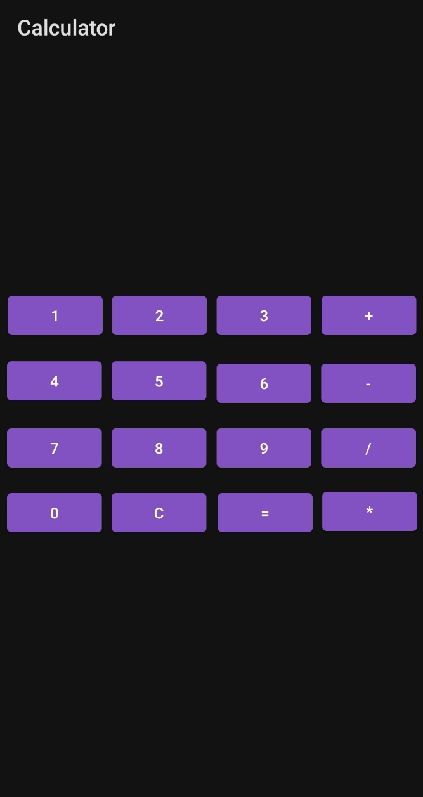

Addition of 1+2:

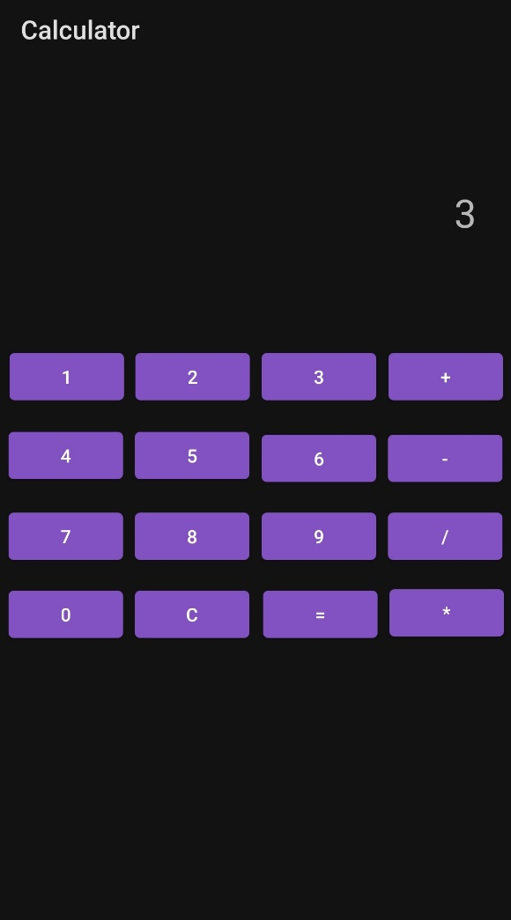

Subtraction Of 10-1:

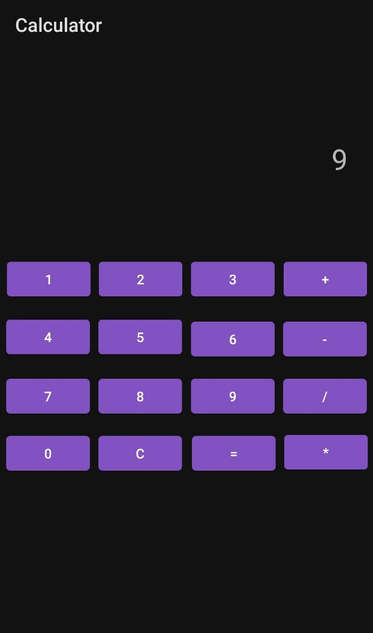

Division of 9/3:

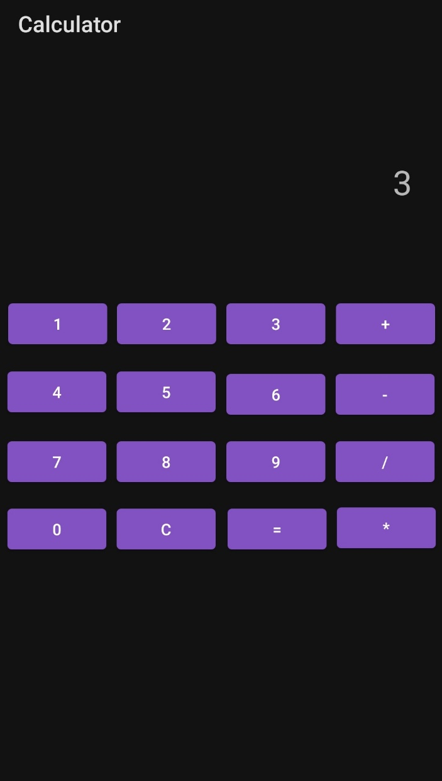

Multiplication of 2*2:

