**Instructions: VIT-AP UNIVERSITY, ANDHRA PRADESH**

**Lab Sheet 4 : INTENTS**

**Academic year:** 2021-2022  **Branch/ Class:** B.Tech

**Semester:** Fall  **Date: 28-10-2021**

**Faculty Name:** Dr.N.Anupama  **School:** SCOPE

**NAME:** GVS SAI MADHAV **REGNO:** 19BCN7228

**\*\*\*\*\*\*\*\*\*\*\*\*\*\*\*\*\*\*\*\*\*\*\*\*\*\*\*\*\*\*\*\*\*\*\*\*\*\*\*\*\*\*\*\*\*\*\*\*\*\*\*\*\*\*\*\*\*\*\*\*\*\*\*\*\*\*\*\*\*\*\*\*\*\*\*\*\*\*\*\*\*\*\*\*\*\*\*\*\*\*\*\*\*\*\*\*\*\*\*\*\*\*\*\*\*\***

* Fill your Name and REGNO.
* Complete the program, add the code java and XML, input and output Screenshots after the question on the same document.
* Save this File name with your **registerno**_**lab4**

**eg 18ABC1234_LAB4.doc**

* Upload it in assignment ->LAB4 in MS TEAM

Design an App that prints 5 random numbers of cards(1 to 13) when select cards button is pressed, on clicking sort button, these numbers need to send to second activity and sort and display. When the reply button is pressed, the sum of the cards need to be returned back to the MainActivity.

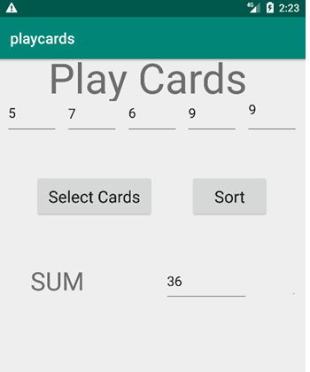 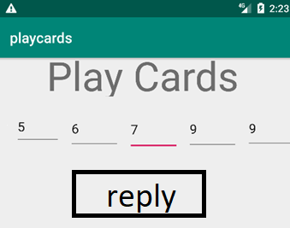

**activity_main.xml:**

<?xml version="1.0" encoding="utf-8"?>  
<androidx.constraintlayout.widget.ConstraintLayout  
 xmlns:android="http://schemas.android.com/apk/res/android"  
 xmlns:app="http://schemas.android.com/apk/res-auto"  
 xmlns:tools="http://schemas.android.com/tools"  
 android:layout_width="match_parent"  
 android:layout_height="match_parent"  
 tools:context=".MainActivity">  
 <EditText  
 android:id="@+id/T5"  
 android:layout_width="0dp"  
 android:layout_height="47dp"  
 android:layout_marginEnd="16dp"  
 android:ems="10"  
 android:inputType="textPersonName"  
 app:layout_constraintBaseline_toBaselineOf="@+id/T4"  
 app:layout_constraintEnd_toEndOf="parent"  
 app:layout_constraintStart_toEndOf="@+id/T4" />  
 <EditText  
 android:id="@+id/T4"  
 android:layout_width="0dp"  
 android:layout_height="0dp"  
 android:layout_marginEnd="9dp"  
 android:ems="10"  
 android:inputType="textPersonName"  
 app:layout_constraintBottom_toBottomOf="@+id/T1"  
 app:layout_constraintEnd_toStartOf="@+id/T5"  
 app:layout_constraintStart_toEndOf="@+id/T3"  
 app:layout_constraintTop_toTopOf="@+id/T1" />  
 <EditText  
 android:id="@+id/T3"  
 android:layout_width="69dp"  
 android:layout_height="48dp"  
 android:layout_marginEnd="10dp"  
 android:ems="10"  
 android:inputType="textPersonName"  
 app:layout_constraintBaseline_toBaselineOf="@+id/T2"  
 app:layout_constraintEnd_toStartOf="@+id/T4"  
 app:layout_constraintStart_toEndOf="@+id/T2" />  
 <EditText  
 android:id="@+id/T2"  
 android:layout_width="0dp"  
 android:layout_height="47dp"  
 android:layout_marginTop="113dp"  
 android:layout_marginEnd="8dp"  
 android:ems="10"  
 android:inputType="textPersonName"  
 app:layout_constraintEnd_toStartOf="@+id/T3"  
 app:layout_constraintStart_toEndOf="@+id/T1"  
 app:layout_constraintTop_toTopOf="parent" />  
 <EditText  
 android:id="@+id/T1"  
 android:layout_width="0dp"  
 android:layout_height="47dp"  
 android:layout_marginStart="16dp"  
 android:layout_marginEnd="7dp"  
 android:ems="10"  
 android:inputType="textPersonName"  
 app:layout_constraintBaseline_toBaselineOf="@+id/T2"  
 app:layout_constraintEnd_toStartOf="@+id/T2"  
 app:layout_constraintStart_toStartOf="parent" />  
 <Button  
 android:id="@+id/B1"  
 android:layout_width="wrap_content"  
 android:layout_height="wrap_content"  
 android:layout_marginStart="45dp"  
 android:layout_marginEnd="44dp"  
 android:text="SELECT CARDS"  
 app:layout_constraintBaseline_toBaselineOf="@+id/B2"  
 app:layout_constraintEnd_toStartOf="@+id/T4"  
 app:layout_constraintStart_toStartOf="@+id/T1" />  
 <Button  
 android:id="@+id/B2"  
 android:layout_width="wrap_content"  
 android:layout_height="wrap_content"  
 android:layout_marginStart="26dp"  
 android:layout_marginTop="101dp"  
 android:layout_marginBottom="101dp"  
 android:text="SORT"  
 app:layout_constraintBottom_toTopOf="@+id/T6"  
 app:layout_constraintStart_toEndOf="@+id/B1"  
 app:layout_constraintTop_toBottomOf="@+id/T3" />  
 <TextView  
 android:id="@+id/T6"  
 android:layout_width="wrap_content"  
 android:layout_height="wrap_content"  
 android:layout_marginEnd="33dp"  
 android:text=" SUM "  
 android:textColor="@color/black"  
 android:textSize="24sp"  
 app:layout_constraintBottom_toBottomOf="@+id/T7"  
 app:layout_constraintEnd_toStartOf="@+id/T7" />  
 <EditText  
 android:id="@+id/T7"  
 android:layout_width="wrap_content"  
 android:layout_height="wrap_content"  
 android:layout_marginEnd="40dp"  
 android:layout_marginBottom="291dp"  
 android:ems="10"  
 android:inputType="textPersonName"  
 app:layout_constraintBottom_toBottomOf="parent"  
 app:layout_constraintEnd_toEndOf="parent" />  
</androidx.constraintlayout.widget.ConstraintLayout>

**activity_main2.xml:**

<?xml version="1.0" encoding="utf-8"?>  
<androidx.constraintlayout.widget.ConstraintLayout  
 xmlns:android="http://schemas.android.com/apk/res/android"  
 xmlns:app="http://schemas.android.com/apk/res-auto"  
 xmlns:tools="http://schemas.android.com/tools"  
 android:layout_width="match_parent"  
 android:layout_height="match_parent"  
 tools:context=".MainActivity2">  
 <EditText  
 android:id="@+id/C3"  
 android:layout_width="48dp"  
 android:layout_height="45dp"  
 android:layout_marginStart="2dp"  
 android:layout_marginTop="200dp"  
 android:layout_marginEnd="8dp"  
 android:layout_marginBottom="88dp"  
 android:ems="10"  
 android:inputType="textPersonName"  
 app:layout_constraintBottom_toTopOf="@+id/B3"  
 app:layout_constraintEnd_toStartOf="@+id/C4"  
 app:layout_constraintStart_toEndOf="@+id/C2"  
 app:layout_constraintTop_toTopOf="parent" />  
 <EditText  
 android:id="@+id/C4"  
 android:layout_width="48dp"  
 android:layout_height="45dp"  
 android:layout_marginStart="2dp"  
 android:layout_marginTop="168dp"  
 android:layout_marginEnd="14dp"  
 android:layout_marginBottom="518dp"  
 android:ems="10"  
 android:inputType="textPersonName"  
 app:layout_constraintBottom_toBottomOf="parent"  
 app:layout_constraintEnd_toStartOf="@+id/C5"  
 app:layout_constraintStart_toEndOf="@+id/C3"  
 app:layout_constraintTop_toTopOf="parent" />  
 <EditText  
 android:id="@+id/C5"  
 android:layout_width="48dp"  
 android:layout_height="44dp"  
 android:layout_marginStart="10dp"  
 android:layout_marginTop="168dp"  
 android:layout_marginEnd="64dp"  
 android:layout_marginBottom="519dp"  
 android:ems="10"  
 android:inputType="textPersonName"  
 app:layout_constraintBottom_toBottomOf="parent"  
 app:layout_constraintEnd_toEndOf="parent"  
 app:layout_constraintStart_toEndOf="@+id/C4"  
 app:layout_constraintTop_toTopOf="parent" />  
 <EditText  
 android:id="@+id/C2"  
 android:layout_width="48dp"  
 android:layout_height="45dp"  
 android:layout_marginStart="19dp"  
 android:layout_marginTop="168dp"  
 android:layout_marginEnd="12dp"  
 android:layout_marginBottom="160dp"  
 android:ems="10"  
 android:inputType="textPersonName"  
 app:layout_constraintBottom_toTopOf="@+id/B3"  
 app:layout_constraintEnd_toStartOf="@+id/C3"  
 app:layout_constraintStart_toEndOf="@+id/C1"  
 app:layout_constraintTop_toTopOf="parent" />  
 <EditText  
 android:id="@+id/C1"  
 android:layout_width="48dp"  
 android:layout_height="44dp"  
 android:layout_marginStart="35dp"  
 android:layout_marginTop="168dp"  
 android:layout_marginEnd="19dp"  
 android:layout_marginBottom="519dp"  
 android:ems="10"  
 android:inputType="textPersonName"  
 app:layout_constraintBottom_toBottomOf="parent"  
 app:layout_constraintEnd_toStartOf="@+id/C2"  
 app:layout_constraintStart_toStartOf="parent"  
 app:layout_constraintTop_toTopOf="parent" />  
 <Button  
 android:id="@+id/B3"  
 android:layout_width="wrap_content"  
 android:layout_height="wrap_content"  
 android:layout_marginStart="139dp"  
 android:layout_marginTop="70dp"  
 android:layout_marginEnd="184dp"  
 android:layout_marginBottom="350dp"  
 android:text="REPLY"  
 app:layout_constraintBottom_toBottomOf="parent"  
 app:layout_constraintEnd_toEndOf="parent"  
 app:layout_constraintStart_toStartOf="parent"  
 app:layout_constraintTop_toBottomOf="@+id/C3" />  
</androidx.constraintlayout.widget.ConstraintLayout>

**MainActivity.java:**

package com.example.playcards;  
  
import androidx.appcompat.app.AppCompatActivity;  
import android.content.Intent;  
import android.os.Bundle;  
import android.view.View;  
import android.widget.Button;  
import android.widget.EditText;  
import java.util.Random;  
public class MainActivity extends AppCompatActivity  
{  
 EditText t1,t2,t3,t4,t5,t7;  
 Button b1,b2;  
 int[] cards = new int[5];  
 Random rand = new Random();  
 @Override  
 protected void onCreate(Bundle savedInstanceState)  
 {  
 super.onCreate(savedInstanceState);  
 setContentView(R.layout.*activity_main*);  
 t1 = findViewById(R.id.*T1*);  
 t2 = findViewById(R.id.*T2*);  
 t3 = findViewById(R.id.*T3*);  
 t4 = findViewById(R.id.*T4*);  
 t5 = findViewById(R.id.*T5*);  
 t7 = findViewById(R.id.*T7*);  
 b1 = findViewById(R.id.*B1*);  
 b2 = findViewById(R.id.*B2*);  
 b1.setOnClickListener(new View.OnClickListener()  
 {  
 @Override  
 public void onClick(View v)  
 {  
 for (int k = 0; k < 5; k++)  
 {  
 cards[k] = rand.nextInt(14);  
 }  
 t1.setText(String.*valueOf*(cards[0]));  
 t2.setText(String.*valueOf*(cards[1]));  
 t3.setText(String.*valueOf*(cards[2]));  
 t4.setText(String.*valueOf*(cards[3]));  
 t5.setText(String.*valueOf*(cards[4]));  
 }  
 });  
 b2.setOnClickListener(new View.OnClickListener()  
 {  
 @Override  
 public void onClick(View v)  
 {  
 Intent i = new Intent(getApplicationContext(), MainActivity2.class);  
 i. putExtra("Card1", t1.getText().toString());  
 i.putExtra("Card2", t2.getText().toString());  
 i.putExtra("Card3", t3.getText().toString());  
 i.putExtra("Card4", t4.getText().toString());  
 i.putExtra("Card5", t5.getText().toString());  
 startActivityForResult(i, 2);  
 }  
 });  
 }  
 protected void onActivityResult(int requestCode, int resultCode, Intent data)  
 {  
 super.onActivityResult(requestCode, resultCode, data);  
 if (requestCode == 2)  
 {  
 if(resultCode == *RESULT_OK*)  
 {  
 t1.setText(data.getStringExtra("c1"));  
 t2.setText(data.getStringExtra("c2"));  
 t3.setText(data.getStringExtra("c3"));  
 t4.setText(data.getStringExtra("c4"));  
 t5.setText(data.getStringExtra("c5"));  
 t7.setText(data.getStringExtra("sum"));  
 }  
 }  
 }  
}

**MainActivity2.java:**

package com.example.playcards;  
  
import androidx.appcompat.app.AppCompatActivity;  
import android.content.Intent;  
import android.os.Bundle;  
import android.view.View;  
import android.widget.Button;  
import android.widget.EditText;  
public class MainActivity2 extends AppCompatActivity  
{  
 EditText c1,c2,c3,c4,c5;  
 Button b3; String temp; int sum = 0;  
 String[] sortedCards = new String[5];  
 @Override  
 protected void onCreate(Bundle savedInstanceState)  
 {  
 super.onCreate(savedInstanceState);  
 setContentView(R.layout.*activity_main2*);  
 //Bundle extras = getIntent().getExtras();  
 Intent i = getIntent();  
 c1 = findViewById(R.id.*C1*);  
 c2 = findViewById(R.id.*C2*);  
 c3 = findViewById(R.id.*C3*);  
 c4 = findViewById(R.id.*C4*);  
 c5 = findViewById(R.id.*C5*);  
 b3 = findViewById(R.id.*B3*);  
 String card1 = i.getStringExtra("Card1");  
 String card2 = i.getStringExtra("Card2");  
 String card3 = i.getStringExtra("Card3");  
 String card4 = i.getStringExtra("Card4");  
 String card5 = i.getStringExtra("Card5");  
 sortedCards[0] = card1;  
 sortedCards[1] = card2;  
 sortedCards[2] = card3;  
 sortedCards[3] = card4;  
 sortedCards[4] = card5;  
 for (int j = 0; j < 5; j++)  
 {  
 for (int k = 0; k < 5; k++)  
 {  
 if (Integer.*parseInt*(sortedCards[j]) < Integer.*parseInt*(sortedCards[k]))  
 {  
 temp = sortedCards[j];  
 sortedCards[j] = sortedCards[k]; sortedCards[k] = temp;  
 }  
 }  
 }  
 for (int j = 0; j < 5; j++)  
 {  
 sum += Integer.*parseInt*(sortedCards[j]);  
 }  
 c1.setText(sortedCards[0]);  
 c2.setText(sortedCards[1]);  
 c3.setText(sortedCards[2]);  
 c4.setText(sortedCards[3]);  
 c5.setText(sortedCards[4]);  
 b3.setOnClickListener(new View.OnClickListener()  
 {  
 @Override  
 public void onClick(View v)  
 {  
 Intent i = new Intent(getApplicationContext(), MainActivity.class);  
 i. putExtra("c1", sortedCards[0]);  
 i.putExtra("c2", sortedCards[1]);  
 i.putExtra("c3", sortedCards[2]);  
 i.putExtra("c4", sortedCards[3]);  
 i.putExtra("c5", sortedCards[4]);  
 i.putExtra("sum", String.*valueOf*(sum));  
 setResult(*RESULT_OK*, i);  
 finish();  
 }  
 });  
 }  
}

**OUTPUT:**

Initial Screen:

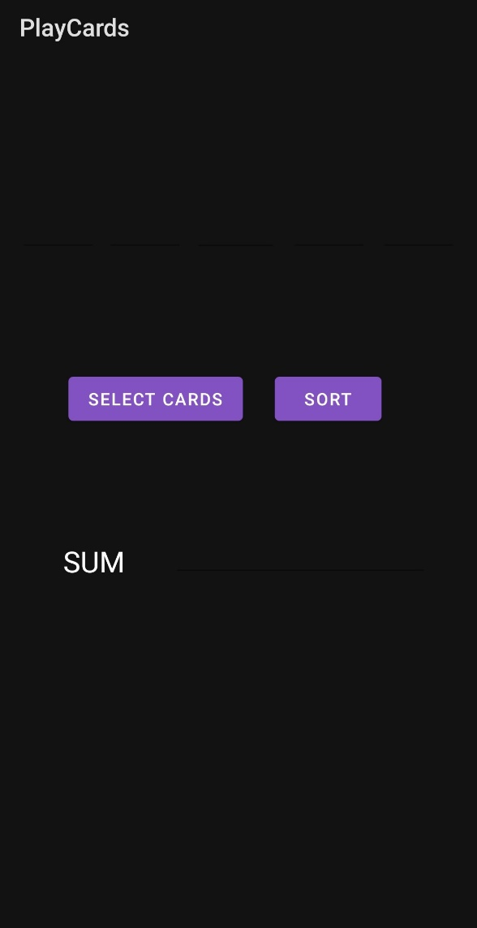

Screen When Clicked on Select Cards:

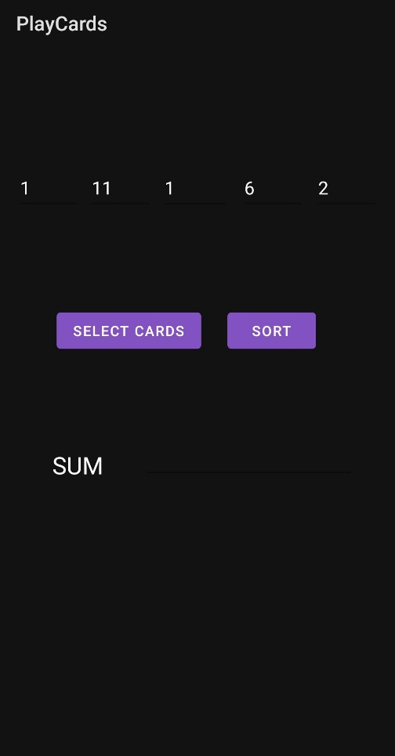

Screen When Clicked on Sort:

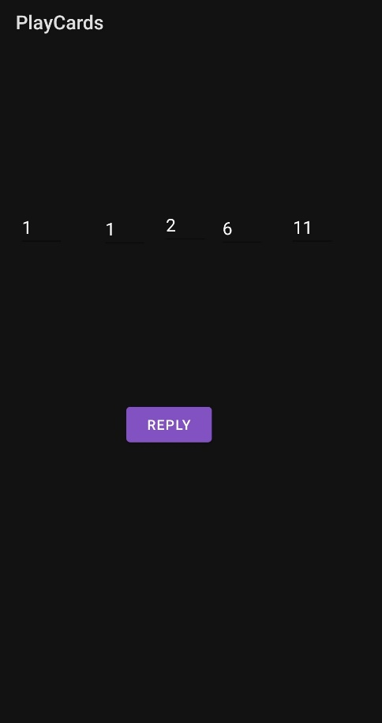

Screen When Clicked on Reply:

