**Instructions: VIT-AP UNIVERSITY, ANDHRA PRADESH**

**Lab Sheet 5 : Animation and FABs**

**Academic year:** 2021-2022  **Branch/ Class:** B.Tech

**Semester:** Fall  **Date: 30-10-2021**

**Faculty Name:** Dr.N.Anupama  **School:** SCOPE

NAME: GVS SAI MADHAV REGNO: 19BCN7228

**\*\*\*\*\*\*\*\*\*\*\*\*\*\*\*\*\*\*\*\*\*\*\*\*\*\*\*\*\*\*\*\*\*\*\*\*\*\*\*\*\*\*\*\*\*\*\*\*\*\*\*\*\*\*\*\*\*\*\*\*\*\*\*\*\*\*\*\*\*\*\*\*\*\*\*\*\*\*\*\*\*\*\*\*\*\*\*\*\*\*\*\*\*\*\*\*\*\*\*\*\*\*\*\*\*\***

* Fill your Name and REGNO.
* Complete the program, add the code java and XML, input and output Screenshots after the question on the same document.
* Save this File name with your **registerno**_**lab5**

**eg 18ABC1234_LAB5.doc**

* Upload it in assignment ->LAB5 in MS TEAM

1.Design a Floating action button demo. Initially only the pink button should display when the the pink button is click the rest of the three buttons should be displayed. When each button is clicked then taost message should be displayed. When the pink button is pressed again the three buttons should hide.

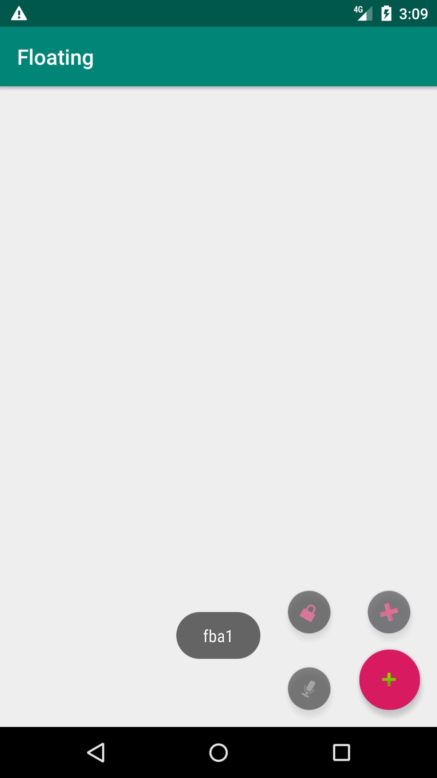

2. Design an App to scale one image big and one image small and vice versa.

1:

**MainActivity.java:**

package com.example.labapp;  
  
import androidx.appcompat.app.AppCompatActivity;  
import android.os.Bundle;  
import android.view.View;  
import android.view.animation.Animation;  
import android.view.animation.AnimationUtils;  
import android.widget.Toast;  
import com.google.android.material.floatingactionbutton.FloatingActionButton;  
public class MainActivity extends AppCompatActivity  
{  
 @Override  
 protected void onCreate(Bundle savedInstanceState)  
 {  
 super.onCreate(savedInstanceState);  
 setContentView(R.layout.*activity_main*);  
 final boolean[] flag = {false};  
 FloatingActionButton fab1 = (FloatingActionButton) findViewById(R.id.*fab1*);  
 final FloatingActionButton fab2 = (FloatingActionButton) findViewById(R.id.*fab2*);  
 final FloatingActionButton fab3 = (FloatingActionButton) findViewById(R.id.*fab3*);  
 final FloatingActionButton fab4 = (FloatingActionButton) findViewById(R.id.*fab4*);  
 final Animation in = AnimationUtils.*loadAnimation*(getApplicationContext(),R.anim.*show*);  
 final Animation out = AnimationUtils.*loadAnimation*(getApplicationContext(),R.anim.*hide*);  
 fab1.setOnClickListener(new View.OnClickListener()  
 {  
 @Override  
 public void onClick(View v) { if (flag[0])  
 {  
 Toast.*makeText*(getApplicationContext(), "fba1", Toast.*LENGTH_SHORT*).show();  
 fab2.startAnimation(in); fab3.startAnimation(in); fab4.startAnimation(in);  
 }  
 else  
 {  
 fab2.startAnimation(out); fab3.startAnimation(out); fab4.startAnimation(out);  
 }  
 flag[0] =!flag[0];  
 }  
 });  
 fab2.setOnClickListener(new View.OnClickListener()  
 {  
 @Override  
 public void onClick(View v)  
 {  
 Toast.*makeText*(getApplicationContext(), "fba2", Toast.*LENGTH_SHORT*).show();  
 }  
 });  
 fab3.setOnClickListener(new View.OnClickListener()  
 {  
 @Override  
 public void onClick(View v)  
 {  
 Toast.*makeText*(getApplicationContext(), "fba3", Toast.*LENGTH_SHORT*).show();  
 }  
 });  
 fab4.setOnClickListener(new View.OnClickListener()  
 {  
 @Override  
 public void onClick(View v)  
 {  
 Toast.*makeText*(getApplicationContext(), "fba4", Toast.*LENGTH_SHORT*).show();  
 }  
 });  
 }  
}

**MainActivity2.java:**

package com.example.labapp;  
  
import androidx.appcompat.app.AppCompatActivity;  
  
import android.os.Bundle;  
  
public class MainActivity2 extends AppCompatActivity {  
  
 @Override  
 protected void onCreate(Bundle savedInstanceState) {  
 super.onCreate(savedInstanceState);  
 setContentView(R.layout.*show*);  
 }  
}

**MainActivity3.java:**

package com.example.labapp;  
  
import androidx.appcompat.app.AppCompatActivity;  
  
import android.os.Bundle;  
  
public class MainActivity3 extends AppCompatActivity {  
  
 @Override  
 protected void onCreate(Bundle savedInstanceState) {  
 super.onCreate(savedInstanceState);  
 setContentView(R.layout.*hide*);  
 }  
}

**Activity_main.xml:**

<?xml version="1.0" encoding="utf-8"?>  
<androidx.constraintlayout.widget.ConstraintLayout  
 xmlns:android="http://schemas.android.com/apk/res/android"  
 xmlns:app="http://schemas.android.com/apk/res-auto"  
 xmlns:tools="http://schemas.android.com/tools"  
 android:layout_width="match_parent"  
 android:layout_height="match_parent"  
 tools:context=".MainActivity">  
  
 <com.google.android.material.floatingactionbutton.FloatingActionButton  
 android:id="@+id/fab1"  
 android:layout_width="51dp"  
 android:layout_height="53dp"  
 android:layout_marginTop="15dp"  
 android:layout_marginEnd="16dp"  
 android:layout_marginBottom="16dp"  
 android:clickable="true"  
 app:layout_constraintBottom_toBottomOf="parent"  
 app:layout_constraintEnd_toEndOf="parent"  
 app:layout_constraintStart_toEndOf="@+id/fab3"  
 app:layout_constraintTop_toBottomOf="@+id/fab2"  
 app:srcCompat="@android:drawable/ic_input_add" />  
  
 <com.google.android.material.floatingactionbutton.FloatingActionButton  
 android:id="@+id/fab2"  
 android:layout_width="wrap_content"  
 android:layout_height="wrap_content"  
 android:layout_marginEnd="25dp"  
 android:layout_marginBottom="88dp"  
 android:clickable="true"  
 app:backgroundTint="#19171A"  
 app:fabSize="mini"  
 app:layout_constraintBottom_toBottomOf="parent"  
 app:layout_constraintEnd_toEndOf="parent"  
 app:srcCompat="@android:drawable/ic_delete" />  
  
 <com.google.android.material.floatingactionbutton.FloatingActionButton  
 android:id="@+id/fab3"  
 android:layout_width="wrap_content"  
 android:layout_height="wrap_content"  
 android:layout_marginStart="271dp"  
 android:layout_marginEnd="27dp"  
 android:layout_marginBottom="16dp"  
 android:clickable="true"  
 app:backgroundTint="#181515"  
 app:fabSize="mini"  
 app:layout_constraintBottom_toBottomOf="parent"  
 app:layout_constraintEnd_toStartOf="@+id/fab1"  
 app:layout_constraintStart_toStartOf="parent"  
 app:srcCompat="@android:drawable/ic_btn_speak_now" />  
  
  
 <com.google.android.material.floatingactionbutton.FloatingActionButton  
 android:id="@+id/fab4"  
 android:layout_width="wrap_content"  
 android:layout_height="wrap_content"  
 android:layout_marginBottom="15dp"  
 android:clickable="true"  
 app:backgroundTint="#131111"  
 app:fabSize="mini"  
 app:layout_constraintBottom_toTopOf="@+id/fab1"  
 app:layout_constraintStart_toStartOf="@+id/fab3"  
 app:srcCompat="@android:drawable/ic_lock_lock" />  
</androidx.constraintlayout.widget.ConstraintLayout>

**Show.xml:**

<?xml version="1.0" encoding="utf-8"?>  
<set xmlns:android="http://schemas.android.com/apk/res/android"  
 android:fillAfter="true">  
  
 <rotate  
 android:duration="500"  
 android:fromDegrees="30"  
 android:interpolator="@android:anim/linear_interpolator"  
 android:pivotX="50%"  
 android:pivotY="50%"  
 android:repeatCount="4"  
 android:repeatMode="reverse"  
 android:toDegrees="0">  
 </rotate>  
 <translate  
 android:duration="1000"  
 android:fromXDelta="170%"  
 android:fromYDelta="25%"  
 android:interpolator="@android:anim/linear_interpolator"  
 android:toXDelta="0%"  
 android:toYDelta="0%">  
 </translate>  
  
 <alpha  
 android:duration="2000"  
 android:fromAlpha="0.0"  
 android:interpolator="@android:anim/decelerate_interpolator"  
 android:toAlpha="1.0">  
 </alpha>  
</set>

**Hide.xml:**

<?xml version="1.0" encoding="utf-8"?>  
<set xmlns:android="http://schemas.android.com/apk/res/android"  
 android:fillAfter="true">  
  
 <translate  
 android:duration="1000"  
 android:fromXDelta="0%"  
 android:fromYDelta="0%"  
 android:interpolator="@android:anim/linear_interpolator"  
 android:toXDelta="100%"  
 android:toYDelta="100%">  
 </translate>  
  
 <alpha  
 android:duration="2000"  
 android:fromAlpha="1.0"  
 android:interpolator="@android:anim/accelerate_interpolator"  
 android:toAlpha="0.0">  
 </alpha>  
</set>

**OUTPUT:**

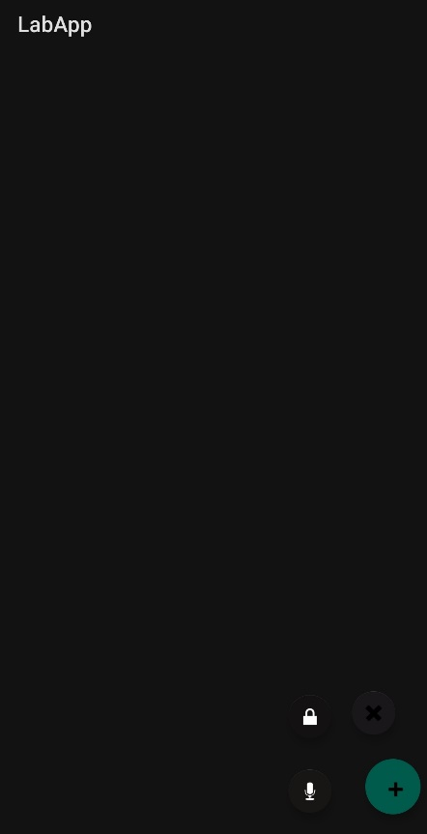

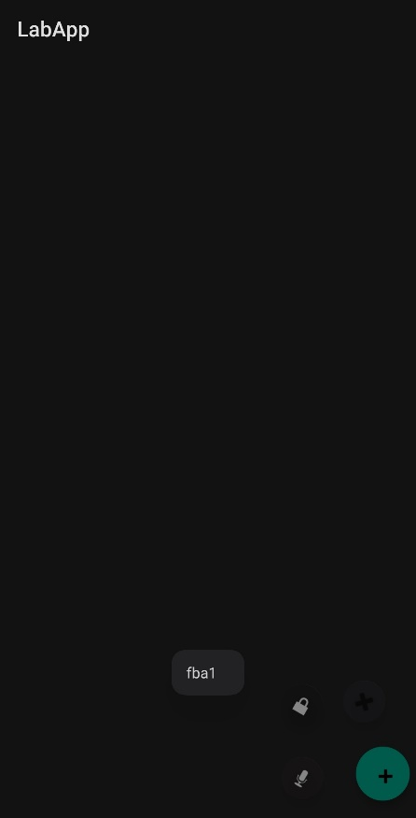

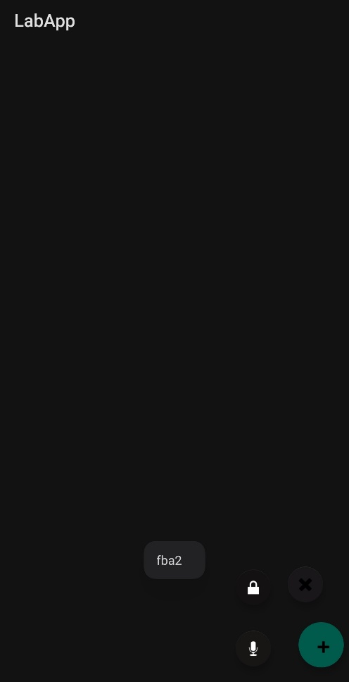

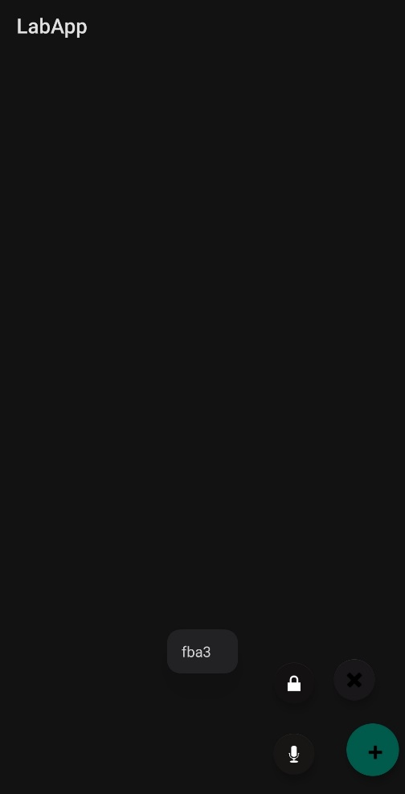

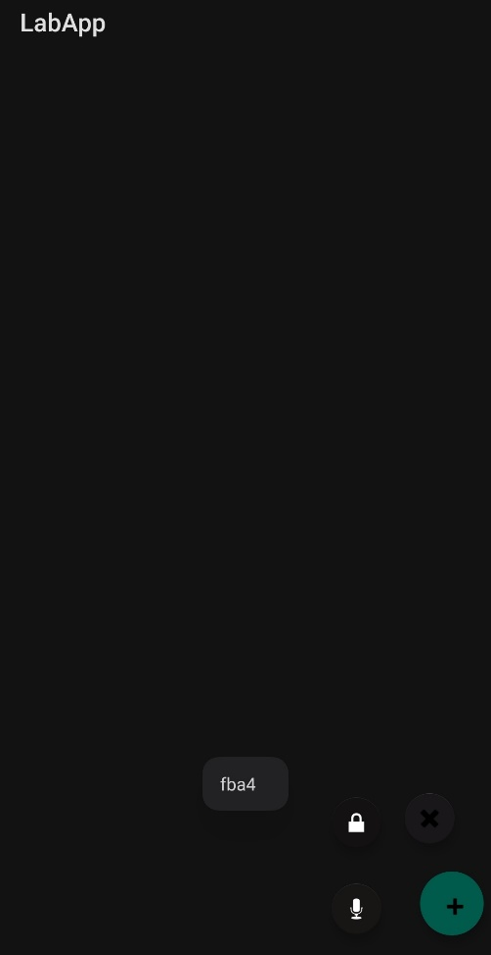

**2.**

**MainActivity.java:**

package com.example.resizeapp;  
  
import androidx.appcompat.app.AppCompatActivity;  
import android.os.Bundle;  
import android.view.animation.Animation;  
import android.view.animation.AnimationUtils;  
import android.widget.ImageView;  
public class MainActivity extends AppCompatActivity  
{  
 @Override  
protected void onCreate(Bundle savedInstanceState)  
 {  
 super.onCreate(savedInstanceState);  
 setContentView(R.layout.*activity_main*);  
 final ImageView iv1=(ImageView)findViewById(R.id.*imageView*);  
 final ImageView iv2=(ImageView)findViewById(R.id.*imageView1*);  
 final Animation animZoomIn = AnimationUtils.*loadAnimation*(getApplicationContext(),R.anim.*zoom_in*);  
 final Animation animZoomIn2 = AnimationUtils.*loadAnimation*(getApplicationContext(),R.anim.*zoom_in*);  
 final Animation animZoomOut = AnimationUtils.*loadAnimation*(getApplicationContext(),R.anim.*zoom_out*);  
 final Animation animZoomOut2 = AnimationUtils.*loadAnimation*(getApplicationContext(),R.anim.*zoom_out*);  
 iv1.startAnimation(animZoomIn); iv2.startAnimation(animZoomOut2);  
  
 animZoomIn.setAnimationListener(new Animation.AnimationListener()  
 {  
 @Override  
 public void onAnimationStart(Animation animation) { }  
 @Override  
 public void onAnimationEnd(Animation animation)  
 {  
 iv1.startAnimation(animZoomOut);  
 }  
 @Override  
 public void onAnimationRepeat(Animation animation)  
 { } });  
  
  
 animZoomOut.setAnimationListener(new Animation.AnimationListener()  
 {  
 @Override  
 public void onAnimationStart(Animation animation) { } @Override  
 public void onAnimationEnd(Animation animation) { iv1.startAnimation(animZoomIn);  
 }  
 @Override  
 public void onAnimationRepeat(Animation animation) { } });  
  
 animZoomIn2.setAnimationListener(new Animation.AnimationListener() { @Override  
 public void onAnimationStart(Animation animation) { } @Override  
 public void onAnimationEnd(Animation animation) { iv2.startAnimation(animZoomOut2);  
 }  
 @Override  
 public void onAnimationRepeat(Animation animation) { } });  
  
  
 animZoomOut2.setAnimationListener(new Animation.AnimationListener() {  
 @Override  
 public void onAnimationStart(Animation animation) { } @Override  
 public void onAnimationEnd(Animation animation) { iv2.startAnimation(animZoomIn2);  
 }  
 @Override  
 public void onAnimationRepeat(Animation animation) {  
 }  
 });  
}  
}

**Activity_main.xml:**

<?xml version="1.0" encoding="utf-8"?>  
<androidx.constraintlayout.widget.ConstraintLayout  
 xmlns:android="http://schemas.android.com/apk/res/android"  
 xmlns:app="http://schemas.android.com/apk/res-auto"  
 xmlns:tools="http://schemas.android.com/tools"  
 android:layout_width="match_parent"  
 android:layout_height="match_parent"  
 tools:context=".MainActivity">  
  
 <ImageView  
 android:id="@+id/imageView"  
 android:layout_width="wrap_content"  
 android:layout_height="wrap_content"  
 app:layout_constraintBottom_toTopOf="@+id/imageView1"  
 app:layout_constraintEnd_toEndOf="parent"  
 app:layout_constraintStart_toStartOf="parent"  
 app:layout_constraintTop_toTopOf="parent"  
 app:srcCompat="@drawable/test1" />  
  
 <ImageView  
 android:id="@+id/imageView1"  
 android:layout_width="wrap_content"  
 android:layout_height="wrap_content"  
 app:layout_constraintBottom_toBottomOf="parent"  
 app:layout_constraintEnd_toEndOf="parent"  
 app:layout_constraintStart_toStartOf="parent"  
 app:layout_constraintTop_toTopOf="parent"  
 app:layout_constraintVertical_bias="0.823"  
 app:srcCompat="@drawable/test2" />  
</androidx.constraintlayout.widget.ConstraintLayout>

**Zoomin.xml:**

<?xml version="1.0" encoding="utf-8"?>  
<set  
 xmlns:android="http://schemas.android.com/apk/res/android">  
 <scale  
 xmlns:android="http://schemas.android.com/apk/res/android"  
 android:duration="1000"  
 android:fromXScale="0"  
 android:fromYScale="0"  
 android:pivotX="50%"  
 android:pivotY="50%"  
 android:toXScale="1"  
 android:toYScale="1" >  
 </scale>  
</set>

**Zoomout.xml:**

<?xml version="1.0" encoding="utf-8"?>  
<set  
 xmlns:android="http://schemas.android.com/apk/res/android">  
 <scale  
 android:duration="1000"  
 android:fromXScale="1"  
 android:fromYScale="1"  
 android:pivotX="50%"  
 android:pivotY="50%"  
 android:toXScale="0"  
 android:toYScale="0" />  
</set>

**OUTPUT:**

