**Instructions: VIT-AP UNIVERSITY, ANDHRA PRADESH**

**Lab Sheet 8: Chip Buttons**

**Academic year:** 2021-2022  **Branch/ Class:** B. Tech

**Semester:** Fall  **Date: 09-11-2021**

**Faculty Name:** Dr. Anupama  **School:** SCOPE

NAME: GVS SAI MADHAV REGNO: 19BCN7228

**\*\*\*\*\*\*\*\*\*\*\*\*\*\*\*\*\*\*\*\*\*\*\*\*\*\*\*\*\*\*\*\*\*\*\*\*\*\*\*\*\*\*\*\*\*\*\*\*\*\*\*\*\*\*\*\*\*\*\*\*\*\*\*\*\*\*\*\*\*\*\*\*\*\*\*\*\*\*\*\*\*\*\*\*\*\*\*\*\*\*\*\*\*\*\*\*\*\*\*\*\*\*\*\*\*\***

* Fill your Name and REGNO.
* Complete the program, add the code java and XML, input and output Screenshots after the question on the same document.
* Save this File name with your **registerno**_**lab8**

**eg 18ABC1234_LAB8.doc**

* Upload it in assignment ->LAB8 in MS TEAM

1. Design an app that creates dynamic adding and removing of chip buttons.
2. Design an App for the gmail header. Whenever the user enters an email in the To section create a chipbutton with photo and the email. It should also contain close button to remove the chip button.

MainActivity.Java:

package com.example.emailcard;  
import androidx.appcompat.app.AppCompatActivity;  
  
import android.os.Bundle;  
import android.view.View;  
import android.widget.Button;  
  
import com.google.android.material.chip.Chip;  
import com.google.android.material.chip.ChipGroup;  
  
public class MainActivity extends AppCompatActivity {  
 Button b1,b2;  
 ChipGroup c;  
  
 @Override  
 protected void onCreate(Bundle savedInstanceState) {  
 super.onCreate(savedInstanceState);  
 setContentView(R.layout.*activity_main*);  
  
 b1 = findViewById(R.id.*b1*);  
 b2 = findViewById(R.id.*b2*);  
 c = findViewById(R.id.*chipgr*);  
 b1.setOnClickListener(new View.OnClickListener() {  
 @Override  
 public void onClick(View v) {  
 Chip chip = new Chip(MainActivity.this);  
 chip.setCloseIconVisible(true);  
 c.addView(chip);  
 chip.setOnCloseIconClickListener(new View.OnClickListener() {  
 @Override  
 public void onClick(View v) {  
 c.removeView(chip);  
 }  
 });  
 b2.setOnClickListener(new View.OnClickListener() {  
 @Override  
 public void onClick(View v) {  
 c.removeView(chip);  
 }  
 });  
 }  
 });  
 }  
}

activity_main.xml:

<?xml version="1.0" encoding="utf-8"?>  
<androidx.constraintlayout.widget.ConstraintLayout xmlns:android="http://schemas.android.com/apk/res/android"  
 xmlns:app="http://schemas.android.com/apk/res-auto"  
 xmlns:tools="http://schemas.android.com/tools"  
 android:layout_width="match_parent"  
 android:layout_height="match_parent"  
 tools:context=".MainActivity">  
  
 <Button  
 android:id="@+id/b1"  
 android:layout_width="wrap_content"  
 android:layout_height="wrap_content"  
 android:layout_marginStart="75dp"  
 android:layout_marginBottom="137dp"  
 android:text="create"  
 app:layout_constraintBottom_toBottomOf="parent"  
 app:layout_constraintStart_toStartOf="parent" />  
  
 <Button  
 android:id="@+id/b2"  
 android:layout_width="wrap_content"  
 android:layout_height="wrap_content"  
 android:layout_marginEnd="59dp"  
 android:text="delete"  
 app:layout_constraintBottom_toBottomOf="@+id/b1"  
 app:layout_constraintEnd_toEndOf="parent"  
 app:layout_constraintTop_toTopOf="@+id/b1" />  
  
 <com.google.android.material.chip.ChipGroup  
 android:id="@+id/chipgr"  
 android:layout_width="332dp"  
 android:layout_height="415dp"  
 android:layout_marginStart="44dp"  
 android:layout_marginTop="88dp"  
 app:layout_constraintStart_toStartOf="parent"  
 app:layout_constraintTop_toTopOf="parent">  
  
 </com.google.android.material.chip.ChipGroup>  
</androidx.constraintlayout.widget.ConstraintLayout>

Initial Screen:

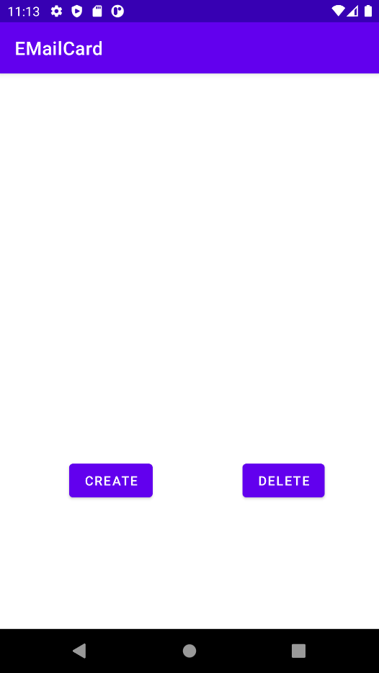

Upon clicking Create:

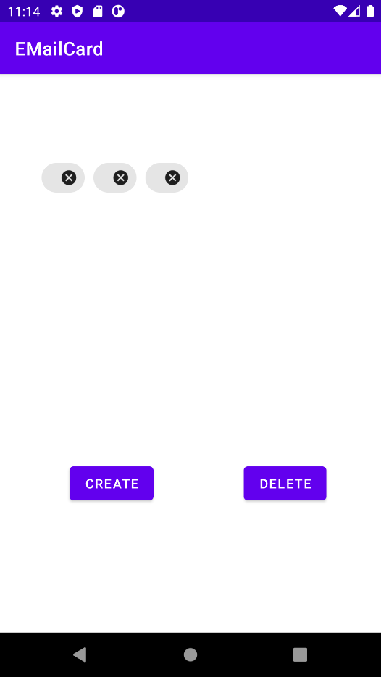

Upon clicking delete option:

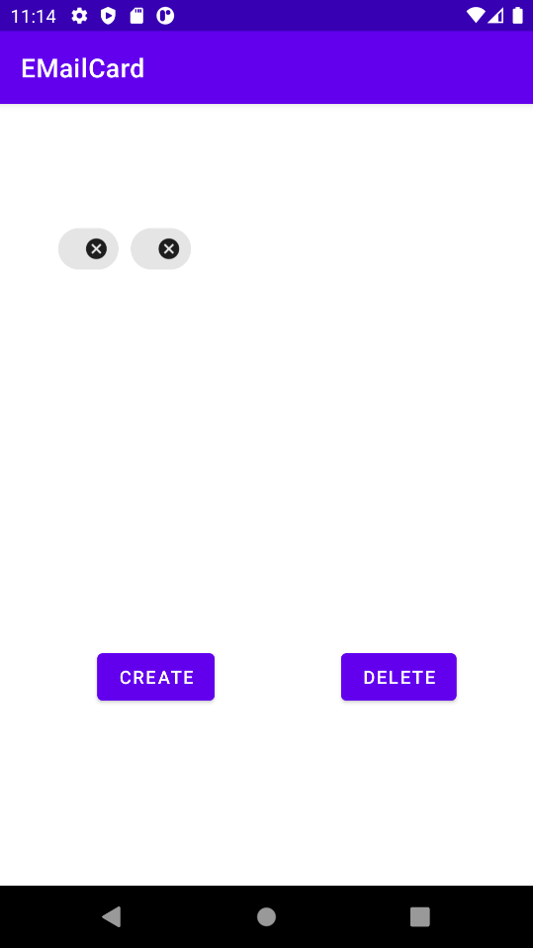

MainActivity.java:

package com.example.emailcard2;  
import androidx.annotation.DrawableRes;  
import androidx.appcompat.app.AppCompatActivity;  
  
import android.os.Bundle;  
import android.view.View;  
import android.widget.Button;  
import android.widget.EditText;  
import android.widget.Toast;  
  
import com.google.android.material.chip.Chip;  
import com.google.android.material.chip.ChipGroup;  
  
public class MainActivity extends AppCompatActivity {  
 Button b1;  
 EditText e1,e2,e3,e4;  
 private ChipGroup c;  
  
 @Override  
 protected void onCreate(Bundle savedInstanceState) {  
 super.onCreate(savedInstanceState);  
 setContentView(R.layout.*activity_main*);  
 b1 = findViewById(R.id.*b*);  
 e1 = findViewById(R.id.*from*);  
 e2 = findViewById(R.id.*to*);  
 e3 = findViewById(R.id.*msg*);  
 e4 = findViewById(R.id.*subject*);  
 c = findViewById(R.id.*chipgr*);  
  
 b1.setOnClickListener(new View.OnClickListener() {  
 @Override  
 public void onClick(View v) {  
 Chip chip = new Chip(MainActivity.this);  
 c.addView(chip);  
 chip.setText(e2.getText());  
 chip.setChipIcon(getDrawable(R.drawable.*user*));  
 e2.setText(null);  
 chip.setCloseIconVisible(true);  
  
 chip.setOnCloseIconClickListener(new View.OnClickListener() {  
 @Override  
 public void onClick(View v) {  
 c.removeView(chip);  
 }  
 });  
  
 }  
 });  
 }  
}

activity_main.xml:

<?xml version="1.0" encoding="utf-8"?>  
<androidx.constraintlayout.widget.ConstraintLayout xmlns:android="http://schemas.android.com/apk/res/android"  
 xmlns:app="http://schemas.android.com/apk/res-auto"  
 xmlns:tools="http://schemas.android.com/tools"  
 android:layout_width="match_parent"  
 android:layout_height="match_parent"  
 tools:context=".MainActivity">  
  
 <EditText  
 android:id="@+id/from"  
 android:layout_width="wrap_content"  
 android:layout_height="wrap_content"  
 android:layout_marginTop="51dp"  
 android:ems="10"  
 android:hint="from"  
 android:inputType="textEmailAddress"  
 android:textSize="16sp"  
 app:layout_constraintEnd_toEndOf="@+id/to"  
 app:layout_constraintStart_toStartOf="@+id/to"  
 app:layout_constraintTop_toTopOf="parent"  
 tools:ignore="TouchTargetSizeCheck" />  
  
 <EditText  
 android:id="@+id/to"  
 android:layout_width="wrap_content"  
 android:layout_height="wrap_content"  
 android:layout_marginTop="196dp"  
 android:layout_marginEnd="25dp"  
 android:ems="10"  
 android:hint="To"  
 android:inputType="textEmailAddress"  
 android:textSize="16sp"  
 app:layout_constraintEnd_toStartOf="@+id/b"  
 app:layout_constraintTop_toTopOf="parent"  
 tools:ignore="TouchTargetSizeCheck" />  
  
 <EditText  
 android:id="@+id/subject"  
 android:layout_width="wrap_content"  
 android:layout_height="wrap_content"  
 android:layout_marginStart="5dp"  
 android:layout_marginTop="42dp"  
 android:ems="10"  
 android:hint="subject"  
 android:inputType="textPersonName"  
 android:textSize="16sp"  
 app:layout_constraintStart_toStartOf="@+id/to"  
 app:layout_constraintTop_toBottomOf="@+id/to"  
 tools:ignore="TouchTargetSizeCheck" />  
  
 <EditText  
 android:id="@+id/msg"  
 android:layout_width="0dp"  
 android:layout_height="248dp"  
 android:layout_marginStart="46dp"  
 android:layout_marginEnd="46dp"  
 android:layout_marginBottom="33dp"  
 android:background="@drawable/round"  
 android:ems="10"  
 android:hint="message"  
 android:inputType="textMultiLine"  
 android:textSize="18sp"  
 app:layout_constraintBottom_toBottomOf="parent"  
 app:layout_constraintEnd_toEndOf="parent"  
 app:layout_constraintStart_toStartOf="parent" />  
  
 <Button  
 android:id="@+id/b"  
 android:layout_width="wrap_content"  
 android:layout_height="wrap_content"  
 android:layout_marginEnd="33dp"  
 android:text="enter"  
 app:layout_constraintBaseline_toBaselineOf="@+id/to"  
 app:layout_constraintEnd_toEndOf="parent" />  
  
 <com.google.android.material.chip.ChipGroup  
 android:id="@+id/chipgr"  
 android:layout_width="0dp"  
 android:layout_height="50dp"  
 android:layout_marginStart="16dp"  
 android:layout_marginTop="50dp"  
 android:layout_marginEnd="16dp"  
 android:layout_marginBottom="48dp"  
 android:background="@color/white"  
 app:layout_constraintBottom_toBottomOf="@+id/b"  
 app:layout_constraintEnd_toEndOf="@+id/to"  
 app:layout_constraintStart_toStartOf="@+id/to"  
 app:layout_constraintTop_toBottomOf="@+id/from">  
  
 </com.google.android.material.chip.ChipGroup>  
</androidx.constraintlayout.widget.ConstraintLayout>

Output:

Initial Screen:

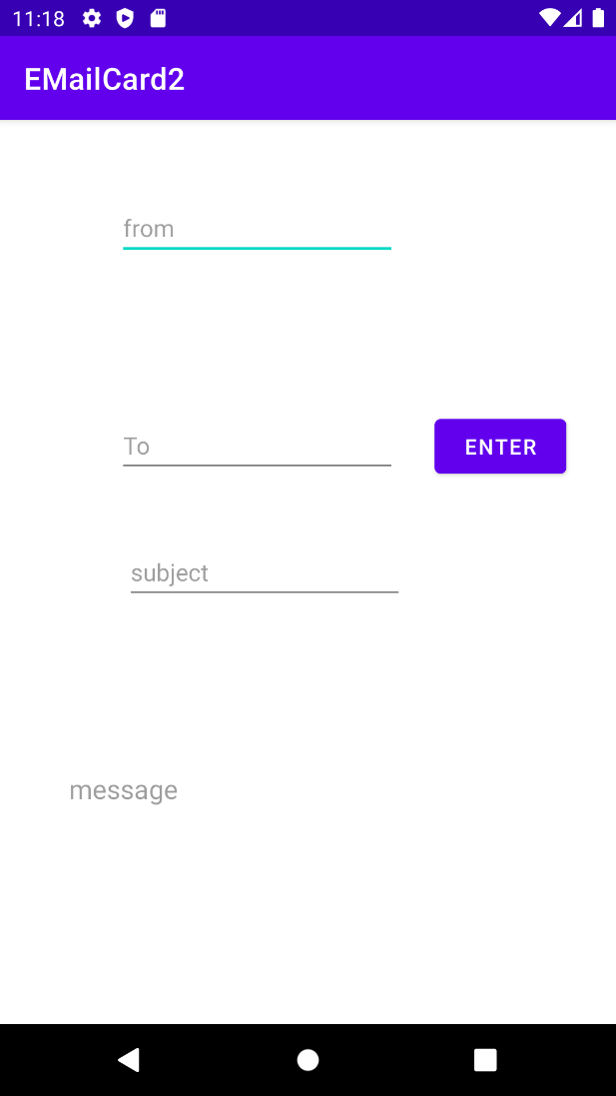

Upon clicking Enter, the Email gets changed as card, The Line Test Is Subject, Hello World is Test

