Instructions: VIT-AP UNIVERSITY, ANDHRA PRADESH
Lab Sheet 9 : AlertBox

Academic year: 2021-2022
Semester: Fall
Faculty Name: Dr.N. Anupama

Branch/ Class: B.Tech
Date: 11-11-2021
School: SCOPE

NAME: GVS SAI MADHAV
REGNO: 19BCN7228

**********************************************************************************************************

Fill your Name and REGNO.

Complete the program, add the code java and XML, input and output Screenshots after the question on the same document.

Save this File name with your registerno_lab9
eg 18ABC1234_LAB9.doc

Upload it in assignment ->LAB9 in MS TEAM

- Design an App that create an Alertbox contain the radio buttons for selection single choice. On Clicking the option call a new activity displaying the message about the option selected.
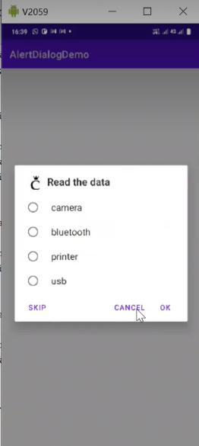

XML CODE: (Activity1)

<?xml version="1.0" encoding="utf-8"?>
<androidx.constraintlayout.widget.ConstraintLayout
xmlns:android="http://schemas.android.com/apk/res/android"
xmlns:app="http://schemas.android.com/apk/res-auto"
xmlns:tools="http://schemas.android.com/tools"
android:layout_width="match_parent"
android:layout_height="match_parent"
tools:context=".MainActivity">
<TextView
android:id="@+id/t_1"
android:layout_width="wrap_content"
android:layout_height="wrap_content"
android:layout_marginTop="377dp"
android:text="Show Alert Dialogue"
android:textSize="20sp"
app:layout_constraintEnd_toEndOf="parent"
app:layout_constraintStart_toStartOf="parent"
app:layout_constraintTop_toTopOf="parent" />
</androidx.constraintlayout.widget.ConstraintLayout>

XML CODE: (Activity2)

<?xml version="1.0" encoding="utf-8"?>
<androidx.constraintlayout.widget.ConstraintLayout
xmlns:android="http://schemas.android.com/apk/res/android"
xmlns:app="http://schemas.android.com/apk/res-auto"
xmlns:tools="http://schemas.android.com/tools"
android:layout_width="match_parent"
android:layout_height="match_parent"
tools:context=".MainActivity2">
<TextView
android:id="@+id/t"
android:layout_width="232dp"
android:layout_height="59dp"
android:layout_marginTop="404dp"
android:textAlignment="center"
android:textSize="20sp"
app:layout_constraintEnd_toEndOf="parent"
app:layout_constraintHorizontal_bias="0.497"
app:layout_constraintStart_toStartOf="parent"
app:layout_constraintTop_toTopOf="parent" />
</androidx.constraintlayout.widget.ConstraintLayout>

Java Code:

MainActivity:

package com.example.alertdialoguedemo;
import androidx.appcompat.app.AlertDialog;
import androidx.appcompat.app.AppCompatActivity;
import android.content.DialogInterface;
import android.content.Intent;
import android.os.Bundle;
import android.view.View;
import android.widget.TextView;
import android.widget.Toast;
public class MainActivity extends AppCompatActivity
{
TextView t1;
@Override
protected void onCreate(Bundle savedInstanceState)
{
super.onCreate(savedInstanceState);
setContentView(R.layout.activity_main);
t1=findViewById(R.id.t_1);
t1.setOnClickListener(new View.OnClickListener()
{
@Override
public void onClick(View view)
{
showAlertDialog();
}
});
}
private void showAlertDialog()
{
AlertDialog.Builder alertDialog = new AlertDialog.Builder(MainActivity.this);
alertDialog.setTitle("Alert Dialog");
alertDialog.setCancelable(false);
alertDialog.setNegativeButton("Cancel", new DialogInterface.OnClickListener()
{
@Override
public void onClick(DialogInterface dialogInterface,int which)
{
dialogInterface.cancel();
}
});
alertDialog.setPositiveButton("Ok", new DialogInterface.OnClickListener()
{
@Override
public void onClick(DialogInterface dialogInterface,int which)
{
finish();
}
});
String[] items = {"Camera","Bluetooth","Printer","USB"};
int check = 1;
Intent intent = new Intent(MainActivity.this, MainActivity2.class);
alertDialog.setSingleChoiceItems(items, check, new DialogInterface.OnClickListener()
{
@Override
public void onClick(DialogInterface dialogInterface, int which)
{
switch(which)
{
case 0:
String msg = "Camera is Clicked";
intent.putExtra("message",msg);
startActivity(intent);
Toast.makeText(MainActivity.this, "Camera is Clicked", Toast.LENGTH_LONG).show();
break;
case 1:
String msg1 = "Bluetooth is Clicked";
intent.putExtra("message",msg1);
startActivity(intent);
Toast.makeText(MainActivity.this, "Bluetooth is Clicked", Toast.LENGTH_LONG).show();
break;
case 2:
String msg2 = "Printer is Clicked";
intent.putExtra("message",msg2);
startActivity(intent);
Toast.makeText(MainActivity.this, "Printer is Clicked", Toast.LENGTH_LONG).show();
break;
case 3:
String msg3 = "USB is Clicked";
intent.putExtra("message",msg3);
startActivity(intent);
Toast.makeText(MainActivity.this, "USB is Clicked", Toast.LENGTH_LONG).show();
break;
}
}
});
AlertDialog alert = alertDialog.create();
alert.setCanceledOnTouchOutside(false);
alert.show();
}
}

MainActivity2:

package com.example.alertdialoguedemo;
import androidx.appcompat.app.AppCompatActivity;
import android.content.Intent;
import android.os.Bundle;
import android.widget.EditText;
import android.widget.TextView;
public class MainActivity2 extends AppCompatActivity
{
TextView t1;
@Override
protected void onCreate(Bundle savedInstanceState)
{
super.onCreate(savedInstanceState);
setContentView(R.layout.activity_main2);
t1=findViewById(R.id.t);
Intent i = getIntent();
t1.setText(i.getStringExtra("message"));
}
}

Output:
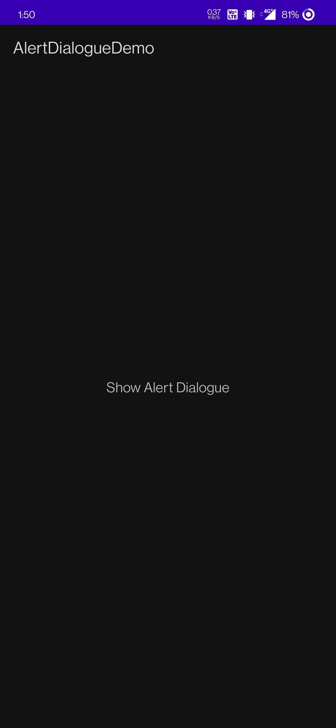
When Camera is Clicked New Activity opens Displaying Camera is Clicked
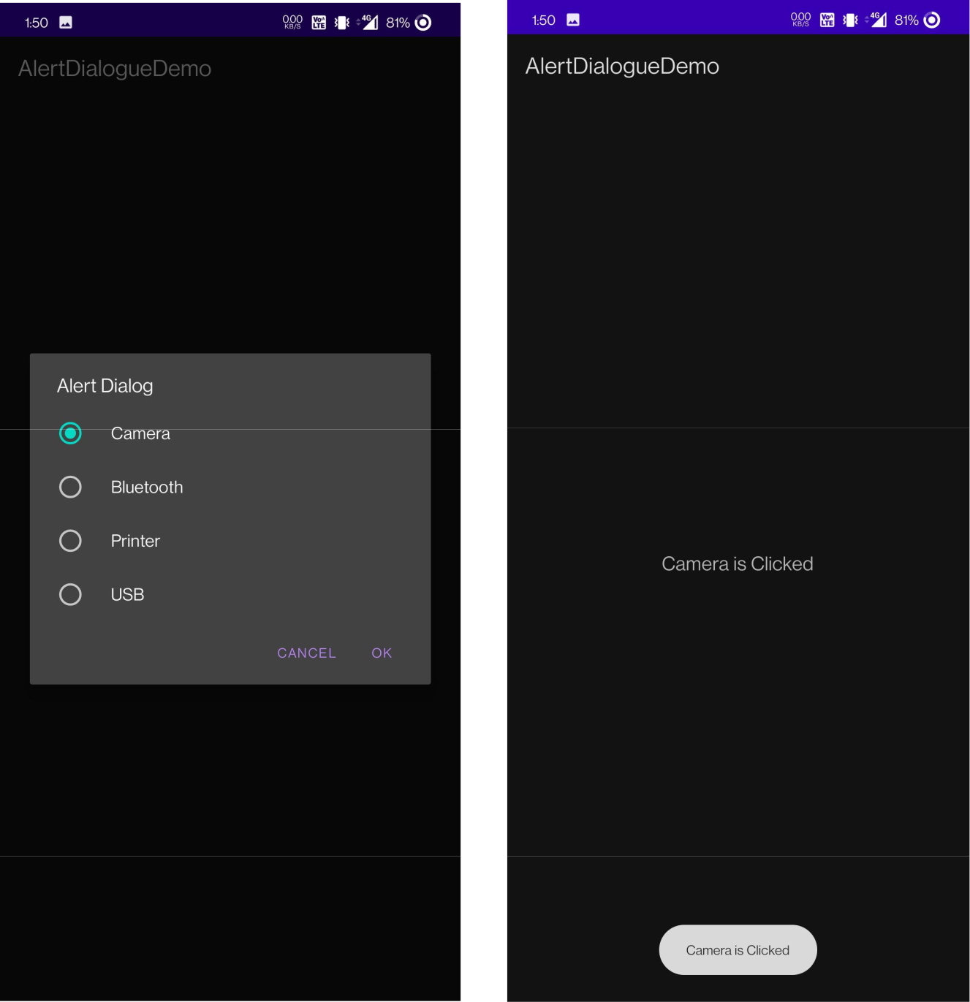
When Bluetooth is Clicked New Activity opens Displaying Bluetooth is Clicked
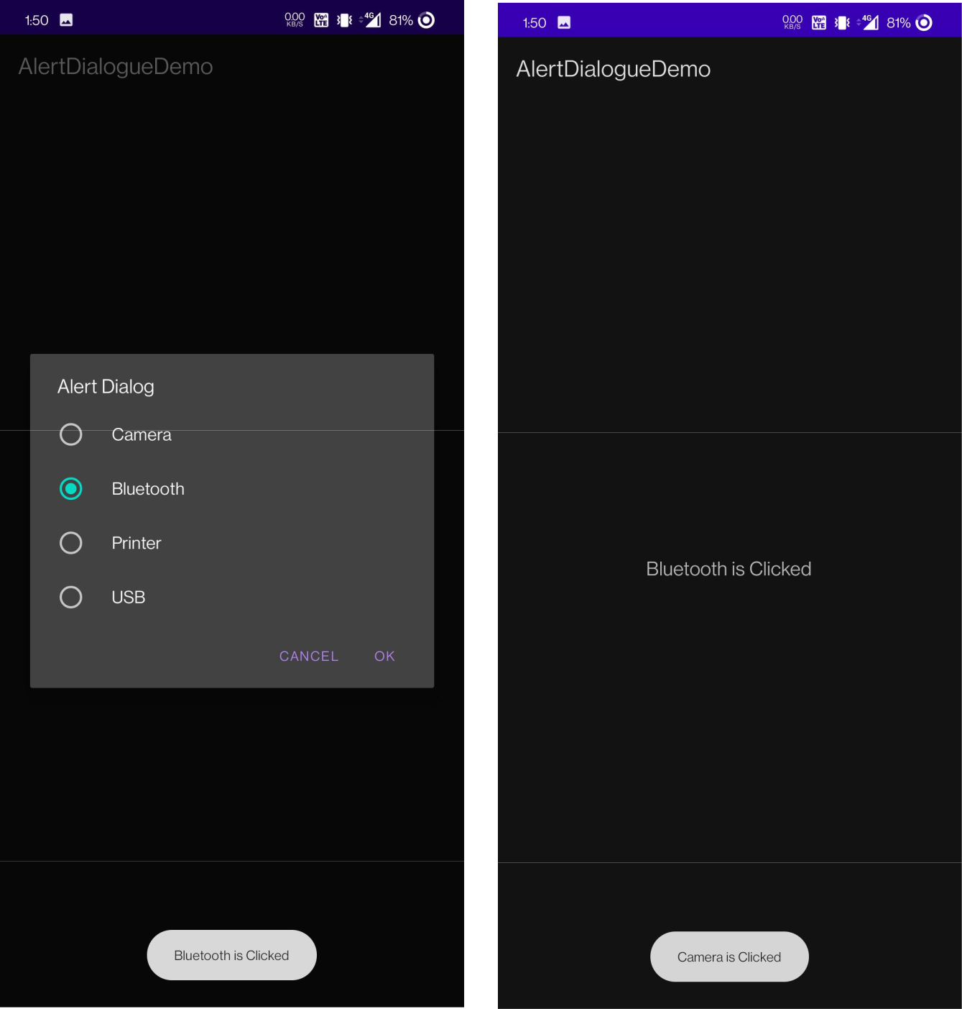
When Printer is Clicked New Activity opens Displaying Printer is Clicked
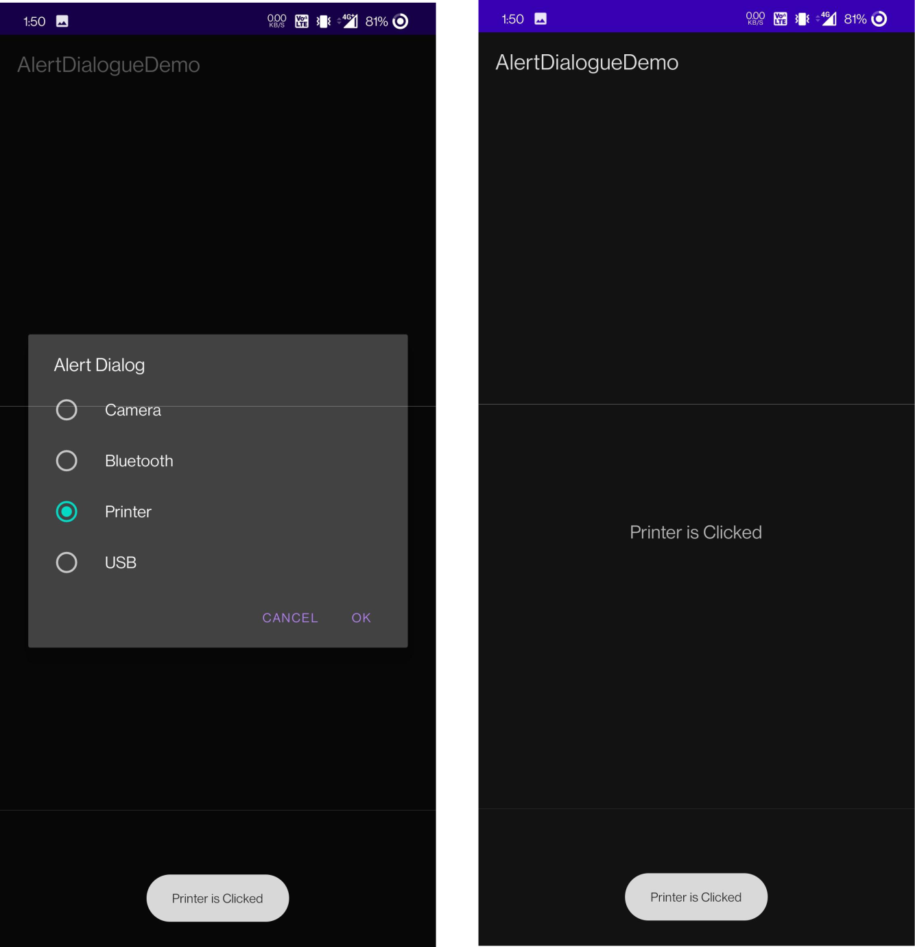
When Cancel is opted the Alert Dialog box gets Closed.
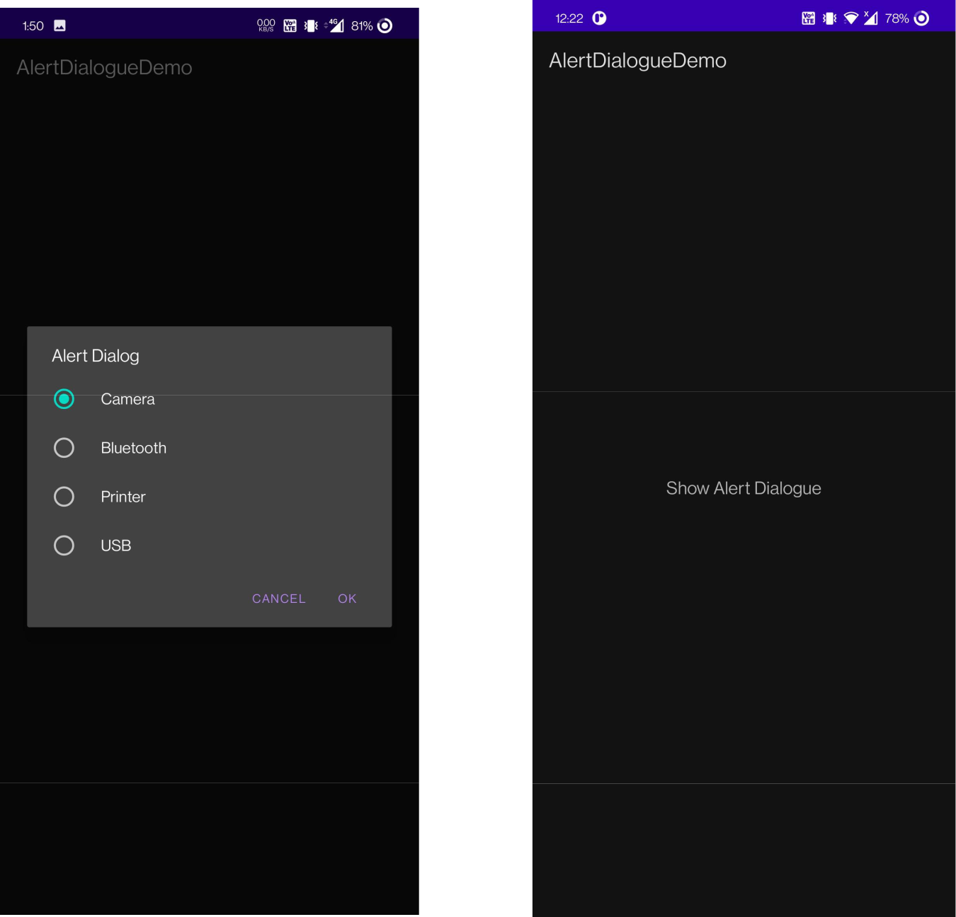
- Create below app for event management. When ever the button clock is pressed, an alertBox containing Timepicker should be loaded.On selecting the Time and clicked OK, the time should be displayed in editbox. On Clicking No, the dialog should dismiss with out setting the time
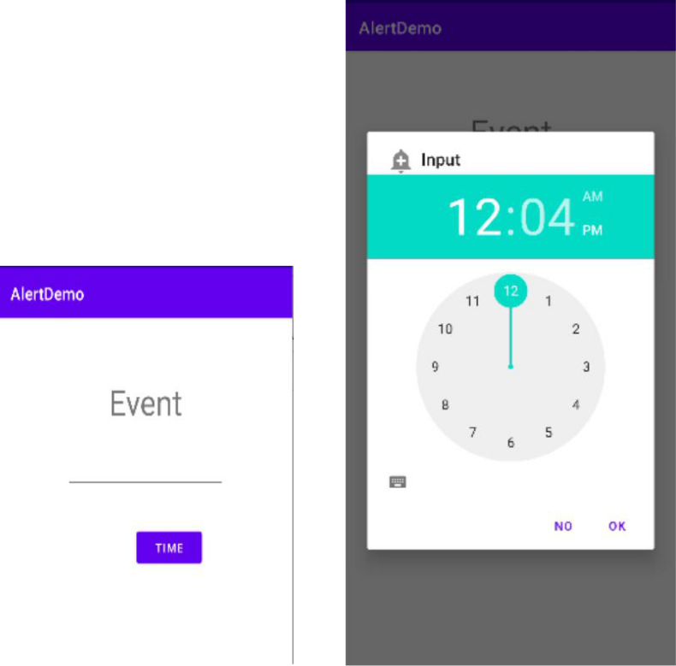

XML CODE:

<?xml version="1.0" encoding="utf-8"?>
<androidx.constraintlayout.widget.ConstraintLayout
xmlns:android="http://schemas.android.com/apk/res/android"
xmlns:app="http://schemas.android.com/apk/res-auto"
xmlns:tools="http://schemas.android.com/tools"
android:layout_width="match_parent"
android:layout_height="match_parent"
tools:context=".MainActivity">
<EditText
android:id="@+id/et1"
android:layout_width="163dp"
android:layout_height="43dp"
android:layout_marginStart="100dp"
android:ems="10"
android:inputType="textPersonName"
app:layout_constraintBottom_toBottomOf="parent"
app:layout_constraintStart_toStartOf="parent"
app:layout_constraintTop_toTopOf="parent"
app:layout_constraintVertical_bias="0.569" />
<EditText
android:id="@+id/et2"
android:layout_width="161dp"
android:layout_height="42dp"
android:layout_marginStart="100dp"
android:ems="10"
android:inputType="textPersonName"
app:layout_constraintBottom_toBottomOf="parent"
app:layout_constraintStart_toStartOf="parent"
app:layout_constraintTop_toTopOf="parent"
app:layout_constraintVertical_bias="0.667" />
<EditText
android:id="@+id/et3"
android:layout_width="160dp"
android:layout_height="40dp"
android:layout_marginStart="100dp"
android:ems="10"
android:inputType="textPersonName"
app:layout_constraintBottom_toBottomOf="parent"
app:layout_constraintStart_toStartOf="parent"
app:layout_constraintTop_toTopOf="parent"
app:layout_constraintVertical_bias="0.765" />
<TextView
android:id="@+id/textView"
android:layout_width="wrap_content"
android:layout_height="wrap_content"
android:layout_marginTop="165dp"
android:text="Time Picker"
android:textSize="20sp"
app:layout_constraintEnd_toEndOf="parent"
app:layout_constraintStart_toStartOf="parent"
app:layout_constraintTop_toTopOf="parent" />
<TextView
android:id="@+id/textView2"
android:layout_width="wrap_content"
android:layout_height="wrap_content"
android:layout_marginStart="32dp"
android:text="Event 1"
android:textSize="16sp"
app:layout_constraintBaseline_toBaselineOf="@+id/et1"
app:layout_constraintStart_toStartOf="parent" />
<TextView
android:id="@+id/textView3"
android:layout_width="wrap_content"
android:layout_height="wrap_content"
android:layout_marginStart="36dp"
android:text="Event 2"
android:textSize="16sp"
app:layout_constraintBaseline_toBaselineOf="@+id/et2"
app:layout_constraintStart_toStartOf="parent" />
<TextView
android:id="@+id/textView4"
android:layout_width="wrap_content"
android:layout_height="wrap_content"
android:layout_marginStart="36dp"
android:layout_marginBottom="10dp"
android:text="Event 3"
android:textSize="16sp"
app:layout_constraintBottom_toBottomOf="@+id/et3"
app:layout_constraintStart_toStartOf="parent" />
<Button
android:id="@+id/bt1"
android:layout_width="wrap_content"
android:layout_height="wrap_content"
android:layout_marginEnd="34dp"
android:text="SET"
app:layout_constraintBottom_toBottomOf="@+id/et1"
app:layout_constraintEnd_toEndOf="parent" />
<Button
android:id="@+id/bt2"
android:layout_width="wrap_content"
android:layout_height="wrap_content"
android:layout_marginEnd="34dp"
android:text="SET"
app:layout_constraintBottom_toBottomOf="@+id/et2"
app:layout_constraintEnd_toEndOf="parent" />
<Button
android:id="@+id/bt3"
android:layout_width="wrap_content"
android:layout_height="wrap_content"
android:layout_marginEnd="34dp"
android:text="SET"
app:layout_constraintBottom_toBottomOf="@+id/et3"
app:layout_constraintEnd_toEndOf="parent" />
</androidx.constraintlayout.widget.ConstraintLayout>

Java Code:

package com.example.timepicker;
import androidx.appcompat.app.AppCompatActivity;
import android.app.TimePickerDialog;
import android.os.Bundle;
import android.view.View;
import android.widget.Button;
import android.widget.EditText;
import android.widget.TimePicker;
public class MainActivity extends AppCompatActivity
{
EditText e1,e2,e3;
Button b1,b2,b3;
TimePickerDialog timePickerDialog;
//Calendar calendar;
int hr;
int min;
String amPm;
@Override
protected void onCreate(Bundle savedInstanceState)
{
super.onCreate(savedInstanceState);
setContentView(R.layout.activity_main);
e1=findViewById(R.id.et1);
e2=findViewById(R.id.et2);
e3=findViewById(R.id.et3);
b1=findViewById(R.id.bt1);
b2=findViewById(R.id.bt2);
b3=findViewById(R.id.bt3);
b1.setOnClickListener(new View.OnClickListener()
{
@Override
public void onClick(View view)
{
timePickerDialog = new TimePickerDialog(MainActivity.this, new TimePickerDialog.OnTimeSetListener()
{
@Override
public void onTimeSet(TimePicker timePicker, int ihr, int imin)
{
if(ihr >= 12)
{
amPm = " PM";
}
else
{
amPm = " AM";
}
e1.setText(String.format("%02d:%02d",ihr,imin) + amPm);
}
},hr,min,false);
timePickerDialog.show();
}
});
b2.setOnClickListener(new View.OnClickListener()
{
@Override
public void onClick(View view)
{
timePickerDialog = new TimePickerDialog(MainActivity.this, new TimePickerDialog.OnTimeSetListener()
{
@Override
public void onTimeSet(TimePicker timePicker, int ihr, int imin)
{
if(ihr >= 12)
{
amPm = " PM";
}
else
{
amPm = " AM";
}
e2.setText(String.format("%02d:%02d",ihr,imin) + amPm);
}
}, hr, min, false);
timePickerDialog.show();
}
});
b3.setOnClickListener(new View.OnClickListener()
{
@Override
public void onClick(View view)
{
timePickerDialog = new TimePickerDialog(MainActivity.this, new TimePickerDialog.OnTimeSetListener()
{
@Override
public void onTimeSet(TimePicker timePicker, int ihr, int imin)
{
if(ihr >= 12)
{
amPm = " PM";
}
else
{
amPm = " AM";
}
e3.setText(String.format("%02d:%02d",ihr,imin) + amPm);
}
},hr,min,false);
timePickerDialog.show();
}
});
}
}

Output:

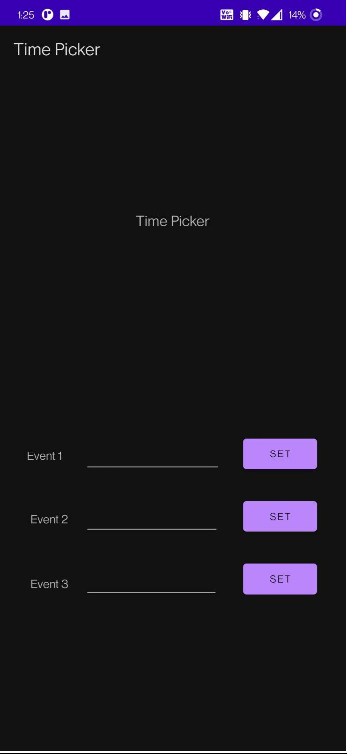
After Clicking Set, Time picker opens After pressing Ok, Time displays on edit Text
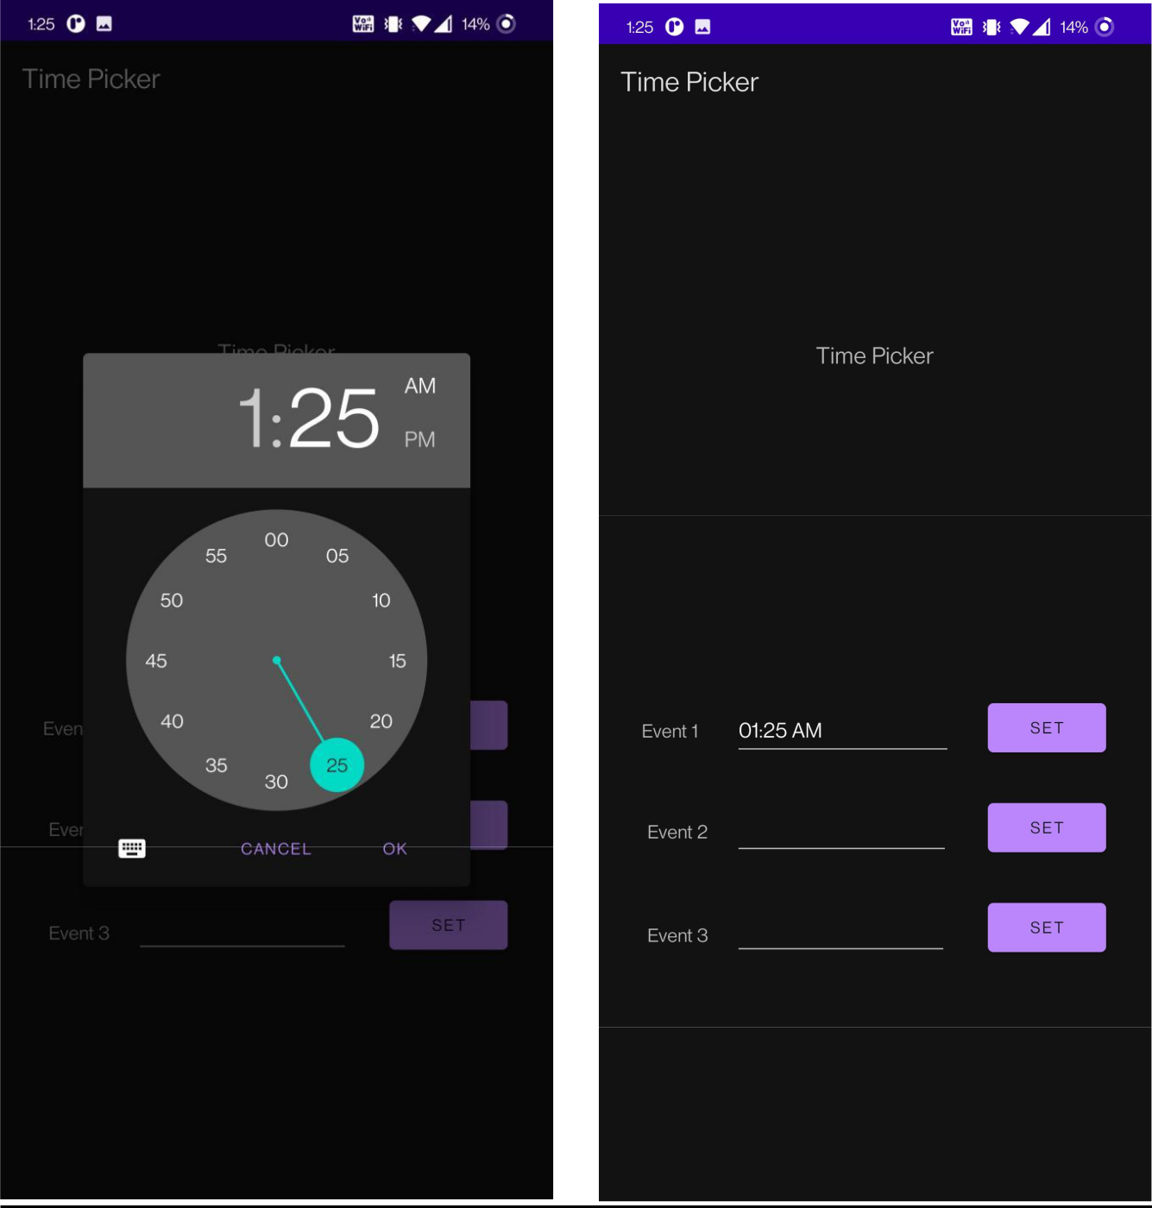
After Clicking set again and clicking Cancel Button, dismisses without taking time input.

