**NAME: GVS SAI MADHAV**

**REG.NO: 19BCN7228**

**SUBJECT: NETWORK PROGRAMMING**

**LAB-1:**

**Serverinterface.java:**

import java.rmi.*;

import java.rmi.server.*;

public interface servinterface extends *Remote*

{

      public *double* add(*double* *a*,*double* *b*) throws *RemoteException*;

      public *double* sub(*double* *a*,*double* *b*) throws *RemoteException*;

      public *double* mul(*double* *a*,*double* *b*) throws *RemoteException*;

      public *double* div(*double* *a*,*double* *b*) throws *RemoteException*;

      public *double* mod(*double* *a*,*double* *b*) throws *RemoteException*;

 }

**servimpl.java:**

import java.rmi.*;

import java.rmi.server.*;

public class servimpl extends *UnicastRemoteObject* implements servinterface

  {

    public servimpl() throws *RemoteException*

    {

       super();

    }

    public *double* add(*double* *a*,*double* *b*)

    {

       return(a+b);

    }

    public *double* sub(*double* *a*,*double* *b*)

    {

       return(a-b);

    }

    public *double* mul(*double* *a*,*double* *b*)

    {

       return(a*b);

    }

    public *double* div(*double* *a*,*double* *b*)

    {

       return(a/b);

    }

    public *double* mod(*double* *a*,*double* *b*)

    {

       return(a%b);

    }

  }

**server.java**

import java.rmi.*;

 import java.rmi.server.*;

 import java.rmi.registry.*;

 public class server extends servimpl

 {

      public server() throws *RemoteException*

      {

      }

      public static *void* main(*String* *args*[]) throws *RemoteException*

      {

           try

           {

*Registry* reg = LocateRegistry.createRegistry(9999);

                servimpl s = new servimpl();

                reg.rebind("Server",s);

                System.out.println("Server is ready!");

           }

           catch(*Exception* *e*)

           {

                System.out.println(e);

           }

      }

 }

**client.java**

import java.rmi.*;

import java.rmi.server.*;

import java.rmi.registry.*;

public class client

 {

      public static *void* main(*String* *args*[])throws *RemoteException*

      {

           try

           {

*int* a = Integer.parseInt(args[0]);

*int* b = Integer.parseInt(args[1]);

*Registry* reg=LocateRegistry.getRegistry("127.0.0.1",9999);

                servinterface i = (servinterface)reg.lookup("Server");

                System.out.println("First number: "+a);  System.out.println("Second number: "+b);

                System.out.println("Add:\t"+i.add(a,b));

                System.out.println("Sub:\t"+i.sub(a,b));

                System.out.println("Mul:\t"+i.mul(a,b));

                System.out.println("Div:\t"+i.div(a,b));

                System.out.println("Mod:\t"+i.mod(a,b));

           }

           catch(*Exception* *e*)

           {

                System.out.println(e);

           }

      }

}

**Execution:**

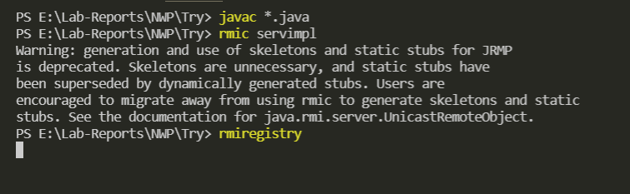

**Starting the server:**

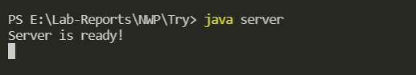

**Executing the client:**

