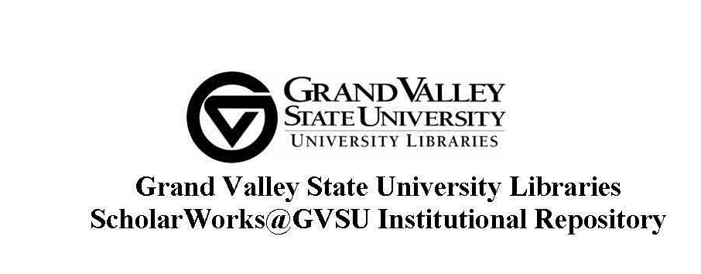

**Thesis Submission Agreement**

I agree to grant the Grand Valley State University Libraries the non-exclusive right to distribute my submitted thesis ("the Work") over the Internet and make it part of ScholarWorks@GVSU (scholarworks.gvsu.edu). *Non-exclusive means that you retain the copyrights to your work.*

ScholarWorks@GVSU is an open-access repository maintained by the Grand Valley State University (GVSU) Libraries that showcases and maintains scholarship produced by faculty, researchers, and students. ScholarWorks@GVSU is administered by the GVSU Libraries, with the goal of organizing, preserving, and increasing the impact of scholarly and creative work at Grand Valley State University.

I warrant as follows:

1. I hold the copyright to this work, and agree to permit this work to be posted in the ScholarWorks@GVSU institutional repository.
2. I understand that accepted works may be posted immediately as submitted, unless I request otherwise.
3. I have read, understand, and agree to abide by the policies of the ScholarWorks@GVSU Institutional Repository (http://scholarworks.gvsu.edu/about.html).

Title of thesis:

Signature of author: Date:

Printed name of author:



**Embargo Option:** *(For up to three years from the date it is submitted to ScholarWorks, you may elect to restrict electronic access to your work. Upon the expiration of the embargo, content will automatically become available.)*

Length of Embargo:

**Keywords:** *(six relevant words to describe the content of your thesis)*