<Application (or) Product name> - Solution Design Template

Contents
- Contents
- Introduction
  - Reference documents
  - Principles, Standards, Best Practices and Regulatory Guidelines
- Overview
  - Business context
  - Solution Overview Model (System View)
  - Solution description
- Process & Functional view
  - High Level Process Flows [EPC’s]
  - Functional Solution Design
    - Solution Diagram
    - Solution Components
- Application View
- API, Integration and Data View
- Deployment View
- Non-functional View & Design
  - Reconciliation Design
  - Reporting Design for MI & BI
  - Resilience & High Availability Design
  - Scaling and Capacity Specifications & Design
  - Backup & Recovery Design
  - Security Design
- Service and Support View - Operational Design
  - Service Design
  - Monitoring & Alerting Design
  - 24x7 Support Requirements
  - Recovery Design
- Appendix
  - Architecture Design Decisions
  - Technical Debts
  - RAID Log
    - Risks
    - Assumptions
    - Issues
    - Dependencies

Introduction
The document purpose is to describe the architectural components involved in the solution and to provide architecture level design and guidance for the delivery teams during detailed design and implementation.
Change log
Date | Version | Change Summary | Project Phase
<Please update> | <Start with 0.1 for Draft> | <Please add a summary of change for this version> First draft | <Specify the project phase>
Review/Authorisation log
Area | Stakeholder | Version | Review Date | Reviewed
Architecture Review | Samuel Jeyakumar | <insert version> | <specify date> | <Status of review>
Security Review | Chaitanya Duddu & Chris Kolade | <insert version> | <specify date>
Data Compliance Review
Service Operations
Supplier Review

Reference documents
Document | Version | Location
Cloud Security Design Principles | Live Published Version | Cloud Office - Confluence
Non-Functional Requirements | Live Published Version | Architecture - Central Confluence

Principles, Standards, Best Practices and Regulatory Guidelines
Principles:
Design Principle 1:
Design Principle 2:
Design Principle 3:
Design Principle (n):
Standards:
These documents reflect the latest standards and guidelines, which the solution design and subsequent development should adhere to, where applicable.
Industry Best Practices and Regulatory Guidelines
This design prescribes to the following industry best practices:
- Adherance to compliance and best practices as recommended by
The following regulatory guidelines and advisory notes are adhered to in this design:
- Guidline 1 reference
- …

Overview
Scope
- <blah blah blah>
- <blah blah blah>
Out of scope
- <blah blah blah>
- <blah>

Business context
Post Office branch data is currently mastered in MDM. There are a number of aspects of data related to branches that are modelled

Solution Overview Model (System View)
The below (capability) model shows a high level solution view for <application/platform/product name> including all impacted and peripheral system capabilities.

Solution description
Option 2 from the previous CTO deck (in the document references) is now the recommendation for the solution. Eventually, under SPM, the right platforms will be procured and integrated to manage the business processes that create and maintain the required core data. At a high level, this is the architectural approach:

Process & Functional view
Relevant data about locations to this solution design is captured in a number of key tables within MDM. The data is then transformed to the location data service data model (assuming option 2 of KDD-1 is adopted).

High Level Process Flows [EPC’s]
Please show the high level business process flows for this solution design.
Process diagram 1:
A high level process flow of the solution in context.
Note: For system flows and data flows, use the same flow diagram to show how data / system information flows in your solution. For application designs, use this diagram to show the various process flows the application supports.
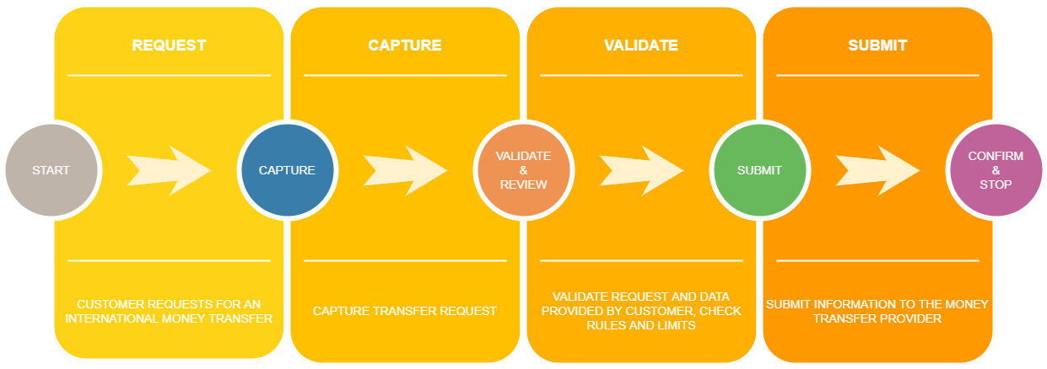
Process diagram description:
The above flow shows the key business process flow in context. The process also shows the various steps involved in the process. The below solution describes how this solution will be implemented.
(repeat the diagram and description sections for each process within the context of this solution)

Functional Solution Design
- Please provide solution design diagram(s) showing all components involved in the applications/platforms that are involved in the end to end solution design.
- Show all application to application connectivity in the solution.
- In the section below explain the role of each solution component

Solution Diagram
<Insert the big solution design diagram here…>

Solution Components
<In this section, list out each of the component used in the above solution design diagram and describe the components role>

Application View
Application View

API, Integration and Data View
The high level data models and transformations are already described in the design document.

Deployment View
Deployment diagram of production across e.g. availability zones and regions (can be logical)

Non-functional View & Design
This section should highlight and show the design that meets the NFRs for the solution. (Although part of the overall NFR’s, Security, Support views are covered below over separate sections)

Reconciliation Design
- Show the process used for reconciliation for this product/solution.
- Describe people/process and technology used in reconciliation.
- Describe the various scenarios that may result as a result of reconciliation.

Reporting Design for MI & BI
- Add a diagram that shows how reporting work for this solution, show both BI and MI reporting.
- Describe the diagrams and explain the role of each solution component used in the diagram.
Note: Operational reporting is covered under support and operational view.

Resilience & High Availability Design
- Add a network/infrastructure including a diagram showing all solution components that describe how resilience is achieved.
- Describe how the end to end architectural components are highly available by design to support the required capacity/scalability requirements.
- Describe how data and software are backed up and restored to fulfil service recovery.

Scaling and Capacity Specifications & Design
- Please list all scalability and capacity requirements/spec
- Describe how the solution meets the requirements across the end to end process (including people and technology).

Backup & Recovery Design
- Please specify backup requirements for data and application config.

Security Design
What are the high level security considerations? Describe potential impact areas, e.g. In PCI scope, Sensitive data, Third parties. Is the information subject to any external governance and compliance regime data, specific law, contract obligations etc.)?
Should show a data flow diagram and depict how information flows through systems.
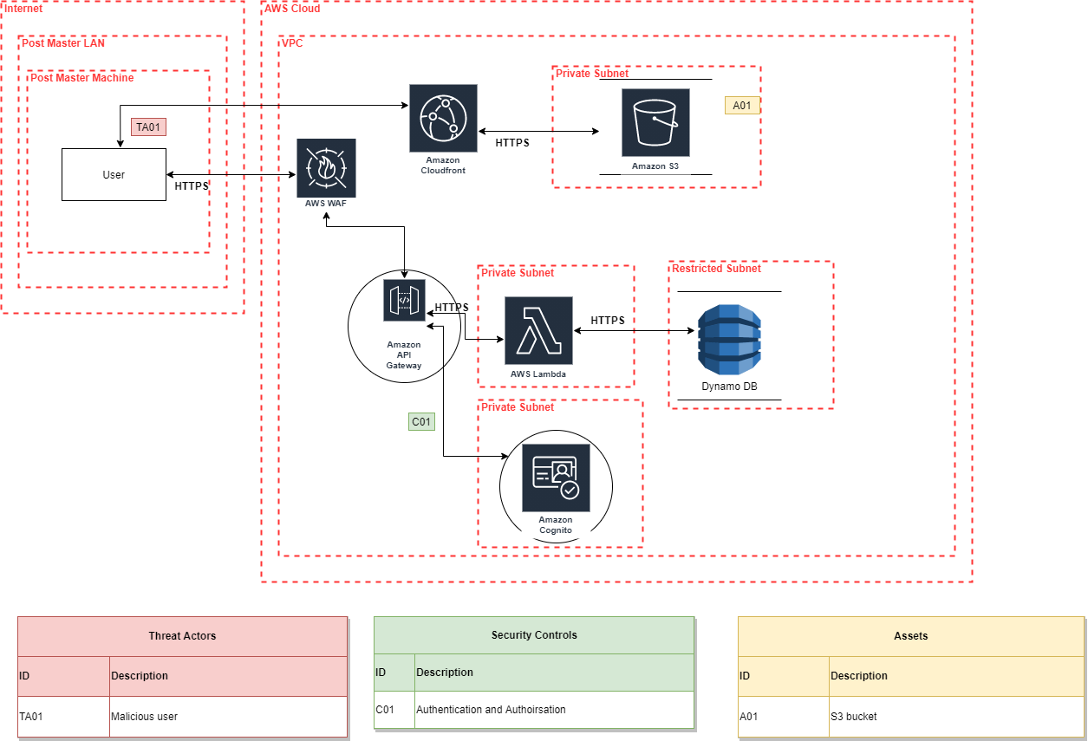
Once DFD is complete, perform STRIDE threat modelling, identify threat actors and create threat table.

Service and Support View - Operational Design

Service Design

Monitoring & Alerting Design

24x7 Support Requirements

Recovery Design

Appendix

Architecture Design Decisions
ID | Architecture Issue | Options | Decision and Rationale | Approval Authority and Status

Technical Debts
ID | Technical Debt | Description | Tech Debt Register ID | Status

RAID Log

Risks
ID | Risk Description | Risk Score | Mitigation
1
2

Assumptions
ID | Assumption | Comments
1
2

Issues
ID | Issue Description

Dependencies
ID | Dependency | Comments
← End of Design →

