Laboratory work #1

Submission format: word or pdf document containing screenshots of your tasks with answers that covers full-page (Alt+PrtSc).

1. Create following tables with corresponding attributes (30 %):

* Airline_info: airline_id (int), airline_code (varchar (30)),airline_name (varchar(50)),airline_country(varchar(50)), created_at(timestamp), updated_at(timestamp), info(varchar(50)) ;

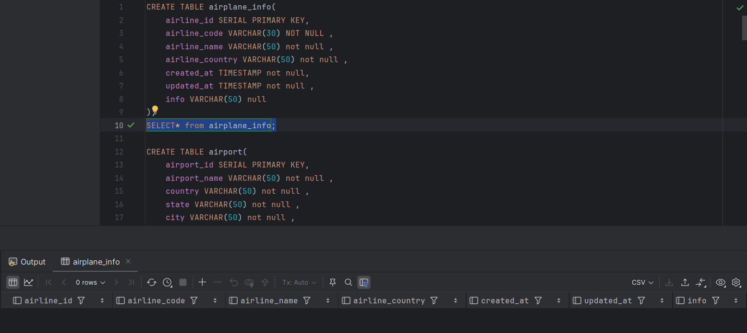

* Airport: airport_id(int), airport_name (varchar(50)),country (varchar(50)), state (varchar(50)), city(varchar(50)), created_at(timestamp), updated_at(timestamp) ;

* Baggage_check: baggage_check_id(int), check_result (varchar(50)), created_at(timestamp), updated_at(timestamp), booking_id(int), passenger_id(int);

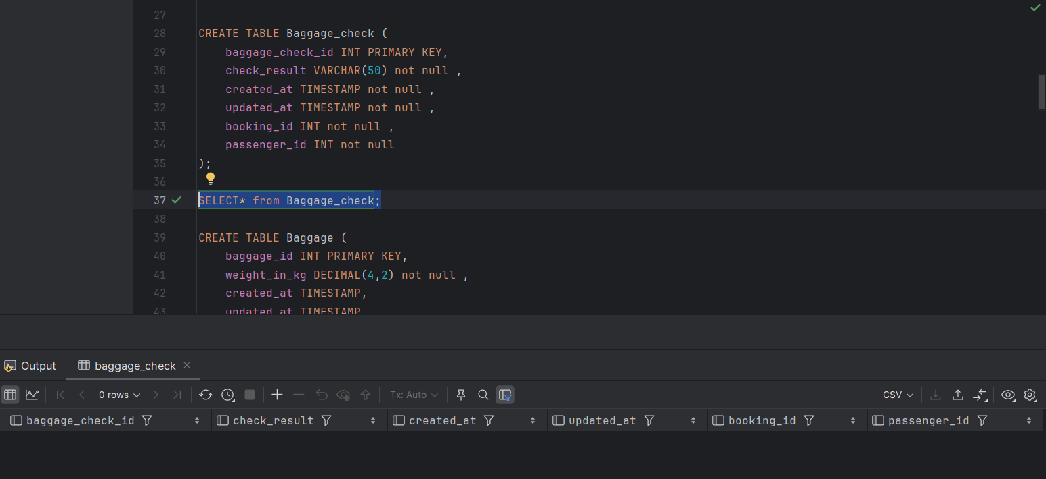

* Baggage: baggage_id(int), weight_in_kg (decimal(4,2)), created_at(timestamp, updated_at(timestamp) , booking_id(int);

* Boarding_pass: boarding_pass_id(int), booking_id(int), seat (varchar(50)), boarding_time(timestamp), created_at(timestamp), updated_at(timestamp);

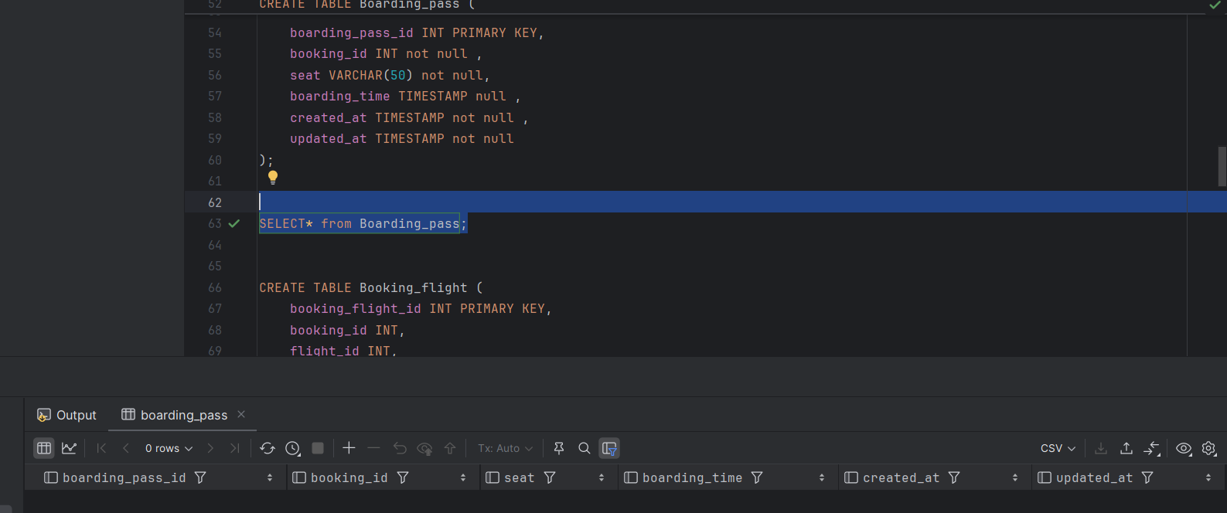

* Booking_flight: booking_flight_id(int), booking_id(int), flight_id(int), created_at(timestamp), updated_at(timestamp);

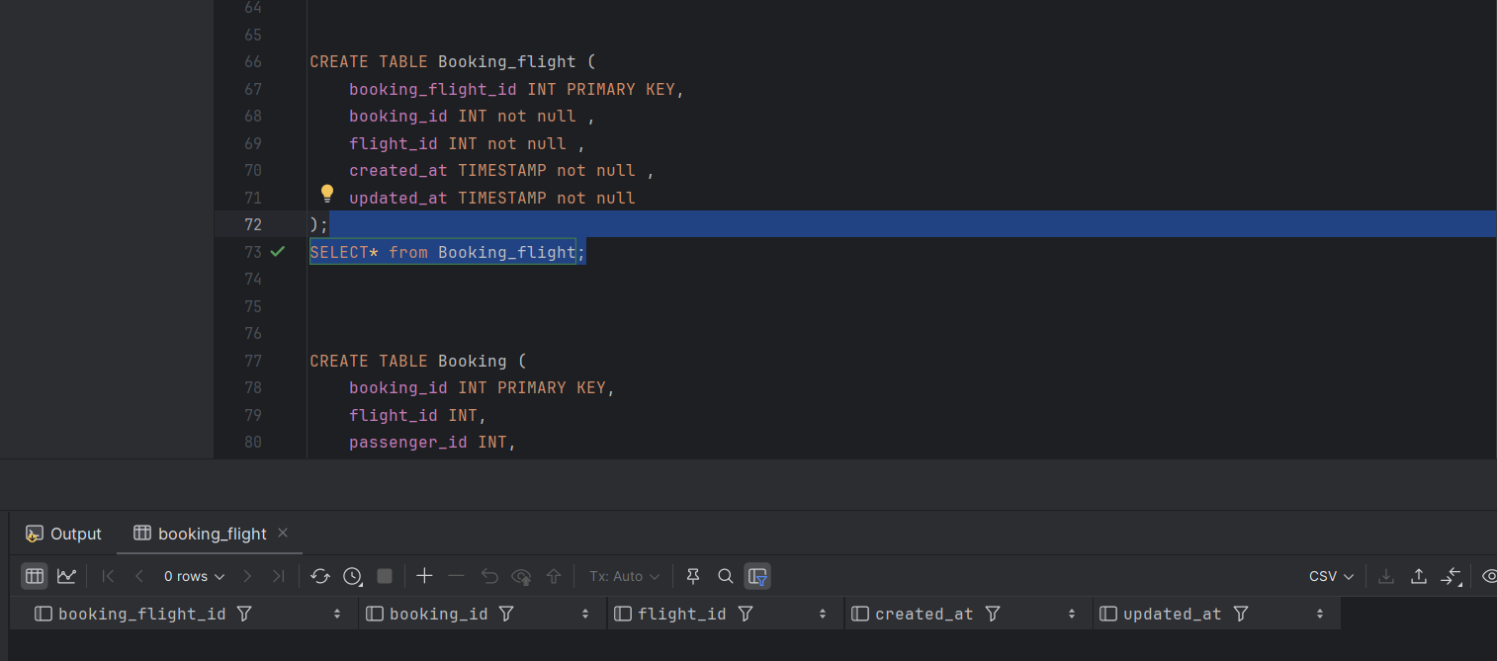

* Booking: booking_id(int), flight_id(int), passenger_id(int), booking_platform(varchar(50)), created_at(timestamp), updated_at(timestamp), status(varchar(50)), price(decimal(7,2));

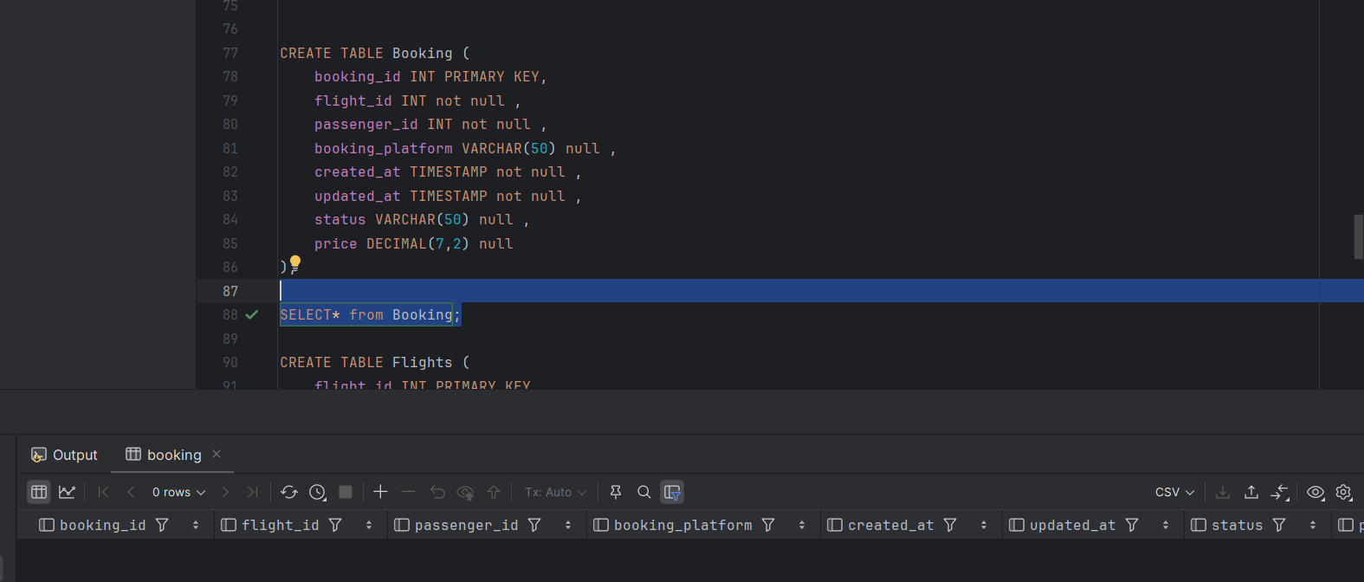

* Flights: flight_id(int), sch_departure_time(timestamp), sch_arrival_time(timestamp), departing_airport_id(int), arriving_airport_id(int), departing_gate(varchar(50)), arriving_gate(varchar(50)), airline_id(int), act_departure_time(timestamp), act_arrival_time(timestamp), created_at(timestamp), updated_at(timestamp) ;

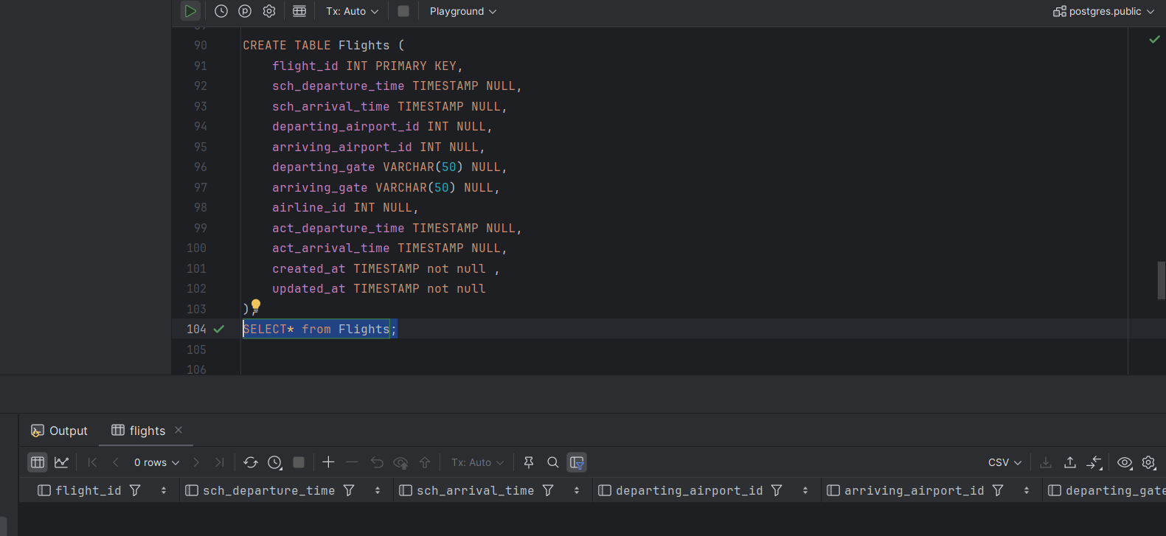

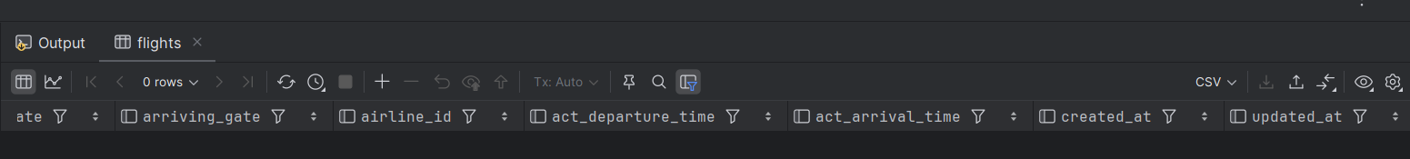

* Passengers: passenger_id(int), first_name(varchar(50)), last_name(varchar(50)), date_of_birth(date), gender(varchar(50)), country_of_citizenship(varchar(50)), country_of_residence(varchar(50)), passport_number(varchar(20)), created_at(timestamp), updated_at(timestamp) ;

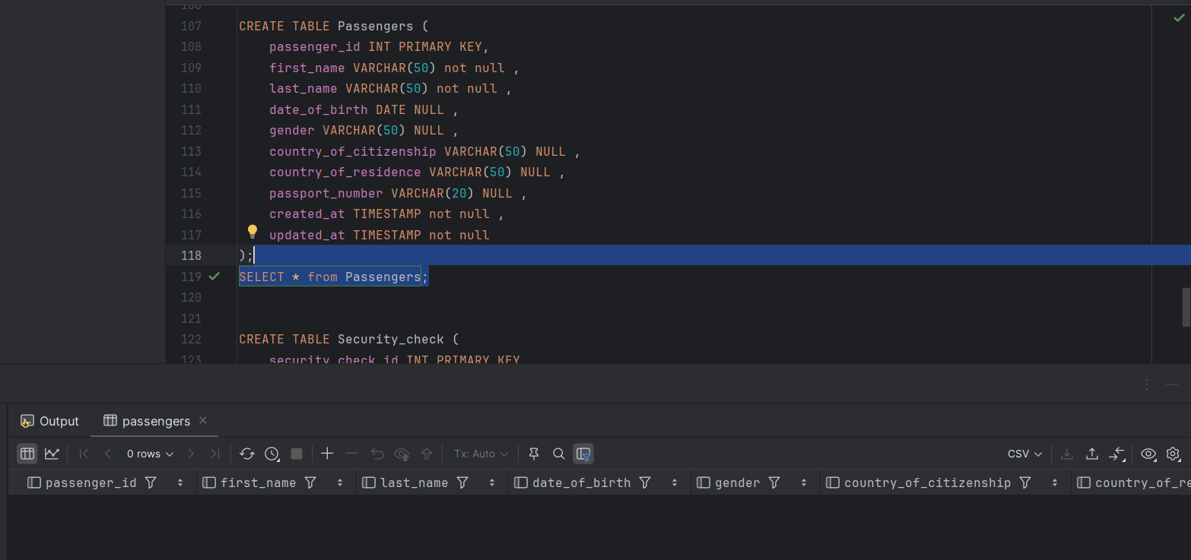

* Security_check: security_check_id(int), check_result(varchar(20)), created_at(timestamp), updated_at(timestamp), passenger_id(int);

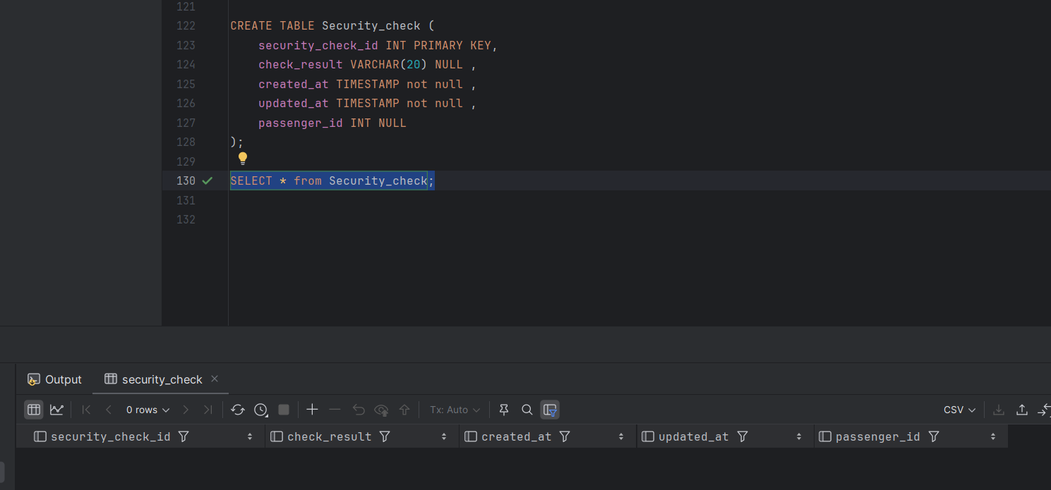

1. Define Primary Keys for each tables (15%);
2. Define for all attributes null, not null constraint(15%);
3. Rename airline_info table to airline (10%).

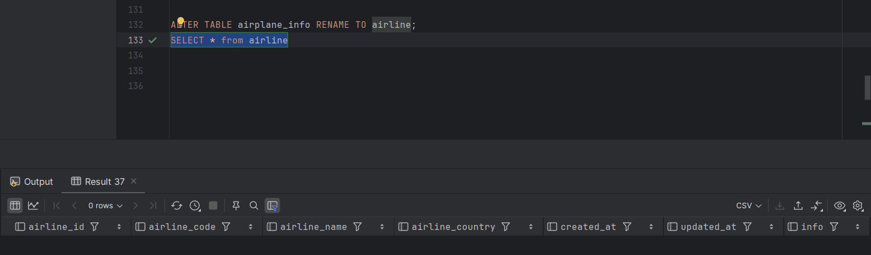

1. Rename column price to ticket_price (10%)

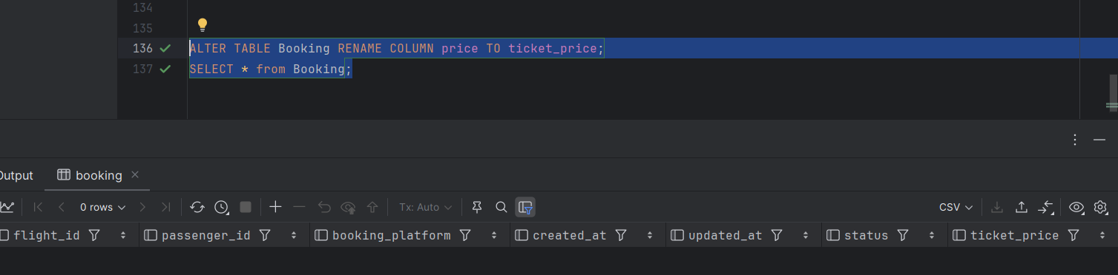

1. Change data type of departing_gate(varchar(50)) from varchar(50) to text (10%);

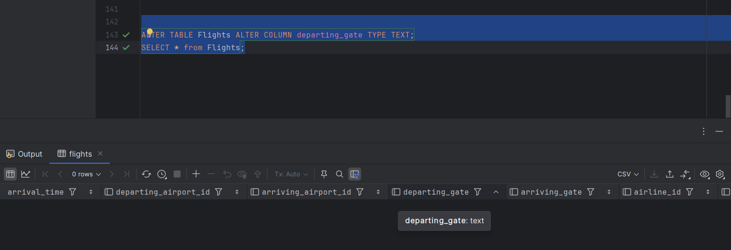

1. Drop the column info(varchar(50)) from the airline table (10%).

