**Laboratory work 2**

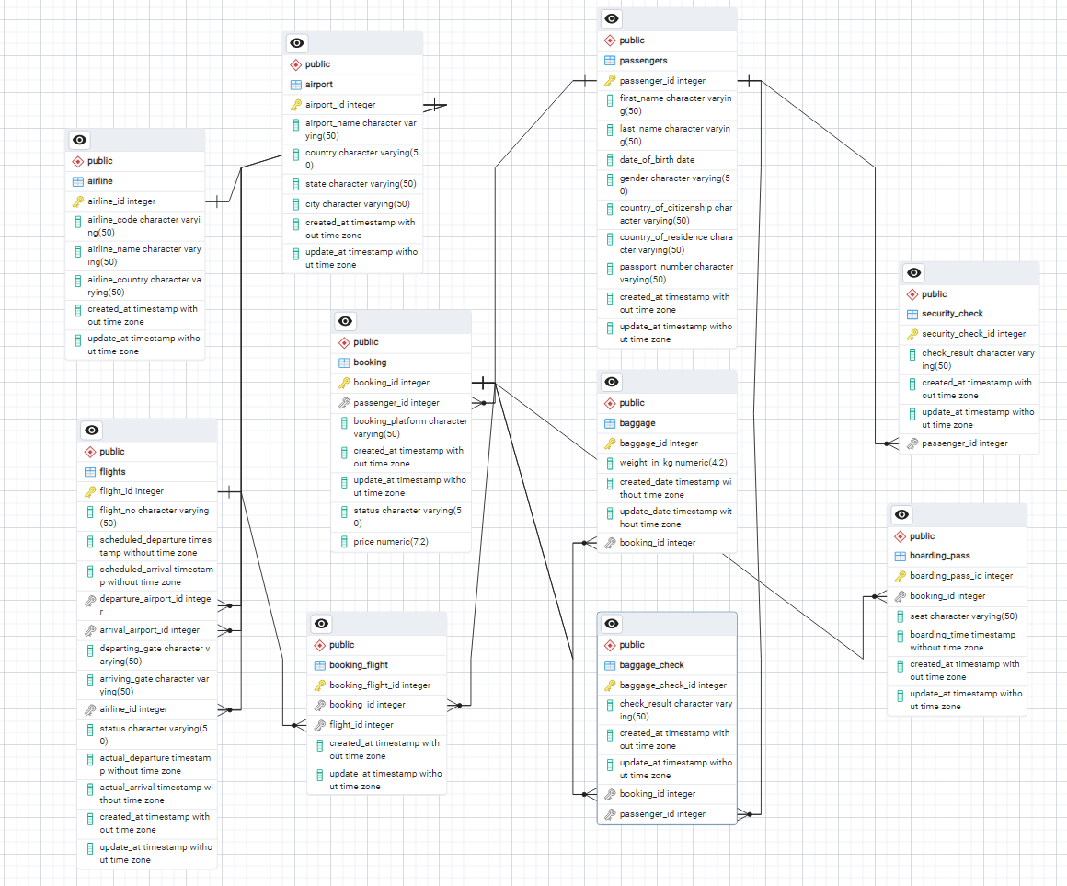

Make a relationship between following tables **(20%):**

- Passengers with Secuitiry_check, Booking, Baggage_check by passenger_id;

-Booking with Baggage_check, Baggage, Boarding_pass, Booking_flight by booking_id;

- Flights with Booking_flight by flight_id;

- Airport with Flights by departing_airport_id;

- Airport with Flights by arriving_airport_id;

- Airline with Flights by airline_id;

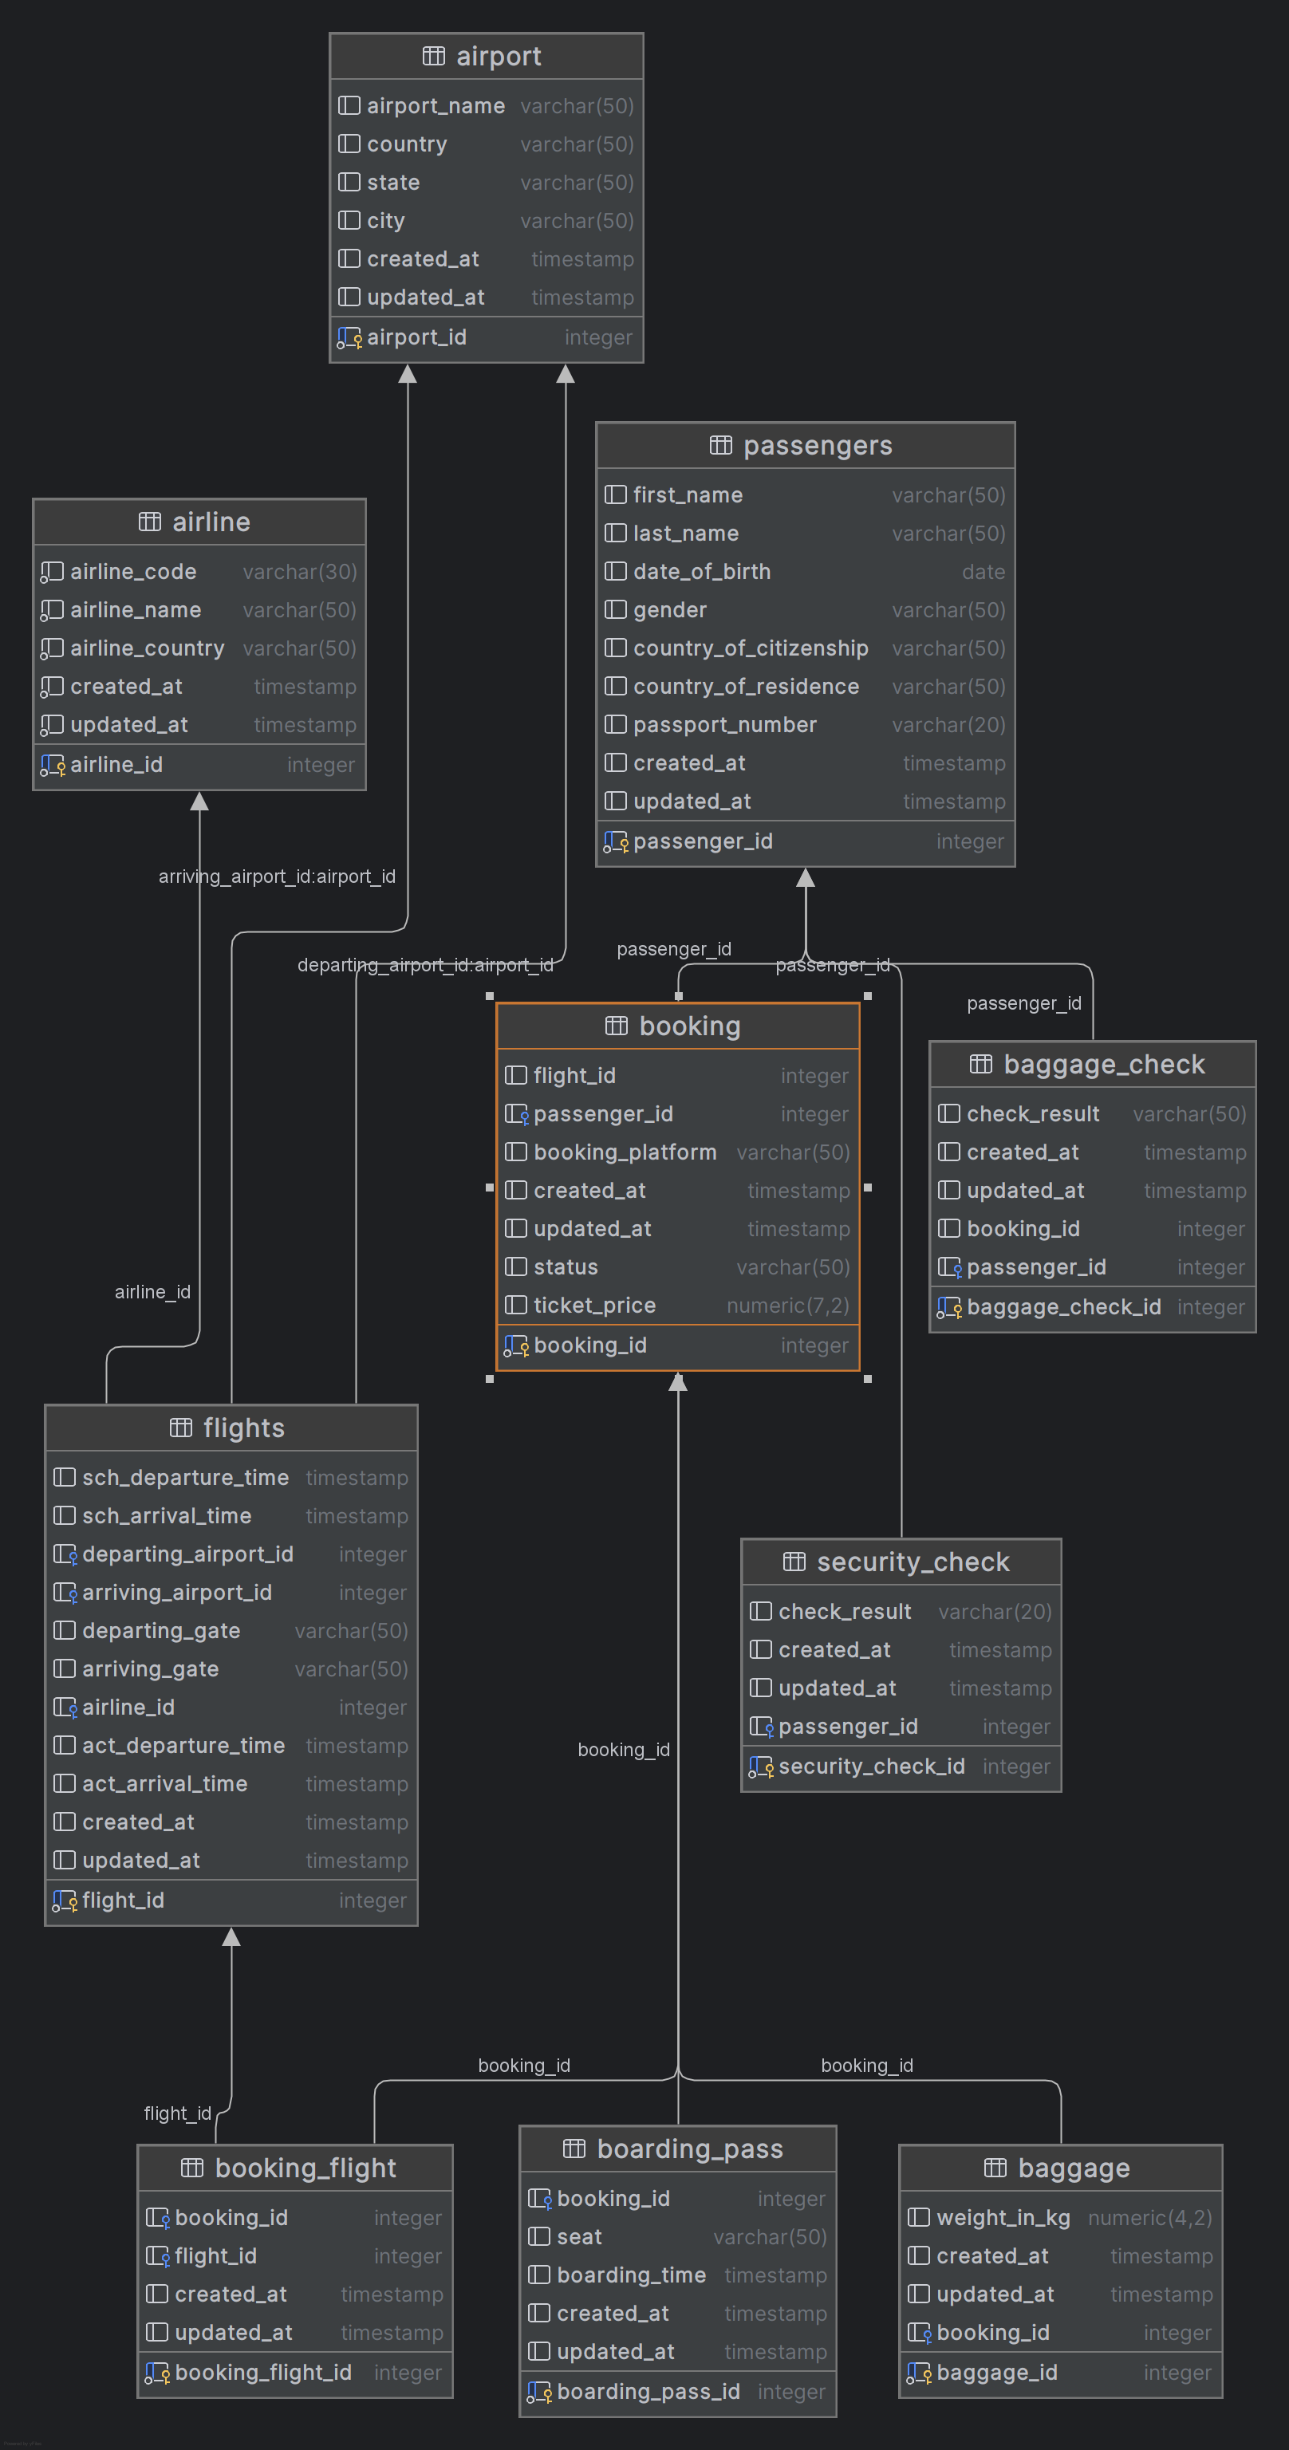

**DML – Data Manipulation Language**

1. Generate and insert 100 random rows in your airline database using mockaroo service (https://www.mockaroo.com/).**(10%)**
2. Add a new airline named "KazAir" based in "Kazakhstan" to the airline table.(**10%** )

insert into Airline (airline_id, airline_code, airline_name, airline_country, created_at, updated_at)  
values (101, 'KZA', 'KazAIR', 'Kazakhstan', '12-02-2024', '01-01-2024');



1. Update the airline country "KazAir" to "Turkey".(**10%** )

UPDATE Airline  
SET airline_country = 'Turkey'  
WHERE airline_name = 'KazAIR';



1. Remove the airline named "SIT" from the airline table. (**10%** )

DELETE FROM Airline  
WHERE airline_name = 'Don Miguel';

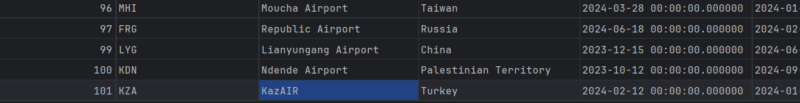

1. Add three airlines at once: "AirEasy" in "France", "FlyHigh" in "Brazil" and "FlyFly" in "Poland". (**10%** )

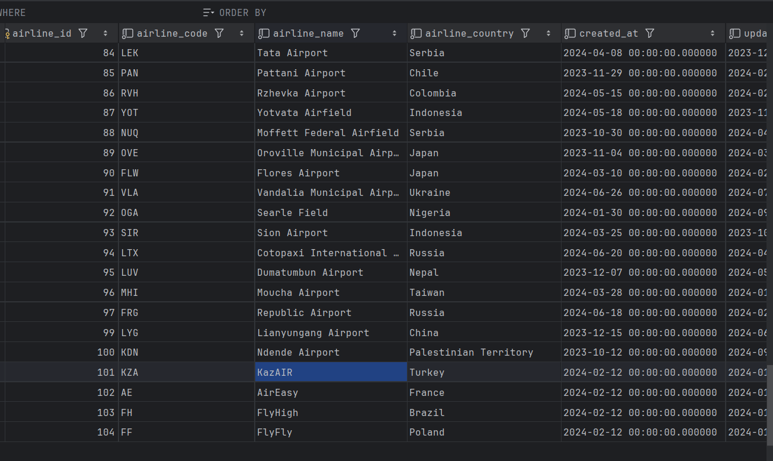

INSERT INTO Airline (airline_id, airline_code, airline_name, airline_country, created_at, updated_at)  
VALUES  
 (102, 'AE', 'AirEasy', 'France', '2024-02-12', '2024-01-01'),  
 (103, 'FH', 'FlyHigh', 'Brazil', '2024-02-12', '2024-01-01'),  
 (104, 'FF', 'FlyFly', 'Poland', '2024-02-12', '2024-01-01');

1. Delete all flights whose arrival in 2024 year. (**10%** )

DELETE FROM airline

WHERE EXTRACT(YEAR FROM updated_at) = 2023

1. Increase the price of all tickets in booking table for flights by 10%.(**10%** )

UPDATE Booking

SET ticket_price = ticket_price * 1.10;

1. Delete all tickets whose price is less than 1000 units. (**10%** )

DELETE FROM Booking

WHERE ticket_price < 1000;