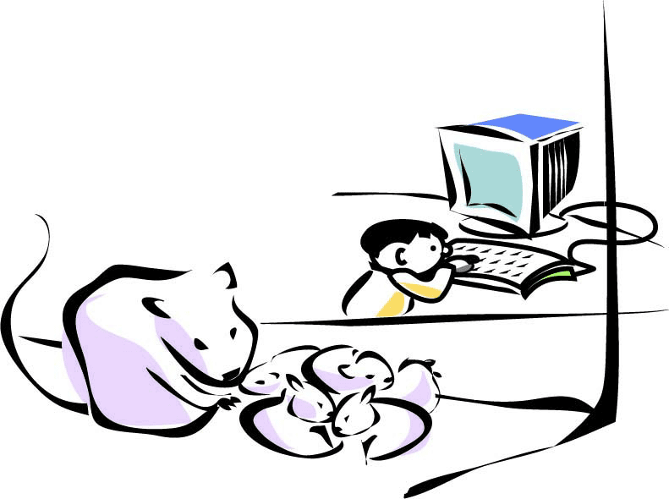 | Aaron's hamster had just had babies. They lay against their mother in the bottom of their cage. Each one was smaller than his thumbnail.  "What should I call them?" Aaron asked his mother.  "I don't know," his mother said. "But your grampa might. Why don't you ask him?"  So Aaron sat down at the computer and typed:

From: aaron@frobble.com
To: grampa@squiggle.com
Dear Grampa,
How are you? My hamster had six babies yesterday. Can you please help me think of names for them?
Love,
Aaron

Aaron clicked on the Send button. Then he went to look at his hamsters again. Here's what happened next…
Click went the D key. Click went the e. A little jolt of electricity tickled the computer each time. Each tickle told the computer what letter Aaron had typed. The computer put the letters side by side in its memory, and drew them on the screen for Aaron to see.
Then Aaron moved the mouse. The ball in the mouse turned a little wheel. More electricity tickled the computer. "Up!" the little tickles told the computer. "Up again! Left! Left! Left!" The computer drew a little arrow on the screen each time it was tickled.
Aaron clicked the Send button. "Aha!" the computer thought. "He wants to send the message. That's the modem's job."
The computer took the letters and gave them to the modem one by one. The modem hummed a little tune into the phone line for each letter: bee boo brr… Another computer called frobble.com heard those little tunes. It knew that each one meant a different letter. When frobble.com heard bee, it put a D in its memory. When it heard boo, it put an e. | 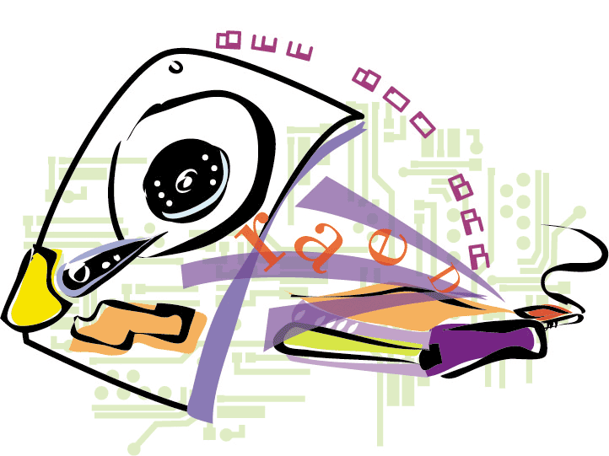
Aaron's computer finally went bleep to tell frobble.com that the message was done. frobble.com bleeped back, then read the top of the message. It didn't know where squiggle.com was, but it knew a bigger computer that might.
That bigger computer was called splatto.net. It was connected to frobble.com by a thick cable that ran underground for blocks and blocks. Inside the cable were thousands of tiny threads of glass. Each thread was polished like a mirror. Instead of humming little tunes for the letters, frobble.com blinked a little laser beam on and off.
Zing! Zing! Zing! Little flashes of light went flying through the glass thread. Ping! Ping! Ping! The light bounced off the polished sides of the thread at every corner. One x bounced so hard that it got scrambled! It turned into an t, so that Aaron's message said, "My hamster had sit babies." frobble.com knew this might happen, though, so it did a clever thing. It added a few extra flashes of light to the message so that splatto.net could fix anything that went wrong.
splatto.net turned the flashes of light back into letters. Then it looked at the extra flashes that frobble.com had added. "Hm," it thought. It flipped the t over, so that sit became six again. "That's better!"
Now it was splatto.net's turn to read the message. It didn't actually know where squiggle.com was either, but it knew a computer called jellybean.net that did. That computer was right on the other side of the country! The quickest way to get Aaron's message there would be to send it into outer space.
splatto.net put Aaron's message in line for the big antenna. Scrunch! Scrunch! The big antenna scrunched each message into a little bundle of radio waves. Fling! It threw each message up into outer space.
Whee! The letters in Aaron's email flew straight up. Ka-boing! They bounced off a satellite twenty-three thousand miles high. Whoooaaaa! Down they came. | 
Whump! Another big antenna caught them, just like you would catch a rubber ball. It unscrunched the letters and gave the message to jellybean.net.
jellybean.net looked at the message. squiggle.com… squiggle.com… It knew two computers that were connected to squiggle.com. Both were very busy, though, so jellybean.net split Aaron's message in two. It sent one piece to one computer, and the other piece to the other.
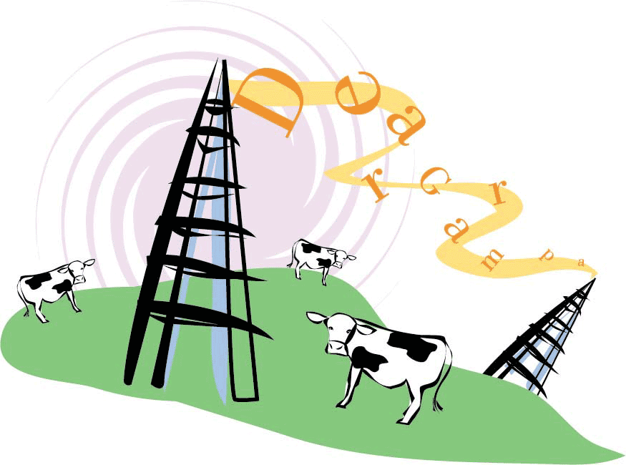 | Whoosh! Whizz! The first part of the message went under a city—through a TV antenna—and over a field full of cows. The other raced along beside the highway for miles and miles. It went so fast that the cars on the highway seemed to be standing still.
"This isn't for me!" each computer said when its half of the message arrived. "It's for squiggle.com. But I know where that is!" And off the two pieces of the message went again.
The second half of Aaron's email reached squiggle.com first. "Hm," thought squiggle.com. "I don't have the first half of this, so I can't tell who it's for. I'll just hang onto it." squiggle.com stuffed the message into its memory, then went back to its other chores.
The first half of Aaron's email arrived a few seconds later. " Now I know what to do with you!" squiggle.com said. "I'm supposed to give you to Grampa!"
But Grampa was not on-line. He was out picking apples. So squiggle.com put Aaron's email in a little file on its hard drive to keep it safe.
Round and round the message went, thousands and thousands of times, as it waited for Grampa to get on-line. Hundreds of other files went round and round with it: messages, pictures, games, and even a recipe for spaghetti sauce. | 
Grampa finally filled his bucket with apples. He came inside, washed his hands, and got a glass of milk from the fridge. "I wonder if I have mail?" he thought. He went upstairs to his computer, and clicked on the Get Messages button.
Bloop bleep blurp. "There you are!" said squiggle.com. "I have a message for you!" It took Aaron's message from its hard drive and hummed some little tunes to Grampa's modem. Plock plock plock, the modem turned the little tunes into letters. Swoosh swoosh swoosh, Grampa's computer drew each letter on the screen.
 | "Dear Grampa," Grampa read. "How are you?" Grampa smiled as he read the message. Aaron's message had been turned into sound, into light, into radio waves, and all the way back into letters. As Grampa read it, it turned into a warm smile.

