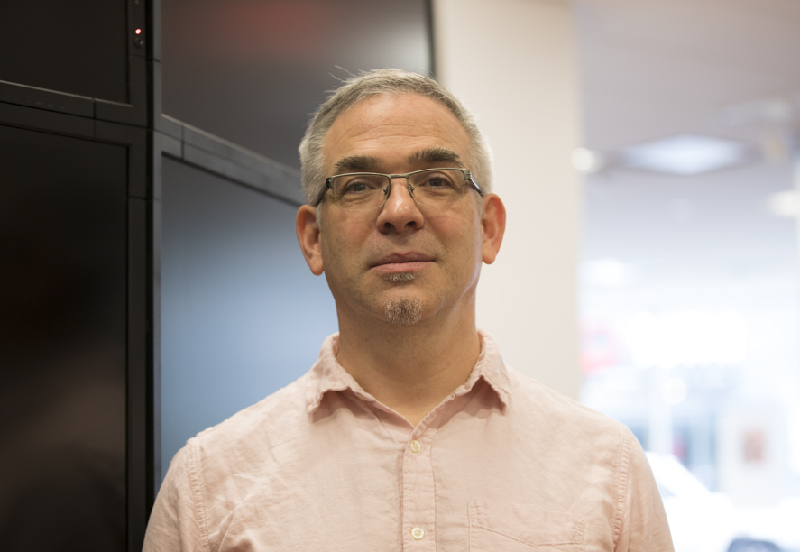 | Dr. Gregory V. Wilson  gvwilson@third-bit.com  http://third-bit.com  416 435 9779

Employment

2017–present Head of Instructor Training at DataCamp; member of the Toronto Public Library's Innovation Council.

2017 Principal Consultant at Rangle.io focusing on technical training.

2015–2016 Director of Instructor Training for the Software Carpentry Foundation, a volunteer non-profit organization that teaches basic lab skills for research computing.

2014–2015 Executive Director of the Software Carpentry Foundation. Developed curriculum, trained instructors, negotiated partnerships with universities and other organizations, and led developed of a web-based tool for tracking instructors and workshops.

2012–2014 Project lead for Software Carpentry while employed by the Mozilla Foundation on a Sloan Foundation grant; co-edited Volume 2 of The Architecture of Open Source Applications, a collection of essays on the design of large software systems.

2011 Software engineer, Side Effects Software Inc. Helped design and build a web application for their flagship product; co-edited Volume 1 of The Architecture of Open Source Applications.

2010–2011 Project lead for Software Carpentry; co-edited Making Software, a collection summarizing evidence-based results in software engineering; supervised MSc theses at the University of Toronto while an Adjunct Professor in the Department of Computer Science.

2006–2010 Assistant Professor in the Department of Computer Science at the University of Toronto. Taught graduate and undergraduate courses; developed a Professional Master’s degree in Computer Science; co-edited Beautiful Code; on the editorial boards of Computing in Science and Engineering and Doctor Dobb’s Journal; supervised MSc theses; published a children's book titled Bottle of Light.

2004–2006 Wrote and published Data Crunching; rewrote the Software Carpentry course under a grant from the Python Software Foundation; lAdjunct Professor in Computer Science at the University of Toronto; contributing editor with Doctor Dobb's Journal.

2000–2004 Helped developed an access control and authorization product at Baltimore Technologies and Hewlett-Packard; contributing editor with Doctor Dobb’s Journal; developed a new course on software design and supervised undergraduate honors projects at the University of Toronto.

1998–2000 Organized and ran Software Carpentry classes at Los Alamos National Laboratory; worked on SelectAccess for Nevex Software Technologies; editorial work for Doctor Dobb’s Journal; published a children’s picture book titled Three Sensible Adventures.

1996–1998 Visible Decisions Inc., Toronto. Led development of an IDE for building 3D data visualization applications.

1995–1996 Centre for Advanced Studies, IBM Toronto. Co-developed a C++ library for parallel and distributed computing; co-edited Parallel Programming Using C++.

1992–1995 Post-doctoral work at the University of Oregon, University of Alberta, Australian National University (Canberra), Vrije Universiteit (Amsterdam), and University of Toronto while writing Practical Parallel Programming.

1986–1992 Edinburgh Parallel Computing Centre. Developed and parallelized large scientific applications for the Centre's industrial sponsors; supervised graduate and undergraduate theses; created and ran the Centre's Summer Scholarship Program; developed an entry for the 1989 World Computer Chess Championship while completing PhD part-time.

1985 Design Interpretive Division, Bell-Northern Research, Ottawa. Developed a real-time interface to a 3D digitizer for use in an office automation system prototype.

1984–1985 Developed signal processing software for Miller Communications in Ottawa.

1975–1983 Various part-time and summer jobs, including an NSERC USRA in 1982.

Education

1993 PhD in Computer Science, University of Edinburgh. Thesis was Structuring and
Supporting Programs on Parallel Computers.

1986 MSc in Artificial Intelligence, University of Edinburgh. Thesis was An Implementation of a Connection Method Theorem Prover for S5 Modal Logic. Shared Howe Prize for best thesis in year.

1984 BSc in Mathematics and Engineering (First Class Honors), Faculty of Applied Science, Queen’s University, Ontario. Top student in graduating class.

Awards

- Winner of ComputerWorld Canada’s “IT Educator of the Year” award, 2010.
- Co-winner with Andy Oram of 2008 Jolt Award for Best General Book (for Beautiful Code).
- University of Toronto Computer Science Student Union Teaching Award, 2004.
- Shared Howe Prize (best MSc thesis in Artificial Intelligence), University of Edinburgh, 1986.
- Commonwealth Scholarship, 1985–86.
- University Medal, Queen's University, 1984 (top student in graduating class).
- Co-winner of A.B. Lillie Prize, 1984 (top student in Mathematics).
- Dean's Scholar, Queen's University, 1982–84.

Technical Books

- Amy Brown and Greg Wilson (eds.): The Architecture of Open Source Applications: Elegance, Evolution, and a Few Fearless Hacks (two volumes), Lulu.com, 2011 and 2012.
- Andy Oram and Greg Wilson (eds.): Making Software: What Really Works, and Why We Believe It. O’Reilly, 2010.
- Jennifer Campbell, Paul Gries, Jason Montojo, and Greg Wilson: Practical Programming. Pragmatic Bookshelf, 2009.
- Andy Oram and Greg Wilson (eds.): Beautiful Code: Leading Programmers Explain How They Think. O’Reilly & Associates, 2007; winner of 2008 Jolt Award for Best General Book.
- Greg Wilson: Data Crunching: Solve Everyday Problems Using Java, Python, and More. Pragmatic Bookshelf, 2005.
- Gregory V. Wilson and Paul Lu (eds.): Parallel Programming Using C++. MIT Press, 1996.
- Gregory V. Wilson: Practical Parallel Programming. MIT Press, 1995.
- Arthur Trew and Greg Wilson (eds.): Past, Present, Parallel: A Survey of Available Parallel Computing Systems. Springer-Verlag, London, 1991.

Selected Papers and Articles

- John D. Blischak, Emily R. Davenport, and Greg Wilson: “A Quick Introduction to Version Control with Git and GitHub”. PLOS Computational Biology, 2016.
- Marian Petre and Greg Wilson: “Code Review For and By Scientists”. WSSSPE 2014.
- Jory Schossau and Greg Wilson: “Which Sustainable Software Practices Do Scientists Find Most Useful?” WSSSPE 2014.
- Greg Wilson: “Software Carpentry: Lessons Learned”. F1000 Research, 2014.
- Greg Wilson et al: “Best Practices for Scientific Computing”. PLOS Biology, 2014.
- Eleni Stroulia, Ken Bauer, Michelle Craig, Karen Reid, and Greg Wilson: "Teaching Distributed Software Engineering with UCOSP: The Undergraduate Capstone Open-Source Project". CTGDSD'11, 2011.
- Jordi Cabot and Greg Wilson: “Tools for Teams: A Survey of Web-Based Software Project Portals”. Doctor Dobb’s Journal, October 2009.
- Greg Wilson: “How Do Scientists Really Use Computers?” American Scientist, Sep/Oct 2009.
- Jo Erskine Hannay, Hans Petter Langtangen, Carolyn MacLeod, Dietmar Pfahl, Janice Singer, and Greg Wilson: “How Do Scientists Develop and Use Scientific Software?” Proc. Second International Workshop on Software Engineering for Computational Science and Engineering, May 2009.
- David Matthews, Greg Wilson, and Steve Easterbrook: “Configuration Management for Large-Scale Scientific Computing at the UK Met Office”. Computing in Science and Engineering, Nov/Dec 2008.
- Greg Wilson: "Those Who Will Not Learn From History…" Computing in Science and Engineering, 10(3), May 2008.
- D. Winter, B. Vinegar, H. Nahal, R. Ammar, G. V. Wilson, and N. J. Provart: “An ‘Electronic Fluorescent Pictograph’ Browser for Exploring and Analyzing Large-Scale Biological Data Sets”. PLoS ONE 2(8): e718, 2007.
- Jorge Aranda, Steve Easterbrook, and Greg Wilson: “Requirements in the wild: How small companies do it”. Proc. 15th Int’l Conference on Requirements Engineering (RE'07), October 2007.
- Karen L. Reid and Gregory V. Wilson: "DrProject: a software project management portal to meet educational needs". Proc. 38th SIGCSE Technical Symposium on Computer Science Education, Cleveland, Ohio, 2007.
- Greg Wilson: “Where’s the Real Bottleneck in Scientific Computing?” American Scientist, Jan.-Feb. 2006.
- Greg Wilson: “Extensible Programming for the 21st Century”. ACM Queue, November/ December 2004-05.
- Michelle Levesque and Greg Wilson: “Open Source, Cold Shoulder”. Software Development, November 2004.

Sole or joint author of over 130 other articles and book reviews in academic journals, popular science magazines, newspapers, and trade publications, including Doctor Dobb’s Journal, IEEE Software, New Scientist, and The Independent.

Children’s Books and Fiction

- Greg Wilson: Still. Lulu.com, 2013.
- Ellen Hsiang and Greg Wilson: And Then… Lulu.com, 2011.
- Greg Wilson: “Still” On Spec, 22/2, Summer 2010.
- Greg Wilson: Bottle of Light. Scholastic Press Canada, 2008.
- Greg Wilson: “Controlled Release” On Spec, 19/4, Winter 2007.
- Greg Wilson: “…But With a Whimper” On Spec, 19/3, Fall 2007.
- Greg Wilson: Three Sensible Adventures. Annick Press, 1999.

Other Achievements

- Member, Python Software Foundation, 2010-present.
- Advisory Board, Ladies Learning Code, 2012-2014.
- Mentor for Google’s Summer of Code, 2005-2015.
- Supervised or co-supervised over 100 undergraduate theses at several universities.
- Ultimate frisbee, 1991-2003 (Toronto "C" Division championship team 2002).
- PADI Open Water Diver certification, 1998.
- Competitor in 6th World Computer Chess Championship, Edmonton, 1989.
- Past or current member/volunteer with the Canadian National Institute for the Blind, the Sierra Club, Amnesty International, OXFAM, the Bruce Trail Association, and the Green Party of Canada.

References available upon request.

