Dispersion laboratory
Theory and interface review · Version 2.0 · 30 October 2026

1. Physical processes

Advection, dispersion, and mixing
Advection carries dissolved mass with moving water. Mechanical dispersion describes spreading caused by differences in velocity and pathway. Molecular diffusion redistributes solute through molecular motion. A plume can spread without becoming locally well mixed; plume width alone is not a mixing measure (Devlin, 2020; Dentz, Hidalgo & Lester, 2023).
This module represents a conservative, passive solute by equal-mass markers. They are computational parcels of dissolved mass, not grains or molecules that collide. A left/right choice summarizes unresolved pathway selection. The physical Galton board motivates the analogy, but the code does not calculate gravitational acceleration or disk collisions.
Read the sections below, then use the fixed experiment to connect the equations with individual paths. Full source details and model limits are available under References and model notes.
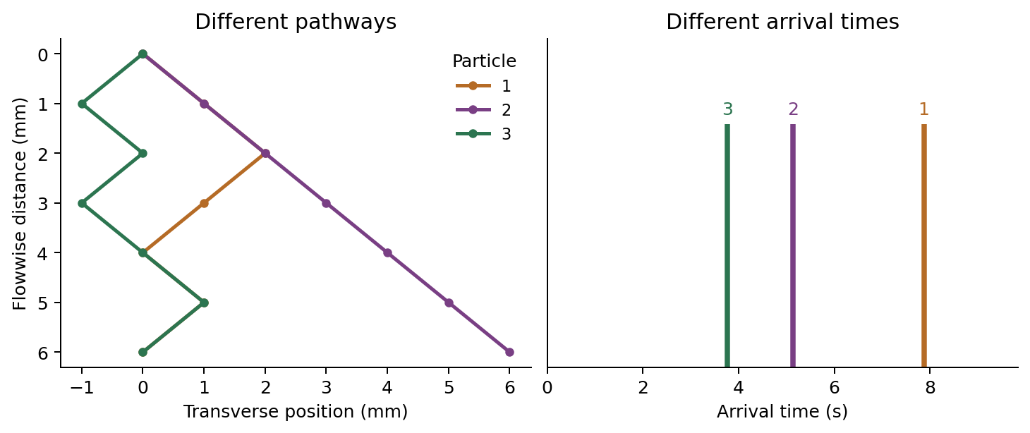
Three calculated trajectories and their arrival times for six rows, mean step time 1 s, time CV 0.6, seed 42. Directions and times are independent. Line heights in the arrival panel identify events; they are not mass rates.

2. The pinboard

Independent choices create transverse spreading
At every pin, a marker moves one row forward and either left or right. Each decision is independent, with probability 1/2. Let n be the number of rows and a the horizontal and flowwise increment. After K rightward choices, the outlet position is
$$K∼Binomial\left(n,1/2\right), X_{n}=a\left(2K−n\right).$$
Counting the possible decision sequences gives the exact outlet probabilities:
$$Pr\left[X_{n}=a\left(2k−n\right)\right]=\left({n \atop k}\right)2^{−n}, k=0,…,n.$$
The mean and variance follow by adding independent signed increments:
$$E\left[X_{n}\right]=0, Var\left(X_{n}\right)=na^{2}, σ_{x}=a\sqrt{n}.$$
This is the coin-toss version of the Galton-board principle illustrated by Yale Physics. The finite distribution is binomial, not exactly Gaussian. A normal approximation improves as the number of independent steps increases, especially away from the tails. Adding more particles samples a fixed distribution more clearly; it does not change its theoretical width.

What fixed times do—and do not—show
If each step lasts μ seconds, every marker traverses the board in
$$T=nμ, Var\left(T\right)=0.$$
An instantaneous pulse therefore spreads across outlets but arrives everywhere at the same time. At integer step times before collection, the population variance satisfies
$$Var\left[X\left(t\right)\right]=2D_{T,board}t, D_{T,board}=\frac{a^{2}}{2μ}.$$
This is an effective transverse random-walk coefficient for the ideal board. Between nodes, the app linearly interpolates the motion for visualization; the displayed continuous trajectory is not a Brownian path. The coefficient is not a fitted soil dispersivity. With fixed n, changing a changes both the spread and the physical board dimensions.
Prediction: doubling n increases the population standard deviation by √2; doubling the number of markers leaves that population value unchanged.
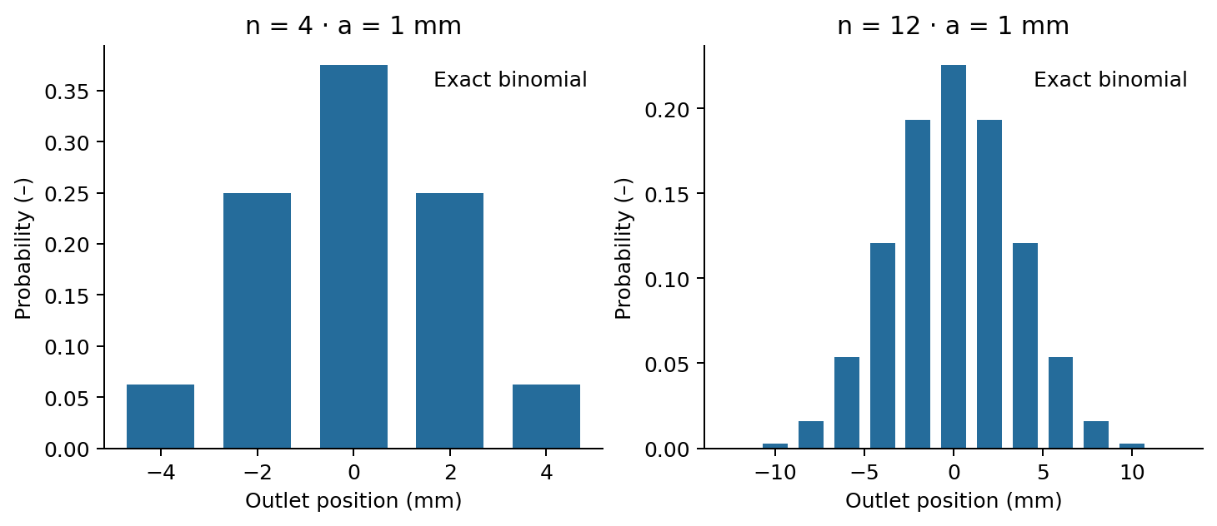
Exact binomial outlet probabilities for 4 and 12 rows, with a = 1 mm. The number of markers changes sampling precision, not these population probabilities.

3. Arrival times and injection

Travel time and release time are different quantities
In variable-time mode, step times are independent positive lognormal variables with mean μ and coefficient of variation c = standard deviation / mean. Direction and step time are sampled independently. For a standard normal variable Z, the code uses
$$τ=μexp​\left(σ_{ℓ}Z−\frac{σ_{ℓ}^{2}}{2}\right), σ_{ℓ}^{2}=ln\left(1+c^{2}\right).$$
Thus E[τ] = μ and Var(τ) = μ²c². For the transit time T, measured from a particle’s own release to its collection,
$$T=\sum_{j=1}^{n}{τ_{j}}, E\left[T\right]=nμ, Var\left(T\right)=nμ^{2}c^{2}.$$
This is a deliberately simple random-walk construction, related conceptually to classical random-step descriptions (Saffman, 1959). The lognormal choice is an instructional assumption, not an empirical law for all soils. Real pore-flow velocity correlations can matter; correlated continuous-time random walks address this additional structure (de Anna et al., 2013).

A longer injection also broadens arrival times
Let R denote release time and d the injection duration. R is sampled uniformly on [0,d], independently of route and transit time; for an impulse, R = 0. The arrival time A is measured from the start of the whole injection:
$$A=R+T, E\left[A\right]=\frac{d}{2}+E\left[T\right], Var\left(A\right)=\frac{d^{2}}{12}+Var\left(T\right).$$
Where probability densities exist, the arrival distribution is the convolution of the release distribution and the transit-time distribution:
$$f_{A}\left(t\right)=\int_{0}^{t}{f_{R}}\left(s\right)f_{T}\left(t−s\right) ds.$$
For fixed transit time, this reduces to a shifted copy of the injection signal. A finite injection can therefore broaden the outlet record without any transit-time dispersion. The app reports both mean transit time and mean arrival time to keep this distinction visible. A single histogram bar for simultaneous arrivals represents a point mass using a finite bin; its height is not a physical peak concentration.
Prediction: with n = 12, μ = 1 s and c = 0.6, transit-time variance is 4.32 s². Adding a 6 s injection contributes another 3 s² to arrival-time variance. These are population values; a small sample fluctuates.
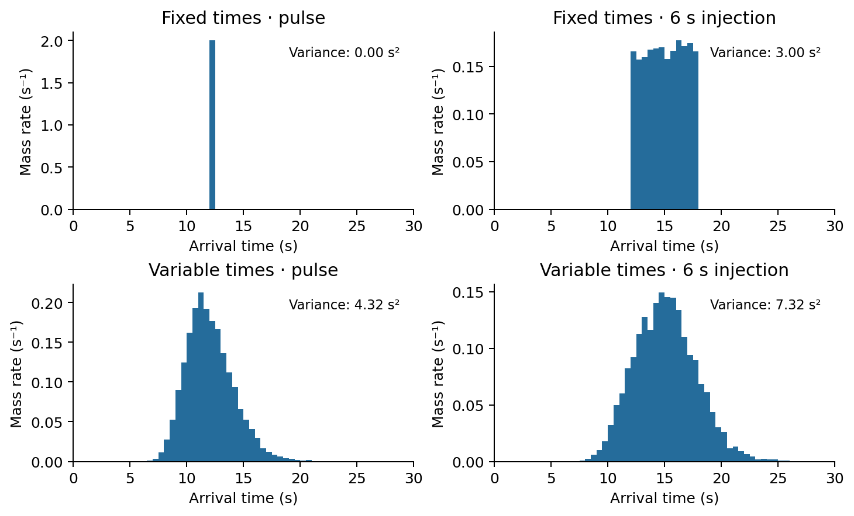
Calculated arrival histograms for 10,000 markers per case; n = 12, mean step time 1 s, CV = 0 or 0.6, injection duration 0 or 6 s, seed 42. Labels give exact population arrival-time variances. Bin width is 0.5 s. Vertical scales differ; compare widths rather than peak heights.

4. Grey-grain network

From grain geometry to an idealized hydraulic network
The grey-grain version retains a triangular diamond lattice of pore nodes. Grain centres lie on its dual lattice. For lattice increment a, neighbouring grain centres are separated by √2a. Grain radii are defined by
$$R_{g}=\frac{a}{\sqrt{2}}κ\left(1−vU_{g}\right), U_{g}∼Uniform\left(0,1\right).$$
Here κ is the grain-size factor (formerly the packing control) and v the grain-size variation. Larger κ narrows gaps. Larger v broadens the radius distribution while also reducing its mean, E[Rg] = aκ(1−v/2)/√2. Neither control is measured porosity; grains stay on fixed centres and are not mechanically compacted.
For the two grains flanking edge e, the surface gap is mapped to a circular tube diameter:
$$r_{e}=\frac{\sqrt{2}a−R_{g1}−R_{g2}}{2}, L_{e}=\sqrt{2}a.$$
This is the app’s geometric surrogate, not the exact aperture or resistance of a real three-dimensional pore. Pore bodies have zero storage and no added resistance. Conductance-based network modelling and simple cylindrical throat approximations are described in the official OpenPNM documentation; this app uses its own solver.

Solve water flow before moving solute
For dynamic water viscosity $μ_{w}$ = 0.001 Pa s, the ideal tube conductance and signed flow are
ge=πre48μwLe, Qij=gePi−Pj, j​Qij=0.
The last equation applies at every internal node. Inlet pressure potential is ΔP; every outlet is held at zero. There are no connections across the outer sides. The downward coordinate is flowwise distance, not elevation head; gravity is not added separately. No solute is moved in the preparation preview, although the steady water-flow field is already calculated.
An outgoing route is sampled with its fraction of the outgoing flow, and each throat is traversed at its cross-sectional mean velocity:
pij=Qijk:Qik>0​Qik, ue=Qeπre2, τe=πre2LeQe.
This imposes instantaneous complete mixing at zero-volume junctions. Molecular mixing and velocity profiles within tubes are not simulated. The routing rule is therefore a model closure, not a claim that pore junctions always mix completely. The flow always follows decreasing pressure; a local edge can point upward on the drawing without forming a loop. Zero-flow throats are excluded.

Independent model references
Exact outlet probabilities and first two transit-time moments are computed recursively on the pressure-directed graph. For expected remaining transit time mᵢ and second moment sᵢ, with zero values at outlets,
mi=j​pijτij+mj, si=j​pijτij2+2τijmj+sj.
The inlet variance is s₀−m₀². A separate check is m₀ = flowing throat volume / inlet flow. Outlet probabilities also equal outlet water-flux fractions under the stated mixing rule. These checks verify the mathematical implementation; they do not validate the geometric surrogate against a soil.
Prediction: doubling ΔP doubles flows and halves transit times while preserving route probabilities. With identical grains, reducing every tube radius by half reduces flow by 16 and increases transit time by four at fixed pressure. Check the reported throat Reynolds number, Re = 2ρur/$μ_{w}$ (ρ = 1000 kg/m³); creeping-flow conditions are not assured if Re approaches or exceeds 1.
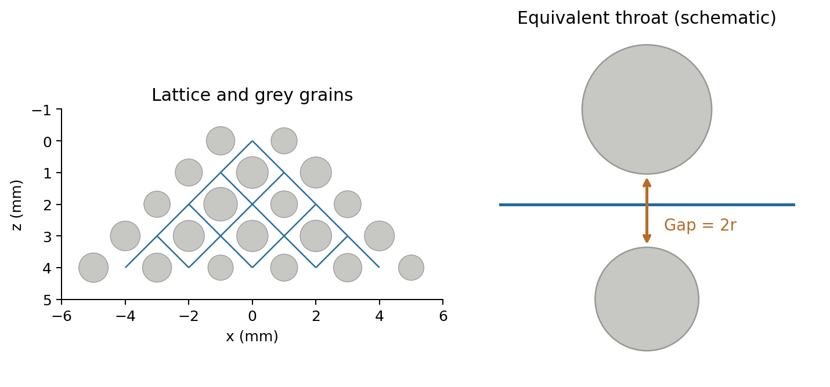
Left: a four-row grey-grain network with default geometry. Right: schematic surface gap mapped to an equivalent tube diameter; the centreline and circular grains do not resolve a real three-dimensional pore cross-section.

5. Continuum interpretation

Connection to continuum solute-transport equations
For a saturated medium with constant mobile porosity, steady incompressible flow, a conservative dilute solute, and appropriate averaging, a common continuum description is the advection–dispersion equation (ADE):
$$\frac{∂C}{∂t}+v⋅∇C=∇⋅\left(D∇C\right).$$
Here C is dissolved concentration, v the mean pore-water velocity (not Darcy flux), and D the dispersion tensor. In a uniform medium with flow along z and transverse coordinate x, constant coefficients give
$$\frac{∂C}{∂t}+v\frac{∂C}{∂z}=D_{L}\frac{∂^{2}C}{∂z^{2}}+D_{T}\frac{∂^{2}C}{∂x^{2}}.$$
A common constitutive representation is $D_{L}$ = $α_{L}$|v| + $D_{m,eff}$ and $D_{T}$ = $α_{T}$|v| + $D_{m,eff}$. Dispersion coefficients D have units of length²/time; dispersivities α have units of length. Effective molecular diffusion $D_{m,eff}$ accounts for porous-medium restrictions. These continuum relations provide context; the module does not solve this ADE or prescribe $α_{L}$ and $α_{T}$ (Wexler, 1992).

A spatial variance is not an arrival-time variance
For an unbounded, constant-coefficient continuum pulse, longitudinal spatial variance grows as $2D_{L}t$. For a different observable—the first-passage time to an absorbing plane at distance L starting at zero with an unbounded upstream domain, constant v > 0, and $D_{L}$—the moments are
$$E\left[T\right]=\frac{L}{v}, Var\left(T\right)=\frac{2D_{L}L}{v^{3}}.$$
These identities concern specific boundary conditions and observables (Probability Distribution Explorer, Inverse Gaussian distribution). As a mathematical illustration, matching the pinboard moments with L = na and v = a/μ would give
$$D_{L,moment}=\frac{Var\left(T\right)v^{3}}{2L}=\frac{a^{2}c^{2}}{2μ}.$$
This is only a moment-matched analogy. It does not make the board’s transit-time distribution the ADE first-passage distribution; a sum of lognormal step times is generally not inverse Gaussian. The module therefore reports widths and moments, without presenting this expression as an estimated soil dispersion coefficient. Arrival-time variance from a finite injection must first be separated from transit-time variance even for that analogy.

Why finite networks may not be Fickian
Bijeljic and Blunt (2006) show that an asymptotic dispersion description can require transport through many pores; their network explicitly includes advection and molecular diffusion. The present board has only 2–20 rows and uses simpler physics. A smooth-looking histogram does not establish an asymptotic regime, Gaussian transport, or a scale-independent dispersivity. The single inlet, widening triangular geometry, and equal-pressure outlet boundary all influence the grain-network response.

6. Mass markers and model limits

Highlighted and background particles carry the same mass
Let H be the number of highlighted particles (1–10) and B the number of background particles per highlighted particle (0–1000). The total is
$$N=H\left(1+B\right), m_{p}=\frac{1}{N}.$$
There are H numbered markers and HB blue background markers, at most 10,010 in total. Background markers are independent samples of the same transport process; they are not clones of a visible path. Highlighting is a display choice and has no effect on motion or mass.
When B changes, the same seed preserves the release times and complete trajectories of the first H markers. The experiment replays from its beginning. The total normalized injected mass remains 1, so each marker’s statistical weight changes to 1/N. This is an increase in sampling resolution, not an additional physical dose. With independent samples, typical sampling errors decrease approximately as $N^{−1/2}$; more particles do not create stronger dispersion.

Read the plots as mass distributions
At every time, the model partitions all markers into three disjoint groups:
$$N_{waiting}+N_{inside}+N_{collected}=N.$$
The spatial bars give collected mass per outlet, $n_{k}/N$. In temporal bin b with width $Δt_{b}$, the plotted height is
$$h_{b}=\frac{n_{b}}{NΔt_{b}}.$$
Its units are s⁻¹. The complete histogram has area 1; an incomplete histogram integrates to the collected fraction. This is a normalized arrival mass rate, not a resident concentration. Converting it to an outlet concentration would require injected mass and water discharge, with a consistent flux-averaging convention. Those conversions are not implemented here.
The exact reference describes the probability distribution of this model. Empirical standard deviations use division by N, appropriate to the plotted empirical distribution. They are not N−1 estimates. With one marker, the empirical width is zero even when the population width is positive. Ten markers are useful for understanding paths, not for establishing a smooth distribution.

Limits to keep in view
The marker model omits sorption, reaction, density effects, collisions, explicit molecular diffusion, and diffusion into immobile regions. The grain model additionally omits pore-body storage, pore-body hydraulic resistance, and velocity profiles within throats. Instantaneous junction mixing is imposed rather than resolved. Thus spatial spreading, node redistribution, and molecular homogenization must not be treated as interchangeable processes (Dentz et al., 2023).
Parameter changes can affect several quantities together: spacing changes board size, grain variation changes mean size as well as variability, and pressure changes velocity. State what was held constant before attributing an observed change to a single mechanism.

7. Where the controls belong
Existing setting or function | Location in the new module | Interpretation
Model, rows, lattice spacing | Explore → Board and transport | Updates stationary geometry immediately.
Mean step time and time CV | Explore → Board and transport, pinboard modes | Changes the travel-time law; CV is shown only in variable-time mode.
Packing, grain variation, medium seed | Explore → Board and transport, grey-grain mode | Packing is labelled grain-size factor; changes pore geometry, not measured porosity.
Pressure difference | Explore → Board and transport, grey-grain mode | Recalculates water flow and preview flow summary.
Particle count | Guided: 1–10; Explore → Injection and repetition, plus Add background particles | Replaced by H and B, with N = H(1+B). Maximum 10,010.
Injection duration and particle seed | Explore → Injection and repetition | Defines release timing and repeatable particle samples.
Run / new realization | Explore → Run highlighted particles | Applies settings and starts a highlighted-only run. New realization increments the particle seed.
Blue particles | Explore → Add background particles | 0–1,000 per highlighted marker; same highlighted routes retained.
Play, pause, reset, step, complete, time slider | Both experiments → Playback and display | Changes the observed time, not the physical transport.
Trace, pathways, bins, plot arrangement | Both experiments → Playback and display | Display controls retained; any highlighted particle can be inspected.
Save comparison; CSV and JSON | Both experiments → Results, comparison, and downloads | Full-run values; saved comparisons survive parameter changes.
Learning activities | Explore → Explore, predict, and explain | Predictions before controlled comparisons.
Equations and assumptions | Principles and guided experiment | Expanded theory in numbered Markdown sections.
References and model limits | References and model notes | Source details and interpretation.
Language and page layout | Sidebar | Same shared language and Markdown fallback conventions as Soil Water Retention.

8. References

Research basis
The model equations in this module are derived from its stated stochastic and hydraulic assumptions. The sources below establish the surrounding scientific context; they do not constitute calibration or validation of this particular board.
- Yale Physics Lecture Demonstrations. Galton Board, demonstration 4G10.10. Official demonstration. Physical motivation: repeated approximately equiprobable left/right outcomes and a binomial distribution.
- Wexler, E. J. (1992). Analytical solutions for one-, two-, and three-dimensional solute transport in ground-water systems with uniform flow. USGS Techniques of Water-Resources Investigations 3-B7, 190 pp. DOI: 10.3133/twri03B7. Context for continuum advection–dispersion equations, sources, and boundary conditions.
- Devlin, J. F. (2020). Groundwater Velocity. The Groundwater Project. Section 4.3: Subsurface mixing. Explains why plume spreading and local mixing should be distinguished.
- Saffman, P. G. (1959). A theory of dispersion in a porous medium. Journal of Fluid Mechanics, 6(3), 321–349. DOI: 10.1017/S0022112059000672; author repository and abstract. Historical connection to random steps with variable directions and durations; the board is not a reproduction of Saffman’s theory.
- Bijeljic, B., & Blunt, M. J. (2006). Pore-scale modeling and continuous time random walk analysis of dispersion in porous media. Water Resources Research, 42, W01202. DOI: 10.1029/2005WR004578. Demonstrates the importance of pore travel-time variability and the distance needed to reach asymptotic dispersion. Their model includes physics absent from this teaching network.
- de Anna, P., Le Borgne, T., Dentz, M., Tartakovsky, A. M., Bolster, D., & Davy, P. (2013). Flow intermittency, dispersion, and correlated continuous time random walks in porous media. Physical Review Letters, 110, 184502. DOI: 10.1103/PhysRevLett.110.184502. Establishes a link between correlated temporal increments and non-Fickian transport; supports caution about independent step-time assumptions.
- Dentz, M., Hidalgo, J. J., & Lester, D. (2023). Mixing in porous media: Concepts and approaches across scales. Transport in Porous Media, 146, 5–53 (online 2022). DOI: 10.1007/s11242-022-01852-x. Review distinguishing dispersion, stirring, and mixing, including suitable measures of mixing.
- OpenPNM documentation. Simulating Single Phase Transport and Basic Transport. Official documentation for conductance laws, pressure boundary conditions, and conservation-based network solutions. OpenPNM is a reference, not an app dependency.
- Uliana, M. M. (2025). Basic Hydrogeology: An Introduction to the Fundamentals of Groundwater Science. The Groundwater Project. Section 12.4: Mass transport equations. Accessible companion reading on advection, dispersion coefficients, and transport equations. Book DOI: 10.62592/CBIQ7579.
- Probability Distribution Explorer. Inverse Gaussian distribution. Author-maintained technical documentation giving the first-passage interpretation, parameter mapping, and moments used in the continuum comparison.
Sources checked on 30 October 2026. The Saffman and de Anna connections above are limited to their accessible abstracts and bibliographic records. All diagrams supplied with this module are original schematics or calculations from its own model; no source figures are reproduced.

