Unions and Income Distribution

In the United States

Brandon Gilbert, Greg Moore, Tyler O’Toole

University of Cincinnati

Carl. H. Linder College of Business

**Introduction**

Since the industrial revolution, labor unions have played a vital role in advocating for the rights of workers and shaping the current American work environment; however, labor union participation in the United States has steadily been declining since the 80s. In 1983 20.1% of the working labor force was in a union and in 2015 it was nearly halved to 11.1%. The decline of labor unions cannot be pinned to a single cause or say for certain that it is a bad trend, but it has had consequences. One of the potential consequences that will be tested in this report is the growing disparity in American income distribution, and it too has numerous causes. The increase in the income distribution gap has been happening for over 30 years. The timeline of these two trends and possible consequences and causes has given reason for further investigation into a possible link between them. The authors of “Union and Inequality Over the Twentieth Century: New Evidence from Survey Data” came to the conclusion that “unions have had a significant, equalizing effect on the income distribution.” A large income gap slows GDP growth in advanced economies like the United States and has also been connected increases in crime and middle-class debt. Something that has such dramatic effects on the majority of the country needs to be addressed and in order to address it, its causes need to be recognized. The absence of union presence could be a partial explanation. In the study, by Bruce Western and Jake Rosenfeld, “Unions, Norms, and the Rise in the U.S. Wage Inequality” there was evidence that “a fifth to a third of the growth in inequality—and effect comparable to the growing stratification of wages by education” is caused by the decrease in union participation. Without unions advocating for fair wages and benefits, inequal income distribution could be a direct consequence. Panel data was collected from [yadayada.com]. The Gini index is the best way to measure income equality, and this measurement has been found on a state level from 2007 to 2016. After implementing a fixed-effects model a conclusion was formulated. There was not enough evidence to make a connection between the Gini index and labor union participation.

**Data:**

Our main variable of interest in estimating the Gini index was the percent of the workforce belonging to a union in any specific state. We also attempted to control for other variables, including: the percent of the workforce under a collective bargaining agreement, population, GDP, minimum wage, personal income, size of the civilian labor force, the percent of the population with a bachelor’s degree or higher, unemployment, and homeownership rate. We collected our data from the United States Census Bureau American Community Survey (ACS), from a Union Membership and Coverage Database utilizing the Current Population Survey (CPS), and from the Federal Reserve Economic Database (FRED). All the data collected ranges from the years 2006 through 2016. A description of our variables, as well as summary statistics can be found below.

|  |  |
| --- | --- |
| **Variable** | **Description** |
| percent_union_members | % of workforce belonging to a union |
| percent_collective | % of workforce belonging to a union |
| gini_index | Gini Index measured from 0 - 1 |
| population | Population in thousands. Not seasonally adjusted |
| gdp_in_millions | Real GDP in millions of dollars |
| state_min_wage_rate | State minimum wage rate in dollars per hour |
| per_capital_personal_income | Per capita personal income. Measured in dollars |
| yearly_avg_clf | Yearly average civilian labor force |
| perc_w_bach_deg_or_higher | Percent of population with a bachelor's degree or higher |
| yearly_avg_unemply_rate | Yearly average unemployment rate in percent |
| homeownership_rate | Homeownership rate in percent |

|  |  |  |  |  |
| --- | --- | --- | --- | --- |
| **Variable** | **Mean** | **Standard Deviation** | **Minimum** | **Maximum** |
| percent_union_members | 10.728 | 5.387492903 | 1.6 | 25.2 |
| percent_collective | 12.05527273 | 5.385831055 | 2.6 | 27.2 |
| gini_index | 0.456355818 | 0.020278936 | 0.402 | 0.5138 |
| population | 6214.379733 | 6877.38364 | 522.667 | 39296.476 |
| gdp_in_millions | 319495.1329 | 391382.0226 | 26801.5 | 2500645.2 |
| state_min_wage_rate | 7.096509091 | 1.085639913 | 2.65 | 10 |
| per_capital_personal_income | 42281.82909 | 7525.351781 | 27907 | 69547 |
| yearly_avg_clf | 3087521.748 | 3363924.251 | 281246.8333 | 19093657.42 |
| perc_w_bach_deg_or_higher | 28.12818182 | 4.974062631 | 16.5 | 42.7 |
| yearly_avg_unemply_rate | 6.267227273 | 2.176720477 | 2.566666667 | 13.65833333 |
| homeownership_rate | 68.37527273 | 5.100163166 | 51.5 | 79 |

There are variations in our data, both over time and by state. Below, figures 1a and 2a show variation in the average Gini index and average union membership over time. We observe a strong positive trend in the average Gini index over time, while over the same period, we see that average union membership has a weak negative trend. Comparing this to the longer time period trends we found in our research, our union participation data is quite stable. Figure 1b and 2b below show the variation in Gini index and union participation rate across states. These plots illustrate that there is a large amount of heterogeneity between states.

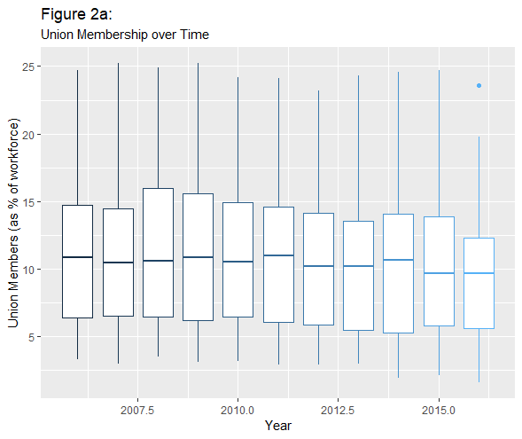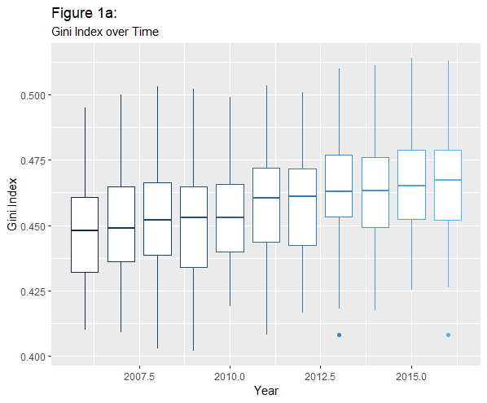

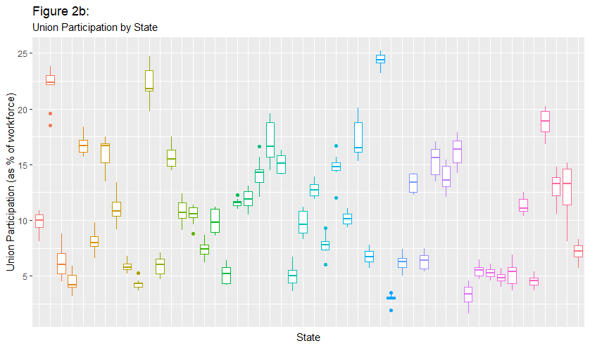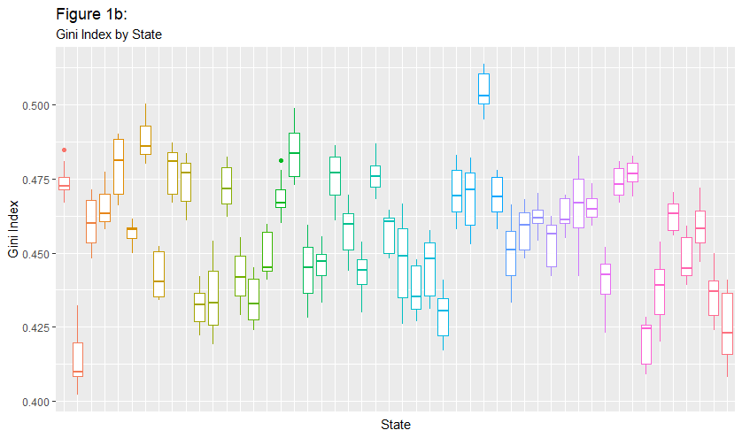

**Methodology**

Our empirical approach is summarized by follow two equations.

1:

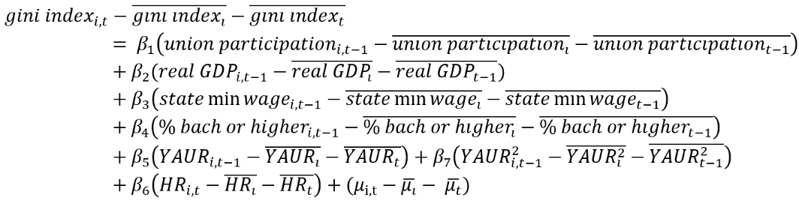

2:

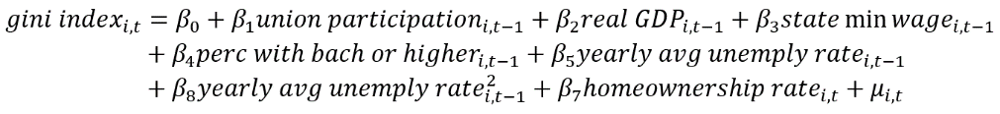

In both equations one and two we regress Gini index on the percent of the work force represented by a union for state `I` at time `T`, while controlling for one year lagged real GDP, state minimum wage, percent of population with a bachelor’s degree or higher, year averaged unemployment rate, year averaged unemployment rate squared, and non-lagged homeownership rate. We believe these control variables also influence a state’s income distribution, so it is important that we include them in our models. The difference between the two equations is that equation one contains state and time fixed effects, and equation two is a pooled OLS that does not account for state of time heterogeneity. Since we have panel data, there is a good chance that we have heterogeneity bias between states and years. If so, pooled OLS would not be a good estimation technique because the covariance between our independent variables and the unobserved heterogeneity will not be zero. That will make pooled OLS estimates biased and inconsistent.

To decide if we should include fixed effects in our model, we performed an F-test for individual and time effects. The null hypothesis is that we have homogeneous data and have no need for fixed effects. The F-test was statistically significant, with a p-value of less than 2.22e-16. We reject the null hypothesis and conclude that we have heterogeneity in our data, and fixed effects is the correct specification.

Next, we tested for heteroskedastic and serial correlation. We performed the Breusch-Pagan test for heteroskedastic and the Breusch-Godfrey test for serial correlation of the error term. The null hypothesis in these tests is that heteroskedastic and serial correlation are not present. We found statistically significant results in both tests with p-values less than 0.05. We reject the null hypothesis and conclude that heteroskedastic and serial correlation are present. We obtained Arellano robust standard errors for correct for these issues.

Finally, we checked the presence of multicollinearity in our model. We calculated the variance inflation factor for the fixed effects model. We did not find evidence of multicollinearity, as none of our variables had an VIF above 2, except for lagged average unemployment rate and lagged average unemployment rate squared, which can happen when including a squared term in a model. We tested the VIF of our model both including and excluding lagged average unemployment rate squared. We found the VIF of lagged average unemployment rate is below 2 when lagged average unemployment rate squared is not present in the model.

We were unable to find a suitable interment variable for union participation rate. Because of this, we are unable to address whether the exogeneity assumption holds for our model. Finding some suitable interment variables for union participation rate is a large area for future research for this project, as we believe that union participation rate may suffer from endogeneity.

**Results**

Our results with the robust standard errors are below.

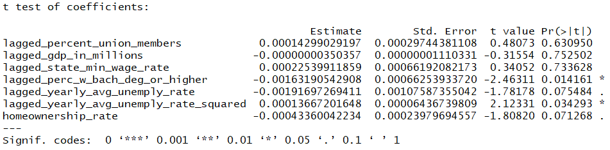

Our overall model is statistically significant with a P-value of 0.0009. Our primary variables of interest, lagged union participation, is not statistically significant, holding all other variables constant. Based on this, our hypothesis that increases in union participation would lead to decreases in the Gini index is unfounded. However, we did find statistically significant evidence that lagged percent of the population with a bachelor’s degree or higher, lagged average yearly unemployment, and homeownership rate influences the distribution of income, holding all other variables constant. The coefficients on lagged percent with a bachelor’s degrees, lagged average yearly unemployment, and homeownership rate do have the expected signs, which is a positive signal about the specification of our model. However, none of these variables seem to have economic significance, as the variables have very small effect sizes.

**Conclusion**

It is clear that the income gap in the United States is a problem that must be addressed, but it is a complex one. Following the implementation of the fixed-effects model, there were no definite conclusions that could be made. The coefficient for labor union participation was not significant in contrast to what the original hypothesis was. There were some significant variables like education, which would coincide with the belief that there is a skill premium, and home ownership in the test, but their beta values were small and had a minimal effect on the Gini index level. Looking back there are some aspects of this research that, if changed, would give a better idea of what is leading to the increase in state Gini indexes. There was a limited amount of observations so there was not an ideal amount of observations that could supply a more descript outcome. Over a 30 year period labor participation has only had a gradual decrease and that gradual decease continue over the 10 year period of the data used. In future studies there are some things that would give better and more accurate results. Most significantly would be to have a longer time period of observations. With the fixed-effects model that was implemented there could be more variation in the length of the lags. Although it would be difficult, an instrumental variable could be found and simultaneous equation models could be created. Looking at the effect of education and homeownership may give increased insight into income distribution. Further research into this subject is necessary for the wellbeing of the citizens of this country. This is a complex issue that will require years of research and should stay at the forefront of economic policy and thought.

**Works Cited**

Western, Bruce. "Unions, Norms, and the Rise in the U.S. Wage Inequality." Asanet.org. 2011. http://www.asanet.org/sites/default/files/savvy/images/journals/docs/pdf/asr/WesternandRosenfeld.pdf.

Farber, Henry S., Daniel Herbst, and Suresh Naidu. "Unions and Inequality Over the Twentieth Century: New Evidence from Survey Data." NBER. May 10, 2018. Accessed December 07, 2018. https://www.nber.org/papers/w24587.

Bertrand, Marianne, and Adair Morse. "Trickle-Down Consumption." NBER. March 14, 2013. Accessed December 07, 2018. https://www.nber.org/papers/w18883.

Bryan, Kevin A., and Leonardo Martinez. "On the Evolution of Income Inequality in the United States." SSRN. December 11, 2012. Accessed December 07, 2018. https://papers.ssrn.com/sol3/papers.cfm?abstract_id=2187901.

Mayer, Susan E. "The Relationship between Income Inequality and Inequality in Schooling." Journal of Research in Crime and Delinquency. April 22, 2010. Accessed December 07, 2018. https://journals.sagepub.com/doi/abs/10.1177/1477878509356346.