Presenting 101 (P101) – Design document

**Objective:**

This is the software design specification for Presenting 101 (P101). P101 attempts to prepare a public speaker by helping them train in an effective manner that yields optimal public speaking practices. It does this by analyzing many of the common flaws in presentation and pointing them out to the presenter while also offering solutions as to how to correct them. Through the use of audio analysis, flaws in a presentation that show themselves though a presenter’s lack of dynamism, incoherent speech and the use of filler words are determined. Additionally, through the use of video analysis -though the use of Microsoft’s Xbox Kinect, problems with body fluidity and body language i.e. bad posture, improper or bad use of hand gestures and pacing are also pointed out.

**End Users:**

A presenter: This will be the primary user of this software. These will people who are attempting to better their presenting skills. They will be standing in front of and using the application to get direct feedback.

**Use Cases:**

User gives a presentation

* + Actor: A Presenter
  + Pre-condition: The user has all of the required components e.g. the Kinect. The presenter is also standing in front of the Kinect (at an appropriate distance i.e. they understand the instructions on the start screen) ready to give a presentation.
  + Trigger Action: The user presses the start button on the application’s start screen.

Review of presentation

* + Actors: A presenter, teachers/instructors
  + Pre-condition: The presenter has completed presenting and a user error report has been generated.
  + Trigger Action: When the user has completed presenting they must press the finish button.

**Workflow:**

User gives a presentation

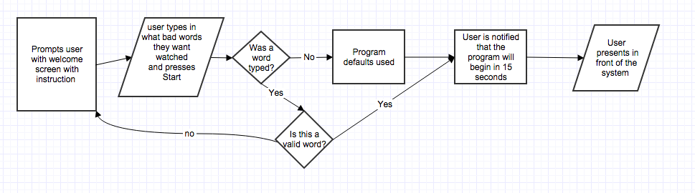

Review of presentation

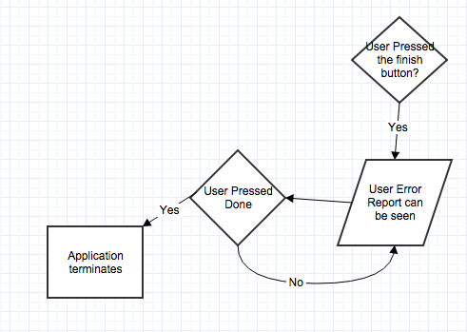

**Functional Components:**

Algorithm to determine appropriate speaking volume, speech flow and detect disfluencies/bad words.

Algorithm to monitor determine appropriate hand gestures, posture and relational movements (pacing).

Algorithm to take the above and offer suggestions as to how to correct the issues found above.

Be able to represent all of that data and show it to users as well as tell them solutions.

**Non-Functional Components:**

Users must press starts to have the application warn them before it begins recording.

Users must press finish in order to get a user error report.

Users are able to input bad words they want detected.