Functional Specification

Project Information
Project Name: | Presenting 101
Author: | Terrence Lewis
Organization: | GWU CS Senior Design
Project Version: | v1.0
Spec Version: | v1.0
Date of Current Spec: | 2015/10/26

Overview
Product Perspective:
At any given time in a person’s life, whether that is in an academic or professional environment, they will have to give some type of presentation. Often, however, nerves or lack of preparation hinders many peoples’ presentations. Flaws in a presentation can show themselves though a presenter’s lack of dynamism, incoherent speech and the use of filler words. Issues also brought up include problems with body fluidity and body language i.e. bad posture, improper or bad use of hand gestures and pacing. Interestingly, however, these are key elements to any presentation and can ultimately change an audiences’ view of a presenter and or decide if the presenter’s points are transmitted effectively to the audience. To aid in preparing a presenter, Presenting 101 was created, which is a program that attempts to analyze many of the common flaws in presentation and point them out to the presenter while also offering solutions as to how to correct them.

Product Features:
Presenting 101 uses the Xbox One Kinect’s motion sensing capabilities and a microphone to take in data about the user. The program is dependent on a user standing in front of the sensor speaking and moving (as one would do during a presentation). Once the user initializes the system they will have the ability to track their volume (decibel level), speech disfluencies, speech rhythm, bodily gestures, posture and relational movements e.g. pacing.

Design and implementation constraints:
This specification is not in its final form and will need to be revised to match any additions or subtractions to the program.

This specification also does not discuss the algorithms used to aid in analyzing user data and to offer solutions. It simply discusses what the user sees when they interact with Presenting 101.

Scenarios
Paralanguage can be defined as the vocal but nonverbal dimension of speech that can include volume, rate and pitch (DeVito 148). “While listening to people – regardless of what they’re saying – we form impressions based on their paralanguage about what kind of people they are” (148).

Bob is a new marketing executive at a startup. The startup is currently battling with another company that is attempting undercut their prices. To compete, Bob has been tasked with meeting with various executives from several fortune 500 companies to form a co-op. To ensure that his company does not loose any profits or customers, Bob must be able to effectively communicate his ideas and concerns in order to get the other executives to agree to the arrangement.
Since Bob is a very busy man, by the time he has any free time everyone has left to go home for the day making it very difficult for him to practice his presentations in front of anyone. He tells this issue to one of his collogues and they tell him about Presenting 101. Bob sets up the required software and device and tells it to notify him if he says ‘basically’ and begins to practice into the late hours of the night. During the first practice round the program notifies Bob of several basic, yet crucial elements that Bob is messing up – like flailing his arms or repeatedly saying ‘basically’ which could prove to be disastrous in such a high stake situation. Over the course of the night Bob has been able to correct several of his initial issues and even modify his presentation to have his voice sound more flowing and have more natural but calculated gestures.
Alice is an undergraduate engineering student. Like many engineers, she dislikes giving presentations as she is quiet and likes to keep to herself. Over the last year Alice has been conducting groundbreaking research that could save countless lives unfortunately, however, the grant that has been funding her research is about to expire. Her advisor approaches her and tells her that she must present her findings (as she has taken the lead on this research project) to a panel of National Science Foundation members in order to renew the grant. As an engineering student many of the classes that she has taken has provided her with little to no experience giving presentations. She does not want to practice her presentation in front of her friends but she knows that if given more time with her research, she could prevent thousands of deaths. Alice tries practicing alone but still feels like she is not doing a good enough job. After some time she stumbles upon Presenting 101 and decides it is her best option for winning the grant. After initial rounds of presenting with the program Alice sees that her volume starts off strong but as her presentation progresses it declines steadily, the program also alerts her that she leans while she speaks and it suggests keeping her feet shoulder width apart while speaking. Over the course of a week with the program, Alice feels not only confident about her speech but also about herself and decides to practice giving presentations in front of her friends.

Non Goals
This version will not support the following features:
- Real time feedback
- Option to re-watch presentation
- Save or export user data

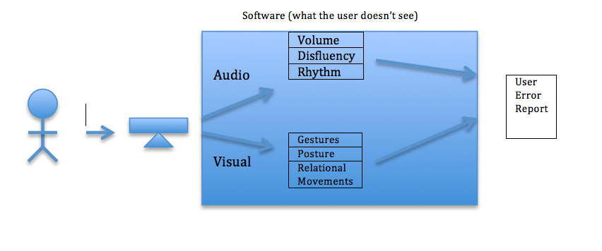
Presenting 101 Flowchart

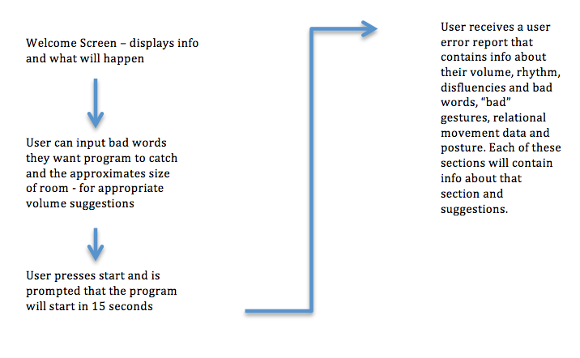

Screen by Screen Specification
Presenting 101 consists of only a few screens. Each screen will have a similar layout – one that is simple and fairly intuitive. The screens will be created using Java dialogue boxes.
Each screen will have a heading located on the top, which will help the user understand what to do.

Welcome Screen
When the program first starts the user is prompted by a Welcome screen, which contains three main components. 1) Information about what the program will do and what to expect as an outcome, as well as what it is analyzing, instructions regarding how far to stand away from the Kinect and how they should give their presentation in a way that best utilizes the software. 2) The user will have options to customize the program for a better experience. There is a text box that takes in “bad words” – these are English words that they wish to have highlighted during their presentation. There is also dropdown option for the user to select the approximate room size so that it may suggest the best speaking volume. The user has the option to leave these blank and the program will automatically use the system defaults. 3) After the user reads the instructions and decides to customize the guidelines the user may press the green start button.
Confirm Screen
Once the start button is pressed the Welcome screen fades and a Confirm dialogue box pops up alerting the user that once they press the ‘OK’ the program will begin recording in 15 seconds.
Finish Screen
When ‘OK’ is pressed the Welcome and Confirm dialogue boxes go away and 1 second remands the program beeps and a Finish dialogue box appears that contains a running timer on it and button that displays ‘analyze’ which will end the program and have it analyze the presentation.
User Error Report
User Error Report is last dialogue box that appears once the user presses the ‘analyze’ button. This screen contains information about the presentation. There are six components to this dialogue box: 1) Volume: average decibel level is output and a chart depicting the progression of the volume from the start of the presentation to the end is displayed. If the sound seems to be consistently low the program will suggest techniques for more consistency. 2) Rhythm: The user will see a text box that contains recommendations about their rhythm, whether it was fast, slow or seemed “unnatural”. 3) Disfluencies: A text box is shown that contains a heading for “bad words” and a section for disfluencies, under each heading is what was caught and a count of how many times it was said and suggestions as to how to fix the problem. 4) Gestures: This a text box displaying what they should work on i.e. their hands went out of the designated “frame” for a proper presentation – this is counted and noted. 5) Relational Movement: this is a text box that will tell the user if they walked around too much and offer suggestions as to how to stop. 6) Posture: This is a text box that will tell the user if they were swaying and suggestions are offered. Underneath each of the results, is a corresponding suggestion or comment that is easily identifiable for the use. At the end of this dialogue box is a button that says ‘close’, which will exit the program completely.

