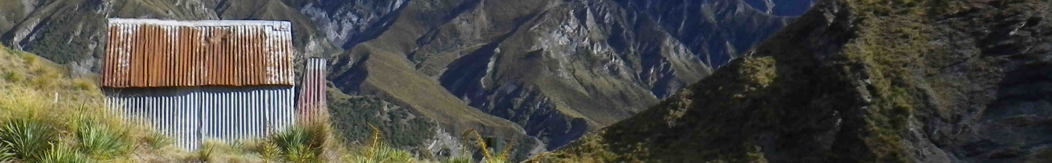
ZL ... On The Air

Introduction

Table of Contents
Introduction 1
Terminology 3
Activating 4
Finding places to go 4
Alerting 5
... via ontheair.nz 5
... via SMS 5
Spotting 6
... via ontheair.nz 6
... via SMS 7
Entering logs 8
... Your Details 8
... Other Party’s details 9
Uploading logs 10
... Advanced options 10
Forwarding logs to other award programmes 11
Chasing: 12
Spots page 12
Alerts page 13
Logging chases 14
Honour Rolls and Awards 15
Honour Rolls 15
Awards 16

Terminology
A wee bit of jargon before we start – so we all know what we’re talking about:

Activating Operating portable from a park, summit, lake, or other portable location
Chasing Contacting a station who is operating portable. Called hunting by some award programmes
Qualifying Making the minimum number of contacts from a portable location to qualify for points, awards, recognition of the activation in a given award scheme. Minimum QSO numbers vary between schemes.
Asset A location belonging to one of the recognised award schemes (e.g. park, lake, summit, lighthouse, etc)
Alert A notification published on a website or mailing list alerting others to the fact that you plan to be operating portable at a specific time and place
Spot A notification published on a website or mailing list informing others that you are currently operating portable at a specific place
Activation Zone The area surrounding an asset within which an activation is valid. This area will vary between asset types and award programmes – see the programme-specific section for details. Also known as AZ

Activating

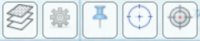
Finding places to go
The ontheair.nz website details all registered assets within NZ that can be activated for the various award programmes. A good place to start is with the map.


You can use the layers menu to choose which type of assets you wish to display on the map. They are not all displayed by default as it gets too crowded. Click the Layers icon and scroll down to Point Layers in the popup. Tick all the map layers you wish to see, and click apply. You can also switch between basemaps to show either airphotos, or public access land details in the layers menu.
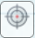
If you are using a device with a GPS, then you can show your current position on the map by clicking the GPS button. Your position will be shown as a large pink dot (note that the map does not recentre automatically, so you may need to zoom out or scroll to find the dot).

As you zoom the map, more detailed mapping will be shown with 1:50,000 topomaps shown at the highest zoom levels.

Assets are shown as coloured points as follows:

Symbol Reference* Type
ZLP/XX-#### Park
ZLL/#### Lake (public access land within AZ)
Lake (AZ entirely on private land)
NZ-#### POTA Park
ZLFF-#### WWFF Park
ZL#/XX-### SOTA Summit (public access land within AZ)
SOTA summit (AZ entirely on private land)
ZL#/HXX-### HEMA summit (public access land within AZ)
HEMA summit (AZ entirely on private land)
ZLI/XX-### Island
ZLV/XXX-### Volcano
ZLB/### Beacon / Lighthouse
ZLH/XX-### Back-country hut

* X – letters, # digits.

If you click on an asset on the map then the right-hand side of the screen will display details about that place (if you are on a mobile or in a small window you will need to click ‘Smaller Map’ to see the right-hand panel).

The Public Access section is important. This gives an indication whether land with a right of public access exists within the activation zone of this asset. It will list the means of public access if they have been found. See the Legal Access section of this document for more details about public access to different types of land in NZ.

If the asset has been activated or chased, you’ll see by who. You can click on their logs (View) to see what bands they used. They may have added photographs or comments in the sections at the bottom of the page.

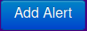
Alerting
An alert is an indication that you intend to activate a specific location at a specific future time.

Once you’ve decided where to go, and when to go there, then placing an Alert is a good idea. Sometimes you might head out at the last minute or make an ad-hoc activation just because you are passing, but otherwise - if you have time beforehand - then chasers will be very grateful if you post an Alert. The best time to post an alert is a day or two before you go, to give chasers the chance to plan to be near a radio when you are activating.

An alert is an indication that you intend to activate a specific location at a specific time. You can also include details of the bands and modes you will be activating. It’s a statement of intent – not a promise. For example if weather conditions change, no-one expects you to head out in unsafe conditions just because you’ve alerted.

You can do this in many ways – most commonly using the ontheair.nz website, or by SMS. Other options include by InReach satellite messenger – this is dealt with in a separate section near the end of this document.

... via ontheair.nz
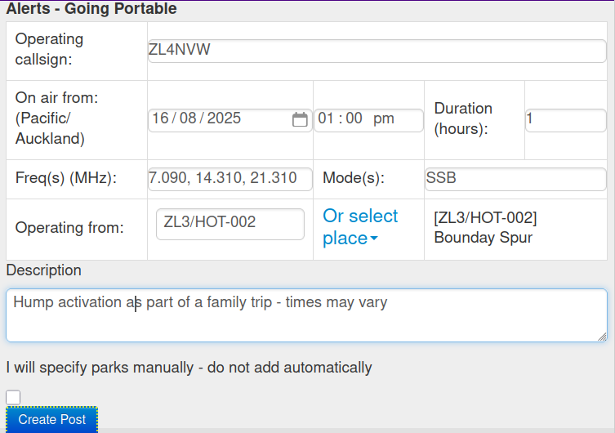
Click the Add Alert button (it’s at the top of the home page and alerts page), and enter details of your planned activation. You will need to include:

Callsign: Your callsign for the activation
On Air From Date and Time you will start activating
Duration Expected length of the activation (in hours)

Frequency and Mode are optional, but will give chasers an idea where to listen, especially if you are not able to spot from the field.

If you are operating from a known reference in an award scheme, then you can type this reference code in the Operating From field. You will need to make sure you get the formatting exactly right (though it is not case-sensitive). Or (safer) you can use the Or select place dropdown to choose the location from a list or from the map. If you make a mistake, then select Clear to clear the incorrect entry before adding a new one.

If you are going portable to an ad-hoc location, you can simply type the name of the location in under Operating From.

By default the alert will include any assets which contain the place you have selected. For example, if you select a summit and it lies within a park, then the park will be included in your Alert. If you do not want this to happen then check the checkbox to disable this feature:

□ I will specify parks manually – do not add automatically

Click Create Post when done.

... via SMS
You can alert via SMS to the ontheair SMS gateway. This is handy if you have poor coverage as SMS will often work where mobile data connections are not available.

The number is 027 3105319

The SMS ALERT format is:
ALERT <callsign> <reference> <frequency in MHz> <mode> <YYYY-MM-DD HH:MM> <comment>
e.g.
ALERT ZL4NVW ZLL/0006 7.090 SSB 2025-10-31 11:00 Quick activation on my way past

(you can test SMS alerting by sending an alert with DEBUG as the first word in the comments. Debug alerts will appear in the Test Alerts channel under the Info menu in the website and will not be emailed out to other users).

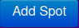
Spotting

A spot is a report that a particular operator is on the air now, activating a given location.

Once you arrive at your asset’s location, and are set up then sending out a spot allows chasers to know that you are on air. You can do this in many ways – commonly through a logging app (PoLo, iPnP, VKParks all support ZLOTA spotting) through the ontheair website, by SMS. Other options include by InReach satellite messenger, or over FT8 using SOTAmat. These are dealt with in separate sections near the end of this document.

You can also spot for someone else who you’ve heard on-air, or who has asked you to do so.

... via ontheair.nz

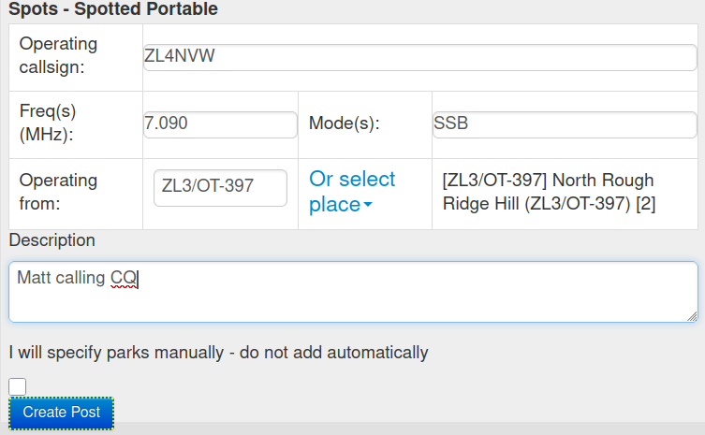
Click the Add Spot button (it’s at the top of the page on the home page or Spots page).

Fill in the form. You’ll need to enter:
Callsign: The callsign of the person
making the activation
Freq Frequency (in MHz)
Mode FM, AM, SSB, FT8, etc

If you are operating from a known reference in an award scheme, then you can type the reference code in the Operating From field. You will need to make sure you get the formatting exactly right (though it is not case-sensitive).

Or (safer) you can use the Or select place dropdown to choose the location from a list, from the map, or using your device’s GPS (if it has one).

Note that when using the from GPS option, you may get a message saying ‘GPS not ready’. If so, wait for the GPS to lock (a pink dot will appear on the map showing your location) and try again. The GPS option will check your current location against all known assets and add any that you are in the activation zone of. If you just get a set of coordinates and no list of assets, it means you are not yet within any AZ.

If you make a mistake, then select Clear to clear the incorrect entry before adding a new one.

If you are just going portable to an ad-hoc location, you can simply type the name of the location, or it’s lat, long coordinates, under Operating From.

By default the spot will include any assets which contain the place you have selected. For example, if you select a summit and it lies within a park, then the park will be included in your Spot. If you do not want this to happen then check the checkbox to disable this feature:

□ I will specify parks manually – do not add automatically

Click Create Post when done.

... via SMS
You can spot via SMS to the ontheair SMS gateway. This is handy if you have poor coverage as SMS will often work where mobile data connections are not available.

The number is 027 3105319

The SMS format is:
(SPOT) <callsign> <reference> <frequency in MHz> <mode> <comment>

e.g.
ZL4NVW ZL3/SL-285 7.090 SSB 10 minutes on 40m then QRT

or:
SPOT ZL4NVW ZLL/0001 14.310 SSB Matt needing 1 more contact!

(you can test SMS spotting by sending a spot with DEBUG as the first word in the comments. Debug spots will appear in the Test Spots channel under the Info menu in the website and will not be emailed out to other users).

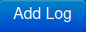
Entering logs
For those who prefer paper logs (or digital notepad apps) in the field over logging programmes, the easiest way to get logs into ontheair (and all the other awards schemes) is to enter them using the ontheair website.

Click My Logs on the menu bar to go to your logs page, and click the Add Log button.

The screen is in two halves.
The top half is for details of your location and setup.
The bottom half of the screen is for the contacts you made and the other parties locations

... Your Details
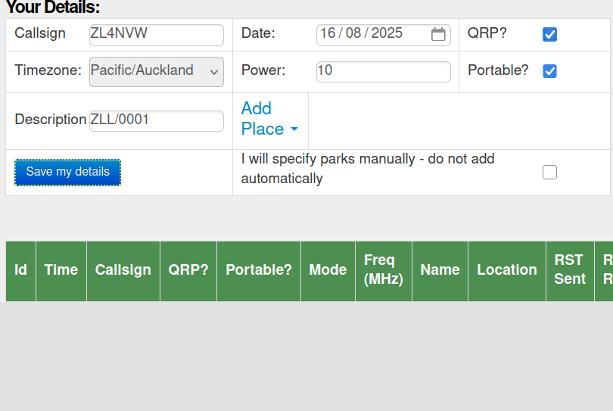
Fill in the Your Details form. You’ll need to enter:
Callsign: The callsign you used for the activation
Date Date the activation commenced (in timezone indicated)
QRP Check this if you were QRP (needed to claim QRP points)
Portable Check this for all but Home-based operation
Power Optionally, enter your tx power

If you were operating from a known reference in an award scheme, then you can type the reference code in the Description field. You will need to make sure you get the formatting exactly right (though it is not case-sensitive).

Or (safer) you can use the Add place dropdown to choose the location from a list or from the map. If you make a mistake, then select Clear to clear the incorrect entry before adding a new one.

If you were just going portable to an ad-hoc location, you can simply type the name of the location in under Description.

By default the log will include any assets which contain the place you have selected. For example, if you select a summit and it lies within a park, then the park will be included in your log. If you do not want this to happen then check the checkbox to disable this feature:

□ I will specify parks manually – do not add automatically

Click the Save my details button when done.

... continues overleaf

... Other Party’s details
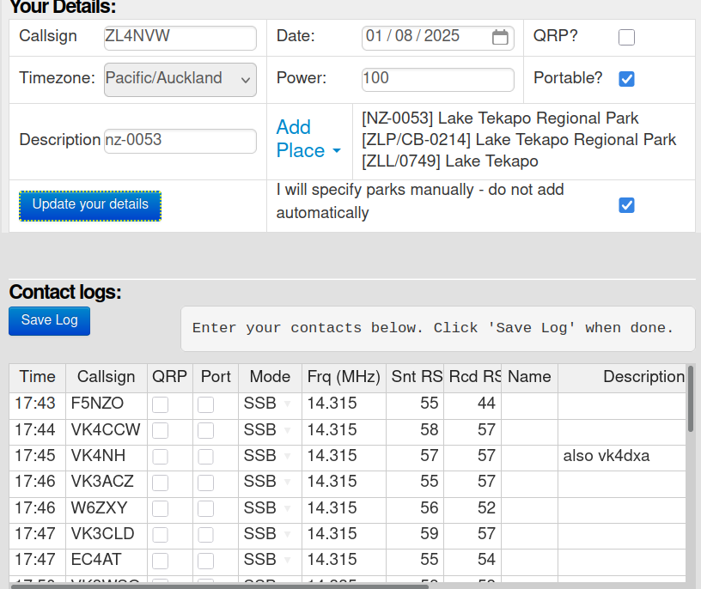
Once you have saved your details, a spreadsheet-style grid will appear for you to enter the details of your contacts and their locations.

You’ll need to enter:
Time: Time of the QSO (HH:MM or HHMM)
Callsign: The callsign of the person you contacted
QRP Check this if the other party was QRP
Portable Check this if the other party was portable
Mode The mode used for the contact (AM, FM, SSB, FT8, etc)
Freq Frequency of the contact (in MHz)
Sent RS(T) Signal report you sent to other party (in ## or ### format)
Rcd RS(T) Signal report you received from other party (in ## or ### format)
Name (optional) Name of the other party

If the other party was operating from a known reference in an award scheme, then you can type this in the Description field. You will need to make sure you get the formatting exactly right (though it is not case-sensitive). Or you can use the Add place dropdown to choose the other party’s location from a list or from the map. If you make a mistake, then select Clear to clear the incorrect entry before adding a new one. You can also add a textual description (e,g. Wellington) in Description.

By default the contact will include any assets which contain the place you have selected for the other party. For example, if you select a summit and it lies within a park, then the park will be included in the contact. If you do not want this to happen then check the Mnl? (manual) checkbox to disable this feature:

Once you have entered once contact, you can add the remainder in the remaining rows. Mode and Frequency will automatically be copied down as you start to enter the next row’s details.

Once you are finished, click the Save Log button to save the contacts. If you are entering a large number of QSOs, it is worth doing this every now and then as you go along so that you do not lose data if things go wrong. Data Saved will appear in the box above the spreadsheet once the save is complete.


Uploading logs

For those who use logging apps when in the field, it is far easier to upload your log from the than type it in again. Export the log from your app in ADIF format.
In PoLo you are recommended to use the Export All rather than Export ZLOTA option, as the ‘All’ option will include all details of your contacts across all award schemes, not just ZLOTA.
Click My Logs on the menu bar to go to your logs page, and click the Upload Log button.

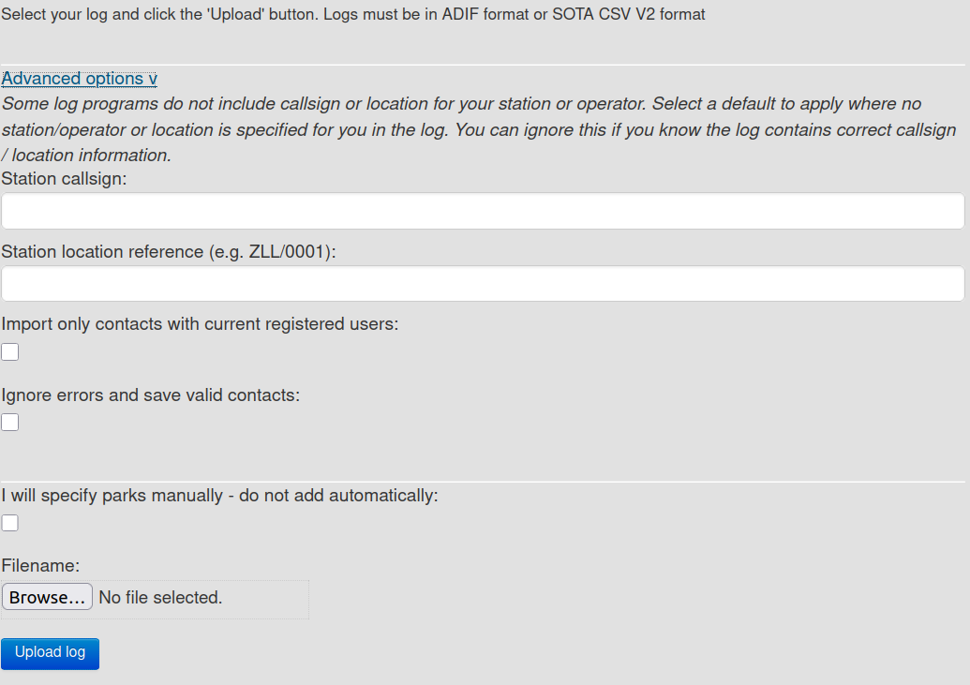
By default the log created at ontheair will include any assets which contain the place you have activated. For example, if you upload a log for a summit and it lies within a park, then the park will be included in your log. If you do not want this to happen then check the checkbox to disable this feature:

□ I will specify parks manually – do not add automatically

Browse for the logfile and click Upload Log when done.

... Advanced options
Some logging programmes not designed specifically for activations do not include all the details we need to create an activator log. For example the log may be missing the activator callsign or the reference for the asset you were activating. You can specify these manually under Advanced Options.

For larger FT8 activations with 50+ of contacts, consider limiting the QSOs you upload to only those with registered users. This keeps our database manageable in size whilst still crediting all registered users with the contacts. You can do this by checking
□ Import only contacts with current registered users

Where logs contain invalid entries we will show error messages indicating what went wrong. By default the entire log is rejected if it contains one invalid entry. You can tell the system to instead ignore and continue with the rest of the contacts by checking:

□ Ignore errors and save valid contacts

Forwarding logs to other award programmes
If you activated assets from award programmes such as POTA, WWFF, SOTA and HEMA, then you should forward your logs to those programmes too. Do this even if you are not interested in that award scheme yourself – your logs will be needed so that chasers get their credits in that programme. And some of your chasers will almost certainly want that.
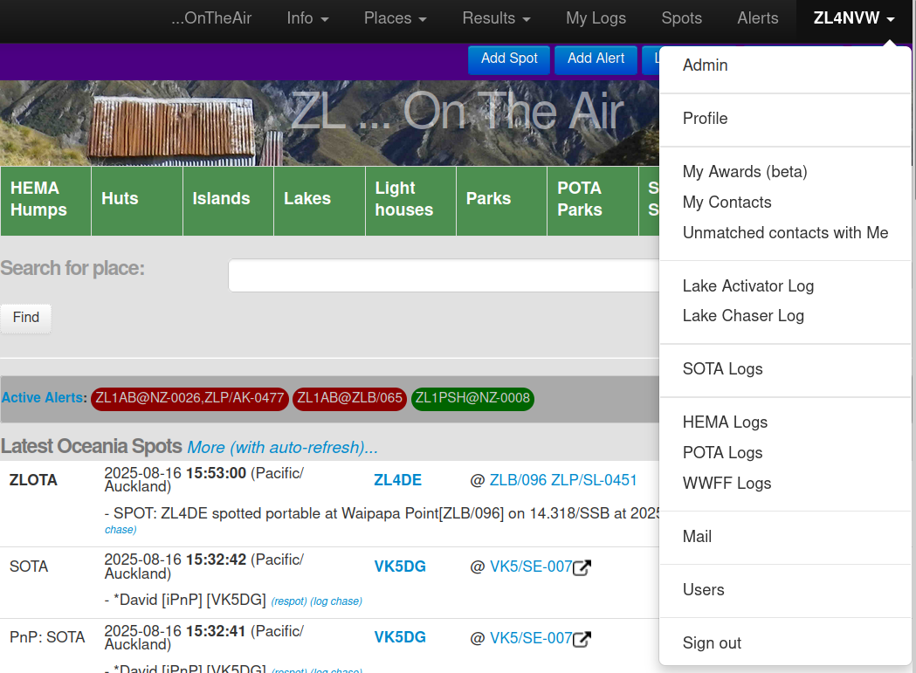
You can find options to export your SOTA and POTA logs in ADIF format under your callsign (top-right) on the menu bar. These ADIF files can then be uploaded to each scheme’s official website.
WWFF logs can be emailed to the ZL WWFF coordinator from the same menu.
HEMA logs can be uploaded directly to HEMA from the menu – but you’ll need a HEMA account and will be prompted to enter your HEMA username and password. Usernames and passwords are sent directly to HEMA – they are not saved or logged at ontheair.nz

Full details of other award programmes are given later in this document.

Chasing:


Spots page
The Spots page shows all current portable operations that have been reported by the various ZL, VK and worldwide spotting sites. By default the screen will show you all spots reported in Oceania in the previous hour.
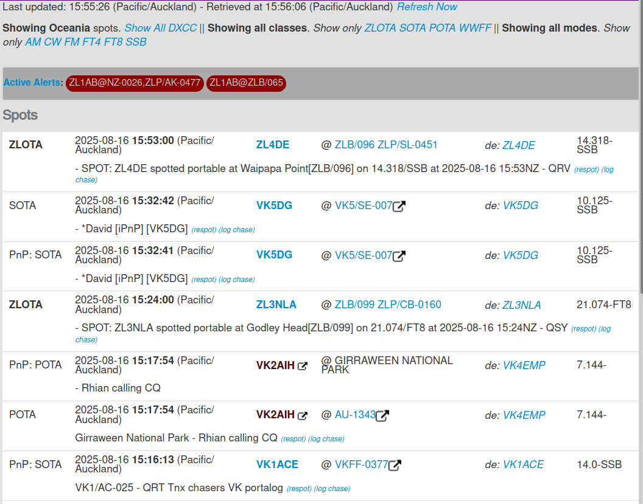
The top few lines allow you to filter the results by continent, scheme and mode.

Clicking Show all ... will clear that filter.

E.g. clicking Show all DXCC will clear the Oceania-only filter and show all spots worldwide. You will then get the option of filtering back down to a specific continent.

Below the filters a grey banner lists all current Alerts – that is all alerts matching your filter where users planned to be active at the current time. The Alerts banner can be scrolled / swiped sideways if reaches the end of the screen.

You can switch to the full alerts screen to see more details of alerts, as well as past and upcoming alerts, by clicking the Active Alerts link.

The majority of the screen is taken up by the list of current spots. These are ordered by time with most recent at the top. As spots are sourced from a range of sites around the world, the same spot may be listed multiple times against various sources (e.g. SOTA and PnP in the above example).

Columns are:
Info source | Time spotted | Activator callsign | Reference / location | Spotter callsign | Frequency - Mode
 | Comments (actions)

If you make contact with any of these activations you can immediately log your contact from this screen by clicking Log chase against the spot

You can also create a new spot for the activation and add your own comments, report frequency changes, etc by clicking Respot against the spot

Hovering over a callsign with the mouse will show you the country and continent of the call – handy for unfamiliar DX!

Spots are pulled from remote sources by the server once per minute and are also refreshed on you screen once per minute. This means there may be up to a 2 minute delay between a spot being posted on a remote server (e.g SOTAWatch) and appearing on your screen. You can refresh your view from the ontheair server by clicking Refresh Now.

The auto-refresh will stop if the internet connection times out, and Timed Out will be displayed instead of the latest retrieved time. This will also occur on a mobile device if your browser does not have permissions to continue operating when the screen is off. Click Refresh Now to restart the updates.

You can also subscribe to receive emailed notifications of all new ontheair spots. See the Email Subscriptions section for details


Alerts page
The Alerts page looks similar to the pots page, but shows planned activations rather than current ones.

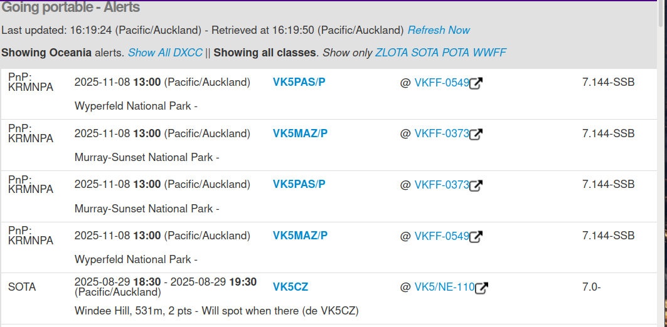
As with spots you can filter the alerts based on continent and programme. By default all Oceania alerts are listed.

Clicking Show all ... will clear that filter.

E.g. clicking Show all DXCC will clear the Oceania-only filter and show all spots worldwide. You will then get the option of filtering back down to a specific continent.
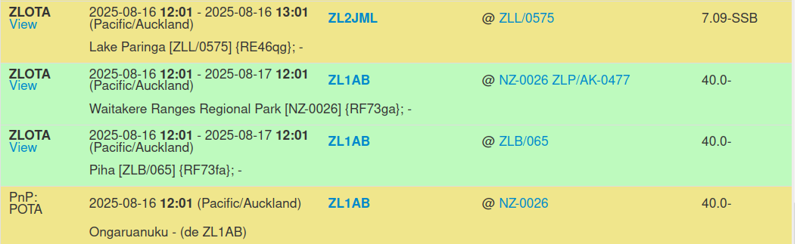
Alerts may be posted days, weeks or even months in advance. The latest start-date is shown at the top.

As the list can be long, the current calendar day’s alerts are highlighted in yellow to help you locate them in the list.

The calendar day used depends on your account’s timezone setting: if you have selected UTC then the current UTC day will be highlighted. If you have selected Pacific/Auckland then the current local day will be highlighted. Edit your profile (under your callsign – top right) to change your timezone setting.

Alerts which span the current time (start before now, end after now) are highlighted green. These are the same alerts that appear on the brief alerts banners on the Spots and Home page.

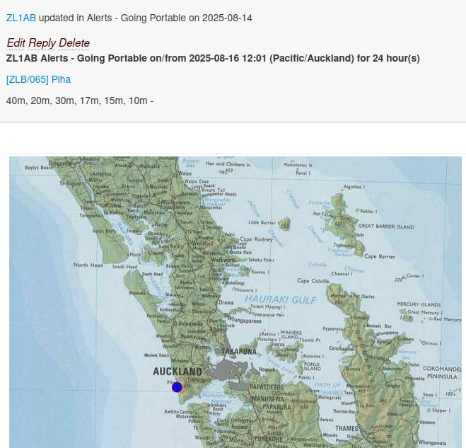
ZLOTA alerts will have a View link that takes you to the original post that created the alert. Here you will find further information including a map (if a location was specified)

You can also subscribe to receive emailed notifications of all new ontheair alerts. See the Email Subscriptions section for details

Logging chases

Some award programmes, notable SOTA and HEMA havce a requirement for chasers to log spots. Some, such as POTA and WWFF rely entirely on activators to upload logs (and if they don’t – chasers miss out). ZLOTA allows both parties to upload logs.

The recommendation is that you log chases:
- For all SOTA and HEMA chases
- For ZLOTA chases where you want to ensure you get credited with the contact

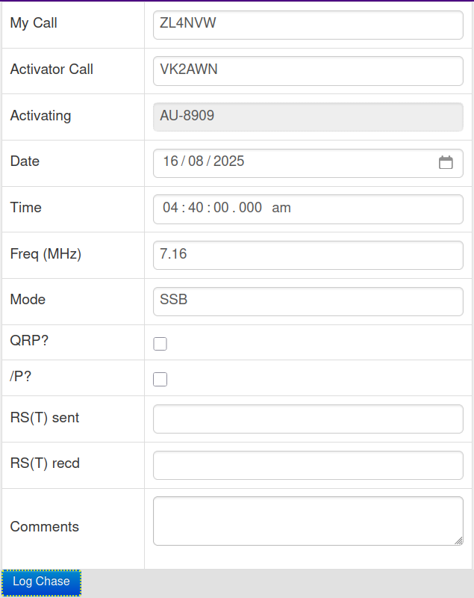
The simplest way to log a chase is at the time, using the Log Chase link on the spots screen as discussed in the Spots section above.

This will take you to a simple single-contact log screen where you can enter details of the QSO. The callsigns, time, mode, frequency and activator’s location will already be completed for you based on the spot.

All you need to do is enter the signal report you sent to the other operator – RS(T) sent, and the signal report you received from the other operator – RS(T) recd. These should be entered in ## or ## format – e.g. 59 or 599.

Other optional fields can be completed as you requied.

Click Log Chase when done.

A chaser log will be created containing this single QSO.

Alternatively you can create a single log for all chases on a given day. See the Entering Logs section under Activations for details of how to do this. The only difference for a chaser log is that you do not need to specify a reference under Your Details as you are not activating yourself, but you do need to select or specify a location for the party you are chasing against their QSO.

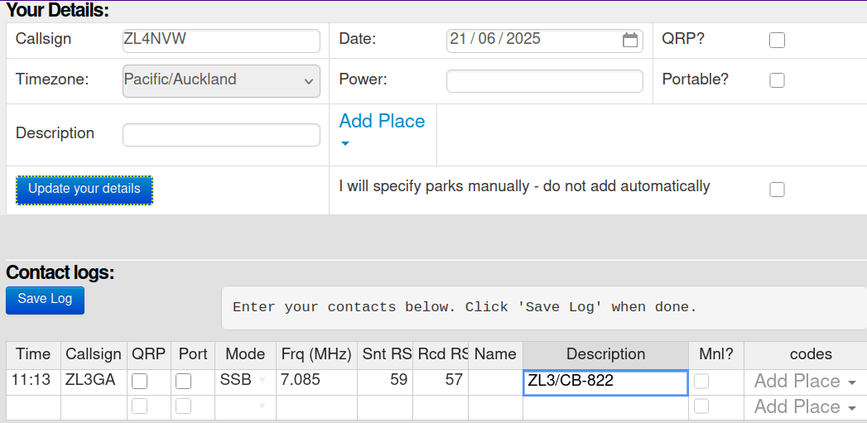
Once you have logged your SOTA and HEMA chases at ontheair.nz, you should also forward them to the SOTA or HEMA websites. You’ll see ‘Chaser Log’ listed under both your SOTA Logs and HEMA Logs lists. See the relevent section of this document for SOTA / HEMA to see how to send these through.

Honour Rolls and Awards

Honour Rolls

As with SOTA, POTA and others, ZLOTA is not intended to be a competitive sport. However, tracking your progress and those of others around you can be part of the fun. As such we include Honour Rolls for each class of asset in the ZLOTA scheme.

You can see the Honour Rolls under the Results menu at the top of the screen.

The first line on the honour rolls screen lists the four categories of statistics that are kept:
- Bagged The unique assets you have chased or activated
- Activated The number of assets you have activated making at least one QSO, with revisits allowed once per calendar year.
- Qualified The number of assets you have activated making at least the minimum required number of QSO for that asset type, with revisits allowed once per UTC calendar year.
- Chased The number of assets you have chased, with additional chases of the same asset allowed once per UTC calendar day.

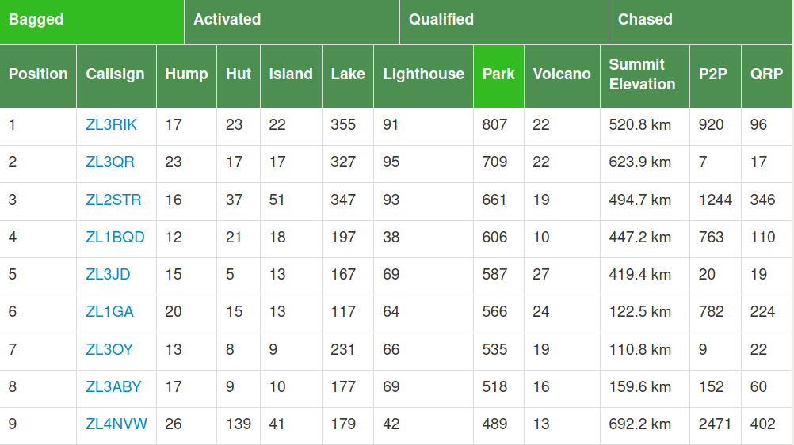
Click on a heading to display the statistics for that category.

The second line lists the classes of asset for which statistics are kept, e.g Lighthouse, Park, Volcano.

Click on the heading to sort the table by that category.

Additional categories are listed for:

Summit Elevation Total cumulative summit elevation for SOTA, HEMA and volcanos
P2P Number of Portable-to-Portable contacts where at least one participant is in a ZLOTA asset and the other is in an asset in any recognised award scheme (ZOTA, SOTA, POTA etc)
Note that you get one P2P for each asset each operator is activating – so if you are on a summit in a park then you get one P2P contact for each asset (2 total)
QRP Number of contacts for which you were operating QRP. This relies on the QRP tickbox in Your Details in your logs, so make sure you tick it if relevant. If you operate QRP for only
part of an activation, you will need to submit two logs (sorry!).

Awards

ZLOTA isn’t about trophies, or certificates for your wall. But we do hand out some virtual awards as pixels against your callsign on the ontheair website - to give you targets to aim for, if that is your thing.

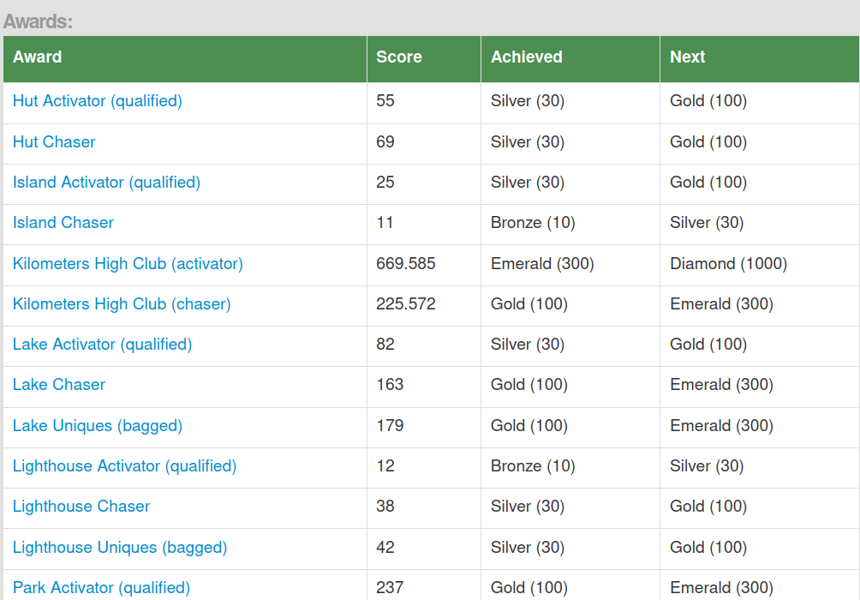
You can view your awards in the menu under your callsign (top-right of the screen).

There are three categories of awards on the system:

Threshold awards

These are based on your result in the honour rolls and give you an award for activating / chasing / bagging 10, 30, 100, 300, etc assets of a given type (or kilometers, for summit elevation).

Worked all Region awards

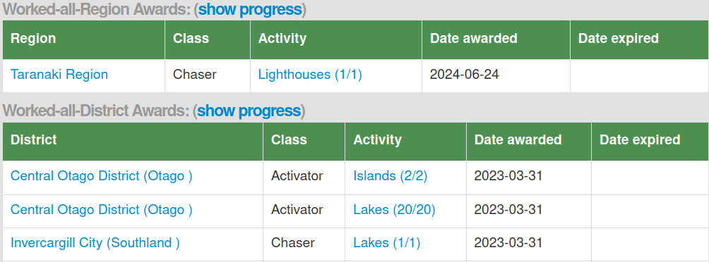
These are awarded for chasing or activating every asset of the specified type in a regional council region. Some are easy (how many lighthouses are there in Taranaki?). Others are immensely challenging (summits in Fiordland, anyone?).

Worked all District awards

Because activating, for example, all the summits in Otago, seems a little over the top, we break some categories down to district council districts.

The threshold-based awards table shows you your current score, the latest award threshold you have achieved, and the next threshold award you can aim for.

For worked all region or worked all district awards you will need to click on the Show Progress link to see your progress towards any yet-unclaimed awards.

Other people’s awards

If you want to see what awards other people have achieved you can view the same information by clicking on the Show Awards link on their Profile page. You can find their profile page either by clicking on their callsign anywhere it appears, or by searching for them in the Users page (which you’ll find in the menu under your callsign, top-right).

Award Programmes:

ZLOTA / NZART

Lakes

Parks

Beacons / Lighthouses

Islands

Huts

Volcanos

SOTA

Rules
Logging

POTA
Rules
Logging

WWFF
Rules
Logging

HEMA
Rules
Logging

====

SMS Spotting

SOTAmat Spotting

Inreach Spotting / Alerting

Confirming chasers vs activator contacts

Legal access in New Zealand

