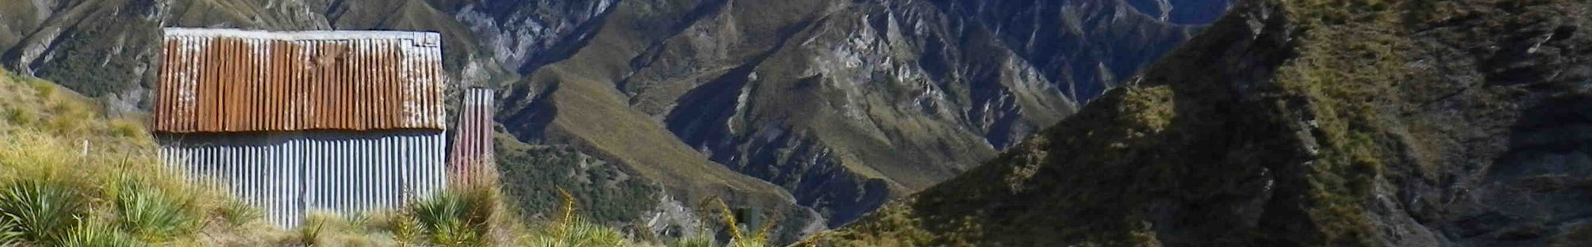
ZL ... On The Air

O

A home for portable radio operators and activities
in New Zealand
Version 1.04 (2026-04-11) – Matt, ZL4NVW

The ontheair.nz website combines information for all current organised portable award programmes that operate in New Zealand. A one-stop-shop where you can see proposed activations (alerts) and current operations (spots) across all award programmes. A single place in which you can enter and upload logs for all schemes and track your progress in them. And home to the national ZL On the Air (ZLOTA) award programme.

ZLOTA provides a national awards programme to fill the gaps left by the international schemes. Covering a range of portable activities it has options suitable for all physical abilities, and in all areas of the country. The ZLP/ parks programme, for example, with its 3500+ registered locations provides a wide choice of places to visit, activate or chase in everyone’s neighbourhood. Or the ZLB/ Beacons and Lighthouse scheme with 100-odd coastal lights and beacons, providing the realistic chance to activate or chase every light and beacon in the country. ZLOTA aims to provide something for everyone.

Our goals are: to support the outdoor portable amateur radio community in all they do; to encourage existing amateurs to get out there and explore our wonderful back-country and conservation estate; and to provide the information, enjoyment and activities that might just attract the next generation of amateurs.

“Here in New Zealand, our own program – ZLOTA (ZL on the Air) – is the one I’m most invested in. It celebrates our unique landscapes and gives activators like me a chance to put special places on the air for hunters across the country and beyond. Whether it’s a park, a lake, or even the rim of volcano, ZLOTA ties the experience to our home turf and makes every activation feel connected to something bigger.

I also enjoy Parks on the Air (POTA) and World Wide Flora and Fauna (WWFF). POTA links me to activators and hunters around the world, while WWFF adds a conservation angle that resonates with me. But for me, ZLOTA is at the heart of it – it’s ours, and it feels like carrying a bit of New Zealand radio spirit wherever I go.

There’s always a bit of friendly rivalry with my mates, competing for the most contacts or who can reach the furthest station. It pushes me to keep going and makes every activation more thrilling and fun”

Ian - ZL1HIM

Table of Contents
Terminology 4
Activating 5
Finding places to go 5
Alerting 7
... via ontheair.nz 7
... via SMS 8
Spotting 9
... via ontheair.nz 9
... via SMS 10
Entering logs 11
... Your Details 11
... Other Party’s details 12
Uploading logs 13
... Advanced options 13
Forwarding logs to other award programmes 15
Chasing: 16
Spots page 16
Alerts page 18
Logging chases 20
... From a spot 20
... As a chaser log 20
Honour Rolls and Awards 22
Honour Rolls 22
Awards 23
Award Programmes 25
Summary of differences 25
ZLOTA / NZART Rules 26
ZLOTA General Rules 26
NZART General Rules 27
Sending ZLOTA logs to NZART 28
Huts 29
ZLOTA Rules 29
NZART 29
Parks 30
ZLOTA Rules 31
NZART Rules 31
Islands 33
ZLOTA Rules 33
NZART 33
Lakes 35
ZLOTA Rules 35
NZART Rules 35
Beacons and Lighthouses 37
ZLOTA Rules 37
NZART Rules 38
Volcanos 39
ZLOTA Rules 39
NZART 39
SOTA 40
Rules 40
Logging 41
... Exporting SOTA logs from ontheair.nz 42
... Importing into SOTAdata 43
POTA 44
Rules 44
Logging 45
... Exporting POTA logs from ontheair.nz 46
... Importing into POTA 48
WWFF 49
Rules 49
Logging 50
... Exporting WWFF logs from ontheair.nz 51
... Uploading logs into WWFF 52
HEMA 53
Rules 54
Logging 55
... Sending HEMA logs from ontheair.nz 56
LLOTA 58
Rules 59
... Exporting LLOTA logs from ontheair.nz 60
... Importing LLOTA logs into llota.app 61
Other information 62
Common SSB Frequencies 62
Legal access in New Zealand 63
SOTAmat Spotting 66
InReach Spotting / Alerting 68
When chaser logs which do not match your own 69
Using secondary and club callsigns 70
Spot and Alert Notifications 71
Email Notifications 71
Push Notifications 72

Terminology
A wee bit of jargon before we start – so we all know what we’re talking about:

Activating Operating portable from a park, summit, lake, or other portable location
Chasing Contacting a station who is operating portable. Called hunting by some award programmes
Qualifying Making the minimum number of contacts from a portable location to qualify for points, awards, recognition of the activation in a given award scheme. Minimum QSO numbers vary between schemes.
Asset A location belonging to one of the recognised award schemes (e.g. park, lake, summit, lighthouse, etc)
Alert A notification published on a website or mailing list alerting others to the fact that you plan to be operating portable at a specific time and place
Spot A notification published on a website or mailing list informing others that you are currently operating portable at a specific place
Activation Zone The area surrounding an asset within which an activation is valid. This area will vary between asset types and award programmes – see the programme-specific section for details. Also known as AZ

Activating

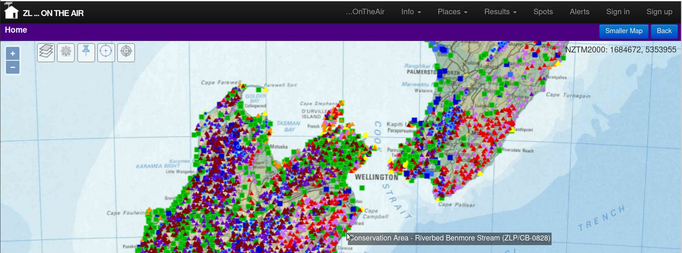

Finding places to go
The ontheair.nz website details all registered assets within NZ that can be activated for the various award programmes. A good place to start is with the map. If you are on a mobile device or small browser window, you may been to click the Larger Map button to display the map.


You can use the layers menu to choose which type of assets you wish to display on the map. They are not all displayed by default as it gets too crowded. Click the Layers icon and scroll down to Point Layers in the popup. Tick all the map layers you wish to see, and click apply. You can also switch between basemaps to show topomaps, airphotos, or public access land details.

Enabling polygon layers will show you the boundaries for locations such as parks. Polygon layers use quite a lot of data / memory – so keep them off by deault.

If you are using a device with a GPS, then you can show your current position on the map by clicking the GPS button. Your position will be shown as a large pink dot (note that the map does not recentre automatically, so you may need to zoom out or scroll to find the dot).

As you zoom the map, more detailed mapping will be shown with 1:50,000 topomaps shown at the highest zoom levels.

Assets are shown as coloured points as follows:

Symbol Reference* Type
ZLP/XX-#### Park
ZLL/#### Lake (public access land within AZ)
Lake (AZ entirely on private land)
NZ-#### POTA Park
ZLFF-#### WWFF Park
ZL#/XX-### SOTA Summit (public access land within AZ)
SOTA summit (AZ entirely on private land)
ZL#/HXX-### HEMA summit (public access land within AZ)
HEMA summit (AZ entirely on private land)
ZLI/XX-### Island
ZLV/XXX-### Volcano
ZLB/### Beacon / Lighthouse
ZLH/XX-### Back-country hut

* X – letters, # digits.

If you click on an asset on the map then the right-hand side of the screen will display details about that place (if you are on a mobile or in a small window you will need to click Smaller Map to see the right-hand panel).

The Public Access section is important. This gives an indication whether land with a right of public access exists within the activation zone of this asset. It will list the means of public access if they have been found. See the Legal Access section of this document for more details about public access to different types of land in NZ.

If the asset has been activated or chased, you’ll see by who. You can click on their logs (View) to see what bands they used. They may have added photographs or comments in the sections at the bottom of the page.

The Activation Zone (AZ) for the asset will be shown on the map in yellow.

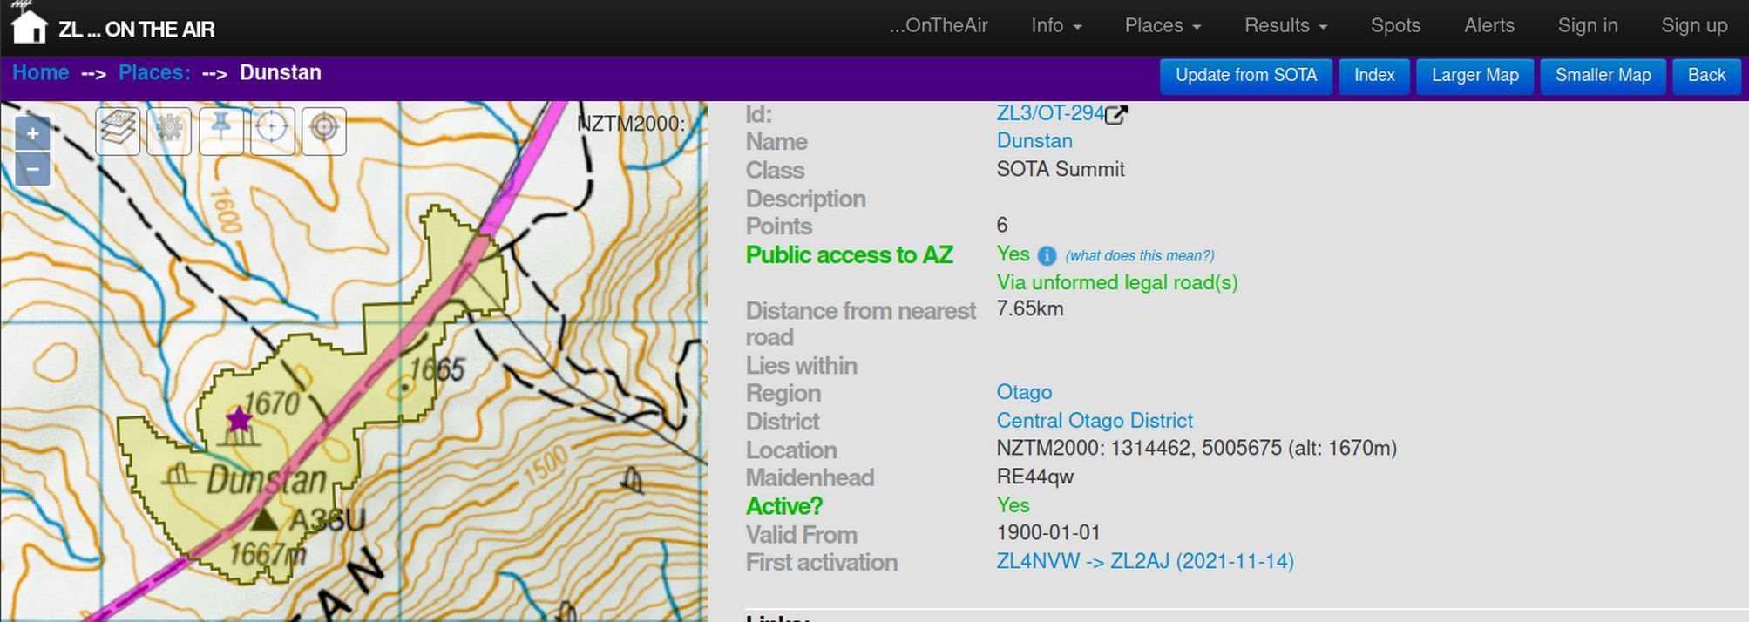


Alerting
An alert is an indication that you intend to activate a specific location at a specific future time.

Once you’ve decided where to go, and when to go there, then placing an Alert is a good idea. Sometimes you might head out at the last minute or make an ad-hoc activation just because you are passing, but otherwise - if you have time beforehand - chasers will be grateful if you post an Alert. The best time to post an alert is a day or two before you go. This gives chasers the chance to plan to be near a radio when you are activating.

An alert is an indication of your intent to activate a specific location at a specific time. You can also include details of the bands and modes you will be activating. It’s a statement of intent – not a promise. For example if weather conditions change, no-one expects you to head out in unsafe conditions just because you’ve alerted.

You can do this in many ways – the most common is via the ontheair.nz website, or by SMS. Other options include by InReach satellite messenger – this is dealt with in a separate section near the end of this document.

... via ontheair.nz

Click the Add Alert button (it’s at the top of the home page and alerts page), and enter details of your planned activation.

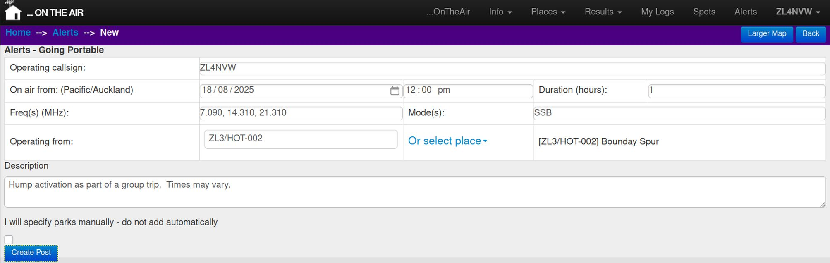
You will need to include:

Callsign: Your callsign for the activation
On Air From Date and Time you will start activating
Duration Expected length of the activation (in hours)

Make sure you use the correct timezone (UTC / local time) for your alert. You can set your preferred timezone in your profile (under your callsign, top-right). Note that most other websites and apps use UTC for all times by default.

Frequency and Mode are optional, but will give chasers an idea where to listen, especially if you are not able to spot from the field.

If you are operating from a known reference in an award scheme, then you can type this reference code in the Operating From field. You will need to make sure you get the formatting exactly right (though it is not case-sensitive). Or (safer) you can use the Or select place dropdown to choose the location from a list or from the map. If you make a mistake, then select Clear to clear the incorrect entry before adding a new one.

If you are going portable to an ad-hoc location, you can simply type the name of the location in under Operating From.

By default the alert will include any assets which contain the place you have selected. For example, if you select a summit and it lies within a park, then the park will be included in your Alert. If you do not want this to happen then check the checkbox to disable this feature:

□ I will specify parks manually – do not add automatically

Click Create Post when done.

... via SMS
You can alert via SMS to the ontheair SMS gateway. This is handy if you have poor coverage as SMS will often work where mobile data connections are not available.

The number is 027 3105319

The SMS ALERT format is:
ALERT <callsign> <reference> <frequency in MHz> <mode> <YYYY-MM-DD HH:MM> <comment>
e.g.
ALERT ZL4NVW ZLL/0006 7.090 SSB 2025-10-31 11:00 Quick activation on my way past

Notes:
- all SMS alerts must use UTC timezone. Alerst created by SMS will always have a duration of 1 hour.
- Do not include the word ‘SPOT’ or ‘spot’ in your ALERT comments – (the filter in our 3rd-party SMS gateway very crude!)

(you can test SMS alerting by sending an alert with DEBUG as the first word in the comments. Debug alerts will appear in the Test Alerts channel under the Info menu in the website and will not be emailed out to other users).


Spotting

A spot is a report that a particular operator is on the air now, activating a given location.

Once you arrive at your asset’s activation zone, and are set up then sending out a spot allows chasers to know that you are on air. You can do this in many ways – if you have internet access you can spot through a logging app (PoLo, iPnP, VKPortaLog all support ZLOTA spotting) or through the ontheair website, or alternatively by SMS. SMS works in many locations where coverage is too marginal for mobile data connections to be successful. Other options include by InReach satellite messenger, or over FT8 using SOTAmat. These are dealt with in separate sections near the end of this document.

You can also spot for someone else who you’ve heard on-air, or who has asked you to do so.

... via ontheair.nz
Click the Add Spot button (it’s at the top of the page on the home page or Spots page).

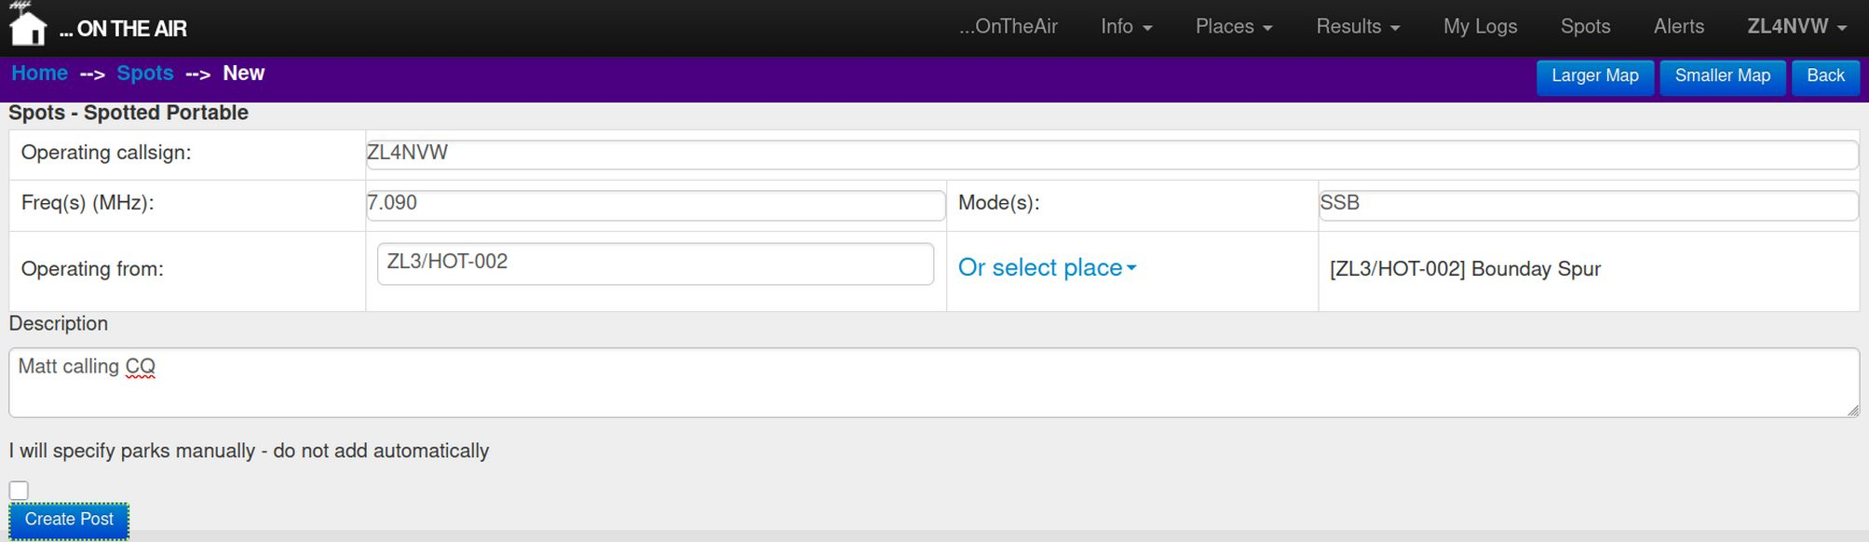
Fill in the form. You’ll need to enter:
Callsign: The callsign of the person making the activation
Freq Frequency (in MHz)
Mode FM, AM, SSB, FT8, etc

If you are operating from a known reference in an award scheme, then you can type the reference code in the Operating From field. You will need to make sure you get the formatting exactly right (though it is not case-sensitive). Or (safer) you can use the Or select place dropdown to choose the location from a list, from the map, or using your device’s GPS (if it has one).

Note that when using the from GPS option, you may get a message saying GPS not ready. If so, wait for the GPS to lock (a pink dot will appear on the map showing your location) and try again. The GPS option will check your current location against all known assets and add any that you are in the activation zone of. If you just get a set of coordinates and no list of assets, it means you are not yet within any AZ.

If you make a mistake, then select Clear to clear the incorrect entry before adding a new one.

If you are just going portable to an ad-hoc location, you can simply type the name of the location, or it’s lat, long coordinates, under Operating From.

By default the spot will include any assets which contain the place you have selected. For example, if you select a summit and it lies within a park, then the park will be included in your Spot. If you do not want this to happen then check the check-box to disable this feature:

□ I will specify parks manually – do not add automatically

Click Create Post when done.

... via SMS
You can spot via SMS to the ontheair SMS gateway. This is handy if you have poor coverage as SMS will often work where mobile data connections are not available.

The number is 027 3105319

The SMS format is:
(SPOT) <callsign> <reference> <frequency in MHz> <mode> <comment>

e.g.
ZL4NVW ZL3/SL-285 7.090 SSB 10 minutes on 40m then QRT

or:
SPOT ZL4NVW ZLL/0001 14.310 SSB Matt needing 1 more contact!

(you can test SMS spotting by sending a spot with DEBUG as the first word in the comments. Debug spots will appear in the Test Spots channel under the Info menu in the website and will not be emailed out to other users).


Entering logs
For those who prefer paper logs (or digital notepad apps) in the field over logging programmes, the easiest way to get logs into ontheair (and all the other awards schemes) is to enter them using the ontheair website.

Click My Logs on the menu bar to go to your logs page, and click the Add Log button.

The screen is in two halves.
The top half is for details of your location and setup.
The bottom half of the screen is for the contacts you made and the other parties locations

... Your Details
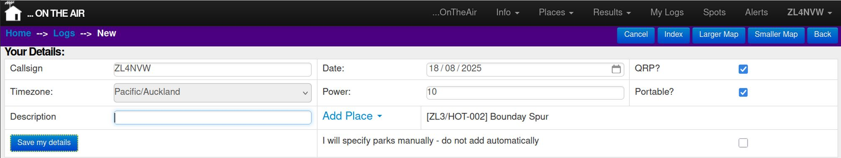
Fill in the Your Details form. You’ll need to enter:
Callsign: The callsign you used for the activation
Date Date the activation commenced (in timezone indicated)
QRP Check this if you were QRP (needed to claim QRP points)
Portable Check this for all but Home-based operation
Power Optionally, enter your tx power

If you were operating from a known reference in an award scheme, then you can type the reference code in the Description field. You will need to make sure you get the formatting exactly right (though it is not case-sensitive).

Or (safer) you can use the Add place dropdown to choose the location from a list or from the map. If you make a mistake, then select Clear to clear the incorrect entry before adding a new one.

If you were just going portable to an ad-hoc location, you can simply type the name of the location in under Description.

By default the log will include any assets which contain the place you have selected. For example, if you select a summit and it lies within a park, then the park will be included in your log. If you do not want this to happen then check the check-box to disable this feature:

□ I will specify parks manually – do not add automatically

Click the Save my details button when done.

... continues overleaf

... Other Party’s details
Once you have saved your details, a spreadsheet-style grid will appear for you to enter the details of your contacts and their locations.

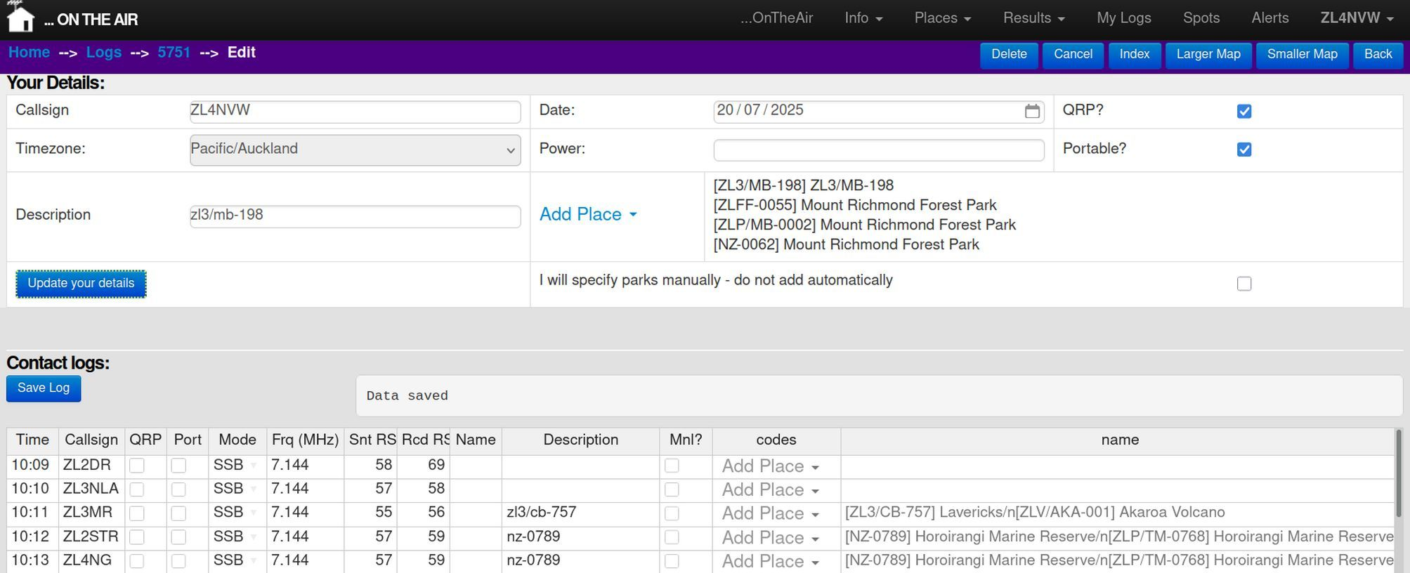
You’ll need to enter:
Time: Time of the QSO (HH:MM or HHMM – using 24hr clock)
Callsign: The callsign of the person you contacted
QRP Check this if the other party was QRP
Portable Check this if the other party was portable
Mode The mode used for the contact (AM, FM, SSB, FT8, etc)
Freq Frequency of the contact (in MHz)
Sent RS(T) Signal report you sent to other party (in ## or ### format)
Rcd RS(T) Signal report you received from other party (in ## or ### format)
Name (optional) Name of the other party

If the other party was operating from a known reference in an award scheme, then you can type this in the Description field. You will need to make sure you get the formatting exactly right (though it is not case-sensitive). Or you can use the Add place dropdown to choose the other party’s location from a list or from the map. If you make a mistake, then select Clear to clear the incorrect entry before adding a new one. You can also add a textual description (e,g. Wellington) in Description.

By default the contact will include any assets which contain the place you have selected for the other party. For example, if you select a summit and it lies within a park, then the park will be included in the contact. If you do not want this to happen then check the Mnl? (manual) checkbox to disable this feature.

Once you have entered one contact, you can add the remainder in the remaining rows. Mode and Frequency will automatically be copied down as you start to enter the next row’s details.

Once you are finished, click the Save Log button to save the contacts. If you are entering a large number of QSOs, it is worth saving the log every now and then as you go along so that you do not lose data if things go wrong. Data Saved will appear in the box above the spreadsheet once the save is complete - do not navigaate away from the page after saving until Data Saved is displayed.


Uploading logs
For those who use logging apps when in the field, it is far easier to upload your log from there than type it in again. Export the log from your app in ADIF format. In PoLo you are recommended to use the Export All rather than Export ZLOTA option, as the ‘All’ option will include all details of your contacts across all award schemes, not just ZLOTA.
In ontheair.nz, click My Logs on the menu bar to go to your logs page, and click the Upload Log button.

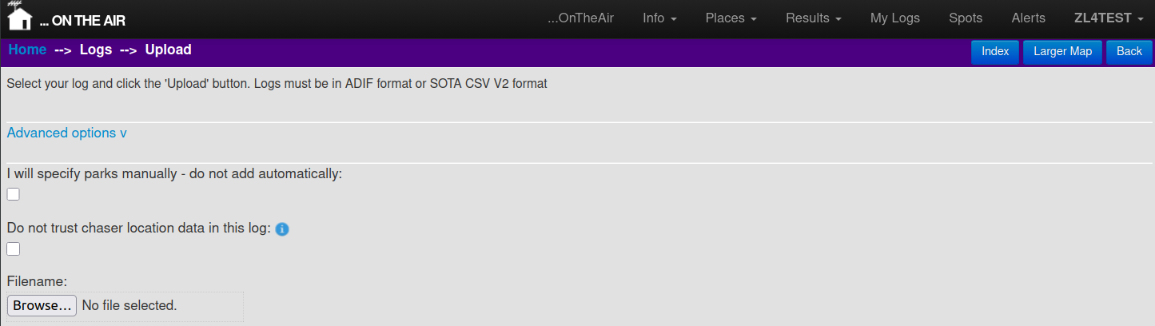
By default the log created at ontheair will include any assets which contain the place you have activated. For example, if you upload a log for a summit and it lies within a park, then the park will be included in your log. If you do not want this to happen then check the checkbox to disable this feature:

□ I will specify parks manually – do not add automatically

Some logging app’s (notable PoLo) use ‘Home QTH’ data from qrz.com and other online sources to determine the location of your chasers. This may be useful for putting a DX contact on a world map, but is too unreliable to use to work out what parks, etc your chasers are located in. The automatic use of home QTH location data is also undesirable in a programme focussed on portable operation where your chasers are likely to be portable. Furthermore, where the user has not specified a Home QTH location on qrz.com, such logging apps use a default location for the DXCC of the callsign. For ZL this default location seems to be Pencarrow Head lighthouse!
If you use a logging app that automatically adds unreliable location data for chasers, please check the checkbox to mark the location data as unreliable:
□ Do not trust chaser location data in this log
By selecting this box, chasers location will, where possible, be derived from any assets they are activating, rather than the supplied lat/long or grid ref. If they are not activating any assets then the supplied location data will be saved and displayed on the map of the contact, but will not be used to determine what assets they are activating.

Browse for the logfile and click Upload Log when done.

... Advanced options
Some logging programmes, not designed specifically for activations, do not include all the details we need to create an activator log. For example the log may be missing the activator callsign or the reference for the asset you were activating. You can specify these manually under Advanced Options.

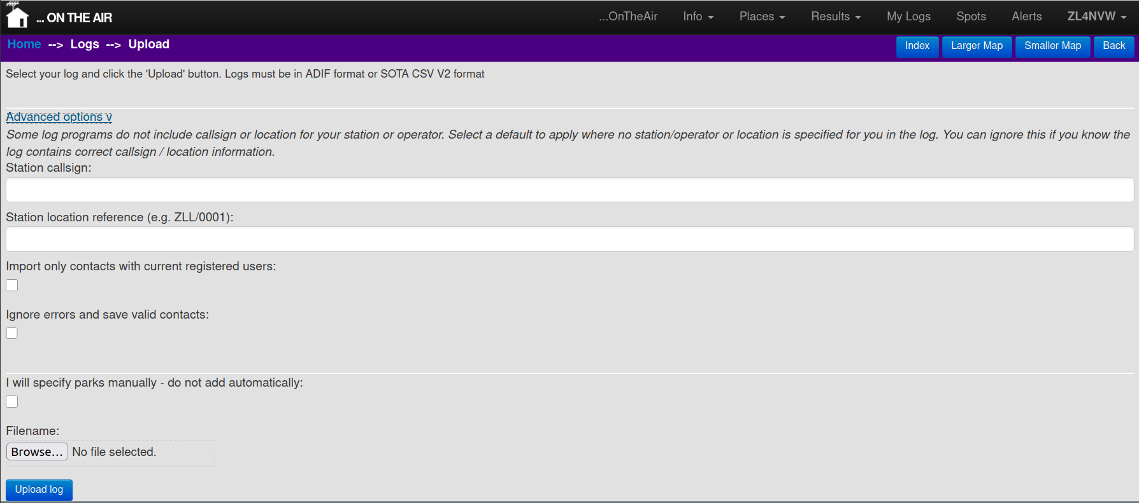
For larger FT8 activations (e.g. 50+ contacts), consider limiting the QSOs uploaded to those with registered users. This keeps our database size manageable whilst still crediting registered users with the contacts. You can do this by checking
□ Import only contacts with current registered users

Where logs contain invalid entries we will show error messages indicating what went wrong. By default the entire log is rejected if it contains one invalid entry. You can tell the system to instead ignore and continue with the rest of the contacts by checking:

□ Ignore errors and save valid contacts

Forwarding logs to other award programmes
If you activated assets from award programmes such as POTA, WWFF, SOTA and HEMA, then you should forward your logs to those programmes too. Do this even if you are not interested in that award scheme yourself – your logs will be needed so that chasers get their credits in that programme. And some of your chasers will almost certainly want that.
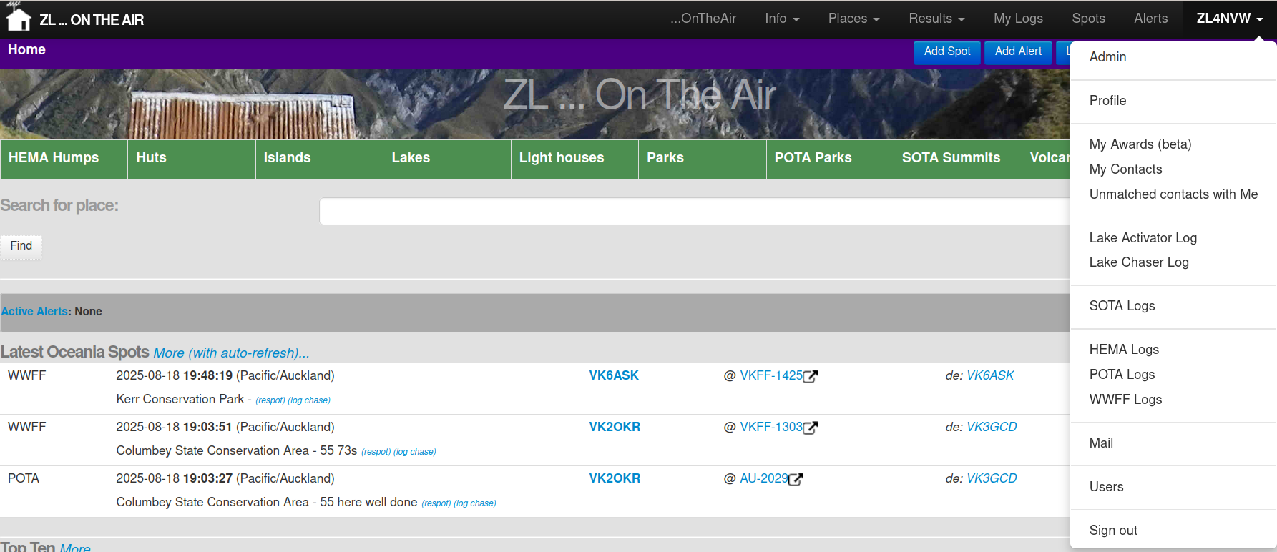
You can find options to export your SOTA and POTA logs in ADIF format under your callsign (top-right) on the menu bar. These ADIF files can then be uploaded to each scheme’s official website.
WWFF logs can be emailed to the ZL WWFF coordinator from the same menu.
HEMA logs can be uploaded directly to HEMA from the menu – but you’ll need a HEMA account and will be prompted to enter your HEMA username and password. Usernames and passwords are sent directly to HEMA – they are not saved or logged at ontheair.nz
Full details of other individual award programmes, and how to submit logs to them, are given later in this document.

Chasing:


Spots page
The Spots page shows all current portable operations that have been reported by the various ZL, VK and worldwide spotting sites. By default the screen will show you all spots reported in Oceania in the previous hour.
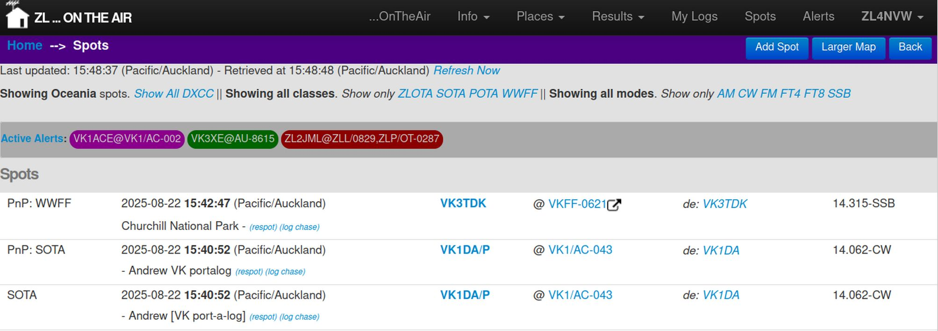
Columns are:
Info source | Time spotted | Activator callsign | Reference / location | Spotter callsign | Frequency - Mode
 | Comments (actions)

The top few lines allow you to filter the results by continent, scheme and mode.

Clicking Show all ... will clear that filter.

E.g. clicking Show all DXCC will clear the Oceania-only filter and show all spots worldwide. You will then get the option of filtering back down to a specific continent.

Below the filters a grey banner lists all current Alerts – that is all alerts matching your filter where users planned to be active at the current time. The Alerts banner can be scrolled / swiped sideways if reaches the end of the screen.

You can switch to the full alerts screen to see more details of alerts, as well as past and upcoming alerts, by clicking the Active Alerts link.

The majority of the screen is taken up by the list of current spots. These are ordered by time with most recent at the top. As spots are sourced from a range of sites around the world, the same spot may be listed multiple times against various sources (e.g. SOTA and PnP in the above example).

If you make contact with any of these activations you can immediately log your contact from this screen by clicking Log chase against the spot

You can also create a new spot for the activation and add your own comments, report frequency changes, etc by clicking Respot against the spot

Hovering over a callsign with the mouse will show you the country and continent of the call – handy for unfamiliar DX!

Spots are pulled from remote sources by the server once per minute and are also refreshed on you screen once per minute. This means there may be up to a 2 minute delay between a spot being posted on a remote server (e.g SOTAWatch) and appearing on your screen. You can refresh your view from the ontheair server by clicking Refresh Now.

The auto-refresh will stop if the internet connection times out, and Timed Out will be displayed instead of the latest retrieved time. This will also occur on a mobile device if your browser does not have permissions to continue operating when the screen is off. Click Refresh Now to restart the updates.

You can also subscribe to receive notifications of all new ontheair spots by email or by push notifications to your mobile device. See the Email Subscriptions and Notification Subscriptions sections for details


Alerts page
The Alerts page looks similar to the pots page, but shows planned activations rather than current ones.

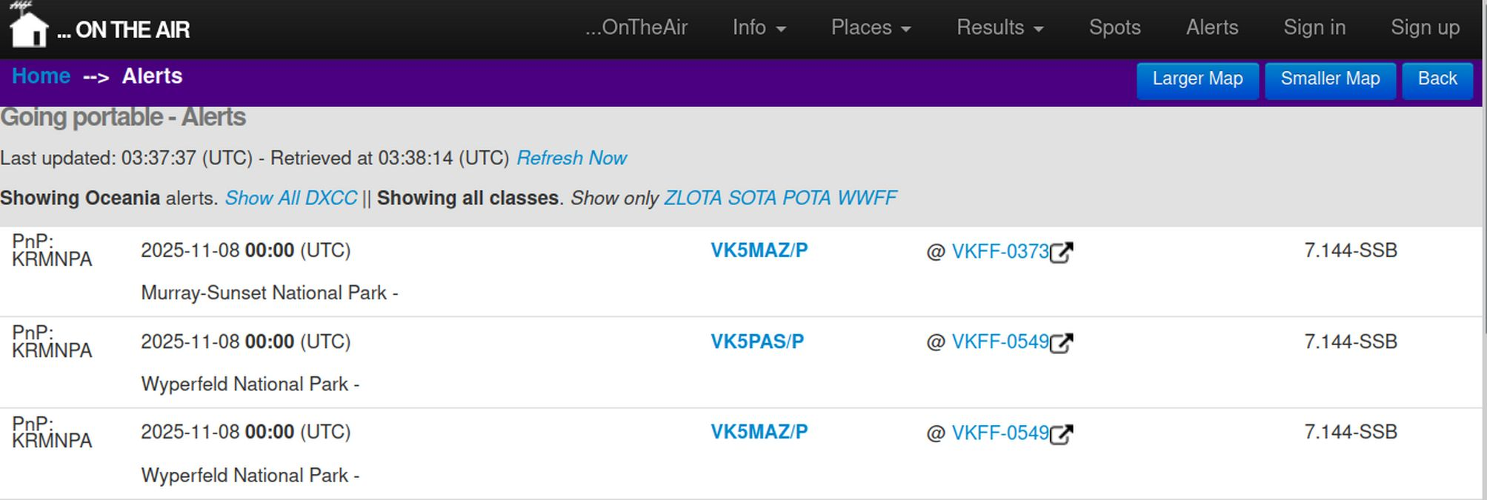
As with spots you can filter the alerts based on continent and programme. By default all Oceania alerts are listed.

Clicking Show all ... will clear that filter. E.g. clicking Show all DXCC will clear the Oceania-only filter and show all spots worldwide. You will then get the option of filtering back down to a specific continent.

Alerts may be posted days, weeks or even months in advance. The latest start-date is shown at the top.

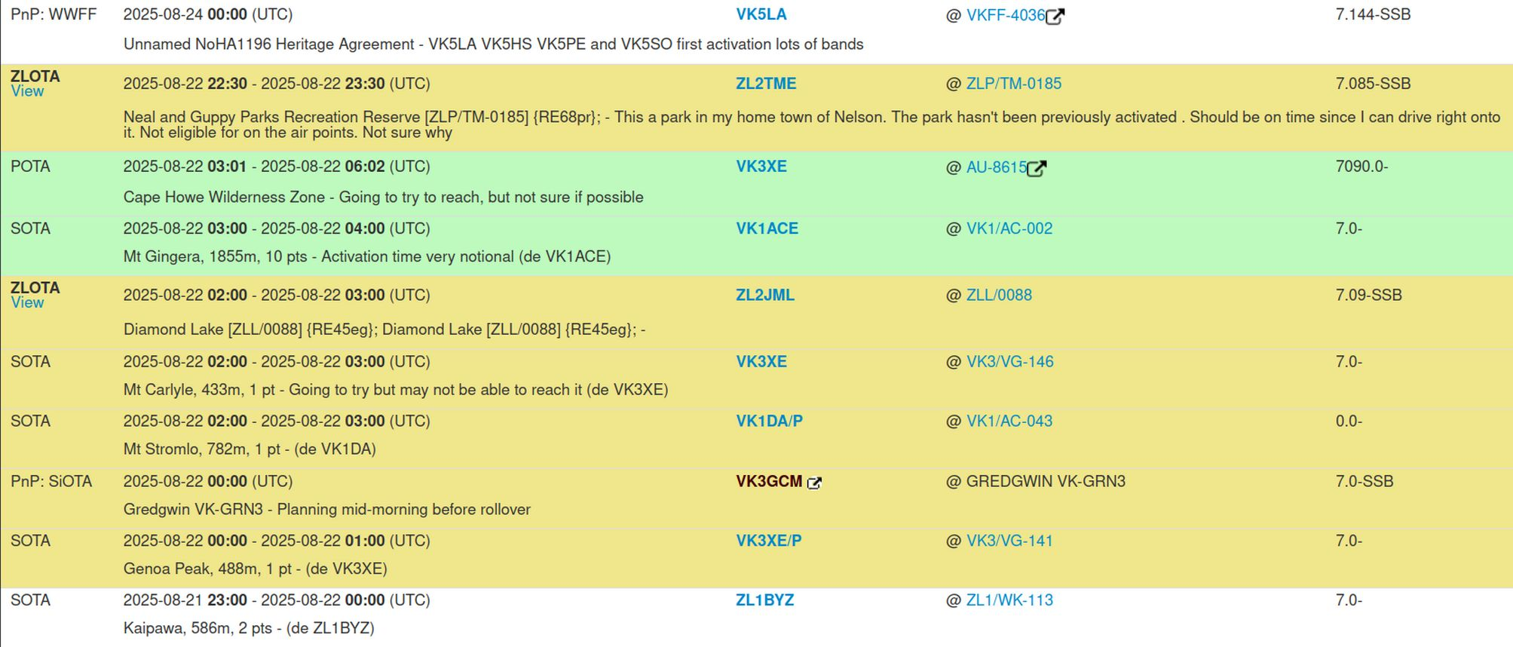
As the list can be long, the current calendar day’s alerts are highlighted in yellow to help you locate them in the list.

The calendar day used depends on your account’s timezone setting: if you have selected UTC then the current UTC day will be highlighted. If you have selected Pacific/Auckland then the current local day will be highlighted. Edit your profile (under your callsign – top right) to change your timezone setting.

Alerts which span the current time (start before now, end after now) are highlighted green. These are the same alerts that appear on the brief alerts banners on the Spots and Home page.

ZLOTA alerts will have a View link that takes you to the original post that created the alert. Here you will find further information including a map (if a location was specified)

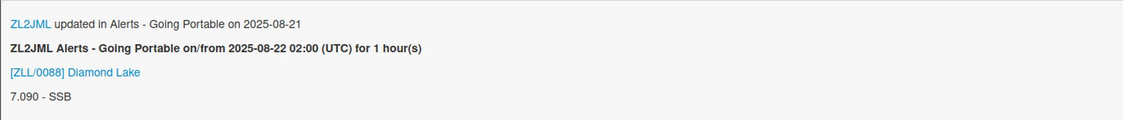
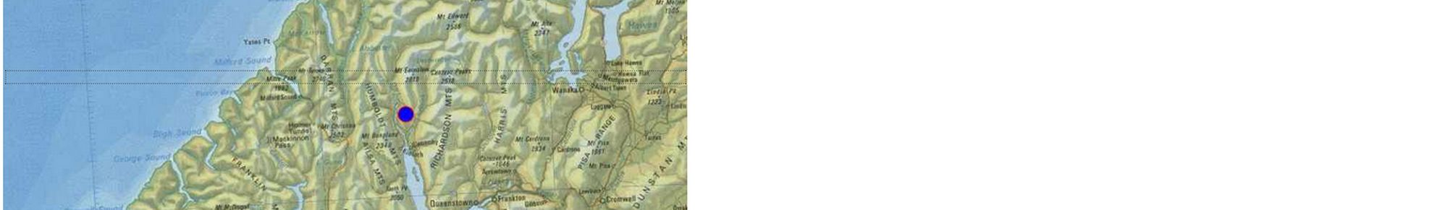
You can also subscribe to receive notifications of all new ontheair alerts by email or by push notifications to your mobile device. See the Email Subscriptions and Notification Subscriptions sections for details

Logging chases

Some award programmes, notable SOTA and HEMA have a requirement for chasers to log spots. Some, such as POTA and WWFF rely entirely on activators to upload logs (and if they don’t – chasers miss out). ZLOTA allows both parties to upload logs.

The recommendation is that you log chases:
- For all SOTA and HEMA chases
- For ZLOTA chases where you want to ensure you get credited with the contact

... From a spot

The simplest way to log a chase is at the time, using the Log Chase link on the spots screen as discussed in the Spots section above.

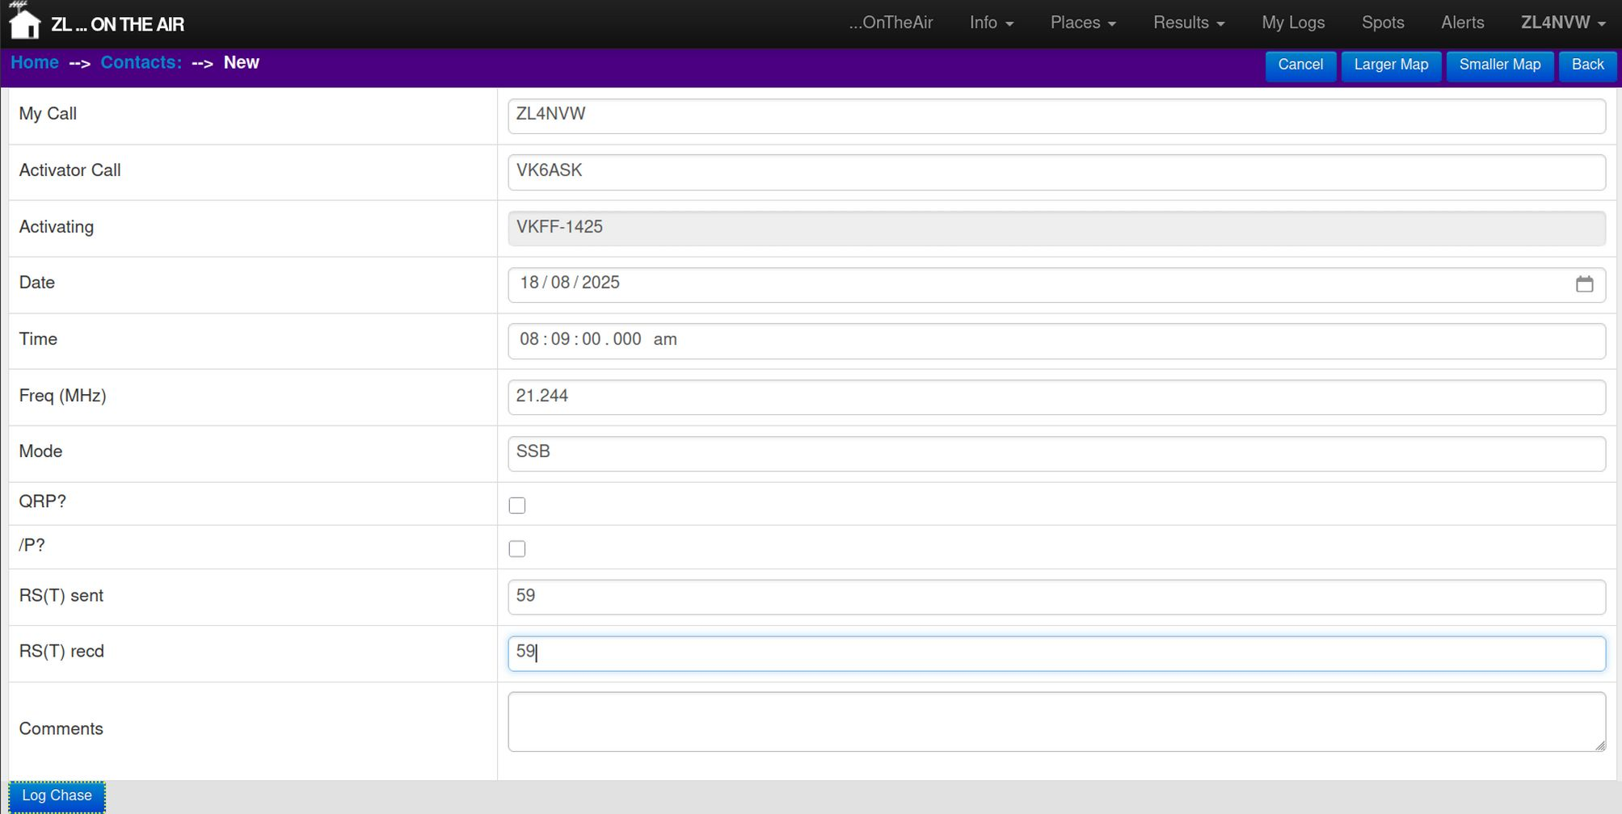
This will take you to a simple single-contact log screen where you can enter details of the QSO. The callsigns, time, mode, frequency and activator’s location will already be completed for you based on the spot.

All you need to do is enter the signal report you sent to the other operator – RS(T) sent, and the signal report you received from the other operator – RS(T) recd. These should be entered in ## or ## format – e.g. 59 or 599.

Other optional fields can be completed as you requied.

Click Log Chase when done.

A chaser log will be created containing this single QSO.

... As a chaser log

Alternatively you can create a single log for all chases on a given day. See the Entering Logs section under Activations for details of how to do this. The only difference for a chaser log is that you do not need to specify a reference under Your Details as you are not activating yourself, but you do need to select or specify a location for the party you are chasing against their QSO.

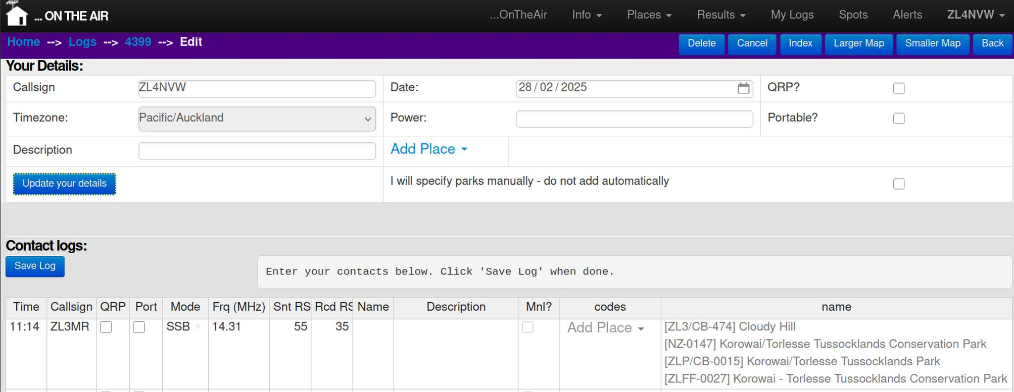
Once you have logged your SOTA and HEMA chases at ontheair.nz, you should also forward them to the SOTA or HEMA websites. You’ll see ‘Chaser Log’ listed under both your SOTA Logs and HEMA Logs lists. See the relevent section of this document for SOTA / HEMA to see how to send these through.

Honour Rolls and Awards

Honour Rolls

As with SOTA, POTA and others, ZLOTA is not intended to be a competitive sport. However, tracking your progress and those of others around you can be part of the fun. As such we include Honour Rolls for each class of asset in the ZLOTA scheme.

You can see the Honour Rolls under the Results menu at the top of the screen.

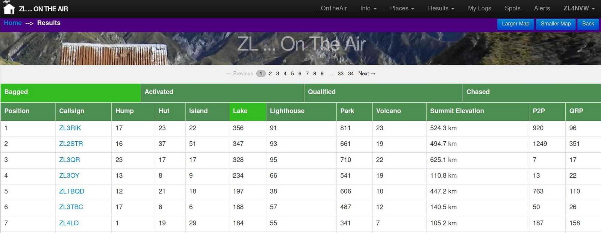
The first line on the honour rolls screen lists the four categories that are tracked:
Bagged The unique assets you have chased or activated
Activated The number of assets you have activated making at least one QSO, with revisits allowed once per calendar year.
Qualified The number of assets you have activated making at least the minimum required number of QSO for that asset type, with revisits allowed once per UTC calendar year.
Chased The number of assets you have chased, with additional chases of the same asset allowed once
per UTC calendar day.

Click on a heading to display the statistics for that category.

The second line lists the classes of asset for which statistics are kept, e.g Lighthouse, Park, Volcano. Click on the heading to sort the table by that category.

Additional categories are listed for:
Summit Elevation Total cumulative summit elevation for SOTA, HEMA and volcanos
P2P Number of Portable-to-Portable contacts where at least one participant is in a
ZLOTA asset and the other is in an asset in any recognised award scheme (ZOTA,
SOTA, POTA etc)
Note that you get one P2P for each asset each operator is activating – so if you are
on a summit in a park then you get one P2P contact for each asset (2 total)
QRP Number of contacts for which you were operating QRP. This relies on the QRP tickbox in Your Details in your logs, so make sure you tick it if relevant. If you
operate QRP for only part of an activation, you will need to submit two logs (sorry!).

Awards

ZLOTA doesn’t hand out trophies, or certificates for your wall. But ou do recieve virtual awards listed against your callsign on the ontheair website. These can give operators targets to aim for, if that is their thing.

You can view your awards from the Awards link in the menu under your callsign (top-right of the screen).

There are three categories of awards on the system:

Threshold awards

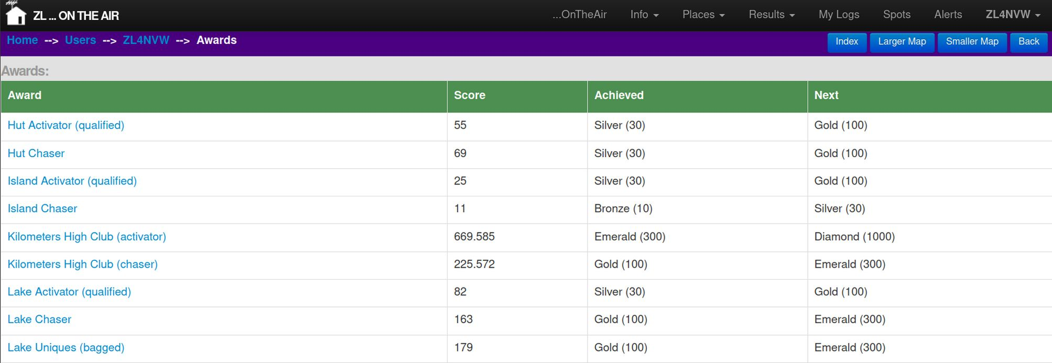
Threshold awards are based on your result in the honour rolls and give you an award for activating / chasing / bagging 10, 30, 100, 300, etc assets of a given type (or kilometers, for summit elevation).

Worked all Region awards
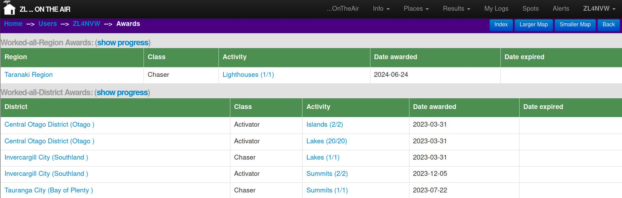
Work all Region awards are awarded for chasing or activating every asset of the specified type in a regional council region. Some are easy (how many lighthouses are there in Taranaki?). Others are immensely challenging (summits in Fiordland, anyone?).

Worked all District awards

Regions can be very big - activating all the summits in Otago seems a little over the top - so we break some categories down to district council districts.

The threshold-based awards table shows you your current score, the latest award threshold you have achieved, and the next threshold award you can aim for.

For worked all region or worked all district awards you will need to click on the Show Progress link to see your progress towards any yet-unclaimed awards.

Other people’s awards

If you want to see what awards other people have achieved you can view the same information by clicking on the Show Awards link on their Profile page. You can find their profile page either by clicking on their callsign anywhere it appears, or by searching for them in the Users page (which you’ll find in the menu under your callsign, top-right).

But I want a certificate!

For those wanting certificates, the ZLOTA programmes align, where possible, with NZART awards. You will likely be able to claim an equivalent award certificate from the NZART awards manager. See the details in the Award Programmes section of this document for details of NZART awards available.

But I still want a ZLOTA certificate

The position of ZLOTA awards manager is vacant for anyone with the skills and time to produce the required professional quality certificates. Make yourself known to admin@ontheair.nz if you are interested.

Award Programmes
Six national and four international award programmes operate within New Zealand. Each has its own set of rules and objectives, so it is worth taking some time to study the details before you participate in each. Additionally, there are some subtle differences between the national ZLOTA programmes hosted at ontheair.nz and the equivalent NZART award.

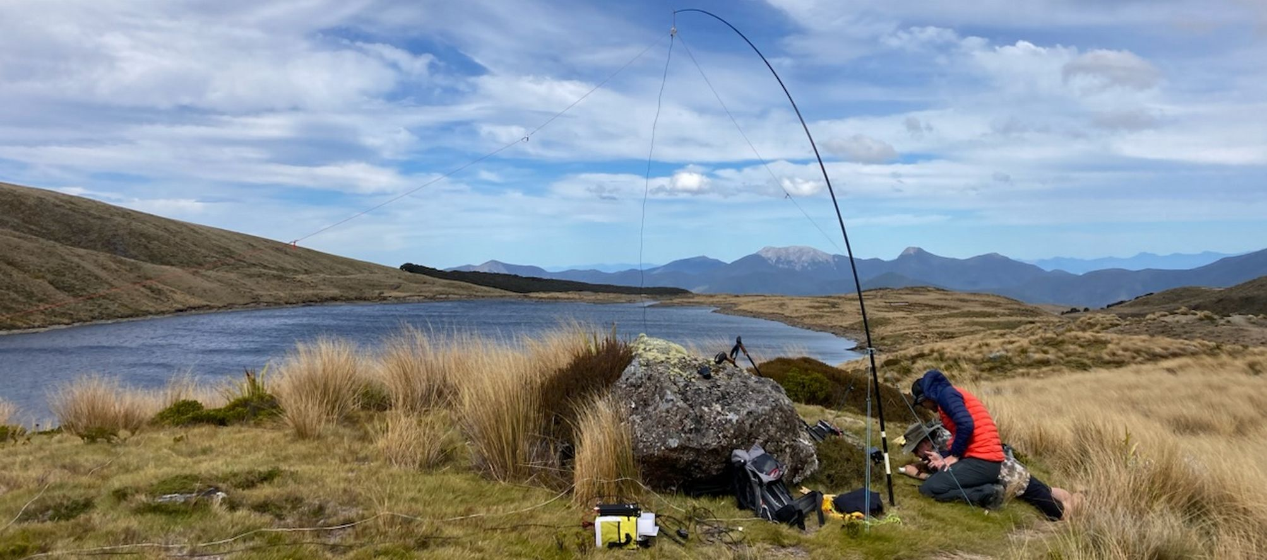

Summary of differences
The following table summarises the differences between award programme rules. See the individual programme’s section for full details.
Programme | Reference format | No QSO to qualify | Activation Zone | Allow activator: |  | Allow chaser:
 |  |  |  | From Vehicle | Multiple assets in same scheme | Multiple callsigns? (8) | Multiple bands / modes?  (8) | Chasing via SDR
ZLOTA
Huts | ZLH/XX-### | 1 | 100m (1) | Yes | N/A | No | No | Yes (4)
Parks | ZLP/XX-#### | 4 | Within boundary (2) | Yes | Yes | No | No | Yes (4)
Islands | ZLI/XX-### | 5 | Onshore, inter-tidal, moored, anchored | Yes | N/A | No | No | Yes (4)
Lakes | ZLL/### | 2 | Within 500m | Yes | (5) | No | No | Yes (4)
Lighthouses & Beacons | ZLB/### | 4 | Within specified radius or within sight | Yes | Yes | No | No | Yes (4)
Volcanos | ZLV/XXX-### | 4 | Within specified radius | Yes | Yes | No | No | Yes (4)
International programmes
SOTA | ZL#/XX-### | 4 | Within 25m vertical (3) | No | N/A | No | No | ? (7)
HEMA | ZL#/HXX-### | 4 | Within 25m vertical (3) | No | N/A | No | No | No
POTA | NZ-#### | 10 | Within boundary (2) | Yes | Yes | Yes | Yes | ? (7)
WWFF | ZLFF-#### | 44 (6) | Within boundary (2) | Yes | No | Yes | Yes | No

(1) Within 100m or on designated campsite
(2) All equipment and operator within (or along) boundary
(3) Operator within AZ, equipment can extend beyond
(4) SDR use by chasers permitted for ZLOTA so long as it is within same DXCC as chaser
(5) ZLOTA allows multiple lakes to be activated simultaneously, but the NZART award does not.
(6) 44 contacts for international WWFF awards. 10 contacts for national ZL awards
(7) Not explicitly prohibited
(8) Some programmes count an additonal QSO with the same operator on a new band, mode or using a new callsign as a new contact counting towards your total. Others count this as a single contact.

ZLOTA / NZART Rules

The ZLOTA award programme covers a number of asset types, all of which come with slightly different rules. See the sections below for a guide to each type of asset and details for activating / chasing it.

The latest rules for the programme can be viewed under ZLOTA – Rules from the Info menu at https://ontheair.nz

Where possible ZLOTA aligns with the equivalent NZART award programme. Where discrepancies exist (where NZART requirements are incompatible with ZLOTA in a way that cannot be accommodated at the ZLOTA end) we are working to eliminate them through updating the NZART ruleset.

You can create a spreadsheet of your ZLOTA contacts (activations / chases) to send to NZART to claim your awards – see exporting logs section below.

ZLOTA General Rules

G. Scoring
- You will receive activator points for a qualifying activation of a location once per UTC calendar year. Reactiviating it within the year is a valid activation but will not add to your points.
- You will receive chaser points for chasing a location once per UTC calendar day. Contacting another operator at the same location on the same day is a valid contact, but will not add to your chaser points.
- Contacts between the same operators and locations on multiple bands or modes count only as a single contact for ZLOTA (but check rules for other award schemes - e.g. POTA/WWFF)
- Your bagged score is the list of unique locations you have either activated or chased. Locations can be bagged only once by each operator.
- The first person to activate or chase a hut, park, lake, lighthouse or island gets bragging rights for participating in the first activation of that location.
H. Required information
- You must exchange, at minimum: callsigns and signal reports (or equivalent verbal information where a signal meter is not present). Exchange of references is also encouraged.
- Your log must include (at minimum): time, date, frequency/band, mode, both callsigns, location/reference of the activating party(s), and both signal reports.
I. Callsigns
- Contacts and awards belong to the operator, not the callsign. So if you have held multiple personal callsigns, then all resulting contacts are combined.
- If a club callsign is registered as a separate ontheair account, contacts logged are to the club, otherwise contacts can count towards the operator’s personal tally.
J. General
- The programme is open-ended and has no closing date.
- Historic (pre 2020) contacts can be included
- Activators must operate off-grid (you must be powered by a power supply you brought with you).
- Operation from within a vehicle or structure is permitted for ZLOTA (but check rules for other awards schemes, specifically SOTA)
- There is no limit on power. QRP or QRO - all welcome. It's your call how much radio gear you wish to lug into the backcountry!
- Participants must comply with their license conditions and all published legislation, bylaws and park regulations.
- The operator must be within the activation zone. Antennas and support can extend beyond the activation zone if required.

NZART General Rules
Rules for all NZART Awards
- NZART stresses the ‘honour system.’ Award applicants do not have to hold QSL cards for claimed contacts. It is sufficient to merely certify that the QSO was legitimately made. This rule applies to all NZART sponsored awards.
- QSOs made by IRLP, Echolink, or other Internet enabled communication are not acceptable for any award. All QSOs must be by two-way conversation made by radio. D-Star and other DV modes are only acceptable if they are radio to radio contacts with no Internet linking.
- Cross-band operation is not acceptable for any awards.
- Repeater QSOs are valid only when specifically stated in the individual award rules.
- Awards are open to SWL (shortwave listeners) as well as amateur radio operators worldwide.
- Satellite and EME contacts are acceptable if they are radio to radio contacts with no Internet linking.
Note that point 2 is explicitly contradicted in many individual award rules which allow SDR use so long as the SDR is in the same DXCC as the operator. The individual award rules should be assumed to take precedence over the general rules in this case.

Sending ZLOTA logs to NZART
You can view a list of all the contacts you have made activating / chasing in a particular award programme from the ZLOTA Logs page (under your callsign, top-right). You will need to be logged in to use this feature.

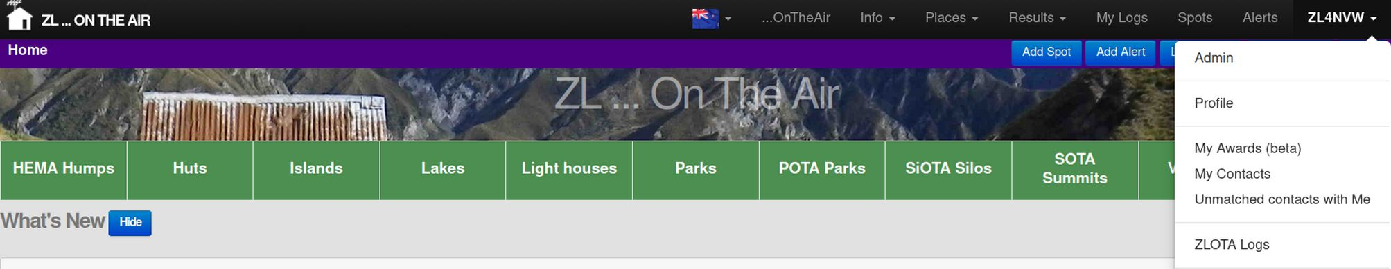
Select the Class of asset you wish to see logs for (e.g. Park, Lighthouse, etc) and check either Activator or Chaser. Then click Filter to show your contacts.

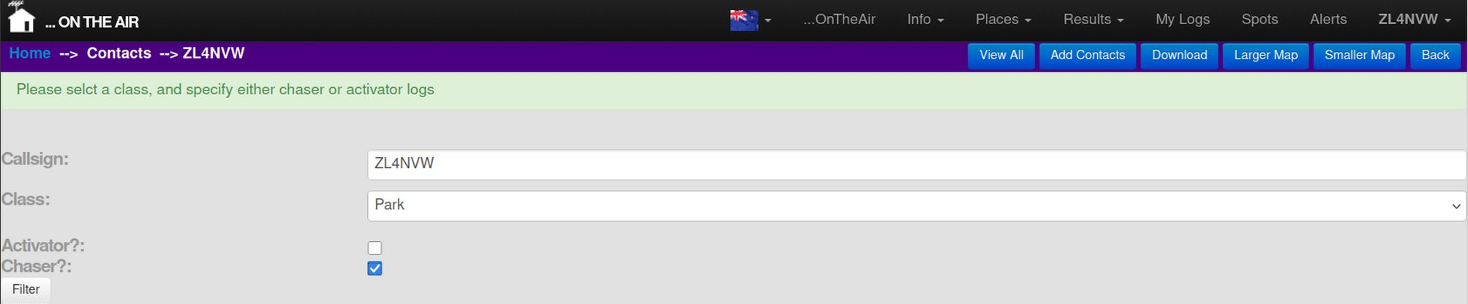

A paged list of all your contacts under that class will be shown.

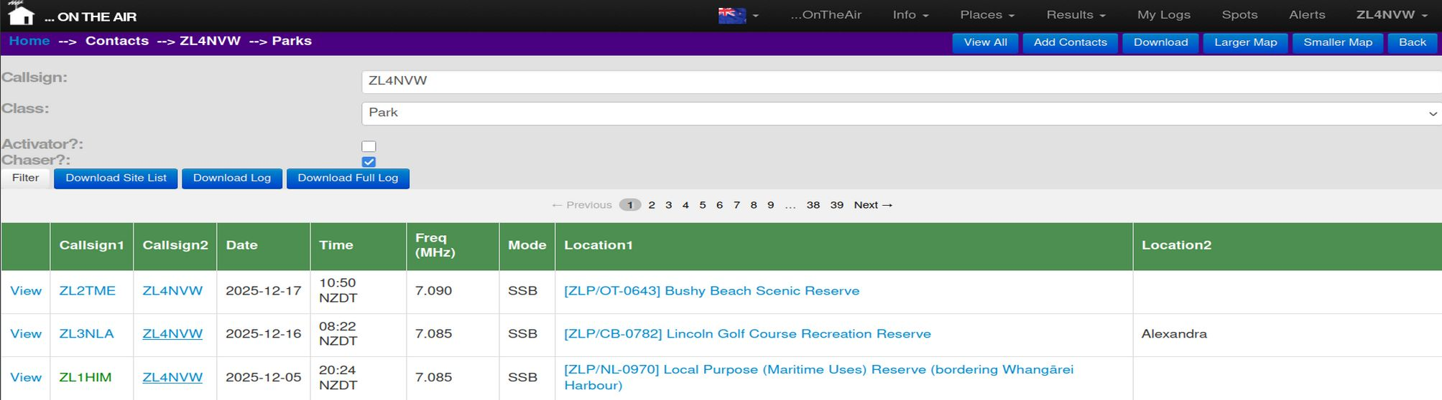
Click on the Download Site List button to save a spreadsheet (csv) of all the sites under that programme that you have activated / chased.

Click on the Download Log button to save a spreadsheet (csv) of all the chaser / activator contacts you have made under that programme.

Check that the Site List and the Log are correct, and email them to the NZART awards manager.

Notes:
- For activations, you may need to use your spreadsheet program to delete any entries where your activation did not meet the NZART minimum criteria for activators (e.g. insufficient QSOs).
- Activator logs will include only QSOs logged by yourself (will not show QSOs logged only by your chasers).
- Chaser logs will list all QSOs logged by either yourself or by the activator you were chasing.
- You can use the Download Full Log button to extract all data ontheair has on these QSOs. However, for readability, NZART request that you send the shorter-format standard log when claiming awards.

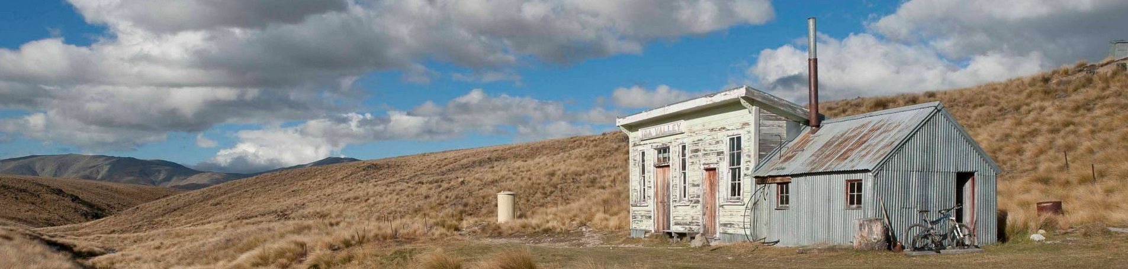
Huts

Huts on the Air was the starting point for the ZLOTA programme. A small number of QRP operators who worked, volunteered of spent recreational time in the backcountry regularly put their radios on 3.690KHz of an evening to talk to each other, and to all comers. The atmosphere was more informal than a typical activation – a mix of some folks calling in for a ragchews, others wanting to ‘bag’ a quick contact with the hut. Rather than the activator calling CQ, they would alert in advance the time and frequency, and chasers would call in at their leisure. Increasingly a following of chasers grew and we put together the predecessor of this website so that chasers and activators alike could track which huts they had contacted.
The original group has drifted away since then, but some activators keep up this tradition – leaving the radio on for the evening to see who calls in. Others treat huts no differently to a park or lake – calling CQ until they have the numbers in the log that they require. As activator, the choice, naturally, is all yours!
All DOC huts are included in the programme, as is any backcountry hut listed on the https://hutbagger.co.nz website. Club huts and private huts can also be included so long as they are off-grid, off-road and backcountry. If you have a hut you want adding, contact admin@ontheair.nz with details and we’ll check its validity and add it if it qualifies. There are currently about 950 public DOC huts, and a little over 1100 total huts in the ZLOTA scheme.
With the exception of a few roadend shelters, most huts are several kilometers from a road, and will require foot (or sometimes bicycle or boat) access.
When activating a hut, be considerate to other users – not everyone is there to listen to you play radio! To aid you in this, ZLOTA allows activations from anywhere within 100m of the hut, or from it’s official designated campsite – where one exists.

ZLOTA Rules

A. Huts - [ZLH/XX-###]
- A single contact from a backcountry hut is all it takes to qualify an activation of a hut
- The activation zone for a hut is within 100m of the hut, or from within it's associated / designated camping area.
- Huts must be either DOC or club huts or off-grid, back country private huts to be valid for ZLOTA.

NZART

There is currently no NZART huts award. However, DOC huts count towards the DOCLands award. See the NZART website for details.

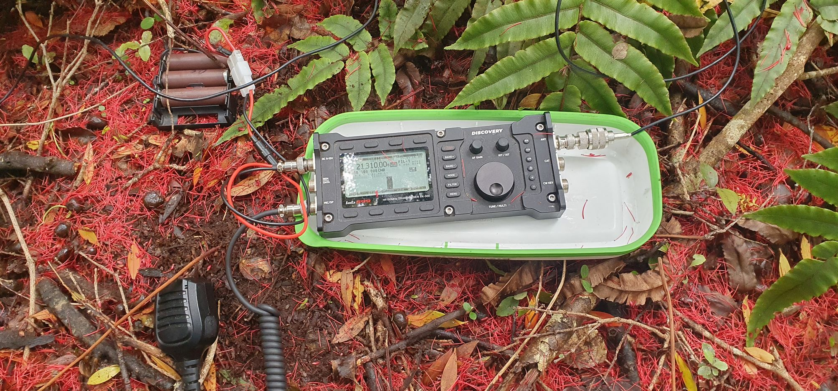
Parks

The ZLOTA Parks list was established to create a definitive list of genuine parks in New Zealand. At that time the number of parks in both POTA and WWFF were very limited, and POTA especially was an ad-hoc collection of people’s favourite places, many of which weren’t even official parks (both POTA and WWFF have since improved considerably – see their sections for details).
There are about 35,000 gazetted parks in New Zealand – that is parcels of land owned by the Crown and protected under one of the various acts – Conservation Act, Reserves Act, National Parks Act, Local Government Act, etc. Unfortunately, the vast majority of these, by number, are marginal strips / Queen’s chain – sections of crown-owned riverbank with a right of public use, but in most cases no practical access. The list also contains numerous cemeteries, rugby pitches, land set aside for future schools, ports, etc. - also not well suited for amateur radio activations.
As such, to keep things manageable, and to ensure practical access, we applied 3 restrictions to inclusion of parks in the ZLOTA ZLP Parks list:
- Must be >=10ha
- Must not be a marginal strip, Queen’s chain, esplanade reserve
- Must not be a ‘local or government purpose reserve’ dedicate to a purpose that does not guarantee public access
With the above condition, a little over 3700 parks in New Zealand qualify for inclusion in ZLOTA.
The ontheair.nz website lists all currently valid parks, and displays them on the map. We source this data from the government official sources details below, and update it from time to time:
- The full list of official parks managed by DOC and district councils in New Zealand can be downloaded from LINZ – the government agency charged with recording land status and title.
https://data.linz.govt.nz/layer/53564-protected-areas/
- For regional parks, gazetted under S.160 of the Local Government Act, you will need to source the information from the regional council or unitary authority in question. Under the act, these parks must be recorded as regional parks in the regional plan / unitary plan and have a documented Park Management Plan.
- Note that both district and regional councils often also own freehold land which is not gazetted as a park, has no legal protection, can be sold or used at any time in the future for development, but is treated as a park in the interim. Such land does not qualify as a park in ZLOTA or any of the other awards schemes.
To activate a park, you and your antenna must be within the park. For clarity: running an antenna along the boundary fence of the park is permitted.

ZLOTA Rules
B. Parks - [ZLP/XX-####]
- A single contact from an park is required to activate that park for ZLOTA
- Four contacts from a park is all it takes to qualify an activation of a park
- The activation zone is the area within the park boundary.
- To be valid for ZLOTA, parks must be listed in the LINZ 'Protected Areas' database, or listed by a Regional Council as a Regional Park; and
- Parks must be >=10Ha in size; and
- Parks must not be classified as 'marginal strips' (a.k.a esplanade reserves, queen's chain) or 'local purpose reserves' (e.g. scout huts, community halls, etc)
- For marine parks (that is any park established to protect areas of sea, who's extent is bounded by the high/low/mid tide mark) the activation zone extends 100m onshore beyond the high tide mark
- All parks listed at ontheair.nz count towards the NZART Parklands award.

NZART Rules
New Zealand Parklands Award
This Award is for Activating and/or Chasing gazetted Crown-owned Protected Areas or Regional Parks, henceforth referred to as ‘parks’. Parks must have to be in the ZLP list, that is they have been assigned a ZLP/XX-#### reference. To qualify for inclusion in the ZLP list the park must be:
- Either:
  - listed in the Land Information New Zealand (LINZ) protected areas database
  - Or: designated by a regional council or unitary authority as a regional park.
- >=10ha in size
- Not be classified as a ‘marginal strip’ or ‘local purpose reserve’
All qualifying ZLP parks are listed at: https://ontheair.nz/parks. As of May 2024, a total of 3,795 parks are included.
The general rules for all NZART Awards apply.
Use of internet-connected SDRs by Chasers is permitted so long as the SDR is located in the same DXCC as the Chaser
NZ PARKLANDS Award Rules.
- Four (4) contacts required to activate a park. Chasers only require one (1) contact for each Park.
All contacts must be made within a single UTC calendar day. Contacts on different UTC days will count as separate activations when determining whether the minimum QSOs per activation has been achieved..
- Both activator and Antenna/s are to be within the Park Boundaries.
- Simplex only on any band within the activators license privileges. Ie. No repeaters but satellite contacts are permitted.
- Any Mode permitted. Certificates will be awarded for mixed modes, same band, same Mode,
- Multiple parks are allowable from the same location providing they are ZLP/xx-####
- Certificates will be issued for Activators and Chasers. Once a activator has earned their award then they can claim an award for “chasing” the same parks. (To clarify it does not matter in which order, Activating or Chasing, a Park is done.)
- Certificates will be issued for.
Bronze | 10 parks
Silver | 30 parks
Gold | 60 parks
Merit | 100 parks
Merit Certificates will then be issued in multiples of 500 parks
ZLP/xx-#### Parks can be logged into the ontheair.nz website and this will be used to check logs submitted for Award Certificates.

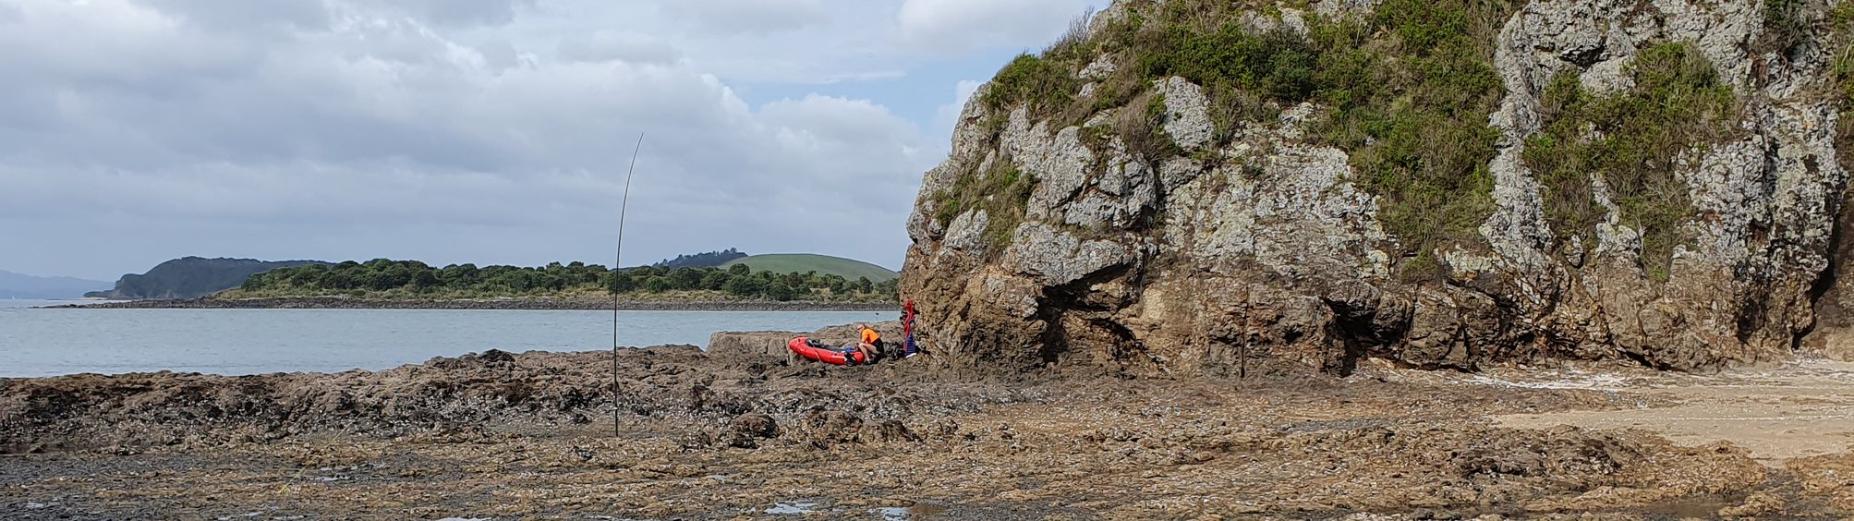
Islands

The ZLOTA Islands award was adapted from the QRPers NZ group’s inshore islands award. The rules have remained consistent, expect for the addition of the requirement to make a minimum of five contacts to qualify the activation – bringing the award into line with the requirements of the equivalent NZART award.
As with ZL Lakes, the NZ Gazetteer (formerly NZGDB / ‘official placenames database’) is used as the definative source for the list of islands in New Zealand to be included in the award. When you hear of a peak being officially named after a famous person, or the name of a town being changed to reflect the correct Maori spelling, it is the official NZ Gazetteer that is being updated.
At the time of writing, there are currently 1289 islands included in the ZLOTA Islands award. We pull updates from the NZ Gazetteer from time-to-time. If you find an island that you believe should be included, check first if it is the Gazetteer – if it’s not there, then we cannot include it in the Island award.
We have found that a number of riverine islands listed in the Gazetteer no longer exist, either due to erosion eliminating the island, or land / river modification draining the surrounding land and resulting in the island becoming part of one bank or the other. Where such modification is reported, we will retire the island from the award programme.
To cover both terrestrial and maritime-mobile activators, an island can be activated from either onshore (including the intertidal zone), or from a boat moored / anchored adjacent to the island.
The original NZART inshore islands award is, at the time of writing, under review with the aim of bringing it into line with the equivalent ZLOTA award (specifically by recognising fresh-water islands as well as salt-water ones). The italic text in the rules below indicates which rules are likely to be relaxed / recoked.

ZLOTA Rules

C. Islands - [ZLI/XX-###]
- A single contact from an island is required to activate an island for ZLOTA
- Five contacts from an island are required to qualify an activation for the NZART minor islands award
- The activation zone is: on the ground of; within the inter-tidal zone of; or on a craft tied to a mooring, wharf, jetty, or anchorage adjacent to the island. For islands linked to the mainland at low tide, the island's intertidal zone can be considered to start at the half-way point between the mainland and island high-tide mark.
- All islands listed in the LINZ 'NZ Gazetteer' qualify for the ZLOTA Islands awards.
- Only salt-water islands, not connected to the mainland by land at low tide count towards the NZART minor islands award.

NZART
The Minor Islands Award is awarded for contacts with or from minor islands off the New Zealand coast. For example, Kapiti Island, Portland Island, Great Barrier Island, Little Barrier Island, Waiheke Island, D’Urville Island, Rangitoto Island, Kawau Island, and Motutapu Island. There are currently 141 islands on the list. Other minor islands may be acceptable at the Award Manager’s discretion*.
- Contact with 5 different islands is required. Endorsements for ten, twenty, or thirty islands.
- Stations operating from minor islands must work a minimum of 5 New Zealand stations from 5 different islands. 25 contacts in total. Endorsements for operating from ten, twenty, or thirty islands.
- Islands which are connected to the mainland by a causeway and rocks covered by water at high tide are not eligible. Islands in rivers or lakes are not eligible.
- The ‘island’ station must be located on the island, or on a boat tied to a mooring, wharf, jetty, or anchorage adjacent to the island.
- The award is for working stations located on or nearby the small islands around the New Zealand coastline, including islands in harbours, sounds and fiords. The list includes Stewart Island but excludes ZL0, ZL8, ZL9 and other islands that have their own DXCC identifier

* This award is pending updates at NZART, including the proposed deletion of Rule #3 to make the two awards compatible. The awards manager has stated that in the interim, ‘any island valid on ZLOTA will be accepted for the NZART award’.

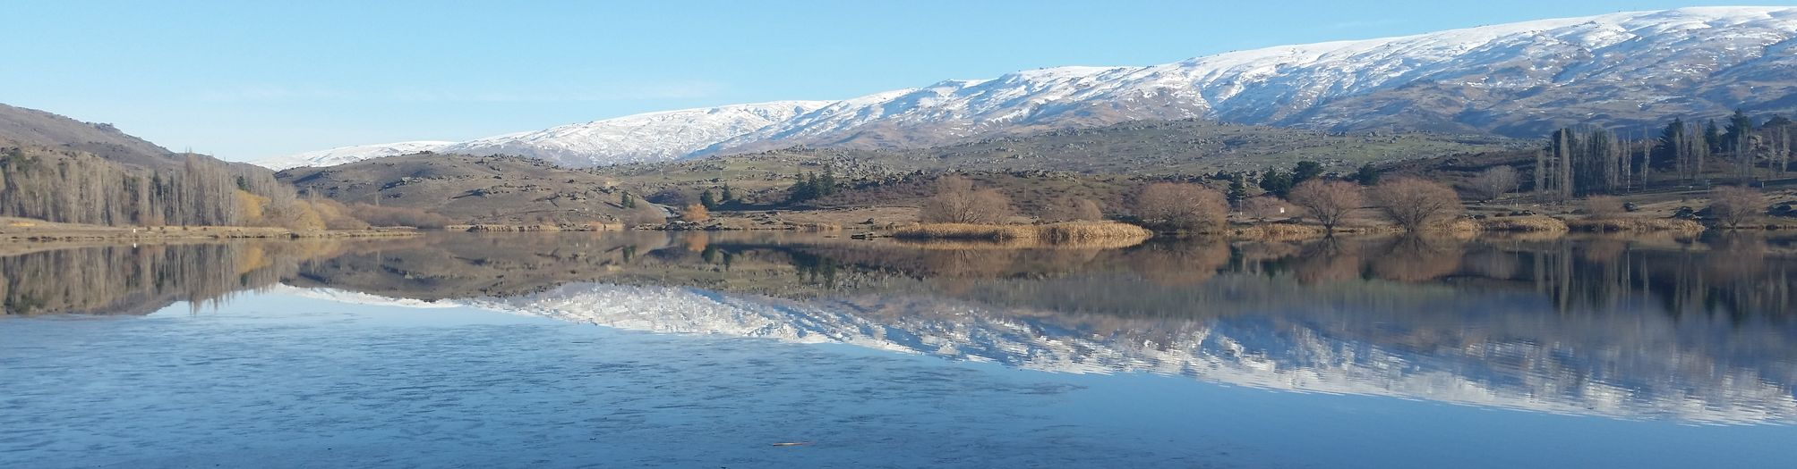
Lakes

In 2020 a group of four amateurs proposed the ZL Lakeside award programme as a more leisurely, accessible pursuit than SOTA.
A number of potential sources of data on lakes were considered, but the most reliable and consistent was found to be the NZ Gazetteer (formerly NZGDB / ‘official placenames database’). When you hear of a peak being officially named after a famous person, or the name of a town being changed to reflect the correct Maori spelling, it is the official NZ Gazetteer that is being updated.
There are currently 1163 lakes listed in the NZ Gazetteer, and thus included in the ZLOTA / NZART Lakeside awards. We pull updates from the NZ Gazetteer from time-to-time. If you find a lake that you believe should be included, check first if it is the Gazetteer – if it’s not there, then we cannot include it in the Lakeside award.
To make access realistic, you can activate a lake from anywhere within 500m of the lake shore. The extent of this 500m AZ is shown in yellow on the ontheair.nz map when you view the lake’s page.
Just two contacts are required (but if the lake lies within a park, why not try for at least 4 to qualify the park too?)

ZLOTA Rules

D. Lakes - [ZLL/####]
- A single contact from a lake is required to activate that lake for ZLOTA
- Two contacts from a lake are required to qualify the activation of a lake.
- The activation zone is the lake surface, the full extent of any islands contained by the lake, or within 500m of the lakeshore
- All lakes listed in the LINZ NZ Gazetteer qualify for the ZLOTA Lakes awards.
- All lakes listed in the LINZ NZ Gazetteer qualify for the NZART Lakes awards.

NZART Rules
NZLA – New Zealand Lakeside Award
The New Zealand Lakeside Award is designed to promote operation from New Zealand’s scenic freshwater lakes and to stimulate mobile and portable operation. Estuaries and inlets are not counted as lakes. The award is open to all amateur radio operators.
General Rules
- Contacts can be made on any band or mode, but not via repeaters or the Internet. Satellite contacts are valid for this award.
- The LOG must contain the date, band, mode, station worked, and LINZ lake number (or name) for each QSO.
- Endorsements are available for all contacts being achieved on a single band, or mode, or for satellites.
Rules for Activators
- The Basic Activator Award is awarded for 10 unique lake activations. A minimum of 2 contacts is required to qualify as an activation.
- You can only activate one lake at a time, and you can’t go back to it once you move on to the next one Activating Stations must be located within 500m of the lake shore.
- An Activator must supply each contact with at a minimum the lake number or the name of the lake
- Activator endorsements are available for each additional unique 10 lakes activated.
- An Activator Honour Award is awarded for 50 unique activations.
- Full rules are on the NZLA Log Sheet which is available from the Award Manager
Rules for Hunters
- For the Basic Hunter Award, contacts are required with stations operating from 10 unique freshwater lakes in New Zealand. There are currently 1184 lakes on the list (which is based on a LINZ list). Download from the NZART website.
- Hunter endorsements are available for each additional group of 10 lakes.
- A Hunter Honour Award is available for contacts with 50 or more lakes.
- Activating Stations must be located within 500m of the lake shore.

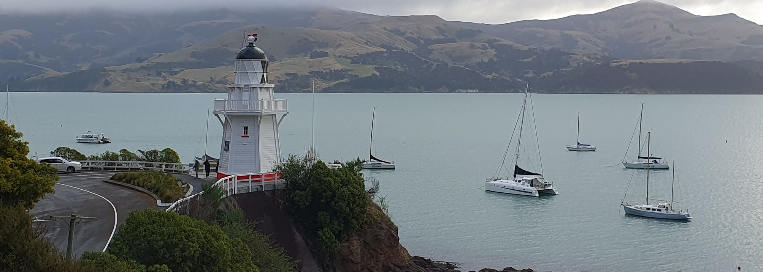
Beacons and Lighthouses

The ZLOTA Beacon & Lighthouses (ZLB/###) award and NZART Coastal Lights award were developed in collaboration between ZLOTA and the NZART awards manager. The objective was to bring information and logging for the NZ lighthouses online, and add a wider range of lights to activate compared to the previous NZART Lighthouse award.

There is no definitive list of lighthouses in NZ, so information is taken from from two sources. To be included in the award, a lighthouse or beacon must be either:
- Listed by Maritime NZ on their published list of coastal beacons and lighthouses; or
- Shown and named on LINZ Topo50 maps

At the time of writing there are 57 qualifying lights in the North Island and 44 in the South Island.

Lighthouses are designed to be seen, so we accept activations from any location within sight of the lighthouse. Additionally, as many are remote, an activation zone radius has been chosen individually for each light, such that all lights can be activated from the nearest public road (or anywhere else within a circle of that radius). As such it should be possible for activators of all fitnesses to activate all lights in New Zealand. A few lights do, however, require ferry crossings: to Great Barrier Island, Stewart Island and West Arm (4WD access also available in the last case). See the individual beacon/lighthouse page for details of the activation zone for the light you are interested in – the AZ will be shown in yellow on the map when you view the light’s page.

Four contacts are required for an activation to be qualified, and operation from a vehicle is permitted.

Note that the NZART award is for unique lights chased / activated – so repeats are not included in your NZART tally, whilst repeats are included in your ZLOTA chased / qualified scores.

ZLOTA Rules
E. Beacons and Lighthouses - [ZLB/###]
- A single contact from a maritime beacon or lighthouse is required to activate that beacon or lighthouse for ZLOTA
- Four contacts from a maritime beacon or lighthouse is required to qualify the activation of that beacon or lighthouse
- The activation zone for beacons/lighthouses is defined as either: within sight of the lighthouse; or where not in sight, within a specified distance from the lighthouse which varies from 1-70km depending on the remoteness of the light (where the specified distance has been chosen to include the nearest public road). See the individual beacon/lighthouse page for details of the individual activation zone for that light.
- All lighthouses shown on LINZ topo50 maps and either named on the map, or listed by Maritime NZ are valid for the ZLOTA lighthouse award
- All listed beacons and lighthouses qualify for the NZART Coastal Lights award

NZART Rules
RULES
- Lights as listed on ontheair.nz
- Activation must be within the AZ radius. The AZ of the lights in general is to be with-in sight of the light being activated. However some are very remote and these can be activated from the nearest road. These AZ are shown on the ontheair.nz website.
- Any Band, Mode.
- No Repeater or Internet use.
- One (1) Point is allocated per light.
- Lights logged from 1st November 1998 or later.
- Four (4) contacts to activate Light. Chasers require only one (1).

CERTIFICATES
Awarded for Activators and for Chasers. Apply to awards@nzart.org.nz for Check Log sheets.
There will be a range of Certificates available. Three for North Island, Three for South Island and Three for All of New Zealand.
 | Basic | Intermediate | Gold | Masters
New Zealand (101lights) | 25 | 50 | 90 | 101
North Island (57) | 10 | 20 | 40 | 57
South Island (44) | 10 | 20 | 35 | 44

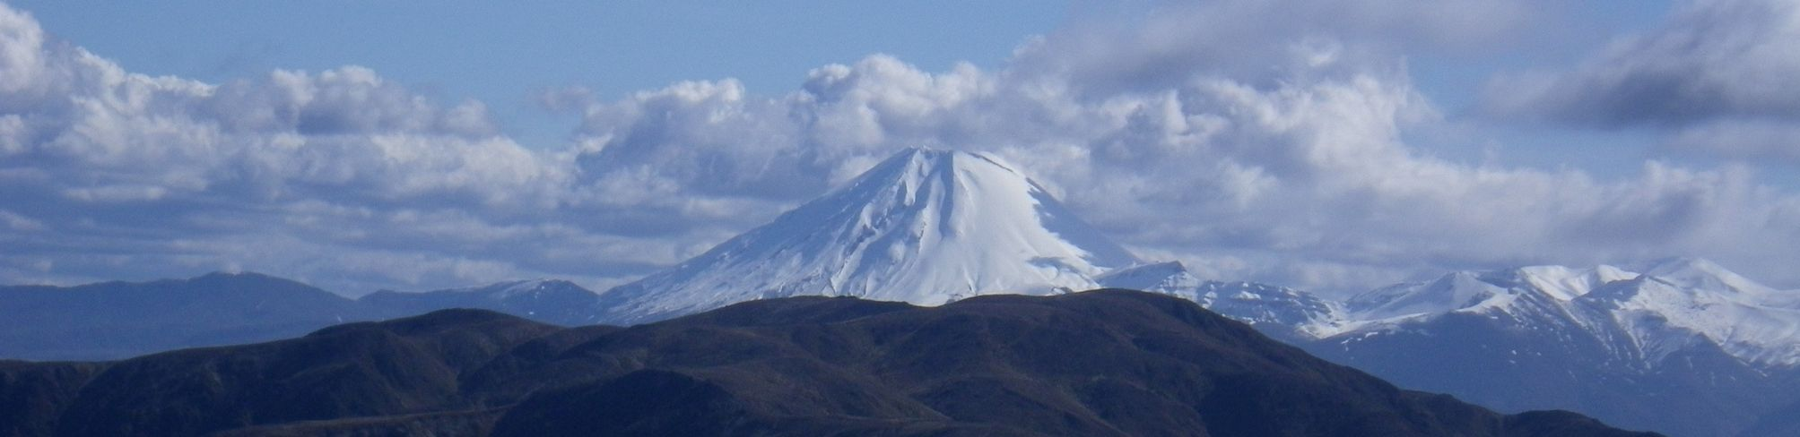
Volcanos

NZ Volcanos on the Air was started by ZL1PSH, covering the Auckland Volcanic Field (ZLV/AK). The motivation behind the scheme was to offer an award programme that gave opportunities to activate in the Auckland metropolitan area where SOTA and HEMA had very limited options. The programme was developed with the philosophy that all assets should be attainable by all activators – that is:
- Activation Zones are chosen so that it is possible to activate every asset from public land: i.e. the nearest road, park, track suitable to all ability levels.

The ZLV/ programme has since been expanded to cover most volcanic fields in the country. There are a vast number of volcanic features in NZ ranging from those visibile and active in the present day, to cryptic traces of volcanic activity dating back 550 million years or more. The majority of the older fields are long buried and detectable only by expert observation of rock-types identifiable in small outcrops, quarries, cuttings, core samples, etc. In choosing what assets to include when expanding the programme to other areas we added a couple more objectives / guidelines:
- All volcanic assets must be an observable geographic feature visible to the activator on the ground
- All volcanic assets must be sourced from a reputable source such as peer reviewed academic publication, government department or geological publication.

Unlike other ZLOTA awards ZL Volcanos is broken down by volcanic field name, rather than political boundary. QMap from GNS is a good source of mapping data on the subject, for those who are keen.

ZLOTA Rules
F. Volcanos

- Four contacts from a volcano or volcanic feature are required to qualify the activation of that volcano
- The activation zone for volcanos is defined as within a specified distance from the feature, usually 800m but sometimes larger - where the specified distance has been chosen to include the nearest public road, track or park. See the individual volcano page for details of the activation zone for that volcano.
- To be included in the scheme a volcano must be: a) publicly accessible; b) a visible feature on the ground that can be seen from publicly accessible land in the activation zone; c) associated with a known, documented volcanic field shown in the NZ geological survey (GNS QMap); d) described in a reputable publication such as an academic journal / book / thesis, encyclopedia, or government publication / study
- The NZ VOTA award scheme is administered by ZL1PSH. Please contact him for details of awards.
Addition of new volcanos can be requested by submitting the above information to the admin of this site. Please notify admin of any volcanos currently included that do not meet the above criteria.

NZART
There is currently no NZART volcano award

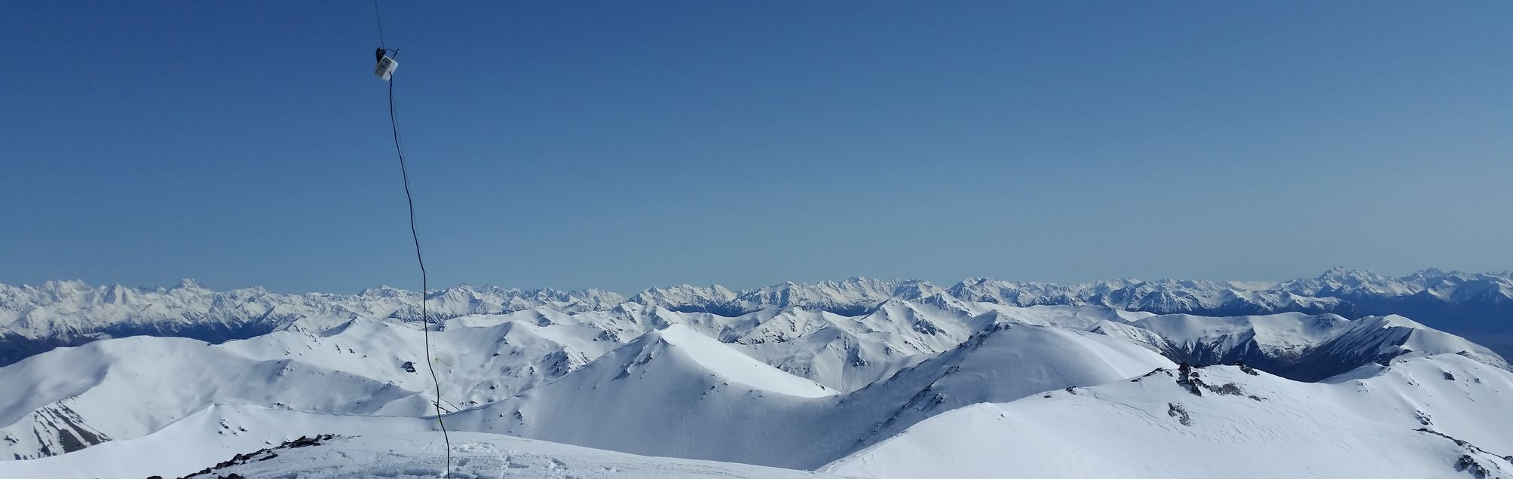
SOTA

SOTA (www.sota.org.uk) was launched in the UK in 2002 and arrived in New Zealand in 2015. The scheme provides an award programme for radio operations from the summit of hills and mountains, and a points structure to reward the amount of effort involved in reaching the peak.

There are clearly a lot of hills in the world and to create a definitive list SOTA needed to adopt a criteria for what could be included in the programme. To be included as a SOTA summit, a peak must be a Maralyn. And to be a Maralyn, the summit must have a prominence of 150m or more (a.k.a. p150) .

Prominence is the elevation difference between the summit and the highest col (saddle) which connects it to another higher peak. Mt Cook’s High Peak (3,724m) has a prominence of 3,724m – because there are no saddles connecting it to a higher peak. Whereas Mt Earnslaw’s west peak (2,820m), only has a prominence of 220m, as a 2,600m saddle connects it to the higher East Peak.

SOTA assigns points to peaks (from 1 to 10) based on their summit elevation. The scales used vary from DXCC to DXCC and so are different in ZL1 and ZL3. SOTA also offers activators 3 bonus points for winter activations – between the 1st June and 15th September (ZL1) or end of September (ZL3).

SOTA require four contacts to qualify a peak for an activator. Contacts with the same operator on different bands, modes or callsigns do not count. Operation from on or near a vehicle is not permitted. To activate a SOTA summit you must be within 25 vertical meters of the summit, and not have any dip or saddle lower than that 25m between you and it. Only the operator needs to be within the AZ – antennas can stretch beyond.

An active SOTA community from around the world communicate via the SOTA Reflector: https://reflector.sota.org.uk – you are encouraged to take a look

Rules
Full rules are available at:
https://www.sota.org.uk/Joining-In/General-Rules
The most important are summarised below:
- All operations must comply with the amateur radio licensing regulations and must use the permitted amateur radio bands of the country in which the Association is based.
- Operations must not be in, or in the close vicinity of, a motor vehicle. No part of the station may be connected in any way to the motor vehicle.
- The Operating Position must be within the Activation Zone. The operating position must lie within a closed contour line at the permitted maximum Vertical Distance below the summit. (Typically the contour line is 25 metres below peak height of the summit). The Operating Position is taken to be the position of the operator.
- All equipment must be operated from a portable power source (batteries, solar cells, etc). Operation is expressly forbidden using permanently installed power sources or fossil-fuel generators of any kind.
- At least one QSO must be made from the Summit to qualify an activation. In order for the activation to qualify for the points attributed to that Summit, a minimum of four QSOs must be made, each of which must be with a different station. QSOs must comprise an exchange of callsigns and signal reports; it is strongly recommended that the summit identifier be given during each contact.
- QSOs via terrestrial repeaters do not count towards the QSO total. Contacts via artificial satellites or free balloon borne repeaters are permitted.
Points:
ZL1 Elevation | Points | ZL3 Elevation
<500m | 1 | <700m
500m-699m | 2 | 700m-1099m
700m-899m | 4 | 1100m-1499m
900m-1199m | 6 | 1500m-1799m
1200m-1499m | 8 | 1800m-2199m
>=1500m | 10 | >=2200m

Winter Bonus points:
ZL1 Elevation | Bonus Points | ZL3 Elevation
>1200m | 3 | >700m

Logging
SOTA require all SOTA activators and chasers to submit logs before they can claim SOTA points and awards. This is done by uploading an ADIF (or CSV or FLE) file to the SOTAdata website: https://www.sotadata.org.uk.

To do this you will need to have created a SOTA account. One account will allow you to access all SOTA sites except the SOTA Reflector discussion forum – https://reflector.sota.org.uk/ which requires a separate login.

If you use a portable logging app such as VK-PortaLog, iPnP or PoLo then you will be able to export SOTA ADIF logs directly from your logging app. You’ll need to see the help for your logging app to find out how to do this.

You can also export SOTA logs from the ontheair.nz website for any SOTA activation (or combined activation) that you have logged here. Details of how to do that are in the next section.

... Exporting SOTA logs from ontheair.nz
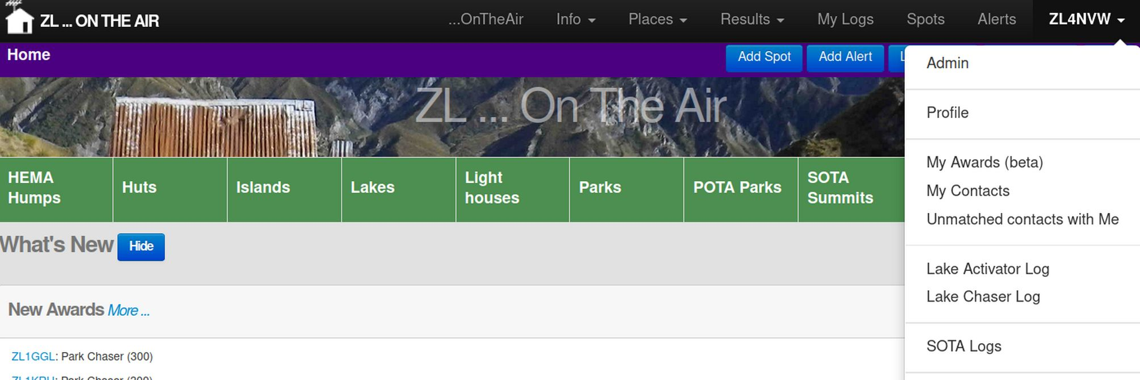
You’ll find a SOTA Logs link on the menu under your callsign (top-right) at ontheair.nz
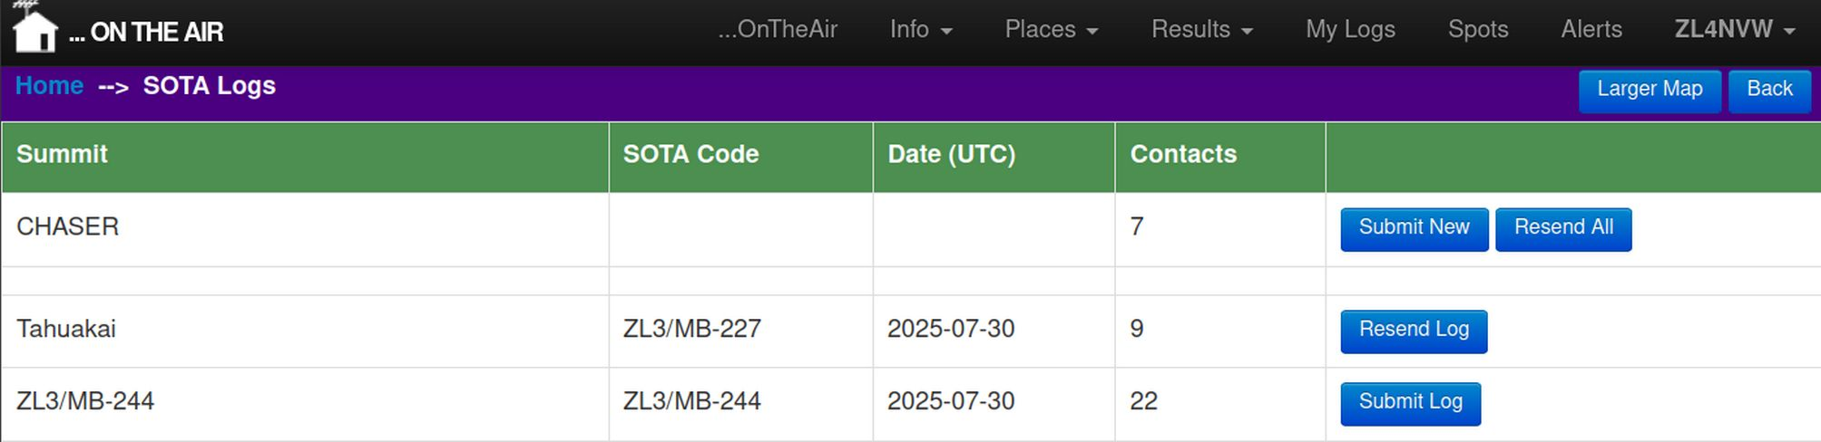
In your SOTA lLogs page you’ll see a list of all your SOTA activations, plus a line at the top tallying your unsubmitted chaser contacts.

New (never-exported) activations will have a button to Submit Log to SOTA. An activation that you have already downloaded for export will have the option to Resend Log.

Click on the log you wish to export / submit.

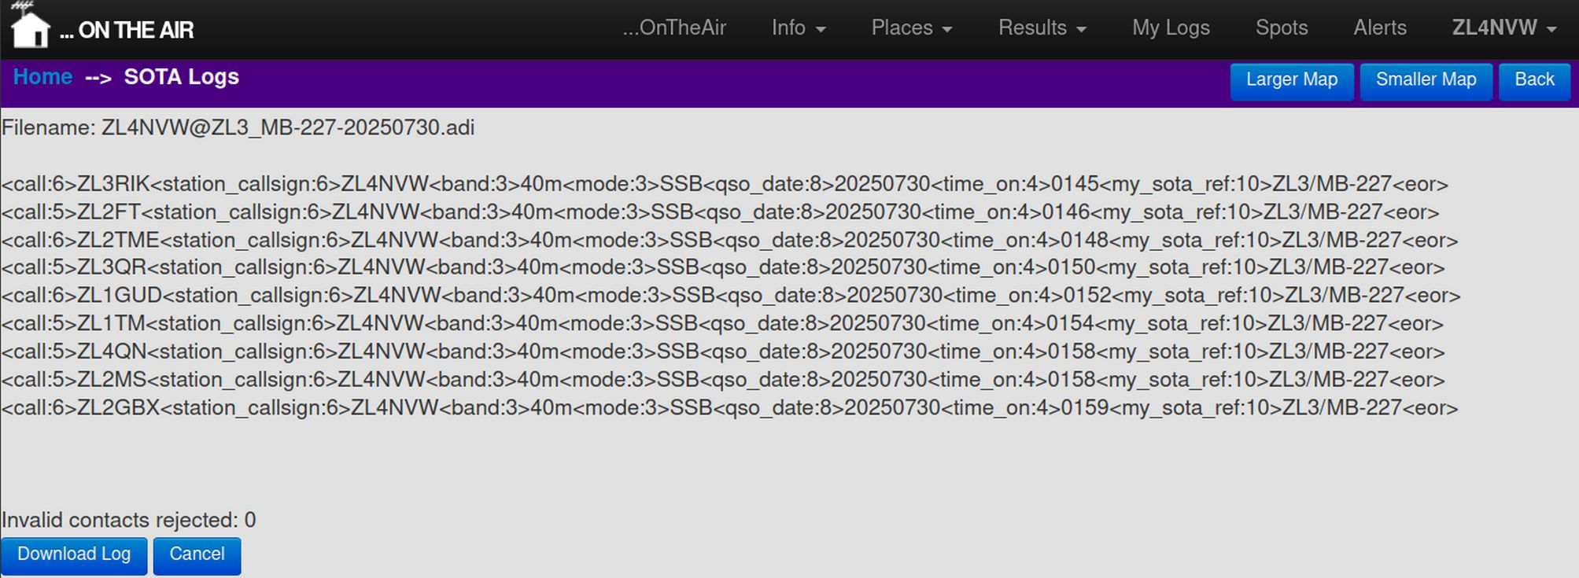
The log will be displayed in ADIF format, and any ‘invalid’ contacts will be listed. Contacts will be classed as invalid for SOTA if they are: duplicates, invalid frequencies (which do not map to a valid band), or are missing mandatory information.

Click on Download Log to save the log to your computer in ADIF format.

... Importing into SOTAdata

Go to https://sotadata.org.uk and click on the Uploads link at the top of the page

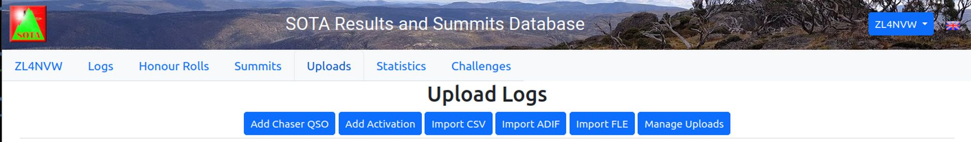
Click Import ADIF

Select the ADIF file you just exported (it’s probably in your Downloads folder) and click Import

Click the Verify Log button – SOTAdata will check the contents look valid.
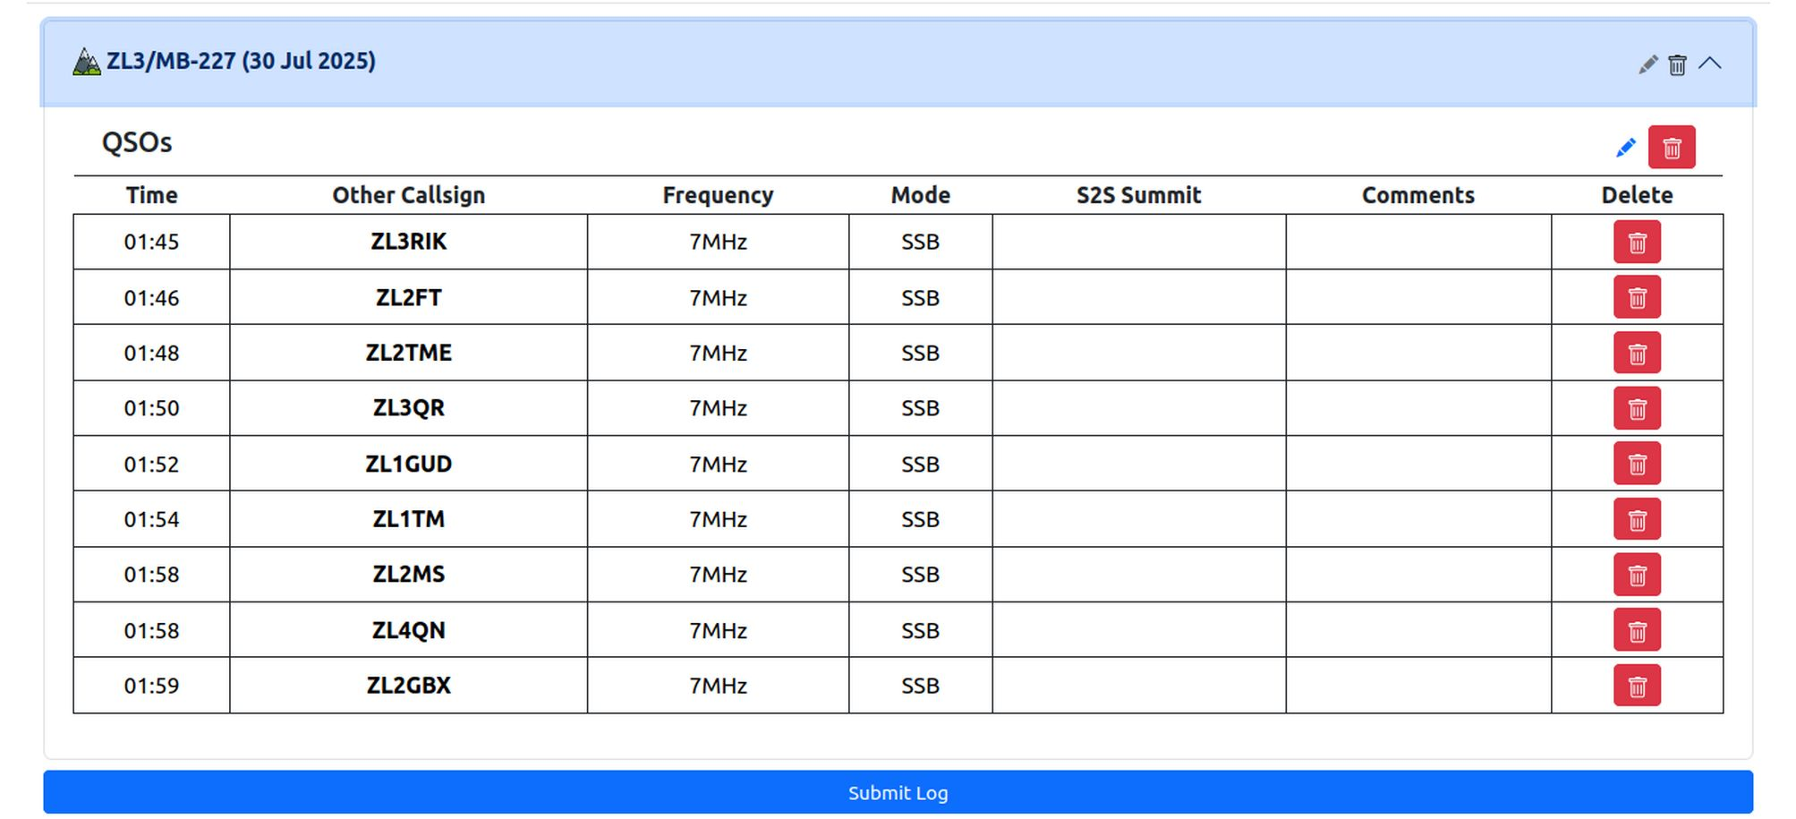
Any issues with the log will be listed. You can click the down-arrow to expand and view the log prior to submission and make edits / changes to the log if required. Click Submit Log when you’re happy.

Agree to the Terms & Conditions, and click Submit a final time.

POTA
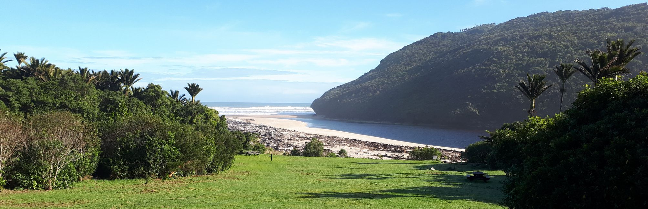
Parks on the Air – POTA (https://pota.app) evolved in the US out of a one-off National Parks On The Air event (participants just didn’t want to stop when it ended). As such, POTA was viewed for a long time as more US-focussed than other award programmes. However, in recent years they have made great efforts to expand across the globe, and to improve their website – making the award programme both locally available and easy to participate in.

The rules for inclusion of parks in the POTA scheme is similar to that for ZLOTA – the parks must be crown-owned, have a right of public access, and be officially registered as protected land. Unlike other schemes, POTA specifically exclude ‘municipal parks’ from the scheme, meaning that district-council owned land is not included, unless co-managed with either DOC or the regional council. Native-title protected areas (e.g. Te Uruwera) are probably also not valid.

POTA currently includes all parks in the LINZ Protected Areas database that are over 500ha in size and are not municipal parks. Additionally, Forest Parks and Regional Parks are all included irrespective of size. At the time of writing there are 860 parks in the POTA scheme in NZ.

To qualify a POTA park as an activator, you must make 10 contacts. Contacts with the same operator on different modes, bands or under different callsigns are each valid.

Only the activator logs to the POTA website, so chaser scores depend entirely on the activator to submit their log. As such you are encouraged to submit logs for any POTA parks you activate, even if you’re not interest in the POTA scheme: your chasers will be depending on you to do so.

Rules
The full POTA rules can be found on the POTA website: https://docs.pota.app/
An indicative summary is below.
- Operator and equipment must be within the park boundary. For ZL activations, an antenna erected on the boundary fence is considered to be valid
- Operation from a vehicle is permitted
- Multiple parks may be activated concurrently, where they overlap
- 10 QSOs are required to qualify an activation
- Operator must have a current POTA account
- Activator logs must be uploaded or emailed to the POTA website.

Logging
POTA require all POTA activators to submit logs before they can claim POTA points and awards. Chasers are awarded points and awards based on information in activator logs only. So even if you’re not interested in POTA yourself, submit your logs so that chasers can get their points.

The preferred method to send logs to POTA is by uploading an ADIF file to the pota.app website: https://pota.app. You can also email an ADIF log to the POTA representative, but this method is deprecated and will cease to be supported at some point.

To submit POTA logs you will need to have created a POTA account at https://pota.app.

If you use a portable logging app such as VK-PortaLog, iPnP or PoLo then you will be able to export POTA ADIF logs directly from your logging app. You’ll need to see the help for your logging app to find out how to do this.

You can also export POTA logs from the ontheair.nz website for any POTA activation (or combined activation) that you have logged here. Details of how to do that are in the next section.

... Exporting POTA logs from ontheair.nz
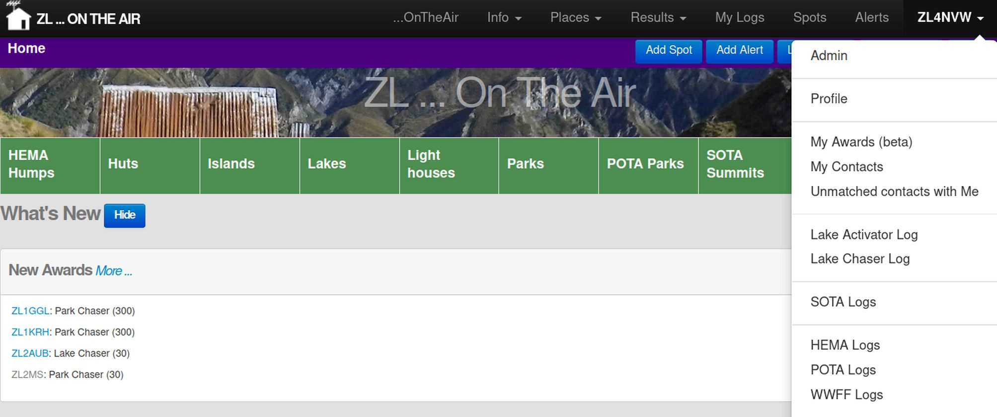
You’ll find a POTA Logs link on the menu under your callsign (top-right) at ontheair.nz

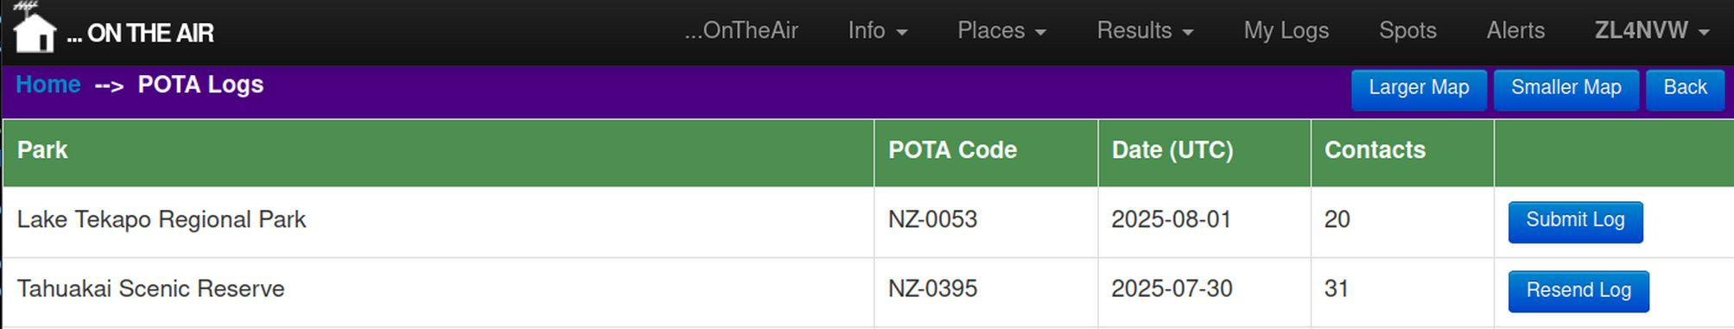
In your POTA Logs page you’ll see a list of all your POTA activations. New (never-exported) activations will have a button to Submit Log to POTA. An activation that you have already downloaded for export will have the option to Resend Log.

Click on the log you wish to export / submit.

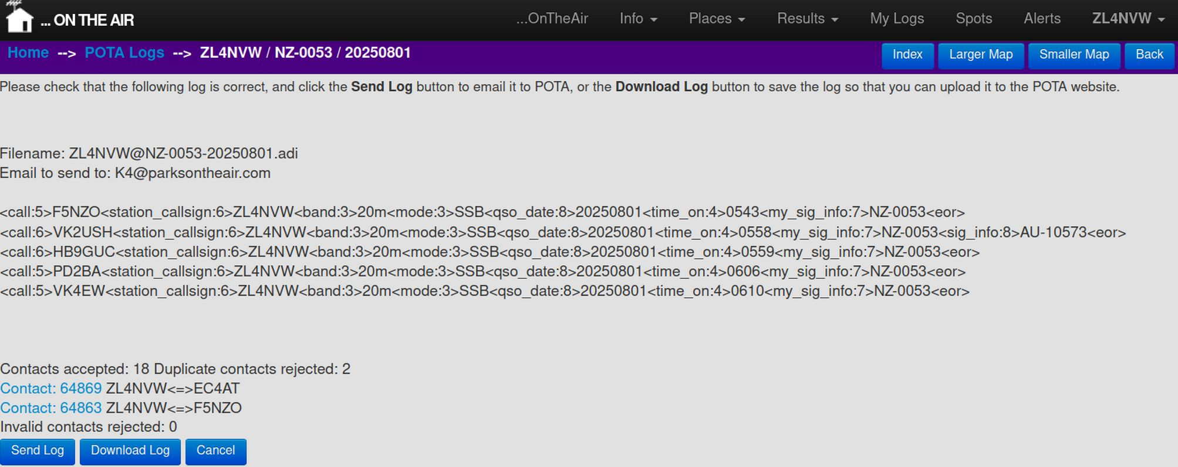
The log will be displayed in ADIF format, and any ‘invalid’ contacts will be listed. Contacts will be classed as invalid for POTA if they are: duplicates, invalid frequencies (which do not map to a valid band), or are missing mandatory information.

Click on Download Log to save the log to your computer in ADIF format.
Alternatively, clicking Send Log will email your log to the POTA representative for them to upload. This method is deprecated and may not be supported in the future.

... Importing into POTA
Log into the https://pota.app website.
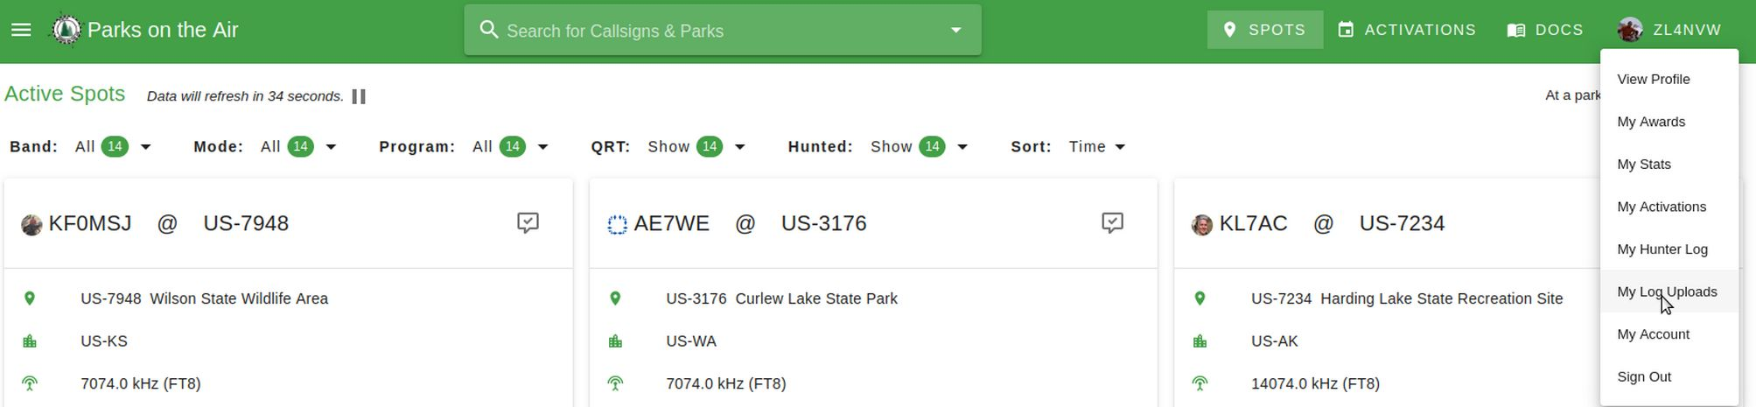
Select My Log Uploads from the menu under your callsign
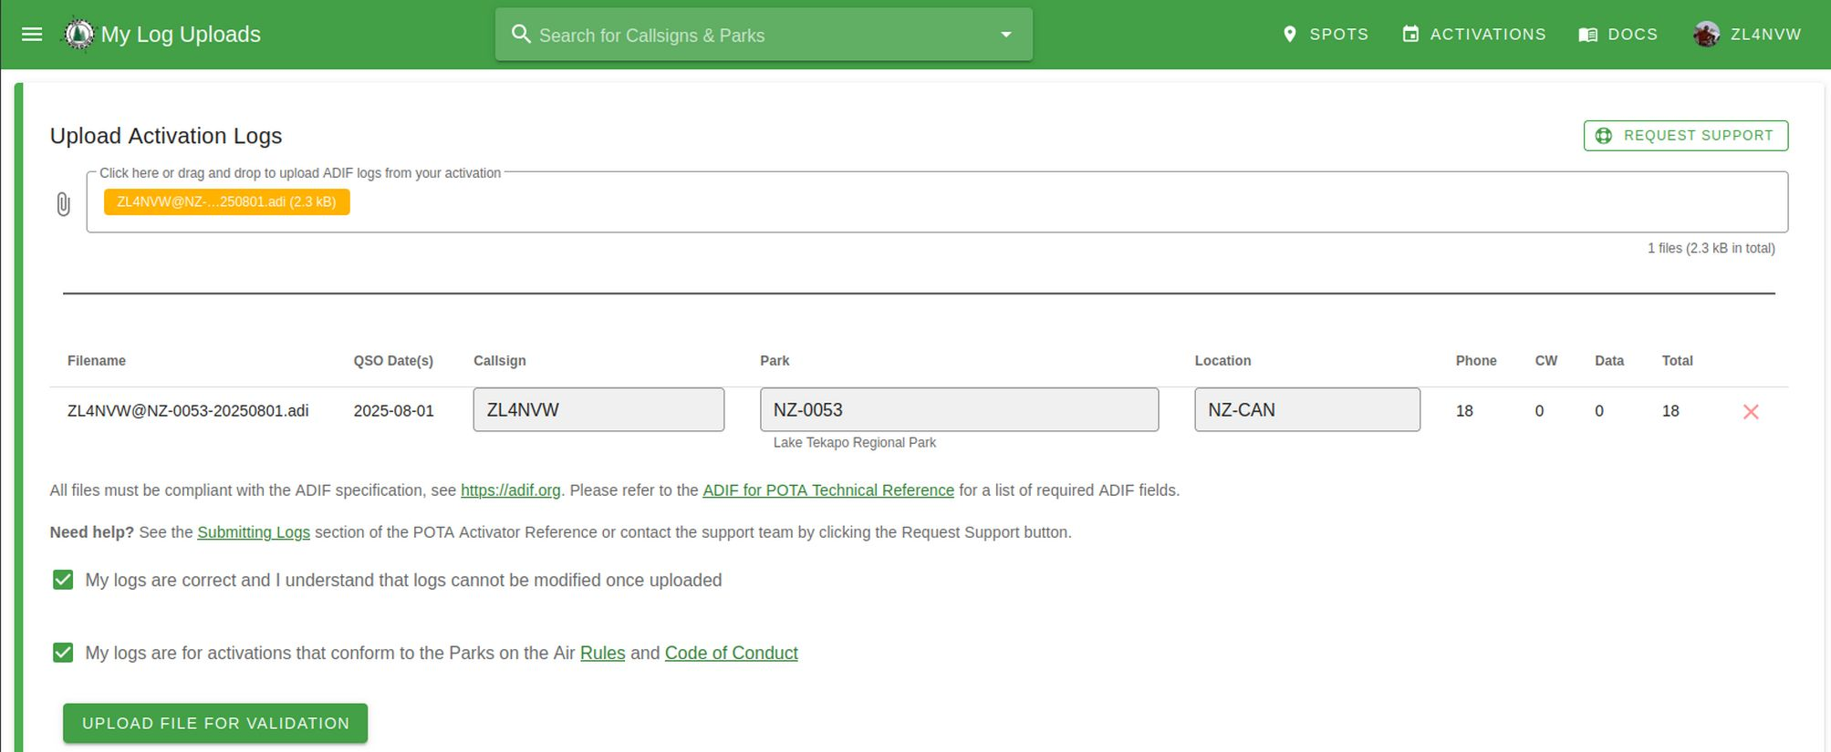
Select the ADIF file you just exported (it’s probably in your Downloads folder). Tick the boxes to agree that your logs are Correct and meet the Rules. Then click Upload File for Validation.

A lift of all your uploaded logs will be displayed. It can take up to a day for your log to be Processed.

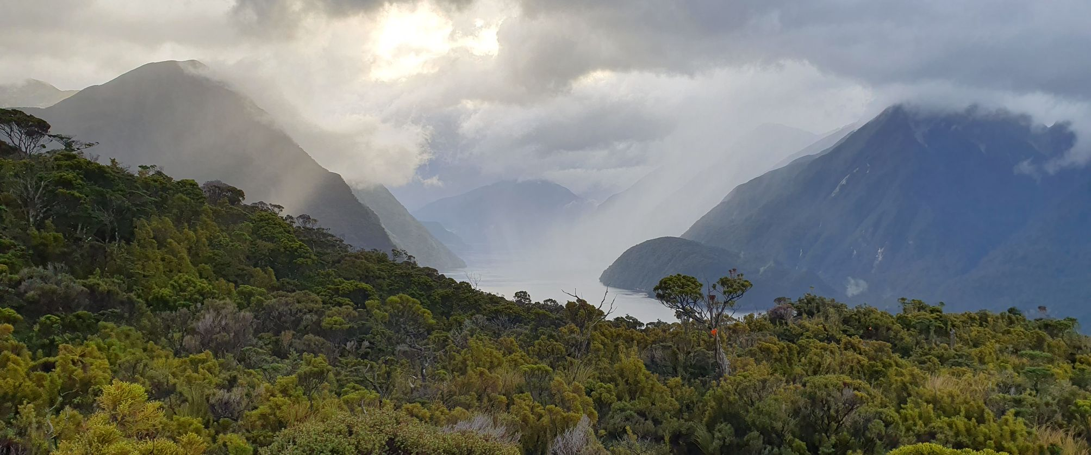
WWFF

World Wide Flora & Fauna – WWFF - (https://wwff.co/) has for long been the most popular portable awards programme in Australia, and has a huge following on that side of the Tasman – which makes for an amazing pool of potential chasers to tap into. If conditions are right, there is also a good European base. Whilst the number of parks available in NZ was for a long time very limited (49!), the programme has expanded considerably in recent years with more parks added and more to come soon.

WWFF is very-much conservation-land focussed, and as such has stricter rules than many other award programmes on the inclusion of parks. Parks must meet the IUCN conditions for inclusion and be assigned to an IUCN category. This excludes parks solely for recreation purposes, but does allow those where ‘sustainable use’ for recreation is permitted so long as there are conservation / landscape protection goals in place. As such, all DOC-administered land qualifies, but council-administered parks need to be considered on a case-by-case basis.

Currently there are 233 WWFF parks in New Zealand: all qualifying parks over 1,000ha in size are in the WWFF scheme, with the exception of Regional Parks. Regional Parks have been submitted to the scheme along with evidence of their conservation status (Park Management Plans) but to date, none have been formally accepted or added.

The details of all DOC-administered parks over 500ha was requested, and has sent through to WWFF in mid-2025, but to date (August 2025) have not been added. Once added, this will bring WWFF into line with POTA by including all DOC-administered land over 500ha.

Unlike other awards programmes, WWFF tracks unique parks activated / chased (akin to the ‘bagged’ score in ZLOTA) rather than a tally of total chases / activations. As such there may be less motivation to re-activate or re-chase a park you already have in your tally. However, it’s still worth getting on the radio and supporting any activator out there in a park, even if there are no points in it for you.

The other major difference between WWFF and other award schemes is that a much higher number of QSOs (44 QSOs) are required. However, the WWFF programme allows you to achieve that number across multiple days and multiple activations – i.e. you can keep going back to a park until you hit the 44 QSO count and qualify the park.

As with POTA, only activators submit logs in WWFF – chasers’ scores are based upon activator logs. As such you are encouraged to submit logs for any WWFF parks you activate, even if you’re not interest in the WWFF scheme: your chasers will be depending on you to do so.

Rules
WWFF rules are an amalgam of extensive global rules (https://wwff.co/rules-faq/how-to-activate-a-wwff-reference/) and a simple set of local rules (http://www.wwffnewzealand.com/).

The local ZLFF page summarises them in brief form:

The rules for ZLFF are quite simple:-
- Ensure you are in a qualifying ZLFF reference area. Only qualifying ZLFF reference areas are valid for the ZLFF program.
- Ensure that you are within the park boundary and that access is allowed.
- Valid contacts will include an exchange between the activator and the hunter of their respective call signs, a signal report, and wherever possible the ZLFF reference number.
- Repeaters, IRLP, Echolink are not allowed.
- The use of amateur satellites is allowed.
- Mobile operation is allowed.
- Relays are not allowed.
- Activators can only activate one reference at a time (please see the ZLFF rules).
- Contacts with other activators within the same reference are not valid.
- QSL cards are not required.
- 10 QSOs required - ZLFF awards.
- 44 QSOs required - global WWFF awards.
Note that multiple contacts with the same operator on different modes, bands, on different days or using different callsigns are valid.

Logging
WWFF require all WWFF activators to submit logs before they can claim WWFF parks. Chasers are awarded points and awards based on information in activator logs only. So even if you’re not interested in WWFF yourself, submit your logs so that chasers can get their points.

Logs are submitted by emailing an ADIF log to the WWFF representative (currently simmopa@iprimus.com.au).

To submit WWFF logs you will need to have created a WWFF account at https://wwff.co

If you use a portable logging app such as VK-PortaLog, iPnP or PoLo then you will be able to export WWFF ADIF logs directly from your logging app. You’ll need to see the help for your logging app to find out how to do this.

You can also email WWFF logs from the ontheair.nz website for any WWFF activation (or combined activation) that you have logged here. Details of how to do that are in the next section.

... Exporting WWFF logs from ontheair.nz
You’ll find a WWFF Logs link on the menu under your callsign (top-right) at ontheair.nz

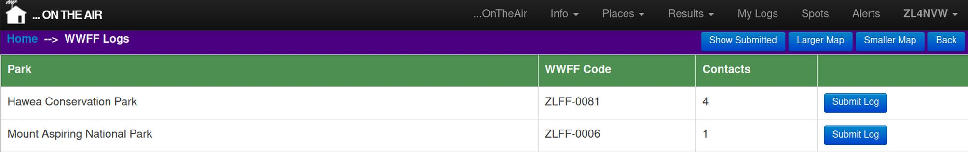
In your WWFF Logs page you’ll see a list of all WWFF activations which have unsubmitted contacts. A Submit Log button allows you to submit the log to WWFF. If you wish to resend a past activation that has already been submitted, you’ll need to click the Show Submitted button at the top of the page to display previously-submitted logs.

Click on the log you wish to export / submit.

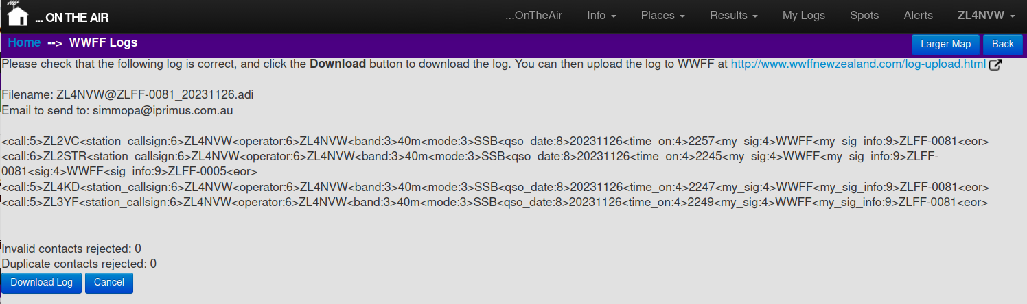
The log will be displayed in ADIF format, and any ‘invalid’ contacts will be listed. Contacts will be classed as invalid for WWFF if they are: duplicates, invalid frequencies (which do not map to a valid band), or are missing mandatory information.

Clicking Download Log will save your log to your computer in ADIF format.

... Uploading logs into WWFF
Navigate to the WWFF ZL log upload page at:
http://www.wwffnewzealand.com/log-upload.html

Select the ADIF file you just exported (it’s probably in your Downloads folder). Enter you name, callsign and email. Then click Submit.

The ZL WWFF coordinator will be notified that your log is available and will submit it to WWFF at their next convenience. From experience, this may take some weeks. In case of issues, the ZL WWFF coordinator’ email is listed on the contact page at http://wwffnewzealand.com and there is also a report issues like on the https://wwff.co page which gets rapid responses.

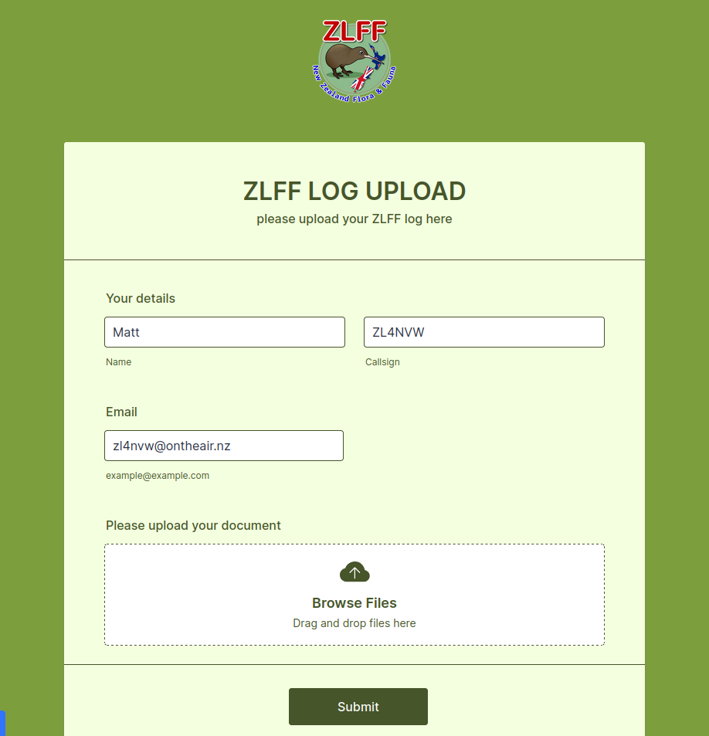

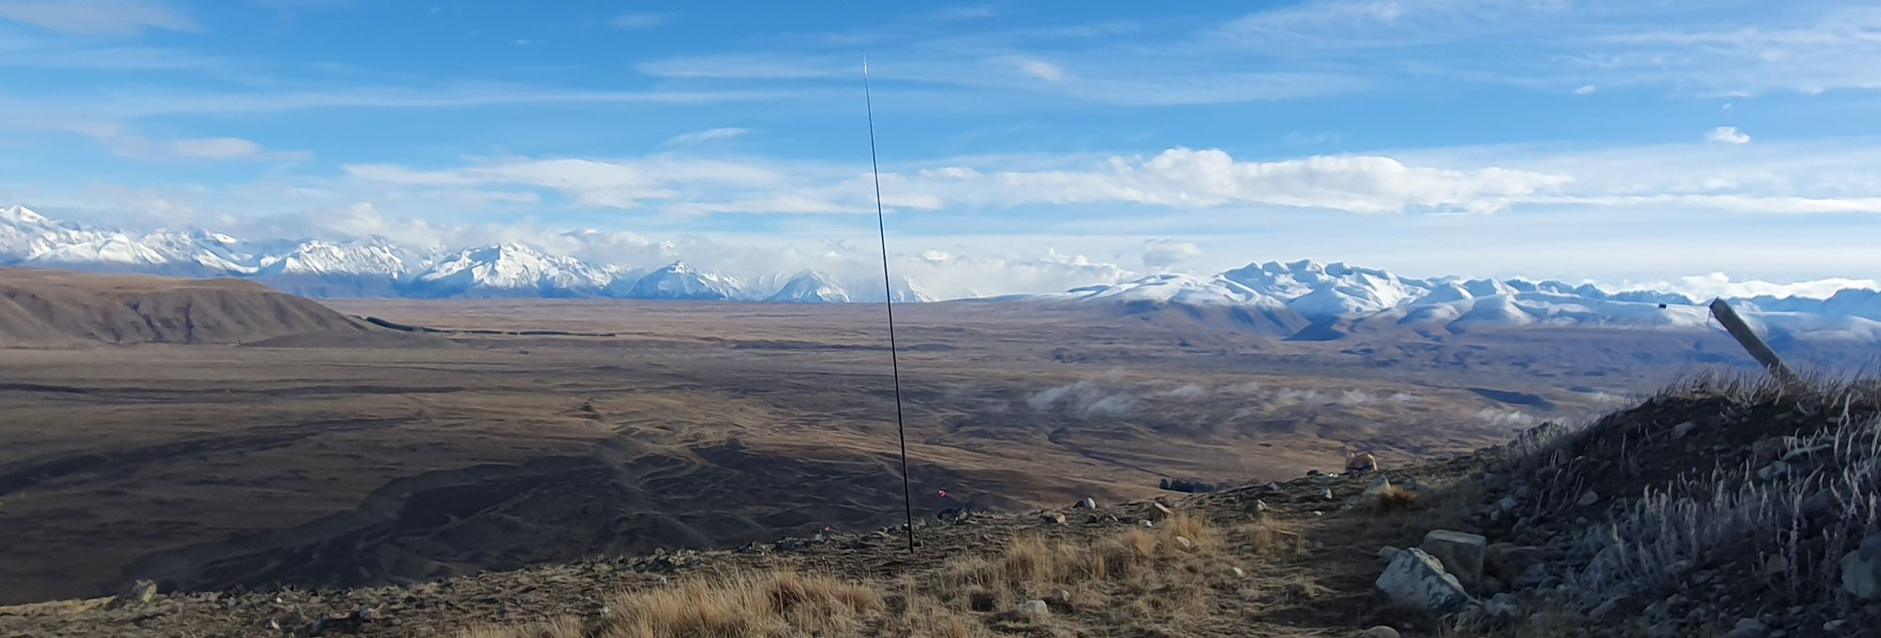
HEMA

Humps Excluding Maralyns (https://hema.org.uk)
How do you define a summit, when at the right scale, the top of every grain of sand could be viewed as having it’s own peak?
SOTA have a requirement that all summits must be a Maralyn to be included in their scheme. And to be a Maralyn, the summit must have a prominence of 150m or more. Prominence is the elevation difference between the summit and the highest col (saddle) which connects it to another higher peak.
Another classification of peak is also common amongst peak-baggers around the world: the Hump. A Hump is a peak that stands 100m or more above the highest col (saddle) which connects it to another higher peak. Thus is born the HEMA scheme: Humps Excluding Maralyns. That is all peaks that have >=100m and <150m of prominence – or to put it another way, all Humps not valid for inclusion in the SOTA scheme.
HEMA was introduced to New Zealand in 2024 to provide an enlarged choice of summits, particularly summits close to the main population centres, than the SOTA scheme alone. A wider choice of summits, and fewer kilometers of driving to reach them – that sounded like a win!
HEMA is being rolled out across New Zealand as LINZ complete aerial LiDAR surveys of each region, giving high accuracy elevation data. At this stage, all the mainland except for Fiordland, Manawatu-Whanganui and parts of Otago are included. Other areas will be added as data becomes available. There are currently around 3500 HEMA summits in New Zealand.

To activate a HEMA summit you must be within 25 vertical meters of the summit, and not have any dip or saddle lower than that 25m between you and it. Only the operator needs to be within the AZ – antennas can stretch beyond. As with SOTA you are not permitted to operate from your vehicle, or powered by it. As with SOTA you must make a minimum of four contacts from the summit. Unlike many schemes, multiple contacts with the same operator on different bands, or using different calls do not count. The use of internet-connected SDRs is not permitted.

Unlike SOTA there is no points system based on elevation. You get 1 point per activation and 1 point per chase, irrespective of the summit elevation – making HEMA a level playing field for activators of all walking/climbing abilities.
Both activators and chasers must submit logs to the official HEMA website (http://hema.org.uk) to claim HEMA points. This can be done through the ontheair website (see HEMA Logs under your callsign, top-right).
HEMA summits also qualify for the ZLOTA ‘Kilometers High’ award, so in addition to your one HEMA point, you will earn the summit elevation (in kilometers) towards the ZLOTA award.

Rules
See http://hema.org.uk/rulesWebsite.jsp for the latest version

General Rules
1. First and foremost these rules are not meant to be exhaustive. Other programmes can be overburdened with endless rules and we hope basing this one on honesty and the "spirit" of amateur radio that it will be easier for all.
2. These rules are written up 12th April 2018 and supplant any previous version. Activations/Chases which were valid based upon older rules are still valid in the database but activity subsequent to the new rules date must abide by this revision. i.e. old points won’t be taken away because they were valid at the time but aren’t now under any new rules.
3. The HEMA programme is available only to licensed radio amateurs who must solely use such frequencies, power levels and modes as are permitted by their licences.
4. Contacts via any "relay" (satellites, repeaters, the Internet, Echolink etc...) are not permitted.
5. The summits used in these Awards must be HEM summits as defined in the HEMA programme. HEMA is expanding all the time and it’s understood the list of summits will increase as we add new DXCCs to the programme.
6. Contacts can take place using any callsign you are allowed to use. For example, you may use a club callsign as long as you subsequently submit to the database using your own account and specify the callsign used.
7. Participation in the HEMA Scheme is on the condition that any activating or chasing is undertaken entirely at the activators or chasers own risk.
8. ALL Award claims are checked and the Awards Manager must, to his satisfaction, be able to verify that the claimed contacts took place.

For Activators
9. Activations must take place within the Activation Zone (AZ).
10. The summit is considered to have been "activated" and relevant points earned (but see 11 below), when four "successful QSOs" are obtained. The four QSOs must be with different stations and operators. This is a noteworthy revision from previous versions of the rules - where four different callsigns were valid. This will stop multiple "contacts" with the same operator holding many callsigns which, it’s believed, is contradictory to the spirit of the programme.
11. Only your first activation of a summit will qualify for a point in the Uniques Table. However, you may repeat your activation of a summit once per calendar year and this will attract a point in the "Qualified" Table. Whilst you might be at liberty to operate from HEMA summits as often as you wish, only those activations that meet the above rules can qualify for points. Awards are available for both Uniques and Qualifying points. Please see the "awards" section for further details.
12. HEMA is a mixture of outdoor pursuit and amateur radio. To this end it's expected the equipment and operator arrive at the operating position by traditional means (walking, cycling, etc…) and the equipment is powered by a portable energy source (battery, solar panel etc…). The "spirit" of the programme here is key. For example, operating from a vehicle or ascending by quad bike is not permitted as a result.
13. Contacts between two or more stations within the AZ on the same summit are not permitted even if that summit is assigned two different references (e.g. on a border between countries).
14. Right of access to summits listed in HEMA must not be assumed. If needed, permission to operate from a summit or to access land must be obtained. (Please see our guidance note on this matter)
15. Activators should always follow whatever guidance exists in the Association in respect of good conduct - e.g the Countryside Code in the UK. As a hobby, amateur radio is regarded with a good level of respect by the wider community. It should be the intention of the activator to uphold this reputation.

For Chasers
16. A valid "chase" occurs when the chaser has one "Successful QSO" with an activator.
17. Only your first chase of a summit will qualify for a point in the Uniques Table. However, you may repeat your chase and accrue chaser points of the same summit once per day and this will attract a point in the Qualified Points Table. Awards are available for both Uniques and Qualifying points. Please see the “awards” section for further details.
* Activators with disabilities who require the use of a motorised device to reach the summit should contact the administrator for advice. Our intention is always to be as inclusive as possible.

Logging

HEMA require all HEMA activators and chasers to submit logs before they can claim HEMA points and awards. This can be done through ontheair.nz or entering your log manually into the HEMA website: https://www.hema.org.uk.

To do this you will need to have created a HEMA account.

You can upload HEMA logs directly to HEMA from the ontheair.nz website for any HEMA activation (or combined activation) that you have logged here. Details of how to do that are in the next section.

If you wish to upload an ADIF log from your logging app to HEMA, the only way to do that currently is to upload it first to ontheair.nz, and then send it from there to HEMA.

... Sending HEMA logs from ontheair.nz
You’ll find a HEMA Logs link on the menu under your callsign (top-right) at ontheair.nz

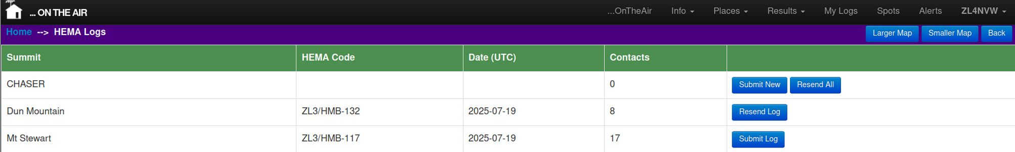
In your HEMA Logs page you’ll see a list of all your HEMA activations, plus a line at the top tallying your unsubmitted chaser contacts.

New (never-exported) activations will have a button to Submit Log to HEMA. An activation that you have already downloaded for export will have the option to Resend Log.

Click on the log you wish to export / submit.

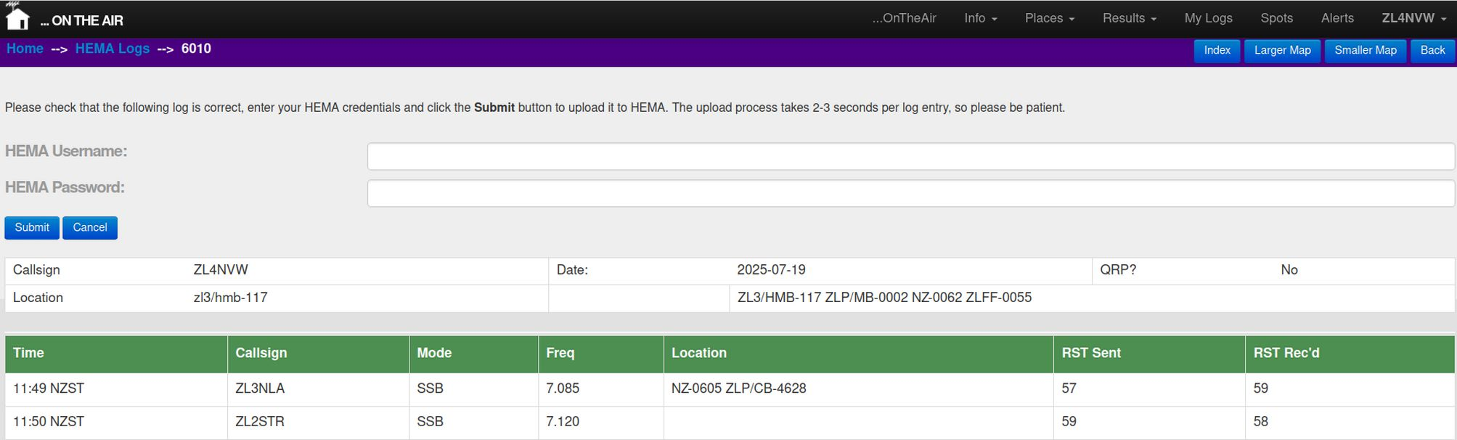
Details of your log will be displayed, along with a login panel for the HEMA Website. If you are happy with the log, enter your HEMA login details and click Submit. You HEMA details are not stored or logged at ontheair.nz and are only used to validate your HEMA account for the log upload process.

The upload process sends each contact one-at-a-time, and takes 2-3 second per contact – be patient!

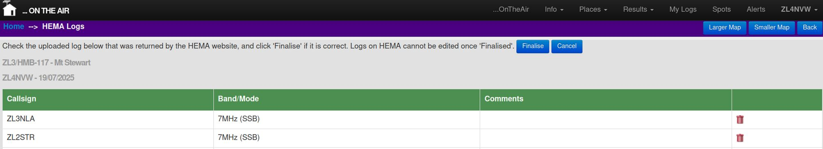
After the log upload has completed, ontheair will display the summary of the uploaded contacts that the HEMA website returned. If you are happy with them, click Finalise to complete submission of the log (the log is not accepted at HEMA until the Finalise button is clicked).

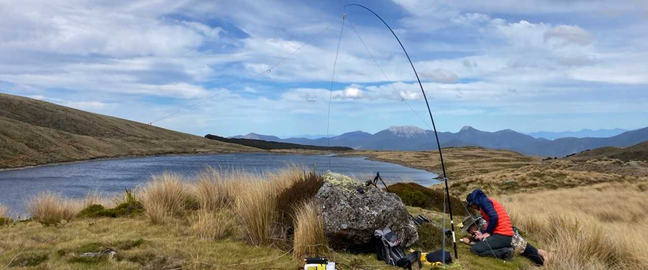
LLOTA

Lakes and Lagoons on the Air is a relative newcomer to the stable of international portable award programmes, but is growing strongly. Established in Chile it now has a presence in 49 countries (April 2026), including both New Zealand and Australia.
Unusually amongst participating countries, New Zealand already had a strong lake activation programme (ZLOTA / ZLL) when LLOTA arrived. The usual LLOTA principal is to start with a handful of lakes, and grow through user requests. However, it made more sense to tie in with the exiting ZLL scheme, so we simply added the existing list of mainland ZLL lakes to the LLOTA programme. Currently, this excludes the Kermadec, sub-Antarctic and Antarctic lakes – feel free to submit a request if you think you’ll be going there though and they can be added.
The official site: https://llota.app includes full details on the worldwide scheme.
There are a few minor differences between the ZLOTA, NZART and LLOTA rules for lakes – see below for details.
Logging:
Only the activator submits logs to LLOTA. So please submit your logs, even if you fail to qualify, as you chasers will be depending on you to do so.
References:
The prefixes used by https://llota.app are LLXX-####, where XX is the ISO designator for the country – e.g. LLNZ-0001 for Abel Lake in New Zealand.
Note that in the past NZ-0001 and NZLL-0001 were also used to refer to LLOTA lakes. These formats are discontinued as of 30th June 2026.
The reference numbers used within New Zealand exactly match the ZLL/#### numbers used by the ZLOTA award programme, except for references over 9000, which are lakes unique to LLOTA which do not meet the rules to qualify for ZLL. So you can confidently expect ZLL/0123 and LLNZ-0123 to be the same lake.
https://lota.app (LLOTA) | https://ontheair.nz (ZLOTA)
LLNZ-0001 | ZLL/0001

Rules
See https://llota.app/reglas.html for the latest version
Minimum Requirements
- 1 10 QSOs minimum to validate the activation.
- 2 Maximum 200 meters from the edge or on the water (/MM) provided it is safe.
- 3 Portable or mobile equipment.
- 4 Upload log (ADIF) within a maximum of 30 days.
Prohibitions
- Operation from moving vehicles.
- Use of terrestrial repeaters (Simplex Only).
- User of VoIP internet based communication (e.g. SDRs)
- Operation from a fixed QTH.
Guidelines:
- N-fers: Participants are now allowed to activatr multiple lakes simultaneously (but note that this will invalidate the activation for those claiming the NZART award)
- Only Lakes, Lagoons, wetlands and reservoirs or dams are permitted as qualifying references.
- LLOTA encourage users to request the addition of new lakes to the scheme. However, within NZ things will be much simpler for everyone if we can keep the NZART, ZLOTA and LLOTA lake lists the same. So priority will be given to including only lakes that comply with the requirements of all three schemes. To avoid confusion, lakes valid only for LLOTA will use a separate number range (9000+)

 | ZLOTA / ZLL | NZART / ZLL | LLOTA
Min Contacts | 2 | 2 | 10
Max distance from lake | 500m | 500m | 200m
N-fers permitted (multiple lakes) | Yes | No | Yes
Terrestrial repeaters | No | No | No
SDR use by chasers | Yes (Same DXCC) | No | No
Operation from vehicle | Yes | Yes | Yes (must be stationary)

June 2026 rule changes highlighted in bold

... Exporting LLOTA logs from ontheair.nz
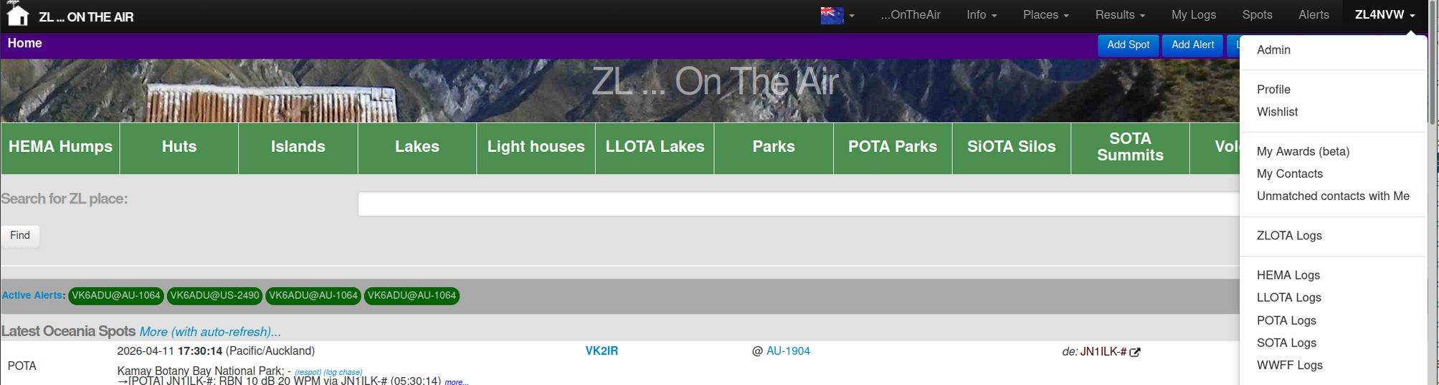
You’ll find a LLOTA Logs link on the menu under your callsign (top-right) at ontheair.nz

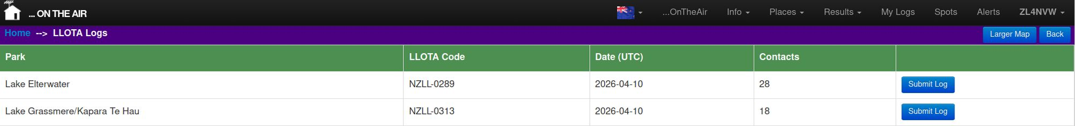
In your LLOTA Logs page you’ll see a list of all your LLOTA activations. New (never-exported) activations will have a button to Submit Log to LLOTA. An activation that you have already downloaded for export will have the option to Resend Log.

Click on the log you wish to export / submit.

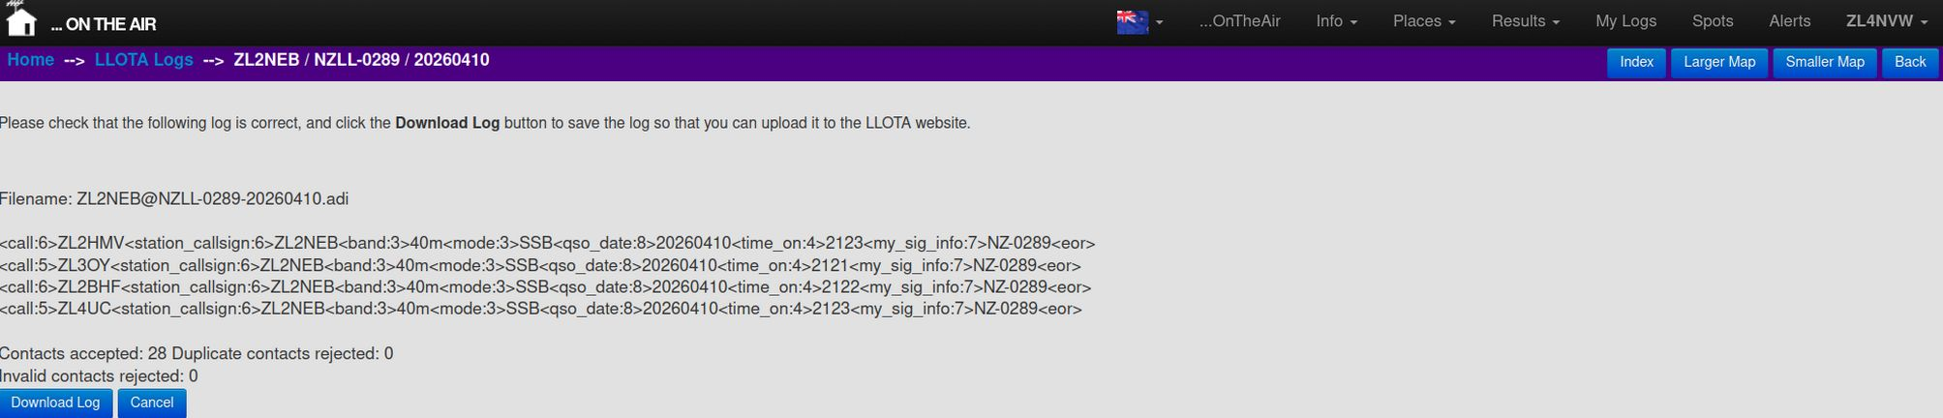
The log will be displayed in ADIF format, and any ‘invalid’ contacts will be listed. Contacts will be classed as invalid for LLOTA if they are: duplicates, invalid frequencies (which do not map to a valid band), or are missing mandatory information.

Click on Download Log to save the log to your computer in ADIF format.

... Importing LLOTA logs into llota.app
Log into https://llota.app (you will need to register using a google account).

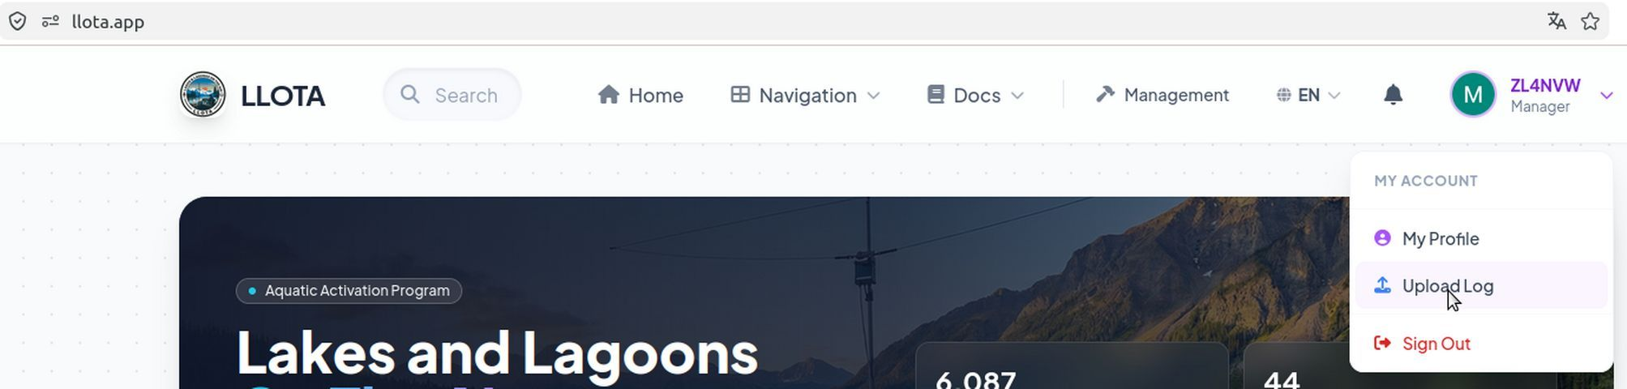

Select Upload Log from the dropdown (click on your callsign, top-right).
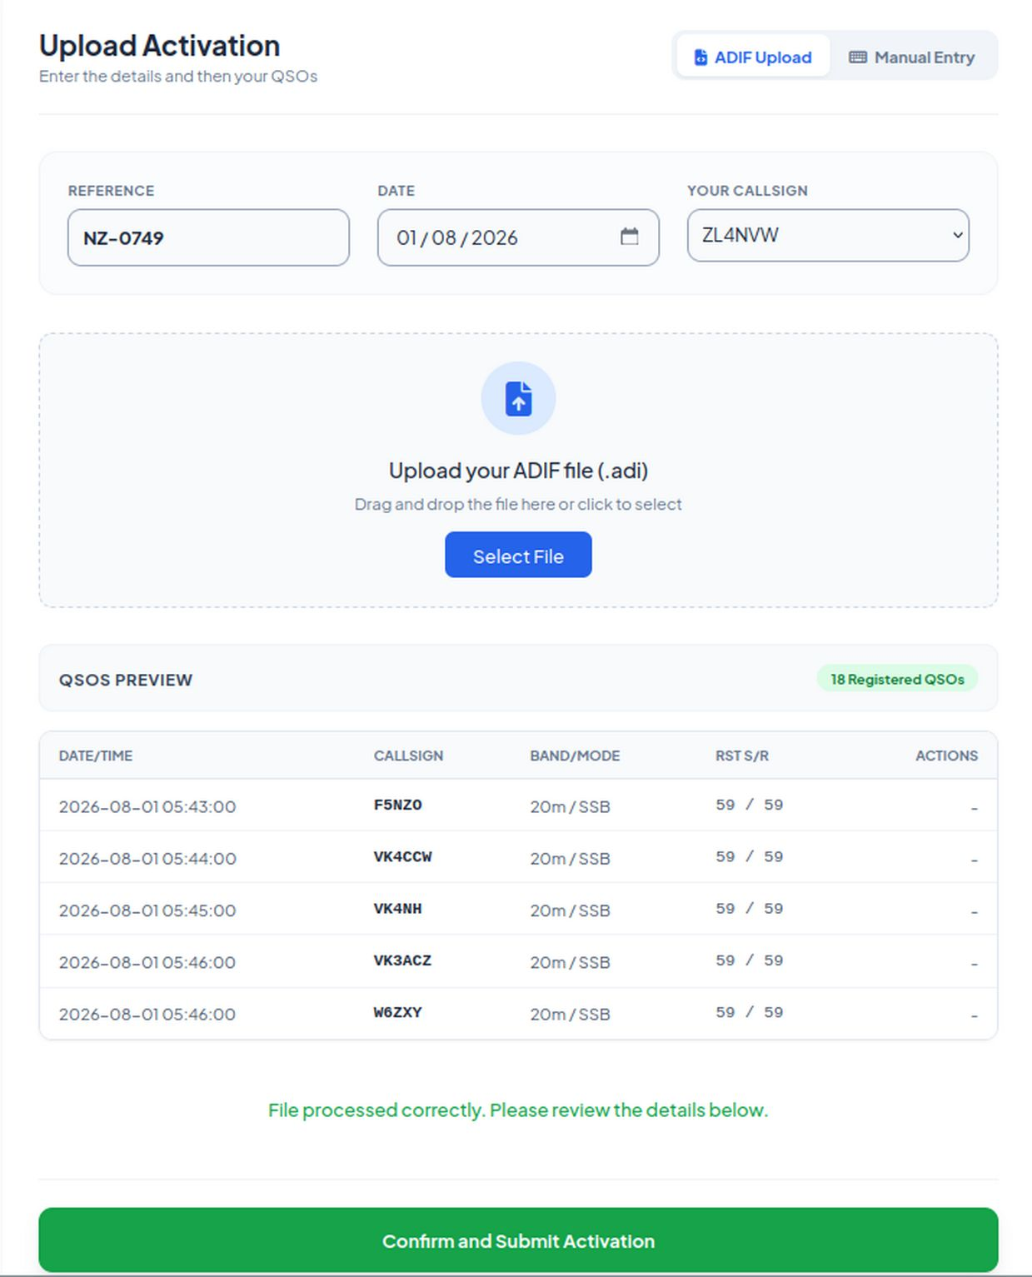
- Enter you park reference (in NZ-#### format), date and callsign used.
- Drag-and-drop, or select your .adif log file
- Check the contacts look correct
- Click Confirm and Submit Activation

Other information

Common SSB Frequencies

There is no ‘official’ allocation of frequencies for the ZLOTA scheme, and of course – ‘no-one owns a frequency’ in amateur radio. But the following table shows commonly used centre-of-activity frequencies, with operators spreading out on either side when things are busy.

Band | SOTA Frequency | ZLOTA Frequency | VK Parks frequency
80m | 3.585 | 3.690* | 3.644
60m |  | 5.363**
40m | 7.090 | 7.085 | 7.144
20m | 14.310 | 14.310 | 14.144 / 14.244
15m | 21.300 | 21.300 | 21.144 / 21.244
10m | 28.480 | 28.3-28.6
2m | 146.500 | 146.500
* Note that this is the designated QRP calling frequency and so non-QRP operation may be frowned upon.
** USB. Note that power limits apply – see your license.

Legal access in New Zealand

The ontheair.nz website lists all aassets in each award prograamme in New Zealand. The list is not restricted to those that are on Crown-owned land or have a right of public access. Places listed at ontheair include many that are:
- On private land with no access rights
- On private land accessible by easements, covenants or legal walkways
- Commercial forests subject to Public Access Easements (PAE's) along forestry roads
- On crown land with a right of public access
- On crown land subject to access restrictions for reasons of conservation (e..g Takehe protected area)
- On islands that have restriction on landings
- On areas that are closed due to safety (e.g active volcanic sites)
- In areas subject to rahui
- Tapu sites of significance to their traditional owners
It is always the operator's responsibility to ensure that they have a right of / permission for access prior to visiting a site. It is the operators responsibility to ensure that radio operations from that site are in compliance with their license regulations and conditions.

Indications of public access shown on this site
For each place listed on ontheair we give an indication of whether the activation zone includes land with public access or not. Where this site indicates 'Yes' there is public access this means:
- We have found land with a right of public access somewhere in the activation zone. This does not mean that the actual lakeshore or the actual summit has public access.
- The specific type of public access land will be shown (formed road, legal road, DOC walkway, DOC / council park or reserve)
- We do not verify whether there is continuous public access from the nearest road to the activation zone. Where we indicate that public access land exists in the AZ, it may be isolated from roads by private land and only accessible by air or boat without neighbouring landowner permission.
- We do not verify that there is practical access through the public access land. Bluffs, rivers, swamps may mean that access, though legally allowed, is impractical.
Classes of public access land
The following is a collection of online resources about access to various classes of land in New Zealand, along with my summaries of their contents. Note that my summary does not constitute legal advice. The Walking Access Commission is a good place to start for information and advice.

https://www.walkingaccess.govt.nz/

Conservation land
Public Conservation Land (PCL) in NZ comes with a default right of public access. Public Conservation Land is shown in green on the Walking Access Commission's maps.

Note, however, there are situations in which the conservation act or national parks acts allow access to be restricted. Offshore islands, breeding sites, and areas of active vulcanism are examples.

DOC can also administratively 'close' a facility if they believe it is not up to their standards. Such closures indicate that the facility is not fit for purpose, but do not remove the right of public access to the area.

DOC currently allow amateur radio activity on DOC land by default - i.e. radio operation is permitted except where it is explicitly prohibited. Note however, that other activities related to an amateur radio activity (e.g. erection of temporary structures, overnight camping) may be restricted.

https://doc.govt.nz

Private land:
Whilst there is no 'right to access' over private land in NZ, the law (trespass act 1980) does not prohibit access unless you fail to leave when asked. This situation creates a lack of clarity and expectations about access that can lead to confusion and conflict.
https://communitylaw.org.nz/community-law-manual/not-rated/trespassing/
https://www.walkingaccess.govt.nz/knowledge/access/do-i-have-the-right-to-walk-over-private-land-to-get-to-public-land/
When considering access over private land - note that:
- There are legislated locations where access permission is a legal requirement under other acts (e.g plantation forestry, ports, etc).
- Most landowners will not be happy about accessing their land without permission irrespective of what the trespass law actually says or doesn't say
- Any access implied by the trespass act may not translate into a right to operate an amateur radio station
- Farms have critical times of year when disturbance to stock or farming operations can have massive impacts and costs to the landowner. Unless you ask, you may not be aware of these until it is too late.
Easements, agreements, walkways and covenants
There are many situations in which public access has been provided across private land. But these are often buried in easements and covenants on the property title and not published elsewhere. DOC and WAMS can give advice on some of these but do not know of all public access easements and covenants.
https://www.doc.govt.nz/map/index.html
http://wams.org.nz/

For former pastoral leases that have completed tenure review the 'full substantive proposal' signed by LINZ and the leasee will list access easements and covenants over the resulting freehold land.
https://www.linz.govt.nz/crown-property/crown-pastoral-land/status-and-location-crown-pastoral-land

For other private land the only definitive way to determine access rights is by requesting the title from LINZ, which is subject to a fee.
https://lrs.linz.govt.nz/search/

Forestry Public Access Easements (PAEs)
When crown-owned NZFS production forests were privatised in the '90s, existing rights of public access that existed along many of the roads within the forests were preserved as Public Access Easements (PAEs). These easements are recorded in the license issued to the forestry company, and not in the land-title register. Unlike normal access easements across private land, which are guaranteed, PAEs may be 'temporarily closed' at the discretion of the forestry owner for 'operational purposes' or 'safety'. This means that they are very unreliable forms of ongoing access. There are cases (e.g. Lower Windley Hut access) where they have been suspended indefinitely - which may or may not be legally valid.

Walking Access have added a PAE layer to their maps - it is unclear at this time how complete the data in that layer is. At the time of writing (2025-01-01) it included just 157 easements, and was missing many that are referenced elsewhere (DOC, Te Araroa trust).

https://www.herengaanuku.govt.nz/types-of-access/public-access-easements

Unformed legal roads:
Legal roads are owned by the crown, not by the neighbouring landowner. The existence of a legal (unformed) road may not be visible on the ground or acknowledged by the neighbour. It is your responsibility to ensure that you remain within the bounds of that road. If you find access to a legal road blocked by barriers or stock, a complaint to the territorial authority is the appropriate step. Legal roads are shown in purple on the Walking Access Commission's maps.
https://www.walkingaccess.govt.nz/knowledge/access/unformed-legal-roads/
https://fmc.org.nz/campaigns/same-as-sh1/
Marginal strips and riverbeds
Marginal strips (Queen's chain) run along the banks of many rivers and lakes in NZ, but not all. Even where they are present they may not be continuous and may not accurately follow the current course of the waterway. Some are 'movable marginal strips' which change as the river course changes, others are fixed and may be nowhere near the current riverbed.
Most marginal strips are crown-owned public conservation land (DOC-managed) and come with a right of public access (that is their purpose). They are 11m or 22m wide and start from the edge of the legal riverbed. Older marginal strips are legal roads, managed by LINZ. Marginal strips are shown on the walking access commission's maps as either purple (roads) or green (conservation land). Note that it is your responsibility to ensure that you remain within the limits of the marginal strip and that access may not always be physically practical. A GPS with the boundaries on it can be a big help.
https://www.walkingaccess.govt.nz/knowledge/rivers-lakes-and-coast/what-is-a-marginal-strip/
The crown owns the beds of most major rivers in NZ, often including dry beds and channels. These are shown as blue 'hydro' areas on the Walking Access Commission's maps. This land is managed by LINZ, not DOC. Where a riverbed is bordered by private land LINZ may agree for it's use (to the centre-line) by the neighbouring landowner - in this case there is no right of public access. Where the riverbed is bordered by public conservation land (e.g. marginal strip) or a legal road then DOC/LINZ are the neighbouring landowner and access will be allowed to the centre-line.
https://www.walkingaccess.govt.nz/knowledge/rivers-lakes-and-coast/access-along-rivers-lakes-and-the-coast/#9

How do I tell what class land / a track falls in to?
The walking access commission provides maps of 'public access land', indicating where there is a right of public access. These maps are reproduced here on ontheair.nz - simply select the 'Public access land' layer from the map layers menu.
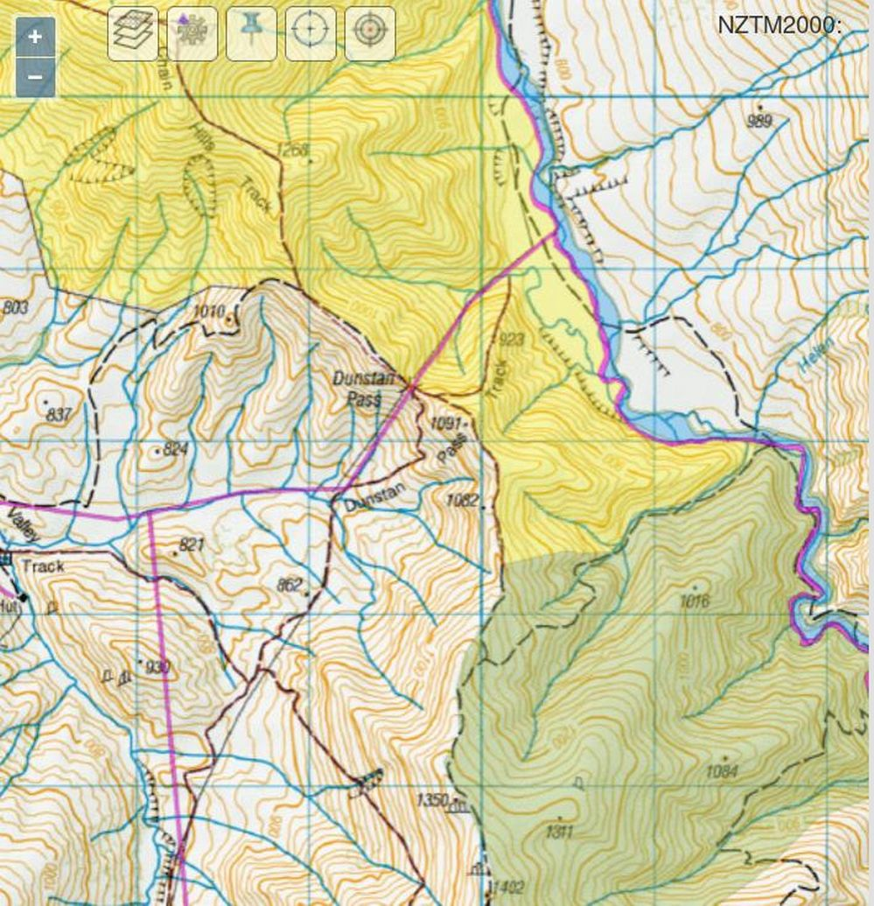
The following colouring is used:
- Dark green: DOC-administered public conservation land
- Light green: district council administered reserve
- Pink: Crown owned 'legal road' - land owned by the crown for the purpose of a roadway. May or may not have been constructed.
- Red dashed - Walkway vested in DOC with a right of public walking access - generally extending 10m either side of the centreline.
- Red solid - Road vested in DOC with a right of public vehicular and walking access - generally extending 10m either side of the centreline.
- Blue (only shown zoomed in) - LINZ-administered crown-owned riverbed.
- Yellow(only shown when zoomed in) - Privately owned land subject to a conservation covenant held by DOC. Some (but not all) include a right of public access.
All other land / tracks are private and access is either by permission or under the goodwill of the landholder.

SOTAmat Spotting

SOTAmat provides an application and web-server that allows spotting of portable activations via FT8 using your mobile phone speaker and your HF radio. It works like this:
Before you go:
- You pre-program the server (https://sotamat.com) with the lists of parks, peaks, etc that you plan to visit and the frequencies you might use
- The server then allocates an abbreviated message suitable for transmission via FT8 to each combination you have created
- You synch this list off the server to the SOTAmat app on your phone.

In the field:
- You tune your radio to the normal FT8 frequency (both 7.074 or 14.074 are well monitored in ZL/VK)
- Select USB, and turn off audio compression / speech processing
- Key the mic and play the FT8 audio into the mic using the SOTAmat app, being careful to keep the volume / distance from the mic such that you do not trigger the radio’s ALC.
- The audio will be repeated 4 times on different sub-frequencies within the 3KHz FT8 channel, to avoid failures due to collisions
  - One or more SOTAmat or PSKreporter monitoring stations receive your FT8 message and pass it to the SOTAmat server
  - The SOTAmat server sends a correctly-formatted SPOT message to the appropriate server for the award programme you are activating

There are an increasing number of SOTAmat dedicated listening stations around the world monitoring the FT8 frequencies for SOTAmat messages and forwarding them immediately to the SOTAmat server. Supplementing that is the full worldwide PSK reporter network which also forwards SOTAmat messages – though only once every five minutes – so you may need to allow for that delay.

There are good guides for using SOTAmat for spotting SOTA and POTA on the SOTAmat website – check them out.

Sadly, SOTAmat does not support ZLOTA (or HEMA or WWFF) intrinsically, and as such spotting these schemes via SOTAmat is way fiddlier than SOTA or POTA spotting from SOTAmat. But it can be done as follows.

In the SOTAmat webpage:
- Go to HF Preparation -> Messaging Commands and select + New Entry

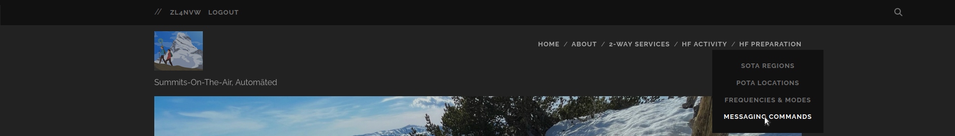

Enter something like:
Command: email
Target: spot@ontheair.nz
Content: /bom ZL4NVW 1234 ! ZLL/0003 7.090 SSB Calling CQ now. /eom
Notes: ZLL/0003 7.090

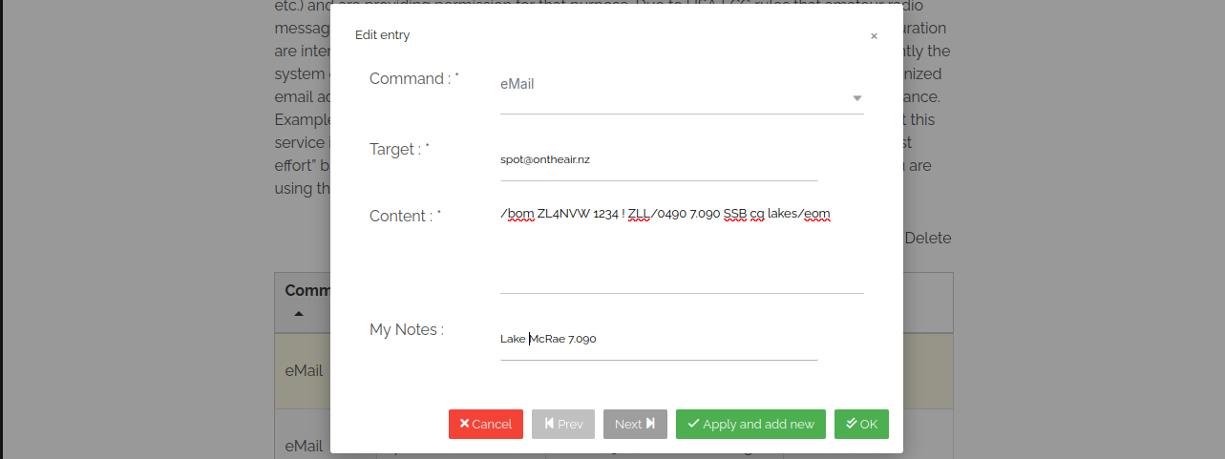
where:
- spot@ontheair.nz is the spotting gateway address at ontheair.nz
- ZL4NVW is your account callsign as registered at ontheair.nz
- 1234 is your ontheair PIN (see you profile under your callsign, top-right, at ontheair.nz)
- ! means you are spotting your own call. You can replace ! with another call if you are spotting for someone else or using a club call, etc
- ZLL/0003 is the lake, hut, island, lighthouse, park, (or even WWFF park) you are activating
- 7.090 is the frequency you plan to use. You will need to define multiple messages if you plan to use multiple bands (or just put those details in the notes)
- SSB is the mode you plan to use
- Calling CQ now is what will be placed in the comments field of the spot. Obviously change this to whatever you want!
- /bom and /eom mark the beginning and end of the spot message. They are required as SOTAmat adds all sorts of junk to the start / end of the email it sends.
- Notes is what shows up in the SOTAmap app when you select from your list of predefined messages

Then sync your SOTAmat app with the server to pick up the new message
- (Setup -> Load config from server)

==

In the field:

You can then select 'message' from the bottom line of the SOTAmat app, and select the message you defined above. Click on Play FT8 Audio to send the ZLOTA spot via FT8. I just hold the mic against the phone speaker and watch the ALC does not trigger on the radio (having turned off audio compression first). Seems to work ok.

I've tried this via both my own always-on SOTAmat-connected FT8 monitor on 7.074 (instant) and via VK5HW and PSKreporter on 14.074 (up to 5 minute delay).

Be aware that if you do this, your ontheair PIN will be logged at the SOTAmat website. So do not use any PIN for ontheair that you use to protect anything else if you try this!

InReach Spotting / Alerting

Users of InReach can create spots and alerts on OnTheAir and ParksNPeaks from their InReach device whilst in the backcountry. This will also work from any device capable of sending an message to an email address.
To create a spot send an InReach message. On your InReach, create a message as follows:
- To: spot@ontheair.nz
- Containing a message like: ZL4NVW 1234 ZL1THH ZLH/0001 3.690 SSB Calling CQ now inr.ch
Where ZL4NVW is your callsign, 1234 is your PIN (this is different to your password. Set your PIN in your profile)
Creates a spot for: ZL1THH 'calling CQ now' from ZLH/0001 on 3.690 SSB. The inr.ch terminator (as also required by SOTA) is there to mark the end of your message, as inreach adds other information to the end of what you send. Note that the subject of the email is ignored.
To self-spot:
- To: spot@ontheair.nz
- ZL4NVW 1234 ! ZLFF-0001 3.690 SSB On air in 5 mins inr.ch
If you are spotting yourself you can replace the 'calling callsign' with !, as above
To create an alert:
- To: alert@ontheair.nz
- ZL4NVW 1234 ! ZLFF-0002 3.690 SSB 2021-05-26 02:00 Time approx inr.ch
Alerting: ZL4NVW will be in ZLFF-0002 3.690 SSB at 02:00 on 26/05/2021***UTC***. You can specify a different callsign instead of '!' to alert for someone else.
Note that all InReach alerts must use UTC timezone
All spots and alerts for NZ entities will be notified on both OnTheAir and ParksNPeaks. VK entities will only spot/alert on ParksNPeaks
If the comment contains the word 'debug' then the spot / alert will be verified and displayed on ontheair but not forwarded to other schemes, and not sent to the email lists

When chaser logs which do not match your own

When a chaser uploads a log recording you activating the wrong location, that location shows up in your scores and lists of places activated - which can be annoying. We now check chaser logs against activator logs and if a chaser records you in (for example) a park that does not match your own activation log then that chase of you in that park is now flagged as 'unmatched'.

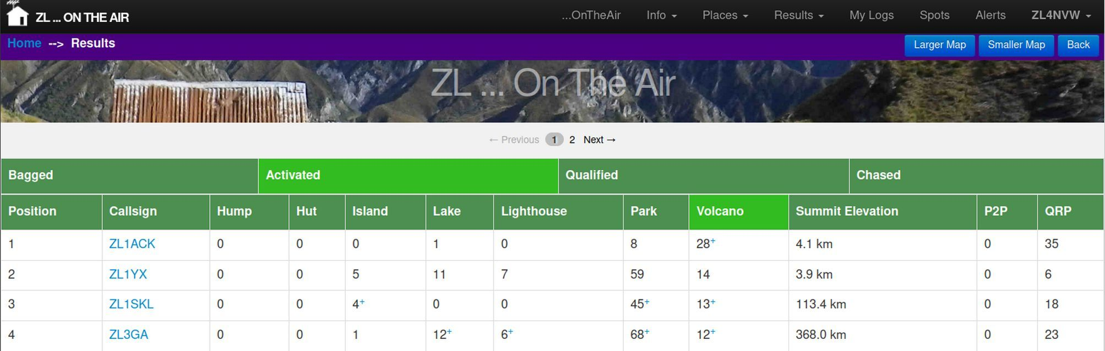
Scores in the honour roll which include unmatched contacts submitted by a chaser are highlighted with a small blue + to indicate that they may be incorrect.

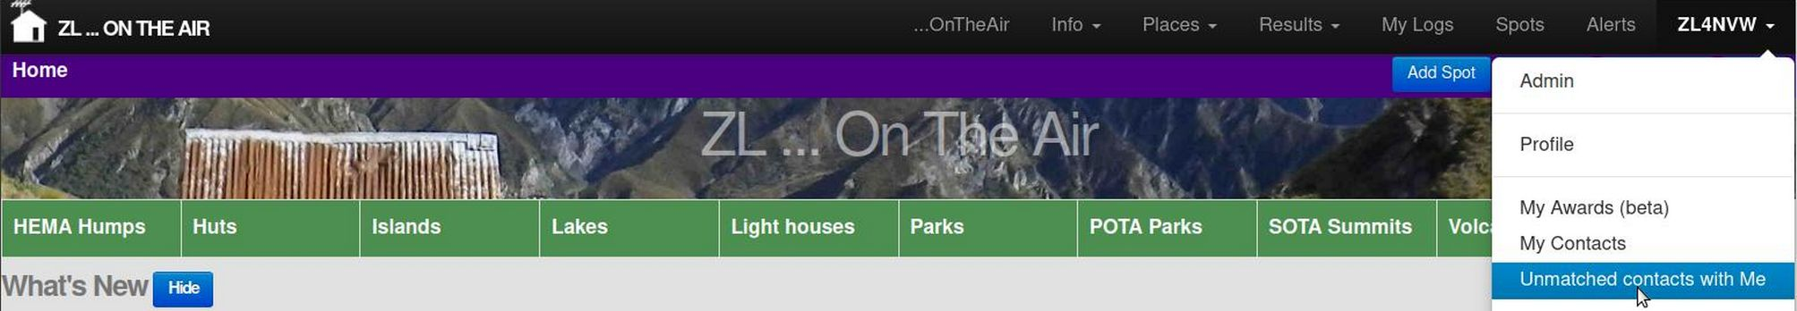
You can view the list of chaser logs that do not match your own activations in the menu under your callsign by clicking Unmatched Contacts with Me.

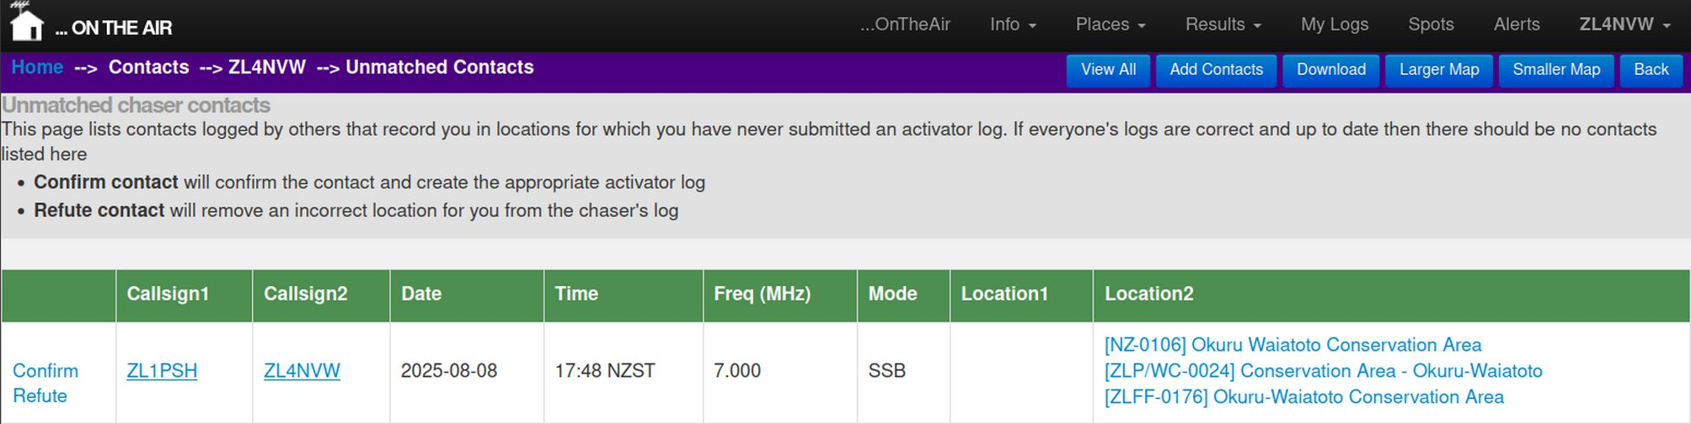
You have the choice to either Confirm or Refute each unmatched chaser contact:
- Confirm will add a record of that QSO to your own logs, confirming the contact and adding the location to your list of places activated.
- Refute will 'comment out' the chaser's recorded location for you in their log, and indicate that the recorded location is not correct. It will not delete the chaser's contact.

Using secondary and club callsigns

Ontheair.nz supports the use of secondary and club callsigns in spots, alerts and logs.
Look at your Profile (under your callsign, top-right) to see a list of callsigns currently allocated to your account.
If you have an additional secondary callsign, you can add it here. Use the date it was awarded / the date you started using it for a start date. Leave end date blank.
If you plan to use a club callsign for a specific period of time then add that callsign to your list. Make sure you enter the start and end dates accurately for the period you will be using the call. Failure to enter a start or end date will prevent other people for using that club callsign at otheair.nz

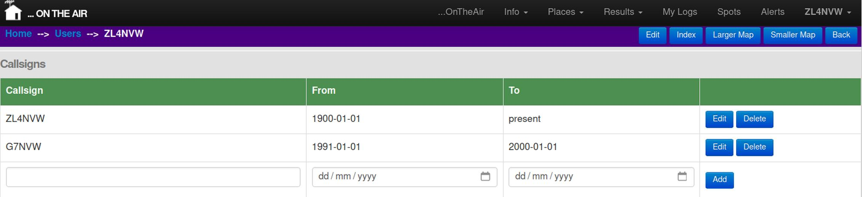

Spot and Alert Notifications
You can choose to receive notifications of all spots and/or alerts posted at ontheair.nz to your email address or mobile device. Two delivery mechanisms are available:
- Email Notifications
  - Requirements: None – you just need an email account
  - Cost: Free to you, but ontheair.nz are charged for emails based on volume, so choosing email service adds to the running costs at ontheair.nz. Notification emails constitute about 50% of the running costs at ontheair.nz at the time of writing.
  - Speed: typically within 1-2 minutes, but dependent on provider and app configuration / settings
  - Content: Only spots created at ontheair.nz (not at SotaWatch, POTA.app, etc)
  - Notifications: yes – dependent on app configuration / settings
- Push Notifications to your mobile device
  - Requirements: You will need to install the 3rd-party Pushover app.
  - Cost: One off charge per mobile device you register with pushover (US$5 at time of writing)
  - Speed: typically within 20 seconds
  - Content: All spots.
  - Notifications: yes

Email Notifications

Email delivery time will depend on your email configuration, the app you use, and your provider. To speed up delivery: enable ‘Push Mail’ and ‘Allow App to run in Background’ in/for your email app. If your app/provider do not have the option of push mails, increase the check frequency in your email app settings.

You need to be a registered user to receive emails and have supplied your valid email address. Once you have registered, view your profile under your callsign at the top of the screen.

You can Add or Delete your subscription to receive Email for the Alerts and Spots topics from your profile page.

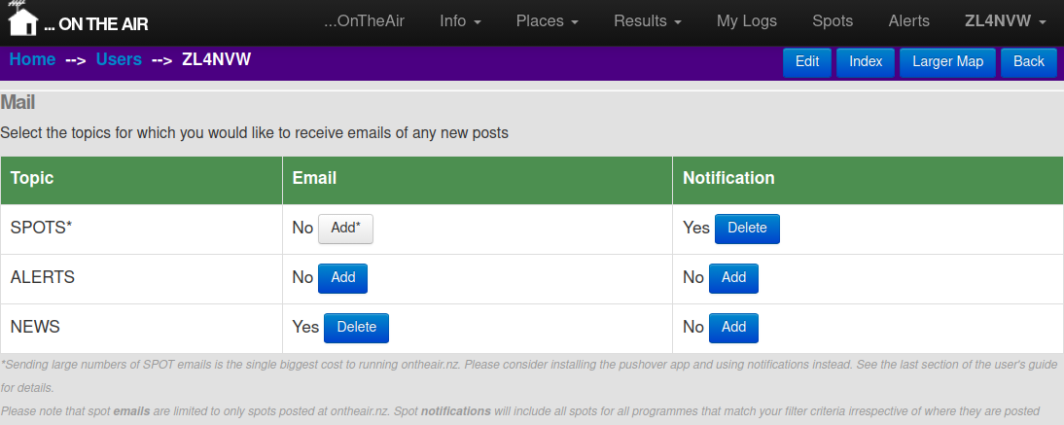
Only spots and alerts created here at ontheair.nz will be emailed to you. Spots/alerts received from ParksNPeaks, SOTA, POTA, etc are displayed on the site, but not sent out by email. If you opt to receive spots by notification then you can receive notifications for all spots irrespective of where they are created. Once enabled, you will be given the option to filter the spots that you receive (see below)
Note: Sending out the thousands of spot emails is the biggest single cost to running ontheair.nz, so we encourage users, where possible, to use notifications instead if they wish to receive spots.

Push Notifications

You need to be a registered user to receive push notifications, and to have installed the PushOver app on your phone. Pushover is available for both Android and iPhones. There is a one-off charge to register your device with pushover, payable after a free trial period of 30 days. Payment can be made by either in-app purchase, or by credit-card/paypal through the pushover website. This is a charge for the pushover server usage, paid to the pushover app developer. This money does not in any way come to ontheair.nz or it’s developers / maintainers.

https://pushover.net/

1) Install the Pushover app on your phone from your app store, and register an account
- You may be asked to give Pushover permissions to show notifications

2) Verify your email address:
- Check your email inbox for the verification email from Pushover. If it’s not there then visit the pushover website (easiest on your pc): https://pushover.net/, check your email address is correct, and request an email.
- Confirm your email address to activate your account

3) Note your Pushover User Key
- Log into the pushover website https://pushover.net/
- Note Your User Key

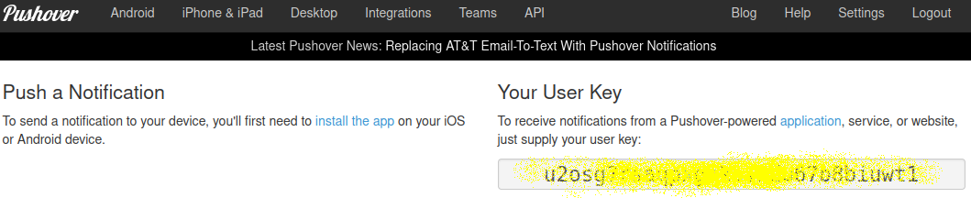

4) Add ontheair to your pushover config and note the API Key
- In the pushover website, logged into your pushover account, Create an Application

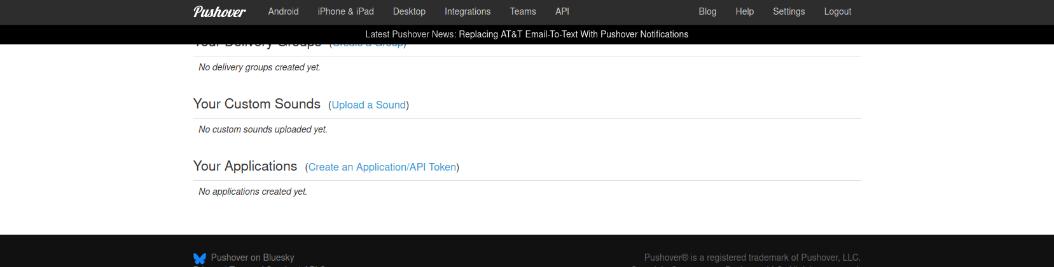

- Give the application name as ontheair and accept the T’s&C’s before clicking Create Application.

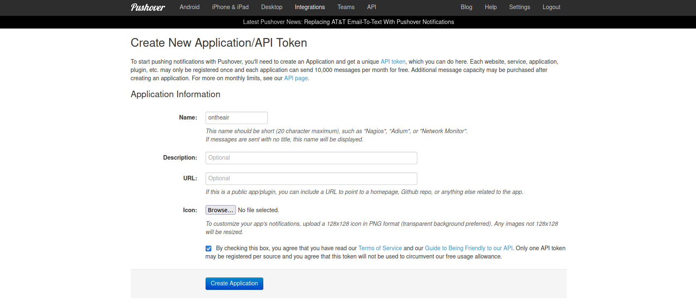
- Note the API Key:
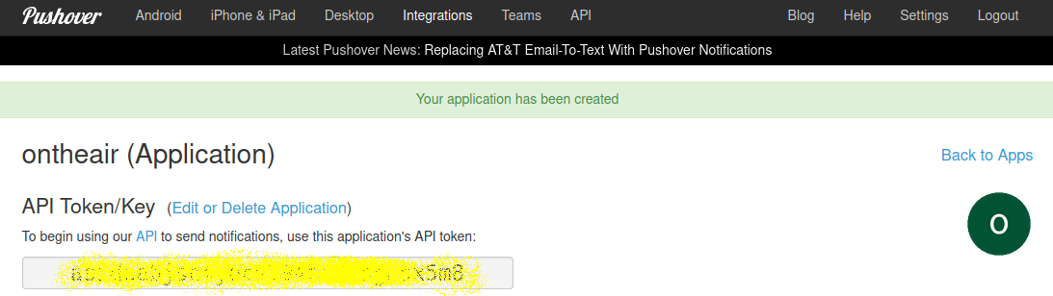
5) Enter your Pushover details into ontheair.nz

- In ontheair, go to your profile (under your callsign, top-right)

- Click the Edit button
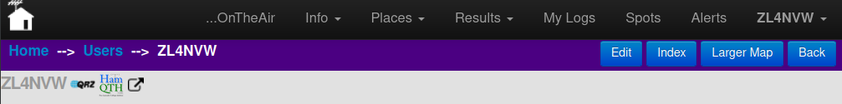

- Enter the pushover API key (from the Pushover applications page) in Pushover API Key
- Enter Your User Key (from pushover home page) under Pushover User Key
By default a brief summary of the spot/alert (as shown in the spots/alerts page of the website) is included in the notification (along with a link to the full post at ontheair.nz). You can choose to additionally include the comments and/or the map in the notification. Note that the more you include, the more mobile data the service will consume.
- Check the relevant checkboxes for the level of detail you wish to include in the notifications.
- Save Changes

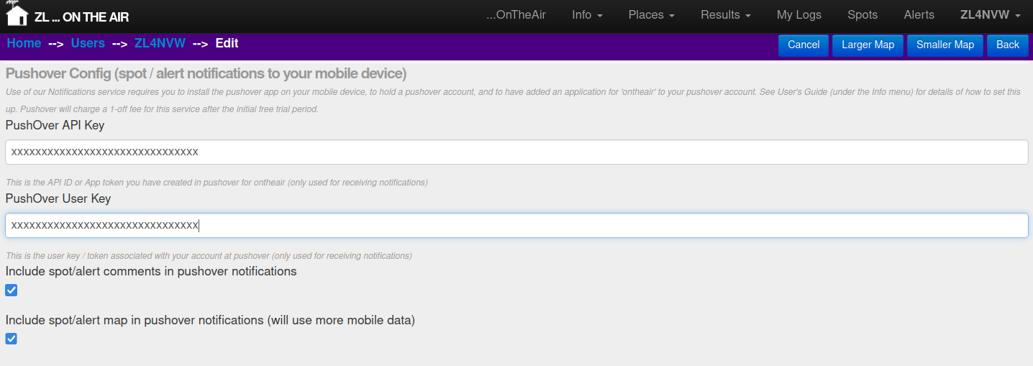
5) Test you have notifications set up correctly
- You can use the Test Notifications button on your profile page to send a notification to your mobile device and check that it all works.

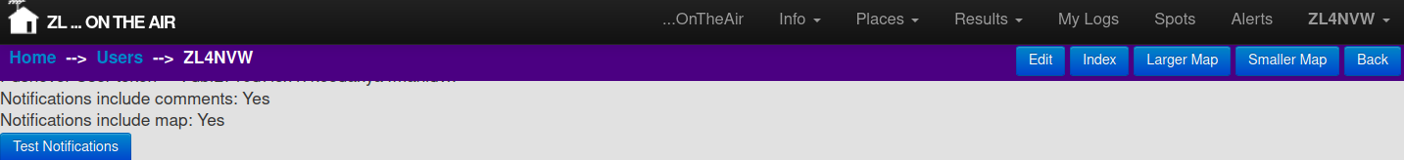
6) Subscribe to notifications for the topics you require
- In your profile and scroll down to the Mail section
- You can now Add and Delete subscriptions to Notifications for each message type.

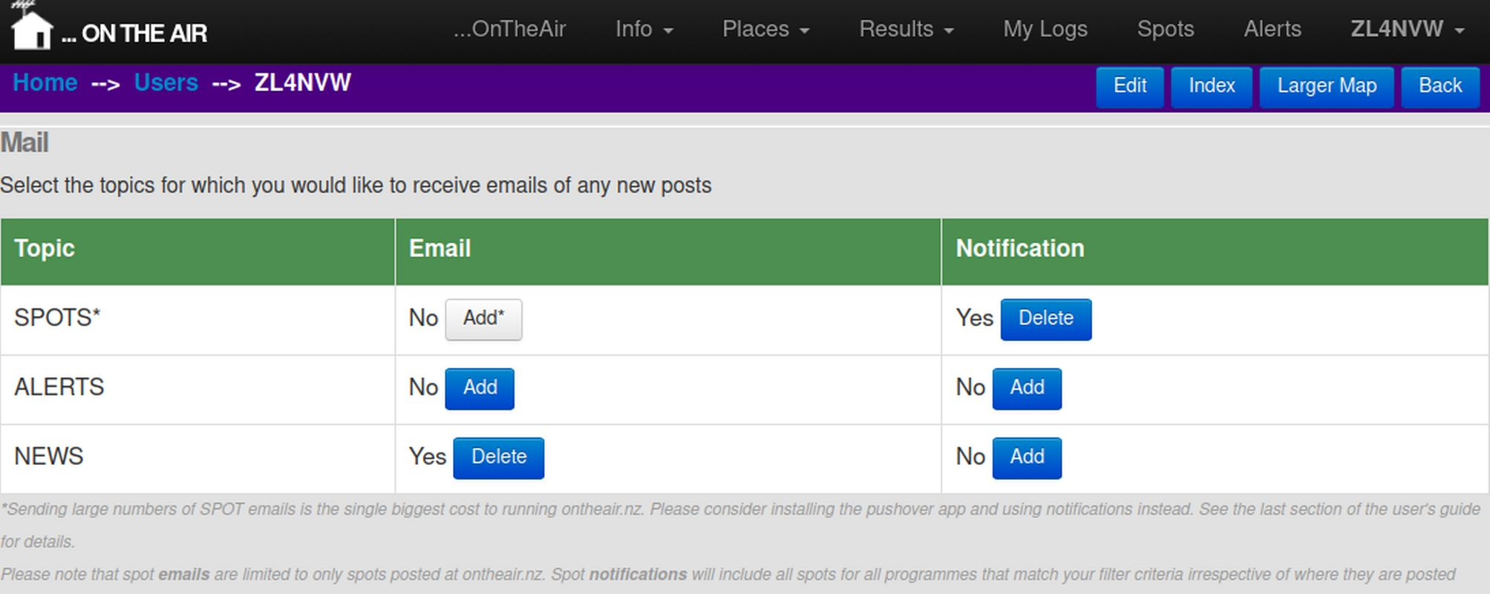
7) Configure spot notification filters (if selected)
- Add Spot Notifications to your subscription as above
- A new section will be shown on your profile screen allowing you to configure the filters on which spots you wish to receive
- Select the desired Programme, Continent, and Mode or leave blank for ‘all’. These lists are multi-select – you may need to use ctrl+click to select more than one.
- Optionally: if you wish to filter down to finer granularity you can also enter a search pattern in Activator Callsign and/or Site reference. E.g. for only sites with Waikato references (e.g. ZLP/WK-0001) you can enter *WK* in the Site Reference field. Or for only activators with ZL callsigns you could enter ZL* in the Activator Callsign field.
- Click Update Filters to save your selections

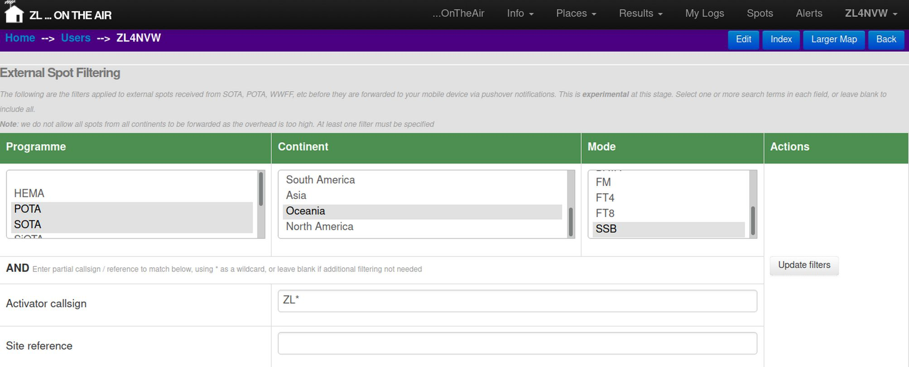
Example – Notify me of all SSB activations of POTA and SOTA sites in Oceania, where the activator callsign starts with ZL

