Title

Subtitle

Full Name Author #1 || Author #1 email address || Author #1 Affiliations

Full Name Author #2 || Author #2 email address || Author #2 Affiliations

ACM Category 1 || ACM Category 2 || ACM Category 3

Keyword 1 || Keyword 2 || Keyword 3

# Abstract

The abstract should state briefly the purpose of the research, the principal results and major conclusions. Abstracts should not exceed 250 words. Abstracts are often presented and read as stand-alone text. Avoid the use of references and abbreviations.

# Introduction

This document is a template to submit a paper to *Journal of Simulation Engineering* (JSimE) (Consortium for True Open Access in Modeling and Simulation, 2017). The use of this template will enable the conversion of your article into the (X)HTML document to publish in JSimE.

Authors should use the standard features of Microsoft Word and the ones available in this document template. Avoid creating new Font Styles or use Add-ins because they are not supported.

The Title of the paper should be formatted using the *Title Font Style*. Subtitle is supported and should be formatted using the *Subtitle Font Style* and placed below the Title.

Each author information should be placed in separate lines and formatted using the *AuthorInfo Font Style*. The author information line should contain the author’s full name, email address, and affiliation. These fields should be separated using || (two pipe symbols). If an author is affiliated to more than one institution, each institution should be provided separated by ||.

ACM Categories should be provided after the authors information and formatted using the *Categories Font Style*. The categories should be separated by ||. Please refer to [The 2012 ACM Computing Classification System](https://www.acm.org/publications/class-2012) to select the proper terms to classify your work.

Keywords should be provided after the ACM categories and formatted using the *Keywords Font Style*. Keywords should be separated by ||. Please provide between 3 to 5 keywords.

The Abstract heading should be formatted using the *Heading 1 Font Style* and the abstract text should be formatted using the *Normal Font Style*.

The manuscript text should be formatted using the *Normal Font Style*.

Sections, subsections, etc should be formatted using the proper *Headings Font Styles* (i.e., *Heading 1*, *Heading 2*, *Heading 3*, and *Heading 4*).

# Language

Either American or British English is accepted, but not a mixture of them. For editors and reviewers to accurately assess the work presented in the manuscript, write your text in good quality English.

If the MS Word is set to a language different than English, please change the language settings to *English (United States)*. First, select the whole text and using the menu options **Review** – **Language** – **Set Proofing Language**, change the *Mark selected text as:* to **English (United States)**, and uncheck the options *Do not check spelling or grammar* and *Detect language automatically*.

Perform this operation whenever you have completed making changes to the document.

# Equation

Equations should be inserted in the document using the standard Microsoft Word Equation feature located at **Insert** – **Equation** in the menu (see Figure 1).



Figure 1 **Insert** – **Equation** menu option.

Example of Equation.

$$A=\int_{0}^{1}{xdx}, B=\sum_{i=1}^{j}{a_{i}}, C=πr^{2}$$

# Illustrations

Figures should be embedded in the document and, if necessary, a caption should be provided. You should use the menu options **Insert** – **Pictures** (see Figure 2).



Figure 2 **Insert** – **Pictures** menu option.

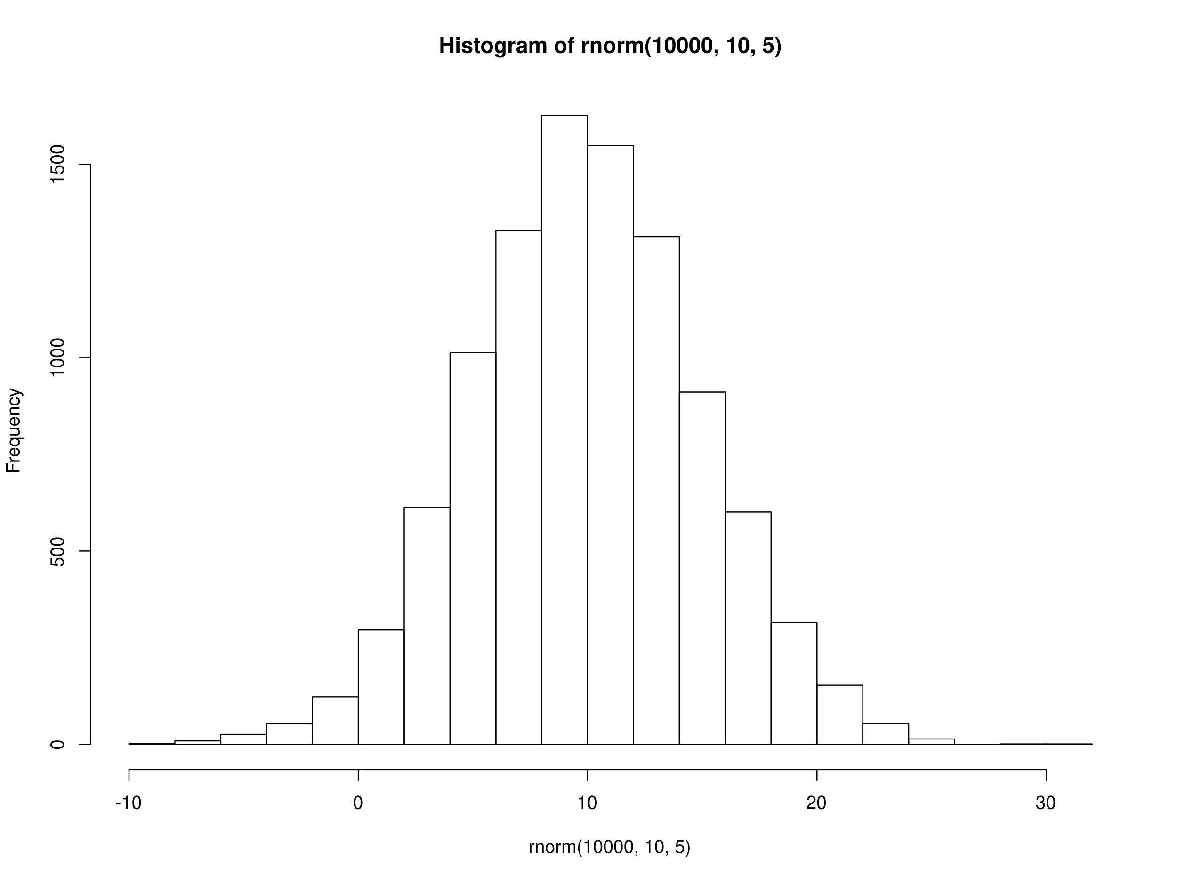

Figure Example of a Figure.

**NOTE 1:** “Copy and paste” figures from other tools is not supported.

**NOTE 2:** Cross-references in the Figure’s caption is not supported.

# Tables

Tables should be embedded in the document and, if necessary, a caption should be provided. You should use the menu options **Insert** – **Table** (see Figure 4).



Figure 4 **Insert** – **Table** menu option.

| **Name** | **Items** | | |
| --- | --- | --- | --- |
| R1 | C1 | C5 | C9 |
| R2 | C2 | C6 | C10 |
| R3 | C3 | C7 | C11 |
| R4 | C4 | C8 | C12 |

Table 1 Example of a Table.

**NOTE 1:** Cross-references in the Table’s caption is not supported.

**NOTE 2:** Table captions should be placed below the table.

# Code

Code snippets must be formatted using the HTML Preformatted style. Follows a code snippet example:

PUSH c TO sd.waitingCustomers

IF sd.waitingCustomers.length = 1

THEN SCHEDULE CustomerDeparture( sd) @ (t + sd.serviceDuration())

Inline code should be formatted using the Courier New font.

# Footnotes

Footnotes should be inserted using the standard Microsoft Word **References** – **Insert Footnote** feature[1] (see Figure 5).



Figure 5 **References** – **Insert Footnotes** menu option.

# Cross-References

Cross-references should be used to reference other parts or components of the paper (see Figure 6). The option “*Insert as hyperlink*” must be checked to the converter recognize the text as a cross-reference (see Figure 7).



Figure 6 **References** – **Cross-reference** menu option.

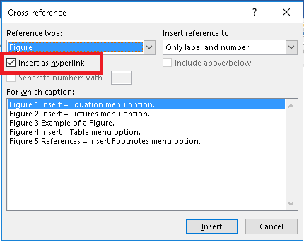

Figure 7 Check box *Insert as hyperlink*.

# Citation and Bibliography

Bibliography should use the Microsoft Word built-in features located at the *References* menu. References should use the [American Psychological Association (APA) style](http://www.apastyle.org/). A tutorial about this style can be found at the [APA website](http://www.apastyle.org/learn/tutorials/basics-tutorial.aspx).

All bibliographic entries should be first registered in the Microsoft Word using the **Managed Source** feature (see Figure 8).



Figure 8 Manages all bibliography entries

The citations in the manuscript should use the **References** – **Insert Citation** menu option (see Figure 9).



Figure 9 **References** – **Insert Citation** menu option.

The manuscript author is responsible to identify and solve any citation ambiguity. If the same list of authors, and in the same order, publish more than one paper in the same year, then a lowercase letter should be inserted after the year. For instance, the following two ambiguous entries

Author1, F.N., & Author2, F. N. (2010) Article 1

Author1, F.N., & Author2, F. N. (2010) Article 2

should be changed to

Author1, F.N., & Author2, F. N. (2010a) Article 1

Author1, F.N., & Author2, F. N. (2010b) Article 2

The bibliography section should be inserted using the References – Bibliography menu option (see Figure 10).



Figure 10 **References** – **Bibliography** menu option.

# Acknowledgements

Acknowledgments should be placed in a separate section at the end of the article before the bibliography, named *Acknowledgements* or *Acknowledgement* and formatted using the *Heading 1 Font Style*. Acknowledgments must not be included on the title page. The acknowledgement text should be formatted using the *Normal Font Style*. The names of funding institutions and organizations should be written in full.

# Bibliography

Consortium for True Open Access in Modeling and Simulation. (2017). *Journal of Simulation Engineering*. Retrieved from https://www.jsime.org

1. The *Insert Footnote* is located at the *References* menu option in MS Word 2016.