In order to complete the project, these are the list of technologies used and the purposes they served
- Twig: a powerful template engine in symfony used to render content
- CSS: style sheets used in restructuring the website and adding beauty to it
- Symfony:Symfony is a good all-purpose PHP framework. It is very configurable, has great features, and provides tons of plug-ins to ease development
- Bootstrap:
- Revolution js
- Custom JavaScript: scripts like fancy js, mail function js, masonry,isotope Effect Js and imagesloaded Js. All used to make the site more dynamic and animated.
- MYSQL databases: Used to store site information
- GIT: Used for version control and committing changes to the cloud
- Swift Mailer: Connecting the App to a mailing service
- Material design admin dashboard template
- cleanix front end template.

2: Describtion of the project
The project task was to develop a business website with symfony( a php framework). As a business website, it has to be able to easily communicate the business to vesitors and find a way of easily engaging them. The project required a responsive fast loading site, since some of its users will be using a mobile device. To taggle this problem the project seeked for a solution using the php framework.

3:these are the various problems or milestones that the project solved.
- Easy navigable site
- responsive site
- contact form to engage with visitors.
- Blog section with updates from a dashboard
- A list of all the mails sent through the contact form
- flash messages to inform vesitors of any ongoing promotion
- light weight site that loads faster even on slow internet speeds
4: the most technical concern apart from responsiveness was the security of the site.

6:Functioning of the website
The page which loads when the website link is visited is the homepage.
The first noticeable feature of the homepage, which is same on every other page is the navigation bar.
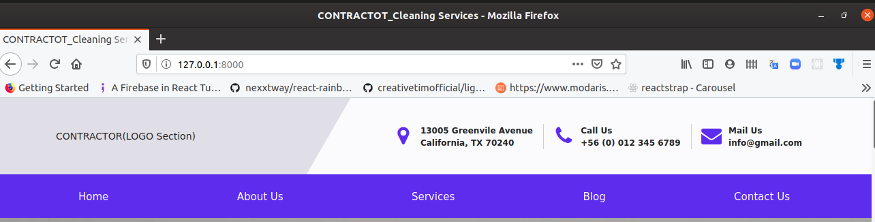

The navigation bar( nav bar) has two prominent sections, which is the logo and contact details section and the the navigation links section. These navigation links open up the various pages.
Upon scroll the logo and contact details section disappear while the navigation links section sticks to the to of the window.

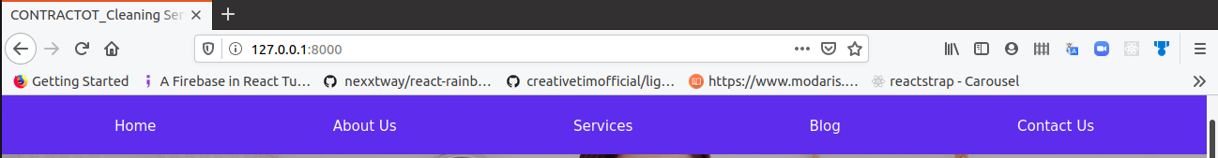

On mobile, logo appears on the navigation bar with a toggle button at the extreme right of the page. Upon clicking this toggle button, the navigation links show up.

Toggle button


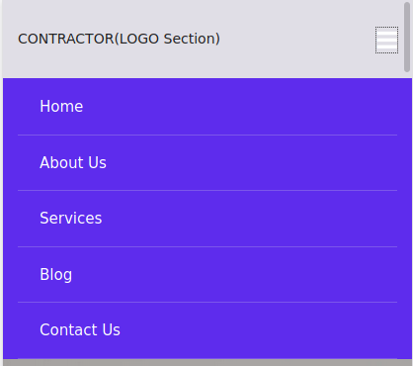

Fig: Functioning of the navigation bar in mobile mode

The next section after the nav bar is a carousel( Content slider) Section.
It contains an image and content on top of it that changes over time or upon click of the slider control arrows.



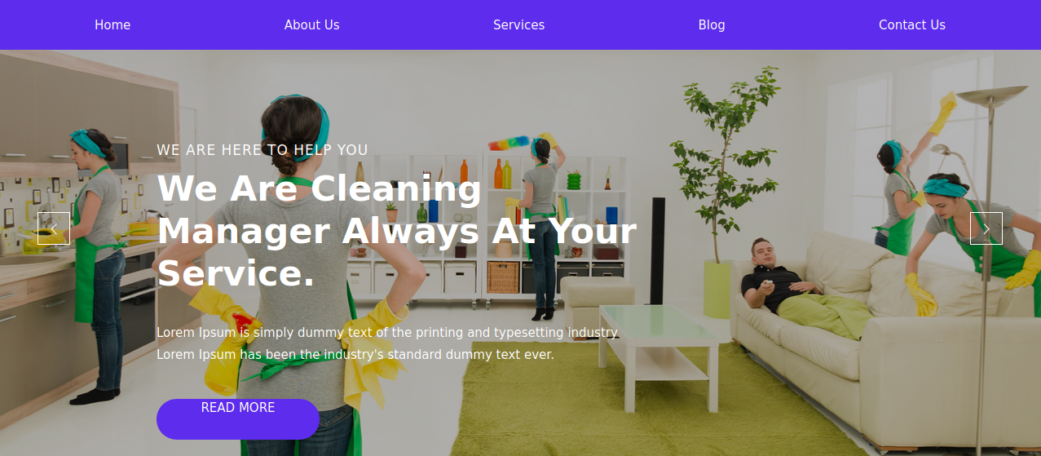

Fig: Carousel Section of homepage

on mobile, this section is very responsive



Fig: Responsive view of carousel section on mobile.

