**Pig Assignment Solution**

**STUDENT NAME: Guan Yue Wang**

1. **Source code for movie_rating.pig**

-- movie_rating script

-- this script list average moving rating from ml-100k dataset

-- Guan Yue Wang

rating = LOAD '/pig/u.data' USING PigStorage('\t') AS (userid:int,itemid:int,rating:int,time:long);

item = LOAD '/pig/u.item' USING PigStorage('|') AS  (movieid:int,movietitle:chararray,releasedate:chararray,videoreleasedate:chararray,url:chararray,unknown:chararray,action:int,adventure:int,animation:int,child:int,comedy:int,crime:int,docu:int,drama:int,fantasy:int,noir:int,horror:int,musical:int,mystery:int,romance:int,scifi:int,triller:int,war:int,western:int);

alldata = JOIN rating BY itemid, item BY movieid;

mydata = FOREACH alldata GENERATE movieid, movietitle, releasedate, url, rating;

groupdata = GROUP mydata BY (movieid,movietitle,releasedate,url);

finaldata = FOREACH groupdata GENERATE FLATTEN(group) as (movieid, movietitle, releasedate, url), AVG(mydata.rating) AS avgrating;

STORE finaldata INTO '/out';

1. **Run the program on command line and place the screenshot of successful run right here.**

**Command Line Output**

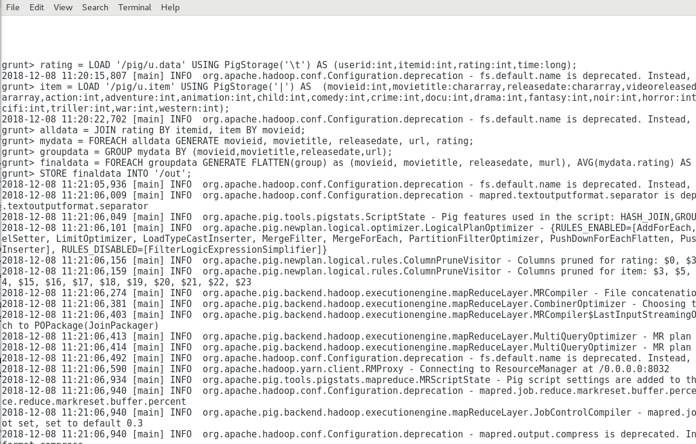

**Success**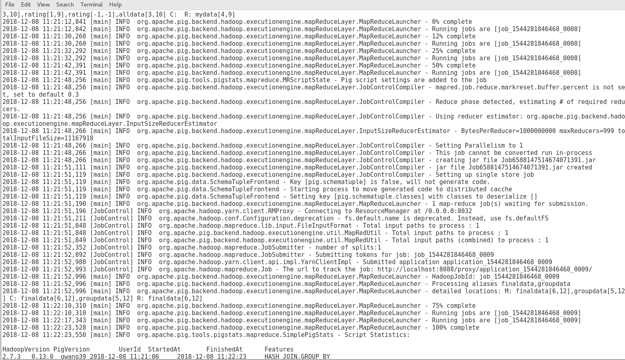

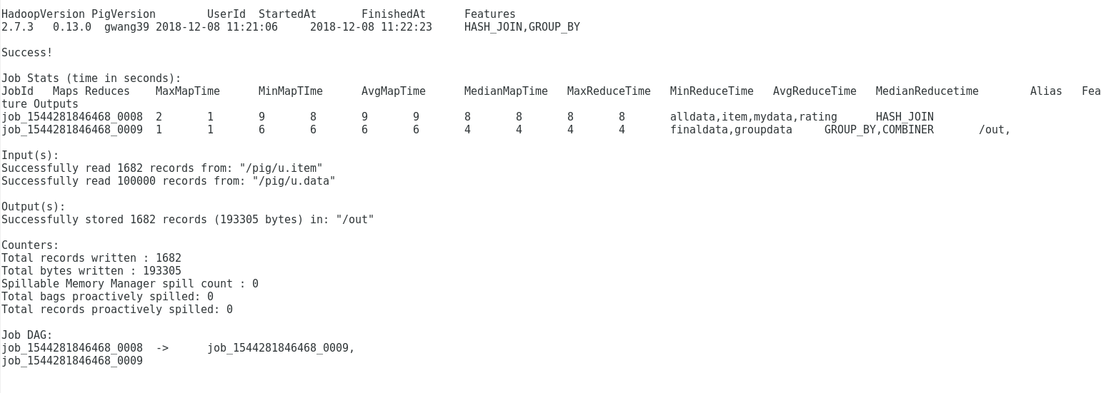

**Output (head and tail records)**

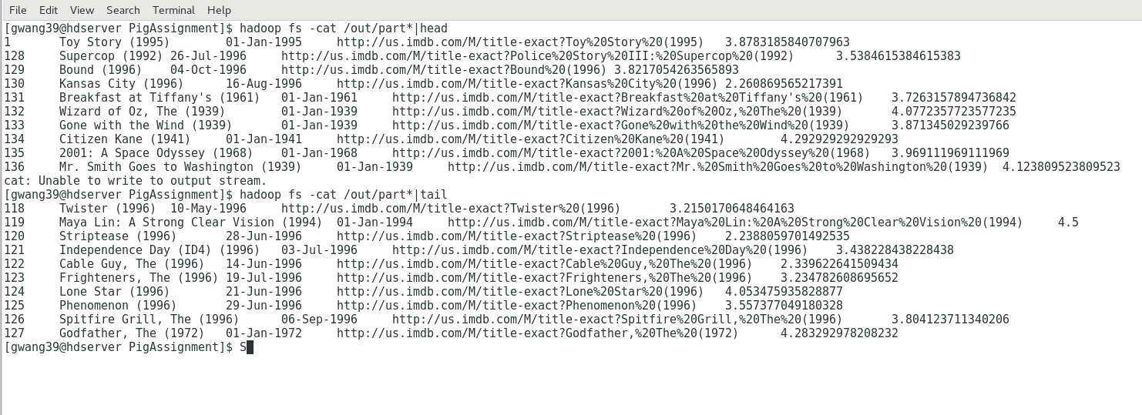

1. **A screen shot of the JobHistoryServer when you ran the job. Click on the Job, get into the details, then take a screen shot.**

History

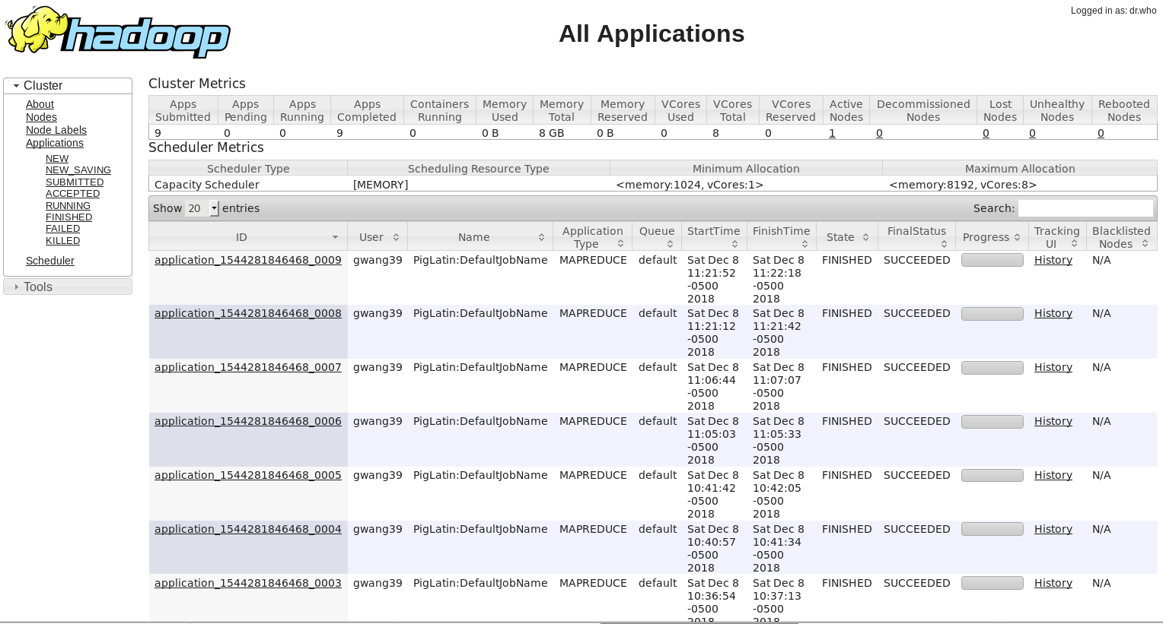

Job

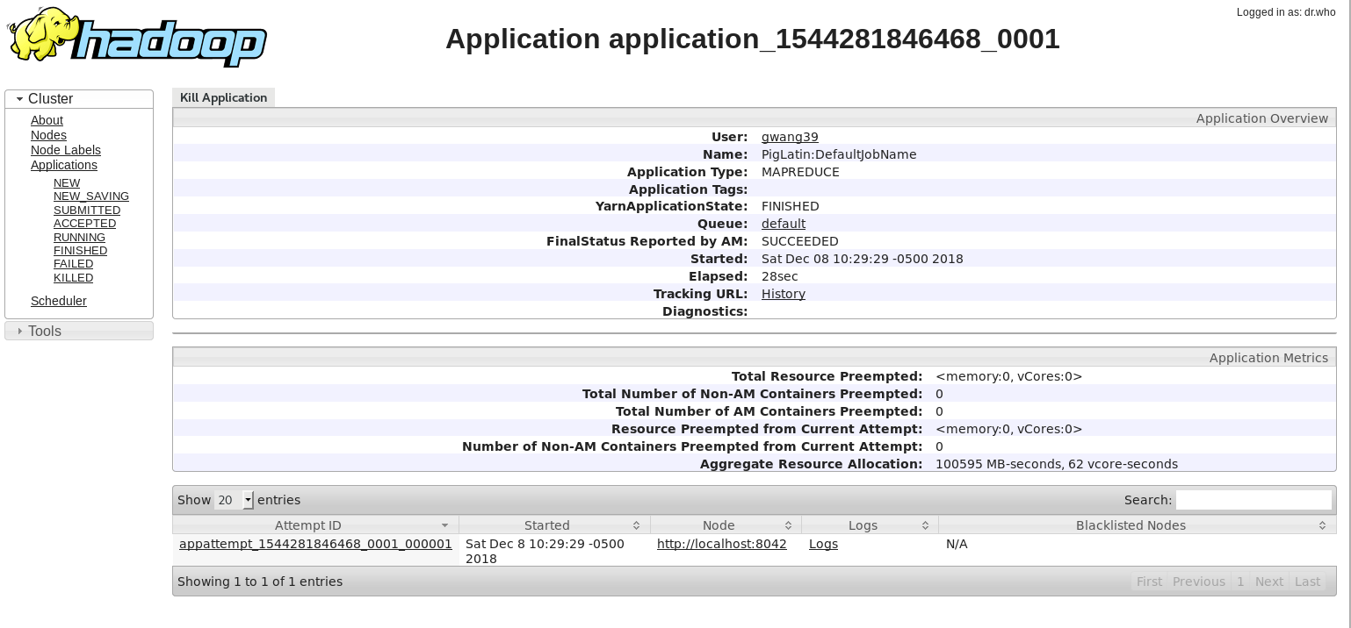

1. **For the movie id 376 and 495, what is the movie title, release date, IMDB URL, average rating, total number of unique users rated, total number of ratings for the movie. Please so please fill the data grid below:**

|  |  |  |  |  |
| --- | --- | --- | --- | --- |
| **Movie**  **id** | **Title** | **Release date** | **IMDB URL** | **Average rating** |
| **376** | Houseguest (1994) | 01-Jan-1994 | http://us.imdb.com/M/title-exact?Houseguest%20(1994) | 2.83 |
| **495** | Around the World in 80 Days (1956) | 01-Jan-1956 | http://us.imdb.com/M/title-exact?Around%20the%20World%20in%2080%20Days%20(1956) | 3.66 |