PrintRxer Suite
IT Installation, Validation and Support QRG
Formal deployment guide for PrintRxerV3, the native capture printer, and HealthMailer
Purpose
This guide is for IT, desktop engineering and local support staff installing or testing the PrintRxer Suite on clean or semi-clean Windows machines. It is deliberately explicit and copy/paste friendly. It includes the practical issues discovered during the final local installation rehearsal.
Safety posture
Start with SendMail=false unless live sending has been formally approved. Do not manually delete pending, failed, quarantine, sent, log, config, or ledger data unless the local governance/audit decision is explicit.

1. Architecture summary
The suite has two runtime applications and one native printer-capture layer. The applications are intentionally separated so that printing workstations do not need Outlook.
Part | Installed where | What it does | Requires Outlook?
PrintRxerV3 watcher/app | Where prescriptions/documents are printed or imported | Checks captured jobs, opens the recipient picker, creates a local durable package, and publishes to the handoff folder. | No
Native printRxer capture printer | Where users print prescriptions/documents | Creates the visible Windows printer queue and captures XPS/OXPS payloads for PrintRxerV3. | No
HealthMailer | Where the approved Outlook/Healthmail profile is available | Watches the handoff folder, validates packages, prevents duplicate sends, sends via Outlook COM, and archives outcomes. | Yes, when SendMail=true
Handoff folder | Local folder or locked-down UNC path | Carries completed READY package directories from PrintRxerV3 to HealthMailer. | No
Key distinction
Installing the PrintRxerV3 watcher is not the same as installing the Windows printer. A live printing workstation needs both the watcher and the native capture printer.

2. Deployment options
Scenario | PrintRxerV3 | HealthMailer | Handoff folder
Same-machine local test | Same test workstation | Same test workstation | C:\ProgramData\printrxer_v3\handoff
Two-machine trial | Clinical workstation or Citrix host where printing occurs | Outlook-enabled workstation/account | \\server\HealthMailerDrop$\incoming
Shared cart / no local Outlook | Shared cart or printing workstation | Approved Outlook sender machine | Locked-down UNC path
- Use UNC paths directly. Do not rely on mapped drives such as H: because scheduled tasks and elevated sessions may not see them.
- Both applications must use the same handoff path. If they differ, PrintRxerV3 may publish successfully but HealthMailer will not see the package.
- For first testing, prefer a local same-machine handoff. Move to UNC after the basic flow is proven.

3. Required rights and identities
- Use elevated PowerShell for native printer, driver, port, port monitor, and spooler actions.
- HealthMailer must run as the Windows user whose Outlook/Healthmail profile is available and approved.
- UNC share permissions must be configured server-side by IT. Local ACL hardening cannot secure a remote share.
- Ordinary users should not need to browse or delete handoff packages directly.
Identity | Minimum need
PrintRxerV3 writer identity | Create/write package staging folders and final package folders in the handoff folder.
HealthMailer watcher/sender identity | Read packages, create lock/result files, move/delete processed packages from the handoff folder.
IT/support group | Administer ACLs and collect support bundles/logs.
Ordinary clinical users | No direct browse/delete access to the share required for normal workflow.

4. Repository files and scripts
Use | File/script | Notes
Solution/test | PrintRxerSuite.slnx | Run tests from repository root.
Publish PrintRxerV3 | tools\Publish-PrintRxerV3.ps1 | Creates publish output for PrintRxerV3.
Publish HealthMailer | tools\Publish-HealthMailer.ps1 | Creates publish output for HealthMailer.
Install PrintRxerV3 watcher | tools\Install-PrintRxerV3Task.ps1 | Writes config and registers scheduled task. Does not create Windows printer queue.
Install native capture printer | tools\Install-PrintRxerCapturePrinter.ps1 | Creates printRxer queue, printrx: port, driver, and port monitor. Requires admin.
Install HealthMailer watcher | tools\Install-HealthMailerTask.ps1 | Registers HealthMailer scheduled task.
Uninstall PrintRxerV3 watcher | tools\Uninstall-PrintRxerV3.ps1 | Preserves data by default.
Uninstall HealthMailer watcher | tools\Uninstall-HealthMailer.ps1 | Preserves data by default.

5. Standard paths
New installs should be self-contained under C:\ProgramData\printrxer_v3. A clean install should not require files from C:\ProgramData\printRxer or from a developer machine.
PrintRxerV3
C:\ProgramData\printrxer_v3\config\printrxer_v3.settings.json
C:\ProgramData\printrxer_v3\work\incoming
C:\ProgramData\printrxer_v3\pending-outbox
C:\ProgramData\printrxer_v3\published
C:\ProgramData\printrxer_v3\processed
C:\ProgramData\printrxer_v3\deferred
C:\ProgramData\printrxer_v3\failed
C:\ProgramData\printrxer_v3\logs
C:\ProgramData\printrxer_v3\handoff
C:\ProgramData\printrxer_v3\data\recipients\recipients.csv
C:\ProgramData\printrxer_v3\data\Images\mncms_400x400.jpg
HealthMailer
C:\ProgramData\HealthMailer\healthmailer.settings.json
C:\ProgramData\HealthMailer\processed-ledger.jsonl
C:\ProgramData\HealthMailer\sent
C:\ProgramData\HealthMailer\failed
C:\ProgramData\HealthMailer\quarantine
C:\ProgramData\HealthMailer\logs

6. Pre-flight checks

6.1 Confirm repository root
Run from the repository root. These checks should return True.
Get-Location
Test-Path .\PrintRxerSuite.slnx
Test-Path .\tools\Publish-PrintRxerV3.ps1
Test-Path .\tools\Publish-HealthMailer.ps1
Test-Path .\tools\Install-PrintRxerV3Task.ps1
Test-Path .\tools\Install-PrintRxerCapturePrinter.ps1
Test-Path .\tools\Install-HealthMailerTask.ps1

6.2 Confirm build/test readiness
dotnet --info
dotnet test .\PrintRxerSuite.slnx

7. Install sequence - same-machine local test
Use this path for a first technical trial. It keeps the handoff folder local and avoids UNC/SMB variables until the basic flow works.

7.1 Publish both applications
powershell -ExecutionPolicy Bypass -File .\tools\Publish-PrintRxerV3.ps1
powershell -ExecutionPolicy Bypass -File .\tools\Publish-HealthMailer.ps1
Test-Path .\publish\PrintRxerV3\printrxer_v3.exe
Test-Path .\publish\HealthMailer\HealthMailer.exe

7.2 Install PrintRxerV3 watcher
This writes the PrintRxerV3 config and registers the PrintRxerV3 scheduled task.
powershell -ExecutionPolicy Bypass -File .\tools\Install-PrintRxerV3Task.ps1
Get-ScheduledTask -TaskName 'PrintRxerV3' -ErrorAction SilentlyContinue
Get-Content 'C:\ProgramData\printrxer_v3\config\printrxer_v3.settings.json'

7.3 Install native printRxer capture printer
Run from elevated PowerShell. This is the step that creates the visible Windows printer queue.
powershell -ExecutionPolicy Bypass -File .\tools\Install-PrintRxerCapturePrinter.ps1
Get-Printer -Name 'printRxer'
Get-PrinterPort -Name 'printrx:'
Get-PrinterDriver -Name 'PrintRxer XPS Driver'
Get-Item 'HKLM:\SYSTEM\CurrentControlSet\Control\Print\Monitors\PrintRxer Port Monitor'
Test-Path 'C:\Windows\System32\PrintRxerPortMonitor.dll'

7.4 Install HealthMailer watcher
For first validation, set SendMail=false unless live sending has been approved.
powershell -ExecutionPolicy Bypass -File .\tools\Install-HealthMailerTask.ps1
Get-ScheduledTask -TaskName 'HealthMailer' -ErrorAction SilentlyContinue
notepad 'C:\ProgramData\HealthMailer\healthmailer.settings.json'
Dry-run setting
For initial validation, set "SendMail": false in C:\ProgramData\HealthMailer\healthmailer.settings.json. This allows package validation/archive testing without sending a live email.

8. Install sequence - two-machine UNC handoff
Use this path when the printing machine should not require Outlook. Machine A runs PrintRxerV3 and the native capture printer. Machine B runs HealthMailer and Outlook/Healthmail.

8.1 PrintRxerV3 machine - install watcher using UNC handoff
powershell -ExecutionPolicy Bypass -File .\tools\Install-PrintRxerV3Task.ps1 `
-HandoffRoot '\\server\HealthMailerDrop$\incoming'

8.2 PrintRxerV3 machine - install capture printer
Run elevated on the printing machine.
powershell -ExecutionPolicy Bypass -File .\tools\Install-PrintRxerCapturePrinter.ps1
Get-Printer -Name 'printRxer'
Get-PrinterPort -Name 'printrx:'

8.3 HealthMailer machine - configure same UNC handoff
.\publish\HealthMailer\HealthMailer.exe --install
notepad 'C:\ProgramData\HealthMailer\healthmailer.settings.json'
Confirm the HealthMailer config watches the same UNC path used by PrintRxerV3.

9. First validation workflow
- Confirm both applications point at the same handoff folder.
- Confirm SendMail=false unless live sending is approved.
- Print a test document to the printRxer printer.
- Confirm the recipient picker opens.
- Select an approved test recipient, optionally preview, then prepare for scheduled sending.
- Confirm a package is created and published to the handoff folder.
- Run HealthMailer once manually, or wait for the watcher.
- Confirm result.json and summary.txt are written under sent, failed, or quarantine.
- Confirm the original Windows print job clears from the queue after successful capture.

9.1 Compare handoff settings
Get-Content 'C:\ProgramData\printrxer_v3\config\printrxer_v3.settings.json'
Get-Content 'C:\ProgramData\HealthMailer\healthmailer.settings.json'

9.2 Process with HealthMailer immediately
This avoids waiting for the scheduled watcher during testing.
.\publish\HealthMailer\HealthMailer.exe --process-once --config C:\ProgramData\HealthMailer\healthmailer.settings.json

9.3 Inspect terminal results
Get-ChildItem 'C:\ProgramData\HealthMailer\sent' -Recurse -Filter result.json | Select-Object -Last 1 | Get-Content
Get-ChildItem 'C:\ProgramData\HealthMailer\failed' -Recurse -Filter result.json | Select-Object -Last 1 | Get-Content
Get-ChildItem 'C:\ProgramData\HealthMailer\quarantine' -Recurse -Filter result.json | Select-Object -Last 1 | Get-Content

10. Network failure and retry test
This validates the durable local outbox. A transient UNC outage should not lose work.
- Configure PrintRxerV3 to a UNC handoff folder.
- Temporarily make the UNC path unavailable or deny write permission for the test identity.
- Print to printRxer and complete the picker.
- Confirm the package remains locally queued under PrintRxerV3.
- Restore UNC access.
- Confirm PrintRxerV3 publishes the queued package on retry.
- Confirm HealthMailer processes it once only.
Get-ChildItem 'C:\ProgramData\printrxer_v3\pending-outbox' -Recurse | Select-Object FullName, Length, LastWriteTime
Get-ChildItem 'C:\ProgramData\printrxer_v3\published' -Recurse | Select-Object FullName, Length, LastWriteTime
Get-ChildItem '\\server\HealthMailerDrop$\incoming' -Recurse | Select-Object FullName, Length, LastWriteTime

11. Handoff package contract
A completed handoff package contains:
request.json
prescription.pdf
request.sha256
summary.txt
READY
PrintRxerV3 publishes via a dot-prefixed upload directory and writes READY last. HealthMailer ignores dot-prefixed folders and only processes final folders containing READY.
.uploading-<packageId>-<suffix>
If HealthMailer archives from a UNC handoff folder to local storage, it must support copy-then-delete rather than relying on same-volume directory move semantics.

12. Recipient list support
The active installed recipient list is:
C:\ProgramData\printrxer_v3\data\recipients\recipients.csv
- The installer should seed this file if missing, but should not overwrite an existing site-maintained recipient file.
- If the picker shows sample or stale recipients, check this file first.
- If changes are not reflected immediately, restart the PrintRxerV3 scheduled task.
Stop-ScheduledTask -TaskName 'PrintRxerV3' -ErrorAction SilentlyContinue
Start-ScheduledTask -TaskName 'PrintRxerV3'

13. User-facing picker reference
The picker is intentionally simple. IT staff should recognise the main fields so they can support users without asking them to re-enter clinical details.
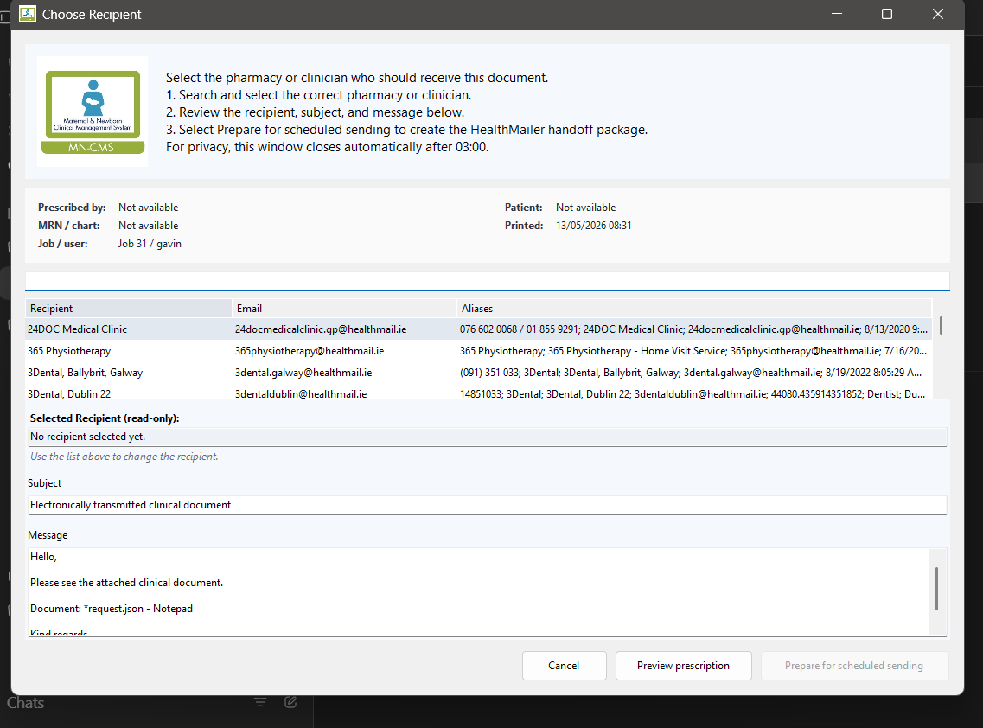
Figure 1. Recipient picker used by prescribers/users. The user chooses an approved recipient, may preview the document, and prepares the package for HealthMailer.
Do not ask users to re-type clinical details
The attached prescription or clinical document is the clinical artefact. The picker is primarily for choosing the correct approved Healthmail recipient and confirming the intended handoff.

14. Reinstall behaviour
- Existing folders are generally not a problem.
- Scheduled tasks are replaced/refreshed.
- Seed recipient CSV and picker image should not be overwritten if already present.
- PrintRxerV3 config may be rewritten during reinstall.
- If a non-default handoff folder is required, pass the handoff folder again during reinstall.
powershell -ExecutionPolicy Bypass -File .\tools\Install-PrintRxerV3Task.ps1 `
-HandoffRoot '\\server\HealthMailerDrop$\incoming'

15. Standard uninstall and rollback
Default uninstall is conservative
It removes scheduled tasks/processes but preserves operational evidence: config, recipients, logs, local pending packages, sent/failed/quarantine archives, and the duplicate-send ledger. Use -RemoveData only for clean lab resets after explicit approval.

15.1 Remove PrintRxerV3 watcher/app task
powershell -ExecutionPolicy Bypass -File .\tools\Uninstall-PrintRxerV3.ps1 -PlanOnly
powershell -ExecutionPolicy Bypass -File .\tools\Uninstall-PrintRxerV3.ps1

15.2 Remove HealthMailer watcher/app task
powershell -ExecutionPolicy Bypass -File .\tools\Uninstall-HealthMailer.ps1 -PlanOnly
powershell -ExecutionPolicy Bypass -File .\tools\Uninstall-HealthMailer.ps1

16. Removing the native printRxer printer stack
The PrintRxerV3 uninstall script may not remove the Windows printer queue, port, driver, or port monitor. If printRxer remains visible in Printers & scanners, remove the native stack separately from elevated PowerShell.

16.1 Remove queue, port and driver
Remove-Printer -Name 'printRxer' -ErrorAction SilentlyContinue
Restart-Service Spooler -Force
Start-Sleep -Seconds 5
Remove-PrinterPort -Name 'printrx:' -ErrorAction SilentlyContinue
Remove-PrinterDriver -Name 'PrintRxer XPS Driver' -ErrorAction SilentlyContinue

16.2 If the port monitor remains
Back up the registry key, remove the monitor key and DLL, then restart the spooler.
Stop-Service Spooler -Force
Start-Sleep -Seconds 3
reg export "HKLM\SYSTEM\CurrentControlSet\Control\Print\Monitors\PrintRxer Port Monitor" "$env:TEMP\PrintRxerPortMonitor.reg" /y
Remove-Item 'HKLM:\SYSTEM\CurrentControlSet\Control\Print\Monitors\PrintRxer Port Monitor' -Recurse -Force -ErrorAction SilentlyContinue
Remove-Item 'C:\Windows\System32\PrintRxerPortMonitor.dll' -Force -ErrorAction SilentlyContinue
Start-Service Spooler
Start-Sleep -Seconds 3

16.3 Final native-stack check
Expected: no output for printer/port/driver/registry key, and False for the DLL path.
Get-Printer -Name 'printRxer' -ErrorAction SilentlyContinue
Get-PrinterPort -Name 'printrx:' -ErrorAction SilentlyContinue
Get-PrinterDriver -Name 'PrintRxer XPS Driver' -ErrorAction SilentlyContinue
Get-Item 'HKLM:\SYSTEM\CurrentControlSet\Control\Print\Monitors\PrintRxer Port Monitor' -ErrorAction SilentlyContinue
Test-Path 'C:\Windows\System32\PrintRxerPortMonitor.dll'

17. Issues discovered during local install rehearsal
Issue discovered | What it means for IT | Required guidance/action
Watcher install did not create the printer | PrintRxerV3 can process captures, but the visible Windows printRxer queue requires the native capture-printer script. | Install PrintRxerV3 watcher and Install-PrintRxerCapturePrinter.ps1 on live printing workstations.
Old path assumptions existed | A clean machine should not need C:\ProgramData\printRxer or files from a developer PC. | Use C:\ProgramData\printrxer_v3 as the self-contained root and verify seeded assets exist.
UNC entry via picker was awkward | Folder browsing is not always convenient for server paths. | Use -HandoffRoot with the UNC path during scripted install.
Manual HealthMailer test command was under-specified | Support staff need a one-pass command to process packages immediately. | Use HealthMailer.exe --process-once --config C:\ProgramData\HealthMailer\healthmailer.settings.json.
Cross-root move can fail | A direct directory move from UNC handoff to local archive can fail on Windows. | HealthMailer should copy to local archive and then delete source while preserving validation/audit behaviour.
Recipient list source was unclear | Picker may show seed/sample recipients if the active installed CSV is not checked. | Active file is C:\ProgramData\printrxer_v3\data\recipients\recipients.csv. Restart watcher after edits.
Uninstall preserved data but left native printer components | App uninstall and native printer-stack removal are separate concerns. | Use native-stack removal steps if printRxer remains in Windows printer list.

18. Troubleshooting quick checks
Symptom | Likely cause | First checks
printRxer does not appear in printer list | Native capture printer not installed, or install failed due to permissions. | Run Install-PrintRxerCapturePrinter.ps1 elevated; check Get-Printer/Get-PrinterPort/Get-PrinterDriver.
Picker does not open after printing | Watcher not running, capture not reaching incoming folder, job owner mismatch, or payload not stable. | Check PrintRxerV3 task, logs, work\incoming, and Windows print queue.
Package remains pending locally | Handoff folder unreachable or permission denied. | Check HandoffRoot, UNC reachability, share ACLs, pending-outbox, logs.
HealthMailer does not process package | Watching wrong folder, package lacks READY, package invalid, or task not running. | Compare configs, run --process-once, inspect failed/quarantine.
Email not sent | SendMail=false, Outlook unavailable, wrong Outlook profile, or COM failure. | Check SendMail setting, Outlook sign-in, logs, failed result.json.
Duplicate/quarantine outcome | Package ID or completed package hash already sent. | Review processed-ledger.jsonl and quarantine result.json.
Print queue retains jobs | Native port-monitor completion issue or spooler state. | Treat as pilot blocker; collect spooler state, logs, and reproduce with Notepad.

19. Escalation pack
- Machine name and logged-in Windows user.
- Whether issue occurred on the PrintRxerV3 machine or HealthMailer machine.
- Date/time of attempted print/send.
- Screenshot of the picker or error if available.
- Logs from C:\ProgramData\printrxer_v3\logs and/or C:\ProgramData\HealthMailer\logs.
- Package state: pending, published, sent, failed, or quarantined.
- Whether Outlook was open/signed in on the HealthMailer machine.
- Whether the handoff UNC path was reachable at the time.
- Relevant result.json and summary.txt from terminal packages.

20. Final acceptance checklist
dotnet test .\PrintRxerSuite.slnx
Get-ScheduledTask -TaskName 'PrintRxerV3' -ErrorAction SilentlyContinue
Get-ScheduledTask -TaskName 'HealthMailer' -ErrorAction SilentlyContinue
Get-Printer -Name 'printRxer' -ErrorAction SilentlyContinue
Get-PrinterPort -Name 'printrx:' -ErrorAction SilentlyContinue
Get-PrinterDriver -Name 'PrintRxer XPS Driver' -ErrorAction SilentlyContinue
- PrintRxerV3 task exists on the print/capture machine.
- printRxer printer exists on the printing machine.
- HealthMailer task exists on the Outlook/Healthmail sender machine.
- Both apps point at the same handoff folder.
- SendMail=false is used for dry-run unless live sending is approved.
- A test print opens the picker.
- A package is created and reaches the handoff folder.
- HealthMailer writes result.json and summary.txt.
- Failed/quarantine/sent folders are reviewed.
- The Windows print queue clears after successful capture.
- Uninstall plan-only output is understood before rollback.

21. Local policy points
- This QRG supports an approved deployment; it does not itself approve one.
- Healthmail/Outlook sender authority must be agreed locally.
- UNC/share permissions must be agreed and configured server-side by IT.

