‘HPIARepo_Downloader’ User Guide

By Dan Felman/HP – August 17, 2021

For version 1.90

The Downloader script is designed to help manage repositories used by HP Image Assistant in an offline mode with the appropriate runtime option (/offlinemode:<path>). This guide explores the use of the script, and is based on the current version posted on GitHub, 1.90

The script uses PowerShell commands and relies on HP’s Client Management Script Library (CMSL) to initialize and maintain repositories. The CMSL modules will be installed, if not already in place by the downloader script

A separate, user-editable initialization file contains basic, default information that allows customization

* Main script: HPIARepo_Downloader_1.90.ps1 – the main script
* Initialization file: HPIARepo_ini.ps1 – (the INI file) user should edit for local use

On startup, the script sources the initialization (defaults) file, HPIARepo_ini.ps1, for information to set up, use, and populate in the UI.

User Interface

Let’s review the top of the UI:

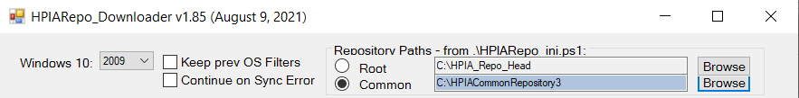

Windows Version

The Windows 10 OS version list is added to the repository filters used to create, or maintain, each repository. This list is populated from an entry in the INI file, which can be edited to reflect the requirements and use case of the Enterprise

$v_OSVALID = @("1909", "2009", "21H1", "21H2")

The script will show the currently selected OS version as default, based on the content of this INI setting/variable

$v_OSVER = "2009"

This file setting changes as the user selects a different OS version version in the User Interface

Keep Filters and Continue on Error

[Keep prev OS Filters] when selected, will prevent the script from removing existing repository filters and new ones will be added. When unchecked, all existing filters are replaced with settings (e.g., checkmarks) from the grid so that the only filters that will exist on the repository will contain the new OS version.

Enabling this setting can allow, for example, a user to maintain product Softpaqs from two different OS versions, for example, 1909 and 2009/20H2. If unchecked, only the visible, selected, OS version is used as part of the repository filters

[Continue on Sync Error] For the rare occasion a Softpaq might be missing during a ‘Sync’ and the process stop at that point, setting this checkmark will set the Sync process to continue, even when a file may be missing at the source. Both these are maintained in the INI file

$v_Continueon404 = $False

$v_KeepFilters = $False

Repository Paths

The next grouping, ‘Repository Paths’, show the default paths (as sourced from INI) for the root folder used to host individual product repositories, and the common/shared repository containing Softpaqs for all models. The ‘Common’ repository can be useful to allow for the removal of any duplicate Softpaq files. These are the ones that are shared across 2 or more models being captured

The INI file settings that are read during the script startup are

$v_Root_IndividualRepoFolder = "C:\HPIA_Repo_Head"

$v_Root_CommonRepoFolder = "C:\HPIACommonRepository"

And this next setting sets up the downloader script to work with the Common or Individual/rooted repositories

$v_CommonRepo = $True

The path and this last variable are manipulated and reset during the script run. For example, if the script runs with the paths and common setting variable as listed above, the script will show this in the UI (as shown above) defaulting to the Common repository path.

If then, the user clicks on the Rooted radio button to select individual repositories, both the UI and the INI files will be reset to show the new values and the Common setting will be rewritten to

$v_CommonRepo = $False

to indicate the user is working with individual repositories, one per model name

NOTE: if the repository path from the INI.ps1 file does not exist when the script runs, it will be created, either as a common/shared repository or as the root/head of individual repositories, as specified in the $v_CommonRepo setting. In this case, the folder is initialized but nothing is done until the user sets what to script to do in the grid and then clicks on ‘Sync Repository’, at which point filters are set and corresponding HP Softpaqs are downloaded, as well as any additional software Softpaqs, maintained with the AddOns tag files, per model

Clicking on the paths’ radio button will select it and refresh the information in the UI. If the selected path is not available or empty, nothing will happen, otherwise, the grid will refresh with information from the filters in the listed path

The Browse buttons allows the user to point to and start using an existing repository, or to create a new one. If a new repository is created, the script will maintain the list of models already being used as a starting point. This can help create a new repository with existing models and perhaps a different set of filters

Models Grid

Next, the UI shows a list of the HP Models to be managed in the repository (or repositories, for individual ones).

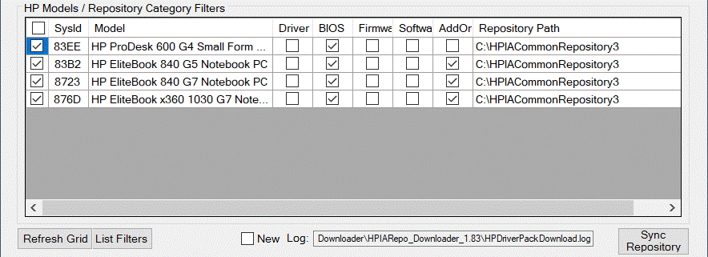

When the script runs, the list is filled in from the INI file’s $HPModelsList entries, for example,

$HPModelsTable = @(

@{ ProdCode = '83B2'; Model = 'HP EliteBook 840 G5 Notebook }

@{ ProdCode = '876D'; Model = 'HP EliteBook x360 1030 G7 Notebook PC' }

@{ ProdCode = '83EE'; Model = 'HP ProDesk 600 G4 Small Form Factor PC' }

@{ ProdCode = '842A'; Model = 'HP ZBook 15 G5 Mobile Workstation' }

@{ ProdCode = '8723'; Model = 'HP ZBook Firefly 14 G7 Mobile Workstation' }

)

If the repository listed in the INI.ps1 file already exists, it is searched for information on filters first, which is then used to populate the settings on the grid.

NOTE: the INI.ps1 file will be reset with the models from the repository.

The left-most checkbox column determines whether the Sync will use filters from the particular model. If set, any category checkmark adds a repository filter and associated Softpaqs are downloaded and maintained in the repository. If unset, filers are cleared from the repository for that model.

Because the downloader script checks the contents of the selected repository, if there is a conflict between the INI.ps1 file and the repository, the script defaults to move forward with the repository.

NOTE: During a Sync, all current filters are removed, and new filters are defined based on the category selections for each model. This means that any rows not having a category selected will be removed from future Syncs until a category is checked. If the script is ended and restarted, the script will ‘reset’ the INI.ps1 with the models from the repository that have filters defined.

Create New Repository

When there is a need to create a new repository, the INI.ps1 file $HPModelsTable list could be cleared prior to starting the downloader script, maintaining the format:

$HPModelsTable = @(

)

Then, assign the name of the desired NEW repository path to the $v_Root_CommonRepoFolder variable for a shared/common path, or $v_Root_IndividualRepoFolder for an individual repository path. Once the script executes, in the UI use the ‘Add Model’ button to add systems to the grid. After you select (check) what Softpaq categories to download and click on ‘Sync Repository’, the INI file will be updated with the new list for the new repository after the CMSL Sync and Cleanup commands are executed

Sync Bar

Below the list of Models, the following actions can be taken: 

[Refresh Grid] resets the list of models from information shown in the INI.ps1 file, and will show each model, its motherboard ID/SysID. NOTE that in this case, all checkmarks are cleared. This might be useful when there is a need to start with a fixed set of models, as listed in the INI.ps1 file, and then select the actions to be taken during Synchronization

[List Filters] lists all current defined repository filters

[Add Model] - New since version 1.85. Clicking on the button will open a dialog form to help find HP supported models that can be added to the models list. In Version 1.86, the dialog us updated to allow the choosing of specific Softpaqs (by name, or part of name) to be added to the standard categories for the chosen model. The information ends up in the INI file and the appropriate repository

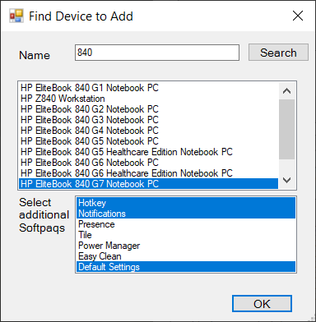

Typing a name, or part of a model name in the ID field and pressing Search will list out any HP systems matching the entry. Selecting an item from the list and pressing OK the script will add that entry to the Grid. If the model shows 2 or more System ID (motherboards) all are added to the list

The INI.ps1 file variable $v_Softpaqs (version 1.86 and newer) holds the entries shown in the above dialog for ‘Select additional Softpaqs’ as the source for what is needed to be included in a particular model’s repository. Use Ctrl-click to add multiple entries. Each entry selected will be added to a flag file created in the .ADDSOFTWARE subfolder named with the platform ID (ex. ‘80FC’). This flag file can be manually edited afterwards to add or remove specific Softpaqs as required

$v_Softpaqs = @(

'Notifications' , 'Presence', 'Tile', 'Power Manager', 'Easy Clean', 'Default Settings'

)

Although the AddOns Softpaqs are typically those marked as category Software in the associated CVA file, any Softpaq name can be included in this list or individual flag file. The idea is to allow the addition of specific Software Softpaqs without tagging for download all Softpaqs marked as Software (which may include items not wanted in an image)

[Log] The script logs all work done. The default log file name is obtained from the INI file, and can be changed from the variable

$v_LogFile = "$PSScriptRoot\HPDriverPackDownload.log"

For troubleshooting , it is useful to have a clean log with just the information from a new action. The [ ] New log checkmark will back up the existing log and start a new one.

[Sync Repository] uses HP CMSL commands to sync the repository based on the filters created (for the categories selected per model) and to clean up afterwards – removing duplicate Softpaqs. In addition, those models that have a list of Softpaqs marked with the AddOns entry, those Softpaqs are downloaded to a folder (..\.ADDSOFTWARE) not managed by CMSL and then copied up to the main repository. This method allows HPIA to also add Software as a category, but ONLY install or update those Softpaqs listed in ‘AddOns’

Every time the user presses [Sync Repository], all filters are cleared out and a new set of filters is created based on the information selected by the user in the UI

Connecting with MEM Configuration Manager

The bar contains items related to managing Softpaq packages and HPIA in a Microsoft Endpoint Manager Configuration Manager environment



The group heading ‘SCCM – Disconnected’ shows that a connection to the CM environment has not yet been established, and therefore the script will not attempt to work with CM. A connection is done whenever a ‘Sync Repository’ is invoked and one of the items here are enabled

The ‘Update Packages’ checkbox tells the script create or update repository packages. This is done during a ‘Sync Repository’ step, where one of the steps is to either create a CM Package pointing to the repository folder or update it if the repository changed. If managing individual repositories, each one will get its own CM Package created

The ‘Update DPs’ checkbox tells CM to also update its Distribution Points with the created packages. This is also only done when doing a repository Sync

The downloader script can create an HP Image Assistant package in Configuration Manager, when the user clicks on ‘Update Package’ shown next to the path to where HPIA is downloaded and available. The ‘Browse’ button allows the user to search of the folder containing the HPIA executable, and then sets the path in the UI as well as updating the INI file with the new entry

These variable settings manage the behavior at start up and are updated with UI interaction to remain for next start

$HPIACMPackage = 'HPIA' # Package Name for creating/maintaining in SCCM

$v_HPIAVersion = '5.0.2.3827' # info pulled from Browsing for the app in UI

$v_HPIAPath = '\\CM01\Share\Applications\SP107374 HPIA 5.0.2'

$v_UpdateCMPackages = $False

$v_DistributeCMPackages = $False

Output Text box

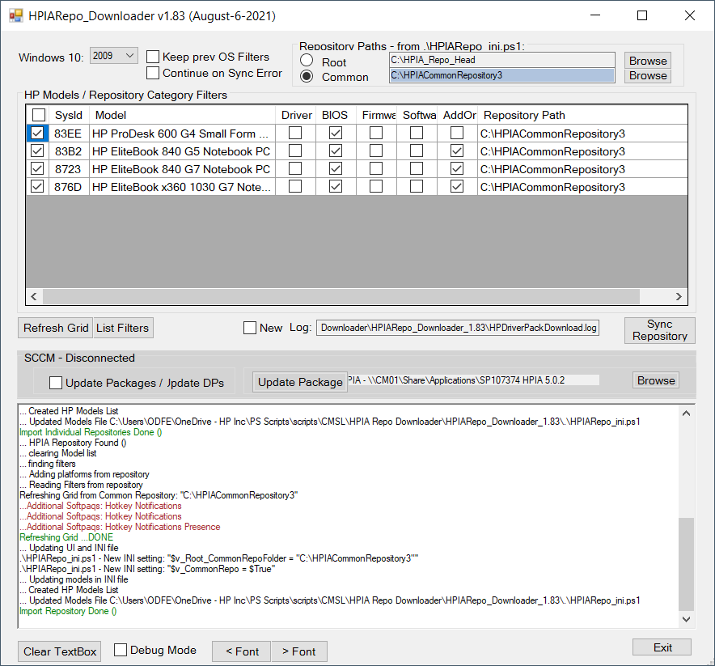

All output from the script actions is sent to the text box, as well as the log file mentioned before. When testing or during troubleshooting, the ‘Clear TextBox’ will empty the contents of the box to allow easy view of next actions

The ‘Debug Mode’ enables additional script feedback that might be useful during testing should behavior be different than expected.

The ‘< Font’ and ‘> Font’ buttons decrease or increase the text size of the content of the text in the box

Other INI Settings

Debug

During development, a Debug flag was used to output additional details of the functioning of the downloader script. If problems arise during startup, the INI file flag variable

$v_DebugMode = $false

can be set to $True to show what happen before the UI is displayed. Set to $True to list what the script does to the console. It can help isolate where the problem occurs. In addition, the ‘Debug Mode’ checkbox will do the same in the UI, sending additional details of operation to the Output Text box

Command Line Options

When the script runs without options, it opens in its standard UI mode. Several options allow it to execute without the user interface, providing a method to script its execution

The following options are available

HPIARepo_Downloader_1.90.ps1 [[-Sync] [-ListFilters] [-inifile .\<filepath>\HPIARepo_ini.ps1] [-RepoStyle common|individual] [-products '80D4,8549,8470'] [-NoIniSw] [-ShowActivityLog]]

These can also be positional without parameter names

<-IniFile>, <-RepoStyle>, <-Products>

-Help | -h displays supported command line options

-ListFilters list repository filters in place on selected product repositories

-IniFile <path to INI.ps1> this option can be used when running from a script to set up different downloads. The default is .\HPIARepo_ini.ps1

-RepoStyle {Common|Individual} selects the repository style used by the downloader script

'Common' - There will be a single repository used for all models - path extracted from INI.ps1

'Individual' - Each model will have its own repository folder

-Products '1234', '2222' a list of HP Model Product codes, as example '80D4,8549,8470'. If omitted, any entry in the INI.ps1 file that has a repository created will be updated

-NoIniSw Prevent from syncing Softpaqs listed by name in INI file

-showActivityLog Show output from CMSL Sync/Cleanup activity log. This option is useful when using the -Sync runtime option

-newLog start new log file in script's directory - backup current log

-Sync Use HP CMSL commands to sync repositories. Command assumes repositories already created

Examples:

Here we use positional parameters for the INI file, the repository style, and the products to sync

HPIARepo_Downloader_1.87.ps1 .\<path>\HPIARepo_ini.ps1 Common '80D4,8549,8470'