Fig # | Date | Event | Context
 |  | This color identifies timeline elements used in Pat’s web site
1 | 2011-06-02 | Very much in control of her faculties in 2011, Pat emailed, texted, planned international travel, paid bills and shopped for books and goods on line. | <a href="../pic/Sickness/E_Pat_corresponding_on_her_laptop.jpg" target="_top">
2 | 2013-04-21 | Pat delighted in her grandchildren. | <a href="../pic/Sickness/E_Grandbaby_Birdie_and_Grandmother_Pat.jpg" target="_top">
3 | 2014-03-18 | Pat relished the grandmother role. | a href="../pic/Sickness/E_MillePatBirdieBreakfast.jpg" target="_top">
4 | 2014-04-06 | Pat with 6K run medals | C:\Users\gwbro\Documents\GitHub\PatsLifeGit\PatsLife\pic\Sickness\Pat with 6K run medals.JPG
5 | 2014-12-30 | She took the teaching responsibility to heart. And if you can enjoy a glass of wine too, why not. | <a href="../pic/Sickness/E_Birdie_Pat_Millie_iPad.jpg" target="_top">
No # | 2016-12-15 | Kate is alarmed that Patricia is noticeably changed; loss of interest in books, los of undersanding of political issues.
 | 2017-03-11 | Pat drives Austin to Seattle
 | 2017-03-11 | SEATTLE AIR B&B | Pat & I drove to Seattle to greet Gus Cook with rest of Embrey’s extended family
 | 2017-03-15 | Drive to Portland O | 3 days in Portland
No # | 2017-03-16 | Drove to Portland | Pat’s driving became more competence diminished. Just noticeably. We returned to Austin by way of Boisie. In the morning, her wit was noticeably diminished. Id asked her to push on the brake, she replied, “this car doesn’t have a brake.”
 | 2017-06-13 | Austin radiology
No # | 2017-06-20 | MRI at 901 W 38th St  Austin, TX, United States
 | 2017-06-22 | MRI (for Pat?) date wrong?
 | 2017-06-30 | Did Dr Verellen get info from MRI
 | 2017-07-29 | Pat goes to San Francisco with Paulette Gravois | Paulette noticed that Pat was not quite right.
 | 2017-07-29 | Pat goes to SF with Paulette
No # | 2017-08-08 | Consult Dr Verellen, Neurologist
 | 2017-08-18 | Dr Verellen
 | 2017-09-22 | Dr Dobberfuhl
 | 2017-10-04 | Dr Wayne Dees, Neuropsych | Evaluation for Pat
 | 2017-10-06 | Dr Dees
 | 2017-10-11 | New range delivered from Lowe’s | Lightning strike earlier in year fried much of household electronics. Oven became dysfunctional. Got a new oven so pat could cook; so she was cooking October 2017.
No # | 2017-10-16 | Dr Wayne Dees, Neuropsych | Evaluation for Pat
No # | 2017-12-05 | Dr Verellen | discusses Dr Dees Neuropshch evaluation.
 | 2017-12-14 | Dr Fagerberg | Pat’s primary care physician
 | 2018-01-29 | Dr Verellen FU; Dr Lindsey eye exam for Pat; Khan Farooqi FU 6
 | 2018-01-31 | Dr McKinley pre-surgery | Pat needed surgeon to deal with Closed angle glaucoma; Dr Lindsey recommended Dr McKinley.
 | 2018-02-05 | Phlebotomy - in home | Probably for Dr Hausman-Cohen
 | 2018-02-15 | Dr Housman-Cohen Calif test | I (Walt) sought Dr Hausman -Cohen because she would apply the Dr Dale Bredesen protocol to “cure” Alzheimers. It was a long shot, but I needed some hope to keep myself out of a pit of despair. Calif test, I believe was a test of mental capacity.
 | 2018-02-16 | Dr Housman-Cohen Calif consultation
 | 2018-02-21 | Dr McKinney cataract op, rt eye | fixes cataract/closed angle glaucoma, 1310 W 38 St, Austin, TX
 | 2018-03-07 | Dr McKinley Post op FU & schedule L eye
 | 2018-03-12 | Dr Fagerberg | Blood draw for Pat
 | 2018-03-19 | Dr Fagerberg FU
 | 2018-04-11 | Dr McKinley visit for next surgery
No # | 2018-04-13 | Testing at Resilient Health | https://www.ncbi.nlm.nih.gov/pmc/articles/PMC7377549/  “When faced with diseases that are currently incurable, like Alzheimer’s disease, it is common for patients and family members to look for hope outside of the physician’s office. A diagnosis can be frightening, and it is understandable that some people are motivated to pursue any intervention claiming a beneficial effect. As direct-to-consumer interventions for dementia have flourished, so has the need to critically evaluate the evidence supporting these options. ”
 | 2018-04-23 | Resilient Health FU
 | 2018-05-01 | Dr McKinley, Left cataract Pat | fixes cataract/closed angle glaucoma, Medical Park Tower Surgery Center, 1301 W 38th St, Unit 109, Austin, TX 78705, United States
 | 2018-05-02 | Dr McKinley Post op FU
 | 2018-05-23 | Dr McKinley Post op 3 week FU
 | 2018-06-12 | Dr Verellen . Can we exclude NPH | She eliminated the idea
 | 2018-06-25 | Walk with Pat Johnson around town lake
 | 2018-07-02 | Walk with Pat Johnson around town lake
 | 2018-07-03 | Dr Rigg, Eye discoloration | Spot on retina
 | 2018-07-10 | Walk with Pat Johnson around town lake
 | 2018-07-16 | Walk with Pat Johnson around town lake
 | 2018-07-26 | Wellness assessment
 | 2018-08-06 | Walk with Pat Johnson around town lake
 | 2018-08-13 | Walk with Pat Johnson around town lake
 | 2018-08-20 | Walk with Pat Johnson around town lake
No # | 2018-08-21 | Cen Tex Speech Path Svscs | Attempt to help Pat’s speech limitations with speech Pathologist, Wes Smith.
 | 2018-08-24 | Dr Stefani
 | 2018-08-27 | Walk with Pat Johnson around town lake
 | 2018-09-03 | Walk with Pat Johnson around town lake
 | 2018-09-17 | Walk with Pat Johnson around town lake
# | 2018-09-04 | Pat turns over cookie making to Kris | C:\Users\gwbro\Pictures\2010-2019\2018\HaleyPics\KrisBirdieMilliePat.jpg
 | 2018-09-24 | Walk with Pat Johnson around town lake
# | 2018-10-01 | Walk with Pat Johnson around town lake | Pat Bronstad and Pat Johnson walking town lake.jpg
 | 2018-10-08 | Second Shingrix
 | 2018-10-11 | Dr Fagerberg
 | 2018-10-16 | Walk with Pat Johnson around town lake
 | 2018-11-05 | Walk with Pat Johnson around town lake
 | 2018-12-12 | Dr Lindsay FU
 | 2018-12-14 | Specialist to see pat’s retinal Nevis
 | 2018-12-18 | Dr Stefani
 | 2018-12-21 | Dr Fagerberg check out pat
No # | 2019-01-04 | End all Central Texas Speech Pathology appointments
 | 2019-01-06 | Margaret, Sherry and Rebecca visit
 | 2019-01-12 | Margaret Norwood graveside service, Mt Olivet, Fort Worth
No # | 2019-02-04 | Pat appointment with Pat Summit Clinic
 | 2019-02-05 | Pat appointment with Dr Stuart
 | 2019-02-25 | Dr Ann Stuart | Pat and Walt both select Dr Ann Stuart for primary care physician
 | 2019-03-27 | Dr Bruce LeForce | Pat's doctor at Pat Summit Clinic
 | 2019-04-08 | Dr Sharp SDF & nite guard
 | 2019-05-06 | Sri for Pat
 | 2019-05-22 | Dr LeForce | MRI diagnostic FU
 | 2019-06-20 | Pat irritable when hungry | Moo up mad, Fed; glad. Food usually helps mood.  Woe unto me if I show confusion. Did about 20 min ago and Moo went dark.  We’re at my dentist now. How to deal with spare time between morning errands. Getting new glasses ordered took far less than I thought. After I voiced my quandary Moo went ballistic.
No # | 2019-06-24 | ? Imardenaginary animals in back yard? 925 E had wild back g | Aphasia makes for many ambiguities:  Sometimes Brutus is “little B”  Sometimes rabbits and squirrels in the back yard are “Little B”.  Frequently it’s “my cat is there in the back yard, or my cat is dead in the back yard.” Curious about the dimensions of what may be delusion or over-motivated perception, I’ve asked her to guide me to the spot where her dead cat lay.  The effort seemed to dissolve into her awareness that there was no cat where she had perceived one.  “Little B” has come to be generic for her need for a pet to pamper. Or perhaps a child-like identification with animals. A step away from rejection of the complexities of the adult world in favor of the simplicity and security of an idealized Winnie-the-Poo world.
 | 2019-06-24 | Tooth pain | Endodontist  Moo’s still in; I asked if she wanted me there with her, she said no.  Dr Ballard said there were 3 kinds of procedural failure.  A) X-ray shows a calcified root; if he cannot follow the old soft tissue but drifts out to jaw bone.  B) Root cracks meaning infection cannot be cleaned out.  C) Infected pocket cannot be cleaned out.  My aborted root canal ended pretty quickly, so I guess the longer wait is a good sign.
 | 2019-06-25 | Attentive to TV program. Binge watching “Killing Eve” til late in evening
 | 2019-06-25 | Post opetivera | Moo still sleeping. Complained of tooth pain; she took two NSAIDs, didn’t want Ibuprofen.; Ballard said some throbbing pain was to be expected. Procedure involves a number of insults to tissue: Injection sites, clamping sites, pls the sub root area is cleansed with “Clorox”.  Tasty Freeze was open, got peanut butter shake that Moo said she wanted.  Moo stayed in bed, saying to put the shake in the freezer. She did take her Rx and Ibuprofen. Didn’t have any before going out.
No # | 2019-07-03 |  | Periodontal cleaninig
 | 2019-07-10 | Dr Shuba DDS | Crown
 | 2019-07-11 | Endodontist | Make offer 2825 FORESTDALE
# | 2019-07-13 | Look for new house; Pat checks out 2925 Forestdale | C:\Users\gwbro\Pictures\iCloud Photos\Photos\IMG_0562.HEIC → IMG_0562.HEIC
 | 2019-07-17 | Dr Stuart | Constipation and hemorrhoids
 | 2019-07-24 | Dr Ballard | Endodontics/root canal
 | 2019-07-26 | Dr Shuba | Core build up for crown
No # | 2019-08-13 | Move from Eleanor to Forestdale | t may be a delicate operation. Need help keeping Moo on an even keel. We may find a way to work in unison. Moo’s mood may go south in which case I hope you can distract her.
 | 2019-08-15 | Dr Shuba | Fit crown
 | 2019-08-20 | Dr Harris | Eye exam, check Nevis, macular degeneration
# | 2019-08-25 | Pat laughs on realizing she has put on my pants | C:\Users\gwbro\Pictures\iCloud Photos\Photos\IMG_0654.HEIC → IMG_0654.HEIC
 | 2019-09-22 | Dr Monica Crane
# | 2019-09-25 | Pat has not lost her saucy side | C:\Users\gwbro\Pictures\iCloud Photos\Photos\IMG_0703.JPG → IMG_0703.JPG
 | 2019-09-28 | CVS | Flu shots
 | 2019-10-30 | Dr Stuart
# | 2019-11-06 | Pat terribly distressed | C:\Users\gwbro\Pictures\iCloud Photos\Photos\IMG_0785.HEIC → IMG_0785.HEIC
 | 2019-11-07 | Dr Crane
 | 2019-11-12 |  | PET scan
 | 2019-11-14 |  | periodontal cleaning
 | 2019-11-14 | Pat at periodontist
 | 2019-11-15 | Dr Crane | Diagnosis Primary Progressive Aphasia, FTD, aphasia form
 | 2019-11-15 | Pat appt with Dr Crane
 | 2019-11-21 |  | Sleep study, phase 1
 | 2019-11-27 | Dr LeForce | FU at Pat Summit Clinic
 | 2019-12-16 | Appt with Stephanie Barbour, | Speech Pathologist, Blount, County, 220 Associates Blvd, Alcoa, TN
 | 2020-01-05 |  | Sleep study. Pat could not sleep
 | 2020-01-09 | Dr Crane’s colleague Amber Tayman | added Nuedextra for 3 week trial. No effect.
 | 2020-01-17 | Dr Slattery | Sleep study FU
 | 2020-01-30 | Dr Crane’s colleague Amber Tayman | Try Nudexta No apparent effect after 20 days
No # | 2020-02-06 | Dr Stuart | Heart hurts. Recommends no NSAID + Pepsi
 | 2020-02-18 | Dr Ange | Pat saw wavy lines (Macular degeneration test) + ask to check Nevis
 | 2020-02-24 | Dr Crane | Asked to leave because of recent fever or cough; Crane has patients with compromised immune systems
 | 2020-03-13 | Dr Crane’s NP, Sarah White
 | 2020-03-30 | Phone call to Dr Crane’s office | Requested Rx Galantamine 16 mg
 | 2020-04-09 | Periodontal | Cancelled for Covid-19
 | 2020-05-07 | Dr Stuart | Heart hurts
 | 2020-05-19 | Cardio, Dr Baljepally
No # | 2020-05-19 | Dr Baljepally, Gayathri | Orders Echocardiogram and nuclear stress test
 | 2020-06-03 | Dr Baljepally, Gayathri | Echocardiogram - looks normal
 | 2020-06-03 | Endocardiogram per Dr G Baljepally
 | 2020-06-10 | Dr Baljepally, Gayathri | Stress test; results normal. Begin acid reducer Famotidine.
 | 2020-06-10 | Nuclear imaging Pat’s heart
 | 2020-06-24 | Dr Baljepally -> Dr Stuart | Pat just feels bad; O2 reading in 80% range
 | 2020-06-24 | Dr Stuart | Heart pain, bad O2 % recording, respiratory distress -> blood test, X-ray order
 | 2020-06-24 | UT X-ray | Had to wheel Pat thru UT in wheelchair; she was too winded to walk.
# | 2020-06-27 | Very restless sleeping | C:\Users\gwbro\Pictures\iCloud Photos\Photos\IMG_1129.HEIC → IMG_1129+.HEIC
No # | 2020-07-01 | Results of X-ray, Blood tests | No heart of lung problem seen; no explanation for breathing problems. Suggested CT scan to examine small spot in left lung. Blood test shows diminished kidney function. Avoid NSAIDS, get plenty of water and avoid fatty foods. More veg and fruit
 | 2020-07-08 | Dr Harris | Eye chk dr Harris; bring Pat, masks!
# | 2020-08-09 | Still saucy after all these years | C:\Users\gwbro\Pictures\iCloud Photos\Photos\IMG_1218.HEIC → E_Still saucy after all these years (2)
 | 2020-09-19 | CVS flu shot
 | 2020-09-19 | Flu shot at CVS
 | 2020-11-10 | DR Ange | fu Pat’s macular degeneration
 | 2020-11-10 | F U Dr Ange | Macular degeneration still dry; sty left lower lid. 3 x / day, 7-10 days. Get drops tomorrow.
# | 2020-12-24 | Walk even in rainy weather | We walked daily, calendared Kate’s joining us.  PatWalkingInWinterRain
# | 2021-01-13 | Pfizer Covid-19 vaccination 1  E_Getting our first Covid jab | Faint soreness at injection site: C:\Users\gwbro\Pictures\iCloud Photos\Photos\IMG_1398.HEIC
# | 2021-01-14 | Sarah white of Genesis video visit  Screaming at ineffable distress  E_Screaming at ineffable distress | Rx trial of Neudextra  C:\Users\gwbro\Pictures\iCloud Photos\Photos\IMG_1400.HEIC
 | 2021-01-20 | Appt Dr Stuart | Pat Lethargic no appetite, poor balance. May B Covid jab reation? May be Covid-19
No # | 2021-02-03 | Covid-19 jab 2 | U T Medical Center Heart Lung Vascular Institute
 | 2021-02-12 | Tammi bathed Pat | Pat could not stand up while Tammi bathed her
# | 2021-02-13 | Ambulance to UT Medical Center Emergency  E_PatPostOp | Periardial effusion, indications of cardiac tamponade, diastolic compression of right ventricle Surgeon Ben Barton opened chest cavity and removed > 300 ml fluid.
 | 2021-02-14 | In MCC (Medical Critical Care) | Zosyn, Vancomycin to deal with high white blood cell count found in pericardial fluid
 | 2021-02-16 | Out of MCC to Room 775
 | 2021-02-18 | Met Pat’s Cardiology team | Drs Jenna Lyn Johnson, David Perkel and Gayathri Baijalpally. Constrictive pericarditis may resolve with colchicine and maloxicanß
 | 2021-02-19 | Pat discharged around 11:00 PM
 | 2021-02-23 | Dr Stuart | Telemed FU on Pats hospitalization
# | 2021-02-25 | Pat up after hospitalization  E_Pat up after hospitalization | C:\Users\gwbro\Pictures\iCloud Photos\Photos\IMG_1452.HEIC
 | 2021-03-02 | Morgan, RN, Kristi Phys Therapy | Amedisys Nurse check on Pat, Physical therapist check on Pat
 | 2021-03-12 | RN Kailye | Amedysis FU
 | 2021-03-14 | RN Nicole, Amber Tayman | Amedysis FU, Amber Tayman teemed visit2021-
 | 2021-03-18 | Dr Barton | In person FU with surgeon
 | 2021-03-23 | OT Kim | Occupational Therapy visit
? | 2021-03-30 | RN Morgan | Amedysis FU
 | 2021-04-07 | RN Tracey | Amedysis FU
 | 2021-04-13 | RN Amber Tayman | Telemed Visit
 | 2021-04-19 | RN Tracey | Amedysis FU
? | 2021-04-21 | RN Tracey | Amedysis FU
# | 2021-04-28 | Pat attempts writimg  Pat chose to write, April 28,2021 | C:\Users\gwbro\Pictures\iCloud Photos\Photos\Doc_Pat_Writes_IMG_1504.HEIC  E_Pat_Writes.jpg
 | 2021-05-07 | Dr Stuart/Bevelheimer | Administered 1 tab Fluconazole 150 mg for kPat’s pubic itching. ~ 6 wk duration
 | 2021-05-17 | Pat fell in sunroom | Fell against chairs and table. Had chair on top of her. I got her up and walked her to rocker recliner. As if May 20, Pat still limps.
 | 2021-05-17 | Pat had a fall in sunroom. | Fall cushioned by furniture.Took a few minutes to clear the furniture away and get her up. She was somewhat subdued. Ate her salad well and had a bit of cheese cake for desert.  She laughed for me when I tried to blame her fall on Gabi.
# | 2021-05-09 | Celebrating Mothers’day | C:\Users\gwbro\Pictures\iCloud Photos\Photos\IMG_1526.HEIC E_CelebratingMothersDay
No # | 2021-05-19 | Amber Tayman of Genesys Neuroscience Clinic television | Will ask for more physical therapy if Pat doesn’t recover walking ability. Tayman recommended estradiol cream for vulvar itch.
 | 2021-06-01 | FU W Dr. G Bajalpally, Cardiologist | Surgeon cut window in pericardium, return pericardial effusion very unlikely. Echocardiogram scheduled for June 30.
 | 2021-06-11 | Sent VAERS report | Vaccine Adverse Event Report (VAERSForm_Mar2021.pdf) sent
 | 2021-06-12 | Express Scripts tried to refill liothyronine | Dr Stuart discontinued liothyronine to help lower Pat’s BP. The only option I found at Express Script’s website was to archive the prescription. I ‘archived’ it.
 | 2021-06-15 | Dr Stuart may do blood work
 | 2021-07-09 | Matt, Jess returned. Pat and I walked. | Pat sleeping 10 am -1:00pm
# | 2021-07-13 | Still walking  E_Still walking, but shorter path | C:\Users\gwbro\Pictures\iCloud Photos\Photos\IMG_1600.HEIC
No # | 2021-07-19 | Gets self up and is active. | Moo up before 8. Ate 4 yogurts. Walked to Boright park and back home then at home wanted to go for a drive. Some times she grabs the door handle of car when the plan is to walk.  Of late she mostly comes home in wheel chair. Today walking home she went for car rather than house so we went for a little fruitless drive.
 | 2021-08-14 |  | Moo resisting rising. Seems OK, took water, spoke sentences; just wants to stay in bed. Dinner (daughter set) was good Moo got lots of granddaughter hugs. She was quite tired going home though.
# | 2021-08-28 | Still feeding self  E_Still feeding self | C:\Users\gwbro\Pictures\iCloud Photos\Photos\IMG_1625.HEIC
? no # | 2021-09-02 |  | Not Moo’s best day. I give her water before bed and before she gets up This morning I had to set her upright so she stopped biting the drinking straw rather than suck on the straw .
# | 2021-09-07 | Needing assist on walks | C:\Users\gwbro\Pictures\iCloud Photos\Photos\IMG_1633.HEIC
 | 2021-09-24 | Crown detached
 | 2021-09-29 | Fixed Pat’s crown, 3rd Pfizer jab | SDF used on dental carie that related to crown separation.
 | 2021-10-06 | FLU VACCINE at Mac’s | Fluzone high dose quadrivalent for both.
# Video | 2021-11-02 | Sh-sh on film clip; | file:///Users/Walt/Library/Messages/Attachments/23/03/CB95603B-4933-448E-BCD0-41801A68E24D/IMG_0044.mov
# | 2021-11-04 | Our dear Patricia | C:\Users\gwbro\Pictures\iCloud Photos\Photos\IMG_1712.HEIC
 | 2021-11-14 | Balance noticeably harder for Moo to find this morning  I take steam train breathing to be upper body analog of restless leg syndrome and/or repetitive behavior Amber Tayman told me to expect as disease progresses  Moo also appears to find feeding herself more difficult.  Got time for a walk?
 | 2021-11-30 | I now dress Patricia | C:\Users\gwbro\Pictures\iCloud Photos\Photos\IMG_0053.JPG
 | 2021-11-16 | F U Dr Ange
 | 2021-12-13 | Covid Jab | Conference Room, Heart Hospital
 | 2021-12-16 |  | Slight blister on Pat’s left hip. Skin problems.
 | 2021-12-20 | Pat walked a mile today (Whittle Springs and back. | 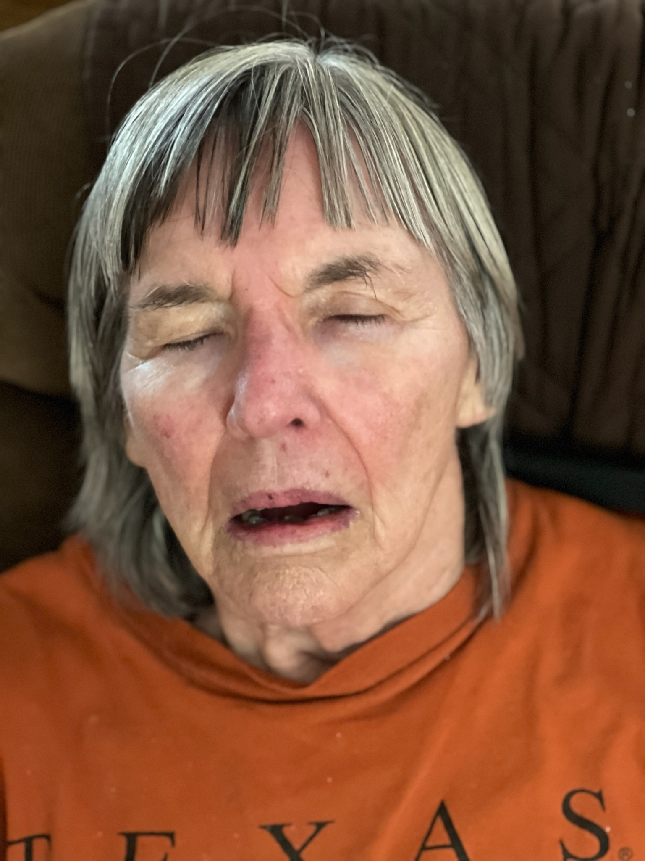
 | 2021-12-27 | Very restless sleeping | C:\Users\gwbro\Pictures\iCloud Photos\Photos\IMG_0117.JPG
 | 2022-01-10 | Pat using sh - sh- almost only speech | Loss of vocal ability nearly totality. C:\Users\gwbro\Pictures\iCloud Photos\Photos\IMG_0178.MOV
 | 2022-01-14 | Self feeding becomes difficult | C:\Users\gwbro\Pictures\iCloud Photos\Photos\IMG_0177.MOV
 | 2022-01-22 | Self feeding coming to a close | C:\Users\gwbro\Pictures\iCloud Photos\Photos\IMG_0187.MOV
 | 2022-01-30 | Pat still initiating walks
 | 2022-02-01 | Pat’s walk more wobbly
 | 2022-02-01 | Patricia helping me dress after I dressed her.  C:\Users\gwbro\Pictures\iCloud Photos\Photos\IMG_0187.MOV | 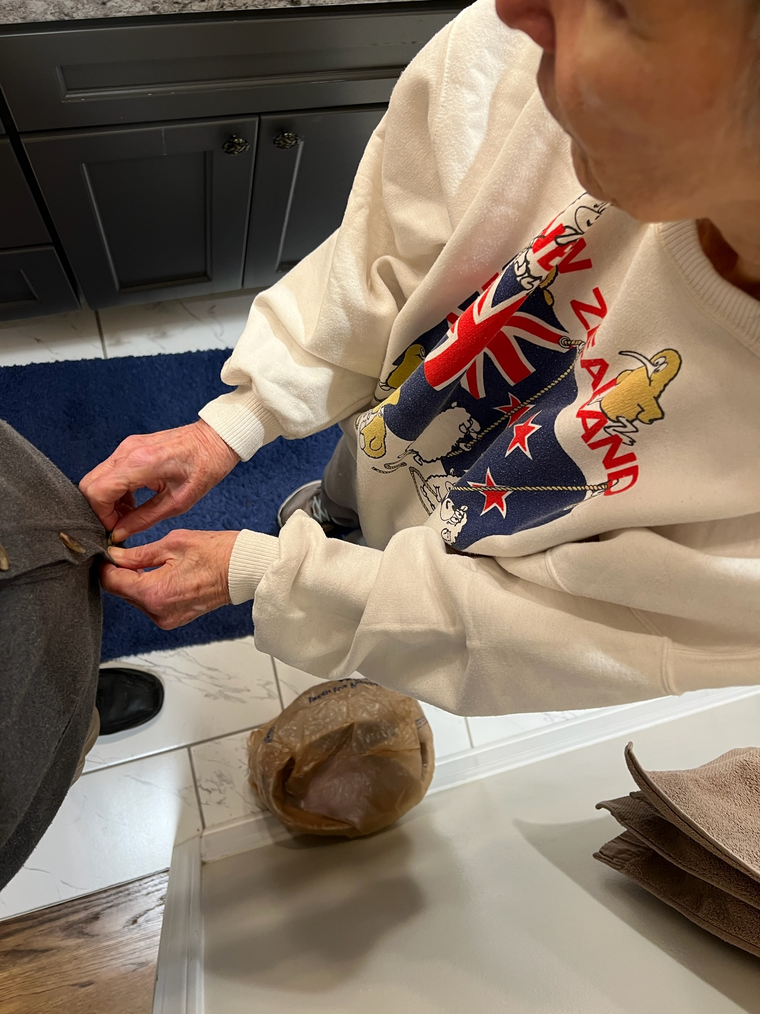
 | 2022-02-10 | Moo’s in fine form this afternoon. Walked on her own to deck, began to make up her bed… | Img0233.MOV; C:\Users\gwbro\Pictures\iCloud Photos\Photos\IMG_0233.MOV
 | 2022-02-17 | UT Palliative care Nurses visit 2825 | Samantha Lansford and Kim Crouch, Nurse Practitioners visit Pat
 | 2022-02-19 | Moo’s just up and eating. Slightly tottier but maybe better rested.
 | 2022-02-23 | Speech pathologist visit 2825 | Kerma Wohlwend of Amedisys checked Pat’s swallowing. Said to be cautious with carrots and nuts
 | 2022-02-28 | Dr Stuart | Wellness visit - Blood draw for both.
 | 2022-03-07 | I’m ok. Moo had an effortful night. No Trazodone last night. More sh-sh and her hand trembles are more pronounced this am.  Going to call UT Palliative Care nurse about stopping trazodone.
 | 2022-03-08 | Self-feeding more difficult | C:\Users\gwbro\Pictures\iCloud Photos\Photos\IMG_0299.MOV
 | 2022-03-09 | Moo's ability to walk with my assistance is declining. Her ability to feed herself wanes. She hasn't had Trazodone for 3 days | C:\Users\gwbro\Pictures\iCloud Photos\Photos\IMG_0302.MOV
 | 2022-03-14 | Yes. I fear that will become the means from bed to toilet. From toilet to living room chair.  I want her to walk, but it looks so hard.
 | 2022-03-15 | her right leg often wobbles near collapse.
 | 2022-03-15 | Palliative Care Samantha Lansford | Calendar event may not have happened.
 | 2022-03-16 | W: You ready to get up?  P: I'm not ready  W: You want another half hour?  P: 'nother half hour.
 | 2022-03-17 | Speech path visit, Samantha. | Speech Path T… will get occup therapy to come offer ideas on bathing
 | 2022-03-19 | Hospice begun | Induction’s Mary Jo visit from U T Hospice
 | 2022-03-20 | Pat having a hard time . | C:\Users\gwbro\Pictures\iCloud Photos\Photos\IMG_0317.MOV
 | 2022-03-22 | 3 visits | 1: Errika Doane, social worker, Kelly, RN, Jane who gave Moo a shower
 | 2022-03-22 | First Hospice visit
 | 2022-03-24 |  | Telemed visit w/ Amber Tayman cancelled because we went with Hospice
 | 2022-03-25 | Pressure wound first noticed
 | 2022-03-29 | Hospice RN Kelly | Begin treating pressure sound on Pat’s left heel.
 | 2022-04-01 | Caught Moo smiling as see watched pictures of both her daughters with granddaughter Millie | 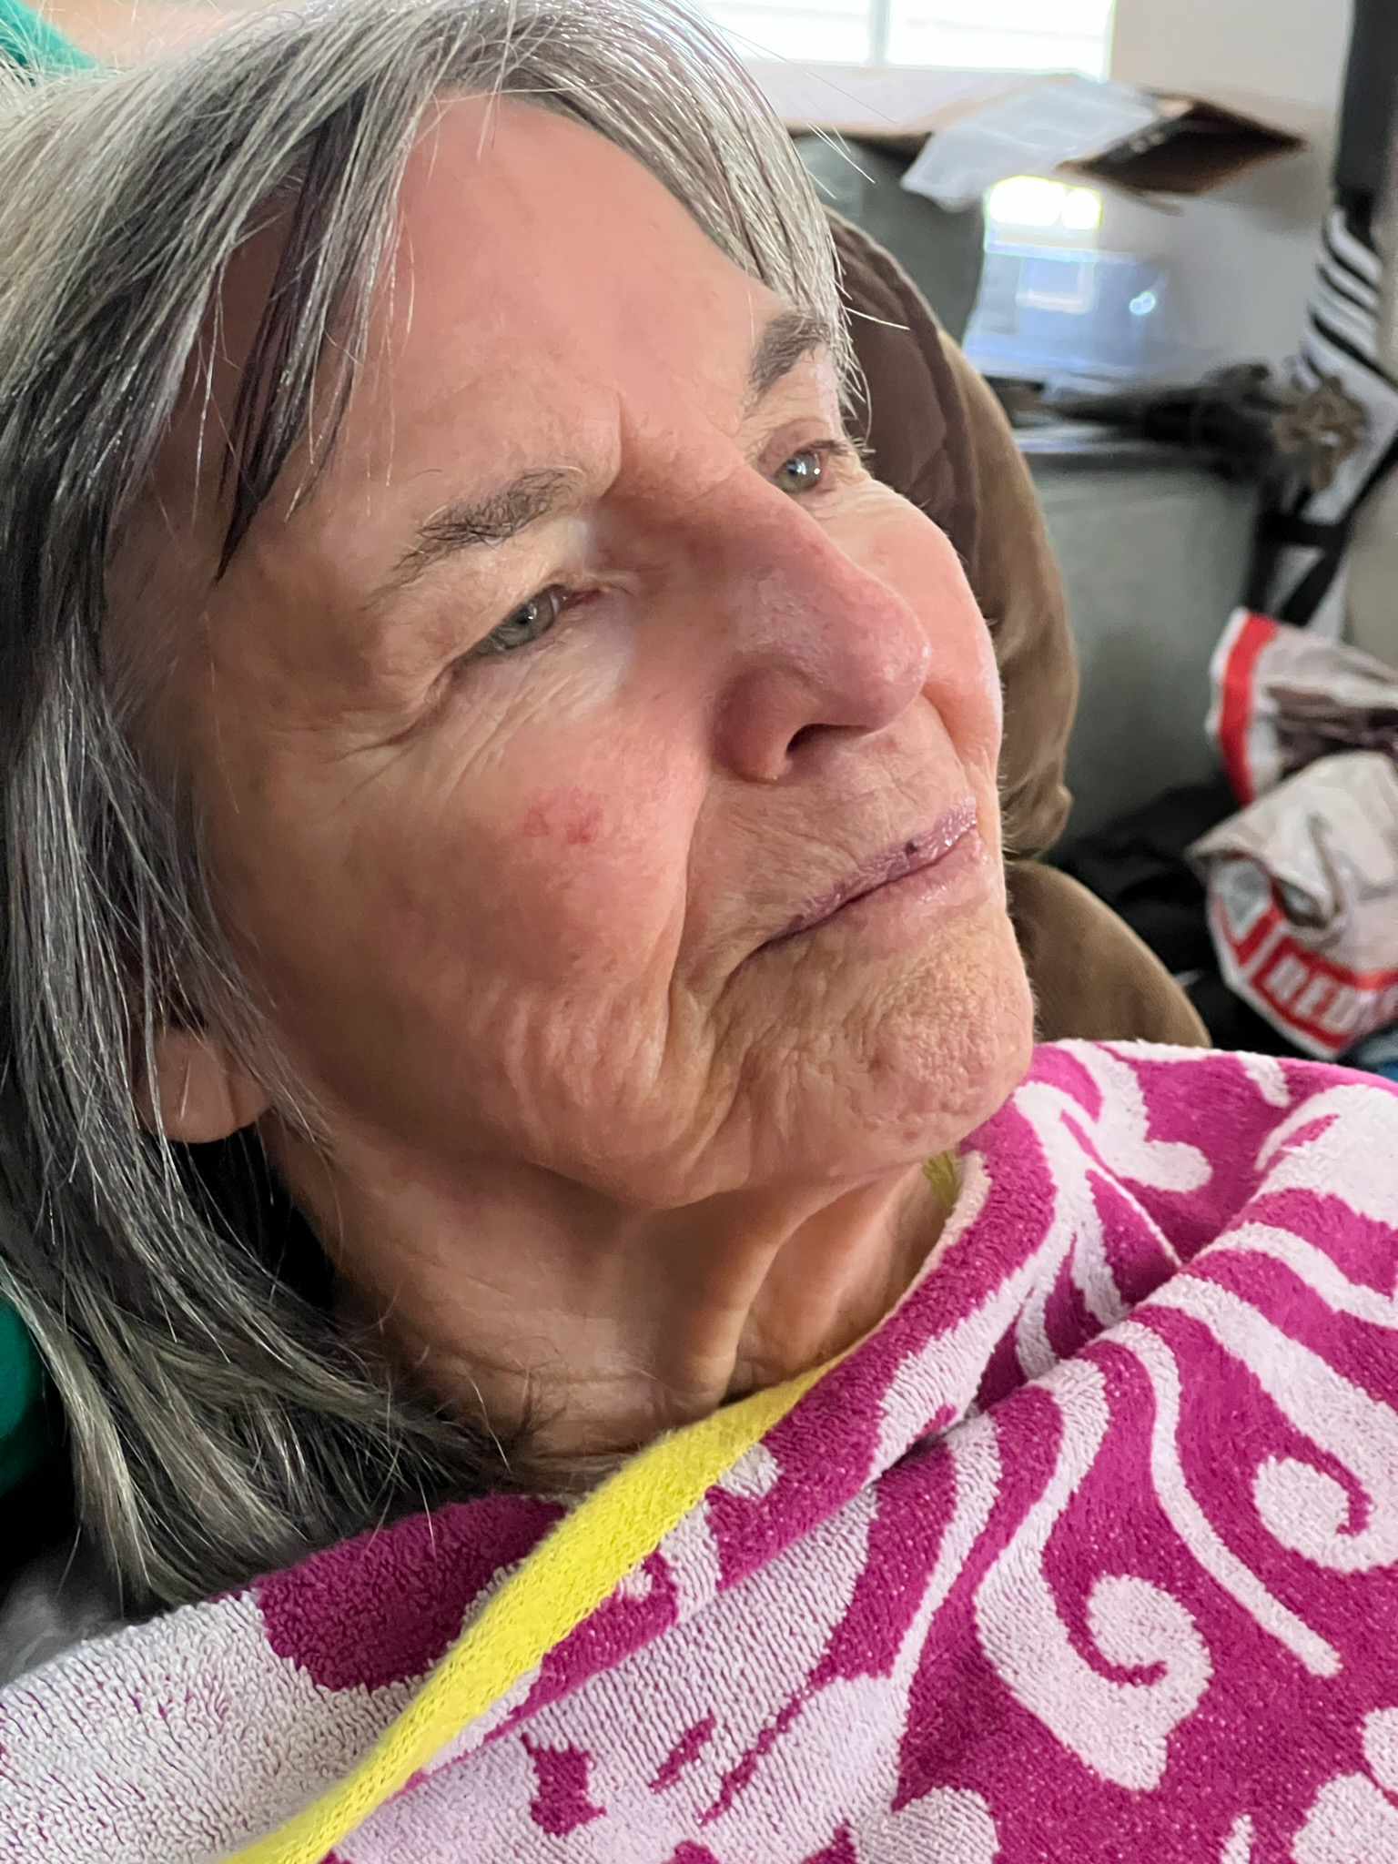
 | 2022-04-04 | Moo’s up. Getting harder to aid her walking; her right tilt more pronounced. She sits tilted right.  3 nights in a row, she drank about a quart of water in the two hours before bedtime.
 | 2022-04-05 | Moo was pretty good. Enjoyed Kris wheeling her around Boright park. Laughed when I announced bedtime bandaging as “time to patch the old girl up”.  But she was quite active in bed. Rotated her self 90 degrees out of the cover by 5 am. Vigorously moving her legs a while ago.
 | 2022-04-08 | Uses “Sh-sh” sound to express discontent
 | 2022-04-11 | Entreaty, fear, bewilderment | C:\Users\gwbro\Pictures\iCloud Photos\Photos\IMG_0379.JPG
 | 2022-04-14 | Wheeled from bed to bathroom for changing and dressing | C:\Users\gwbro\Pictures\iCloud Photos\Photos\IMG_0387.JPG
 | 2022-04-14 | SHAS Jennifer Logan for Pat | 10 to 3 while Walt has blue light treatment
 | 2022-04-18 | Losing ability to support her weight on two legs
 | 2022-04-18 | Maybe I got Moo up too early  She seems to be losing the ability to stand. To support her own weight.  This is important at transfer time; I don't need her to walk only to stand while she and I rotate her to the next seated position.
 | 2022-04-19 | Went well. Moo stood when needed and seemed pleased with herself that she could.
 | 2022-04-20 | We’re good. Lot of sh-sh last night. Beginning to think Moo does it in her sleep.  Much of her life she could talk and even laugh in her sleep. Never would ( or could) tell me what was so funny that she was entitled to wake me.
 | 2022-04-21 | Similar blister to last year; this time not left but right hip. I'm going to have to shift her sleeping position nightly | 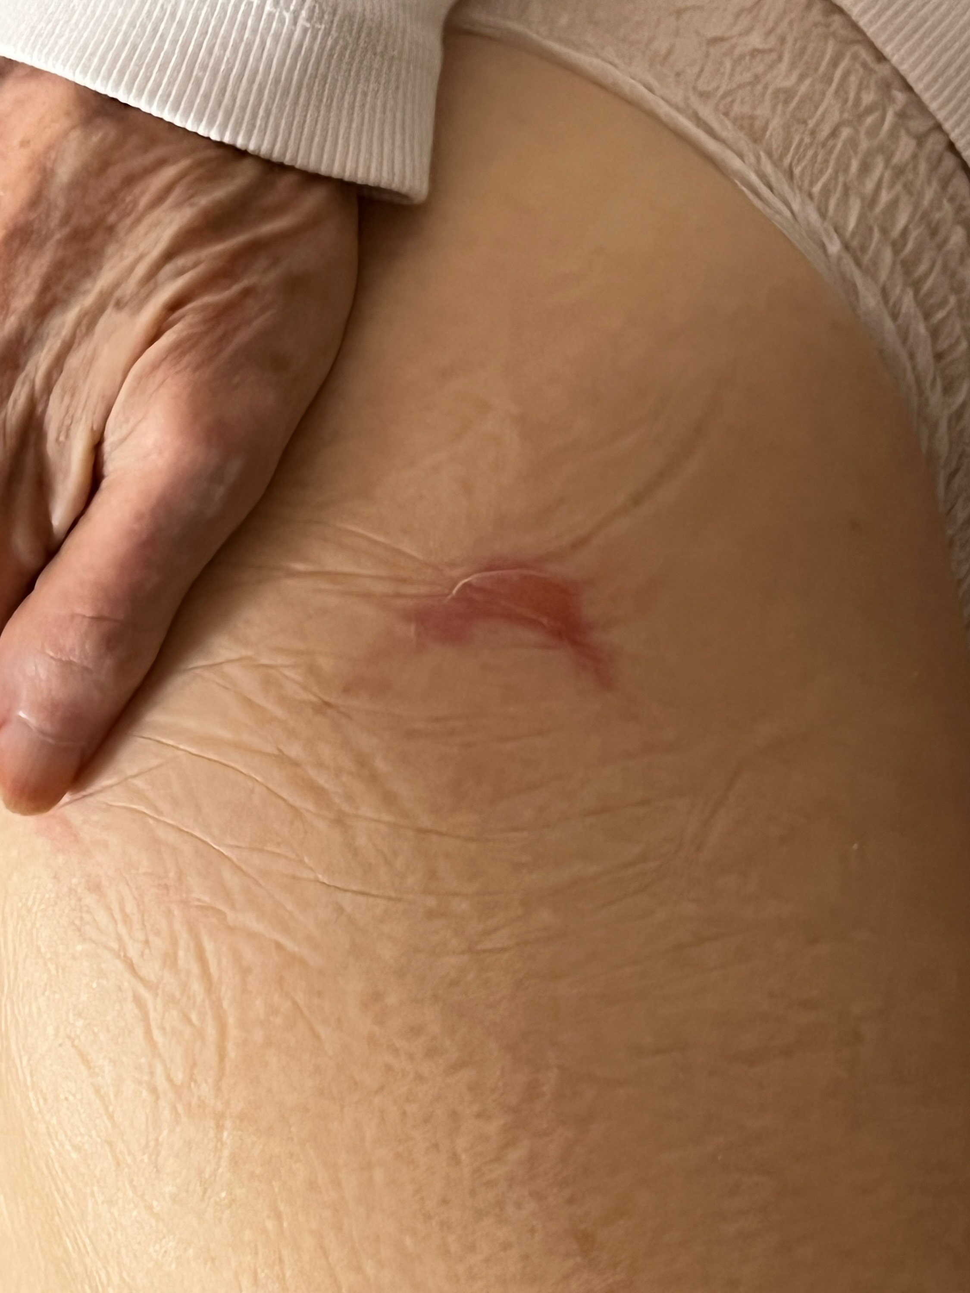
 | 2022-04-25 | Hospital bed thru Hospice | C:\Users\gwbro\Pictures\iCloud Photos\Photos\IMG_0422.JPG
 | 2022-04-29 | "Do you want me to use sandpaper?"  That got a Moo smile.  She had wrinkled her nose the way one does when it itches. I rubbed it with the serape to scratch it. Did that get it {the itch}  Moo: It almost did.  C:\Users\gwbro\Pictures\iCloud Photos\Photos\IMG_0445.JPG | 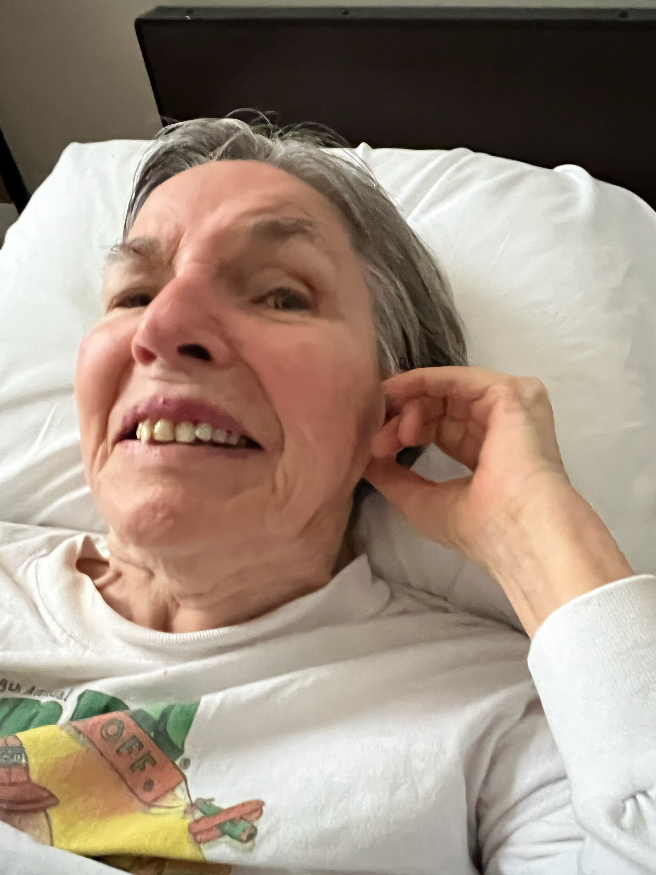
 | 2022-05-02 | Pat still feeds herself
 | 2022-05-03 | Pat wobbles on her good leg during transfer.
 | 2022-05-04 | Pat wobbles on her good leg
 | 2022-05-08 | Pat gave me 3 sentencea
 | 2022-05-12 | Duloxitine, pre-natal vitamins and galantamine stopped by Kelly
 | 2022-05-12 | I’m unable to manage getting Pat out of bed. She holds so little of her weight | Patricia becomes bed bound
 | 2022-05-12 | Stopped getting Pat out of bed | Pat unable to hold self up on good (right) leg while I pull up her panties and pants. Pat and Walt can no longer manage Pat’s upright life.
 | 2022-05-13 | Kelly dressed Moo's pressure wounds, taught me how to change Moo in bed and stopped some of her meds.
 | 2022-05-27 | Kelly's going to use a "wet to dry" solution on Moo's heel wound. Tuesday. | Evolving treatment for Patricia’s pressure wound on heel
 | 2022-05-29 | Pat in hospital bed | C:\Users\gwbro\Pictures\iCloud Photos\Photos\IMG_0652.JPG
 | 2022-06-01 | Cancelled Dr Baljepally
 | 2022-06-01 | Cardiologist G Baljepally FU | Cancelled because care transferred to Hospice
 | 2022-06-04 | Pat’s outdoor excursions are in a wheelchair.
 | 2022-06-09 | Med tests. | EKG for Pat cancelled because care transferred to Hospice
 | 2022-06-10 | No more walking. Wheel chair excursion. A neighbor gave Pat lillies | C:\Users\gwbro\Pictures\iCloud Photos\Photos\IMG_7421.jpg
 | 2022-06-13 | Hospice RN Cindy for Pat | Vitals and heel dressing
 | 2022-06-16 | Hospice RN Stephanie for Pat | Vitals and heel dressing
 | 2022-06-23 | Hospice RN Jenifer for Pat | Vitals and heel dressing
 | 2022-07-13 | Patricia in prayer? | C:\Users\gwbro\Pictures\iCloud Photos\Photos\IMG_0815.JPG
 | 2022-07-13 | Daughters visit | C:\Users\gwbro\Pictures\iCloud Photos\Photos\IMG_0826.JPG
 | 2022-07-16 | I got Moo to speak!  Of course it was, "Oh. . . Fuck you!" | But take your victories where you may. This one was lifting her by her joined hands to adjust position in bed for next rotation.
 | 2022-07-22 | Hospice RN Heather for Pat | Vitals and heel dressing
 | 2022-07-28 | Grapes start interest in a meal | C:\Users\gwbro\Pictures\iCloud Photos\Photos\IMG_0876.JPG
 | 2022-08-06 | Last wheel chair outing for Pat | C:\Users\gwbro\Pictures\iCloud Photos\Photos\Last wheel chair outing for Pat.JPG
 | 2022-08-06 | Daughter's hug | C:\Users\gwbro\Pictures\iCloud Photos\Photos\Daughter's hug.JPG
 | 2022-09-07 | Pat sleeps mid meal
# | 2022-08-09 | Family Visit 2022-08-09 | C:\Users\gwbro\Pictures\iCloud Photos\Photos\Family Visit 2022-08-09.JPG
 | 2022-08-15 | Heel pressure wound healing | C:\Users\gwbro\Pictures\iCloud Photos\Photos\Heel pressure wound healing.JPG
# | 2022-08-25 | Still a bit of self feeding with bananna | C:\Users\gwbro\Pictures\iCloud Photos\Photos\Still a bit of self feeding with bananna.JPG
 | 2022-09-24 | Pat can't bring glass to mouth | Pat can't bring glass to mouth
 | 2022-09-30 | Sundown agitation. | Eventually added sun shade film to north and west glass.
 | 2022-10-03 | Pat needs a hand to hold | C:\Users\gwbro\Pictures\iCloud Photos\Photos\Pat needs a hand to hold.JPG
 | 2022-11-08 | Pat eye appt | Cancelled appt with Dr Ange
 | 2022-12-05 | Pat and caregiver Pamela Moody | C:\Users\gwbro\Pictures\iCloud Photos\Photos\IMG_1126.JPG
 | 2023-03-24 | Pat breathing with loud crackling | Seems temporary
 | 2023-03-27 | Pat voiced “two” with me as I pulled her to the top of the bed. | Last recorded vocalization besides “hissing sound” : sh-sh
 | 2023-04-17 | Pat sleeping more during day
 | 2023-07-13 | Added Omerprazole Cap 2x | RN Victoria Hayes

