# Genome-wide investigation of Chelicerates finds no evidence for a whole genome duplication among spiders and scorpions

A comprehensive, comparative examination of Chelicerate genomes reveals no evidence for a whole genome duplication among spiders and scorptions

Alphabetical by last name author list:

Michael Barker

Matthew Hahn

Michael McKibben

Gregg Thomas

Li Zheng

# Abstract

Whole genome duplications (WGDs) can be a key evolutionary event in a species and may play a role in adaptation and speciation. While WGDs are common throughout the history of plants, only a few examples have been proposed in metazoans. Among those, recent proposals of WGD events in Chelicerates, the group of Arthropods that includes horseshoe crabs, sea spiders, ticks, mites, scorpions, and spiders, have relied on genomic evidence from a few species. Specifically, several rounds of WGD have been proposed in the history of horseshoe crab evolution, and one WGD has been proposed in the ancestor of spiders and scorpions. However, many of these inferences have relied on small portions of the genome. Genome-wide inferences with broader species sampling may give a clearer picture of WGDs in Chelicerates. In this study, we investigate signals of WGD in Chelicerates using whole genomes from 17 species. We employ a myriad of methods to look for these signals, including gene tree analysis of thousands of gene families, intraspecific synteny, and divergence of paralogs. We test several scenarios for WGD in Chelicerates using multiple species tree hypotheses as a backdrop. We find no evidence for a WGD in the history of spiders and scorpions but do find support for at least one WGD in the ancestral horseshoe crab lineage. This study not only sheds light on genome evolution and phylogenetics of Chelicerates, but demonstrates how a combination of comparative methods can be used to investigate signals of ancient WGDs.

# Introduction

Whole genome duplications (WGDs) occur when an individual retains both sets of chromosomes from each parent. This can be highly detrimental to the survival of the individual, but occasionally the influx of novel genetic material can provide adaptive advantages that allow the whole genome duplication to propagate, resulting in a polyploid species with more than 2N chromosomes in its genome (Comai 2005). Polyploid species can arise in one of two ways, with both parental genomes being from the same species, called autopolyploidy, or with a hybridization event where the parental genomes come from different species, called allopolyploidy. But regardless of the origin of the polyploid, whole genome duplication can be a key evolutionary event in the history of a species, and there is some evidence pointing to an association between environmental stress and the success of polyploid species (Van de Peer et al. 2021). While whole genome duplications are thought to be common in plants (Masterson 1994; Adams and Wendel 2005; Barker et al. 2016), there is also evidence pointing to important genome duplications in the history of fungi (Wolfe and Shields 1997; Ma et al. 2009) and vertebrates (Ohno 1970; Furlong and Holland 2002).

A common process in the evolution of polyploid species is diploidization, which is the loss of many of the excess genes and chromosomes that resulted from the whole genome duplication. The end result of diploidization is a return of the gene-content of the species to a diploid state, with most paralogous genes that resulted from the WGD being lost or unidentifiable as paralogs (or homoeologs in the case of allopolyploidy (Glover et al. 2016)) (Wolfe 2001). During diploidization, it is possible that the polypoid species retains more chromosomes than the genome had before WGD (Wolfe 2001). Nevertheless, even in paleopolyploid species that have had ancient WGDs and undergone diploidization, signatures of the WGD can remain in their genomes. For example, an excess of paralogs in the genome will have occurred at the timing of the WGD. This means that when gene tree topologies of the gene families that include these paralogs are inferred along with homologous genes from other species, the paralogs will often be inferred on the same branch when mapped to the species tree (Pfeil et al. 2005; Cannon et al. 2015; Thomas et al. 2017; Yan et al. 2022). This also may lead to spikes in synonymous divergence between paralogs around the timing of the WGD event. There may also be syntenic evidence for the WGD in paleopolyploids, where regions of the extant genome that can trace their history to different parental sub-genomes align to each other.

Recently, whole genome duplications have been proposed in the history of the Arthropod sub-phylum Chelicerata, which includes horseshoe crabs, sea spiders, mites, ticks, scorpions, and spiders. In horseshoe crabs, counts of gene duplications, paralog divergence estimates, and syntenic blocks suggest whole genome duplication has occurred during their evolution (Nossa et al. 2014; Shingate et al. 2020a). Examination of the *hox* gene cluster is also used to suggest that there have been anywhere between 1 to 3 WGDs during the course of horseshoe crab evolution (Kenny et al. 2017; Shingate et al. 2020a; Shingate et al. 2020b). Similar approaches also form the basis for the claim that a WGD has occurred in the lineage ancestral to extant spiders and scorpions (Schwager et al. 2017). In both cases, the number of genes or genomes has been limited. And while the duplication of a conserved gene cluster can be indicative of a larger (perhaps whole genome) duplication event, it may be too simplistic to confirm such an event. Additionally, recent evidence supports an alternate placement of horseshoe crabs in the chelicerate phylogeny. Traditionally, the aquatic horseshoe crabs have been thought to be sister to all arachnids (spiders, scorpions, mites, and ticks), which are mostly terrestrial (Weygoldt and Paulus 1979). However, the possibility of polyphyletic origins of arachnids has been considered (see Shultz 1990) and molecular studies have not supported a scenario of monophyletic arachnids (Sharma et al. 2014; Ballesteros and Sharma 2019; Ontano et al. 2021). Recently, Ballesteros et al. (2022) presented strong evidence for horseshoe crabs being nested within arachnids, sister to spiders and scorpions. This newly proposed species tree could substantially impact how WGDs are inferred within this group.

Here we use whole genome sequences from 19 chelicerates species with a myriad of methods to detect ancient WGDs in this group. Thes methods include the clustering of paralogs in gene tree topologies, synonymous divergence of paralogs, and intraspecific synteny. We test multiple species tree hypotheses and find no evidence for a WGD taking place in the history of spiders and scorpions. In contrast, our suite of methods all find some evidence for at least one WGD occurring during the evolution of horseshoe crabs, even in light of their new placement in the chelicerate phylogeny.

# Methods

To investigate the possible existences of whole genome duplication events in chelicerates on a genome-wide scale we took a multi-faceted approach by analyzing gene family evolution, divergence, and synteny of genomes in this group. We downloaded 18 chelicerate genomes with annotations available at the beginning of this project from various sources: NCBI’s Assembly database (2012 - [cited 2023 Sep 14]), Ensembl Metazoa (Yates et al. 2022; release 51), the i5k database (i5K 2013; Thomas et al. 2020), and, for two samples, the data supplements of their genome publications (Fan et al. 2021; Nong et al. 2021). These genomes span the various taxonomic groups contained within the subphylum Chelicerata, including four species from the superorder Parasitiformes (mites and ticks), two species from the superorder Acariformes (mites), eight species from the order Araneae (spiders), one species from the order Scorpiones (scorpions), and four species from the order Xiphosura (horseshoe crabs). For this study, we treat Parasitiformes and Acariformes as orders. For phylogenetic analyses, we also include two insects (*Drosophila melanogaster* and *Bombyx mori*) as outgroups for tree rooting. See Supplemental Table SX for full details of the samples and summaries of their assemblies and annotations. We observed that one of the horseshoe crab annotations, *Tachypleus tridentatus*, contained 79,557 genes, more than twice as many as any other species in our sample, including the other horseshoe crabs. While on the surface this may indeed be indicative of a recent whole genome duplication in this species, we also note that the median gene length for this species is only 1,377bp which, while not the shortest in our sample, is considerably smaller than the rest of the horseshoe crabs, which all have a median gene length of over 8,500bp. Because this could be indicative of annotation error in this species and because we are interested in more ancient whole genome duplications, we decided to exclude this sample from our analyses. This results in a dataset of 17 chelicerate species and 2 outgroup insects for analysis that spans almost 600 million years of genome evolution.

## Gene family analysis

We extracted the coding sequence of the longest transcript from each gene in each of our 21 species and used FastOrtho (<https://github.com/olsonanl/FastOrtho>), which is a reimplementation of orthomcl (Li et al. 2003), to cluster genes into gene families. Using an Inflation value of 3, we inferred 49,561 gene families (probably a Supplementary Figure). We then extracted the sequences in each gene family, correcting for inconsistencies resulting from the data originating from various sources and aligned each gene family with Guidance2 (Sela et al. 2015) using MAFFT (Katoh and Standley 2013) as the underlying aligner, and removing any alignment columns with a score below 0.93. We then performed our own alignment filtering by removing columns in sliding windows of 3 codons that have 2 codons with 2 or more gaps in 50% of the sequences in that alignment. We also removed any sequences that were made up of greater than 20% gap characters and removed any alignments with sequences from fewer than 4 species or that were shorter than 33 codons after all filtering. See Supplementary Table SX for full alignment filtering stats. We translated the remaining 11,016 alignments from nucleotides to amino acids and inferred gene trees with IQ-TREE (Nguyen et al. 2015) using ultrafast bootstrap (Hoang et al. 2018), and a species tree using all gene families with ASTRAL-Multi (Rabiee et al. 2019). We rooted our gene and species trees using the outgroup insects with Newick Utilities (nw_reroot; Junier and Zdobnov 2010). However, the outgroups were not present in every gene family, in which case the gene tree could not be rooted and was excluded from subsequent analyses. After rooting, we retained gene trees from 6,368 gene families. Then, to reduce possible gene tree inference error, we used bootstrap rearrangement implemented in Notung (Chen et al. 2000) with a bootstrap threshold of 90. This method forces inferred duplications on branches in our gene trees with a bootstrap score less than this threshold to be resolved in such a way that minimizes the number of duplications and losses counted in the tree.

We then used these 6,368 gene trees and a species tree as input to GRAMPA (Thomas et al. 2017) to identify the placement of any WGDs in the chelicerate phylogeny. Briefly, GRAMPA performs least common ancestor (LCA) mapping from each gene tree to the species tree but allows for reticulations to be present in the species tree by representing them as multi-labeled trees (MUL-trees), in which one or more tip label appears twice. By comparing LCA mapping scores between the input species tree and a set of MUL-trees defined by target lineages, GRAMPA can determine if a whole genome duplication has occurred based on an excess of duplications being inferred on a single lineage. For our runs, we set as target lineages for WGD identification those on which WGDs have previously been proposed, specifically the branch leading to spiders and scorpions and the branch leading to horseshoe crabs. We also used multiple species trees as input to GRAMPA and tested the same scenarios. In addition to our inferred species tree, the two alternate species tree topologies we tested were a recently inferred phylogeny from Ballesteros et al. (2022) in which they find that horseshoe crabs group within arachnids, specifically sister to spiders and scorpions, and a ‘traditional’ species tree topology, in which horseshoe crabs are sister to all arachnid species. For the ‘traditional’ tree, because of the unresolved placement of Acariformes and Parasitiformes (Sharma et al. 2014; Ontano et al. 2021), we simply use the topology recovered by Ballesteros et al. (2022) and manually moved horseshoe crabs to be sister to arachnids.

## Synteny analysis

We used syntenic estimates to test for paleopolyploid ancestry in 16 of the 21 Chelicerate species that had annotated reference genomes. Specifically, we used MCScanX, which uses BLASTP and a novel chain score, with default settings to detect and visualize intraspecific syntenic blocks (Wang et al. 2012).

## Synonymous divergence

In addition to our syntenic inferences, we used DupPipe to calculate the Ks for paralogs in each genome (Barker et al. 2010). We then visualized the distributions of Ks values with matplotlib available in python3 (Hunter 2007) and visually assessed for signatures of paleopolyploid ancestry in the form of peaks in the distributions.

Previous work in the Chelicerata used Hox gene duplications as evidence of shared paleopolyploid ancestry [(Schwager et al. 2017)](https://paperpile.com/c/ufcF67/SeQw). Stuff about how the hox genes were found. We then used the duplicate gene classifier available through MCScanX to identify the mode of duplication that formed each Hox gene paralog.

# Results

We assessed the occurrence of whole genome duplications in Chelicerates, the Arthropod sub-phylum consisting of horseshoe crabs, mites, ticks, spiders, and scorpions, using whole genome data across the group and in light of new molecular evidence that Xiphosura (horseshoe crabs) are nested within Arachnids rather than sister to them (Ballesteros et al. 2022). We first used the genomes of 17 chelicerates and 2 insect outgroups to reconstruct the Chelicerate phylogeny, with an emphasis on Arachnids and horseshoe crabs. Using 6,368 genes we confirm the placement of Xiphosura as nested within Arachnids (Fig. 1A), in agreement with (Fig 1B; Ballesteros et al. 2022). However, our inferred tree differs from theirs in the placement of the superorders Acariformes and Parasitiformes. Our results show that Acariformes is sister to the spider, scorpion, and horseshoe crab clade, while Ballesteros et al. (2022) suggest that Parasitiformes is more closely related to them. However, the placement of these groups is inconsistent in their analyses and has been contentious in previous studies (Sharma et al. 2014; Ontano et al. 2021).

We used these species trees as the basis to test various hypotheses of whole genome duplication (WGD) in the history of chelicerate evolution. Specifically, based on synteny and duplication of some gene families, multiple rounds of WGD have been proposed in horseshoe crabs (Nossa et al. 2014; Kenny et al. 2017; Shingate et al. 2020a; Shingate et al. 2020b), and based on the duplication of the *Hox* gene cluster, one WGD has been proposed in the ancestor of spiders and scorpions (Schwager et al. 2017). We find that, when using gene tree topologies to count duplications and losses in thousands of genes, there is no evidence for a WGD in the history of spiders and scorpions using our inferred species tree, the Ballesteros et al. (2022) species tree, or the traditional species tree in which horseshoe crabs are sister to Arachnids (Fig. 1). In each case, we tested whether a tree with a reticulation from any of the proposed H1 branches to any other branch in the phylogeny better explains the duplication history of the genes in these genomes than a bifurcating species tree, which would be indicative of WGD. However, in each case we find the bifurcating species tree results in the lowest duplication and loss score, indicating no WGD has occurred. This evidence is definitive for any WGD in the history of spiders and scorpions; however, we do see evidence for large scale duplications on the branch leading to horseshoe crabs in each species tree (Fig. 1). We also find that the second and third lowest scoring scenarios when using our inferred species tree posit a WGD in horseshoe crabs (Fig. 2, some supp fig of the trees?). That is, while our method of counting duplications and losses did not explicitly show a WGD in the history of horseshoe crabs, there are multiple pieces of evidence that point to one or more occurring.

We also find that, when comparing duplication and loss scores between species trees, our species tree and the Ballesteros et al. (2022) species tree both explain the history of gene duplication and loss better than the ‘traditional’ species tree, in which horseshoe crabs are not nested within Arachnids (Fig. 2). This is further evidence in favor of the placement of this group as sister to spiders and scorpions. And while our species tree always better explains the data, this is unsurprising since we inferred our tree from these data.

We next looked at other genome-wide signatures of WGDs on a subset of species. Specifically, we looked for intraspecific syntenic blocks, which should be widespread in genomes that have undergone WGD, and distributions of synonymous divergence (Ks) of paralogs within each genome. If a WGD has occurred in the history of a genome, a secondary peak of Ks should be present in these distributions. With both of these analyses we again find no evidence for WGD in any spider or scorpion genomes and suggestive evidence for at least one occurring in the history of horseshoe crabs. Only two species, *C. rotundicauda* and *T. gigas*, both horseshoe crabs, showed substantial amounts of intraspecific synteny. Both of these, along with the other horseshoe crab, *L. polyphemus*, also have distinct peaks in their Ks distributions, indicating the possibility of WGD occurring in their ancestor. This is the same branch identified with an excess number of gene duplications and losses in our gene tree topology analysis above (Fig. 1)

# Discussion

Whole genome duplications (WGDs) can be a key event in the evolution of a species, possibly facilitating adaptation (Ohno 1970; Werth and Windham 1991; Adams and Wendel 2005; Crow et al. 2006). While the process of diploidization (the return of the genome to a diploid state after WGD) can make more ancient WGDs harder to detect, methods have been developed that have the potential to capture the signal of these events in extant genomes. Here, we used these methods to investigate the existence of ancient WGDs in the Chelicerates. Several rounds of WGD have been proposed in the history of horseshoe crab evolution, and a single WGD has been proposed in the ancestor of spiders and scorpions. The evidence for these events usually starts with the observation of a duplication of a well-conserved gene family, *hox*. Further investigations of intraspecific synteny, gene tree topologies, and divergence follow, but until now have been limited to only a few genes or genomes.

Using 17 chelicerate genomes and whole genome sequences we find no evidence for a WGD in the history of spiders or scorpions. When mapping gene tree topologies to species trees that both allow and restrict the inference of WGDs, the best scoring scenario is always the one without any WGDs, regardless of the input species tree used. For spiders and scorpions, we also see no intraspecifc synteny or peaks in divergence of paralogs that would indicate a WGD. This implies that the two copies of the *hox* gene cluster observed in some spiders and scorpions may instead be the result of a more limited duplication event.

We do find some evidence for WGDs during horseshoe crab evolution. While no reticulations are favored in the gene tree analysis, we do find a burst of gene duplications on the branch leading to horseshoe crabs. This burst is observed regardless of the species tree considered (Fig. 1). Previously, anywhere from one to three WGDs have been proposed along the horseshoe crab lineage. In fact, if multiple WGDs occurred, this may diminish the signal for any single proposed reticulation. Since our tests are limited to a single reticulation, this may in turn hinder our ability to explicitly identify any single WGD as the most parsimonious scenario. In addition to the large number of duplications on the horseshoe crab lineage, we also observe notable intraspecific synteny and peaks in divergence of paralogs.

In the course of our study of WGDs in Chelicerates, we also reconstructed a species tree for our 17 species (Fig. 1A). Using our whole genome data and including paralogs in our species tree inference, we find that the horseshoe crabs (Xiphosura) are nested within Arachnids, directly sister to spiders (Araneae) and scorpions (Scorpiones). This is in agreement with several recent molecular phylogenies of this group (cites). This is opposed to a tree suggested by the biomes in which the organisms live, where the aquatic horseshoe crabs are sister to the mostly terrestrial arachnids (Fig. 1C). In this traditional monophyletic Arachnid tree, separate WGDs would need to be proposed for both spiders/scorpions and horseshoe crabs. However, the molecular trees allow the possibility that a single WGD took place in the ancestor of spiders, scorpions, and horseshoe crabs. We also tested this scenario (Fig. 1) and were able to rule out this possibility.

# Data availability

The genomes used in our analyses are available from their respective databases (see Supplemental Table SX). All other data generated for this project (gene alignments, gene trees, etc.) are available on XX. Scripts used to parse and analyze this data are available at <https://github.com/gwct/spider-wgd>.

# Acknowledgements

We thank … . Gene family analysis was performed on the FASRC Cannon cluster supported by the FAS Division of Science Research Computing Group at Harvard University.

# Figures

## Figure 1

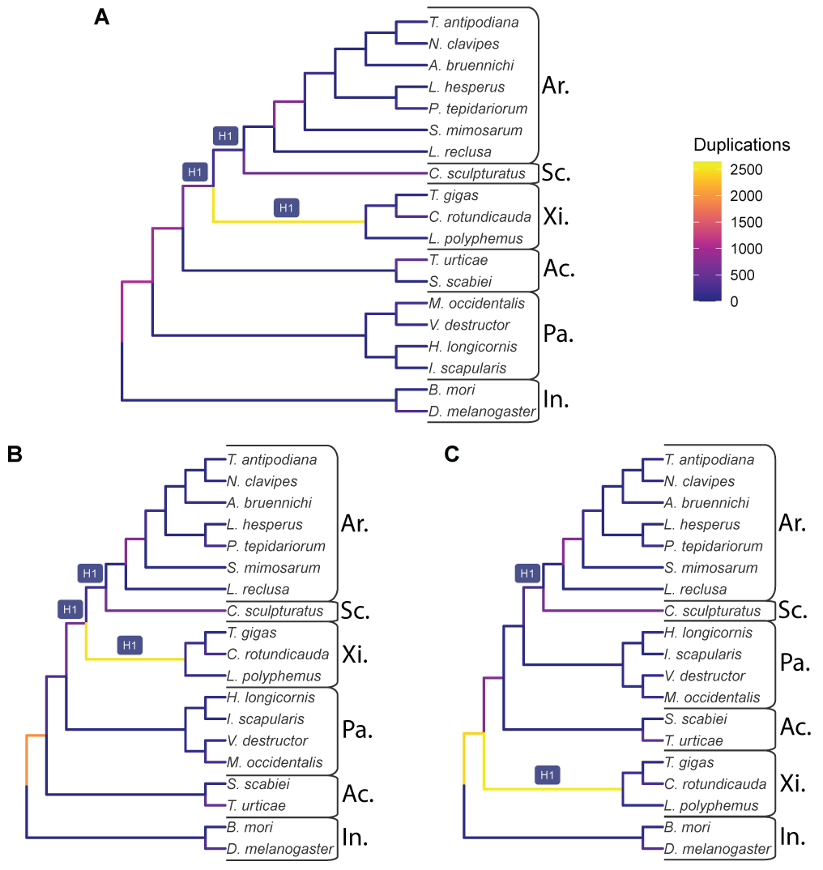

Figure 1: The input species trees used with GRAMPA, which are also the lowest scoring trees when considering possible reticulations at the branches labeled H1. Branches colored by the number of duplications that map to them. A) The species tree topology inferred in this study from 11,016 gene families. B) The species tree inferred by Ballesteros et al. (2022). C) A species tree that places horseshoe crabs (Xiphosura) sister to Arachnids. For all three trees, taxonomic groups are labeled as follows: Ar. = Araneae (spiders); Sc. = Scorpiones (scorpions); Xi. = Xiphosura (horseshoe crabs); Ac. = Acariformes (mites); Pa. = Parasitiformes (mites and ticks); In. = Insecta (insects).

## Figure 2

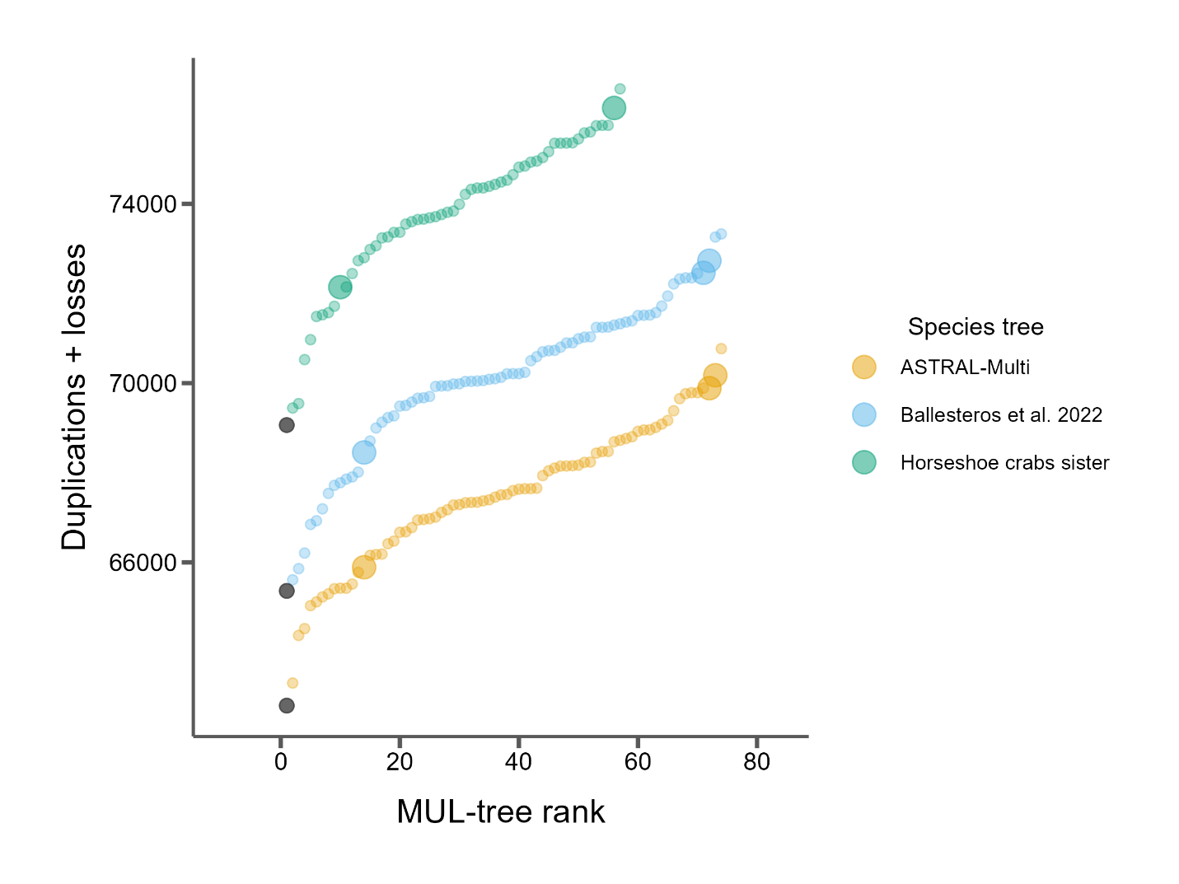

Figure 2: GRAMPA scores (duplications + losses) for every MUL-tree considered for each of the three species trees. Black dots represent the input bifurcating species tree with no WGD proposed. All other dots propose one WGD at one of the H1 branches (see Fig. 1). Larger dots indicate autopolyploidy scenarios and smaller dots indicate allopolyploidy scenarios.

## Figure 3

Figure 3: Some examples of the dotplots and ks plots?

# References

Adams KL, Wendel JF. 2005. Polyploidy and genome evolution in plants. *Curr Opin Plant Biol*. 8:135-141.

Assembly [Internet]. Bethesda (MD): National Library of Medicine (US) NCBI. 2012 - [cited 2023 Sep 14]. Available from: <https://www.ncbi.nlm.nih.gov/assembly/>.

Ballesteros JA, Santibanez-Lopez CE, Baker CM, Benavides LR, Cunha TJ, Gainett G, Ontano AZ, Setton EVW, Arango CP, Gavish-Regev E, et al. 2022. Comprehensive species sampling and sophisticated algorithmic approaches refute the monophyly of arachnida. *Mol Biol Evol*. 39.

Ballesteros JA, Sharma PP. 2019. A critical appraisal of the placement of xiphosura (chelicerata) with account of known sources of phylogenetic error. *Syst Biol*. 68:896-917.

Barker MS, Arrigo N, Baniaga AE, Li Z, Levin DA. 2016. On the relative abundance of autopolyploids and allopolyploids. *New Phytologist*. 210:391-398.

Barker MS, Dlugosch KM, Dinh L, Challa RS, Kane NC, King MG, Rieseberg LH. 2010. Evopipes.Net: Bioinformatic tools for ecological and evolutionary genomics. *Evol Bioinform Online*. 6:143-149.

Cannon SB, McKain MR, Harkess A, Nelson MN, Dash S, Deyholos MK, Peng Y, Joyce B, Stewart CN, Jr., Rolf M, et al. 2015. Multiple polyploidy events in the early radiation of nodulating and nonnodulating legumes. *Mol Biol Evol*. 32:193-210.

Chen K, Durand D, Farach-Colton M. 2000. Notung: A program for dating gene duplications and optimizing gene family trees. *J Comput Biol*. 7:429-447.

Comai L. 2005. The advantages and disadvantages of being polyploid. *Nat Rev Genet*. 6:836-846.

Crow KD, Wagner GP, Investigators ST-NY. 2006. Proceedings of the smbe tri-national young investigators' workshop 2005. What is the role of genome duplication in the evolution of complexity and diversity? *Mol Biol Evol*. 23:887-892.

Fan Z, Yuan T, Liu P, Wang LY, Jin JF, Zhang F, Zhang ZS. 2021. A chromosome-level genome of the spider trichonephila antipodiana reveals the genetic basis of its polyphagy and evidence of an ancient whole-genome duplication event. *Gigascience*. 10.

Furlong RF, Holland PW. 2002. Were vertebrates octoploid? *Philosophical Transactions of the Royal Society of London. Series B: Biological Sciences*. 357:531-544.

Glover NM, Redestig H, Dessimoz C. 2016. Homoeologs: What are they and how do we infer them? *Trends Plant Sci*. 21:609-621.

Hoang DT, Chernomor O, von Haeseler A, Minh BQ, Vinh LS. 2018. Ufboot2: Improving the ultrafast bootstrap approximation. *Mol Biol Evol*. 35:518-522.

Hunter JD. 2007. Matplotlib: A 2d graphics environment. *Computing in Science & Engineering*. 9:90-95.

i5K C. 2013. The i5k initiative: Advancing arthropod genomics for knowledge, human health, agriculture, and the environment. *J Hered*. 104:595-600.

Junier T, Zdobnov EM. 2010. The newick utilities: High-throughput phylogenetic tree processing in the unix shell. *Bioinformatics*. 26:1669-1670.

Katoh K, Standley DM. 2013. Mafft multiple sequence alignment software version 7: Improvements in performance and usability. *Mol Biol Evol*. 30:772-780.

Kenny NJ, Chan KW, Nong W, Qu Z, Maeso I, Yip HY, Chan TF, Kwan HS, Holland PWH, Chu KH, et al. 2017. Ancestral whole-genome duplication in the marine chelicerate horseshoe crabs. *Heredity (Edinb)*. 119:388.

Li L, Stoeckert CJ, Jr., Roos DS. 2003. Orthomcl: Identification of ortholog groups for eukaryotic genomes. *Genome Res*. 13:2178-2189.

Ma LJ, Ibrahim AS, Skory C, Grabherr MG, Burger G, Butler M, Elias M, Idnurm A, Lang BF, Sone T, et al. 2009. Genomic analysis of the basal lineage fungus rhizopus oryzae reveals a whole-genome duplication. *PLoS Genet*. 5:e1000549.

Masterson J. 1994. Stomatal size in fossil plants: Evidence for polyploidy in majority of angiosperms. *Science*. 264:421-424.

Nguyen LT, Schmidt HA, von Haeseler A, Minh BQ. 2015. Iq-tree: A fast and effective stochastic algorithm for estimating maximum-likelihood phylogenies. *Mol Biol Evol*. 32:268-274.

Nong W, Qu Z, Li Y, Barton-Owen T, Wong AYP, Yip HY, Lee HT, Narayana S, Baril T, Swale T, et al. 2021. Horseshoe crab genomes reveal the evolution of genes and micrornas after three rounds of whole genome duplication. *Commun Biol*. 4:83.

Nossa CW, Havlak P, Yue JX, Lv J, Vincent KY, Brockmann HJ, Putnam NH. 2014. Joint assembly and genetic mapping of the atlantic horseshoe crab genome reveals ancient whole genome duplication. *Gigascience*. 3:9.

Ohno S. 1970. Evolution by gene duplication: Springer-Verlag.

Ontano AZ, Gainett G, Aharon S, Ballesteros JA, Benavides LR, Corbett KF, Gavish-Regev E, Harvey MS, Monsma S, Santibanez-Lopez CE, et al. 2021. Taxonomic sampling and rare genomic changes overcome long-branch attraction in the phylogenetic placement of pseudoscorpions. *Mol Biol Evol*. 38:2446-2467.

Pfeil BE, Schlueter JA, Shoemaker RC, Doyle JJ. 2005. Placing paleopolyploidy in relation to taxon divergence: A phylogenetic analysis in legumes using 39 gene families. *Syst Biol*. 54:441-454.

Rabiee M, Sayyari E, Mirarab S. 2019. Multi-allele species reconstruction using astral. *Mol Phylogenet Evol*. 130:286-296.

Schwager EE, Sharma PP, Clarke T, Leite DJ, Wierschin T, Pechmann M, Akiyama-Oda Y, Esposito L, Bechsgaard J, Bilde T, et al. 2017. The house spider genome reveals an ancient whole-genome duplication during arachnid evolution. *BMC Biol*. 15:62.

Sela I, Ashkenazy H, Katoh K, Pupko T. 2015. Guidance2: Accurate detection of unreliable alignment regions accounting for the uncertainty of multiple parameters. *Nucleic Acids Res*. 43:W7-14.

Sharma PP, Kaluziak ST, Perez-Porro AR, Gonzalez VL, Hormiga G, Wheeler WC, Giribet G. 2014. Phylogenomic interrogation of arachnida reveals systemic conflicts in phylogenetic signal. *Mol Biol Evol*. 31:2963-2984.

Shingate P, Ravi V, Prasad A, Tay BH, Garg KM, Chattopadhyay B, Yap LM, Rheindt FE, Venkatesh B. 2020a. Chromosome-level assembly of the horseshoe crab genome provides insights into its genome evolution. *Nat Commun*. 11:2322.

Shingate P, Ravi V, Prasad A, Tay BH, Venkatesh B. 2020b. Chromosome-level genome assembly of the coastal horseshoe crab (tachypleus gigas). *Mol Ecol Resour*. 20:1748-1760.

Shultz JW. 1990. Evolutionary morphology and phylogeny of arachnida. *Cladistics*. 6:1-38.

Thomas GWC, Ather SH, Hahn MW. 2017. Gene-tree reconciliation with mul-trees to resolve polyploidy events. *Syst Biol*. 66:1007-1018.

Thomas GWC, Dohmen E, Hughes DST, Murali SC, Poelchau M, Glastad K, Anstead CA, Ayoub NA, Batterham P, Bellair M, et al. 2020. Gene content evolution in the arthropods. *Genome Biol*. 21:15.

Van de Peer Y, Ashman TL, Soltis PS, Soltis DE. 2021. Polyploidy: An evolutionary and ecological force in stressful times. *Plant Cell*. 33:11-26.

Wang Y, Tang H, Debarry JD, Tan X, Li J, Wang X, Lee TH, Jin H, Marler B, Guo H, et al. 2012. Mcscanx: A toolkit for detection and evolutionary analysis of gene synteny and collinearity. *Nucleic Acids Res*. 40:e49.

Werth CR, Windham MD. 1991. A model for divergent, allopatric speciation of polyploid pteridophytes resulting from silencing of duplicate-gene expression. *The American Naturalist*. 137:515-526.

Weygoldt P, Paulus HF. 1979. Untersuchungen zur morphologie, taxonomie und phylogenie der chelicerata1 ii. Cladogramme und die entfaltung der chelicerata. *Journal of Zoological Systematics and Evolutionary Research*. 17:177-200.

Wolfe KH. 2001. Yesterday's polyploids and the mystery of diploidization. *Nat Rev Genet*. 2:333-341.

Wolfe KH, Shields DC. 1997. Molecular evidence for an ancient duplication of the entire yeast genome. *Nature*. 387:708-713.

Yan Z, Cao Z, Liu Y, Ogilvie HA, Nakhleh L. 2022. Maximum parsimony inference of phylogenetic networks in the presence of polyploid complexes. *Syst Biol*. 71:706-720.

Yates AD, Allen J, Amode RM, Azov AG, Barba M, Becerra A, Bhai J, Campbell LI, Carbajo Martinez M, Chakiachvili M, et al. 2022. Ensembl genomes 2022: An expanding genome resource for non-vertebrates. *Nucleic Acids Res*. 50:D996-D1003.