# Genome-wide investigation of Chelicerates finds no evidence for a whole genome duplication among spiders and scorpions

A comprehensive examination of Chelicerate genomes reveals no evidence for a whole genome duplication among spiders and scorpions

Gregg W.C. Thomas1, Michael T.W. McKibben2, Matthew W. Hahn3,4, Michael S. Barker2

1Informatics Group, Harvard University, Cambridge, MA, USA

2Department of Ecology & Evolutionary Biology, University of Arizona, Tucson, AZ, USA

3Department of Biology, Indiana University, Bloomington, IN, USA

4Department of Computer Science, Indiana University, Bloomington, IN, USA

# Abstract

Whole genome duplications (WGDs) can be a key event in evolution and may play a role in adaptation and speciation. While WGDs are common throughout the history of plants, only a few examples have been proposed in metazoans. Among those, recent proposals of multiple WGD events in Chelicerates, the group of Arthropods that includes horseshoe crabs, sea spiders, ticks, mites, scorpions, and spiders, have relied on evidence from a small number of incomplete genomes. Specifically, several rounds of WGD have been proposed in the history of horseshoe crabs, with an additional WGD proposed in the ancestor of spiders and scorpions. However, many of these inferences are based on evidence from only a small portion of the genome (in particular, the Hox gene cluster); therefore, genome-wide inferences with broader species sampling may give a clearer picture of WGDs in Chelicerates. In this study, we investigate signals of WGD in Chelicerates using whole genomes from 17 species. We employ a myriad of methods to look for these signals, including gene tree analysis of thousands of gene families, comparisons of synteny, and signals of divergence among within-species paralogs. We test several scenarios of WGD in Chelicerates using multiple species trees as a backbone for all hypotheses. While we do find support for at least one WGD in the ancestral horseshoe crab lineage, we find no evidence for a WGD in the history of spiders and scorpions using any genome-scale method. This study not only sheds light on genome evolution and phylogenetics of Chelicerates but demonstrates how a combination of comparative methods can be used to investigate signals of ancient WGDs.

# Introduction

Whole genome duplications (WGDs) occur when an individual retains both sets of chromosomes from one or more parents. While such events are often highly detrimental, occasionally the combination of novel genetic material can provide adaptive advantages that allow the whole genome duplication to propagate, resulting in a polyploid species with more than 2N chromosomes in its genome. Whole genome duplication is an important evolutionary event, with some evidence pointing to an association between environmental stress and the success of polyploid species (Van de Peer et al. 2021). Whole genome duplications are common in plants (Masterson 1994; Adams and Wendel 2005; Barker et al. 2016), but there are also a smaller number of important genome duplications in the history of fungi (Wolfe and Shields 1997; Ma et al. 2009) and vertebrates (Ohno 1970; Furlong and Holland 2002).

A common process in the evolution of polyploid species is diploidization, which is the loss of many of the excess genes and chromosomes that resulted from the whole genome duplication. The end result of diploidization is a return of the gene-content of the species to a nearly diploid state, with most paralogous genes that resulted from the WGD being lost or unidentifiable as paralogs (Wolfe 2001). During diploidization, it is also possible that the polypoid species retains more chromosomes than the genome had before WGD (Wolfe 2001). Nevertheless, even in paleopolyploid species that have had ancient WGDs and undergone diploidization, signatures of the WGD can remain in their genomes. For example, an excess of paralogs in the genome will have an origin that coincides with the timing of the WGD. The timing of such events can be determined by multiple methods. One class of methods, generally referred to as gene tree-species tree reconciliation, uses gene tree topologies to map duplication events onto branches of the species tree (Pfeil et al. 2005; Cannon et al. 2015; Thomas et al. 2017; Yan et al. 2022). A second class of methods examines pairwise divergence between paralogs in the same species, with the expectation that a WGD event will lead to a spike in synonymous divergence (*K*S) between paralogs (Lynch and Conery 2000; Blanc and Wolfe 2004). Finally, there may also be syntenic evidence for the WGD in polyploids, where whole paralogous regions of the same genome (including both coding and non-coding sequence) trace their history to the WGD event.

Recently, whole genome duplications have been proposed in the history of the Arthropod sub-phylum Chelicerata, which includes horseshoe crabs, sea spiders, mites, ticks, scorpions, and spiders. In horseshoe crabs, counts of gene duplications, paralog divergence estimates, and syntenic blocks suggest whole genome duplication has occurred during their evolution (Nossa et al. 2014; Shingate et al. 2020a). Examination of the *hox* gene cluster is also used to suggest that there have been anywhere between 1 to 3 WGDs during the course of horseshoe crab evolution (Kenny et al. 2017; Shingate et al. 2020a; Shingate et al. 2020b). Similar approaches also form the basis for the claim that a WGD has occurred in the lineage ancestral to extant spiders and scorpions (Schwager et al. 2017). In both cases, the number of genes or genomes has been limited. And while the duplication of a conserved gene cluster (i.e. the Hox cluster) may be indicative of a larger (perhaps whole genome) duplication event, it is too limited a dataset with which to confirm such an event. In addition to issues with the amount of data used for inferences, recent evidence supports an alternate placement of horseshoe crabs in the chelicerate phylogeny. Traditionally, the aquatic horseshoe crabs have been thought to be sister to all arachnids (spiders, scorpions, mites, and ticks), which are mostly terrestrial (Weygoldt and Paulus 1979). However, the possibility of polyphyletic origins of arachnids has been considered (see Shultz 1990) and molecular studies have not supported a scenario of monophyletic arachnids (Sharma et al. 2014; Ballesteros and Sharma 2019; Ontano et al. 2021). Recently, Ballesteros et al. (2022) presented strong evidence for horseshoe crabs being nested within arachnids, sister to spiders and scorpions. This newly proposed species tree could substantially impact how WGDs are inferred within this group when phylogenetic methods are used.

Here we use whole genome sequences from 19 chelicerate species, in combination with several different analytical methods, to look for ancient WGDs in this group. These methods include gene tree reconciliation, synonymous divergence between paralogs, and whole-genome analyses of synteny. Using multiple species trees, we find no evidence for a WGD taking place in the history of spiders and scorpions. In contrast, our suite of methods all find some evidence for at least one WGD occurring during the evolution of horseshoe crabs, even in light of their new placement in the chelicerate phylogeny.

# Methods

To investigate the possible existences of whole genome duplication events in chelicerates on a genome-wide scale, we took a multi-faceted approach. We downloaded 18 chelicerate genomes with annotations available at the beginning of this project from various sources: NCBI’s Assembly database (2012 - [cited 2023 Sep 14]), Ensembl Metazoa (Yates et al. 2022; release 51), the i5k database (i5K 2013; Thomas et al. 2020), and, for two samples, the data supplements of their genome publications (Fan et al. 2021; Nong et al. 2021). These genomes span the various taxonomic groups contained within the subphylum Chelicerata, including four species from the superorder Parasitiformes (mites and ticks), two species from the superorder Acariformes (mites), eight species from the order Araneae (spiders), one species from the order Scorpiones (scorpions), and four species from the order Xiphosura (horseshoe crabs). For this study, we treat Parasitiformes and Acariformes as orders. For phylogenetic analyses, we also include two insects (*Drosophila melanogaster* and *Bombyx mori*) as outgroups for tree rooting. See Supplemental Table S1 for full details of the samples and summaries of their assemblies and annotations. We observed that one of the horseshoe crab annotations, *Tachypleus tridentatus*, contained 79,557 genes, more than twice as many as any other species in our sample, including the other horseshoe crabs. While on the surface this may indeed be indicative of a recent whole genome duplication in this species, we also note that the median gene length for this species is only 1,377 bp which, while not the shortest in our sample, is considerably smaller than the rest of the horseshoe crabs, which all have a median gene length of over 8,500 bp (see Suppelemntal Table S1). Because this could be indicative of annotation error in this species and because we are interested in more ancient whole genome duplications, we excluded this sample from our analyses. In total, our final dataset contained 17 chelicerate species and 2 outgroup insects for analyses that span almost 600 million years of genome evolution.

## Gene tree reconciliation analysis

We extracted the coding sequence of the longest transcript from each gene in each of our 19 species and used FastOrtho (<https://github.com/olsonanl/FastOrtho>), which is a reimplementation of orthomcl (Li et al. 2003), to cluster genes into gene families. Using an inflation value of 3, we inferred 49,561 gene families. We then extracted the sequences in each gene family, correcting for inconsistencies resulting from the data originating from various sources and aligned each gene family with Guidance2 (Sela et al. 2015) using MAFFT (Katoh and Standley 2013) as the underlying aligner, and removing any alignment columns with a score below 0.93. We also performed our own alignment filtering by removing columns in sliding windows of 3 codons that have 2 codons with 2 or more gaps in 50% of the sequences in that alignment. We also removed any sequences that were made up of greater than 20% gap characters and removed any alignments with sequences from fewer than 4 species or that were shorter than 33 codons after all filtering. See Supplementary Table S1 for alignment filtering details. We translated the remaining 11,016 alignments from nucleotides to amino acids and inferred gene trees with IQ-TREE (Nguyen et al. 2015) using ultrafast bootstrap (Hoang et al. 2018); the gene trees were used to infer a species tree with ASTRAL-Multi (Rabiee et al. 2019). We rooted our gene and species trees using the outgroup insects with Newick Utilities (nw_reroot; Junier and Zdobnov 2010). Gene trees that could not be rooted because there was no outgroup were excluded from subsequent analyses. After rooting, we retained gene trees from 6,368 gene families. To further reduce possible gene tree inference error, we used bootstrap rearrangement implemented in Notung (Chen et al. 2000) with a bootstrap threshold of 90. This method forces inferred duplications on branches in our gene trees with a bootstrap score less than this threshold to be resolved in such a way that minimizes the number of duplications and losses counted in the tree.

We used these 6,368 rooted, bootstrap-resolved gene trees and a species tree as input to GRAMPA (Thomas et al. 2017) to identify the placement of any WGDs in the chelicerate phylogeny. Briefly, GRAMPA performs least common ancestor (LCA) mapping from each gene tree to the species tree but allows for reticulations to be present in the species tree by representing them as multi-labeled trees (MUL-trees), in which one or more tip label appears twice. By comparing LCA mapping scores between the input species tree and a set of MUL-trees defined by target lineages, GRAMPA can determine if a whole genome duplication has occurred on a hypothesized lineage. For our runs, we set as target lineages for WGD identification those on which WGDs have previously been proposed: specifically, the branch leading to spiders and scorpions and the branch leading to horseshoe crabs. We also used multiple different species trees as input to GRAMPA to test the same scenarios. In addition to the species tree we inferred using ASTRAL, the two alternate species tree topologies we tested were a recently inferred phylogeny from Ballesteros et al. (2022) in which they find that horseshoe crabs group within arachnids, specifically sister to spiders and scorpions (Fig?), and a ‘traditional’ species tree topology, in which horseshoe crabs are sister to all arachnid species (Fig?). For the ‘traditional’ tree, because of the unresolved placement of Acariformes and Parasitiformes (Sharma et al. 2014; Ontano et al. 2021), we simply use the topology recovered by Ballesteros et al. (2022) and manually placed horseshoe crabs sister to arachnids.

## Synteny analysis

We used syntenic estimates to test for paleopolyploid ancestry in 16 of the 21 Chelicerate species that had annotated reference genomes. Specifically, we used MCScanX, which uses BLASTP and a novel chain score, with default settings to detect and visualize intraspecific syntenic blocks (Wang et al. 2012).

## Synonymous divergence between paralogs (K**S**)

In addition to our syntenic inferences, we used DupPipe to calculate the Ks for paralogs in each genome (Barker et al. 2010). We then visualized the distributions of Ks values with matplotlib available in python3 (Hunter 2007) and visually assessed for signatures of paleopolyploid ancestry in the form of peaks in the distributions.

Previous work in the Chelicerata used Hox gene duplications as evidence of shared paleopolyploid ancestry [(Schwager et al. 2017)](https://paperpile.com/c/ufcF67/SeQw). Stuff about how the hox genes were found. We then used the duplicate gene classifier available through MCScanX to identify the mode of duplication that formed each Hox gene paralog.

# Results

## Inference of species tree

We used the genomes of 17 chelicerates and 2 insect outgroups to reconstruct the Chelicerate phylogeny, with an emphasis on Arachnids and horseshoe crabs. Using 11,016 gene trees we confirm the placement of Xiphosura (horseshoe crabs) as nested within Arachnids (Fig. 1A), in agreement with Ballesteros et al. (Fig 1B; Ballesteros et al. 2022). However, our inferred tree differs from theirs in the placement of the superorders Acariformes and Parasitiformes. Our results show that Acariformes is sister to the spider, scorpion, and horseshoe crab clade, while Ballesteros et al. (2022) suggest that Parasitiformes is more closely related to them. However, the placement of these groups is also ambiguous in their analyses and has been contentious in previous studies (Sharma et al. 2014; Ontano et al. 2021).

## Reconciliation analysis

We used the inferred species tree, as well as two other hypothesized sets of relationships, to test various hypotheses of whole genome duplication (WGD) in the history of chelicerate evolution. Specifically, based on synteny and duplication of some gene families, multiple rounds of WGD have been proposed in horseshoe crabs (Nossa et al. 2014; Kenny et al. 2017; Shingate et al. 2020a; Shingate et al. 2020b), and based on the duplication of the *Hox* gene cluster, one WGD has been proposed in the ancestor of spiders and scorpions (Schwager et al. 2017). Using gene tree topologies from thousands of genes, GRAMPA finds no evidence for a WGD in the history of spiders and scorpions using our inferred species tree, the Ballesteros et al. (2022) species tree, or the traditional species tree in which horseshoe crabs are sister to Arachnids (Figs. 1 and 2). In each case, we tested whether the species tree with a WGD proposed on any of the target lineages (H1 lineages in Fig. 1) better explains the duplication history of the genes in these genomes than a species tree with no proposed WGDs. However, in each case we find that the species tree without any proposed WGDs results in the lowest duplication and loss score. Our evidence is definitive for any WGD in the history of spiders and scorpions; however, we do see evidence for large scale duplications on the branch leading to horseshoe crabs in each species tree (Fig. 1). We also find that the second- and third-lowest scoring scenarios when using our inferred species tree posit a WGD in horseshoe crabs (Fig. 2, Supplemental Tables S3-5, some supp fig of the trees?). That is, while GRAMPA did not find that a WGD in the history of horseshoe crabs is the single most parsimonious reconciliation, there are multiple pieces of evidence that point to one or more possibly occurring.

We also find that, when comparing reconciliation scores between species trees, our species tree and the Ballesteros et al. (2022) species tree both explain the history of gene duplication and loss better than the ‘traditional’ species tree, in which horseshoe crabs are not nested within Arachnids (Fig. 2). This is further evidence in favor of the placement of this group as sister to spiders and scorpions. While our species tree always better explains the data than Ballesteros et al. (2002), this should not be surprising since we inferred our tree from these data.

## Synteny analysis and KS analysis

We next looked at other genome-wide signatures of WGDs on a subset of species. Specifically, we looked for intraspecific syntenic blocks, which should be widespread in genomes that have undergone WGD, and distributions of synonymous divergence (*K*S) of paralogs within each genome. If a WGD has occurred in the history of a genome, a secondary peak of *K*S should be present in these distributions. With both of these analyses we again find no evidence for WGD in any spider or scorpion genomes and suggestive evidence for at least one occurring in the history of horseshoe crabs (see Fig. 3 for between group comparison). Only two species, *C. rotundicauda* and *T. gigas*, both horseshoe crabs, showed substantial amounts of intraspecific synteny. Both of these, along with the other horseshoe crab, *L. polyphemus*, also have distinct peaks in their Ks distributions, indicating the possibility of WGD occurring in their ancestor. This is the same branch identified with an excess number of gene duplications and losses in our gene tree topology analysis above (Fig. 1)

# Discussion

Whole genome duplications (WGDs) can be a key event in the evolution of a species, possibly facilitating adaptation (Ohno 1970; Werth and Windham 1991; Adams and Wendel 2005; Crow et al. 2006). While the process of diploidization (the return of the genome to a diploid state after WGD) can make more ancient WGDs harder to detect, methods have been developed that have the potential to capture the signal of these events in extant genomes. Here, we used these methods to investigate the existence of ancient WGDs in the Chelicerates. Several rounds of WGD have been proposed in the history of horseshoe crab evolution, and a single WGD has been proposed in the ancestor of spiders and scorpions. The evidence for these events usually starts with the observation of a duplication of a well-conserved gene family, *hox*. Further investigations of intraspecific synteny, gene tree topologies, and divergence follow, but until now have been limited to only a few genes or genomes.

Using 17 chelicerate genomes and whole genome sequences we find no evidence for a WGD in the history of spiders or scorpions. When mapping gene tree topologies to species trees that both allow and restrict the inference of WGDs, the best scoring scenario is always the one without any WGDs, regardless of the input species tree used. For spiders and scorpions, we also see no intraspecifc synteny or peaks in divergence of paralogs that would indicate a WGD. This implies that the two copies of the Hox gene cluster observed in some spiders and scorpions may instead be the result of a more limited duplication event.

We do find some evidence for WGDs during horseshoe crab evolution. While no MUL-trees are favored in the gene tree analysis, we do find a burst of gene duplications on the branch leading to horseshoe crabs. This burst is observed regardless of the species tree considered (Fig. 1). Previously, anywhere from one to three WGDs have been proposed along the horseshoe crab lineage. In fact, if multiple WGDs occurred, this may diminish the signal for any single proposed MUL-tree. Since our tests are limited to a single MUL-tree, this may in turn hinder our ability to explicitly identify any single WGD as the most parsimonious scenario. In addition to the large number of duplications on the horseshoe crab lineage, we also observe notable intraspecific synteny and peaks in divergence of paralogs.

In the course of our study of WGDs in Chelicerates, we also reconstructed a species tree for our 17 species (Fig. 1A). Using our whole genome data and including paralogs in our species tree inference, we find that the horseshoe crabs (Xiphosura) are nested within Arachnids, directly sister to spiders (Araneae) and scorpions (Scorpiones). This is in agreement with several recent molecular phylogenies of this group (Sharma et al. 2014; Ballesteros and Sharma 2019; Ontano et al. 2021; Ballesteros et al. 2022). This is opposed to a tree suggested by the biomes in which the organisms live, where the aquatic horseshoe crabs are sister to the mostly terrestrial arachnids (Fig. 1C). In this traditional monophyletic Arachnid tree, separate WGDs would need to be proposed for both spiders/scorpions and horseshoe crabs. However, the molecular trees allow the possibility that a single WGD took place in the ancestor of spiders, scorpions, and horseshoe crabs. We also tested this scenario (Fig. 1) and were able to rule out this possibility.

Our work shows that even for ancient polyploids, whole genome comparative evidence can still find signals of the whole genome duplication. While the duplication of a single gene family can be a good initial clue that a WGD has occurred, as it was for metazoans (Amores et al. 1998), whole genome evidence is still needed for a more confident inference (Furlong and Holland 2002; Dehal and Boore 2005). Our work shows that this is also the case for Chelicerates. In the case of horseshoe crabs, duplications in Hox gene clusters coincide with synteny, peaks of synonymous divergence in intraspecific paralogs, and gene duplication counts in the chelicerate phylogeny. None of these pieces of evidence is present in the lineage leading to spiders and scorpions. Our work also adds to the growing body of evidence that horseshoe crabs are not sister to all arachnids as was traditionally thought, but rather are placed within the arachnid group, directly sister to spiders and scorpions with our sampling.

# Data availability

The genomes used in our analyses are available from their respective databases (see Supplemental Table S1). All other data generated for this project (gene alignments, gene trees, etc.) are available on XX. Scripts used to parse and analyze this data are available at <https://github.com/gwct/spider-wgd>.

# Acknowledgements

We thank Zheng Li for helpful discussions on our analyses. Gene family analysis was performed on the FASRC Cannon cluster supported by the FAS Division of Science Research Computing Group at Harvard University.

# Figures

## Figure 1

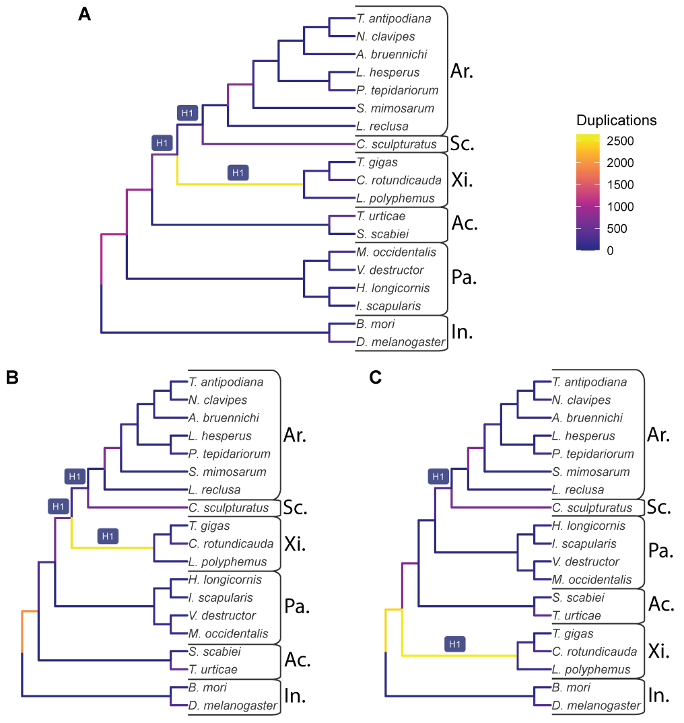

Figure 1: The input species trees used with GRAMPA, which are also the lowest scoring trees when considering possible WGDs at the branches labeled H1. Branches are shaded by the number of duplications that map to them. A) The species tree topology inferred in this study from 11,016 gene families. B) The species tree inferred by Ballesteros et al. (2022). C) A species tree that places horseshoe crabs (Xiphosura) sister to Arachnids. For all three trees, taxonomic groups are labeled as follows: Ar. = Araneae (spiders); Sc. = Scorpiones (scorpions); Xi. = Xiphosura (horseshoe crabs); Ac. = Acariformes (mites); Pa. = Parasitiformes (mites and ticks); In. = Insecta (insects).

## Figure 2

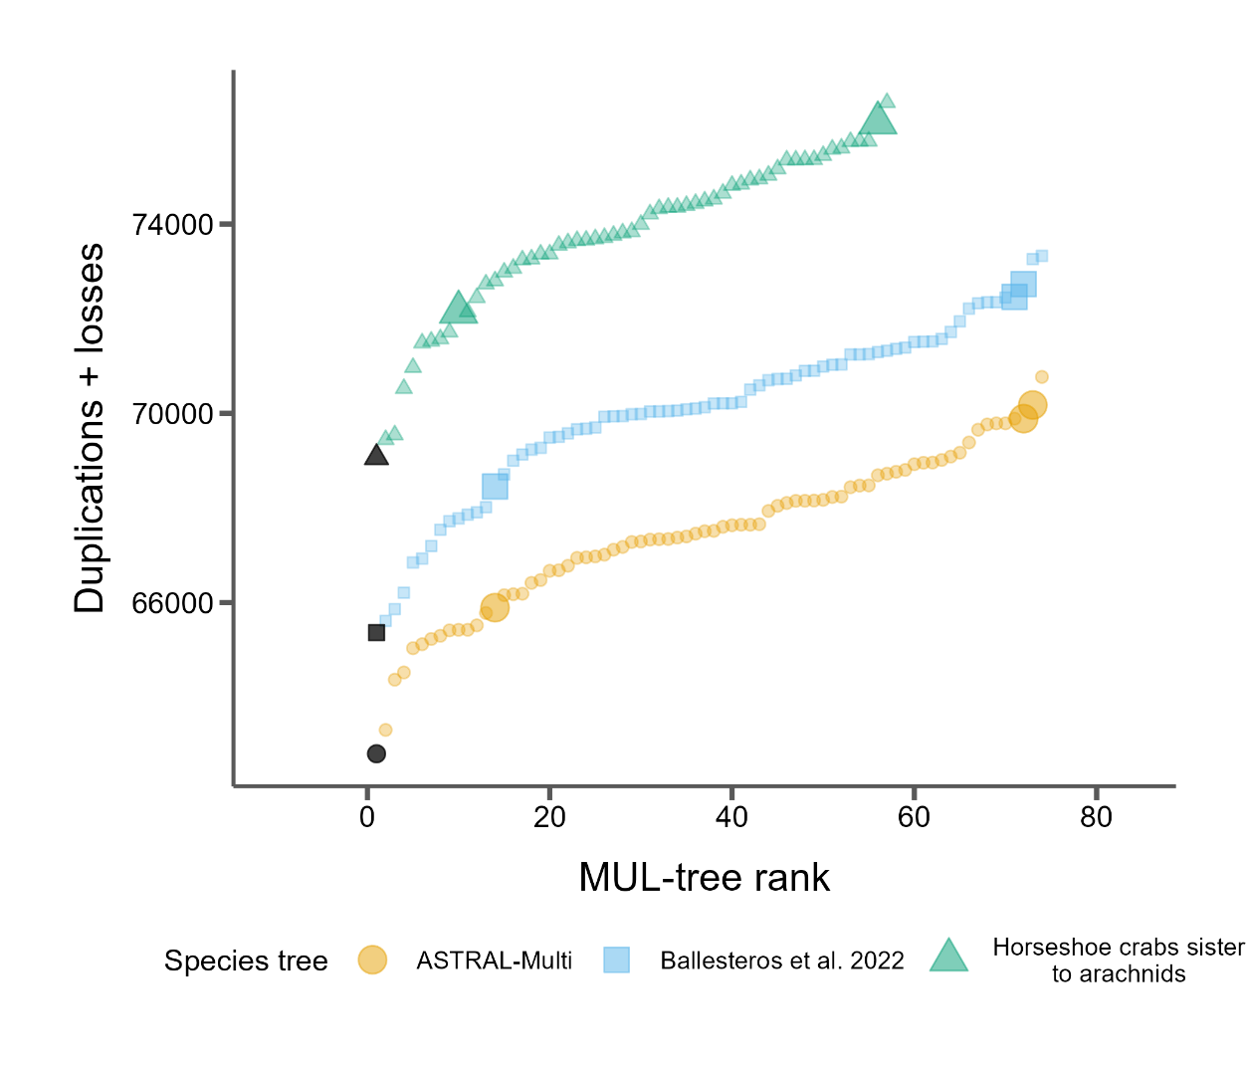

Figure 2: GRAMPA scores (duplications + losses) for every MUL-tree considered for each of the three species trees. Black points represent the input singly-labeled species tree with no WGD proposed. All other shaded points propose one WGD on one of the target H1 branches (see Fig. 1). Larger points indicate autopolyploidy scenarios and smaller dots indicate allopolyploidy scenarios.

## Figure 3

Figure 3: Distributions of *K*S(left) and synteny (right) for select samples (See Supplemental File X for all samples) from Acariformes (Ac.), Xiphosura (Xi.), Araneae (Ar.) and Scorpiones (Sc.). These samples all showed the highest levels of synteny among samples in each group. The species tree topology is shown on the far left.

# References

Adams KL, Wendel JF. 2005. Polyploidy and genome evolution in plants. *Curr Opin Plant Biol*. 8:135-141.

Amores A, Force A, Yan YL, Joly L, Amemiya C, Fritz A, Ho RK, Langeland J, Prince V, Wang YL, et al. 1998. Zebrafish hox clusters and vertebrate genome evolution. *Science*. 282:1711-1714.

Assembly [Internet]. Bethesda (MD): National Library of Medicine (US) NCBI. 2012 - [cited 2023 Sep 14]. Available from: <https://www.ncbi.nlm.nih.gov/assembly/>.

Ballesteros JA, Santibanez-Lopez CE, Baker CM, Benavides LR, Cunha TJ, Gainett G, Ontano AZ, Setton EVW, Arango CP, Gavish-Regev E, et al. 2022. Comprehensive species sampling and sophisticated algorithmic approaches refute the monophyly of arachnida. *Mol Biol Evol*. 39.

Ballesteros JA, Sharma PP. 2019. A critical appraisal of the placement of xiphosura (chelicerata) with account of known sources of phylogenetic error. *Syst Biol*. 68:896-917.

Barker MS, Arrigo N, Baniaga AE, Li Z, Levin DA. 2016. On the relative abundance of autopolyploids and allopolyploids. *New Phytologist*. 210:391-398.

Barker MS, Dlugosch KM, Dinh L, Challa RS, Kane NC, King MG, Rieseberg LH. 2010. Evopipes.Net: Bioinformatic tools for ecological and evolutionary genomics. *Evol Bioinform Online*. 6:143-149.

Blanc G, Wolfe KH. 2004. Widespread paleopolyploidy in model plant species inferred from age distributions of duplicate genes. *Plant Cell*. 16:1667-1678.

Cannon SB, McKain MR, Harkess A, Nelson MN, Dash S, Deyholos MK, Peng Y, Joyce B, Stewart CN, Jr., Rolf M, et al. 2015. Multiple polyploidy events in the early radiation of nodulating and nonnodulating legumes. *Mol Biol Evol*. 32:193-210.

Chen K, Durand D, Farach-Colton M. 2000. Notung: A program for dating gene duplications and optimizing gene family trees. *J Comput Biol*. 7:429-447.

Crow KD, Wagner GP, Investigators ST-NY. 2006. Proceedings of the smbe tri-national young investigators' workshop 2005. What is the role of genome duplication in the evolution of complexity and diversity? *Mol Biol Evol*. 23:887-892.

Dehal P, Boore JL. 2005. Two rounds of whole genome duplication in the ancestral vertebrate. *PLoS Biol*. 3:e314.

Fan Z, Yuan T, Liu P, Wang LY, Jin JF, Zhang F, Zhang ZS. 2021. A chromosome-level genome of the spider trichonephila antipodiana reveals the genetic basis of its polyphagy and evidence of an ancient whole-genome duplication event. *Gigascience*. 10.

Furlong RF, Holland PW. 2002. Were vertebrates octoploid? *Philosophical Transactions of the Royal Society of London. Series B: Biological Sciences*. 357:531-544.

Hoang DT, Chernomor O, von Haeseler A, Minh BQ, Vinh LS. 2018. Ufboot2: Improving the ultrafast bootstrap approximation. *Mol Biol Evol*. 35:518-522.

Hunter JD. 2007. Matplotlib: A 2d graphics environment. *Computing in Science & Engineering*. 9:90-95.

i5K C. 2013. The i5k initiative: Advancing arthropod genomics for knowledge, human health, agriculture, and the environment. *J Hered*. 104:595-600.

Junier T, Zdobnov EM. 2010. The newick utilities: High-throughput phylogenetic tree processing in the unix shell. *Bioinformatics*. 26:1669-1670.

Katoh K, Standley DM. 2013. Mafft multiple sequence alignment software version 7: Improvements in performance and usability. *Mol Biol Evol*. 30:772-780.

Kenny NJ, Chan KW, Nong W, Qu Z, Maeso I, Yip HY, Chan TF, Kwan HS, Holland PWH, Chu KH, Hui JHL. 2017. Ancestral whole-genome duplication in the marine chelicerate horseshoe crabs. *Heredity (Edinb)*. 119:388.

Li L, Stoeckert CJ, Jr., Roos DS. 2003. Orthomcl: Identification of ortholog groups for eukaryotic genomes. *Genome Res*. 13:2178-2189.

Lynch M, Conery JS. 2000. The evolutionary fate and consequences of duplicate genes. *Science*. 290:1151-1155.

Ma LJ, Ibrahim AS, Skory C, Grabherr MG, Burger G, Butler M, Elias M, Idnurm A, Lang BF, Sone T, et al. 2009. Genomic analysis of the basal lineage fungus rhizopus oryzae reveals a whole-genome duplication. *PLoS Genet*. 5:e1000549.

Masterson J. 1994. Stomatal size in fossil plants: Evidence for polyploidy in majority of angiosperms. *Science*. 264:421-424.

Nguyen LT, Schmidt HA, von Haeseler A, Minh BQ. 2015. Iq-tree: A fast and effective stochastic algorithm for estimating maximum-likelihood phylogenies. *Mol Biol Evol*. 32:268-274.

Nong W, Qu Z, Li Y, Barton-Owen T, Wong AYP, Yip HY, Lee HT, Narayana S, Baril T, Swale T, et al. 2021. Horseshoe crab genomes reveal the evolution of genes and micrornas after three rounds of whole genome duplication. *Commun Biol*. 4:83.

Nossa CW, Havlak P, Yue JX, Lv J, Vincent KY, Brockmann HJ, Putnam NH. 2014. Joint assembly and genetic mapping of the atlantic horseshoe crab genome reveals ancient whole genome duplication. *Gigascience*. 3:9.

Ohno S. 1970. Evolution by gene duplication: Springer-Verlag.

Ontano AZ, Gainett G, Aharon S, Ballesteros JA, Benavides LR, Corbett KF, Gavish-Regev E, Harvey MS, Monsma S, Santibanez-Lopez CE, et al. 2021. Taxonomic sampling and rare genomic changes overcome long-branch attraction in the phylogenetic placement of pseudoscorpions. *Mol Biol Evol*. 38:2446-2467.

Pfeil BE, Schlueter JA, Shoemaker RC, Doyle JJ. 2005. Placing paleopolyploidy in relation to taxon divergence: A phylogenetic analysis in legumes using 39 gene families. *Syst Biol*. 54:441-454.

Rabiee M, Sayyari E, Mirarab S. 2019. Multi-allele species reconstruction using astral. *Mol Phylogenet Evol*. 130:286-296.

Schwager EE, Sharma PP, Clarke T, Leite DJ, Wierschin T, Pechmann M, Akiyama-Oda Y, Esposito L, Bechsgaard J, Bilde T, et al. 2017. The house spider genome reveals an ancient whole-genome duplication during arachnid evolution. *BMC Biol*. 15:62.

Sela I, Ashkenazy H, Katoh K, Pupko T. 2015. Guidance2: Accurate detection of unreliable alignment regions accounting for the uncertainty of multiple parameters. *Nucleic Acids Res*. 43:W7-14.

Sharma PP, Kaluziak ST, Perez-Porro AR, Gonzalez VL, Hormiga G, Wheeler WC, Giribet G. 2014. Phylogenomic interrogation of arachnida reveals systemic conflicts in phylogenetic signal. *Mol Biol Evol*. 31:2963-2984.

Shingate P, Ravi V, Prasad A, Tay BH, Garg KM, Chattopadhyay B, Yap LM, Rheindt FE, Venkatesh B. 2020a. Chromosome-level assembly of the horseshoe crab genome provides insights into its genome evolution. *Nat Commun*. 11:2322.

Shingate P, Ravi V, Prasad A, Tay BH, Venkatesh B. 2020b. Chromosome-level genome assembly of the coastal horseshoe crab (tachypleus gigas). *Mol Ecol Resour*. 20:1748-1760.

Shultz JW. 1990. Evolutionary morphology and phylogeny of arachnida. *Cladistics*. 6:1-38.

Thomas GWC, Ather SH, Hahn MW. 2017. Gene-tree reconciliation with mul-trees to resolve polyploidy events. *Syst Biol*. 66:1007-1018.

Thomas GWC, Dohmen E, Hughes DST, Murali SC, Poelchau M, Glastad K, Anstead CA, Ayoub NA, Batterham P, Bellair M, et al. 2020. Gene content evolution in the arthropods. *Genome Biol*. 21:15.

Van de Peer Y, Ashman TL, Soltis PS, Soltis DE. 2021. Polyploidy: An evolutionary and ecological force in stressful times. *Plant Cell*. 33:11-26.

Wang Y, Tang H, Debarry JD, Tan X, Li J, Wang X, Lee TH, Jin H, Marler B, Guo H, et al. 2012. Mcscanx: A toolkit for detection and evolutionary analysis of gene synteny and collinearity. *Nucleic Acids Res*. 40:e49.

Werth CR, Windham MD. 1991. A model for divergent, allopatric speciation of polyploid pteridophytes resulting from silencing of duplicate-gene expression. *The American Naturalist*. 137:515-526.

Weygoldt P, Paulus HF. 1979. Untersuchungen zur morphologie, taxonomie und phylogenie der chelicerata1 ii. Cladogramme und die entfaltung der chelicerata. *Journal of Zoological Systematics and Evolutionary Research*. 17:177-200.

Wolfe KH. 2001. Yesterday's polyploids and the mystery of diploidization. *Nat Rev Genet*. 2:333-341.

Wolfe KH, Shields DC. 1997. Molecular evidence for an ancient duplication of the entire yeast genome. *Nature*. 387:708-713.

Yan Z, Cao Z, Liu Y, Ogilvie HA, Nakhleh L. 2022. Maximum parsimony inference of phylogenetic networks in the presence of polyploid complexes. *Syst Biol*. 71:706-720.

Yates AD, Allen J, Amode RM, Azov AG, Barba M, Becerra A, Bhai J, Campbell LI, Carbajo Martinez M, Chakiachvili M, et al. 2022. Ensembl genomes 2022: An expanding genome resource for non-vertebrates. *Nucleic Acids Res*. 50:D996-D1003.