A comprehensive examination of Chelicerate genomes reveals no evidence for a whole genome duplication among spiders and scorpions

Gregg W.C. Thomas1, Michael T.W. McKibben2, Matthew W. Hahn3,4, Michael S. Barker2

1Informatics Group, Harvard University, Cambridge, MA, USA

2Department of Ecology & Evolutionary Biology, University of Arizona, Tucson, AZ, USA

3Department of Biology, Indiana University, Bloomington, IN, USA

4Department of Computer Science, Indiana University, Bloomington, IN, USA

# Abstract

Whole genome duplications (WGDs) can be a key event in evolution, playing a role in both adaptation and speciation. While WGDs are common throughout the history of plants, only a few examples have been proposed in metazoans. Among these, recent proposals of multiple WGD events in Chelicerates, the group of Arthropods that includes horseshoe crabs, ticks, scorpions, and spiders, have relied on evidence from a small number of incomplete genomes. Specifically, several rounds of WGD have been proposed in the history of horseshoe crabs, with an additional WGD proposed in the ancestor of spiders and scorpions. However, many of these inferences are based on evidence from only a small portion of the genome (in particular, the *Hox* gene cluster); therefore, genome-wide inferences with broader species sampling may give a clearer picture of WGDs in this clade. Here, we investigate signals of WGD in Chelicerates using whole genomes from 17 species. We employ multiple methods to look for these signals, including gene tree analysis of thousands of gene families, comparisons of synteny, and signals of divergence among within-species paralogs. We test several scenarios of WGD in Chelicerates using multiple species trees as a backbone for all hypotheses. While we do find support for at least one WGD in the ancestral horseshoe crab lineage, we find no evidence for a WGD in the history of spiders and scorpions using any genome-scale method. This study not only sheds light on genome evolution and phylogenetics within Chelicerates, but also demonstrates how a combination of comparative methods can be used to investigate signals of ancient WGDs.

# Introduction

Whole genome duplications (WGDs) occur when an individual retains both sets of chromosomes from one or more parents. While such events are often highly deleterious, occasionally the combination of novel genetic material can provide advantages that allow the whole genome duplication to propagate, resulting in a polyploid species with more than 2n chromosomes in its genome. WGDs have been important evolutionary events, with some evidence pointing to an association between environmental stress and the success of polyploid species (Van de Peer, et al. 2021). WGDs are common in plants (Masterson 1994; Adams and Wendel 2005; Barker, et al. 2016; One Thousand Plant Transcriptomes 2019), but there are also a smaller number of important genome duplications in the history of fungi (Wolfe and Shields 1997; Ma, et al. 2009) and vertebrates (Ohno 1970; Furlong and Holland 2002; McLysaght, et al. 2002).

A common process in the evolution of polyploid species is diploidization, which is the loss of many of the excess genes and chromosomes that resulted from the WGD (Li, et al. 2021). The end result of diploidization is a return of the gene-content of the polyploid species to a nearly diploid state, with most paralogous genes that resulted from the WGD being lost or unidentifiable as paralogs (Wolfe 2001). Nevertheless, even in paleopolyploid species that have had ancient WGDs and have undergone diploidization, signatures of the WGD can remain in their genomes. For example, an excess of paralogs in the genome will have an origin that approximately coincides with the timing of the WGD. The timing of such events can be determined by multiple methods. One class of methods, generally referred to as gene tree-species tree reconciliation, uses gene tree topologies to map duplication events onto branches of the species tree (Pfeil, et al. 2005; Cannon, et al. 2015; Thomas, et al. 2017; Yan, et al. 2022). These topological methods can also potentially identify the mode of polyploidy (Thomas, et al. 2017) and more accurately identify independent WGDs when diploidization occurs during speciation (Redmond, et al. 2023). A second class of methods examines pairwise divergence between paralogs in the same species, with the expectation that a WGD event will lead to a peak of synonymous divergence (*K*S) between paralogs (Lynch and Conery 2000; Blanc and Wolfe 2004; Tiley, et al. 2018). Finally, there may also be syntenic evidence for the WGD in polyploids, where whole paralogous regions of the same genome (including both coding and non-coding sequence) trace their history to the WGD event (Tang, et al. 2008; Hao, et al. 2021).

Recently, WGDs have been proposed in the history of the Arthropod sub-phylum Chelicerata, which includes horseshoe crabs, sea spiders, mites, ticks, scorpions, and spiders. In horseshoe crabs, counts of gene duplications, paralog divergence estimates, and syntenic blocks suggest whole genome duplication has occurred during their evolution (Nossa, et al. 2014; Shingate, Ravi, Prasad, Tay, et al. 2020). Examination of the *Hox* gene cluster has also been used to suggest that there have been anywhere between one and three WGDs during the course of horseshoe crab evolution (Kenny, et al. 2017; Shingate, Ravi, Prasad, Tay, et al. 2020; Shingate, Ravi, Prasad, Tay and Venkatesh 2020). Similar approaches also form the basis for the claim that a WGD has occurred in the lineage ancestral to extant spiders and scorpions (Sharma, et al. 2014; Clarke, et al. 2015; Schwager, et al. 2017; Leite, et al. 2018; Fan, et al. 2021; Harper, et al. 2021; Aase-Remedios, et al. 2023). In both cases, the number of genes or genomes used for analysis has been limited. In addition, while the duplication of a conserved gene cluster (i.e. the *Hox* cluster) may be indicative of a larger (perhaps whole genome) duplication event, it is too limited a dataset with which to confirm such an event. As well as issues with the amount of data used for inferences, recent evidence supports an alternate placement of horseshoe crabs in the chelicerate phylogeny. Traditionally, the aquatic horseshoe crabs have been thought to be sister to all arachnids (spiders, scorpions, mites, and ticks), which are mostly terrestrial (Weygoldt and Paulus 1979). However, the possibility of polyphyletic origins of arachnids has been considered (see Shultz 1990) and some molecular studies have supported a scenario of polyphyletic arachnids (Sharma, et al. 2014; Ballesteros and Sharma 2019; Ontano, et al. 2021). Recently, Ballesteros, et al. (2022) presented strong evidence for horseshoe crabs being nested within arachnids, sister to spiders and scorpions, making arachnids polyphyletic. This newly proposed species tree could substantially impact how WGDs are inferred within this group when phylogenetic methods are used (McKibben, et al. 2024).

Here, we use whole-genome sequences from 17 chelicerate species, in combination with several different analytical methods, to look for ancient WGDs in this group. These methods include gene tree reconciliation, synonymous divergence between paralogs, and whole-genome analyses of synteny. Using multiple species trees as a backbone for analysis, we find no evidence for a WGD taking place in the history of spiders and scorpions. In contrast, our suite of methods all find some evidence for at least one WGD occurring during the evolution of horseshoe crabs, even in light of their new placement in the chelicerate phylogeny.

# Methods

*Data*

To investigate the possible existence of whole genome duplication (WGD) events in chelicerates on a genome-wide scale, we took a multi-faceted approach. We initially downloaded 18 chelicerate genomes with annotations available at the beginning of this project from various sources: NCBI’s Assembly database (2012 - [cited 2023 Sep 14]), Ensembl Metazoa (Yates, et al. 2022; release 51), the i5k database (i5K 2013; Thomas, et al. 2020), and, for two samples, the data supplements of their genome publications (Fan, et al. 2021; Nong, et al. 2021). These genomes span the various taxonomic groups contained within the subphylum Chelicerata, including four species from the superorder Parasitiformes (mites and ticks), two species from the superorder Acariformes (mites), eight species from the order Araneae (spiders), one species from the order Scorpiones (scorpions), and four species from the order Xiphosura (horseshoe crabs) (Fig. 1). For this study, we treat Parasitiformes and Acariformes as orders. For phylogenetic analyses, we also include two insects (*Drosophila melanogaster* and *Bombyx mori*) as outgroups for tree rooting. See Supplemental Table S1 for full details of the samples and summaries of their assemblies and annotations.

We observed that annotations of one of the horseshoe crabs, *Tachypleus tridentatus*, contained 79,557 genes, more than twice as many as any other species in our sample, including the other horseshoe crabs. While on the surface this may indeed be indicative of a recent WGD in this species, we also note that the median gene length for this species is only 1,377 bp. While this is not the shortest gene length in our sample, it is considerably smaller than the rest of the horseshoe crabs, which all have a median gene length of over 8,500 bp (see Supplemental Table S1). Because this could be indicative of annotation error in this species and because we are interested in ancient rather than recent WGDs, we excluded this sample from our analyses. In total, our final dataset contained 17 chelicerate species and 2 outgroup insects for analyses that span almost 600 million years of genome evolution.

## Gene tree reconciliation analysis

We extracted the coding sequence of the longest transcript from each gene in each of our 19 species and used FastOrtho (<https://github.com/olsonanl/FastOrtho>), which is a reimplementation of orthomcl (Li, et al. 2003), to cluster genes into gene families. Using an inflation value of 3, we inferred 49,561 gene families. We then extracted the sequences in each gene family, correcting for inconsistencies resulting from the data originating from various sources and aligned each gene family with Guidance2 (Sela, et al. 2015) using MAFFT (Katoh and Standley 2013) as the underlying aligner, and removing any alignment columns with a score below 0.93. We also performed our own alignment filtering by removing columns in sliding windows of 3 codons that have 2 codons with 2 or more gaps in 50% of the sequences in that alignment. We also removed any sequences that were made up of greater than 20% gap characters and removed any alignments with sequences from fewer than 4 species or that were shorter than 33 codons after all filtering. See Supplementary Table S2 for alignment filtering details.

We translated the remaining 11,016 alignments from nucleotides to amino acids and inferred gene trees with IQ-TREE (Nguyen, et al. 2015) using ultrafast bootstrap (Hoang, et al. 2018); the gene trees were used to infer a species tree with ASTRAL-Multi (Rabiee, et al. 2019). For subsequent reconciliation analyses, we rooted our gene and species trees using the outgroup insects with Newick Utilities (nw_reroot; Junier and Zdobnov 2010). Gene trees that could not be rooted because there was no outgroup were excluded from reconciliation analyses. After rooting, we retained gene trees from 6,368 gene families. To further reduce possible gene tree inference error, we used bootstrap rearrangement implemented in Notung (Chen, et al. 2000) with a bootstrap threshold of 90. This method forces inferred duplications on branches in our gene trees with a bootstrap score less than this threshold to be resolved in such a way that minimizes the number of duplications and losses counted in the tree.

We used these 6,368 rooted, bootstrap-resolved gene trees and a species tree as input to GRAMPA (Thomas, et al. 2017) to identify the placement of any WGDs in the chelicerate phylogeny. Briefly, GRAMPA performs least common ancestor (LCA) mapping from each gene tree to the species tree but allows for WGDs to be present in the species tree by representing them as multi-labeled trees (MUL-trees), in which one or more tip labels appear twice. By comparing LCA mapping scores between the input species tree and a set of MUL-trees defined by target lineages, GRAMPA can determine if a WGD has occurred on a hypothesized lineage. For our runs, we set as target lineages for WGD identification those on which WGDs have previously been proposed: specifically, the branch leading to spiders and scorpions and the branch leading to horseshoe crabs. We also used multiple different species trees as input to GRAMPA to test the same scenarios. In addition to the species tree we inferred using ASTRAL (Fig. 1A), the two alternate species tree topologies we tested were a recently inferred phylogeny from Ballesteros, et al. (2022)—in which horseshoe crabs group within arachnids, specifically sister to spiders and scorpions (Fig. 1B)—and a ‘traditional’ species tree topology, in which horseshoe crabs are sister to all arachnid species (Fig. 1C). For the ‘traditional’ tree, because of the unresolved placement of Acariformes and Parasitiformes (Sharma, et al. 2014; Ontano, et al. 2021), we simply use the topology recovered by Ballesteros, et al. (2022) and manually placed horseshoe crabs sister to arachnids.

## Synteny analysis

We used estimates of synteny to test for paleopolyploid ancestry in each of our 19 species. Self-self syntenic analyses for each genome were made using MCScanX (Wang et al. 2012). We used the default settings of MCScanX to detect and visualize intraspecific syntenic blocks. Given that ancient WGDs may be highly fractionated, we also used a minimum block size of 3 to recover potentially highly fragmented blocks of synteny.

## Synonymous divergence between paralogs (K**S**)

To construct gene families and to estimate the age distribution of gene duplications we used the DupPipe pipeline (Barker et al. 2008; Barker et al. 2010). Briefly, DupPipe translates coding transcripts from nucleotide to peptide sequences and identifies reading frames by comparing Genewise (Birney, et al. 2004) alignments to the best-hit protein from a collection of proteins from the 19 sampled genomes. For all DupPipe runs, we used protein-guided DNA alignments to align our nucleic acid sequences while maintaining the reading frame. We estimated synonymous divergence (*K*S) using PAML (Yang 2007) with the F3X4 model for each node in the gene-family phylogenies. We identified peaks of gene duplication as evidence for potential ancient WGDs in histograms of the age distribution of gene duplications (*K*S plots). To infer ancient WGDs in the paralog age distributions, we used a recently developed machine learning approach, SLEDGe (Sutherland, et al. 2024), to classify *K*S plots with peaks consistent with an ancient WGD. Specifically, we applied the support vector machine classifier from SLEDGe on node *K*S values for species that had greater than 1,500 gene duplicates, subsampling down to 3,000 duplicates when more than 3,000 were present. For each *K*S distribution that SLEDGe predicted as being indicative of a WGD, we also used mixture modeling and manual curation to identify significant peaks of gene duplication consistent with a WGD and to estimate their median paralog *K*S values. We ran normalmixEM for a maximum of 400 iterations to fit the maximum number of *k*-components for each *K*S distribution selected from a likelihood ratio test available in the boot.comp function from the mixtools R library (Benaglia, et al. 2009). Finally, to assess if WGD peaks in the paralog *K*Sdistributions were shared between species we used OrthoPipe from EvoPipes (Barker et al. 2008; Barker et al. 2010) to identify orthologs between species and PAML (Yang et al. 2000; Yang et al. 2007) to estimate their *K*S using the same procedure and protein database as described for the DupPipe analyses. We then assessed species divergence by estimating the median *K*S of all orthologs with a *K*S of 5 or lower for each species pair and compared to the median *K*S of each WGD peak.

# Results

## Inference of the species tree

We used the genomes of 17 chelicerates and 2 insect outgroups to reconstruct the Chelicerata phylogeny, with an emphasis on Arachnids and horseshoe crabs. Using 11,016 gene trees we confirm the placement of Xiphosura (horseshoe crabs) as nested within Arachnids (Fig. 1A), in agreement with Ballesteros et al. (Fig 1B; Ballesteros, et al. 2022). However, our inferred tree differs from theirs in the placement of the superorders Acariformes and Parasitiformes. Our results show that Acariformes is sister to the spider, scorpion, and horseshoe crab clade, while Ballesteros, et al. (2022) suggest that Parasitiformes is more closely related to them. However, the placement of these groups is also ambiguous in their analyses and has been contentious in previous studies (Sharma, et al. 2014; Ontano, et al. 2021).

## Reconciliation analysis

We used the inferred species tree, as well as two other hypothesized sets of relationships, to test various hypotheses of WGD in the history of chelicerate evolution. Specifically, based on synteny and duplication of some gene families, multiple rounds of WGD have been proposed in horseshoe crabs (Nossa, et al. 2014; Kenny, et al. 2017; Shingate, Ravi, Prasad, Tay, et al. 2020; Shingate, Ravi, Prasad, Tay and Venkatesh 2020), and, based on the duplication of the *Hox* gene cluster, one WGD has been proposed in the ancestor of spiders and scorpions (Schwager, et al. 2017). Using gene tree topologies from thousands of genes, GRAMPA (Thomas, et al. 2017) finds no evidence for a WGD in the history of spiders and scorpions using either our inferred species tree, the Ballesteros, et al. (2022) species tree, or the traditional species tree in which horseshoe crabs are sister to Arachnids (Figs. 1 and 2). In each case, we tested whether the species tree with a WGD proposed on any of the target lineages (H1 lineages in Fig. 1) better explains the duplication history of the genes in these genomes than a species tree with no proposed WGDs. However, in each case we find that the species tree without any proposed WGDs results in the lowest duplication and loss score (black shapes in Fig. 2). Our evidence is definitive for any WGD in the history of spiders and scorpions; however, we do see evidence for large scale duplications on the branch leading to horseshoe crabs regardless of the species tree used (Fig. 1). We also find that the second- and third-lowest scoring scenarios when using our inferred species tree posit a WGD in horseshoe crabs (Fig. 2, Supplemental Table S3, Fig. S1). The horseshoe crab clade is also often inferred as being involved in a WGD in the next lowest scoring MUL-trees when using the other two species trees, but usually in more complicated scenarios (Figs. S1 and S2; Supplemental Tables S4 and S5). That is, while GRAMPA did not find that a WGD in the history of horseshoe crabs as the single most parsimonious reconciliation, there are multiple pieces of evidence that point to one or more possibly occurring.

We also find that, when comparing reconciliation scores between species trees, our species tree and the Ballesteros, et al. (2022) species tree both explain the history of gene duplication and loss better than the ‘traditional’ species tree in which horseshoe crabs are not nested within Arachnids (Fig. 2). This is further evidence in favor of the placement of this group as sister to spiders and scorpions. While our species tree always better explains the data than Ballesteros et al. (2002), this should not be surprising since we inferred our tree from these data.

## Synteny and KS analyses

We next looked at other genome-wide signatures of WGDs among chelicerates. Specifically, we looked for intraspecific syntenic blocks, which should be widespread in genomes that have undergone WGD, and distributions of synonymous divergence (*K*S) of paralogs within each genome. If a WGD has occurred in the history of a genome, a secondary peak of *K*S should be present in these distributions. Across both analyses, we again find no evidence for WGD in any spider or scorpion genomes but do find suggestive evidence for at least one occurring in the history of horseshoe crabs (Fig. 3). Only two species, *C. rotundicauda* and *T. gigas*, both horseshoe crabs, showed substantial amounts of intraspecific synteny. Both of these species, along with the other horseshoe crab, *L. polyphemus*, were also predicted by SLEDGe to have signatures of WGD in their *K*Sdistributions (Fig. 3, Supplemental Table S6). Mixture models placed the median *K*Sof this duplication at ~0.85-1.35 (Fig. 3, Supplemental Table S6). The average ortholog divergence between the three horseshoe crabs was ~0.22, compared to the average divergence with *C. sculpturatus* at ~4.09, suggesting the WGD peak corresponds to the same branch identified with an excess number of gene duplications and losses in our gene tree topology reconciliation analysis above (Fig. 1, Fig. 3, Supplemental Table S7). In addition, one mite species, *Tetranychus urticae*, was predicted by SLEDGe to contain a WGD in its *K*S distribution (Fig. 3). However, this species had few intraspecific syntenic blocks (Fig. 3; Supplemental Table S6) and no signal of excess duplication in the reconciliation analysis (Fig. 1).

# Discussion

Whole genome duplications (WGDs) can be a key event in the evolution of a species, possibly facilitating adaptation (Ohno 1970; Werth and Windham 1991; Adams and Wendel 2005; Crow, et al. 2006). While the process of diploidization (the return of the genome to a diploid state after WGD) can make more ancient WGDs harder to detect, multiple methods have been developed that have the potential to capture the signal of these events in extant genomes. Here, we used several of these methods to investigate the existence of ancient WGDs in the Chelicerates (Nossa, et al. 2014; Kenny, et al. 2017; Shingate, Ravi, Prasad, Tay, et al. 2020; Shingate, Ravi, Prasad, Tay and Venkatesh 2020). Several rounds of WGD have been proposed in the history of horseshoe crab evolution, and a single WGD has been proposed in the ancestor of spiders and scorpions (Sharma, et al. 2014; Clarke, et al. 2015; Schwager, et al. 2017; Leite, et al. 2018; Fan, et al. 2021; Harper, et al. 2021; Aase-Remedios, et al. 2023). The evidence for these events usually starts with the observation of the duplication of a well-conserved gene family cluster, the *Hox* genes. Further investigations of intraspecific synteny, gene tree topologies, and divergence have also been used previously, but until now have been limited to only a few genes or genomes.

Using 17 chelicerate whole genomes we find no evidence for a WGD in the history of spiders and scorpions. When reconciling gene tree topologies to a species tree that allows for the inference of WGDs, the best-scoring scenario is always the one without any WGDs, regardless of the input species tree topology used. For spiders and scorpions, we also see no excess intraspecific synteny or peaks in divergence of paralogs that would indicate a WGD. This implies that the two copies of the *Hox* gene cluster observed in some spiders and scorpions may instead be the result of a more limited duplication event. While *Hox* gene clusters are thought to be relatively slowly evolving outside of WGDs, this is not always the case (Mulhair, et al. 2023; Mulhair and Holland 2024). Therefore, inferences about WGDs should not be made from the *Hox* cluster alone (e.g. Farhat, et al. 2023).

We do find some evidence for WGDs during horseshoe crab evolution. While no MUL-trees are the single-most optimal solution in the gene tree analysis, we do find a burst of gene duplications on the branch leading to horseshoe crabs. This burst is observed regardless of the species tree considered (Fig. 1). Previously, anywhere from one to three WGDs have been proposed along the horseshoe crab lineage. In fact, if multiple WGDs occurred, this may diminish the signal for any single proposed MUL-tree. Since our tests using GRAMPA are limited to a single MUL-tree, this may in turn hinder our ability to explicitly identify any single WGD as the most parsimonious scenario. In addition to the large number of duplications on the horseshoe crab lineage, we also observe notable intraspecific synteny and peaks in divergence of paralogs (Fig. 3).

In the course of our study of WGDs in Chelicerates, we also reconstructed a species tree for our 17 species (Fig. 1A). Using our whole genome data and including paralogs in our species tree inference, we find that the horseshoe crabs (Xiphosura) are nested within Arachnids, directly sister to spiders (Araneae) and scorpions (Scorpiones). This agrees with several recent molecular phylogenies of this group (Sharma, et al. 2014; Ballesteros and Sharma 2019; Ontano, et al. 2021; Ballesteros, et al. 2022), and rejects a tree suggested by the biomes in which the organisms live, where the aquatic horseshoe crabs are sister to the mostly terrestrial arachnids (Fig. 1C). In this traditional monophyletic Arachnid tree, separate WGDs would need to be proposed for both spiders/scorpions and horseshoe crabs. However, the molecular trees allow the possibility that a single WGD took place in the ancestor of spiders, scorpions, and horseshoe crabs. We also tested this scenario (Fig. 1A) and were able to rule out this possibility.

Our work shows that, even for ancient polyploids, whole genome comparative evidence can still find signals of WGDs. While the duplication of a single gene family can be a good initial clue that a WGD has occurred, as it was for metazoans (Amores, et al. 1998), whole genome evidence is still needed for a more confident inference (Furlong and Holland 2002; McLysaght, et al. 2002; Hokamp, et al. 2003; Dehal and Boore 2005). Our work shows that this is also the case for Chelicerates. In horseshoe crabs, duplications in *Hox* gene clusters coincide with synteny, peaks of synonymous divergence in intraspecific paralogs, and gene duplication reconciliation in the Chelicerate phylogeny. None of these additional pieces of evidence is present in the lineage leading to spiders and scorpions. Our work also adds to the growing body of evidence that horseshoe crabs are not sister to all arachnids as was traditionally thought, but rather are placed within the arachnid group, directly sister to spiders and scorpions.

# Data availability

The genomes used in our analyses are available from their respective databases (see Supplemental Table S1). All other data generated for this project (gene alignments, gene trees, etc.) are available on XX. Scripts used to parse and analyze this data are available at <https://github.com/gwct/spider-wgd>.

# Acknowledgements

We thank Zheng Li for helpful discussions on our analyses. Gene family analysis was performed on the FASRC Cannon cluster supported by the FAS Division of Science Research Computing Group at Harvard University. M.W.H. was supported by National Science Foundation grant DEB-1936187.

# Figures

## Figure 1

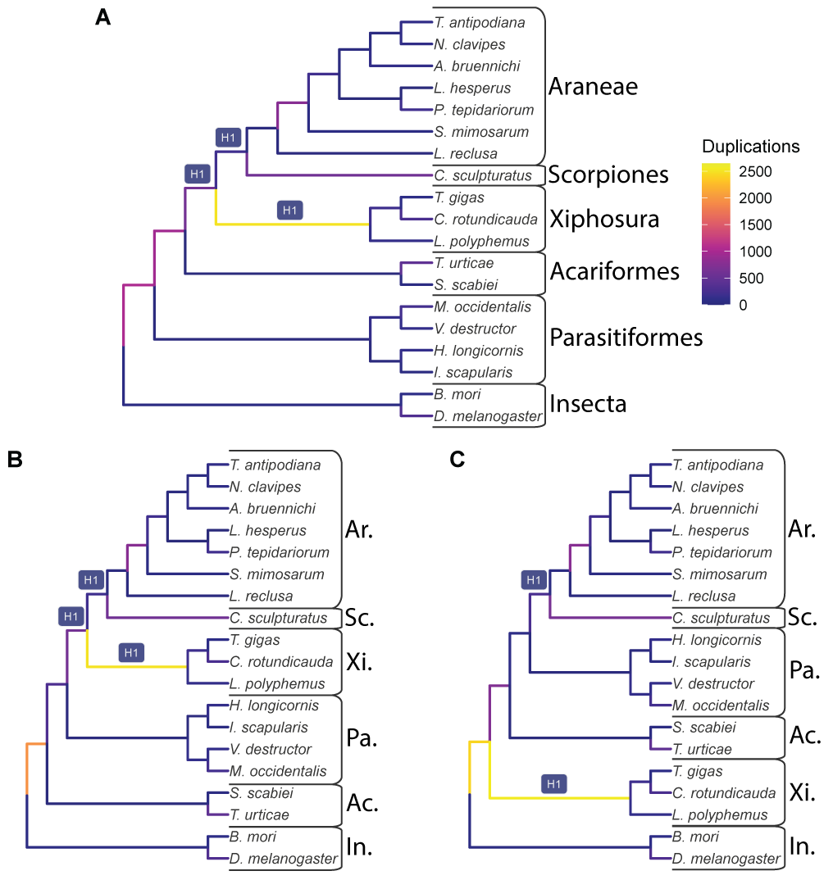

Figure 1: The input species trees used with GRAMPA, which are also the lowest scoring trees when considering possible WGDs at the branches labeled H1. Branches are shaded by the number of duplications that map to them. A) The species tree topology inferred in this study from 11,016 gene families. B) The species tree inferred by Ballesteros, et al. (2022). C) A species tree that places horseshoe crabs (Xiphosura) sister to Arachnids. For all B and C, taxonomic groups are labeled as follows: Ar. = Araneae (spiders); Sc. = Scorpiones (scorpions); Xi. = Xiphosura (horseshoe crabs); Ac. = Acariformes (mites); Pa. = Parasitiformes (mites and ticks); In. = Insecta (insects).

## Figure 2

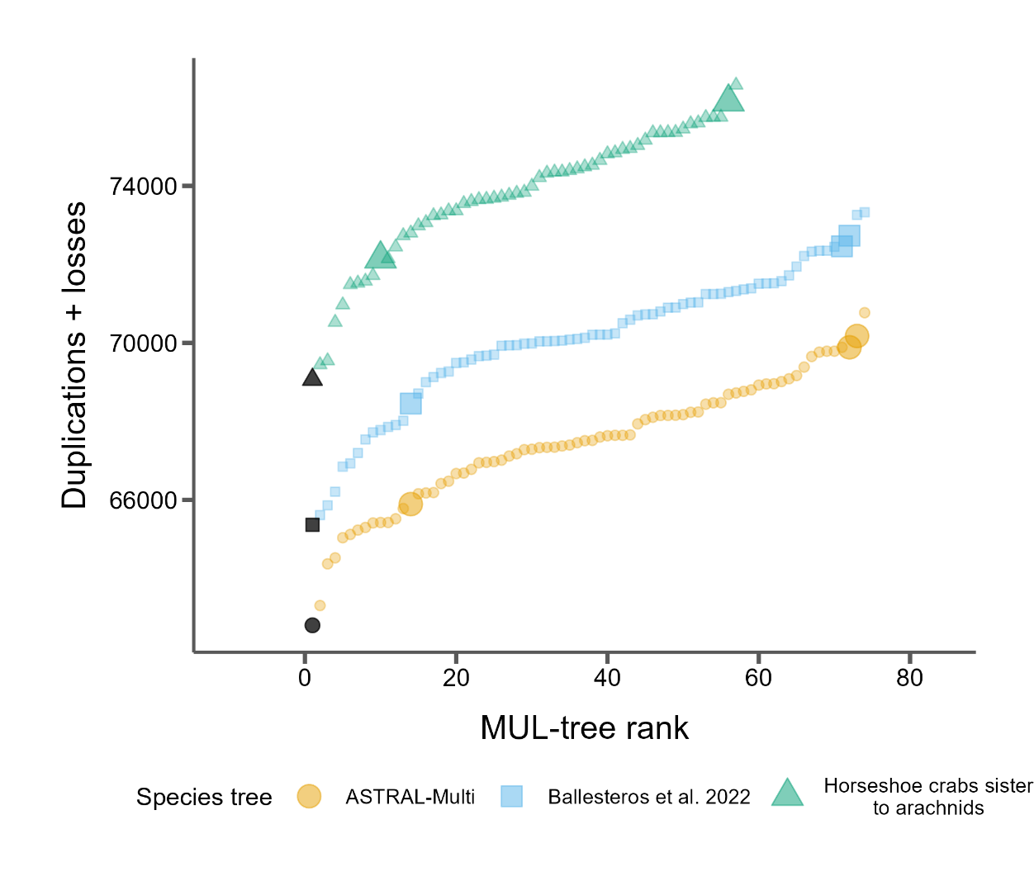

Figure 2: GRAMPA scores (duplications + losses) for every MUL-tree considered for each of the three species trees. Black points represent the input singly-labeled species tree with no WGD proposed. All other shaded points propose one WGD on one of the target H1 branches (see Fig. 1). Larger points indicate autopolyploidy scenarios and smaller dots indicate allopolyploidy scenarios.

## Figure 3

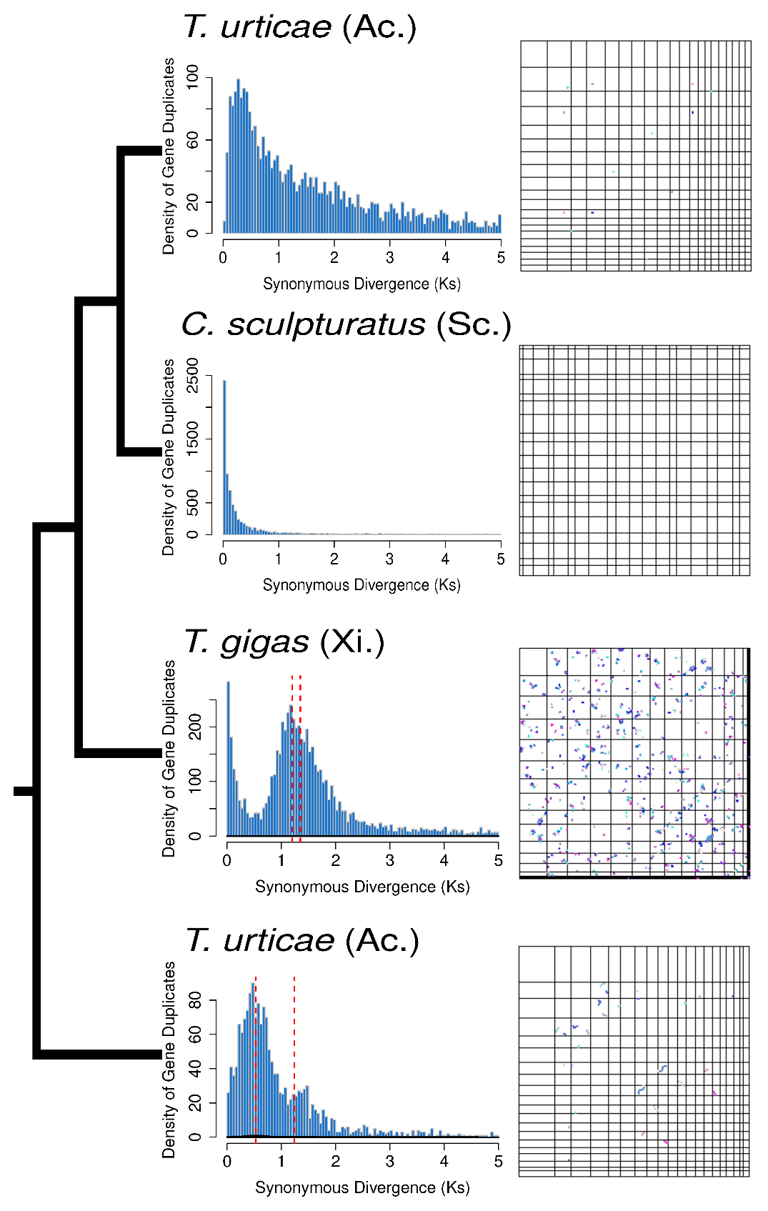

Figure 3: Distributions of *K*S(left) and synteny (right) for select samples (See Figs. S5 and S6 for all samples) from Acariformes (Ac.), Xiphosura (Xi.), Araneae (Ar.) and Scorpiones (Sc.). These samples all showed the highest levels of synteny among samples in each group. The species tree topology is shown on the far left. Red dotted lines indicate the median KS of mixture models fit to distributions that were predicted by SLEDGe to be indicative of WGDs.

# Supplemental Figure Legends

## Figure S1

The lowest scoring MUL-trees from the GRAMPA analysis using our inferred species tree.

## Figure S2

The lowest scoring MUL-trees from the GRAMPA analysis using the Ballesteros, et al. (2022) species tree.

## Figure S3

The lowest scoring MUL-trees from the GRAMPA analysis using a traditional species tree with horseshoe crabs sister to arachnids.

## Figure S4

Dot plots showing intra-species synteny for all species (19 panels, labeled with species name) with a max block size of 3.

## Figure S5

Dot plots showing intra-species synteny for all species (19 panels, labeled with species name) with a max block size of 5.

Figure S6

Distributions of Ks between paralogs of all species (19 panels, labeled with species name). Dashed red lines indicate the median Ks of mixture models fit to each Ks distribution that was indicative of a WGD.

# References

Aase-Remedios ME, Janssen R, Leite DJ, Sumner-Rooney L, McGregor AP. 2023. Evolution of the Spider Homeobox Gene Repertoire by Tandem and Whole Genome Duplication. Mol Biol Evol 40.

Adams KL, Wendel JF. 2005. Polyploidy and genome evolution in plants. Curr Opin Plant Biol 8:135-141.

Amores A, Force A, Yan YL, Joly L, Amemiya C, Fritz A, Ho RK, Langeland J, Prince V, Wang YL, et al. 1998. Zebrafish hox clusters and vertebrate genome evolution. Science 282:1711-1714.

Assembly [Internet]. Bethesda (MD): National Library of Medicine (US) NCBI. 2012 - [cited 2023 Sep 14]. Available from: <https://www.ncbi.nlm.nih.gov/assembly/>.

Ballesteros JA, Santibanez-Lopez CE, Baker CM, Benavides LR, Cunha TJ, Gainett G, Ontano AZ, Setton EVW, Arango CP, Gavish-Regev E, et al. 2022. Comprehensive Species Sampling and Sophisticated Algorithmic Approaches Refute the Monophyly of Arachnida. Mol Biol Evol 39.

Ballesteros JA, Sharma PP. 2019. A Critical Appraisal of the Placement of Xiphosura (Chelicerata) with Account of Known Sources of Phylogenetic Error. Syst Biol 68:896-917.

Barker MS, Arrigo N, Baniaga AE, Li Z, Levin DA. 2016. On the relative abundance of autopolyploids and allopolyploids. New Phytologist 210:391-398.

Benaglia T, Chauveau D, Hunter DR, Young DS. 2009. mixtools: An R Package for Analyzing Mixture Models. Journal of Statistical Software 32:1 - 29.

Birney E, Clamp M, Durbin R. 2004. GeneWise and Genomewise. Genome Res 14:988-995.

Blanc G, Wolfe KH. 2004. Widespread paleopolyploidy in model plant species inferred from age distributions of duplicate genes. Plant Cell 16:1667-1678.

Cannon SB, McKain MR, Harkess A, Nelson MN, Dash S, Deyholos MK, Peng Y, Joyce B, Stewart CN, Jr., Rolf M, et al. 2015. Multiple polyploidy events in the early radiation of nodulating and nonnodulating legumes. Mol Biol Evol 32:193-210.

Chen K, Durand D, Farach-Colton M. 2000. NOTUNG: a program for dating gene duplications and optimizing gene family trees. J Comput Biol 7:429-447.

Clarke TH, Garb JE, Hayashi CY, Arensburger P, Ayoub NA. 2015. Spider Transcriptomes Identify Ancient Large-Scale Gene Duplication Event Potentially Important in Silk Gland Evolution. Genome Biol Evol 7:1856-1870.

Crow KD, Wagner GP, Investigators ST-NY. 2006. Proceedings of the SMBE Tri-National Young Investigators' Workshop 2005. What is the role of genome duplication in the evolution of complexity and diversity? Mol Biol Evol 23:887-892.

Dehal P, Boore JL. 2005. Two rounds of whole genome duplication in the ancestral vertebrate. PLoS Biol 3:e314.

Fan Z, Yuan T, Liu P, Wang LY, Jin JF, Zhang F, Zhang ZS. 2021. A chromosome-level genome of the spider Trichonephila antipodiana reveals the genetic basis of its polyphagy and evidence of an ancient whole-genome duplication event. Gigascience 10.

Farhat S, Modica MV, Puillandre N. 2023. Whole Genome Duplication and Gene Evolution in the Hyperdiverse Venomous Gastropods. Mol Biol Evol 40.

Furlong RF, Holland PW. 2002. Were vertebrates octoploid? Philosophical Transactions of the Royal Society of London. Series B: Biological Sciences 357:531-544.

Hao Y, Mabry ME, Edger PP, Freeling M, Zheng C, Jin L, VanBuren R, Colle M, An H, Abrahams RS, et al. 2021. The contributions from the progenitor genomes of the mesopolyploid Brassiceae are evolutionarily distinct but functionally compatible. Genome Res 31:799-810.

Harper A, Baudouin Gonzalez L, Schonauer A, Janssen R, Seiter M, Holzem M, Arif S, McGregor AP, Sumner-Rooney L. 2021. Widespread retention of ohnologs in key developmental gene families following whole-genome duplication in arachnopulmonates. G3 (Bethesda) 11.

Hoang DT, Chernomor O, von Haeseler A, Minh BQ, Vinh LS. 2018. UFBoot2: Improving the Ultrafast Bootstrap Approximation. Mol Biol Evol 35:518-522.

Hokamp K, McLysaght A, Wolfe KH. 2003. The 2R hypothesis and the human genome sequence. J Struct Funct Genomics 3:95-110.

i5K C. 2013. The i5K Initiative: advancing arthropod genomics for knowledge, human health, agriculture, and the environment. J Hered 104:595-600.

Junier T, Zdobnov EM. 2010. The Newick utilities: high-throughput phylogenetic tree processing in the UNIX shell. Bioinformatics 26:1669-1670.

Katoh K, Standley DM. 2013. MAFFT multiple sequence alignment software version 7: improvements in performance and usability. Mol Biol Evol 30:772-780.

Kenny NJ, Chan KW, Nong W, Qu Z, Maeso I, Yip HY, Chan TF, Kwan HS, Holland PWH, Chu KH, Hui JHL. 2017. Ancestral whole-genome duplication in the marine chelicerate horseshoe crabs. Heredity (Edinb) 119:388.

Leite DJ, Baudouin-Gonzalez L, Iwasaki-Yokozawa S, Lozano-Fernandez J, Turetzek N, Akiyama-Oda Y, Prpic NM, Pisani D, Oda H, Sharma PP, McGregor AP. 2018. Homeobox Gene Duplication and Divergence in Arachnids. Mol Biol Evol 35:2240-2253.

Li L, Stoeckert CJ, Jr., Roos DS. 2003. OrthoMCL: identification of ortholog groups for eukaryotic genomes. Genome Res 13:2178-2189.

Li Z, McKibben MTW, Finch GS, Blischak PD, Sutherland BL, Barker MS. 2021. Patterns and Processes of Diploidization in Land Plants. Annu Rev Plant Biol 72:387-410.

Lynch M, Conery JS. 2000. The evolutionary fate and consequences of duplicate genes. Science 290:1151-1155.

Ma LJ, Ibrahim AS, Skory C, Grabherr MG, Burger G, Butler M, Elias M, Idnurm A, Lang BF, Sone T, et al. 2009. Genomic analysis of the basal lineage fungus Rhizopus oryzae reveals a whole-genome duplication. PLoS Genet 5:e1000549.

Masterson J. 1994. Stomatal size in fossil plants: evidence for polyploidy in majority of angiosperms. Science 264:421-424.

McKibben MTW, Finch G, Barker MS. 2024. Species Tree Topology Impacts the Inference of Ancient Whole-Genome Duplications Across the Angiosperm Phylogeny. bioRxiv:2024.2001.2004.574202.

McLysaght A, Hokamp K, Wolfe KH. 2002. Extensive genomic duplication during early chordate evolution. Nat Genet 31:200-204.

Mulhair PO, Crowley L, Boyes DH, Harper A, Lewis OT, Darwin Tree of Life C, Holland PWH. 2023. Diversity, duplication, and genomic organization of homeobox genes in Lepidoptera. Genome Res 33:32-44.

Mulhair PO, Holland PWH. 2024. Evolution of the insect Hox gene cluster: Comparative analysis across 243 species. Semin Cell Dev Biol 152-153:4-15.

Nguyen LT, Schmidt HA, von Haeseler A, Minh BQ. 2015. IQ-TREE: a fast and effective stochastic algorithm for estimating maximum-likelihood phylogenies. Mol Biol Evol 32:268-274.

Nong W, Qu Z, Li Y, Barton-Owen T, Wong AYP, Yip HY, Lee HT, Narayana S, Baril T, Swale T, et al. 2021. Horseshoe crab genomes reveal the evolution of genes and microRNAs after three rounds of whole genome duplication. Commun Biol 4:83.

Nossa CW, Havlak P, Yue JX, Lv J, Vincent KY, Brockmann HJ, Putnam NH. 2014. Joint assembly and genetic mapping of the Atlantic horseshoe crab genome reveals ancient whole genome duplication. Gigascience 3:9.

Ohno S. 1970. Evolution by Gene Duplication: Springer-Verlag.

One Thousand Plant Transcriptomes I. 2019. One thousand plant transcriptomes and the phylogenomics of green plants. Nature 574:679-685.

Ontano AZ, Gainett G, Aharon S, Ballesteros JA, Benavides LR, Corbett KF, Gavish-Regev E, Harvey MS, Monsma S, Santibanez-Lopez CE, et al. 2021. Taxonomic Sampling and Rare Genomic Changes Overcome Long-Branch Attraction in the Phylogenetic Placement of Pseudoscorpions. Mol Biol Evol 38:2446-2467.

Pfeil BE, Schlueter JA, Shoemaker RC, Doyle JJ. 2005. Placing paleopolyploidy in relation to taxon divergence: a phylogenetic analysis in legumes using 39 gene families. Syst Biol 54:441-454.

Rabiee M, Sayyari E, Mirarab S. 2019. Multi-allele species reconstruction using ASTRAL. Mol Phylogenet Evol 130:286-296.

Redmond AK, Casey D, Gundappa MK, Macqueen DJ, McLysaght A. 2023. Independent rediploidization masks shared whole genome duplication in the sturgeon-paddlefish ancestor. Nat Commun 14:2879.

Schwager EE, Sharma PP, Clarke T, Leite DJ, Wierschin T, Pechmann M, Akiyama-Oda Y, Esposito L, Bechsgaard J, Bilde T, et al. 2017. The house spider genome reveals an ancient whole-genome duplication during arachnid evolution. BMC Biol 15:62.

Sela I, Ashkenazy H, Katoh K, Pupko T. 2015. GUIDANCE2: accurate detection of unreliable alignment regions accounting for the uncertainty of multiple parameters. Nucleic Acids Res 43:W7-14.

Sharma PP, Kaluziak ST, Perez-Porro AR, Gonzalez VL, Hormiga G, Wheeler WC, Giribet G. 2014. Phylogenomic interrogation of arachnida reveals systemic conflicts in phylogenetic signal. Mol Biol Evol 31:2963-2984.

Shingate P, Ravi V, Prasad A, Tay BH, Garg KM, Chattopadhyay B, Yap LM, Rheindt FE, Venkatesh B. 2020. Chromosome-level assembly of the horseshoe crab genome provides insights into its genome evolution. Nat Commun 11:2322.

Shingate P, Ravi V, Prasad A, Tay BH, Venkatesh B. 2020. Chromosome-level genome assembly of the coastal horseshoe crab (Tachypleus gigas). Mol Ecol Resour 20:1748-1760.

Shultz JW. 1990. Evolutionary Morphology and Phylogeny of Arachnida. Cladistics 6:1-38.

Sutherland BL, Tiley GP, Li Z, McKibben MT, Barker MS. 2024. SLEDGe: Inference of ancient whole genome duplications using machine learning. bioRxiv:2024.2001.2017.574559.

Tang H, Bowers JE, Wang X, Ming R, Alam M, Paterson AH. 2008. Synteny and collinearity in plant genomes. Science 320:486-488.

Thomas GWC, Ather SH, Hahn MW. 2017. Gene-Tree Reconciliation with MUL-Trees to Resolve Polyploidy Events. Syst Biol 66:1007-1018.

Thomas GWC, Dohmen E, Hughes DST, Murali SC, Poelchau M, Glastad K, Anstead CA, Ayoub NA, Batterham P, Bellair M, et al. 2020. Gene content evolution in the arthropods. Genome Biol 21:15.

Tiley GP, Barker MS, Burleigh JG. 2018. Assessing the Performance of Ks Plots for Detecting Ancient Whole Genome Duplications. Genome Biol Evol 10:2882-2898.

Van de Peer Y, Ashman TL, Soltis PS, Soltis DE. 2021. Polyploidy: an evolutionary and ecological force in stressful times. Plant Cell 33:11-26.

Werth CR, Windham MD. 1991. A model for divergent, allopatric speciation of polyploid pteridophytes resulting from silencing of duplicate-gene expression. The American Naturalist 137:515-526.

Weygoldt P, Paulus HF. 1979. Untersuchungen zur Morphologie, Taxonomie und Phylogenie der Chelicerata1 II. Cladogramme und die Entfaltung der Chelicerata. Journal of Zoological Systematics and Evolutionary Research 17:177-200.

Wolfe KH. 2001. Yesterday's polyploids and the mystery of diploidization. Nat Rev Genet 2:333-341.

Wolfe KH, Shields DC. 1997. Molecular evidence for an ancient duplication of the entire yeast genome. Nature 387:708-713.

Yan Z, Cao Z, Liu Y, Ogilvie HA, Nakhleh L. 2022. Maximum Parsimony Inference of Phylogenetic Networks in the Presence of Polyploid Complexes. Syst Biol 71:706-720.

Yang Z. 2007. PAML 4: phylogenetic analysis by maximum likelihood. Mol Biol Evol 24:1586-1591.

Yates AD, Allen J, Amode RM, Azov AG, Barba M, Becerra A, Bhai J, Campbell LI, Carbajo Martinez M, Chakiachvili M, et al. 2022. Ensembl Genomes 2022: an expanding genome resource for non-vertebrates. Nucleic Acids Res 50:D996-D1003.