**AWS Tutorial: Launch a VM**

Time spent: 20 min

**What I learned:**

* How to launch an Amazon EC2 instance
* 1. Chomd 400 {path of key}

2. Command : ssh -I {full path of my key}+ ec2-user@{instance IP address}

**What I built:**

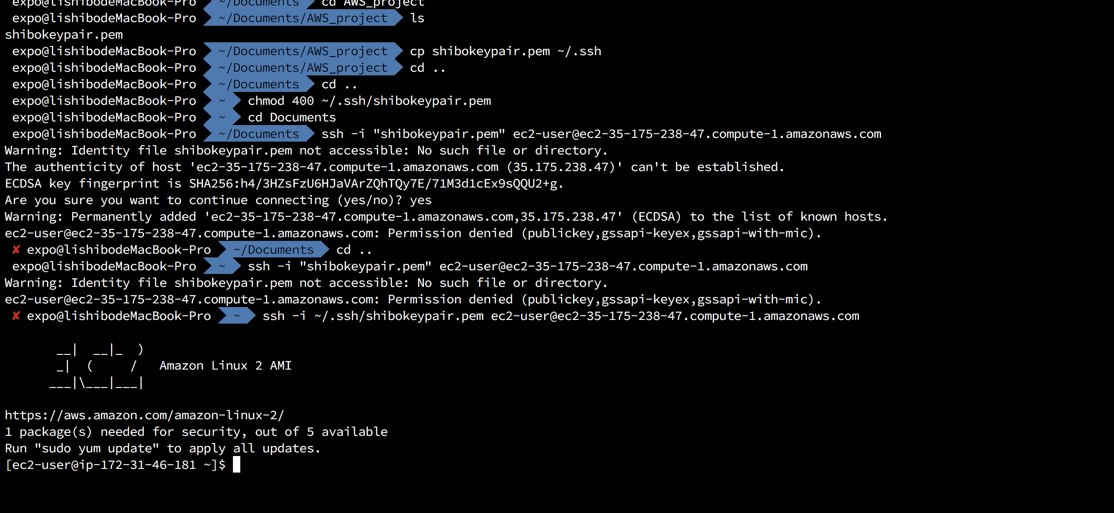

Then terminate:

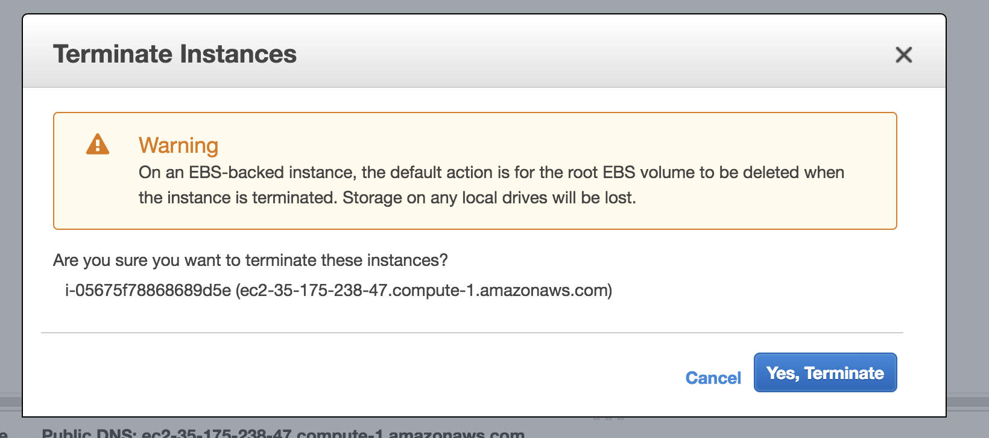

Summary:

It’s a basic tutorial without difficulty, but don’t forget stop the instance after using it!!!!!