**LAB EXERCISE 4**

**TOPIC: ARRAY**

**NAME: GWEE ZI NI  
MATRIC NO:A24CS0078**

**SECTION: SECTION 02**

1. Define the following arrays
   1. heights, 15 elements of type float.

**float heights[15];**

* 1. ages, 9 elements of type integer.

**int ages[9];**

* 1. metrics, 10 elements of type string.

**string metrics[10];**

1. Given the definition of the array. Give reason why definition is not correct.
   1. float points[6.5];

**Size declarator of the array must be an integer**

* 1. int sizeLimit;

int address[sizeLimit];

**The sizeLimit is not initialized yet**

* 1. char category[-8];

**The size declarator of the array must be a positive integer**

* 1. double length[];

**If size of array is implicit,all the elements should be listed out.**

1. Write C++ statements to perform each of the following:
   1. Declare an array named tests to allocate 5 elements of type double.

**double tests[5];**

* 1. Show the memory allocations of the array named tests.

tests[4]

tests[3]

tests[2]

tests[1]

tests[0]

|  |  |  |  |  |
| --- | --- | --- | --- | --- |
| 0 | 0 | 0 | 0 | 0 |

* 1. Read the value 25 from the keyboard and assign it into the array named tests of index 3.

**cin>>value;**

**tests[3]=value;**

* 1. Show the memory allocations of the array named tests.

tests[4]

tests[3]

tests[2]

tests[1]

tests[0]

|  |  |  |  |  |
| --- | --- | --- | --- | --- |
| 0 | 0 | 0 | 25 | 0 |

* 1. Add the content of index 3 with the value 20 and assign the result into tests [4].

**tests[4]=tests[3]+20;**

* 1. Show the memory allocations of the array named tests after question (e).

tests[4]

tests[3]

tests[2]

tests[1]

tests[0]

|  |  |  |  |  |
| --- | --- | --- | --- | --- |
| 0 | 0 | 0 | 25 | 45 |

1. Given the following programs. Show the memory layout of the array and explain each statement.

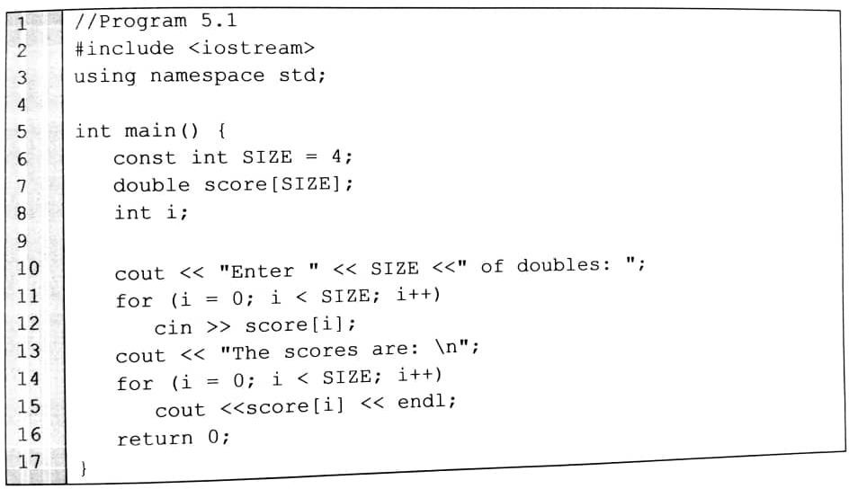

score[3]

score[2]

score[1]

score[0]

|  |  |  |  |
| --- | --- | --- | --- |
|  |  |  |  |

LINE 6: Make the SIZE=4 so that when the SIZE is used,it will automatically use value of 4 throughout the program

LINE 7:Declare the array score with the size of 4 because the SIZE has initialized with value 4

LINE10:This line is used to display the output message and the SIZE will has output 4.The whole statement will has output: Enter 4 of doubles:

LINE11:allow user to input the score in a loop with repeat 4 times,and the i indicated the number of index.When number of index is greater than or equal to SIZE which is 4,it will out of loop

LINE12:allow user to enter input for the score[i]

LINE 13:display the output message which is the score are and the \n make program have next line output

LINE 14: allow user to input the score in a loop with repeat 4 times,and the i indicated the number of index.When number of index is greater than or equal to SIZE which is 4,it will out of loop

LINE 15: allow user to enter input for the score[i]

1. Identify which of the following array declaration are invalid. If a declaration is invalid, explain your answer.
   1. int digits[8] = {2,4,5,3,5,1,8,0};

**Valid.**

* 1. int ids[5] = {101,202,303,404,505,606,707};

**Invalid because there contains 7 elements which is exceed than the size declarator of array with 5**

* 1. float length[] = {30.2,4.99,5.9};

**Valid.**

* 1. int size[8] = {67, ,66, , , 99,39,67};

**Invalid.The element in the array cannot be initialized by skipped.**

e) char feel[] = {‘c’, ‘í’, ‘n’, ‘t’, ‘a’, ‘\0’};

**Valid.**

1. char name[5] = “Azira”;

**Invalid because the size declarator of the name is actually 6 which greater than 5 due to the there actually has ‘\0’ at the end of the element.**

1. char name[20] = “Sharifah Aini”;

**Valid.**

1. Write a C++ program based on the following information, by using array (submit this question in .cpp file):

* Number of students = 10
* There are 10 marks of students to be saved

Student 1: 70

Student 2: 85

Student 3: 57

Student 4: 64

Student 5: 83

Student 6: 92

Student 7: 75

Student 8: 69

Student 9: 95

Student 10: 72

Based on the above information, calculate the total of marks for all students, and then calculate its average.