**Name:GWEE ZI NI**

**MATRIC NO:A24CS0078**

**Question1**

|  |  |
| --- | --- |
| Predefined function | Programmer-defined function |
| Also known as built-in function and library function which is already defined in system libraries | Also known as user-defined function which is created by programmer or the user. |
| Definition of predefined function is unnecessary to be written by the programmer | Definition of programmer-defined function is needed to be written by the programmer which including the return type, name, parameter list and body. |
| Users have to include the proper header file if they are using the predefined function | Users have to write the header for that function before writing the function body if using the programmer-defined function |

**Question2**

1. sqrt(y); // header file used is #include<cmath>
2. pow(x,y);//header file used is #include<cmath>
3. cos(x);//header file used is #include<cmath>
4. toupper(character);//header file used is #include<cctype>
5. strcpy(y,x);//header file used is <cstring>

**Question3**

|  |  |
| --- | --- |
|  | Difference |
| Local variable | Variable that defined inside a function.  Statement of local variable is hidden from the statements in other function and the other function cannot access them.  Lifetime of local variable is it exists only while the function is executing and local variables and parameter variable area destroyed when the function ends |
| Global variable | Variable that is defined outside of all functions in a program.  The global variable can be accessed by all functions that are defined after the global variable is defined.  The scope of global variable is the portion of the program from the variable definition to the end. |
| Global constant | Defined for values that do not change throughout the program’s execution and this constant area then used for those values for throughout the program |
| Static local variables | Defined and initialized only the first time the function is executed and the value can be retained between subsequent calls to the function. |

**Question 4**

#include <iostream>

using namespace std;

int average(int, int, int); _____//Prototype_____

int main()

{

int x, y, z, avrg;

cout << "Please enter three numbers:" << endl;

cin >> x >> y >> z;

avrg = average (x, y, z); __//function call

cout << "The average of the given three numbers is: " << avrg << endl;

return 0;

}

int average(int a, int b, int c) __//function header_____

{

int sum, avrg2;

sum = a + b + c;

avrg2 = sum / 3;

return avrg2; ___//return statement

}

**QUESTION 5**

Find the errors in the following given code.

#include <iostream>

#include<cmath> //because pow is used in this program

using namespace std;

int average(int, int,int); //error there is three numbers

int power (int p); //error because average as argument

int main()

{

int x, y, z, avrg, powerOf;

cout << "Please enter three numbers:" << endl;

cin >> x >> y >> z;

avrg = average (x,y,z); //error

cout << "The average of the given three numbers is: " << avrg << endl;

power (avrg); //error

cout << "The average number to the power of two is: " << power (avrg) << endl; //error

return 0;

}

int average(int a, int b, int c)

{

int sum, avrg2;

sum = a + b + c;

avrg2 = sum / 3;

return avrg2;//error

}

int power (int p)

{

int pOf;

pOf = pow(p,2);

return pOf; //error

}

**Question 6**

Execution1: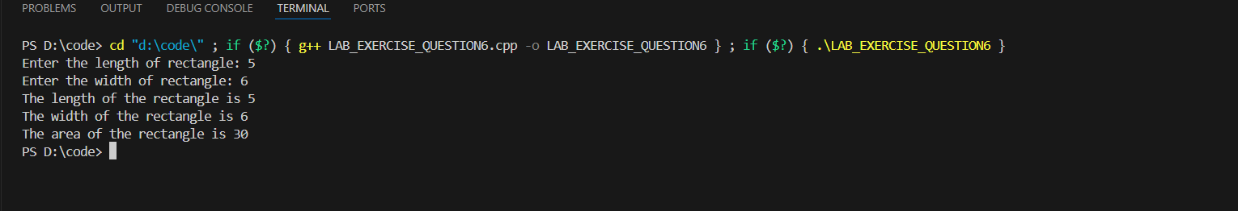

Execution2:

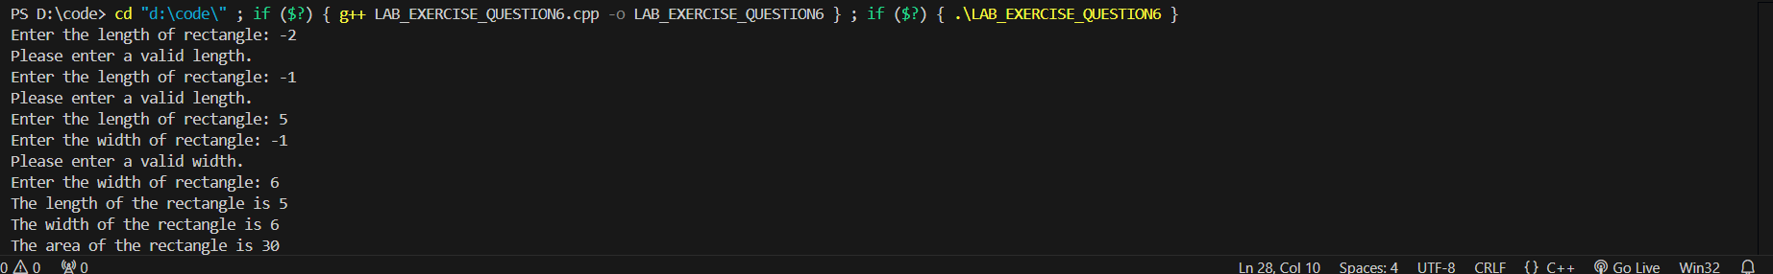

##The .cpp file will be uploaded in e-learning too.