Benchmarking Project – Sequence Assembly
Gabriel Wegman
Abstract:
Constructing genome regions or whole genomes via DNA sequences is known as sequence assembly. This helps us understand how an organism works at its most basic level. Bacterial genome assembly helps researchers learn about evolution, pathogenicity, gene expression, and more. There are different ways to assemble bacterial genomes: short read, long read, hybrid short read first, hybrid long read first. Learning about bacteria through assembly is imperative on the notion that the sequence assembly is accurate, so that researches have valid evidence for understanding the assembled DNA. This project benchmarks three different assembly tools, Spades, Flye, and Unicycler to understand which tool is the most optimal to use for the assembly of bacterial genomes. Spades and Unicycler produced the most accurate and continuous assemblies. Additionally, Spades assembles genomes faster than Unicycler, even at high coverages. Originally, Unicycler was benchmarked against Spades and similar results were found, which Unicycler producing more accurate and continuous assemblies than Spades[6]. At higher coverages and read qualities, Spades marginally outperformed Unicycler. Additionally, I found that read coverage and quality didn’t affect assembly of the 16S region; important for strain identification and novel strain discovery[7]. As new tools release and sequencing technology improves, it is important to benchmark Unicycler and Spades with them since they produce very accurate and continuous assemblies. Improving our knowledge on organisms through accurate sequence assembly will allow us to continue to understand and improve biological life.
Introduction:
Understanding organisms on a biological level is one of the most prioritized and principal components of science that can lead to the betterment of all life. The most important and arguably most basic method to achieve this is through looking at DNA, the genetic code that has the potential to answer any question about a living being. When the genome of an organism is sequenced, its DNA sequences are broken up into smaller, fragmented reads. Sequence assemblers can assemble the genome from these reads, giving researchers the opportunity to gain new biological knowledge.
Specifically, assembling the genomes of bacteria leads to a greater understanding of evolution, bacterial infection, and microbiomes. One of the first bacterial assembly tools was TIGR, produced in 1995, which was able to assemble bacterial genomes from long read sequences[1]. Since then, many different approaches have been taken towards sequence assembly. Long read sequences resolve repeat regions but pose inaccuracies[2]. Short read sequences struggle with repetitive regions but are very accurate[3]. Flye is an assembly tool published in 2019 that uses long read sequences from two possible methods: Oxford Nanopore Technology or Pacbio. On the other hand, SPAdes is a short-read assembler developed in 2012 that can also be used for hybrid assembly. This technique combines short and long read sequencing to produce an assembly that reduces shortcomings and exemplifies accuracy. Another tool that uses hybrid assembly is Unicycler. Developed 5 years after SPAdes, Unicycler builds off of SPAdes’ short read assembly algorithm and then uses long reads to improve the assembly.
Flye generates an assembly graph using k-mers, a subsequence of the DNA with a set length that is used to find the most likely path based on how k-mers match. Flye then randomly walks through this graph, yielding sequences with errors and repeats known to the algorithm as disjointigs. Flye then concatenates these disjointing into one large string. It then uses an accuracy graph in tandem with reads to clean up and fix the continuous, disjointed contig[4]. SPAdes uses multi-sized de Bruijn graphs, a common algorithm that asseses k-mers of all possible lengths within the genome to evaluate the best possible length of a k-mer[5]. Additionally, SPAdes generates k-bimers, a calculated distance between two k-mers. The algorithm uses this to map paired-end reads to each-other, generating long contigs and mitigating the number of repeats. Additionally, SPAdes takes advantage of alignment tools such as BLAST to find overlapping regions of the genome and get rid of them so contigs are more continuous[5]. Unicycler generates multi-sized de Bruijn graphs from short-reads via SPAdes. Unicycler utilizes bridging, a method that combines contigs through examining paired-end read graphs, and later long-read alignments. The short-read graphs generated by SPAdes are made into longer, complete contigs by mapping the long-reads to them. Afterwards, Unicycler uses BOWTIE2 and Pilon to align short-reads for improved accuracy checks[6].
Differences in sequencing technology can lead to errors which negatively affect the assembly, consequently generating an incomplete or inaccurate assembly. Additionally, the 16S region is an important part of the genome that is used for strain identification and novel strain discovery[7]. In this project I assess how quality, coverage, and old vs. modern sequencing technology affects the accuracy, continuity, runtime, and maximum RAM usage of whole bacterial genome assembly as well as 16S region assembly.
Methods:
All results were generated using simulated reads of the Escherichia coli BL21 reference genome. Long reads were generated via Badread[8], and short reads were generated via ART[9]. These are command line tools that were installed and used through Ubuntu linux terminal. Reads were simulated at different coverages and qualities over three different experiments. Experiment 1 changed read quality while coverage and length stayed the same. Experiment 2 changed read coverage while quality and length stayed the same. Experiment 3 changed long read quality, identity, length while short reads stayed the same. 3 replicates were generated per magnitude per experiment.
Spades v4.2.0 and Unicycler v0.4.4 assembled in hybrid mode, while Flye v2.9.6 assembled using only long reads. Spades and Unicycler were assembled at 32 threads, while thread use for Flye could not be specified. In addition to Spades, before repeat-resolution Spades was also benchmarked because its generated more accurate assemblies than Spades in the past⁹. BRRSpades could not be benchmarked for time and space complexity.
Linux command verbose was used to generate metrics time and complexity. BLAST v2.17.0 was used for assembly accuracy metrics LGA90, contig count, and misassemblies [10]. QUAST v5.2.0 was used for 16S assembly metric percent identity [11].
Figure generation was done using Python’s pyplot and seaborn libraries. P-values for data were generated via scipy states library using a one-way Anova test.
See Data Generation for command line code for read simulation, genome assembly, and Figure Generation for accuracy and time/space complexity generation.
Experiment 1:
Read quality was split into 3 different magnitudes: high, mid, low.
Short reads were always simulated at a mean length of 200bp with a standard deviation of 50bp, and a mean fragment length of 300bp. Additionally, read coverage was always set to 50x. High, mid, and low-quality short reads were generated using ART’s quality models MSv3, HS20, and GAIIx, respectively.
Long reads were simulated at a mean length of 7000bp with 400 bp standard deviation, a coverage of 100x, and Badread’s error model nanopore2023. High, mid, and low magnitudes were simulated with 95% identity with 2.5% standard deviation, 73% identity with 10% standard deviation, and 50% identity with 15% standard deviation.
Experiment 2:
Read coverage was split into 3 different magnitudes: high, mid, low.
Short reads were always simulated at a mean length of 200bp with a standard deviation of 50bp, and a mean fragment length of 300bp. Additionally, read quality was simulated using ART’s MSv3 model. High, mid, and low-coverage short reads were generated using 70x, 35x, and 17x, respectively.
Long reads were simulated at a mean length of 7000bp with 400 bp standard deviation, a 95% identity with 2.5% standard deviation, and Badread’s nanopore2023 error model. High, mid, and low-coverage long reads were generated using 100x, 50x, and 15x respectively.
Experiment 3:
Short reads used for hybrid assembly were always experiment 2 low, replicate 1. Simulated long reads were split into 2018 and 2024 and parameters were based on publications around those years.
2018 long reads were generated at an identity of 85% with 5% standard deviation[12], a coverage of 30x[13], and a length of 9600bp with 600bp standard deviation[14].
2024 long reads were generated at an identity of 99% with 1% standard deviation[15], a coverage of 35x[16], and a length of 6000bp with 1200bp standard deviation[17].
Results
LGA90 is a metric that was used to assess assembly continuity and accuracy. It corresponds to the number of aligned contigs needed to reach 90% genome coverage. A smaller LGA90 means there are few aligned contigs in the assembly indicating a more continuous and accurate assembly. Additionally, contig count was used as another way to confirm a continuous assembly. The smaller the contig count, the more continuous an assembly is. Misassemblies were also used to assess assembly accuracy. The fewer misassemblies an assembly has, the more accurate it is. To assess the accuracy of the 16S region, percent identity was used. The higher the percentage identity of the 16S assembly, the more accurate that region is. In terms of runtime an memory usage, the shorter the runtime indicates a more time-efficient assembler and less RAM use indicates a more memory-efficient assembler.
Experiment 1
At varying read qualities, Spades outperformed most of the other tools in the respective metrics. Flye saw the most variation and also performed the worst. Unicycler and Spades were comparable, but BRRSpades produced wildly discontinuous assemblies.
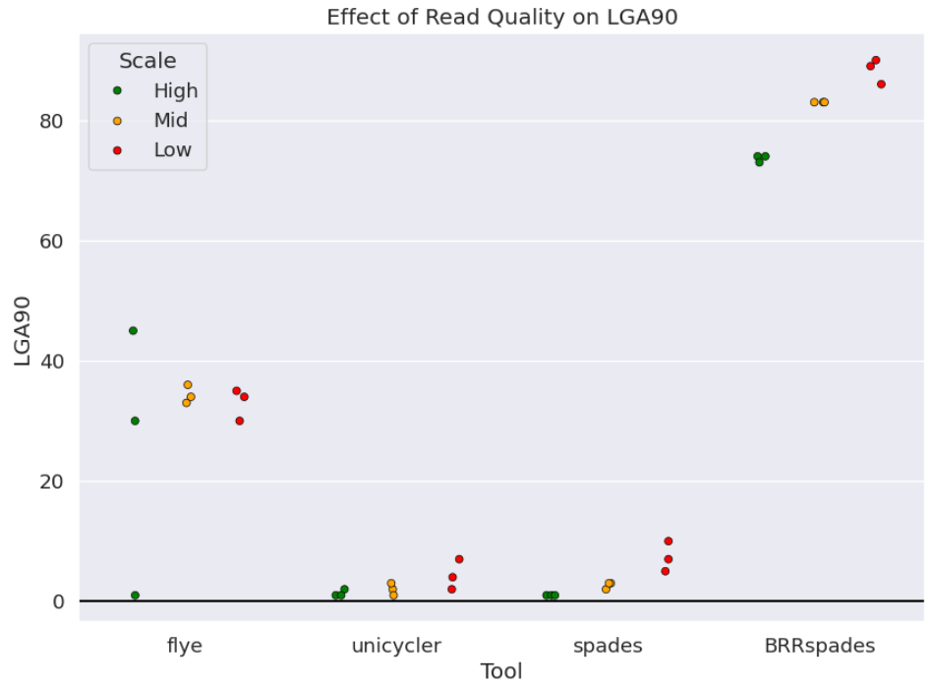
Figure 1: Read Quality and LGA90.
(P-values: Flye=0.68, Unicycler=0.13, Spades=0.005, BRRSpades=2.07e-5)
BRRspades performed the worst out of the four assemblies for LGA90, since it is before repeat resolution. Flye performed poorly compared to Unicycler and Spades, also having the most variation among high read quality. Unicycler and Spades were pretty comparable, performing the best out of the four tools. As read quality decreased, LGA90 increased, indicating that at a low read quality, the tools generated less accurate, less continuous assemblies. P-values indicate that Flye and Unicycler assemblies were due to random chance, instead of the effect of read quality.
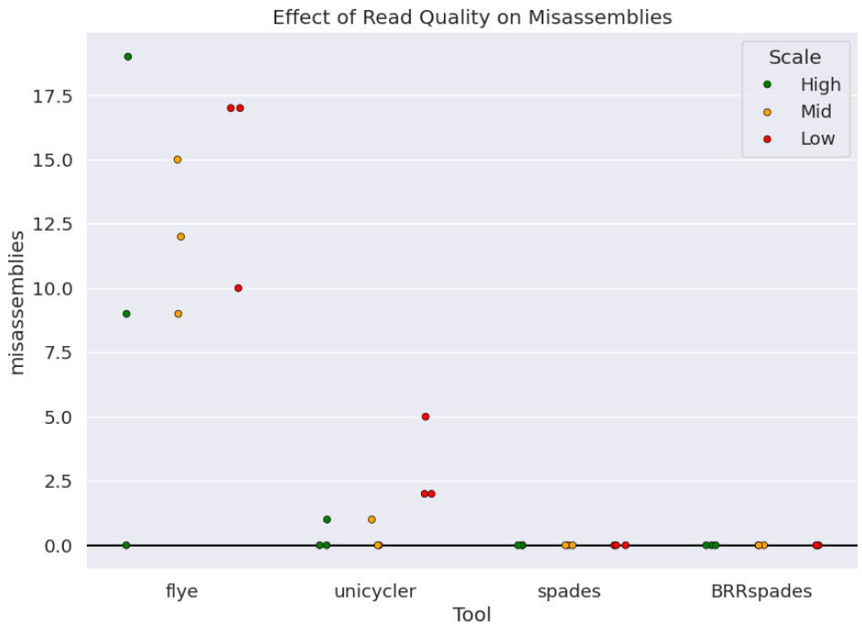
Figure 1.2: Read Quality and Misassemblies
(P-values: Flye=0.60, Unicycler=0.039, Spades=nan, BRRSpades=nan)
Flye performed the worst, seeing the most inaccuracy and variation. Unicycler’s accuracy decreased as read quality decreased. Spades and BRRspades performed the best, both had 0 misassemblies for all three replicates at all read qualities. This is why their p-value is nan, because it cannot be computed with a variation of zero. Flye had a higher p-value, indicating its generation was due to random chance.
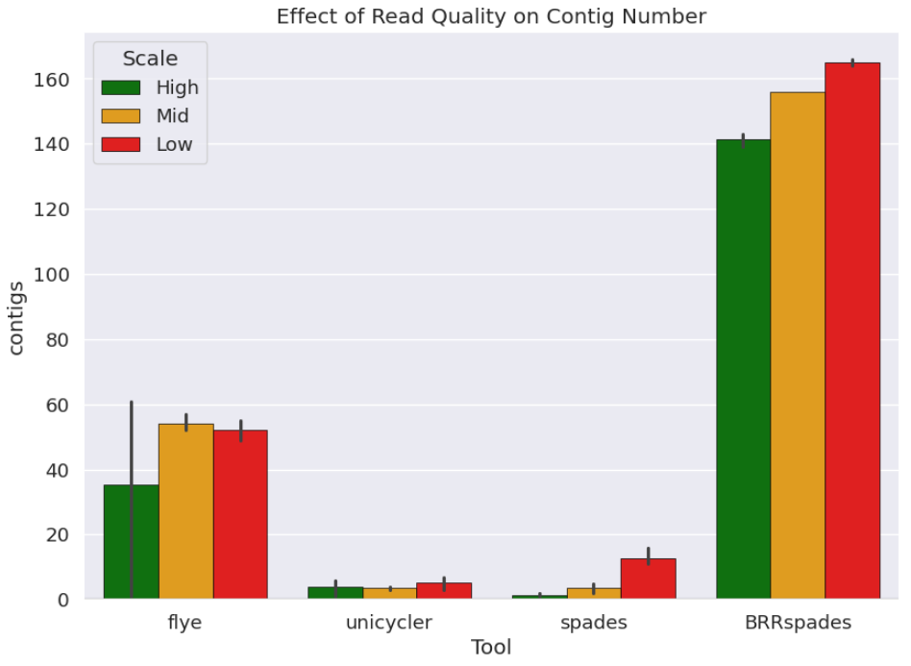
Figure 1.3: Read Quality and Mean Contig Count
(P-values: Flye=0.43, Unicycler=0.57, Spades=0.0008, 1.86e-06)
BRRSpades boasted the highest mean contig count for each read quality with the least variation. Flye had the most variation, specifically in the high-quality reads. This is the same variation that was found in Figure 1 and 2, which is likely causing the statistical insignificance. Unicycler and Spades had the least contig count and the most continuous assemblies, with Spades edging Unicycler out.
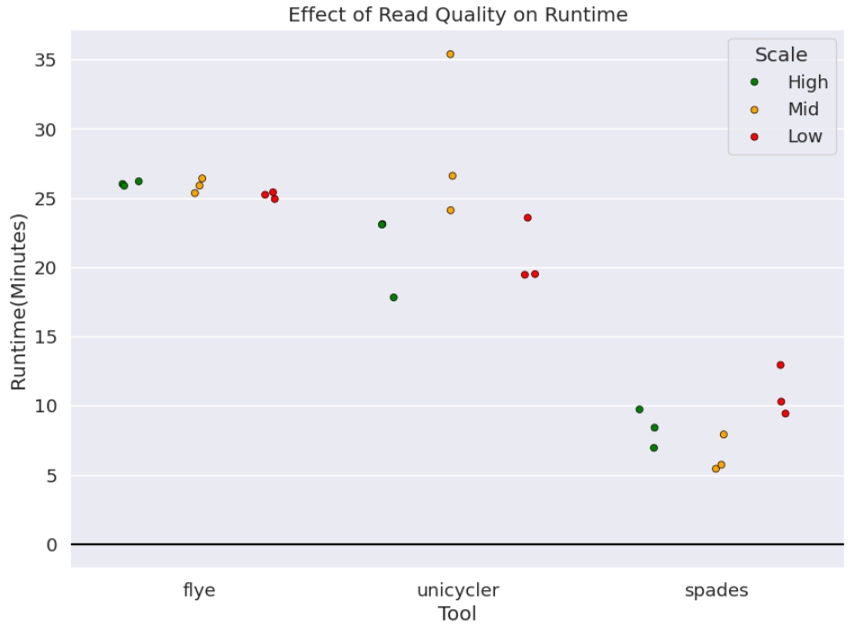
Figure 1.4: Read Quality and Runtime
(P-values: Flye=0.054, Unicycler=0.098, Spades=0.032)
Runtime was variable among the tools, however Spades was the most time efficient at different read qualities. Flye and Unicycler saw a slight downward trend in runtime as read-quality decreased, whereas Spades took slightly longer to assemble when read quality was low. Flye and Unicycler were due to random chance based on the p-value, and due to the high variation, especially in Unicycler’s assembly of the mid quality reads.
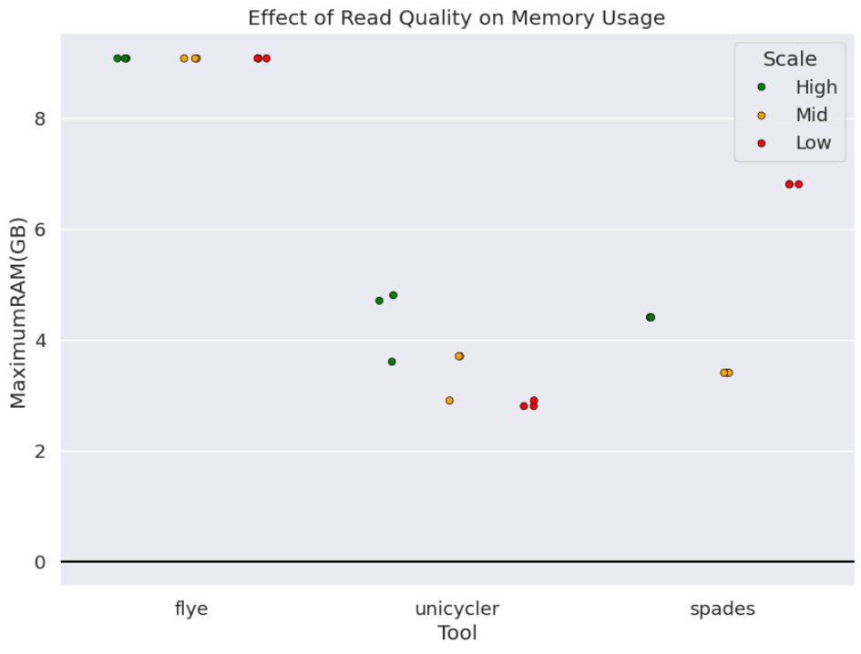
Figure 1.5: Read Quality and Memory Usage
(P-values: Flye=nan, Unicycler=0.019, Spades=0.0)
Unicycler and Spades handled memory usage the best, but Unicycler trumped Spades in the generation from low quality reads. Spades saw a nearly 4GB of RAM increase from mid to low quality reads. Flye performed the worst, using the most RAM out of any tool. There was no variation for Flye, leading to a nan p-value, both Spades and Unicycler were statistically significant.
Experiment 2
At different read coverages, Spades and Unicycler performed the best, with Spades having the best time-efficiency once again. Flye performed the worst at different read coverages, but better than its assemblies at different read qualities.
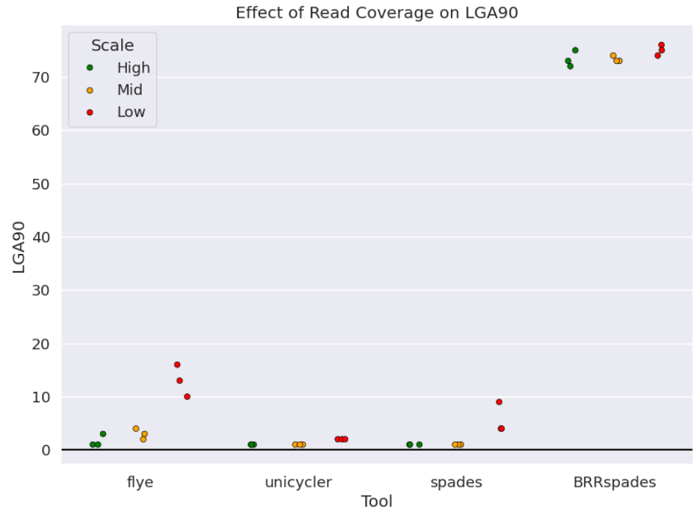
Figure 2.1: Read Coverage and LGA90
(P-values: Flye=0.0007, Unicycler=0.0, Spades=0.021, BRRSpades=0.18)
Spades, Unicycler, and Flye all had continuous and accurate assemblies with relatively low variation. Flye and Spades struggled more when read coverage got to 15-17x. BRRSpades had the highest LGA90, suggesting a discontinuous assembly once again. The p-values for Flye, Spades, and Unicycler were all significant, most likely due to the lower variation at different read coverages.
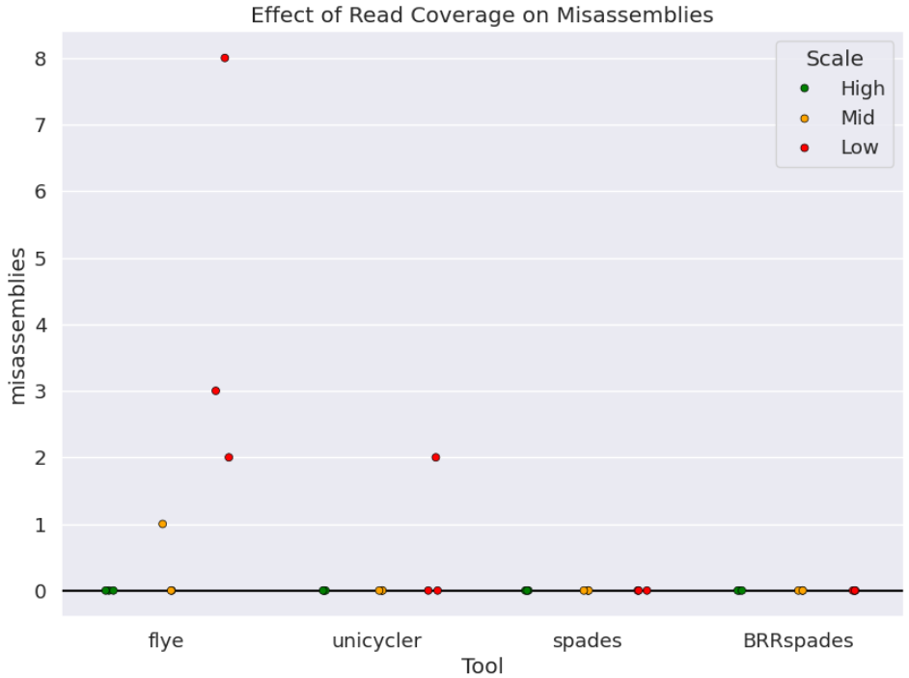
Figure 2.2: Read Coverage and Misassemblies
(P-values: Flye=0.054, Unicycler=0.42, Spades=nan, BRRSpades=nan)
Every tool generated a completely accurate assembly at 100x long read coverage and 70x short read coverage. Flye misassembled more as read coverage got lower, and Unicycler misassembled a couple of bases in one of the replicates with 15-17x coverage. Both Flye and Unicycler saw statistical insignificance due to variation, and Spades and BRRSpades had nan p-values because they didn’t have any variation.
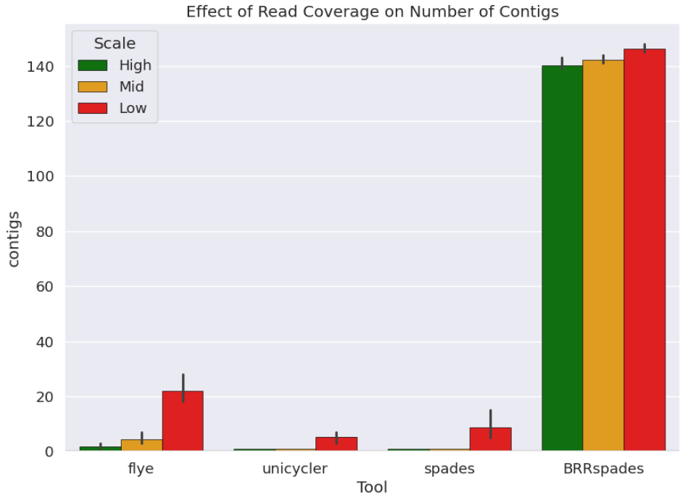
Figure 2.3: Read Coverage and Mean Contig Number
(P-values: Flye=0.0008, Unicycler=0.0065, Spades=0.039, BRRSpades=0.018)
Again, Unicycler and Spades assembled the most continuous genomes, with Spades having a little more trouble than Unicycler with 15-17x read coverage. Flye’s assemblies had minimal contig counts, but more than Spades and Unicycler. BRRSpades had the highest contig counts once again because it did not bridge contigs together. All tools were statistically significant for mean contig count.
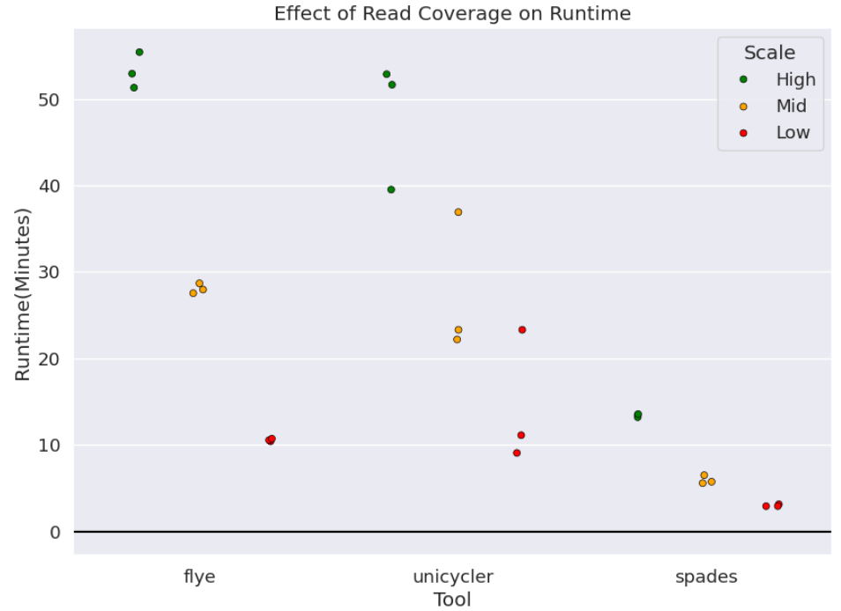
Figure 2.4: Read Coverage and Runtime
(P-values: Flye=3.78e-08, Unicycler=0.005, Spades=3.81e-08)
In terms of runtime, Spades performed the best again. At 70-100x read coverage, Flye and Unicycler took an upwards of 50 minutes, likely because as coverage increases, the size/amount of bases in the files increase, so it is more for the tools to sort through. Despite this, Spades had relatively low runtimes, even at high coverage. For all tools, as read coverage decreased, runtime did too because the amount of bases in the read files decreased.
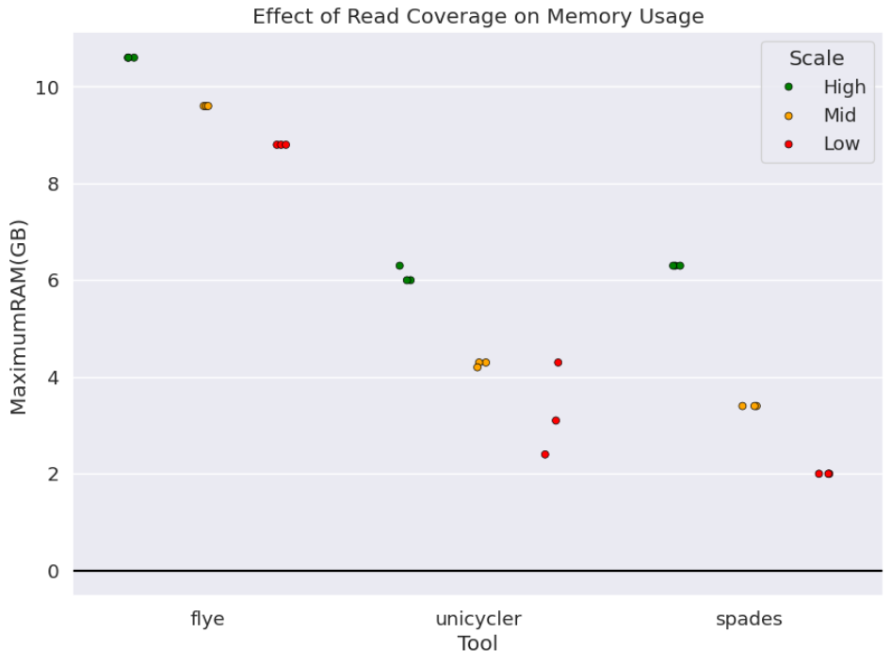
Figure 2.5: Read Coverage and Memory Usage
(P-values: Flye=0.0, Unicycler=0.002, Spades=0.0)
The effect of read coverage on maximum RAM usage mirrors that of runtime, as coverage decreases, so does memory usage, for the same reason as read coverage’s effect on runtime. Spades seemed to use the least amount of RAM, although it was comparable to Unicycler. Unicycler had the most variation of the three tools, with Spades and Flye have no variation within each scale of read coverage.
Experiment 3
The effect of simulated 2018 and 2024 ONT long reads seemed to have little effect across tools, but Spades and Unicycler performed the best in terms of assembly continuity and accuracy. Spades outperformed Unicycler in runtime again. Flye was again the tool that performed the worst. BRRSpades was consistent with its other experiments, producing accurate but discontinuous assemblies.
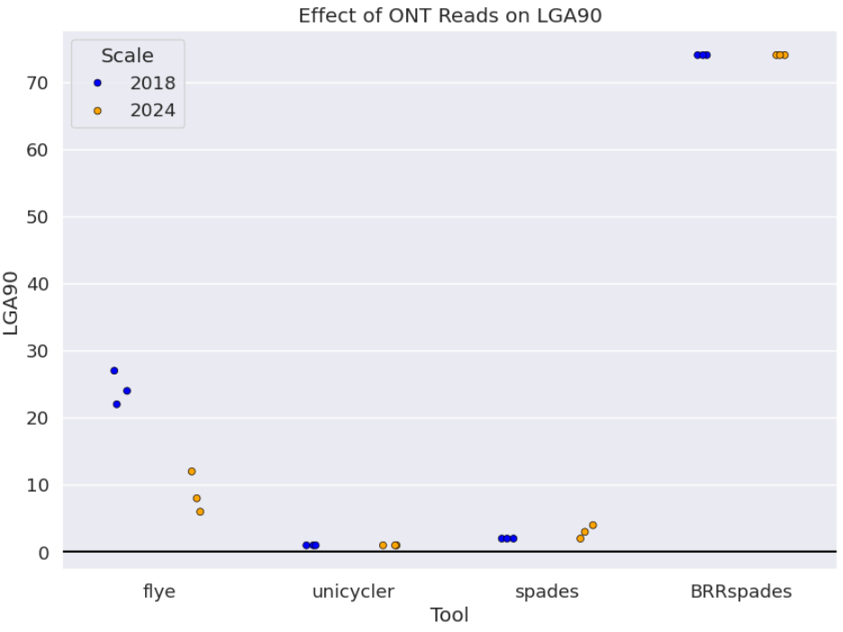
Figure 3.1: Simulated ONT and LGA90
(P-values: Flye=0.002, Unicycler=nan, Spades=0.158, BRRSpades=nan)
BRRSpades had predictably the highest LGA90 values. Flye performed the worst compared to Unicycler and Spades, with LGA90 noticeably decreasing from 2018 to 2024. This effect was not seen in Unicycler or Spades, with Unicycler having an LGA90 score of 1 across 2018 and 2024 assemblies. Spades varied a little more in 2024 and had statistical insignificance.
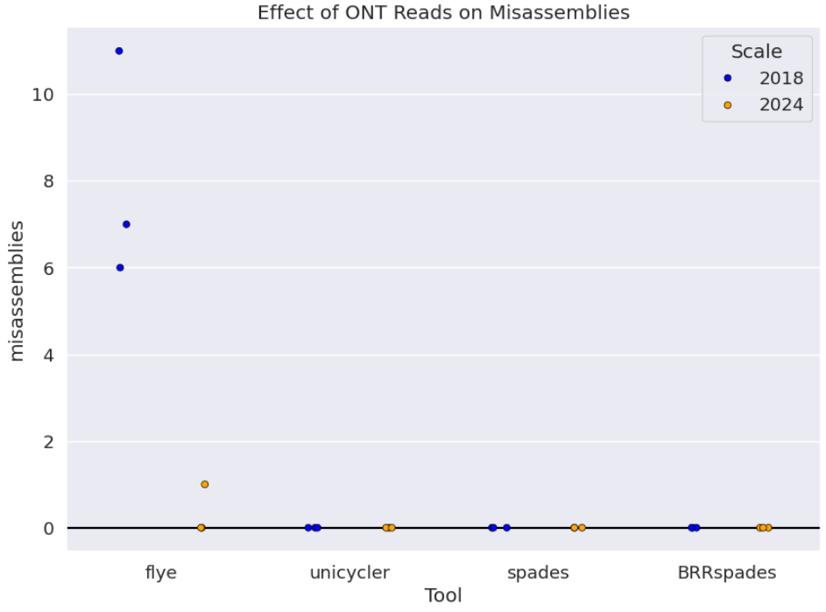
Figure 3.2: Simulated ONT and Misassemblies
(P-values: Flye=0.008, Unicycler=nan, Spades=nan, BRRSpades=nan)
Unicycler, Spades, and BRRSpades all yielded zero misassemblies for both 2018 and 2024 simulated assemblies. Flye was the most affected by the different read simulations, with a large decrease in misassemblies from 2018 to 2024. Since Unicycler, Spades, and BRRSpades had no variation, they generated p-values of nan.
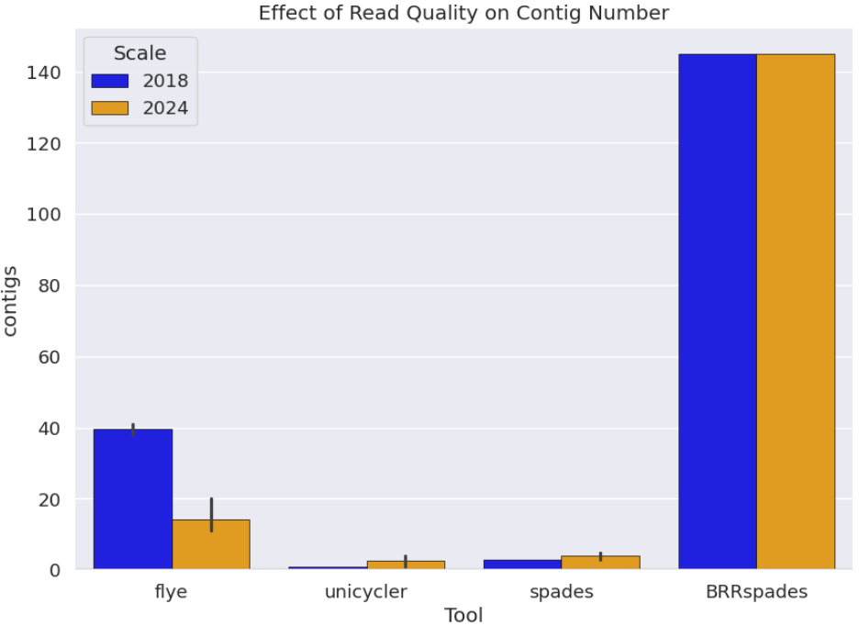
Figure 3.3: Simulated ONT and Mean Contig Number
(P-values: Flye=0.001, Unicycler=0.006, Spades=0.039, BRRSpades=0.018)
Coinciding with its other assemblies across experiments, BRRSpades generates the most contigs. Flye generated more contigs than Unicycler and Spades, and saw the jump from 2018 to 2024 improve its assembly once again. Flye had less contigs in 2024 than 2018, indicating a more continuous assembly. Unicycler and spades were largely unaffected, with variation occurring in 2024. All tools’ contig count was statistically significant, indicating that 2018 v 2024 simulated ONT reads influenced contig count.
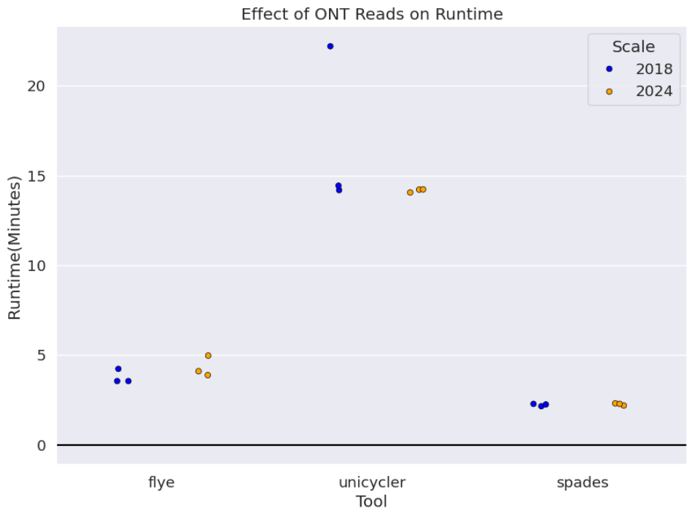
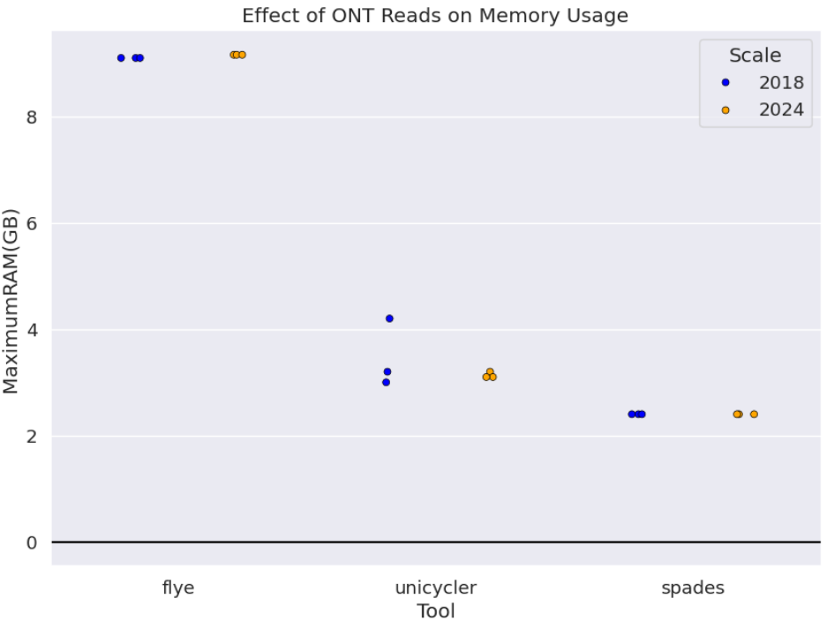
Figure 3.4: Simulated ONT and Runtime and Memory Usage
(Runtime p-values: Flye=0.25, Unicycler=0.35, Spades=0.56)
(Memory Usage p-values: Flye=0.0, Unicycler=0.42, Spades=nan)
There was no clear observed effect of 2018 v 2024 simulated ONT reads on runtime or memory usage. One replicate in 2018 increased runtime for Unicycler. Generally, Spades performed the best due to its memory efficiency and extremely low runtime. Flye performed the worst, using the most memory and taking the longest to complete an assembly again.
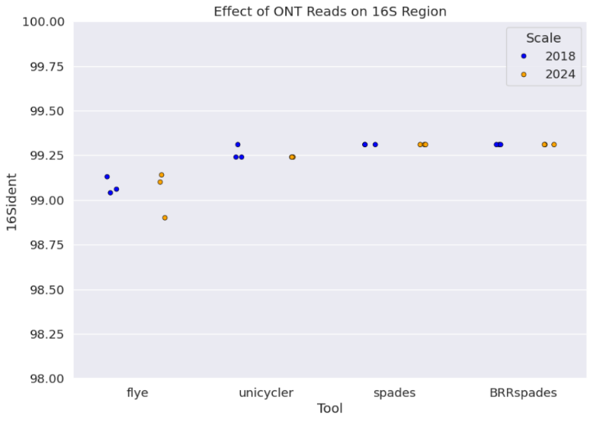
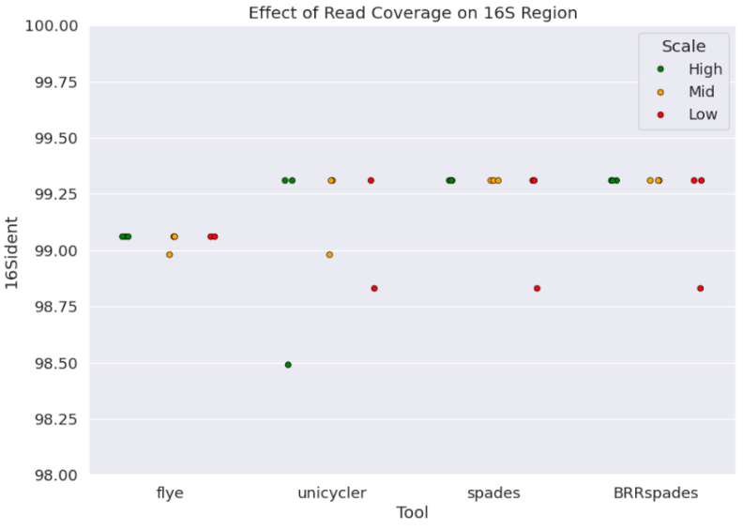
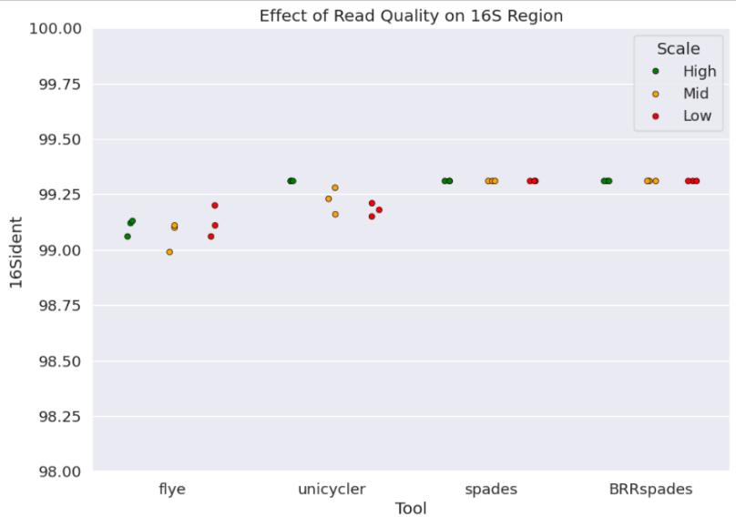

Figure 4: Read Quality, Coverage, and Simulated ONT for the 16S Region
(Read Quality p-values: Flye=0.54, Unicycler=0.016, Spades=nan, BRRSpades=nan)
(Read Coverage p-values: Flye=0.445, Unicycler=0.464, Spades=3.8e-08, BRRSpades=0.42)
(Simulated ONT p-values: Flye=0.72, Unicycler=0.37, Spades=nan, BRRSpades=nan)
Across all experiments, different read qualities and coverages did not have a noticeable effect on the assembly of the 16S region. All tools assembled the 16S region with at least 99% accuracy. Flye had a marginally lower accuracy compared to the other tools but stayed in the 99% identity range.
Discussion
Previously, Unicycler was benchmarked against Spades, Abyss, npScarf, and Cerulean in which Unicycler marginally performed the best at varying read accuracy, length, and coverage[6]. Researchers used read coverages from 1-16x and mainly assessed assembly accuracy through QUAST. They simulated reads from different E. coli strains and real reads from Klebsiella pneumoniae. In this project, I benchmarked Unicycler against Spades and Flye at varying read qualities and coverage. I used E. coli BL-21, an extensively researched strain for its protein expression[18]. My project assembled reads with much higher coverages (15-100x) and included simulated ONT 2018 and 2024 long reads. Additionally, I used QUAST for the genome assembly accuracy, and BLAST for assembly accuracy of the 16S region.
In my project, Unicycler and Spades were both comparable in hybrid assembly. Both tools assembled very accurately; however Spades was often the most accurate, even at lower read qualities and coverages (Figures 1.2, 2.2, 3.2). Furthermore, Spades assembled genomes much faster than Unicycler, especially at high coverages (Figures 1.4, 2.4, 3.4). Unicycler and Flye both presented some statistical insignificance with their p-values, indicating the results were due to random chance (Figures 1.1-1.5, 2.4, 3.4, 4). Flye, a long-read assembler, generally performed the worst. Flye was extremely variable and often assembled genomes with the most discontinuity, memory usage, and misassemblies (Figures 1.1-1.3, 2.1-2.3, 3.1-3.3, 4.1-4.3). At first glance, it seems that read quality didn’t have a large effect on assembly accuracy, continuity, and runtime (Figures 1.1-1.4). However, short reads were simulated with 50x coverage, and long reads 100x. These are high coverages, as it corresponds to how many reads cover each base. At 100x coverage, each base is covered by 100 reads. This is likely why, even at 50% long read identity, Unicycler and Spades were able to assemble genomes with less than 5 misassemblies. This suggests that with enough coverage, the effect of read quality is insignificant.
Similarly, there was no large effect of varying read coverage on assembly accuracy and continuity. Even at low coverages of 15-17x, Spades and Unicycler were assembling accurate and continuous genomes (Figures 2.1-2.3). Flye was observed to be the weakest tool in this project, and as such the effect of varying read coverages was more observable. For Flye, as genome coverage decreased, so did the assembly continuity and accuracy (Figures 2.1-2.3). This coincides with the nature of genome coverage, since each base is covered less, the assembler doesn’t have as much evidence to support the arrangement of different reads as its assembling. The largest effect of long read coverage was seen on runtime and memory. At higher coverages, each base is covered by a higher amount of reads, which means there are more reads for the tools to parse through and store. There was a clear and definitive decline in the amount of memory usage and runtime as read coverage decreased. Also, all tools were statistically significant for these metrics. Simulated ONT reads had observable effects on Flye. 2024 ONT reads were simulated with more coverage, read identity, and the 2023 nanopore error model within Badread. This led to Flye assembling the genomes with higher accuracy (Figure 3.2) and higher continuity (Figures 3.1, 3.3). As for assembly of the 16S region, there was no observable effect of read quality and coverage on assembly accuracy. The 16S region is a very short stretch of DNA, which may suggest why the tools were able to assemble it with at least 99% accuracy, regardless of read condition.
All in all, I would suggest using Spades in hybrid mode for bacterial genome assembly due to its consistency in assembling accurate, continuous genomes. Additionally, Spades is very time efficient, which is important when running assemblies of larger datasets. However, I would not recommend using Spades’ before repeat resolution assembly as it provides no accuracy benefit and assembles extremely incomplete genomes (Figures 1.3, 2.3, 3.3). It was previously benchmarked in 2008 when average read coverages and identities were much lower and found to be more accurate[6]. Unicycler is also a viable option as it was very comparable to Spades throughout this project, but Unicycler v0.5.0 has a consistent stalling issue in which it will remain infinitely on a read bridging step until the command is halted. For this reason I would not recommend using Unicycler v0.5.0 and would recommend downgrading Unicycler to v0.4.4. Flye is a tool that I would not recommend at all, seeing that it struggled to have the same accuracy and continuity as Unicycler and Spades. Also, Flye used the most RAM out of any tool, suggesting that it is inefficient at storing memory for assembly (Figures 1.5, 2.5, 3.4).
There were many limitations with this study. Firstly, I originally wanted to simulate 5 replicates per state, per experiment, but due to the time constraints of this project, I was unable to. This led to a lot of statistical insignificance with my data because variation had a greater impact on significance. Additionally, this project did not use any real data. I wanted to use real 2018 and 2024 ONT reads to compare how they have improved in the past 6 years, but I was not able to find any viable ONT read sets from within 1 year of those times. I downgraded Unicycler to an earlier version, which could have affected its runtime, accuracy, and continuity, so I was not able to benchmark the most recent version. I also wanted to benchmark all hybrid assembly tools, to understand the effect of long-reads more on hybrid assembly. I wanted to use Hybracter, a long-read first approach bacterial assembly tool, but I could not get it to assemble properly after extensive troubleshooting. In the future, Unicycler and Spades should be benchmarked against Hybracter to understand the effect of long-read first vs short-read first hybrid assembly approaches, since Unicycler and Spades are both short-read first. In terms of my analysis of the 16S region, simulated reads of even lower qualities (50-80% read identity) and coverages (1-8x) along with real data sets should be assembled to better assess where the assembly of this region starts to fall off.
References
[1] TIGR Assembler: A New Tool for Assembling Large Shotgun Sequencing Projects. www.liebertpub.com/doi/epdf/10.1089
[2] New research algorithms yield accuracy gains for nanopore sequencing. 2020. Oxford Nanopore Technologies. https://nanoporetech.com
[3] Bruzek S, Vestal G, Lasher A, Lima A, Silbert S. 2020. Bacterial Whole Genome Sequencing on the Illumina iSeq 100 for Clinical and Public Health Laboratories. J Mol Diagn. 22(12):1419–29
[4] Kolmogorov M, Yuan J, Lin Y, Pevzner PA. 2019. Assembly of long, error-prone reads using repeat graphs. Nat Biotechnol. 37(5):540–46
[5] Bankevich A, Nurk S, Antipov D, Gurevich AA, Dvorkin M, et al. 2012. SPAdes: A New Genome Assembly Algorithm and Its Applications to Single-Cell Sequencing. J Comput Biol. 19(5):455–77
[6] Wick RR, Judd LM, Gorrie CL, Holt KE. 2017. Unicycler: Resolving bacterial genome assemblies from short and long sequencing reads. PLoS Comput Biol. 13(6):e1005595
[7] Janda JM, Abbott SL. 2007. 16S rRNA Gene Sequencing for Bacterial Identification in the Diagnostic Laboratory: Pluses, Perils, and Pitfalls. J Clin Microbiol. 45(9):2761–64
[8] Wick RR. 2019. Badread: simulation of error-prone long reads. Journal of Open Source Software. 4(36):1316
[9] Huang W, Li L, Myers JR, Marth GT. 2012. ART: a next-generation sequencing read simulator. Bioinformatics. 28(4):593–94
[10] Altschul SF, Gish W, Miller W, Myers EW, Lipman DJ. 1990. Basic local alignment search tool. J Mol Biol. 215(3):403–10
[11] Gurevich A, Saveliev V, Vyahhi N, Tesler G. 2013. QUAST: quality assessment tool for genome assemblies. Bioinformatics. 29(8):1072–75
[12] Rang FJ, Kloosterman WP, de Ridder J. 2018. From squiggle to basepair: computational approaches for improving nanopore sequencing read accuracy. Genome Biol. 19(1):90
[13] Jain M, Koren S, Miga KH, Quick J, Rand AC, et al. 2018. Nanopore sequencing and assembly of a human genome with ultra-long reads. Nat Biotechnol. 36(4):338–45
[14] Robust long-read native DNA sequencing ... | Wellcome Open Research. https://wellcomeopenresearch.org
[15] ont-interim-results-for-the-six-months-ended-30-june-2024-final-3-sep-2024.pdf (could not find citable article/website, only pdf)
[16] Gustafson JA, Gibson SB, Damaraju N, Zalusky MP, Hoekzema K, et al. 2024. High-coverage nanopore sequencing of samples from the 1000 Genomes Project to build a comprehensive catalog of human genetic variation. Genome Res. gr.279273.124
[17] Zhao W, Zeng W, Pang B, Luo M, Peng Y, et al. 2023. Oxford nanopore long-read sequencing enables the generation of complete bacterial and plasmid genomes without short-read sequencing. Front Microbiol. 14:1179966
[18] Heyde SAH, Nørholm MHH. 2021. Tailoring the evolution of BL21(DE3) uncovers a key role for RNA stability in gene expression toxicity. Commun Biol. 4(1):963

